Different antigenic distance metrics generate similar predictions of influenza vaccine response breadth despite low correlation

Authors
- W. Zane Billings$​^{1,2,*}$ (ORCID: 0000-0002-0184-6134);
- Yang Ge$​^{1,2}$ (0000-0001-5100-0703);
- Amanda L. Skarlupka$​^{3,†}$ (0000-0002-3654-9076);
- Savannah M. Hammerton$​^{1,2}$ (0000-0003-2231-3510);
- Hayley Hemme$​^{1,2}$ (0009-0002-6609-1390);
- Murphy John$​^{1,2}$ (0009-0009-9591-1117);
- Ted M. Ross$​^{3,4}$ (0000-0003-1947-7469);
- Andreas Handel$​^{1,2,*}$ (0000-0002-4622-1146).

Author affiliations
- $1$: College of Public Health, University of Georgia, Athens, GA, USA.
- $2$: Center for the Ecology of Infectious Diseases, University of Georgia, Athens, GA, USA.
- $3$: Center for Vaccines and Immunology, Department of Veterinary Medicine, University of Georgia, Athens, GA, USA.
- $4$: Florida Research & Innovation Center, Cleveland Clinic, Port St. Lucie, FL, USA.
$†$: ALS is currently an employee of the National Cancer Institute, National Institutes of Health, Bethesda, Maryland, USA. ALS prepared work for this manuscript while acting as an employee of the University of Georgia, Athens, GA, USA. The opinions expressed here are the authors’ own and do not express the views of the National Cancer Institute, the National Institutes of Health, or the Department of Health and Human Services.
$*$: Corresponding author: W. Zane Billings; 131 B.S. Miller Hall, 101 Buck Road, Athens, GA 30602, USA; email wesley.billings@uga.edu. Alternate corresponding author: Andreas Handel; 124 B.S. Miller Hall, 101 Buck Road, Athens, GA 30602, USA; email ahandel@uga.edu.

Author contributions (CRediT)
- ZB: conceptualization, data curation, formal analysis, methodology, software, visualization, writing (original draft preparation), writing (review and editing)
- YG: data curation, methodology, writing (review and editing)
- ALS: data curation, methodology, writing (review and editing)
- SMH: methodology, validation, writing (review and editing)
- HH: methodology, validation, writing (review and editing)
- MJ: methodology, validation, writing (review and editing)
- TMR: data curation, investigation, resources, writing (review and editing)
- AH: conceptualization, methodology, supervision, writing (original draft preparation), writing (review and editing), funding acquisition

Funding sources
- ZB: none declared
- YG: ?
- ALS: none declared
- SMH: none declared
- HH: none declared
- MJ: none declared
- TMR: Eminent Scholar, Georgia Research Alliance
- AH: partial funding from NIH contracts/grants NIH grants/contracts U01AI150747, R01AI170116, 75N93019C00052, and 75N93021C00018

Abstract
Introduction: influenza constantly evolves to escape population immunity, which makes formulating a vaccine challenging. Licensed vaccine formulations are based on strains that are expected to circulate, so if the circulating strain is different, vaccine effectiveness (VE) can be reduced. The effect on vaccine effectiveness should depend on how different the circulating strain and vaccine strain are, which is measured by antigenic distance. Antigenic distance is normally quantified using antigenic cartography of hemagglutination inhibition (HAI) titer data, which is costly and has the potential to produce biased antigenic distances. While multiple antigenic distance measurements have been developed and compared in previous literature, they have not been compared in their ability to predict immunological outcomes. We compare how predicted breadth of vaccine response varies when different metrics are used to calculate antigenic distance.
Methods: We analyzed data from a seasonal influenza vaccine cohort which collected serum samples from 2013/14 – 2017/18 at three study sites. The data include pre- and post-vaccination hemagglutination inhibition titers to the vaccine strains and a panel of heterologous strains. We used that data to calculated four different antigenic distance measures between assay strains and vaccine strains: difference in year of isolation (temporal), $p$-Epitope (sequence), Grantham’s distance (biophysical), and antigenic cartography distance (serological). We analyzed agreement between the four metrics using Spearman’s correlation and intraclass correlation (ICC). We then fit bayesian generalized additive mixed-effects models (GAMMs) to predict the effect of antigenic distance on post-vaccination titer after controlling for confounders and analyzed the pairwise difference in predictions between metrics.
Results: the four antigenic distance metrics demonstrated weak correlations for influenza subtypes A(H1N1), B (Victoria), and B (Yamagata). The exception was A(H3N2), which showed high correlations. However, we found that after accounting for pre-vaccination titer, study site, and repeated measurements across individuals, the predicted post-vaccination titers conditional on antigenic distance and subtype were nearly identical across antigenic distance metrics, with A(H1N1) showing the only notable deviation between metrics.
Discussion: Despite low correlation among metrics, we found that different antigenic distance metrics generate similar predictions about breadth of vaccine response. Costly titer arrays for antigenic cartography may not be needed when simple sequence-based metrics suffice for quantifying vaccine breadth.

Introduction
Influenza viruses constantly evolve over time. As host immunity induces selective pressure, new influenza strains accumulate mutations, a phenomenon called antigenic drift (1–6). As mutations accumulate, antigenic drift leads to vaccine escape (7–9). Seasonal influenza vaccines are formulated based on the strains that are expected to circulate, but these predictions are sometimes incorrect and vaccine effectiveness (VE) varies annually (10). A major determinant of VE is the similarity between the strains used for vaccine formulation and the circulating influenza strains (11–20). While previous analyses have analyzed the effect of binary match or mismatch, measuring the full effect of antigenic distance on vaccine response requires quantitative antigenic distance calculations (21–25).
The most common method for quantifying antigenic distance between influenza strains is antigenic cartography, which relies on extensive panels of serological data (26). Cartographic distance has proven useful in understanding influenza evolution, but validating the ability of cartography to estimate population-level protection is difficult because of the required data (27–29). Evolution or sequence-based methods can accurately predict cartographic distance based on genetic sequences of influenza strains, but still rely on accurate serological data for calibration (30–38). Furthermore, multiple cartography methods yield different maps on the same data (26,27,39–41). Maps based on HAI titers also incorporate bias from HAI assays, which are often not replicable between labs (42,43) and do not always accurately reflect differences in antigenic clusters (21–25,35,39,44–46). While cartographies can be generated from alternative assays (47–49), HAI is still the most common immunological assay used for influenza and the majority of highly-cited cartographies in use are based on HAI (26–28,50,51).
Not all antigenic distance measurements involve serological data, however. Simpler analyses of the genetic or amino acid sequence of influenza strains can provide reliable measures of antigenic distance that correlate with vaccine effectiveness at a population level (52–54), even though they only weakly correlate with serological antigenic distance (27,32,55). Notably, new antigenic lineages can be reliably differentiated by analyzing changes at just a few sites (56–58), and advanced predictive models consistently identify sequence-based biophysical and phylogenetic properties as important predictors of antigenic innovation (59–62). Analyses of vaccine response or immunogenicity based on temporal (63–68) or sequence-based distances can provide information about breadth of vaccine response (30,44,52–55,69–71). Taken together, these results imply that simple genetic analyses should provide important information about antigenic evolution without the need for serology. A direct comparison of antigenic distance methods is necessary to determine whether serological and genetic antigenic distance calculations can provide the same information in a practical setting.
To compare the implications of multiple antigenic distance metrics on practical outcomes, we perform a secondary data analysis of an influenza vaccine cohort with a panel of HAI measurements to historical strains for each individual. We find that, despite the low correlation in antigenic distance metrics, these different metrics make similar conclusions about vaccine response to antigenically distant strains. Our results suggest that implementing costly antigenic analyses or deep learning methods may not be necessary, as simple sequence-based measures lead to essentially equivalent predictions about vaccine response as antigenic distance varies.

Methods

Data source
The data for our study are from a prospective, ongoing human vaccination cohort study which has been described in detail previously (72–74). Briefly, the study recruited participants at three study sites: Pittsburgh, PA, USA, and Port St. Lucie, FL, USA beginning in the 2013/14 influenza season (approximately September through March (75)) and continuing through the 2016/17 influenza season. Beginning in January 2017, the study moved to Athens, GA, USA. Participants received Fluzone (Sanofi-Pasteur) vaccines and donated two serum samples, one before being vaccinated, and one at a follow-up visit approximately 21 days after the first visit. The study was a prospective, open cohort design where individuals could enroll in multiple years in the study, but were not required to re-enroll in every consecutive year. Individuals under 65 received a standard dose Fluzone vaccination, and individuals aged 65 and older were given the choice between standard dose (SD) and high dose (HD) Fluzone vaccines.
Researchers used each serum sample for a panel of hemagglutination inhibition (HAI) assays to the homologous strains, included in the seasonal vaccine formulation, and a panel of historical, heterologous influenza virus strains. Strains included in the historical panel represented the major clades of circulating influenza viruses. In each season, all prior vaccine strains from 2012 onward were included in the historical panel. See the Supplement for details on the Fluzone vaccine formulation and for a list of strains used in each season.
For our secondary data analysis, we extracted previously deidentified records from the 2013/14 through 2017/18 influenza seasons. We included all participants with both pre-vaccination and post-vaccination blood samples in our analysis. Our primary outcome of interest was the reciprocal post-vaccination HAI titer, which we log transformed:
$$y=\log_{2}\left(\frac{\text{reciprocal HAI titer}}{5}\right).$$
We divided the raw reciprocal titer by $5$ before taking the log because the HAI assay had a lower limit of detection (LoD) of $10$, and an upper LoD of $20,480$. Values below the LoD were coded as 5 in the dataset. After our transformation, values below the LoD had a value of $0$. All observed values in our dataset were below the upper LoD. We used the same outcome definitions defined in our previous work on this dataset (76).
Each HAI assay in our dataset has an associated subtype, vaccine strain, and assay strain. Here, we use “subtype” for simplicity to describe both Influenza A subtypes (H1N1 and H3N2), and Influenza B lineages (Victoria-like and Yamagata-like). The vaccine strains associated with an HAI assay are the strains used in the Fluzone vaccine formulation in the season when the serum sample was drawn. Each assay has three or four associated vaccine strains, depending on whether the individual who gave the serum sample received a trivalent or quadrivalent vaccine (see Supplement for details on the vaccine formulations). The assay strain for a vaccine is the strain of the actual virus added to the serum sample during the HAI assay.
We computed the pairwise antigenic distance for all strains used in the dataset (again, see the Supplement for a complete list). We used four different methods to compute the antigenic distance: temporal distance, dominant $p$-Epitope distance (52), Grantham’s distance (77), and cartographic distance (26). For complete details on antigenic distance calculation, see the Supplement.

Statistical analyses
We first summarized demographic information about the cohort in a descriptive analysis, stratifying by measurements, individuals, and person-years to demonstrate the multilevel structure of our data.
For our formal analysis, we built generalized additive mixed-effects models (GAMMs) and linear mixed-effects models (LMMs) (78,79) (see the Supplement for details). We fit a separate model for each of the antigenic distance metrics. We used a Gaussian outcome family with the transformed post-vaccination titer as the outcome and adjusted for censoring in the outcome (80). To answer our primary question, we modeled antigenic distance in two ways. For the LMM, we included a linear effect of antigenic distance which was allowed to vary by strain type. For the GAMM, we modeled antigenic distance using a flexible semiparametric spline which allows the relationship to be nonlinear, but constrained.
We fit the LMMs and GAMMs in a Bayesian framework using weakly informative priors chosen by a prior predictive simulation. We obtained posterior samples of the model parameters using the No U-Turn Sampler (NUTS) algorithm implemented by Stan (81,82), via the brms (83–85) and cmdstanr (86) packages for R (87). After obtaining the posterior samples, we calculated marginal posterior predictions for many values normalized antigenic distance (88). We summarized the posterior prediction samples with a mean point estimate and 95% highest density continuous interval (HDCI). We compared the GAMM and LMM for each antigenic distance metric using the leave-one-out expected log pointwise predictive density (LOO-ELPD) which is conceptually similar to model selection using cross-validation in a frequentist scenario (90). See the Supplement for extensive details on our models.
To examine the differences in predictions across each of the antigenic distance metrics, we compared the slope and intercept for LMMs and the fold change in predicted post-vaccination HAI titer for the LMM and GAMM since the GAMM has no equivalent simple parametrization (shown in the Supplement).

Implementation
We conducted our analysis with R version 4.4.2 (2024-10-31 ucrt) (87) in RStudio version 2024.09.0+375 (91). We used the packages here (92), renv (93), tidyverse (94), zoo (95), and qs2 (96) for data curation and project management and the packages parallel (97), marginaleffects (88), tidybayes (98), ggdist (99,100), and loo (90) for formal analysis. We used the packages ggplot2 (102) and GGally (103) for generating figures; and the packages gtsummary (104) and flextable (105) for generating tables. We generated the manuscript using Quarto version 1.6.40 (106) along with the R packages knitr (107–109) and softbib (110). We implemented our Bayesian models with the brms package (83–85) using the cmdstanr backend and cmdstan version 2.34.1 (86) as the interface to the Stan programming language for bayesian modeling. The Supplement contains more exhaustive details on our methodology, including instructions for reproducing our results. Our dataset and code are archived on GitHub (PUT THE GH LINK HERE) and Zenodo (PUT THE ZENODO LINK HERE).

Results

Data description
Our dataset included 54101 paired (pre-vaccination and post-vaccination) HAI titer measurements drawn from 677 who contributed 1163 person-years to the study across three different study sites. The contributions of paired measurements, person-years, and unique participants from each study site are shown in Table 1. Each person-year represented in the data contributed median 48 paired HAI assays with a minimum contribution of 8 assays to a maximum contribution of 52 assays. Additional demographic information about our cohort is provided in the Supplement (summaries of race/ethnicity, sex assigned at birth, contributed person-years, age at enrollment, and pre-vaccination titer).
Table 1: Counts of paired HAI assays, person years, and unique participants contributed by each study site for the duration of the study. Note that the PA and FL study sites operated from September 2013 to December 2016 and the UGA study site began operating in January 2017 (during the 2016/17 influenza season).
 | Season
 | 2013/14 | 2014/15 | 2015/16 | 2016/17 | 2017/18 | Total
Paired HAI assays
FL | 2459 | 6597 | 6656 | 6188 | 0 | 21900
PA | 2163 | 3716 | 4131 | 3136 | 0 | 13146
UGA | 0 | 0 | 0 | 6815 | 12240 | 19055
Overall | 4622 | 10313 | 10787 | 16139 | 12240 | 54101
Person years
FL | 60 | 150 | 128 | 119 | 0 | 457
PA | 73 | 88 | 81 | 64 | 0 | 306
UGA | 0 | 0 | 0 | 145 | 255 | 400
Overall | 133 | 238 | 209 | 328 | 255 | 1163
New participants
FL | 60 | 113 | 37 | 31 | 0 | 241
PA | 73 | 46 | 2 | 12 | 0 | 133
UGA | 0 | 0 | 0 | 145 | 158 | 303
Overall | 133 | 159 | 39 | 188 | 158 | 677

Antigenic distance metrics have low correlation for all subtypes except A(H3N2)
First, we examined the overall agreement and pairwise correlations between the different distance metrics (Figure 1). We analyzed the overall agreement using the intraclass correlation (ICC) and the metrics tended to disagree for all subtypes except A(H3N2) (the full ICC analysis is shown in the supplement). The pairwise correlations between distance measurements varied widely across subtypes and combinations, indicating that low agreement was not driven by a specific metric. All distance metrics tended to correlate well for H3N2. Distance metrics correlated highly for both influenza B subtypes with the exception of the cartographic distance, which had a moderately high correlation with the other three distances for B(Yamagata) and a low correlation with the other three distances for B(Victoria). The only high correlation for A(H1N1) was between Grantham and $p$-Epitope distance, with small correlations between the other distance metrics. Grantham and $p$-Epitope distances correlated well for all strains (although it was notably lower for A(H1N1)), which we expected given the similarity between the measures. The Supplement contains plots showing each subtype individually.
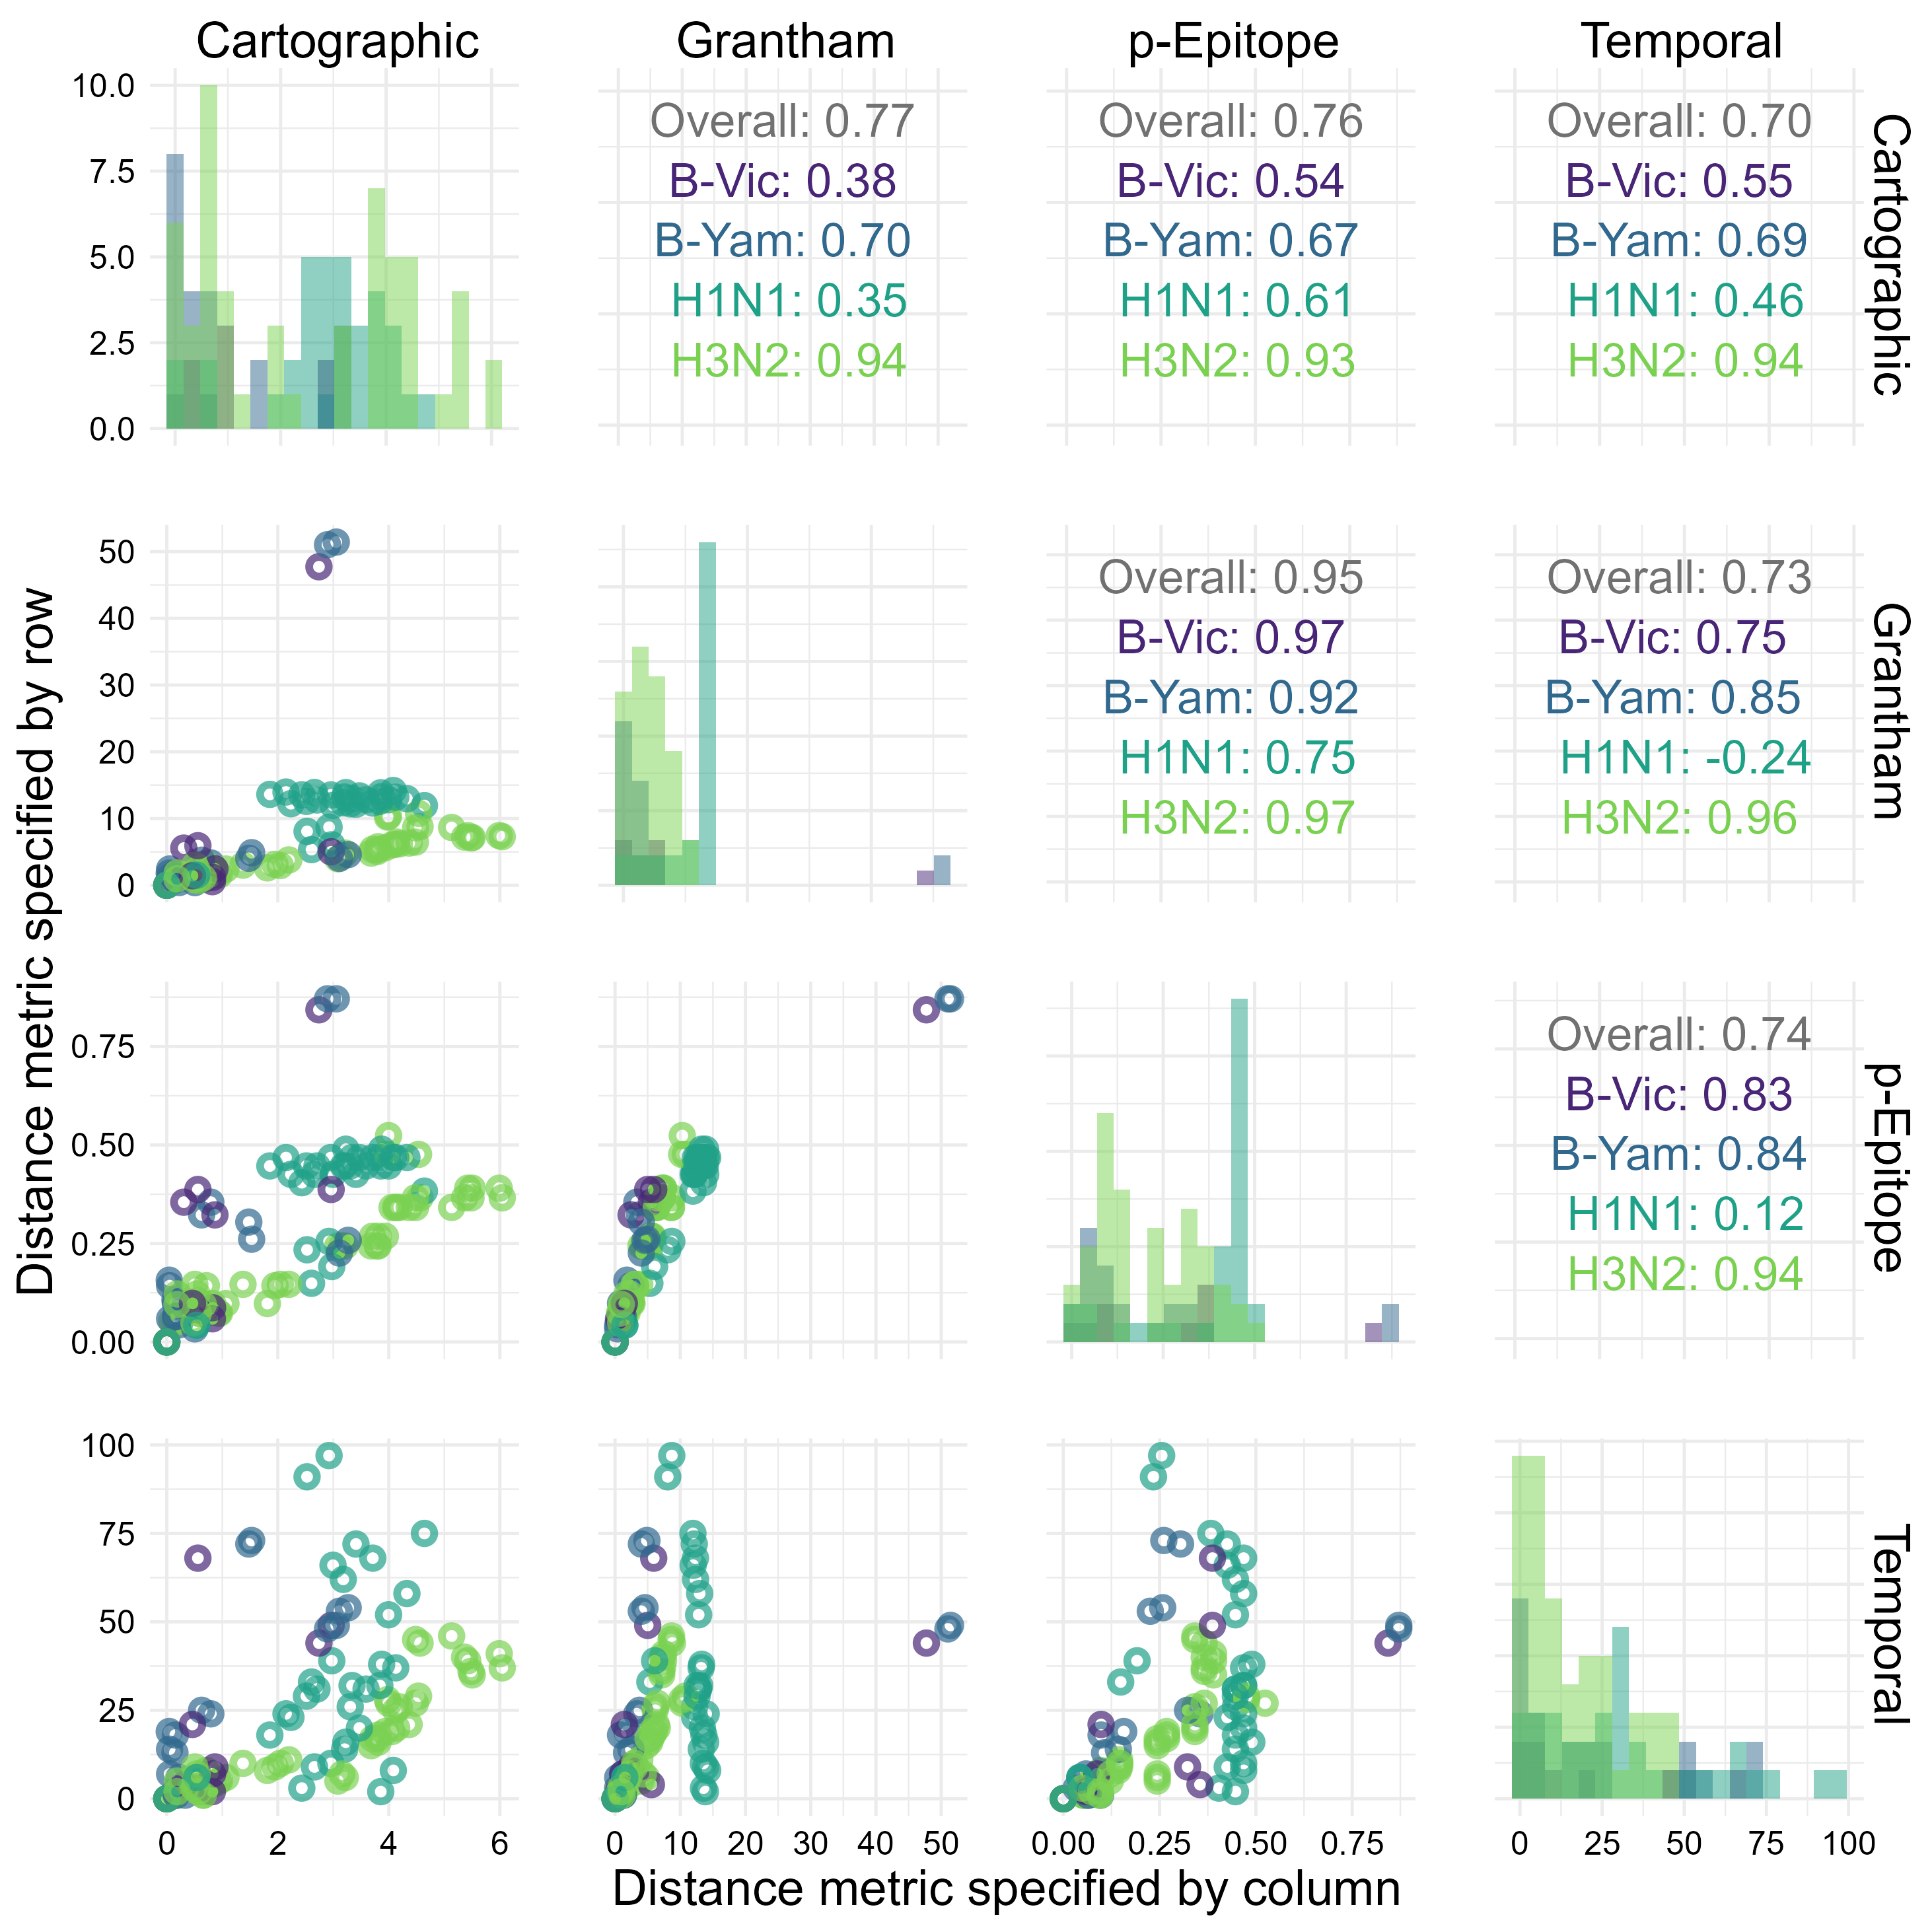
Figure 1: Distribution and correlation plots for each of the antigenic distance metrics. For each HAI assay in the dataset, we calculated the antigenic distance between the vaccine and assay strains with four different methods. We examined the distribution (shown along the diagonal) and the correlation between the different metrics for the same pairwise comparisons (we show pairwise scatterplots in the plots below the diagonal, and overall Spearman’s correlation values in the plots above the diagonal). We include each unique combination as only one point in this plot. We calculated correlation coefficients separately for each subtype – colors in the plot indicate subtype.

Predicted vaccine response breadth is similar across antigenic distance metrics, despite the low between-metric correlation
Examining the agreement and pairwise correlations between the different distance metrics is useful for understanding which metrics disagree most, but these disagreements do not necessarily translate into qualitatively different predictions about vaccine response. So, to examine the relationship between vaccine outcomes and antigenic distance after controlling for other influential subject characteristics, we fit generalized additive mixed models (GAMMs) and linear mixed effects models (LMMs) that controlled for pre-vaccination titers, direct effects of the vaccine and assay strains, study site, and repeated measurements of the same individual. Figure 2 shows how the average post-vaccination titer predicted by the model changes along with antigenic distance for each subtype. For both influenza B lineages, the data were sparsely measured across the span of any of the antigenic distance metrics, making the GAMM predictions difficult to distinguish from the LMMs. Both influenza A subtypes showed a larger difference in predictions made by the GAMMs vs. the LMMs where the GAMMs predicted non-monotone relationships between post-vaccination titer and antigenic distance. The LMM and GAMM were most similar for cartographic distance for both A(H1N1) and A(H3N2), perhaps suggesting that cartographic distance partially accounts for nonlinear effects of antigenic distance, but the fluctuations appeared to be random and driven by gaps in antigenic distance space rather than by true non-monotone signals.
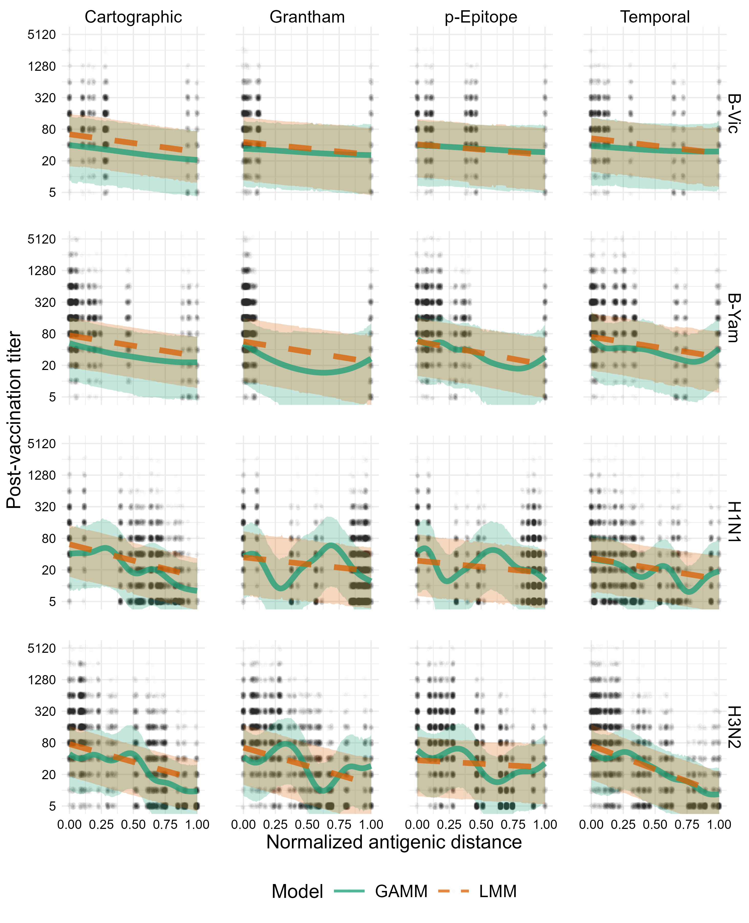
Figure 2: Model predictions for both the GAMM and LMM. Solid green lines and green ribbons show the mean and 95% highest density continuous interval (HDCI) for GAMM predictions. Dashed orange lines and orange ribbons show the mean and 95% HDCI for LMM predictions. Circular points show the observed data values. Each subplot shows the model predictions for a particular subtype (changes by row) and distance metric (changes by column). Outcomes shown on the plot are predicted post-vaccination titers for an average individual to an average strain (see Supplement for computational details).
To quantify whether the effect of antigenic distance deviated strongly from a linear effect, we calculated the LOO-ELPD for the GAMM and LMM models fit with each antigenic distance metric, shown in Table 2. LOO-ELPD is comparable to (W)AIC or BIC, and differences in ELPD strongly supported the linear model for every antigenic distance metric. The difference in ELPD between the two models favored the linear model for all metrics, and the ratio of the difference in ELPD was always much greater than its standard error. Including spline terms to account for nonlinearity does not improve the model fit.
Table 2: Differences in expected log pointwise predictive density (ELPD) from the best-fitting model, estimated by the leave-one-out (LOO) method for all models and all antigenic distance metrics. We fit the models separately for each antigenic distance metric, so comparisons are shown separately. The ΔELPD is the difference in ELPD between the LMM and the GAMM, so a larger number means the LMM outperforms the GAMM more. We show the ΔELPD ± its standard error, along with the ratio of the estimate to its standard error.
Metric | ΔELPD (LMM - GAMM) | ΔELPD / SE
Cartographic | 350.65 (±36.03) | 9.7
Grantham | 508.33 (±46.15) | 11.0
p-Epitope | 485.71 (±45.04) | 10.8
Temporal | 224.67 (±25.81) | 8.7

Predictions made by different antigenic distance metrics are similar after accounting for host factors
Finally, we directly compared estimates from the models across antigenic distance metrics for each subtype (Figure 3). Since the LMM is easier to interpret and was supported by our ELPD analysis, we examined the slope and intercept for each subtype across the four antigenic distance metrics. The intercepts (representing the predicted post-vaccination titer to the homologous strain of the specified subtype for an individual with no pre-vaccination antibodies) were similar across all metrics regardless of the subtype. The slopes varied more, although for both B lineages, estimates of the slope were nearly identical across antigenic distance metrics. For A(H1N1), the cartographic distance model had a lower slope than the other three antigenic distance metrics, but the credible interval still overlapped with the credible interval for the temporal distance. For A(H3N2), the slope for the $p$-Epitope distance was much smaller than the other slopes (reflecting our results in Figure 2), despite the high correlation between the antigenic distances for A(H3N2) (Figure 1). We can only perform a visual inspection of these overlaps, because there is not a valid way to combine posterior distributions across the four models, and these estimates do not take variance from the random effects in our model into account. To analyze predictions for both the LMM and GAMM, with the random effects variances included in uncertainty calculations, we directly compared predictions from the models and saw much higher overlap (shown in the Supplement), as we would expect when we include all of the variance in the data.
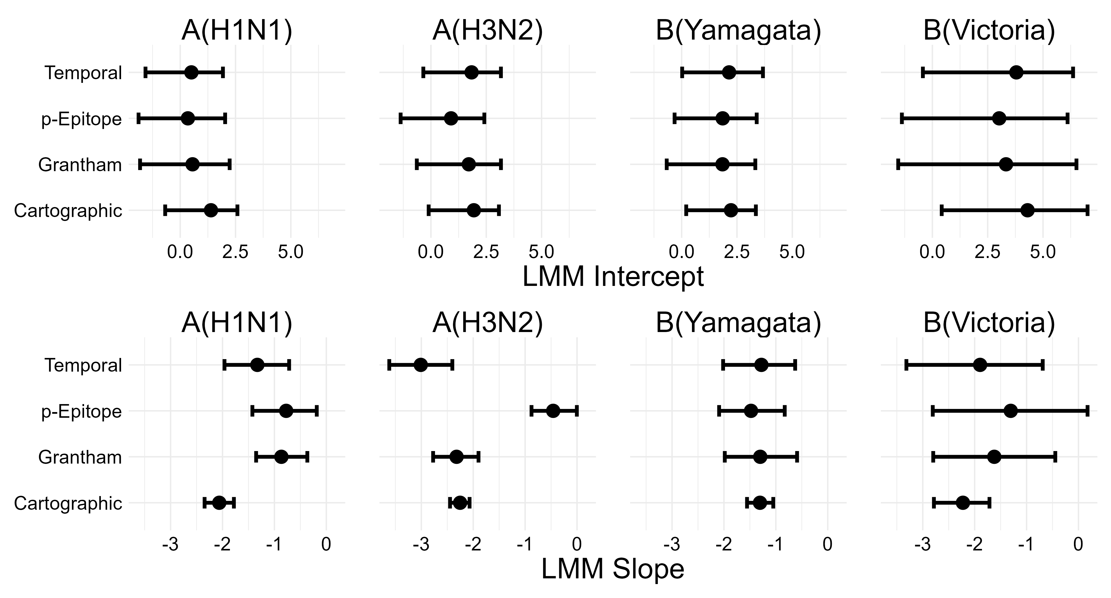
Figure 3: Intercept and slope estimates stratified by subtype for each LMM (one for each distance metric). Points and intervals show the mean and 95% HDCI of posterior samples of the indicated parameter. The top row of plots shows the mean and CI for estimates of the intercept, and the bottom row of plots shows the mean and CI for estimates of the slope. Columns of plots indicate which subtype the slope and intercept are for.

Discussion
We computed multiple antigenic distance metrics on the same set of influenza strains. Using immunological data from a human cohort, we were able to compare cartographic data to sequence-based, biophysical, and temporal antigenic distance measures which have been used before for analyzing vaccine breadth. We then fit linear mixed-effects models (LMMs) and generalized additive mixed models (GAMMs) to the immunological data separately for each cohort, controlling for subtype, pre-vaccination titer, and multiple sources of random variation. By comparing the predictions and parameters from the estimated models across the four antigenic distance metrics, we were able to assess the similarity of the metrics in a more practical context.
Despite low correlations between the four antigenic distance measures for all subtypes except A(H3N2), we found that all four antigenic distance measures produced similar predictions about the heterologous vaccine response, regardless of subtype. Unexpectedly, the subtype generating the most different predictions was A(H3N2), which had the highest correlation between metrics. After we account for important confounders and other sources of variation, the differences between metrics seemed to disappear, with the exception of the unusually small slope for $p$-Epitope distance for influenza A(H3N2). Along with our pointwise prediction comparisons (shown in the supplement), these results suggest a systematic disagreement on the vaccine outcome scale between $p$-Epitope distance and other metrics for A(H3N2), which contrasts with the high pairwise correlations between $p$-Epitope and other metrics for this subtype. Perhaps important antigenic changes for H3N2 have occurred outside of the immunodominant epitopes, or features like glycosylation which might be more easily captured by Grantham or cartographic distance are important. Or, perhaps the difference is due to some form of noise in our study — we have no data from equivalent human cohort studies with wide heterologous panels to compare our results to, so we do not know if this result is consistent.
Our overall results could imply that the differences between antigenic distance metrics can appear large but are small compared to between-subject and between-study variability in real life, or that accounting for interindividual differences or pre-vaccination titer helps to explain the differences between metrics. We also found that a linear model was sufficient for explaining the relationship between post-vaccination titer and antigenic distance, rather than a nonlinear model which we might expect under the assumption of original antigenic sin or immune imprinting, which could imply a nonlinear effect where strains with intermediate antigenic distance from the vaccine have the lowest vaccine response (9,111). Notably, we even found that temporal distance tends to produce similar predictions to cartographic distance in this setting, despite the evidence for epochal antigenic evolution and emergence or circulation of multiple clusters in a single year (3,9,59,112).
While we used data from a multicenter study with tens of thousands of measurements and over one thousand contributed person-years, our study still has some weaknesses. First, as a secondary data analysis, none of the data were designed with our questions in mind. While we have attempted to control for as much confounding as possible, we lack data on the exposure histories of individuals in our cohort which could confound our results. Our results also only apply to the split-inactivated Fluzone standard dose vaccine. Higher doses can either help or hinder heterologous responses (113–115), and in a previous study we found that the heterologous antibody response varied by Fluzone vaccine dose (76), so our results might change for other vaccine doses or formulations. A balanced design with randomized vaccine design would be preferable for understanding the impact of vaccine design on agreement between antigenic distance measurements.
We also used cartographies based on our pre-immune human data, which were generated on the same data we analyzed. With access to multiple cartographies on the same data set or imputation techniques (116,117) we could treat different cartographies as different antigenic distance metrics and compare cartographic distances in the same way. Our metrics also did not all cover antigenic distance space evenly as the strains in the historical panel were selected to cover a wide variety of years. However, there were several “gaps” between discrete antigenic distance values for A(H1N1) and the two B lineages, which could impact our estimates (see Supplement for details), and a broader panel with more evenly spaced strains would make our effect estimates more precise. Finally, we have no real proxy for the response to “future” strains. We could get a better predictive understanding of how the vaccine generates immune responses to future strains by testing serum samples from, say, 2016, to novel vaccine strains which have emerged since the samples were collected. Such measurements would allow us to validate the use of the historical panel as a proxy for future vaccine response. Longitudinal studies designed with long-term collection and multiplex assays in mind would be beneficial for answering similar questions about antigenic distance and vaccine breadth.
Overall, we found that simple antigenic distance measurements like Grantham’s distance generated very similar predictions about vaccine breadth to distances based on antigenic cartography. While some distance metrics potentially deviated, the effect was subtype specific ($p$-Epitope for A(H3N2) strains) and could be an artifact of the specific data we used. While cartography is important for understanding the antigenic diversity and evolution of influenza, researchers analyzing vaccine breadth should not be afraid to use easier, potentially less biased metrics of antigenic distance.

References
1. Krammer F, Smith GJD, Fouchier RAM, et al. Influenza. Nature Reviews Disease Primers. 2018;4(1):1–21.
2. van de Sandt CE, Kreijtz JHCM, Rimmelzwaan GF. Evasion of Influenza A Viruses from Innate and Adaptive Immune Responses. Viruses. 2012;4(9):1438–1476.
3. Petrova VN, Russell CA. The evolution of seasonal influenza viruses. Nature Reviews Microbiology. 2018;16(1):47–60.
4. Morens DM, Taubenberger JK, Fauci AS. The 2009 H1N1 Pandemic Influenza Virus: What Next? mBio. 2010;1(4):e00211–10.
5. Paules CI, Fauci AS. Influenza Vaccines: Good, but We Can Do Better. The Journal of Infectious Diseases. 2019;219(Suppl 1):S1–S4.
6. Kim H, Webster RG, Webby RJ. Influenza Virus: Dealing with a Drifting and Shifting Pathogen. Viral Immunology. 2018;31(2):174–183.
7. Koelle K, Cobey S, Grenfell B, et al. Epochal Evolution Shapes the Phylodynamics of Interpandemic Influenza A (H3N2) in Humans. Science. 2006;314(5807):1898–1903.
8. Zinder D, Bedford T, Gupta S, et al. The Roles of Competition and Mutation in Shaping Antigenic and Genetic Diversity in Influenza. PLOS Pathogens. 2013;9(1):e1003104.
9. Oidtman RJ, Arevalo P, Bi Q, et al. Influenza immune escape under heterogeneous host immune histories. Trends in microbiology. 2021;29(12):1072–1082.
10. Centers for Disease Control and Prevention (CDC). National, Regional, and State Level Outpatient Illness and Viral Surveillance.
11. Smith DJ, Forrest S, Ackley DH, et al. Variable efficacy of repeated annual influenza vaccination. Proceedings of the National Academy of Sciences of the United States of America. 1999;96(24):14001–14006.
12. Skowronski DM, Chambers C, De Serres G, et al. Serial Vaccination and the Antigenic Distance Hypothesis: Effects on Influenza Vaccine Effectiveness During A(H3N2) Epidemics in Canada, 2010–2011 to 2014–2015. The Journal of Infectious Diseases. 2017;215(7):1059–1099.
13. Lim WW, Cowling BJ, Nakafero G, et al. The impact of repeated vaccination on relative influenza vaccine effectiveness among vaccinated adults in the United Kingdom. Epidemiology and Infection. 2022;150:e198.
14. Jones-Gray E, Robinson EJ, Kucharski AJ, et al. Does repeated influenza vaccination attenuate effectiveness? A systematic review and meta-analysis. The Lancet Respiratory Medicine. 2023;11(1):27–44.
15. Xie H, Wan X-F, Ye Z, et al. H3N2 Mismatch of 2014–15 Northern Hemisphere Influenza Vaccines and Head-to-head Comparison between Human and Ferret Antisera derived Antigenic Maps. Scientific Reports. 2015;5:15279.
16. Sandbulte MR, Westgeest KB, Gao J, et al. Discordant antigenic drift of neuraminidase and hemagglutinin in H1N1 and H3N2 influenza viruses. Proceedings of the National Academy of Sciences of the United States of America. 2011;108(51):20748–20753.
17. Smith GJD, Vijaykrishna D, Bahl J, et al. Origins and evolutionary genomics of the 2009 swine-origin H1N1 influenza A epidemic. Nature. 2009;459(7250):1122–1125.
18. Morimoto N, Takeishi K. Change in the efficacy of influenza vaccination after repeated inoculation under antigenic mismatch: A systematic review and meta-analysis. Vaccine. 2018;36(7):949–957.
19. Okoli GN, Racovitan F, Abdulwahid T, et al. Variable seasonal influenza vaccine effectiveness across geographical regions, age groups and levels of vaccine antigenic similarity with circulating virus strains: A systematic review and Meta-analysis of the evidence from test-negative design studies after the 2009/10 influenza pandemic. Vaccine. 2021;39(8):1225–1240.
20. Erbelding EJ, Post DJ, Stemmy EJ, et al. A Universal Influenza Vaccine: The Strategic Plan for the National Institute of Allergy and Infectious Diseases. The Journal of Infectious Diseases. 2018;218(3):347–354.
21. Hensley SE, Das SR, Bailey AL, et al. Hemagglutinin receptor binding avidity drives influenza A virus antigenic drift. Science (New York, N.Y.). 2009;326(5953):734–736.
22. Hensley SE. Challenges of selecting seasonal influenza vaccine strains for humans with diverse pre-exposure histories. Current Opinion in Virology. 2014;8:85–89.
23. Wang Y, Tang CY, Wan X-F. Antigenic characterization of influenza and SARS-CoV-2 viruses. Analytical and Bioanalytical Chemistry. 2021-12-14, 2021-12;414(9):2841–2881.
24. Parker L, Wharton SA, Martin SR, et al. Effects of egg-adaptation on receptor-binding and antigenic properties of recent influenza A (H3N2) vaccine viruses. The Journal of General Virology. 2016;97(6):1333–1344.
25. Gambaryan AS, Robertson JS, Matrosovich MN. Effects of Egg-Adaptation on the Receptor-Binding Properties of Human Influenza A and B Viruses. Virology. 1999;258(2):232–239.
26. Smith DJ, Lapedes AS, de Jong JC, et al. Mapping the Antigenic and Genetic Evolution of Influenza Virus. Science. 2004;305(5682):371–376.
27. Bedford T, Suchard MA, Lemey P, et al. Integrating influenza antigenic dynamics with molecular evolution. eLife. 2014;3:e01914.
28. Fonville JM, Wilks SH, James SL, et al. Antibody landscapes after influenza virus infection or vaccination. Science (New York, N.Y.). 2014;346(6212):996–1000.
29. Hay JA, Laurie K, White M, et al. Characterising antibody kinetics from multiple influenza infection and vaccination events in ferrets. PLoS Computational Biology. 2019;15(8):e1007294.
30. Sun H, Yang J, Zhang T, et al. Using sequence data to infer the antigenicity of influenza virus. mBio. 2013-08-30, 2013-08;4(4).
31. Neher RA, Russell CA, Shraiman BI. Predicting evolution from the shape of genealogical trees. eLife. 2014;3:e03568.
32. Neher RA, Bedford T, Daniels RS, et al. Prediction, dynamics, and visualization of antigenic phenotypes of seasonal influenza viruses. Proceedings of the National Academy of Sciences. 2016-03-07, 2016-03;113(12).
33. Huang L, Li X, Guo P, et al. Matrix completion with side information and its applications in predicting the antigenicity of influenza viruses. Bioinformatics. 2017;33(20):3195–3201.
34. Han L, Li L, Wen F, et al. Graph-guided multi-task sparse learning model: A method for identifying antigenic variants of influenza A(H3N2) virus. Bioinformatics. 2019;35(1):77–87.
35. Li L, Chang D, Han L, et al. Multi-task learning sparse group lasso: A method for quantifying antigenicity of influenza A(H1N1) virus using mutations and variations in glycosylation of Hemagglutinin. BMC Bioinformatics. 2020-05-11, 2020-05;21(1):182.
36. Harvey WT, Davies V, Daniels RS, et al. A Bayesian approach to incorporate structural data into the mapping of genotype to antigenic phenotype of influenza A(H3N2) viruses. PLOS Computational Biology. 2023;19(3):e1010885.
37. Jia Q, Xia Y, Dong F, et al. MetaFluAD: Meta-learning for predicting antigenic distances among influenza viruses. Briefings in Bioinformatics. 2024;25(5):bbae395.
38. Wang L, Yao S, Pei Y, et al. Using pathogen genomics to predict antigenic changes of influenza H3N2 virus. 2024;
39. Cai Z, Zhang T, Wan X-F. A computational framework for influenza antigenic cartography. PLoS Computational Biology. 2010-10-07, 2010-10;6(10):e1000949.
40. Barnett JL, Yang J, Cai Z, et al. AntigenMap 3D: An online antigenic cartography resource. Bioinformatics. 2012;28(9):1292–1293.
41. Arhami O, Rohani P. TOPOLOW: A MAPPING ALGORITHM FOR ANTIGENIC CROSS-REACTIVITY AND BINDING AFFINITY ASSAY RESULTS. 2025;
42. Waldock J, Zheng L, Remarque EJ, et al. Assay harmonization and use of biological standards to improve the reproducibility of the hemagglutination inhibition assay: A FLUCOP collaborative study. mSphere. 2021-08-25, 2021-08;6(4):10.1128/msphere.00567–21.
43. Zacour M, Ward BJ, Brewer A, et al. Standardization of hemagglutination inhibition assay for influenza serology allows for high reproducibility between laboratories. Clinical and Vaccine Immunology. 2016;23(3):236–242.
44. Adabor ES, Ndifon W. Bayesian inference of antigenic and non-antigenic variables from haemagglutination inhibition assays for influenza surveillance. Royal Society Open Science. 2018;5(7):180113.
45. Ndifon W. New methods for analyzing serological data with applications to influenza surveillance. Influenza and Other Respiratory Viruses. 2011-01-05, 2011-01;5(3):206–212.
46. Forghani M, Khachay M. Convolutional Neural Network Based Approach to In Silico Non-Anticipating Prediction of Antigenic Distance for Influenza Virus. Viruses. 2020;12(9):1019.
47. Einav T, Creanga A, Andrews SF, et al. Harnessing low dimensionality to visualize the antibody–virus landscape for influenza. Nature Computational Science. 2023;3(2):164–173.
48. Azulay A, Cohen-Lavi L, Friedman LM, et al. Mapping antibody footprints using binding profiles. Cell Reports Methods. 2023;3(8):100566.
49. Catani JPP, Smet A, Ysenbaert T, et al. The antigenic landscape of human influenza N2 neuraminidases from 2009 until 2017. eLife. 2024;12:RP90782.
50. Cai Z, Zhang T, Wan X-F. Antigenic Distance Measurements for Seasonal Influenza Vaccine Selection. Vaccine. 2011;30(2):448.
51. Vijaykrishna D, Holmes EC, Joseph U, et al. The contrasting phylodynamics of human influenza B viruses. eLife. 2015;4:e05055.
52. Gupta V, Earl DJ, Deem MW. Quantifying influenza vaccine efficacy and antigenic distance. Vaccine. 2006;24(18):3881–3888.
53. Pan K, Subieta KC, Deem MW. A novel sequence-based antigenic distance measure for H1N1, with application to vaccine effectiveness and the selection of vaccine strains. Protein Engineering Design and Selection. 2011;24(3):291–299.
54. Pan Y, Deem MW. Prediction of influenza B vaccine effectiveness from sequence data. Vaccine. 2016;34(38):4610–4617.
55. Anderson CS, McCall PR, Stern HA, et al. Antigenic cartography of H1N1 influenza viruses using sequence-based antigenic distance calculation. BMC bioinformatics. 2018;19(1):51.
56. Koel BF, Burke DF, Bestebroer TM, et al. Substitutions Near the Receptor Binding Site Determine Major Antigenic Change During Influenza Virus Evolution. Science. 2013;342(6161):976–979.
57. Harvey WT, Benton DJ, Gregory V, et al. Identification of Low- and High-Impact Hemagglutinin Amino Acid Substitutions That Drive Antigenic Drift of Influenza A(H1N1) Viruses. PLoS pathogens. 2016;12(4):e1005526.
58. Mögling R, Richard MJ, Vliet S van der, et al. Neuraminidase-mediated haemagglutination of recent human influenza A(H3N2) viruses is determined by arginine 150 flanking the neuraminidase catalytic site. Journal of General Virology. 2017;98(6):1274–1281.
59. Castro LA, Bedford T, Ancel Meyers L. Early prediction of antigenic transitions for influenza A/H3N2. PLOS Computational Biology. 2020-02-18, 2020-02;16(2):e1007683.
60. Borkenhagen LK, Allen MW, Runstadler JA. Influenza virus genotype to phenotype predictions through machine learning: A systematic review: Computational Prediction of Influenza Phenotype. Emerging Microbes & Infections. 2021;10(1):1896–1907.
61. Forna A, Weedop KB, Damodaran L, et al. Sequence-based detection of emerging antigenically novel influenza A viruses. Proceedings of the Royal Society B: Biological Sciences. 2024;291(2028):20240790.
62. Lefrancq N, Duret L, Bouchez V, et al. Learning the fitness dynamics of pathogens from phylogenies. Nature. 2025;637(8046):683–690.
63. Auladell M, Phuong HVM, Mai LTQ, et al. Influenza virus infection history shapes antibody responses to influenza vaccination. Nature Medicine. 2022;28(2):363–372.
64. Boyoglu-Barnum S, Ellis D, Gillespie RA, et al. Quadrivalent influenza nanoparticle vaccines induce broad protection. Nature. 2021-03-24, 2021-03;592(7855):623–628.
65. Hinojosa M, Shepard SS, Chung JR, et al. Impact of immune priming, vaccination, and infection on influenza A(H3N2) antibody landscapes in children. The Journal of Infectious Diseases. 2020-10-22, 2020-10;
66. Li Z-N, Liu F, Gross FL, et al. Antibody landscape analysis following influenza vaccination and natural infection in humans with a high-throughput multiplex influenza antibody detection assay. mBio. 2021-02-23, 2021-02;12(1).
67. Yang B, Lessler J, Zhu H, et al. Life course exposures continually shape antibody profiles and risk of seroconversion to influenza. PLOS Pathogens. 2020;16(7):e1008635.
68. Carlock MA, Ross TM. A computationally optimized broadly reactive hemagglutinin vaccine elicits neutralizing antibodies against influenza B viruses from both lineages. Scientific Reports. 2023;13:15911.
69. Nachbagauer R, Choi A, Hirsh A, et al. Defining the antibody cross-reactome directed against the influenza virus surface glycoproteins. Nature Immunology. 2017-02-13, 2017-02;18(4):464–473.
70. Anderson CS, Sangster MY, Yang H, et al. Implementing sequence-based antigenic distance calculation into immunological shape space model. BMC Bioinformatics. 2020-06-19, 2020-06;21(1):256.
71. Lee M-S, Chen JS-E. Predicting antigenic variants of influenza A/H3N2 viruses. Emerging Infectious Diseases. 2004;10(8):1385–1390.
72. Nuñez IA, Carlock MA, Allen JD, et al. Impact of age and pre-existing influenza immune responses in humans receiving split inactivated influenza vaccine on the induction of the breadth of antibodies to influenza A strains. PLOS ONE. 2017;12(11):e0185666.
73. Carlock MA, Allen JD, Hanley HB, et al. Longitudinal assessment of human antibody binding to hemagglutinin elicited by split-inactivated influenza vaccination over six consecutive seasons. PLOS ONE. 2024;19(6):e0301157.
74. Abreu RB, Kirchenbaum GA, Sautto GA, et al. Impaired memory B-cell recall responses in the elderly following recurrent influenza vaccination. PLOS ONE. 2021;16(8):e0254421.
75. CDC Seasonal Flu Vaccine Effectiveness Studies Flu Vaccines Work CDC. 2025;
76. Billings WZ, Ge Y, Knight JH, et al. High-Dose Inactivated Influenza Vaccine Inconsistently Improves Heterologous Antibody Responses in an Older Human Cohort. The Journal of Infectious Diseases. 2025;jiaf003.
77. Grantham R. Amino Acid Difference Formula to Help Explain Protein Evolution. Science. 1974;185(4154):862–864.
78. McElreath R. Statistical rethinking: A Bayesian course with examples in R and Stan. Second edition. Boca Raton: CRC Press; 2020.
79. Gelman A, Hill J. Data analysis using regression and multilevel/hierarchical models. Cambridge ; New York: Cambridge University Press; 2007.
80. Breen R. Regression Models: Censored, Sample Selected, or Truncated Data. SAGE Publications, Inc.; 1996.
81. Carpenter B, Gelman A, Hoffman MD, et al. Stan: A Probabilistic Programming Language. Journal of Statistical Software. 2017;76(1):1–32.
82. Stan Development Team. Stan Modeling Language Users Guide and Reference Manual. 2024;
83. Bürkner P-C. brms: An R package for Bayesian multilevel models using Stan. Journal of Statistical Software. 2017;80(1):1–28.
84. Bürkner P-C. Advanced Bayesian multilevel modeling with the R package brms. The R Journal. 2018;10(1):395–411.
85. Bürkner P-C. Bayesian item response modeling in R with brms and Stan. Journal of Statistical Software. 2021;100(5):1–54.
86. Gabry J, Češnovar R, Johnson A, et al. Cmdstanr: R interface to ’CmdStan’. 2024.(https://github.com/stan-dev/cmdstanr)
87. R Core Team. R: A language and environment for statistical computing. Vienna, Austria: R Foundation for Statistical Computing; 2024.(https://www.R-project.org/)
88. Arel-Bundock V, Greifer N, Heiss A. How to interpret statistical models using marginaleffects for R and Python. Journal of Statistical Software. 2024;111(9):1–32.
89. Vehtari A, Gelman A, Gabry J. Practical bayesian model evaluation using leave-one-out cross-validation and WAIC. Statistics and Computing. 2017;27:1413–1432.
90. Yao Y, Vehtari A, Simpson D, et al. Using stacking to average bayesian predictive distributions. Bayesian Analysis. 2017;
91. RStudio Team. RStudio: Integrated development environment for R. Boston, MA: RStudio, PBC.; 2024.
92. Müller K. Here: A simpler way to find your files. 2020.(https://CRAN.R-project.org/package=here)
93. Ushey K, Wickham H. Renv: Project environments. 2024.(https://rstudio.github.io/renv/)
94. Wickham H, Averick M, Bryan J, et al. Welcome to the tidyverse. Journal of Open Source Software. 2019;4(43):1686.
95. Zeileis A, Grothendieck G. Zoo: S3 infrastructure for regular and irregular time series. Journal of Statistical Software. 2005;14(6):1–27.
96. Ching T. qs2: Efficient serialization of r objects. 2024.(https://github.com/qsbase/qs2)
97. R Core Team. R: A language and environment for statistical computing. Vienna, Austria: R Foundation for Statistical Computing; 2024.(https://www.R-project.org/)
98. Kay M. tidybayes: Tidy data and geoms for Bayesian models. 2024.(http://mjskay.github.io/tidybayes/)
99. Kay M. ggdist: Visualizations of distributions and uncertainty in the grammar of graphics. IEEE Transactions on Visualization and Computer Graphics. 2024;30(1):414–424.
100. Kay M. ggdist: Visualizations of distributions and uncertainty. 2024.
101. Vehtari A, Gabry J, Magnusson M, et al. Loo: Efficient leave-one-out cross-validation and WAIC for bayesian models. 2024;(https://mc-stan.org/loo/)
102. Wickham H. ggplot2: Elegant graphics for data analysis. Springer-Verlag New York; 2016.(https://ggplot2.tidyverse.org)
103. Schloerke B, Cook D, Larmarange J, et al. GGally: Extension to ’ggplot2’. 2024.(https://ggobi.github.io/ggally/)
104. Sjoberg DD, Whiting K, Curry M, et al. Reproducible summary tables with the gtsummary package. The R Journal [electronic article]. 2021;13:570–580. (https://doi.org/10.32614/RJ-2021-053)
105. Gohel D, Skintzos P. Flextable: Functions for tabular reporting. 2024.(https://ardata-fr.github.io/flextable-book/)
106. Allaire J, Dervieux C. Quarto: R interface to ’quarto’ markdown publishing system. 2024.(https://github.com/quarto-dev/quarto-r)
107. Xie Y. Knitr: A general-purpose package for dynamic report generation in r. 2024.(https://yihui.org/knitr/)
108. Xie Y. Dynamic documents with R and knitr. 2nd ed. Boca Raton, Florida: Chapman; Hall/CRC; 2015.(https://yihui.org/knitr/)
109. Xie Y. Knitr: A comprehensive tool for reproducible research in R. In: Stodden V, Leisch F, Peng RD, eds. Implementing reproducible computational research. Chapman; Hall/CRC; 2014
110. Arel-Bundock V, McCrain J. Software citations in political science. PS: Political Science & Politics. 2023;April:1–4.
111. Cobey S. Vaccination against rapidly evolving pathogens and the entanglements of memory. Nature Immunology. 2024;25(11):2015–2023.
112. Bedford T, Riley S, Barr IG, et al. Global circulation patterns of seasonal influenza viruses vary with antigenic drift. Nature. 2015-06-08, 2015-06;523(7559):217–220.
113. Hilleman MR. ANTIBODY RESPONSE IN VOLUNTEERS TO ASIAN INFLUENZA VACCINE. Journal of the American Medical Association. 1958;166(10):1134.
114. Couch RB, Winokur P, Brady R, et al. Safety and immunogenicity of a high dosage trivalent influenza vaccine among elderly subjects. Vaccine. 2007;25(44):7656–7663.
115. Angeletti D, Yewdell JW. Understanding and Manipulating Viral Immunity: Antibody Immunodominance Enters Center Stage. Trends in Immunology. 2018;39(7):549–561.
116. Einav T, Cleary B. Extrapolating missing antibody-virus measurements across serological studies. Cell Systems. 2022;13(7):561–573.e5.
117. Stacey H, Carlock MA, Allen JD, et al. Leveraging Pre-Vaccination Antibody Titers across Multiple Influenza H3N2 Variants to Forecast the Post-Vaccination Response. 2024;2024.08.01.24311325.

