Impact of dose on norovirus antibody kinetics following infection or vaccination

Authors
- Murphy John$​^{1,2,∧}$ (ORCID: 0009-0009-9591-1117),
- Yang Ge$​^{1}$ (0000-0001-5100-0703),
- W. Zane Billings$​^{1}$ (0000‑0002‑0184‑6134),
- Savannah L. Miller$​^{1,2}$ (0000-0003-2231-3510),
- Cora Hirst$​^{3}$ (0009-0005-3078-8729),
- Rustom Antia$​^{3}$ (0000-0001-7991-614X),
- Katia Koelle$​^{3}$ (0000-0002-0254-6141),
- Ye Shen$​^{1,2}$ (0000-0002-6662-0048),
- Benjamin A. Lopman$​^{4}$ (0000-0002-9238-0068),
- Robert L. Atmar$​^{5,6}$ (0000-0001-9989-6772),
- Andreas Handel$​^{1,2,∧}$ (0000-0002-4622-1146)

Author affiliations
- Department of Epidemiology and Biostatistics, University of Georgia, Athens, GA, USA.
- Center for the Ecology of Infectious Diseases, University of Georgia, Athens, GA, USA.
- Department of Biology, Emory University, Atlanta, GA, USA.
- Department of Epidemiology, Rollins School of Public Health, Emory University, Atlanta, GA, USA.
- Department of Molecular Virology and Microbiology, Baylor College of Medicine, Houston, TX, USA.
- Department of Medicine, Baylor College of Medicine, Houston, TX, USA.
$∧$ Corresponding authors
Emails: MJ (murphy.john@uga.edu), AH (ahandel@uga.edu)

Summary
Across infection and vaccination modalities, norovirus antigen exposure dose influenced early antibody kinetics, but larger initial responses were often followed by faster decay, leading to limited differences in antibody persistence.

Abstract

Background
Noroviruses are a leading cause of acute gastroenteritis worldwide, yet no licensed vaccines currently exist. Antibody-mediated immunity provides protection, but the relationship between norovirus exposure dose and antibody kinetics remains unclear.

Methods
We analyzed longitudinal data on histo-blood group antigen (HBGA)-blocking, IgA, and IgG antibodies from a human norovirus infection trial and a candidate vaccine trial. We developed hierarchical nonlinear Bayesian models to characterize antibody kinetics following different amounts of virus or vaccine antigen exposure within infection and vaccination settings. We fit models with exponential and power-law decay terms and compared their performance.

Results
Across studies and antibody types, the amount of antigen individuals were exposed to influenced early antibody kinetics, including growth, peak, and decay, but effects differed between infection and vaccination. Doses that produced larger initial antibody boosts also decayed faster, resulting in little association with one-year antibody persistence.

Conclusions
Our findings suggest that amount and type of antigen exposure shapes early antibody kinetics but not lasting durability. This reflects a trade-off between dose-induced initial immune boost and subsequent waning.

Introduction
Noroviruses are a leading cause of gastroenteritis and foodborne illness in the United States and globally, contributing to substantial morbidity across all ages [1–3]. Despite high transmissibility [4,5] and significant global impact [3], no licensed vaccines or antiviral therapies are available.
Norovirus vaccines are currently under development [6], and antibodies are expected to contribute to protection [7,8]. However, the duration of protection remains uncertain. Early human challenge studies estimated protection to last approximately 6 months to 2 years [9,10], whereas more recent population-level modeling suggested 4 to 8 years [11]. These differences may reflect waning immune responses over time, limited cross-protection among antigenically diverse strains, and differences in study design and exposure conditions [11].
Understanding antigen-specific antibody kinetics is therefore important for informing vaccine design, dosing strategies, and immunization schedules. No definitive correlate of protection has been established for norovirus, but histo-blood group antigen (HBGA)-blocking activity and serum IgA and IgG responses have been associated with protection or reduced susceptibility in prior studies [8,12]. Characterizing how these antibody responses develop and persist following norovirus infection or vaccination may improve evaluation of immune durability. Norovirus challenge dose magnitude is known to influence infection risk [13] and has been associated with more rapid viral shedding and earlier symptom onset [14]. However, its effects on antibody induction, decay, and lasting durability remain underexplored.
The goals of this study were to analyze how the amount of antigen individuals are exposed to influences antibody kinetics following norovirus infection or vaccination, explore early kinetic predictors of lasting antibody durability across exposure levels, and assess the impact of exposure route (infection versus vaccination) on antibody responses. We conducted secondary analyses of two independent studies: a human norovirus challenge trial and a candidate bivalent virus-like particle (VLP) vaccine trial. We modeled longitudinal antibody kinetics to compare how varying dose levels influenced responses following infection or vaccination and to characterize antibody persistence over time.

Materials and Methods

Data
We analyzed data from two previously conducted studies.
The Norovirus Infection (NI) study randomized healthy adults in a double-blind, placebo-controlled human challenge trial (ClinicalTrials.gov, NCT00138476) [4]. Participants received either placebo or Norwalk virus (GI.1) inoculum. This analysis included participants who became infected after challenge with one of three viral inoculum doses: 4.8 (n=6), 48 (n=7), or 4800 (n=6) RT-PCR units. Infection was pre-defined as meeting at least one of the following criteria: (i) detection of fecal virus by enzyme immunoassay (EIA) or RT-PCR, or (ii) $≥4$-fold rise in serum antibody titers from baseline to day 28.
The Norovirus Vaccination (NV) study was a randomized, double-blind, placebo-controlled phase 1 trial (LV03-104) evaluating a bivalent (GI.1 and GII.4) virus-like particle (VLP) vaccine (ClinicalTrials.gov, NCT01168401) [15]. This analysis included healthy adults who received one of four vaccine antigen doses: 5 (n=10), 15 (n=10), 50 (n=10), or 150 μg (n=9) of each VLP component. Two intramuscular injections of the same dose were administered 28 days apart. The adjuvant formulation was identical across dose groups.
In both studies, blood samples were collected at multiple time points to measure norovirus-specific HBGA-blocking, IgA, and IgG antibodies, as previously described [4,7,15]. In the NI study, samples were collected at approximately days 0, 2, 7, 14, 28, and 180. IgA and IgG were measured at all time points, and HBGA-blocking assays were available for days 0, 14, 28, 180. The NV study collected samples on days 0, 7, 21, 28, 35, 56, 180, and 393, with antibody levels measured for GI.1 HBGA-blocking antibodies and GI.1/GII.4 IgA and IgG antibodies. We summarize participant demographics in the Supplementary Materials (SM) S3.1. Descriptive analyses of antibody responses and observed antibody trajectories are in SM S3.2.

Antibody kinetic models
Our first step in modeling was to describe antibody kinetics using simple models that are able to capture the overall shape of the antibody trajectories, while preventing overfitting of the relatively sparsely sampled time-series data. We chose two heuristic models that produced a parsimonious increase followed by decrease shape and that differed in their decay terms. One model implements exponential decay, and the other implements power-law decay [16–18]. The exponential model assumes a constant decay rate, whereas the power-law model allows the decay rate to decrease over time, potentially capturing long-term immune memory dynamics more accurately [19]. We chose those two decay models since they have been widely used in previous studies to describe antibody kinetics [17–20]. Both models include a logistic induction function to describe the initial rise in antibody titers, with parameters for the magnitude of the response, the rate of antibody increase, and the timing of the transition from induction to decline.
The exponential decay model is given by
$$y_{1}\left(t\right)=\frac{P_{1}}{1+e^{\left(−G_{1}\left(t−K_{1}\right)\right)}}e^{−D_{1}⋅t}$$
and the power-law decay model is defined as
$$y_{2}\left(t\right)=\frac{P_{2}}{1+e^{\left(−G_{2}\left(\left(t+1\right)−K_{2}\right)\right)}}{\left(t+1\right)}^{−D_{2}}$$
In both models, $y_{i}\left(t\right)$ denotes the antibody level at time $t$, $P_{i}$ represents the maximum induction magnitude, $G_{i}$ the rate of antibody increase, $K_{i}$ the transition point between induction and decline, and $D_{i}$ the decay parameter. The index $i=1,2$ corresponds to the exponential or power-law decay models, respectively. To avoid singularities in the power-law model at $t=0$, we shifted the time scale by one unit ($t+1$). We provide further details and the full hierarchical parameterization, including individual-level random effects, in the SM S2.
Although the NV study included a two-dose vaccination regimen 28 days apart, the original trial reported that serum antibody responses peaked 7 days after the first dose, with no evidence of boosting following the second dose [15]. Consistent with these findings, our analyses did not identify evidence of a reproducible secondary peak following the booster (SM S3.7). We therefore applied the same single-peak models to both the NI and NV studies. All antibody titers were log-transformed prior to model fitting.
We fit Bayesian hierarchical models separately for each study and antibody type, with dose of infection or vaccination included as a population-level fixed effect and subject-specific random effects on the latent kinetic parameters to capture individual-level variation. Observations were censored based on assay detection limits. For HBGA, the assay detection range was 25 to 3200. In the NI study, the lower detection limit was 0.8 for IgA and 0.7 for IgG. In the NV study, the lower limits were 3.1 for IgA and 1.6 for IgG. We treated values at or exceeding the upper detection limit as right-censored and values at or below the lower detection limit as interval-censored between ${10}^{−6}$ and the lower limit, because antibody titers were modeled on the log scale. Censoring was incorporated directly into the likelihood using the censored-response functionality in brms [21], allowing censored observations to contribute appropriately to posterior inference. Alternative lower bounds produced similar results (SM S3.9.2).
We compared exponential and power-law models using approximate leave-one-out cross-validation based on the expected log predictive density (ELPD) [22,23]. We computed the difference in ELPD, $ΔELPD$, and the probability that the power-law model had better predictive performance than the exponential model, $P\left(ΔELPD>0\right)$, under a normal approximation. Because our sample size was small, we conservatively inflated the standard error by a factor of two when computing these probabilities [23,24].
We used posterior draws of the group-level model parameters to reconstruct antibody trajectories and estimate relevant kinetic measures, including growth rate (per day), peak response (the difference between log peak titer and log baseline titer), time of peak (days), antibody waning rate (per day), and response at one year post-infection or post-vaccination (the difference between the estimated log titer at one year and the log baseline titer). Posterior medians and 95% equal-tailed credible intervals were used to summarize the posterior distribution of each measure. For the power-law model, we summarized waning as the implied exponential decay rate at days 60, 90, 180, and 365. Detailed model specifications and additional implementation details are provided in the SM S2.
We conducted all analyses in R [25] in RStudio [26], with the pipeline implemented in targets [27]. We used the packages here [28], renv [29], and the tidyverse suite [30] for data management; ggplot2 [31], patchwork [32], ggokabeito [33], and ggh4x [34] for figures; gtsummary [35] and flextable [36] for tables; and knitr [37] and Quarto [38] for manuscript generation. Bayesian models were fit using brms [21] with the cmdstanr backend [39]. Data and code are archived on GitHub (https://github.com/ahgroup/john-norovirus-antibody-kinetics-public) and Zenodo (https://doi.org/10.5281/zenodo.19799472).

Results
We analyzed longitudinal antibody responses from two controlled human studies, one of norovirus infection and one of norovirus vaccination (Figure 1).
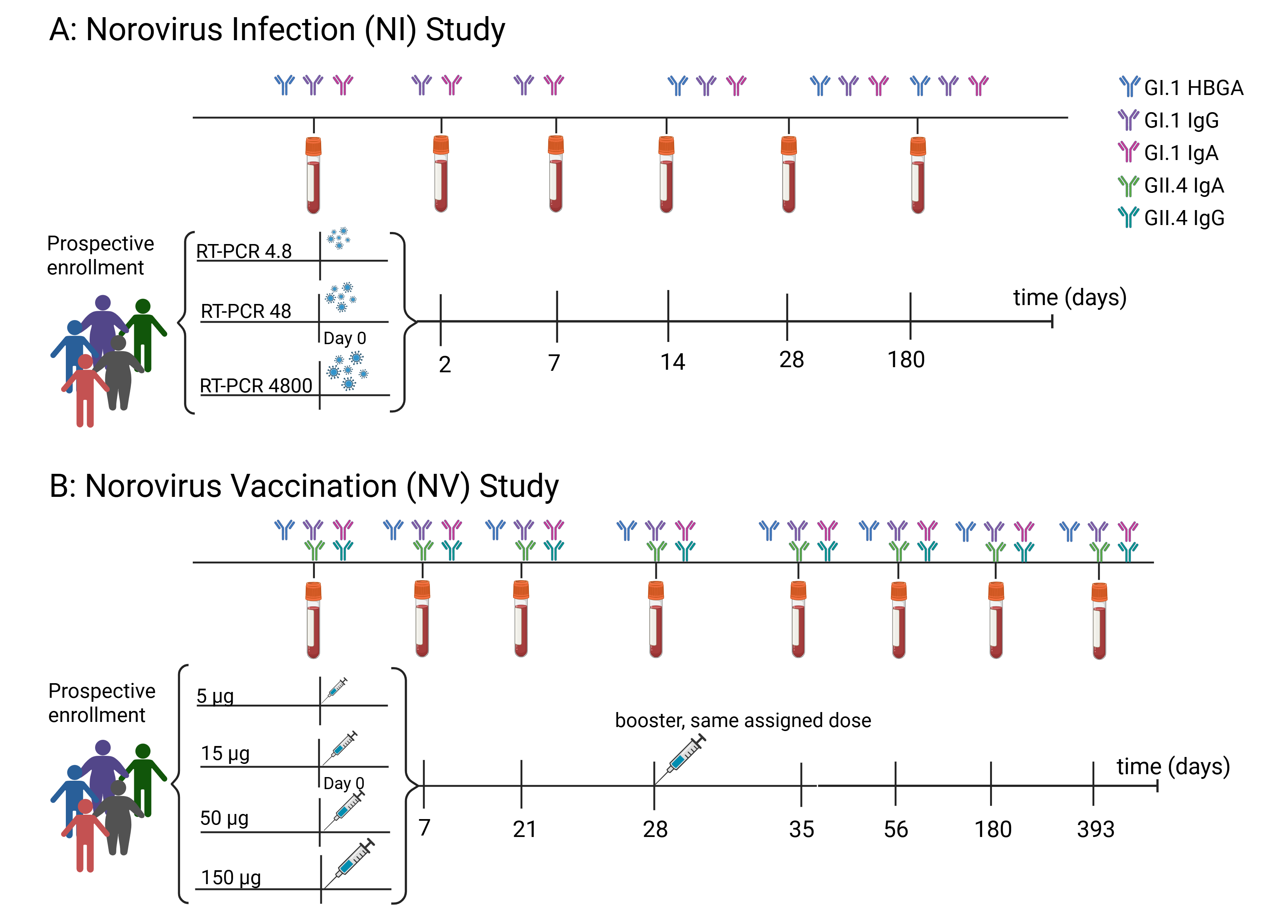
Figure 1: Norovirus infection (NI) and vaccination (NV) study designs. Panel A shows the NI study. Participants were randomized to be challenged with 4.8, 48, or 4800 RT-PCR units of Norwalk virus. Serum samples were collected on days 0, 2, 7, 14, 28, and 180, and antibody responses to GI.1 HBGA-blocking, IgA, and IgG were measured. GI.1 IgA and IgG were assessed at all time points,. HBGA-blocking antibody measurements were only available on days 0, 14, 28, and 180. Panel B shows the NV study. Participants were randomized to receive a bivalent (GI.1 and GII.4) VLP vaccine at doses of 5, 15, 50, or 150 μg of each component. A second injection of the same dose was administered 28 days after the first. Serum samples were collected on days 0, 7, 21, 28, 35, 56, 180, and 393. Antibody responses were measured for GI.1 HBGA-blocking, IgA, and IgG, and GII.4 IgA and IgG. Figure created in BioRender. Handel, A. (2026) https://BioRender.com/p3sb4gj.

Modeled antibody trajectories following infection or vaccination
We characterized antibody kinetics using two models, one with exponential decay and one with power-law decay. We fit models separately by study and antibody type, incorporating dose effects within each study and individual-level variability. Figure 2 shows population-level estimated trajectories from both models for the infection (Panel A) and vaccination (Panel B) studies.
Individual-level heterogeneity was captured through subject-specific random effects on the nonlinear kinetic parameters. Summary distributions of these random effects and corresponding posterior estimates of random-effect standard deviations are provided in the Supplementary Materials (S3.4.1). Across antibody types and models, variability was greatest for the peak parameter, with additional heterogeneity observed in growth and waning, whereas time-to-peak estimates showed comparatively less variability. Model-estimated antibody trajectories are also presented on the linear scale, and the relative decline from peak to one year is summarized in the SM S3.3.2.
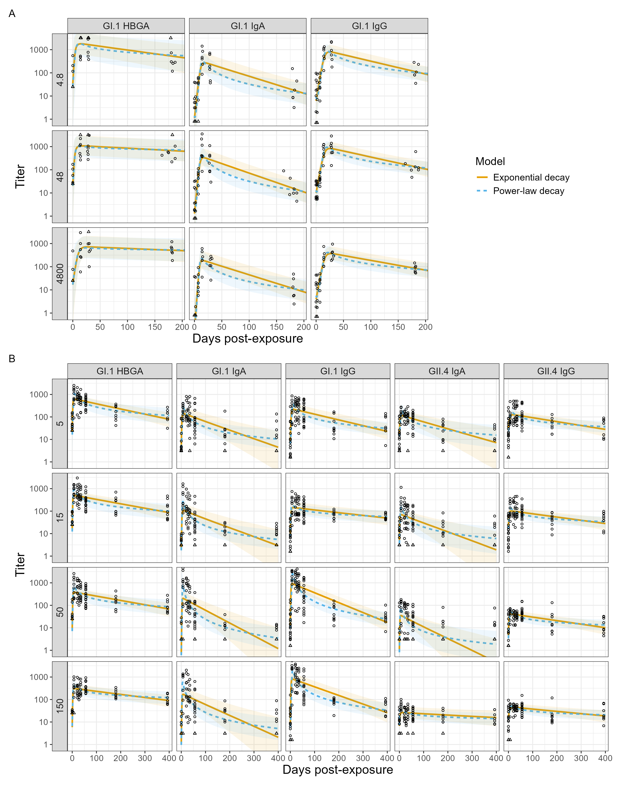
Figure 2: Model-estimated antibody trajectories in the Norovirus Infection (NI; Panel A) and Norovirus Vaccination (NV; Panel B) studies, stratified by dose group and antibody type. Orange solid lines indicate the exponential decay model, and blue dashed lines indicate the power-law decay model. Ribbons represent 95% equal-tailed credible intervals for the model-estimated trajectories. Points represent observed antibody measurements, and censored observations are denoted with triangles at corresponding assay detection limits. Censoring summaries are provided in SM S2.3.2, and individual-level model-estimated trajectories are shown in SM S3.4.2.
We compared the exponential and power-law decay models using expected log predictive density (ELPD)-based metrics. The power-law model was able to overall better describe the data across antibody types, with the exception of the NI GI.1 HBGA-blocking scenario (Table 1). Given this overall pattern, we used the power-law model for the primary analyses presented in the main text and provide corresponding results from the exponential model in SM S3.8.
Table 1: Comparison of exponential and power-law decay models for each study and antibody. Differences in total expected log predictive density (ΔELPD), their standard errors (ΔSE), and the probability that the power-law model is a better match for our data than the exponential model (P(ΔELPD>0)) are shown. Positive ΔELPD values and P(ΔELPD>0) values near 1 indicate better performance of the power-law model.
Study | Antibody | ΔELPD | ΔSE | P(ΔELPD>0)
NI | GI.1 HBGA | -10.403 | 3.059 | 0.045
NI | GI.1 IgA | 28.935 | 6.122 | 0.991
NI | GI.1 IgG | 47.157 | 4.940 | 1.000
NV | GI.1 HBGA | 50.714 | 11.314 | 0.987
NV | GI.1 IgA | 92.703 | 11.667 | 1.000
NV | GII.4 IgA | 48.357 | 12.435 | 0.974
NV | GI.1 IgG | 33.197 | 8.744 | 0.971
NV | GII.4 IgG | 8.737 | 6.799 | 0.740

Infection dose-associated antibody kinetics
Figure 3 summarizes model-estimated population-level kinetic measures, including growth rate, peak response, time of peak, decay rate at day 90, and one-year response. Posterior probabilities (Pr) describing the degree of support for dose-associated differences are provided in SM S3.5.1. Additional analyses of alternative kinetic measures, including non-baseline-normalized measures, the area under the antibody trajectory (AUC), and IgA:IgG ratios are provided in SM S3.5.2 and S3.5.3.
The highest infection dose was associated with slower GI.1 HBGA-blocking antibody growth rates and later peak times, although wide credible intervals indicate substantial uncertainty. Peak responses were similar across dose groups. The 4.8 dose showed faster decay than the 48 and 4800 doses (Pr(4.8 > 48) = 0.98; Pr(4.8 > 4800) = 0.99). Despite these differences in early kinetics, model-estimated one-year responses were similar across doses.
GI.1 IgA measures varied little across challenge doses. The 4800 dose had the highest estimated peak response, although credible intervals overlapped. The 4800 dose showed slower waning than the other doses and a modestly higher one-year response than the 48 dose (Pr(4800 > 48) = 0.8). GI.1 IgG growth rates and peak responses were similar across doses. Time of peak showed evidence of dose-associated differences, particularly for the 4800 dose, but estimated differences were small. Waning rates modestly decreased with increasing dose (Pr(4.8 > 4800) = 0.94), while model-estimated one-year responses remained similar.
Across antibody types, IgA showed the strongest peak responses and the fastest waning. Model-estimated one-year responses were highest for HBGA-blocking antibody.
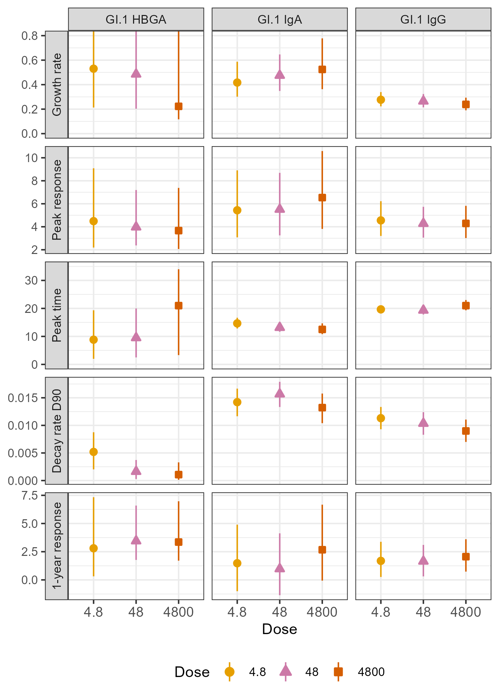
Figure 3: Power-law model-estimated antibody kinetic measures following norovirus infection by challenge dose. Growth rate (per day), peak response, time of peak (days), decay rate (per day; evaluated at day 90), and response at one year are shown. Rows correspond to kinetic measures and columns correspond to antibody types. Solid points represent population-level posterior medians, with vertical lines indicating 95% equal-tailed credible intervals (CIs). For visualization purposes, the y-axis scales for growth rate were truncated. The upper bounds of the 95% CIs for the GI.1 HBGA-blocking antibody growth rate at doses 4.8, 48, and 4800 were 2.49, 2.00, and 1.46, respectively.

Vaccine antigen dose-associated antibody kinetics
Figure 4 presents population-level kinetic measures across vaccine antigen dose groups. Pairwise posterior probabilities are shown in SM S3.5.1.
GI.1 HBGA-blocking antibody growth rates and peak responses were similar across dose groups. The 150 dose showed slower waning than the other groups (Pr(150 < 5), Pr(150 < 15), and Pr(150 < 50) $≥$ 0.99), and modestly higher one-year responses.
GI.1 IgA growth rates were higher in the 50 and 150 dose groups than in the lower dose groups. These groups also showed higher peak responses and faster decay rates (Pr $≥$ 0.95 for all higher vs. lower dose comparisons). Despite faster waning, one-year responses were broadly similar across dose groups, with only modest differences observed (Pr(50 > 5) = 0.85). GI.1 IgG responses showed a similar pattern, with higher doses exhibiting higher peak responses and faster decay rates (Pr $≥$ 0.99 for all higher vs. lower dose comparisons). One-year responses were similar across dose groups, with only a slight reduction in the 50 dose compared to the others.
For GII.4 antibodies, peak responses differed non-monotonically across dose groups, with the highest estimated peaks observed in the 50 dose group and lower peaks in the 150 dose group for both IgA and IgG (Pr(50 > 150) = 0.99 and 0.95, respectively). The 150 dose also showed slower waning than the other dose groups (Pr(150 < 5), Pr(150 < 15), and Pr(150 < 50) $≥$ 0.88). Overall, the 50 dose had the highest model-estimated one-year response.
Across antibodies, GI.1 HBGA-blocking antibody showed the slowest decay and highest one-year responses. GI.1 antibodies generally showed higher peak and one-year responses than GII.4 antibodies.
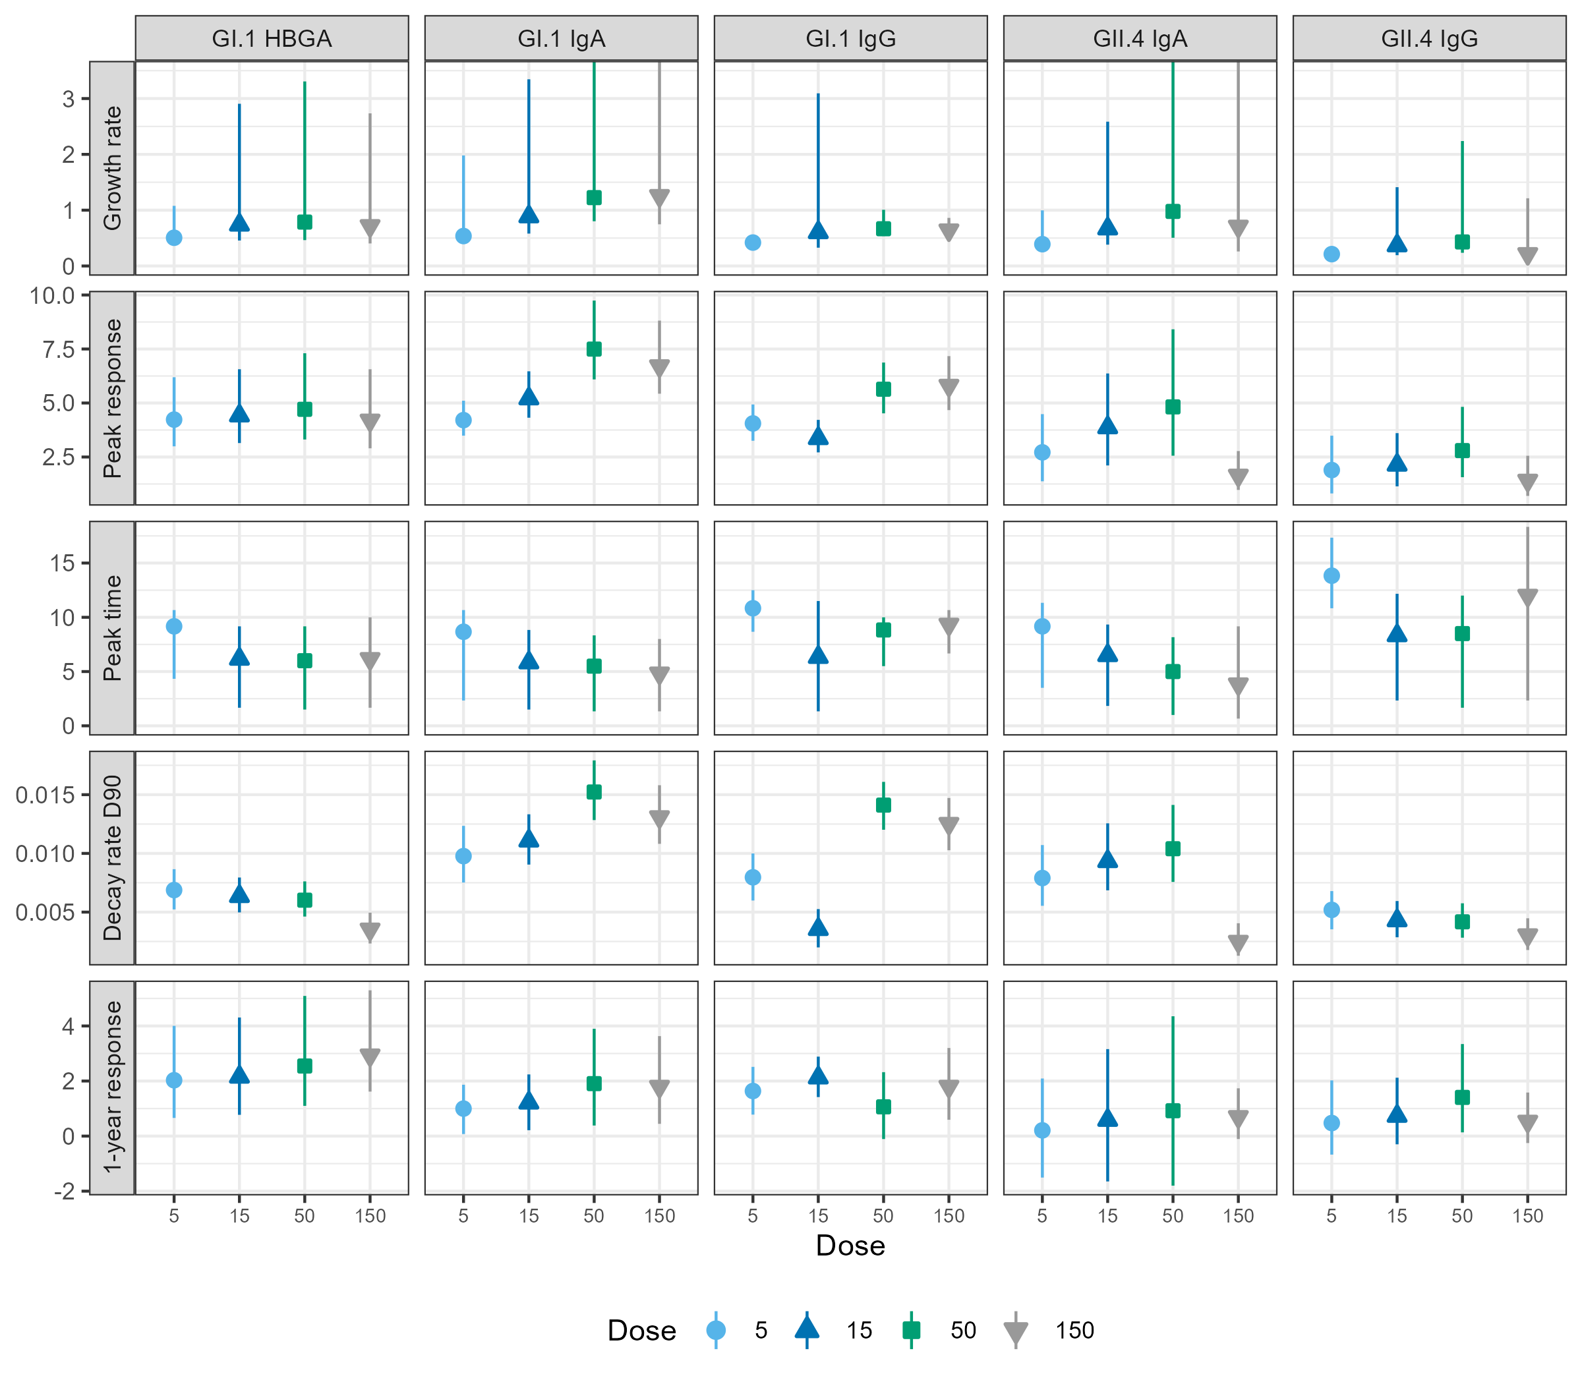
Figure 4: Power-law model-estimated antibody kinetic measures following norovirus vaccination by assigned dose. Growth rate (per day), peak response, time of peak (days), decay rate (per day; evaluated at day 90), and model-estimated response at one year are shown. Rows correspond to kinetic measures and columns correspond to antibody types. Solid points represent population-level posterior estimates, with vertical lines indicating 95% equal-tailed credible intervals (CIs). For visualization purposes, the y-axis scale for growth rate was truncated. The upper bound of the 95% CIs for GI.1 IgA antibody growth rate at the 50 and 150 doses were 4.80 and 4.98, respectively. For GII.4 IgA, they were 5.42 (50) and 4.39 (150).

Associations between early antibody kinetics and persistence
To examine associations between early antibody kinetics and durability, we compared model-estimated growth rate, peak response, decay rate, and one-year response (Figure 5). We present GI.1 here because it was measured in both studies. GII.4 results from the NV study are available in SM S3.6.1. As a sensitivity analysis, we derived similar kinetic measures from the observed data to assess whether the associations observed using model-estimated measures were consistent with those from the observed data; these results are presented in SM S3.9.5.
Growth rates appeared faster following vaccination than infection across antibody types (Figure 5 A). Within dose groups, growth rate was moderately positively associated with one-year response, with 16 of 29 dose-level Spearman correlations $≥$ 0.40 (Figure 5 A and SM S3.6). This association was not observed when posterior draws were pooled across dose groups ($ρ$ = 0.08, 0.31, and 0.05 for GI.1 HBGA, IgA, and IgG, respectively)
IgA and IgG peak responses appeared more variable following vaccination than infection, whereas HBGA peaks were similar across studies (Figure 5 B). Within each dose group, peak response was strongly positively correlated with one-year response, with 23 of 29 Spearman correlations exceeding 0.8 (Figure 5 B and SM S3.6). Across posterior draws from all doses, this association remained for HBGA-blocking antibody and IgA ($ρ$ = 0.67 and 0.80, respectively), but not for IgG ($ρ$ = 0.20).
Decay rates for IgA and IgG appeared more variable following vaccination than infection, whereas HBGA-blocking antibodies showed faster decay following vaccination (Figure 5 C). Across antibody types, IgA decayed faster than HBGA-blocking antibody and IgG. Within dose groups, decay rate was negatively associated with one-year response, although correlations were generally weaker than those observed for peak response (Figure 5 C and SM S3.6). Specifically, 23 of 29 correlations were $≤$ -0.25. Across all pooled posterior draws, this association remained for HBGA-blocking antibody and IgG ($ρ$ = -0.50 and -0.42, respectively), but not for IgA ($ρ$ = -0.02).
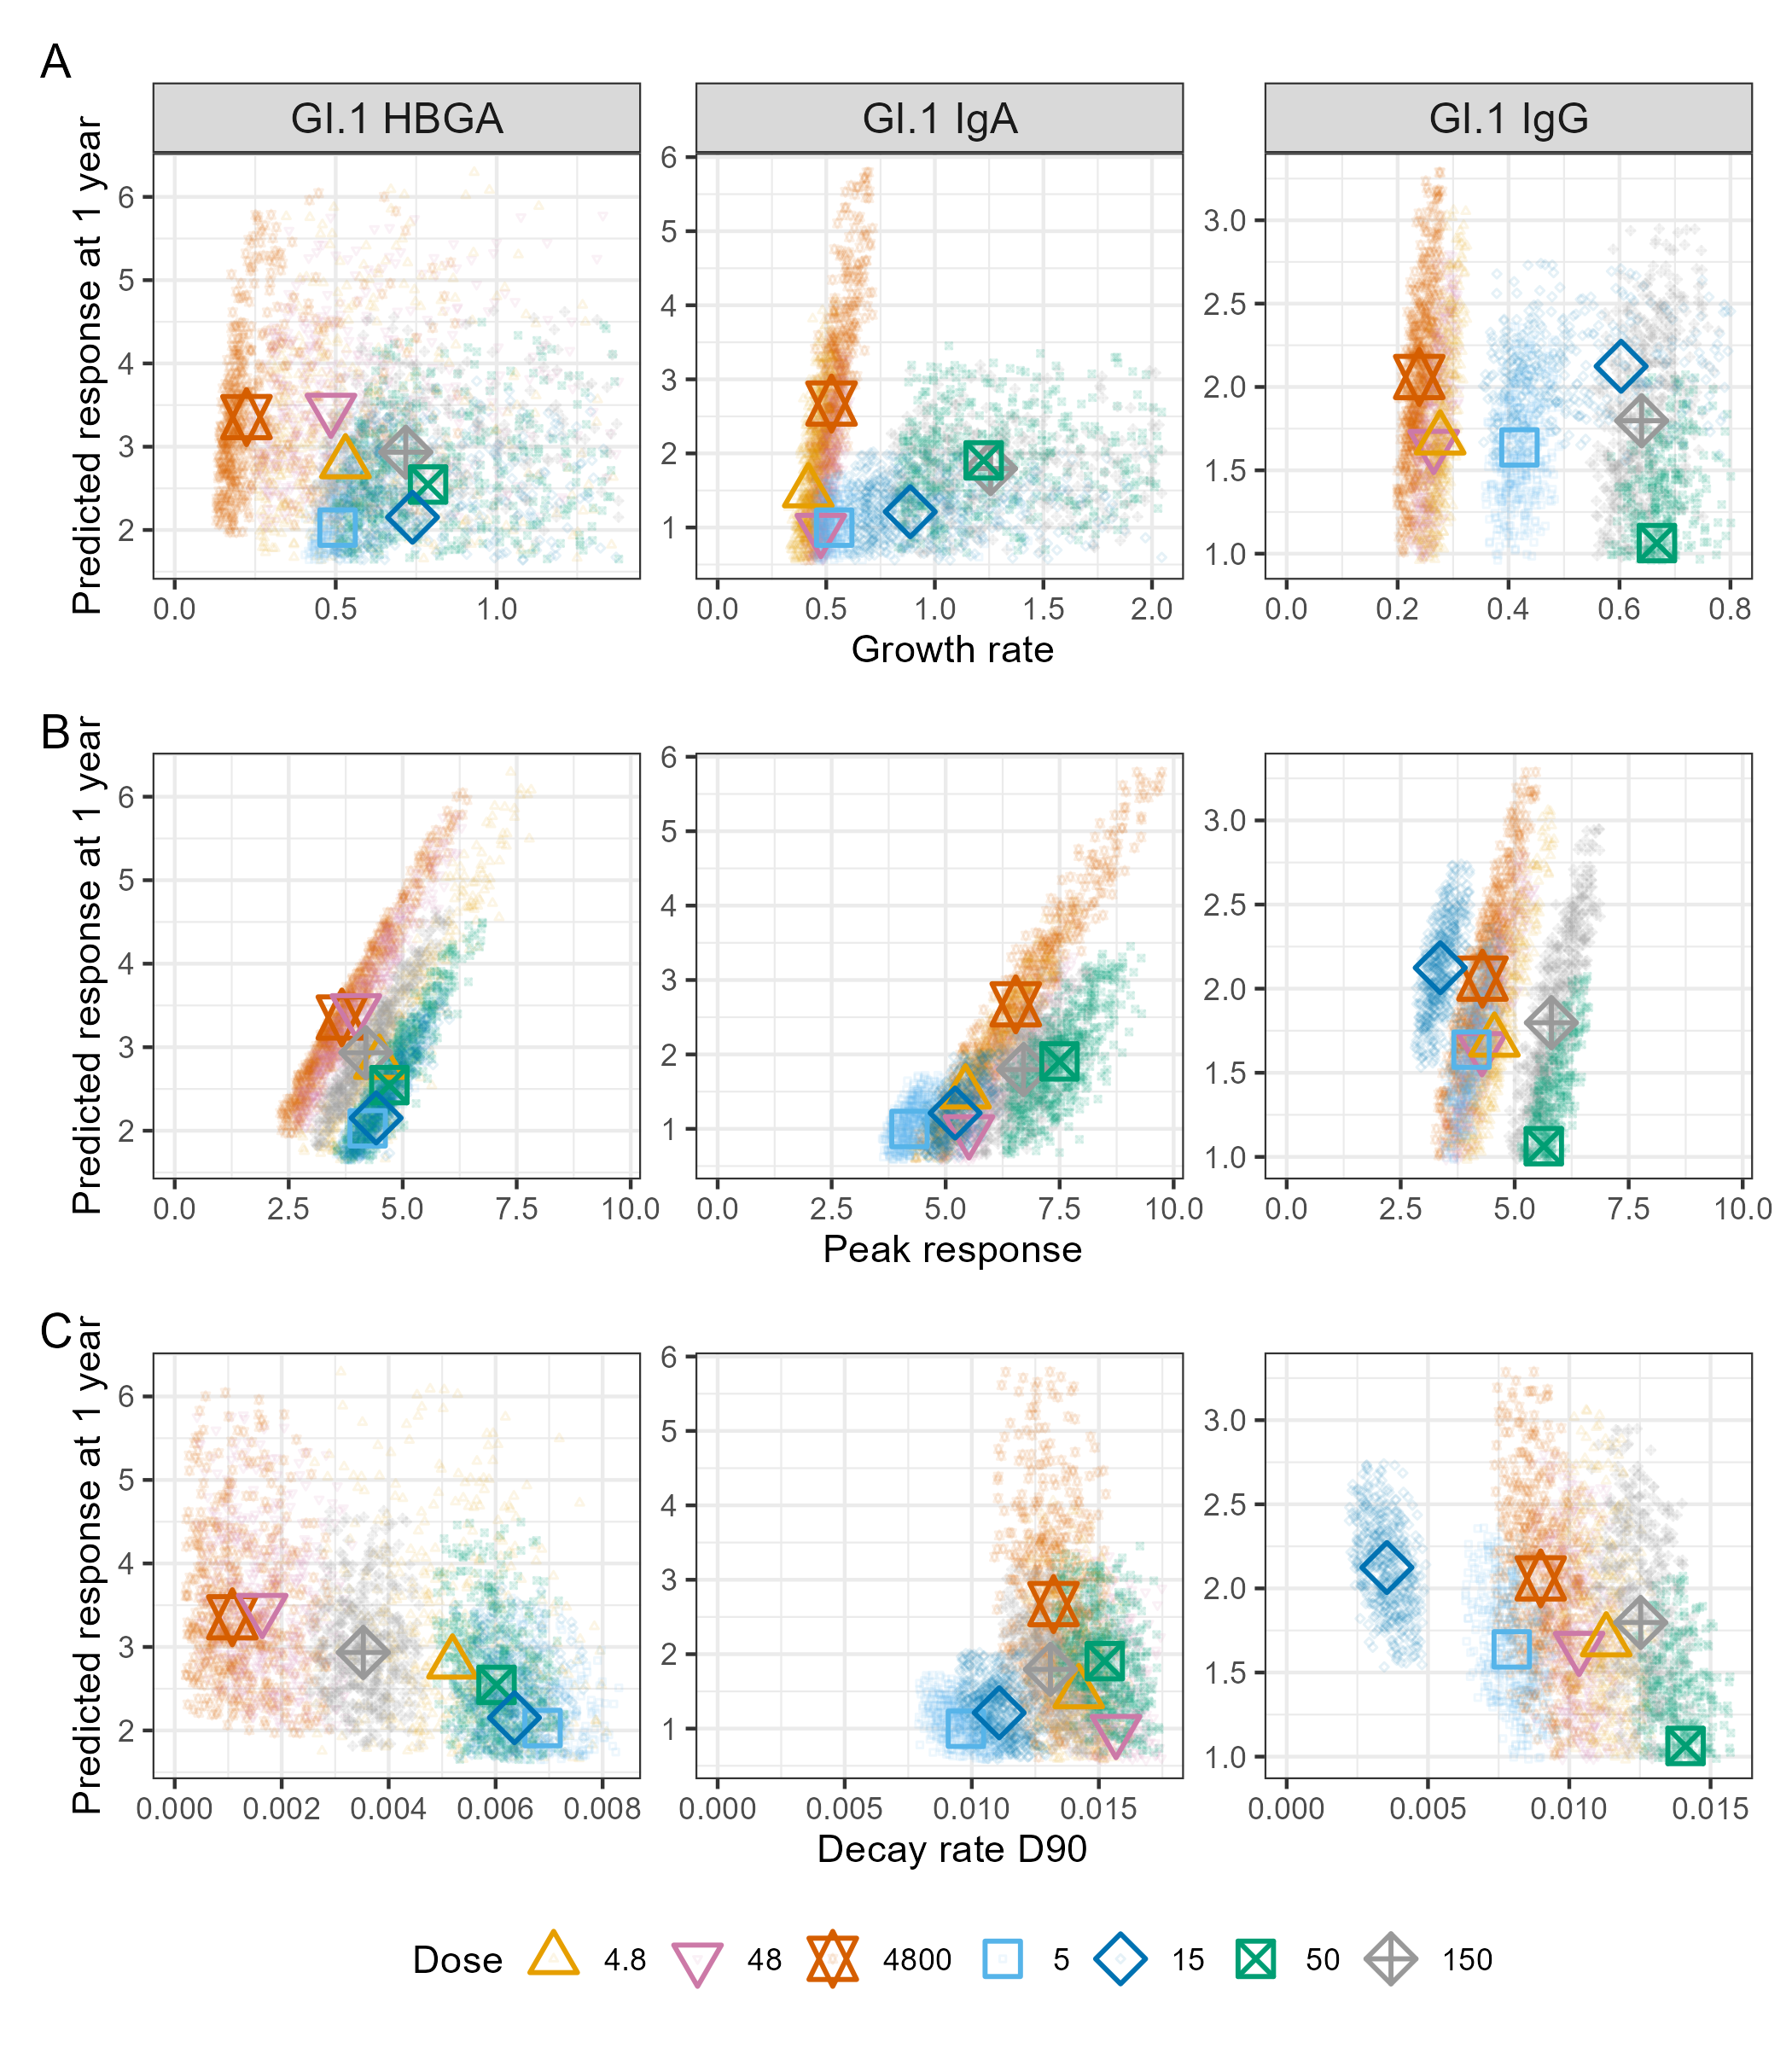
Figure 5: Power-law model-estimated antibody kinetic measures by study, dose group, and antibody. Growth rate (per day), peak response, and decay rate (per day; evaluated at day 90) are plotted against model-estimated response at one year. Larger points represent study- and dose-group posterior medians, and smaller points represent a random subset of 500 posterior draws. Color and shape identify study and dose, with triangles denoting the NI study and square denoting the NV study. For visualization purposes, displayed draws were randomly sampled from posterior trajectories within the 5th-95th percentile range across plotted measures. This visualization step was not applied to posterior inference; all posterior draws were retained for quantitative summaries and correlation analyses. Further, the growth rate axis was limited to the lower 95% of displayed draws to avoid compression of the remaining trajectories by a small number of extreme values. Only GI.1 antibodies are shown because they were measured in both studies. GII.4-specific results from the NV study are provided in SM S3.6.1. Note that while we plot the results for the two studies (infection versus vaccination) together to allow some qualitative comparison, there is no clear correspondence between the virul inoculum doses and the vaccine antigen doses.
Within dose groups, growth rate, peak response, and decay rate were each associated with model-estimated one-year response. Growth rate and peak response were also correlated (SM S3.6.3), although peak response showed the stronger association with one-year response.
Prior studies of other antigens have reported a positive association between peak and subsequent waning, where larger early responses are followed by faster decay [20,40]. Consistent with this, pooled posterior draws followed a positive peak-decay trend (Figure 6 A; $ρ$ = 0.22 for GI.1 HBGA, 0.40 for GI.1 IgA, and 0.74 for GI.1 IgG).
To examine the joint relationship between peak response, decay rate, and persistence, we plotted model-estimated one-year response as a function of peak response and decay rate (Figure 6 B). Within dose groups, posterior draws spanned a range of peak-decay combinations, and one-year response increased with higher peak responses and decreased with faster decay rates. Across pooled dose group draws, higher peak responses were accompanied by faster decay, partially offsetting their individual relationships with one-year response. As a result, dose groups with larger peak responses did not necessarily have higher model-estimated one-year responses.
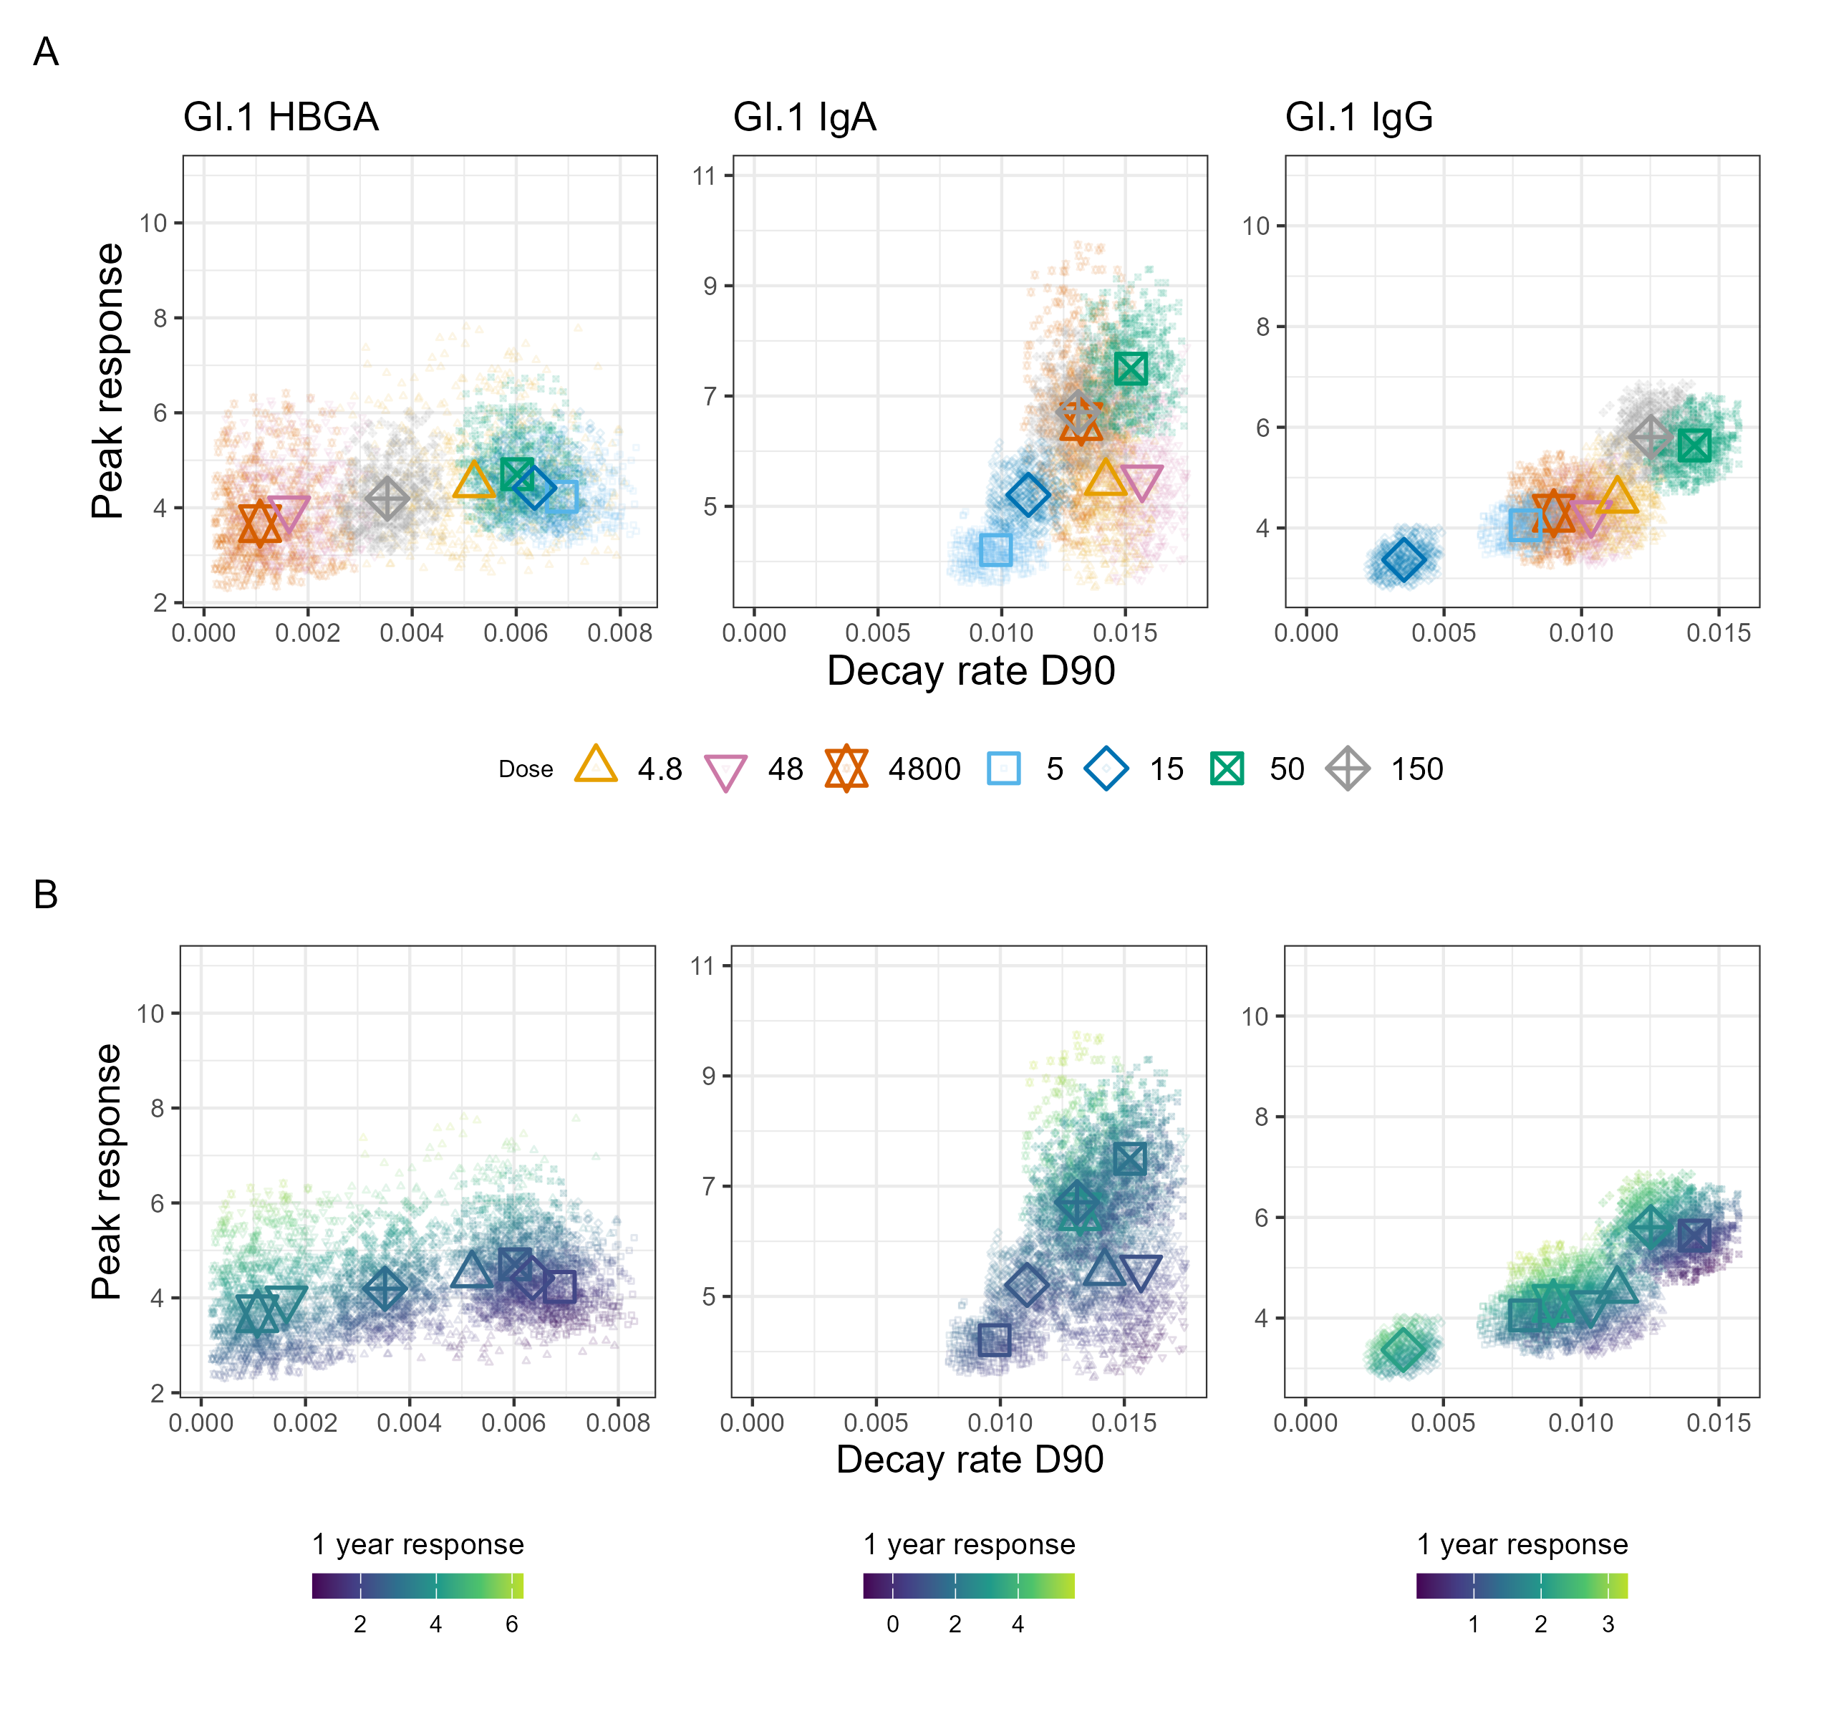
Figure 6: Joint relationships among peak response, decay rate (per day; evaluated at day 90), and model-estimated response at one year. Panel A shows peak response versus decay rate, with study- and dose-group identified by shape and color. Triangles denote the NI study and squares denote the NV study. Panel B shows the same relationship, with color indicating model-estimated response at one year. Antibody-specific color scales are shown below the corresponding plot. Larger points represent study- and dose-group posterior medians, and smaller points represent the same random subset of 500 posterior draws used in Figure 5. To improve readability, draws were randomly sampled from posterior trajectories within the 5th-95th percentile range across plotted measures. This visualization step was not applied to posterior inference; all posterior draws were retained for quantitative summaries and correlation analyses Only GI.1 antibodies are shown because they were measured in both studies. GII.4-specific results from the NV study are provided in SM S3.6.1.

Discussion
We compared antibody kinetics following norovirus infection or vaccination to assess how dose shapes the magnitude and durability of multiple antibody responses. Across both exposure modalities, the power-law decay model provided an overall better fit to our data compared to the exponential decay model. While the sparsity of data at late time points makes it impossible to draw robust conclusions that the power-law is a better descriptor for norovirus antibody decay, the finding is consistent with recent studies that compared power-law to exponential-type models for other pathogens [18,19]. The non-constant decay rate of the power-law function implies slowing antibody loss over time, consistent with heterogeneity in plasma cell lifespans [16,41–43].
Direct mechanistic studies linking these processes to long-term norovirus antibody kinetics remain limited, and these interpretations are informed in part by broader immunological studies.
We found that following infection, dose influenced early antibody kinetics, although many estimates remained uncertain because credible intervals overlapped across dose groups. GI.1 HBGA-blocking antibody peak responses were similar, but the lowest dose showed faster decay. Similarly, GI.1 IgA and IgG shower slowing waning rates with increasing dose. Despite differences in early kinetics, model-estimated responses at one year were similar across doses, suggesting that increases in antigen dose may not translate into differences in long-term antibody levels. Larger studies with longer follow-up are needed to further define the relationship between norovirus infection dose and antibody durability.
Vaccination showed similarly complex dose-kinetic relationships. Increasing vaccine dose did not uniformly increase response or growth rate, and effects varied by antibody type and viral strain. Dose groups with the highest peak responses also exhibited faster decay, consistent with observations from other vaccine and infection settings where stronger early antibody responses can be accompanied by more rapid contraction of antibody-secreting populations [20,44]. Antigenic interference between vaccine components may have further contributed, with higher GI.1 content attenuating GII.4 responses [15,45].
Vaccination and infection elicited different early antibody dynamics despite broadly similar durability. GI.1 IgA and IgG peak responses showed greater dose-dependent heterogeneity following vaccination than infection, suggesting that controlled vaccine dosing permits greater variation in early kinetics than natural infection [46,47]. Despite these differences, model-estimated one-year responses were largely comparable between infection and vaccination for both IgA and IgG. The duration of vaccine-induced immunity relative to natural infection remains unknown, but these results suggest that both exposures may converge to similar IgA and IgG antibody levels over time.
Within dose groups, higher peak responses and slower decay were each associated with greater one-year responses. Across dose groups, larger peak responses were accompanied by faster waning, such that differences in peak response were partially offset by differences in decay. As a result, dose groups with larger early antibody responses did not necessarily exhibit greater long-term antibody persistence. Peak antibody responses are frequently used as a surrogate for protective immunity [48–50], but our results suggest that peak response alone may be insufficient to capture durable immunity and should be considered alongside subsequent antibody decay.
Although this study focused on norovirus, the modeling framework is readily applicable to longitudinal antibody responses against other pathogens and vaccine antigens. More broadly, our findings suggest that infection or vaccine antigen dose primarily influences the early phase of the antibody response. Applying similar quantitative modeling approaches across different vaccine antigens may improve understanding of the mechanisms governing long-term antibody persistence and aid the evaluation of vaccine-induced immunity.
This study has several limitations. Infection and vaccination cohorts differed in route of exposure, dose, and strain composition, limiting direct quantitative comparison. Sample sizes within dose groups were small, sampling was infrequent, and follow-up extended to approximately one year. Model selection between alternative waning functions may be sensitive to the relatively sparse observations available during late follow-up, where differences between decay functions become most apparent. In addition, because one-year responses are derived from the estimated peak and decay parameters within the model framework, some of the observed associations may partly reflect mathematical coupling inherent to the model structure. For the NV study, we applied a single-peak model because neither the original clinical trial nor our additional analyses provided evidence of a reproducible population-level secondary peak following the second vaccine dose. However, sparse sampling may have limited our ability to detect subtle booster-associated effects, and the second dose may have influenced antibody maintenance or subsequent waning in ways not captured by the current model structure. Serum antibody responses represent only one dimension of immunity and do not capture mucosal responses or cellular immunity. Future studies integrating longitudinal measurements of memory B cells, T follicular helper cells, and antibody affinity maturation could help explain inter-individual differences in antibody durability and provide mechanistic insight into the processes governing antibody kinetics and maintenance.
In conclusion, these findings suggest that the effects of dose vary by antibody type and exposure modality, whereas antibody persistence appears to be less sensitive to dose than early response kinetics. Although validation in larger studies is needed, these results suggest that norovirus vaccine development should focus not only on maximizing early antibody induction but also on understanding the factors that promote durable antibody maintenance and functional immune memory.

Acknowledgments

Funding sources
AH, KK and BAL acknowledge partial support from NIH grant R01GM124280. YS acknowledges partial support from NIH grant R35GM146612. No other authors declared any relevant funding sources. The funders had no role in the decision to conduct or publish the study or in the formulation of the study.

Conflicts of interest
All authors declared no potential conflicts of interest.

Author contributions
MJ: conceptualization, data curation, formal analysis, methodology, software, writing - original draft, writing - review & editing, visualization. YG: conceptualization, methodology, writing - review & editing. WZB: methodology, validation, writing - review & editing. SLM: validation, writing - review & editing. CH: methodology, writing - review & editing, RA: methodology, writing - review & editing. KK: methodology, writing - review & editing. YS: methodology, writing - review & editing. BAL: investigation, writing - review & editing. RLA: investigation, writing - review & editing. AH: conceptualization, methodology, writing - review & editing, supervision, funding acquisition
We acknowledge the use of large language models in code and manuscript preparation. All AI-suggested changes were reviewed and approved by co-authors prior to inclusion.

References
1. CDC. About Norovirus. Norovirus. 2024; Available at: https://www.cdc.gov/norovirus/about/index.html. Accessed 16 June 2025.
2. Patel MM, Widdowson M-A, Glass RI, Akazawa K, Vinjé J, Parashar UD. Systematic Literature Review of Role of Noroviruses in Sporadic Gastroenteritis. Emerging Infectious Diseases 2008; 14:1224–1231.
3. Scallan E, Hoekstra RM, Angulo FJ, et al. Foodborne Illness Acquired in the United States—Major Pathogens. Emerging Infectious Diseases 2011; 17:7–15.
4. Atmar RL, Opekun AR, Gilger MA, et al. Determination of the 50% Human Infectious Dose for Norwalk Virus. The Journal of Infectious Diseases 2014; 209:1016–1022. Available at: http://dx.doi.org/10.1093/infdis/jit620.
5. Atmar RL, Opekun AR, Gilger MA, et al. Norwalk Virus Shedding after Experimental Human Infection. Emerging Infectious Diseases 2008; 14:1553–1557. Available at: http://dx.doi.org/10.3201/eid1410.080117.
6. Tan M. Norovirus Vaccines: Current Clinical Development and Challenges. Pathogens 2021; 10:1641. Available at: https://pmc.ncbi.nlm.nih.gov/articles/PMC8709042/. Accessed 22 April 2026.
7. Reeck A, Kavanagh O, Estes MK, et al. Serological Correlate of Protection against Norovirus-Induced Gastroenteritis. The Journal of Infectious Diseases 2010; 202:1212–1218. Available at: https://doi.org/10.1086/656364. Accessed 16 June 2025.
8. Ramani S, Estes MK, Atmar RL. Correlates of Protection against Norovirus Infection and Disease—Where Are We Now, Where Do We Go? PLOS Pathogens 2016; 12:e1005334. Available at: https://journals.plos.org/plospathogens/article?id=10.1371/journal.ppat.1005334. Accessed 6 April 2026.
9. Johnson PC, Mathewson JJ, DuPont HL, Greenberg HB. Multiple-Challenge Study of Host Susceptibility to Norwalk Gastroenteritis in US Adults. The Journal of Infectious Diseases 1990; 161:18–21. Available at: https://doi.org/10.1093/infdis/161.1.18. Accessed 15 February 2022.
10. Parrino TA, Schreiber DS, Trier JS, Kapikian AZ, Blacklow NR. Clinical immunity in acute gastroenteritis caused by Norwalk agent. The New England Journal of Medicine 1977; 297:86–89. Available at: https://www.nejm.org/doi/full/10.1056/NEJM197707142970204. Accessed 30 June 2025.
11. Simmons K, Gambhir M, Leon J, Lopman B. Duration of Immunity to Norovirus Gastroenteritis. Emerging Infectious Diseases 2013; 19:1260–1267. Available at: https://pmc.ncbi.nlm.nih.gov/articles/PMC3739512/. Accessed 29 July 2026.
12. Miller SL, Billings WZ, John M, et al. Evaluation of Serum Antibodies as Correlates of Protection Against Norovirus Infection and Disease. The Journal of Infectious Diseases 2026; :jiag190. Available at: https://doi.org/10.1093/infdis/jiag190. Accessed 10 August 2026.
13. Teunis PFM, Moe CL, Liu P, et al. Norwalk virus: How infectious is it? Journal of Medical Virology 2008; 80:1468–1476. Available at: https://onlinelibrary.wiley.com/doi/abs/10.1002/jmv.21237. Accessed 30 January 2026.
14. Ge Y, Billings WZ, Opekun A, et al. Effect of Norovirus Inoculum Dose on Virus Kinetics, Shedding, and Symptoms. Emerging Infectious Diseases 2023; 29:1349–1356. Available at: https://www.ncbi.nlm.nih.gov/pmc/articles/PMC10310361/. Accessed 6 February 2024.
15. Treanor JJ, Atmar RL, Frey SE, et al. A Novel Intramuscular Bivalent Norovirus Virus-like Particle Vaccine Candidate–Reactogenicity, Safety, and Immunogenicity in a Phase 1 Trial in Healthy Adults. The Journal of Infectious Diseases 2014; 210:1763–1771. Available at: http://dx.doi.org/10.1093/infdis/jiu337.
16. Teunis PFM, Eijkeren JCH van, Graaf WF de, Marinović AB, Kretzschmar MEE. Linking the Seroresponse to Infection to Within-Host Heterogeneity in Antibody Production. Epidemics 2016; 16:33–39.
17. Graaf WF de, Kretzschmar MEE, Teunis PFM, Diekmann O. A Two-Phase within-Host Model for Immune Response and Its Application to Serological Profiles of Pertussis. Epidemics 2014; 9:1–7.
18. Cohen KW, Linderman SL, Moodie Z, et al. Longitudinal Analysis Shows Durable and Broad Immune Memory after SARS-CoV-2 Infection with Persisting Antibody Responses and Memory B and T Cells. Cell Reports Medicine 2021; 2:100354.
19. Saha A, Ahmed H, Hirst C, et al. Quantifying the waning of humoral immunity. Immunity 2025; 58:3144–3152.e2. Available at: https://www.sciencedirect.com/science/article/pii/S1074761325005096. Accessed 9 January 2026.
20. Choi MJ, Heo JY, Seo YB, et al. Six-month longitudinal immune kinetics after mRNA-1273 vaccination: Correlation of peak antibody response with long-term, cross-reactive immunity. Frontiers in Immunology 2023; 13:1035441. Available at: https://pmc.ncbi.nlm.nih.gov/articles/PMC9868900/. Accessed 19 February 2026.
21. Bürkner P-C. Bayesian Item Response Modeling in R with brms and Stan. Journal of Statistical Software 2021; 100:1–54. Available at: https://doi.org/10.18637/jss.v100.i05. Accessed 16 April 2026.
22. McElreath R. Statistical Rethinking: A Bayesian Course with Examples in R and Stan. 2nd ed. Boca Raton: Taylor; Francis, CRC Press, 2020.
23. Sivula T, Magnusson M, Matamoros AA, Vehtari A. Uncertainty in Bayesian Leave-One-Out Cross-Validation Based Model Comparison. Bayesian Analysis 2025; -1:1–31. Available at: https://projecteuclid.org/journals/bayesian-analysis/advance-publication/Uncertainty-in-Bayesian-Leave-One-Out-Cross-Validation-Based-Model/10.1214/25-BA1569.full. Accessed 9 April 2026.
24. Bengio Y, Grandvalet Y. No unbiased estimator of the variance of K-fold cross-validation. Journal of Machine Learning Research (JMLR) 2003; 5:1089–1105.
25. R Core Team. R: A language and environment for statistical computing. 2025; Available at: https://www.R-project.org/.
26. Posit team. RStudio: Integrated Development Environment for R. 2025; Available at: http://www.posit.co/. Accessed 30 April 2026.
27. William Michael Landau. The targets R package: A dynamic Make-like function-oriented pipeline toolkit for reproducibility and high-performance computing. Journal of Open Source Software 2021; 6:2959. Available at: https://doi.org/10.21105/joss.02959.
28. Kirill Müller. Here: A Simpler Way to Find Your Files. 2025; Available at: https://here.r-lib.org/. Accessed 30 April 2026.
29. Kevin Ushey, Hadley Wickham. Renv: Project Environments. 2026; Available at: https://CRAN.R-project.org/package=renv. Accessed 30 April 2026.
30. Wickham H, Averick M, Bryan J, et al. Welcome to the Tidyverse. Journal of Open Source Software 2019; 4:1686. Available at: https://joss.theoj.org/papers/10.21105/joss.01686. Accessed 16 April 2026.
31. Hadley Wickham. ggplot2: Elegant Graphics for Data Analysis. Springer-Verlag New York, 2016. Available at: https://ggplot2.tidyverse.org.
32. Thomas Lin Pedersen. Patchwork: The Composer of Plots. 2025; Available at: https://patchwork.data-imaginist.com. Accessed 30 April 2026.
33. Barrett M. Ggokabeito: ’Okabe-Ito’ Scales for ’ggplot2’ and ’ggraph’. 2021; Available at: https://github.com/malcolmbarrett/ggokabeito. Accessed 30 April 2026.
34. Brand T van den. ggh4x: Hacks for ’ggplot2’. 2025; Available at: https://github.com/teunbrand/ggh4x. Accessed 30 April 2026.
35. Daniel D. Sjoberg, Karissa Whiting, Michael Curry, Jessica A. Lavery, Joseph Larmarange. Reproducible Summary Tables with the gtsummary Package. The R Journal 2021; 13:570–580. Available at: https://doi.org/10.32614/RJ-2021-053.
36. David Gohel, Panagiotis Skintzos. Flextable: Functions for Tabular Reporting. 2026; Available at: https://CRAN.R-project.org/package=flextable. Accessed 30 April 2026.
37. Yihui Xie. _Knitr: A General-Purpose Package for Dynamic Report Generation in R_. 2025; Available at: https://yihui.org/knitr/. Accessed 30 April 2026.
38. J.J. Allaire, Teague C, Scheidegger C, Xie Y, Dervieux C, Gordon Woodhull. Quarto. 2026; Available at: https://github.com/quarto-dev/quarto-cli. Accessed 30 April 2026.
39. Jonah Gabry, Rok Češnovar, Andrew Johnson, Steve Bronder. Cmdstanr: R Interface to ’CmdStan’. 2025; Available at: https://github.com/stan-dev/cmdstanr. Accessed 1 May 2026.
40. Gutiérrez-Bautista JF, López-Nevot MÁ, Gómez-Vicente E, et al. Study of humoral and cellular immunity in vaccinated with mRNA-1273. APMIS 2022; 130:261–269. Available at: https://onlinelibrary.wiley.com/doi/abs/10.1111/apm.13215. Accessed 19 February 2026.
41. Amanna IJ, Carlson NE, Slifka MK. Duration of Humoral Immunity to Common Viral and Vaccine Antigens. New England Journal of Medicine 2007; 357:1903–1915. Available at: https://www.nejm.org/doi/full/10.1056/NEJMoa066092. Accessed 29 January 2026.
42. Chernova I, Jones DD, Wilmore JR, et al. Lasting antibody responses are mediated by a combination of newly formed and established bone marrow plasma cells drawn from clonally distinct precursors. Journal of Immunology (Baltimore, Md: 1950) 2014; 193:4971–4979.
43. Radbruch A, Muehlinghaus G, Luger EO, et al. Competence and competition: The challenge of becoming a long-lived plasma cell. Nature Reviews Immunology 2006; 6:741–750.
44. Amanna IJ, Slifka MK. Mechanisms that determine plasma cell lifespan and the duration of humoral immunity. Immunological Reviews 2010; 236:125–138. Available at: https://pmc.ncbi.nlm.nih.gov/articles/PMC7165522/. Accessed 12 January 2026.
45. Xie Y, Tian X, Zhang X, Yao H, Wu N. Immune interference in effectiveness of influenza and COVID-19 vaccination. Frontiers in Immunology 2023; 14. Available at: https://www.frontiersin.org/journals/immunology/articles/10.3389/fimmu.2023.1167214/full. Accessed 21 March 2026.
46. Valiante NM, O’Hagan DT, Ulmer JB. Innate immunity and biodefence vaccines. Cellular Microbiology 2003; 5:755–760. Available at: https://onlinelibrary.wiley.com/doi/abs/10.1046/j.1462-5822.2003.00318.x. Accessed 13 January 2026.
47. Shen C-F, Yen C-L, Fu Y-C, et al. Innate Immune Responses of Vaccinees Determine Early Neutralizing Antibody Production After ChAdOx1nCoV-19 Vaccination. Frontiers in Immunology 2022; 13:807454. Available at: https://pmc.ncbi.nlm.nih.gov/articles/PMC8822242/. Accessed 13 January 2026.
48. Jin Y, Yang F, Rank CM, Letovsky S, Ramge P, Jochum S. SARS-CoV-2 SPIKE Antibody Levels can Indicate Immuno-Resilience to Re-infection: A Real-World Study. Infectious Diseases and Therapy 2025; 14:229–243. Available at: https://doi.org/10.1007/s40121-024-01090-2. Accessed 12 August 2026.
49. Kaufman HW, Letovsky S, Meyer WA, et al. SARS-CoV-2 spike-protein targeted serology test results and their association with subsequent COVID-19-related outcomes. Frontiers in Public Health 2023; 11. Available at: https://www.frontiersin.org/journals/public-health/articles/10.3389/fpubh.2023.1193246/full. Accessed 12 August 2026.
50. Coudeville L, Bailleux F, Riche B, Megas F, Andre P, Ecochard R. Relationship between haemagglutination-inhibiting antibody titres and clinical protection against influenza: Development and application of a bayesian random-effects model. BMC Medical Research Methodology 2010; 10:18. Available at: https://doi.org/10.1186/1471-2288-10-18. Accessed 12 August 2026.

