Impact of dose on norovirus antibody kinetics following infection or vaccination

Authors
- Murphy John$​^{1,2,∧}$ (ORCID: 0009-0009-9591-1117),
- Yang Ge$​^{1}$ (0000-0001-5100-0703),
- W. Zane Billings$​^{1}$ (0000‑0002‑0184‑6134),
- Savannah L. Miller$​^{1,2}$ (0000-0003-2231-3510),
- Cora Hirst$​^{3}$ (0009-0005-3078-8729),
- Rustom Antia$​^{3}$ (0000-0001-7991-614X),
- Katia Koelle$​^{3}$ (0000-0002-0254-6141),
- Ye Shen$​^{1,2}$ (0000-0002-6662-0048),
- Benjamin A. Lopman$​^{4}$ (0000-0002-9238-0068),
- Robert L. Atmar$​^{5,6}$ (0000-0001-9989-6772),
- Andreas Handel$​^{1,2,∧}$ (0000-0002-4622-1146)

Author affiliations
- Department of Epidemiology and Biostatistics, University of Georgia, Athens, GA, USA.
- Center for the Ecology of Infectious Diseases, University of Georgia, Athens, GA, USA.
- Department of Biology, Emory University, Atlanta, GA, USA.
- Department of Epidemiology, Rollins School of Public Health, Emory University, Atlanta, GA, USA.
- Department of Molecular Virology and Microbiology, Baylor College of Medicine, Houston, TX, USA.
- Department of Medicine, Baylor College of Medicine, Houston, TX, USA.
$∧$ Corresponding authors
Emails: MJ (murphy.john@uga.edu), AH (ahandel@uga.edu)

Abstract

Background
Noroviruses are a leading cause of acute gastroenteritis worldwide, yet no licensed vaccines currently exist. Antibody-mediated immunity provides protection, but the relationship between norovirus exposure amount and antibody kinetics is not well understood.

Methods
We analyzed longitudinal data on histo-blood group antigen (HBGA)-blocking, IgA, and IgG antibodies from two independent human studies: a norovirus infection (NI) trial and a candidate vaccine (NV) trial. We developed hierarchical nonlinear Bayesian models to characterize antibody kinetics following exposure to varying doses across infection and vaccination. We fit models with exponential and power-law decay terms and compared their performance.

Results
The power-law models captured antibody waning better than exponential models, consistent with non-constant decay over time that may arise from heterogeneous B-cell responses. Across both studies and antibody types, we found that dose influenced early antibody kinetics, including growth rate, peak response, and decay rate, but the impact was not consistent. Doses that produced larger initial antibody boosts also decayed faster, which led to little correlation between dose and one-year antibody persistence.

Conclusions
Our findings suggest that dose shapes early antibody kinetics but not lasting persistence. This reflects a trade-off in dose-induced early immune boost and subsequent waning.

Introduction
Noroviruses are the leading cause of gastroenteritis and foodborne illness in the United States, contributing to significant morbidity in people of all ages [1]. Globally, norovirus causes millions of annual infections and contributes to widespread illness, hospitalization, and mortality [2–5]. Despite high transmissibility [6,7] and significant global impact [4,5,8–13], no licensed vaccines or antiviral therapies are available.
Norovirus vaccines are currently under development [14,15]. As these vaccines advance, antibodies are expected to be an important correlate of protection [16,17]. Thus, understanding antigen-specific antibody kinetics is important for informing vaccine design, dosing strategies, and immunization schedules.
The goal of any future norovirus vaccine is to induce strong and durable protection. This is expected to be challenging, as infection-induced protective immunity was estimated to range from only 6 months to 2 years in early human challenge studies [18,19], and 4 to 8 years in recent population-level modeling [20].
The duration of antibody-mediated protective immunity depends on both the magnitude of antibody responses following antigen exposure and the subsequent rate of waning. Identifying relationships between early antibody kinetic features, such as growth rate and peak, and lasting antibody responses could enable reliable inference of immune persistence from fewer post-exposure samples, reducing costs and logistical challenges relative to prolonged longitudinal sampling.
A key feature of any therapeutic intervention is the dose. For norovirus, viral dose is known to be associated with infection risk [21] and has also been linked to more rapid viral shedding and symptom onset [22]. However, the impact of virus or antigen dose on antibody induction, decay, and lasting durability remains underexplored.
The goals of this study were to analyze the impact of dose on antibody kinetics following norovirus infection and vaccination, identify early kinetic predictors of lasting antibody durability across doses, and assess the impact of route of exposure (infection versus vaccination) on antibody responses. To address these questions, we conducted secondary analyses of two independent studies: a human norovirus challenge trial and a candidate bivalent virus-like particle (VLP) vaccine trial. We modeled longitudinal antibody kinetics to compare the dose dependence of responses following infection and vaccination and to evaluate whether early antibody kinetics predict lasting persistence.

Materials and Methods

Data
We analyzed data from two previously conducted studies.
The Norovirus Infection (NI) study randomized healthy adults in a double-blind, placebo-controlled human challenge trial (ClinicalTrials.gov, NCT00138476) [6]. Participants received either placebo or Norwalk virus (GI.1) inoculum. For this analysis, we included participants who became infected after challenge with 4.8 (n=6), 48 (n=7), or 4800 (n=6) RT-PCR units. Infection was pre-defined as meeting at least one of the following criteria: (i) detection of fecal virus by enzyme immunoassay (EIA) or RT-PCR, or (ii) $≥4$-fold rise in serum antibody titers from baseline to day 28. All infected participants met criterion (ii); 16 of 19 also met criterion (i), with the three exceptions being two participants in the 4.8 dose group and one in the 4800 dose group.
The Norovirus Vaccination (NV) study was a randomized, double-blind, placebo-controlled phase 1 trial (LV03-104) evaluating a bivalent (GI.1 and GII.4) virus-like particle (VLP) vaccine (ClinicalTrials.gov, NCT01168401) [23]. Healthy adults received either placebo or one of four vaccine doses: 5 mcg (n=10), 15 mcg (n=10), 50 mcg (n=10), 150 mcg (n=9) of each component. Two intramuscular injections were administered 28 days apart.
In both studies, blood samples were collected at multiple time points to measure norovirus-specific histo-blood group antigen (HBGA)-blocking, IgA, and IgG antibodies, as previously described [6,16,23]. In the NI study, samples were collected at approximately days 0, 2, 7, 14, 28, and 180. IgA and IgG were measured at all time points, and HBGA-blocking assays were available for days 0, 14, 28, 180. The NV study collected samples on days 0, 7, 21, 28, 35, 56, 180, and 393, with antibody levels measured in duplicate for day 0 and day 56 samples. Antibodies included GI.1 HBGA, GI.1 IgA, GI.1 IgG, GII.4 IgA, and GII.4 IgG. We summarize participant demographics in the SM S3.1.

Antibody kinetic models
We described antibody kinetics using two heuristic models that differ in their decay terms. One model implements exponential decay, and the other implements power-law decay [24–26]. Each model contained a flexible function to represent the initial rise in antibody titers. The exponential model assumes a constant decay rate, whereas the power-law model allows the decay rate to decrease over time, potentially capturing long-term immune memory dynamics more accurately [27].
The exponential decay model is given by
$$y_{1}\left(t\right)=\frac{P_{1}}{1+e^{\left(-G_{1}*\left(t-K_{1}\right)\right)}}e^{-D_{1}*t}$$
and the power-law decay model is defined as
$$y_{2}\left(t\right)=\frac{P_{2}}{1+e^{\left(-G_{2}*\left(\left(t+1\right)-K_{2}\right)\right)}}{\left(t+1\right)}^{-D_{2}}$$
In both models, $y\left(t\right)$ denotes the antibody level at time $t$. The parameter $P_{i}$ controls the asymptotic amplitude of the induction term, $G_{i}$ represents the growth rate, $K_{i}$ the inflection point, and $D_{i}$ the decay rate. The index $i=1,2$ corresponds to the exponential and power-law decay models, respectively. To avoid singularities in the power-law model at $t=0$, we shift the time scale by one unit (replacing $t$ with $t+1$). We provide further details and fully parameterized equations, including individual-level random effects, in the SM S2.
Although the NV study included a two-dose vaccination regimen, individual antibody trajectories exhibited a single peak, typically occurring between the first and second doses, with little evidence of a distinct second peak following the booster (see SM S3.2.1). We therefore applied the same single-peak models to both the NI and NV studies. All antibody titers were log-transformed prior to model fitting. Models were specified on the log scale, with $η_{i,t}$ = $E\left[\text{log}\left(y_{i,t}\right)\right]$ denoting the expected log titer for individual $i$ at time $t$, and a Student-t likelihood placed directly on $\text{log}\left(y_{i,t}\right)$.
We fit models separately for each study and antibody type, including dose as a fixed effect and subject-specific random effects on the latent kinetic parameters to capture individual-level variation. We identified censored observations based on assay characteristics, prior literature, or apparent clustering in the data. For HBGA, the assay detection range was 25 to 3200. In the NI study, the lower detection limit was 0.8 for IgA and 0.7 for IgG. In the NV study, the lower limits were 3.1 for IgA and 1.6 for IgG. We treated values at or exceeding the upper detection limit as right-censored and values at or below the lower detection limit as interval-censored between ${10}^{-6}$ and the lower limit. Censoring was incorporated directly into the likelihood using the censored-response functionality in the Bayesian models implemented in brms, allowing right- and interval-censored observations to contribute appropriately to posterior inference. We chose the lower bound of ${10}^{-6}$ to avoid undefined values on the log scale, as antibody levels cannot be negative. Alternative lower bounds produced qualitatively similar results (see SM S3.6).
We compared exponential and power-law decay models using approximate leave-one-out cross-validation based on the expected log predictive density (ELPD) [28,29]. We computed the difference in ELPD between the models ($ΔELPD$) and estimated the probability that the power-law model had better predictive performance than the exponential model ($P\left(ΔELPD>0\right)$) under a normal approximation. Because our sample size was small, we conservatively inflated the standard error by a factor of two [29,30].
We used posterior draws to reconstruct trajectories and determine relevant kinetic measures, namely growth rate (per day), peak response (the difference between log peak titer and log baseline titer), time of peak (days), antibody waning rate (per day), and predicted response at one year post-infection or post-vaccination (the difference between log predicted titer at one year and log baseline titer). For the power-law model, we summarized waning by evaluating the implied exponential decay rate (the tangent of the decay curve on the log scale) at days 60, 90, 180, and 365 to facilitate comparison with the exponential model. The exponential model includes a single decay parameter that directly represents a constant decay rate on the log scale. Detailed descriptions for the full Bayesian models and additional implementation and modeling details are provided in the SM S2.
We conducted all analyses in R [31] in RStudio, with the pipeline implemented in targets [32]. We used the packages here [33], renv [34], and the tidyverse suite [35] for data management; ggplot2 [36], patchwork [37], ggokabeito [38], and ggh4x [39] for figures; gtsummary [40] and flextable [41] for tables; and knitr [42] and Quarto [43] for manuscript generation. Bayesian models were fit using brms [44] with the cmdstanr backend [45]. Data and code are archived on GitHub (https://github.com/ahgroup/john-norovirus-antibody-kinetics-public) and Zenodo (https://doi.org/10.5281/zenodo.19799472).
We conducted all analyses in R version 4.5.2 (2025-10-31 ucrt) [31] in RStudio version 2026.01.0+392 [46]. Our analysis pipeline was implemented in targets [32]. We used the packages here [33], renv [34], and the tidyverse [35] suite for data processing and project management. We used the packages ggplot2 [36], patchwork [37], ggokabeito [38], and ggh4x [39] for generating figures; and the packages gtsummary [40], and flextable [41] for generating tables. We generated the manuscript using Quarto version 1.8.25 [43] along with the R package knitr [42]. We implemented our Bayesian models with the brms package [44] using the cmdstanr backend and cmdstanr version 2.38.0 [45] as the interface to the Stan programming language for Bayesian modeling. The SM contains extended details on our methodology, including instructions for reproducing our results. Our data and code are archived on GitHub (https://github.com/ahgroup/john-norovirus-antibody-kinetics-public) and can also be found on Zenodo (https://doi.org/10.5281/zenodo.19799472).

Results
We analyzed longitudinal antibody responses from two controlled human studies of norovirus infection and vaccination (Figure 1; see Materials and Methods and [6,16,23] for further details). Briefly, the norovirus infection (NI) study experimentally challenged healthy adults with Norwalk virus (GI.1) at three viral dose levels (4.8, 48, and 4800 RT-PCR units). We included only individuals who became infected following challenge. In the norovirus vaccination (NV) study, investigators evaluated a bivalent (GI.1 and GII.4) virus-like particle (VLP) vaccine in healthy adults who received one of four antigen doses (5, 15, 50, and 150 mcg) of each component. In both studies, investigators collected serum samples to quantify norovirus-specific HBGA-blocking antibodies, IgA, and IgG at multiple time points spanning the early response to long-term follow-up.
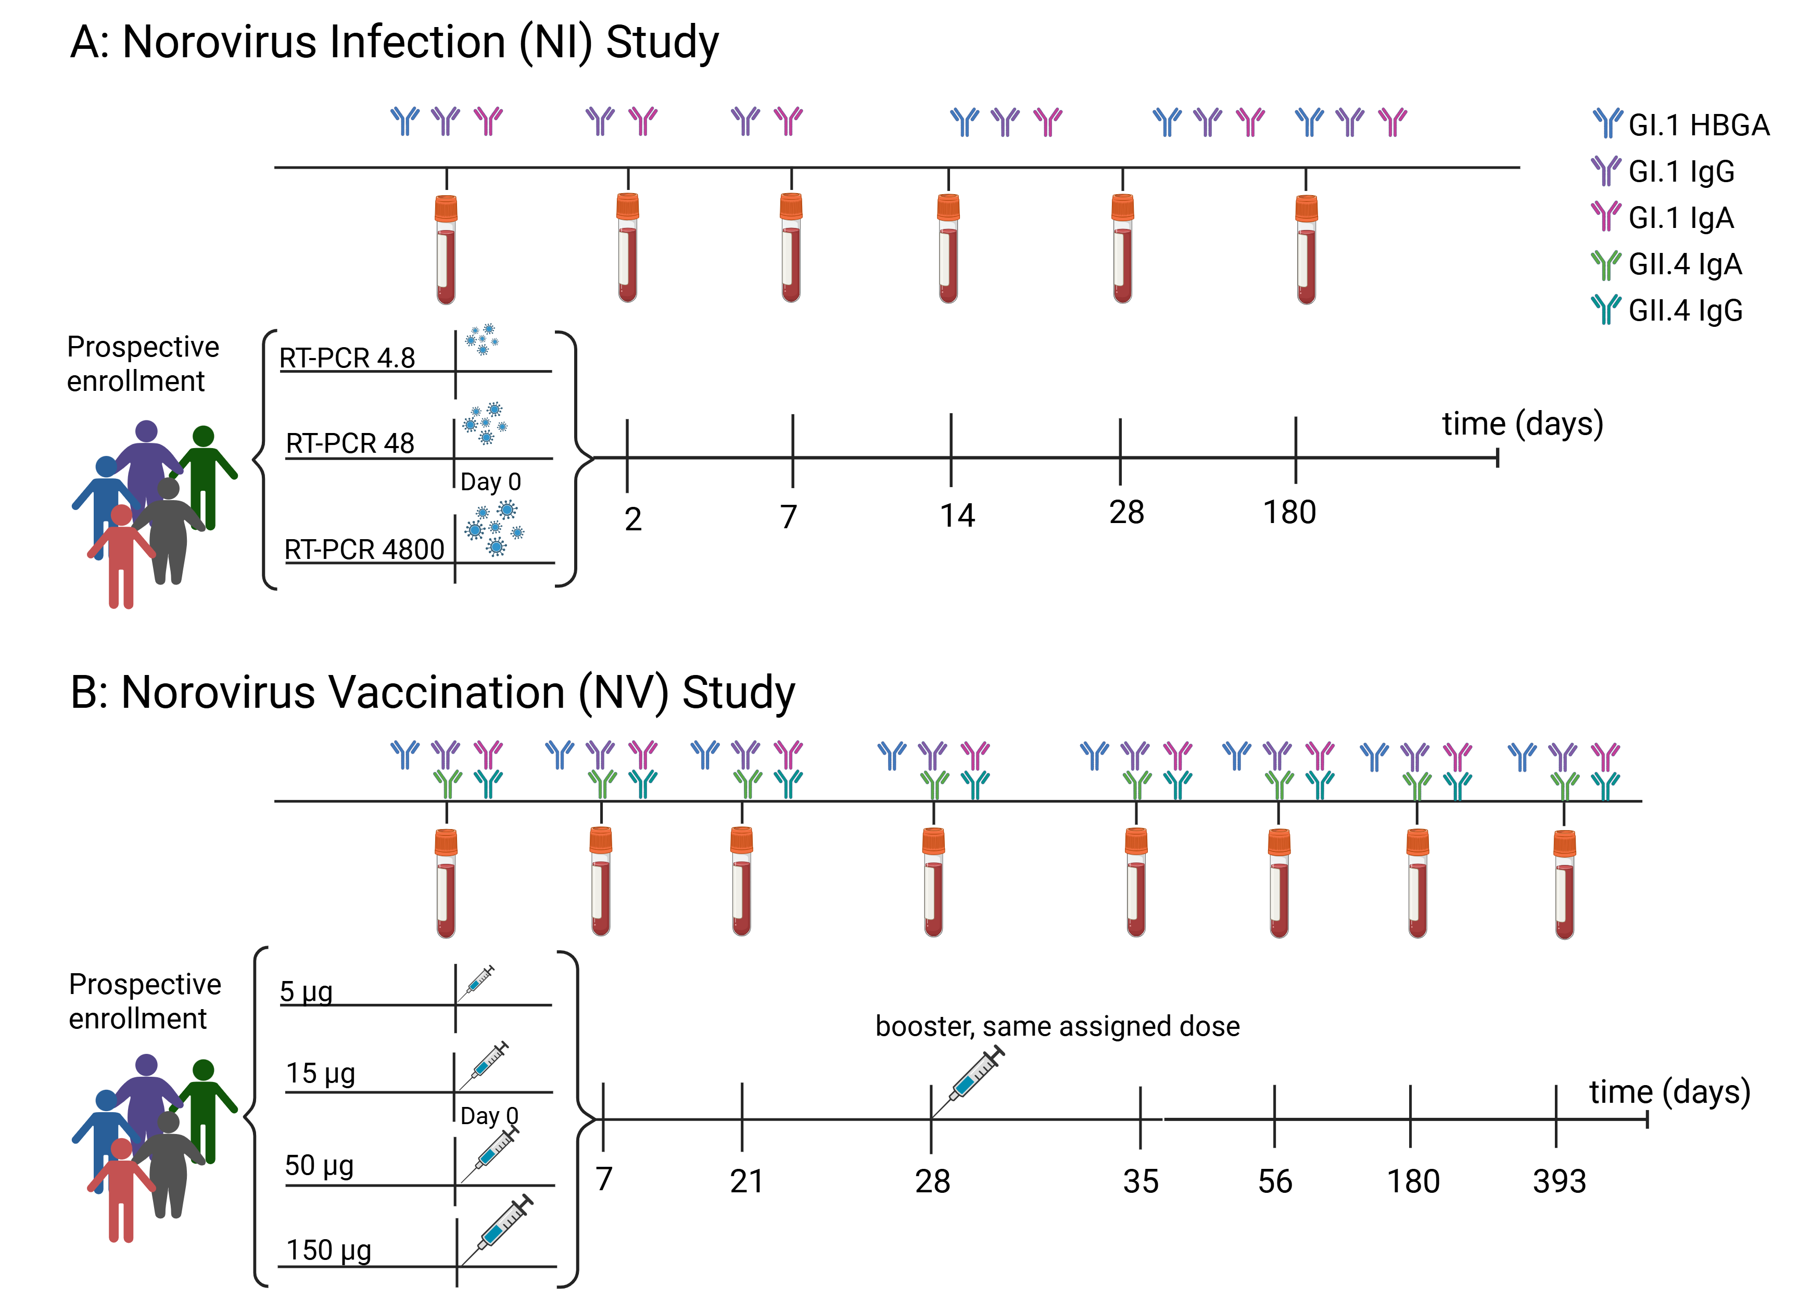
Figure 1: Norovirus infection (NI) and vaccination (NV) study designs. Panel A shows the NI study. Participants were randomized to be challenged with 4.8, 48, or 4800 RT-PCR units of Norwalk virus. Serum samples were collected on days 0, 2, 7, 14, 28, and 180, and antibody responses to GI.1 HBGA-blocking, IgA, and IgG were measured. GI.1 IgA and IgG were assessed at all time points, whereas HBGA-blocking antibody measurements were only available on days 0, 14, 28, and 180. Panel B shows the NV study. Participants were randomized to receive a bivalent (GI.1 and GII.4) VLP vaccine at doses of 5, 15, 50, or 150 mcg of each component. A second dose was administered 28 days after the first. Serum samples were collected on days 0, 7, 21, 28, 35, 56, 180, and 393. Antibody responses were measured for GI.1 HBGA-blocking, IgA, and IgG, as well as GII.4 IgA and IgG. Figure created in BioRender. Handel, A. (2026) https://BioRender.com/p3sb4gj.

Modeled antibody trajectories following infection or vaccination
We characterized antibody kinetics using two models. One model assumes exponential decay, representing a constant rate of antibody loss, while the other assumes power-law decay, allowing for decreased waning over time that may reflect differences in plasma cell lifespans (see Materials and Methods for model equations and further details). We fit models separately by study and antibody type, incorporating dose effects and individual-level variability. Figure 2 and Figure 3 show the population-level predicted trajectories from both models, stratified by antibody type and dose, for the infection and vaccination studies, respectively. We present individual-level fits in the Supplementary Materials (SM) S3.2.
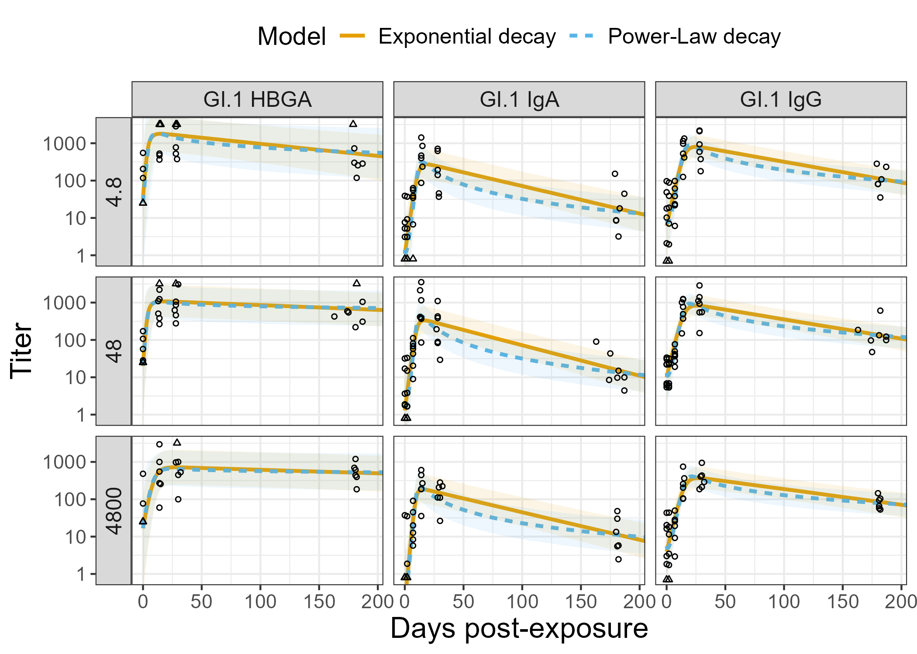
Figure 2: Data and fitted antibody kinetics in the Norovirus Infection (NI) study, by dose group and antibody type among those infected. Orange solid lines represent the exponential decay model, and blue dashed lines represent the power-law decay model. Ninety-five percent equal-tailed credible intervals are shown as ribbons around the trajectories. Points represent the observed data, and censored observations are denoted with triangles plotted at the limit of detection. For a summary of the censored observations at each time point, see SM S2.3.1.

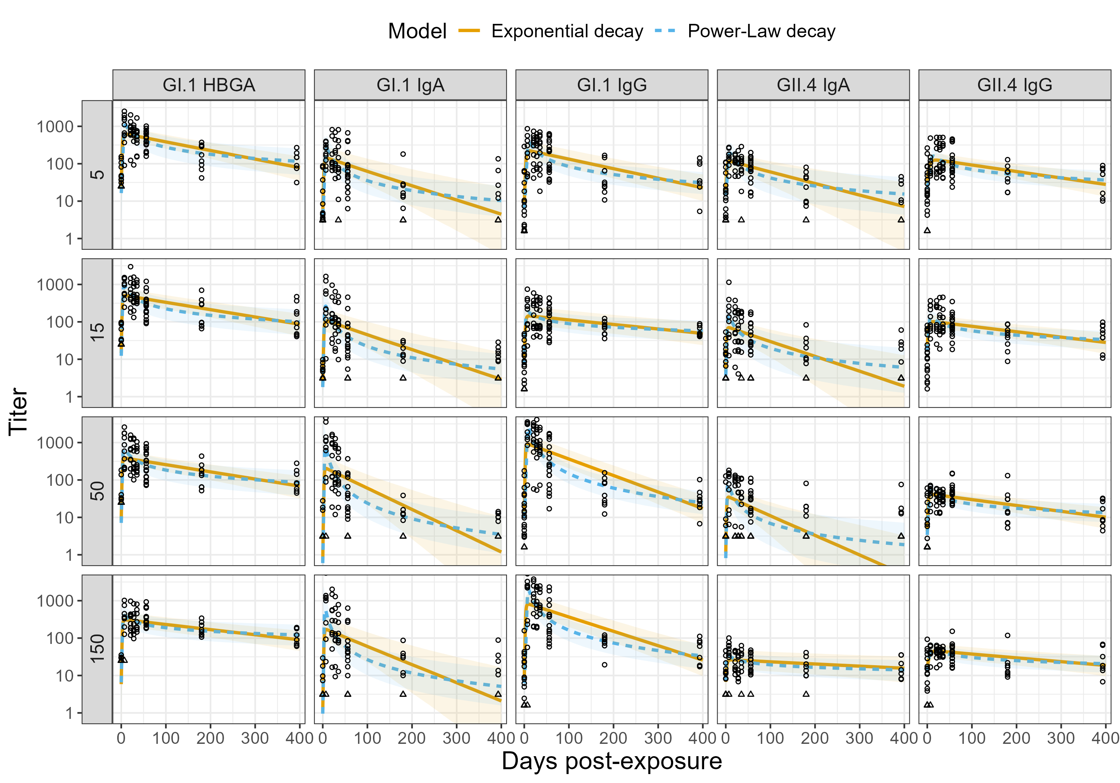
Figure 3: Data and fitted antibody kinetics in the Norovirus Vaccination (NV) study, by dose group and antibody type. Orange solid lines represent the exponential decay model, and blue dashed lines represent the power-law decay model. Ninety-five percent equal-tailed credible intervals are shown as ribbons around the trajectories. Points represent the observed data, and censored observations are denoted with triangles plotted at the limit of detection. For a summary of the censored observations at each time point, see SM S2.3.1.
We compared the predictive performance of the exponential and power-law decay models. We found that the power-law model outperformed the exponential model in all cases except the NI GI.1 HBGA-blocking scenario (Table 1). Given this trend, we base all subsequent main-text analyses on the power-law models and provide corresponding exponential model results in SM S3.5.
Table 1: Comparison of exponential and power-law decay models for each study and antibody. Differences in total expected log predictive density (ΔELPD), their standard errors (ΔSE), and the probability that the power-law model has better predictive performance than the exponential model (P(ΔELPD>0)) are shown. Positive ΔELPD values and P(ΔELPD>0) values near 1 indicate superior performance of the power-law model.
Study | Antibody | ΔELPD | ΔSE | P(ΔELPD>0)
NI | GI.1 HBGA | -10.403 | 3.059 | 0.045
NI | GI.1 IgA | 28.935 | 6.122 | 0.991
NI | GI.1 IgG | 47.157 | 4.940 | 1.000
NV | GI.1 HBGA | 50.714 | 11.314 | 0.987
NV | GI.1 IgA | 92.703 | 11.667 | 1.000
NV | GII.4 IgA | 48.357 | 12.435 | 0.974
NV | GI.1 IgG | 33.197 | 8.744 | 0.971
NV | GII.4 IgG | 8.737 | 6.799 | 0.740

Dose-dependent antibody kinetics following infection
Using model-predicted antibody trajectories, we estimated growth rate, peak response, time of peak, decay rate at day 90, and predicted response at one year. Antibody induction and persistence varied by infection dose across antibody types (Figure 4). Posterior probabilities quantifying dose-dependent differences are provided in SM S3.3.
The highest dose induced slow GI.1 HBGA-blocking antibody growth rates and late peak times, though wide credible intervals indicate substantial uncertainty. Peak responses were similar across dose groups. The 4.8 dose decayed fastest, with posterior probabilities Pr(4.8 > 48) = 0.98 and Pr(4.8 > 4800) = 0.99 that its decay rate exceeded those of the 48 and 4800 doses, respectively. Despite these early kinetic differences, predicted one-year responses were similar across doses.
GI.1 IgA measures varied little across doses. The 4800 dose yielded the highest estimated peak response, though credible intervals overlapped across doses. The 4800 dose also waned more slowly than the other doses, and had a modestly higher one-year response than the 48 dose (Pr(4800 > 48) = 0.8). GI.1 IgG growth rate, peak response, and time of peak were similar across doses. Waning rates modestly decreased with increasing dose (Pr(4.8 > 4800) = 0.94), though predicted one-year responses remained similar.
Across antibody types, IgA showed the strongest peak responses but also the fastest waning. Predicted one-year responses were highest for HBGA-blocking antibody.
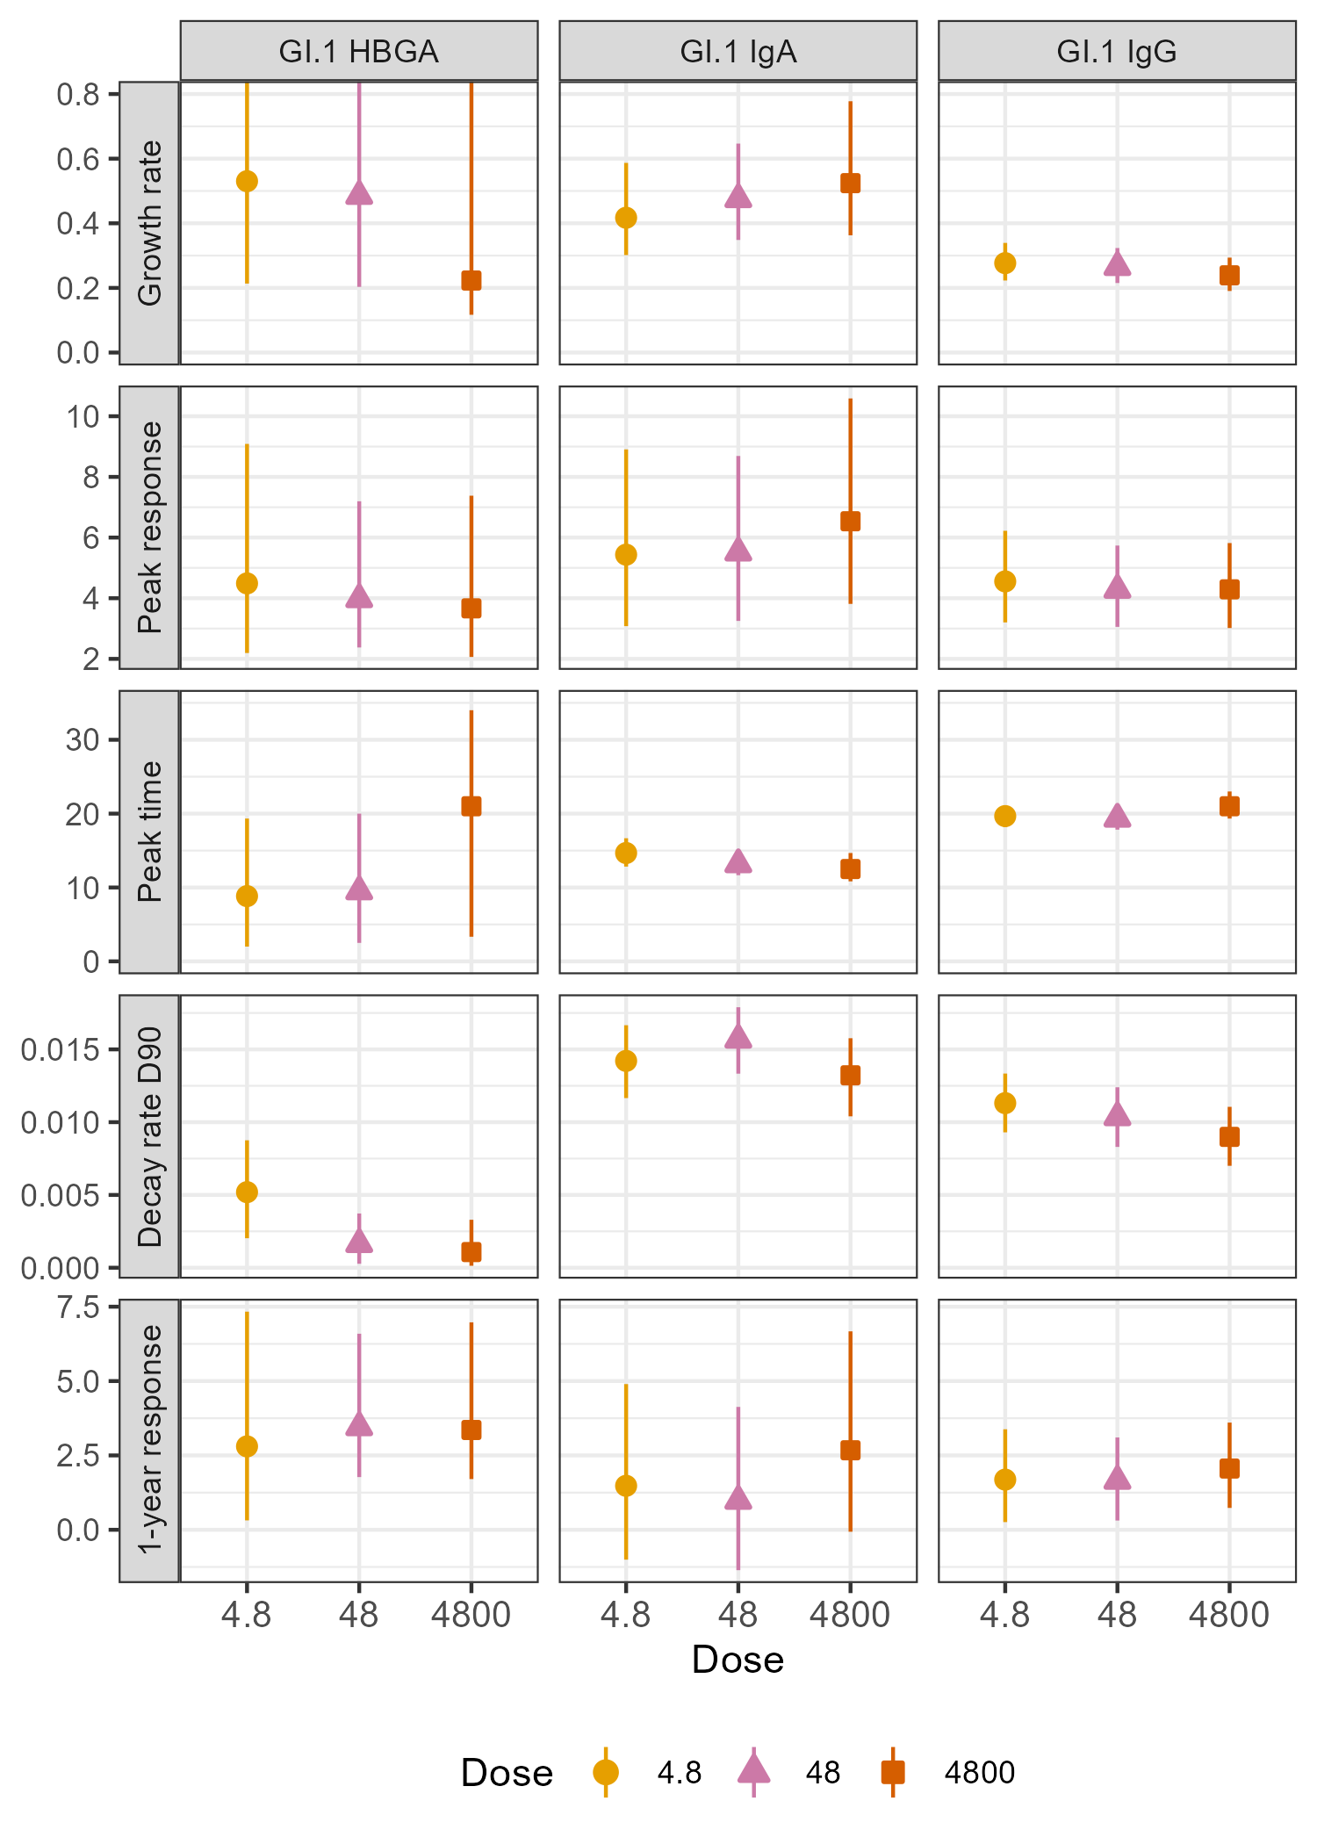
Figure 4: Power-law model-derived antibody kinetic measures following norovirus infection by challenge dose. Growth rate (per day), peak response, time of peak (days), decay rate (per day; evaluated at day 90), and predicted response at one year are shown, with rows corresponding to kinetic measure and columns corresponding to antibody type. Solid points denote population-level posterior estimates, with vertical lines indicating 95% equal-tailed credible intervals (CIs). For visualization purposes, the y-axis scales for growth rate and time to peak were truncated. The upper bounds of the 95% CIs for the GI.1 HBGA-blocking antibody growth rate at doses 4.8, 48, and 4800 were 2.49, 2.00, and 1.46, respectively.

Dose-dependent antibody kinetics following vaccination
Figure 5 presents model-based kinetic measures across vaccination doses and posterior probabilities quantifying pairwise dose differences are shown in SM S3.3.
GI.1 HBGA-blocking antibody growth rates and peak responses were similar across doses. The 150 dose waned more slowly than all others (Pr(150 < 5), Pr(150 < 15), and Pr(150 < 50) $≥$ 0.99), producing modestly higher predicted one-year responses.
GI.1 IgA growth rates increased with dose. The 50 and 150 doses generated stronger peak responses and faster decay than the lower doses (Pr $≥$ 0.95 for all peak and decay comparisons of higher vs. lower dose). Despite faster waning, the larger initial peaks at higher doses translated into slightly higher predicted one-year responses (Pr(50 > 5) = 0.85). GI.1 IgG responses followed a similar pattern, with higher doses producing stronger peaks and faster decay (Pr $≥$ 0.99 for all higher vs. lower dose comparisons). Predicted one-year responses were broadly similar across doses, with a slight reduction at the 50 dose relative to other doses.
For GII.4 antibodies, peak responses followed a non-monotone pattern, increasing up to the 50 dose and declining at the 150 dose for both IgA and IgG (Pr(50 > 150) = 0.99 and 0.95, respectively). The 150 dose also decayed more slowly than the other doses (Pr(150 < 5), Pr(150 < 15), and Pr(150 < 50) $≥$ 0.88). Overall, the 50 dose produced the strongest predicted one-year response.
Across antibodies, GI.1 HBGA-blocking antibody decayed most slowly and sustained the highest one-year responses. GI.1 antibodies generally produced higher peak and one-year responses than GII.4 antibodies.
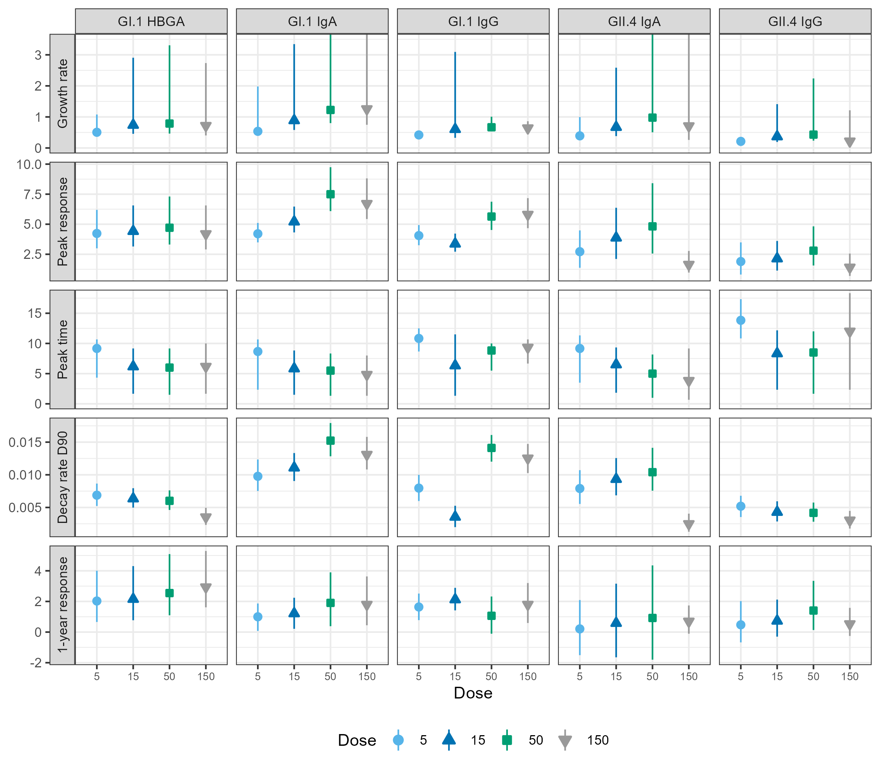
Figure 5: Power-law model-derived antibody kinetic measures following norovirus vaccination by assigned dose. Growth rate (per day), peak response, time of peak (days), decay rate (per day; evaluated at day 90), and predicted response at one year are shown, with rows corresponding to kinetic measure and columns corresponding to antibody type. Solid points denote population-level posterior estimates, with vertical lines indicating 95% equal-tailed credible intervals (CIs). For visualization purposes, the y-axis scale for growth rate was truncated. The upper bound of the 95% CIs for GI.1 IgA antibody growth rate at the 50 and 150 doses were 4.80 and 4.98, respectively. For GII.4 IgA, they were 5.42 (50) and 4.39 (150).

Predictors of antibody persistence
To evaluate whether early kinetics predict durability, we examined associations between growth rate, peak response, decay rate, and predicted one-year response (Figure 6). We focused on GI.1 because it was measured in both studies. GII.4 results from the NV study are available in SM S3.4.
Vaccination generally induced faster growth rates than infection across antibody types (Figure 6 A). Within dose groups, growth rate was consistently but moderately associated with one-year response, with 15 of 23 dose-level Spearman correlations $≥$ 0.40 (Figure 6 A and SM S3.4). This association did not hold across all posterior draws.
IgA and IgG peak responses were more variable following vaccination than infection, whereas HBGA peaks were similar across modalities (Figure 6 B). Within each dose group, peak response was strongly positively associated with predicted one-year response, with 23 of 29 Spearman correlations exceeding 0.8, and posterior draws formed distinct dose-specific bands (Figure 6 B and SM S3.4). The HBGA-blocking and IgA antibodies held this association across all draws ($ρ$ = 0.67 and 0.80, respectively), but IgG did not ($ρ$ = 0.20).
Decay rates were more variable for IgA and IgG following vaccination than infection, while vaccine-induced HBGA-blocking antibodies decayed faster than those following infection (Figure 6 C). Across antibodies, IgA decay rates were generally also faster than those of HBGA-blocking antibody and IgG. Decay rate was negatively associated with one-year response within dose groups, though correlations were of smaller magnitude than those for peak response (Figure 6 C and SM S3.4). This within-dose association held across all draws for HBGA and IgG ($ρ$ = -0.50 and -0.42, respectively), but not for IgA ($ρ$ = -0.02).
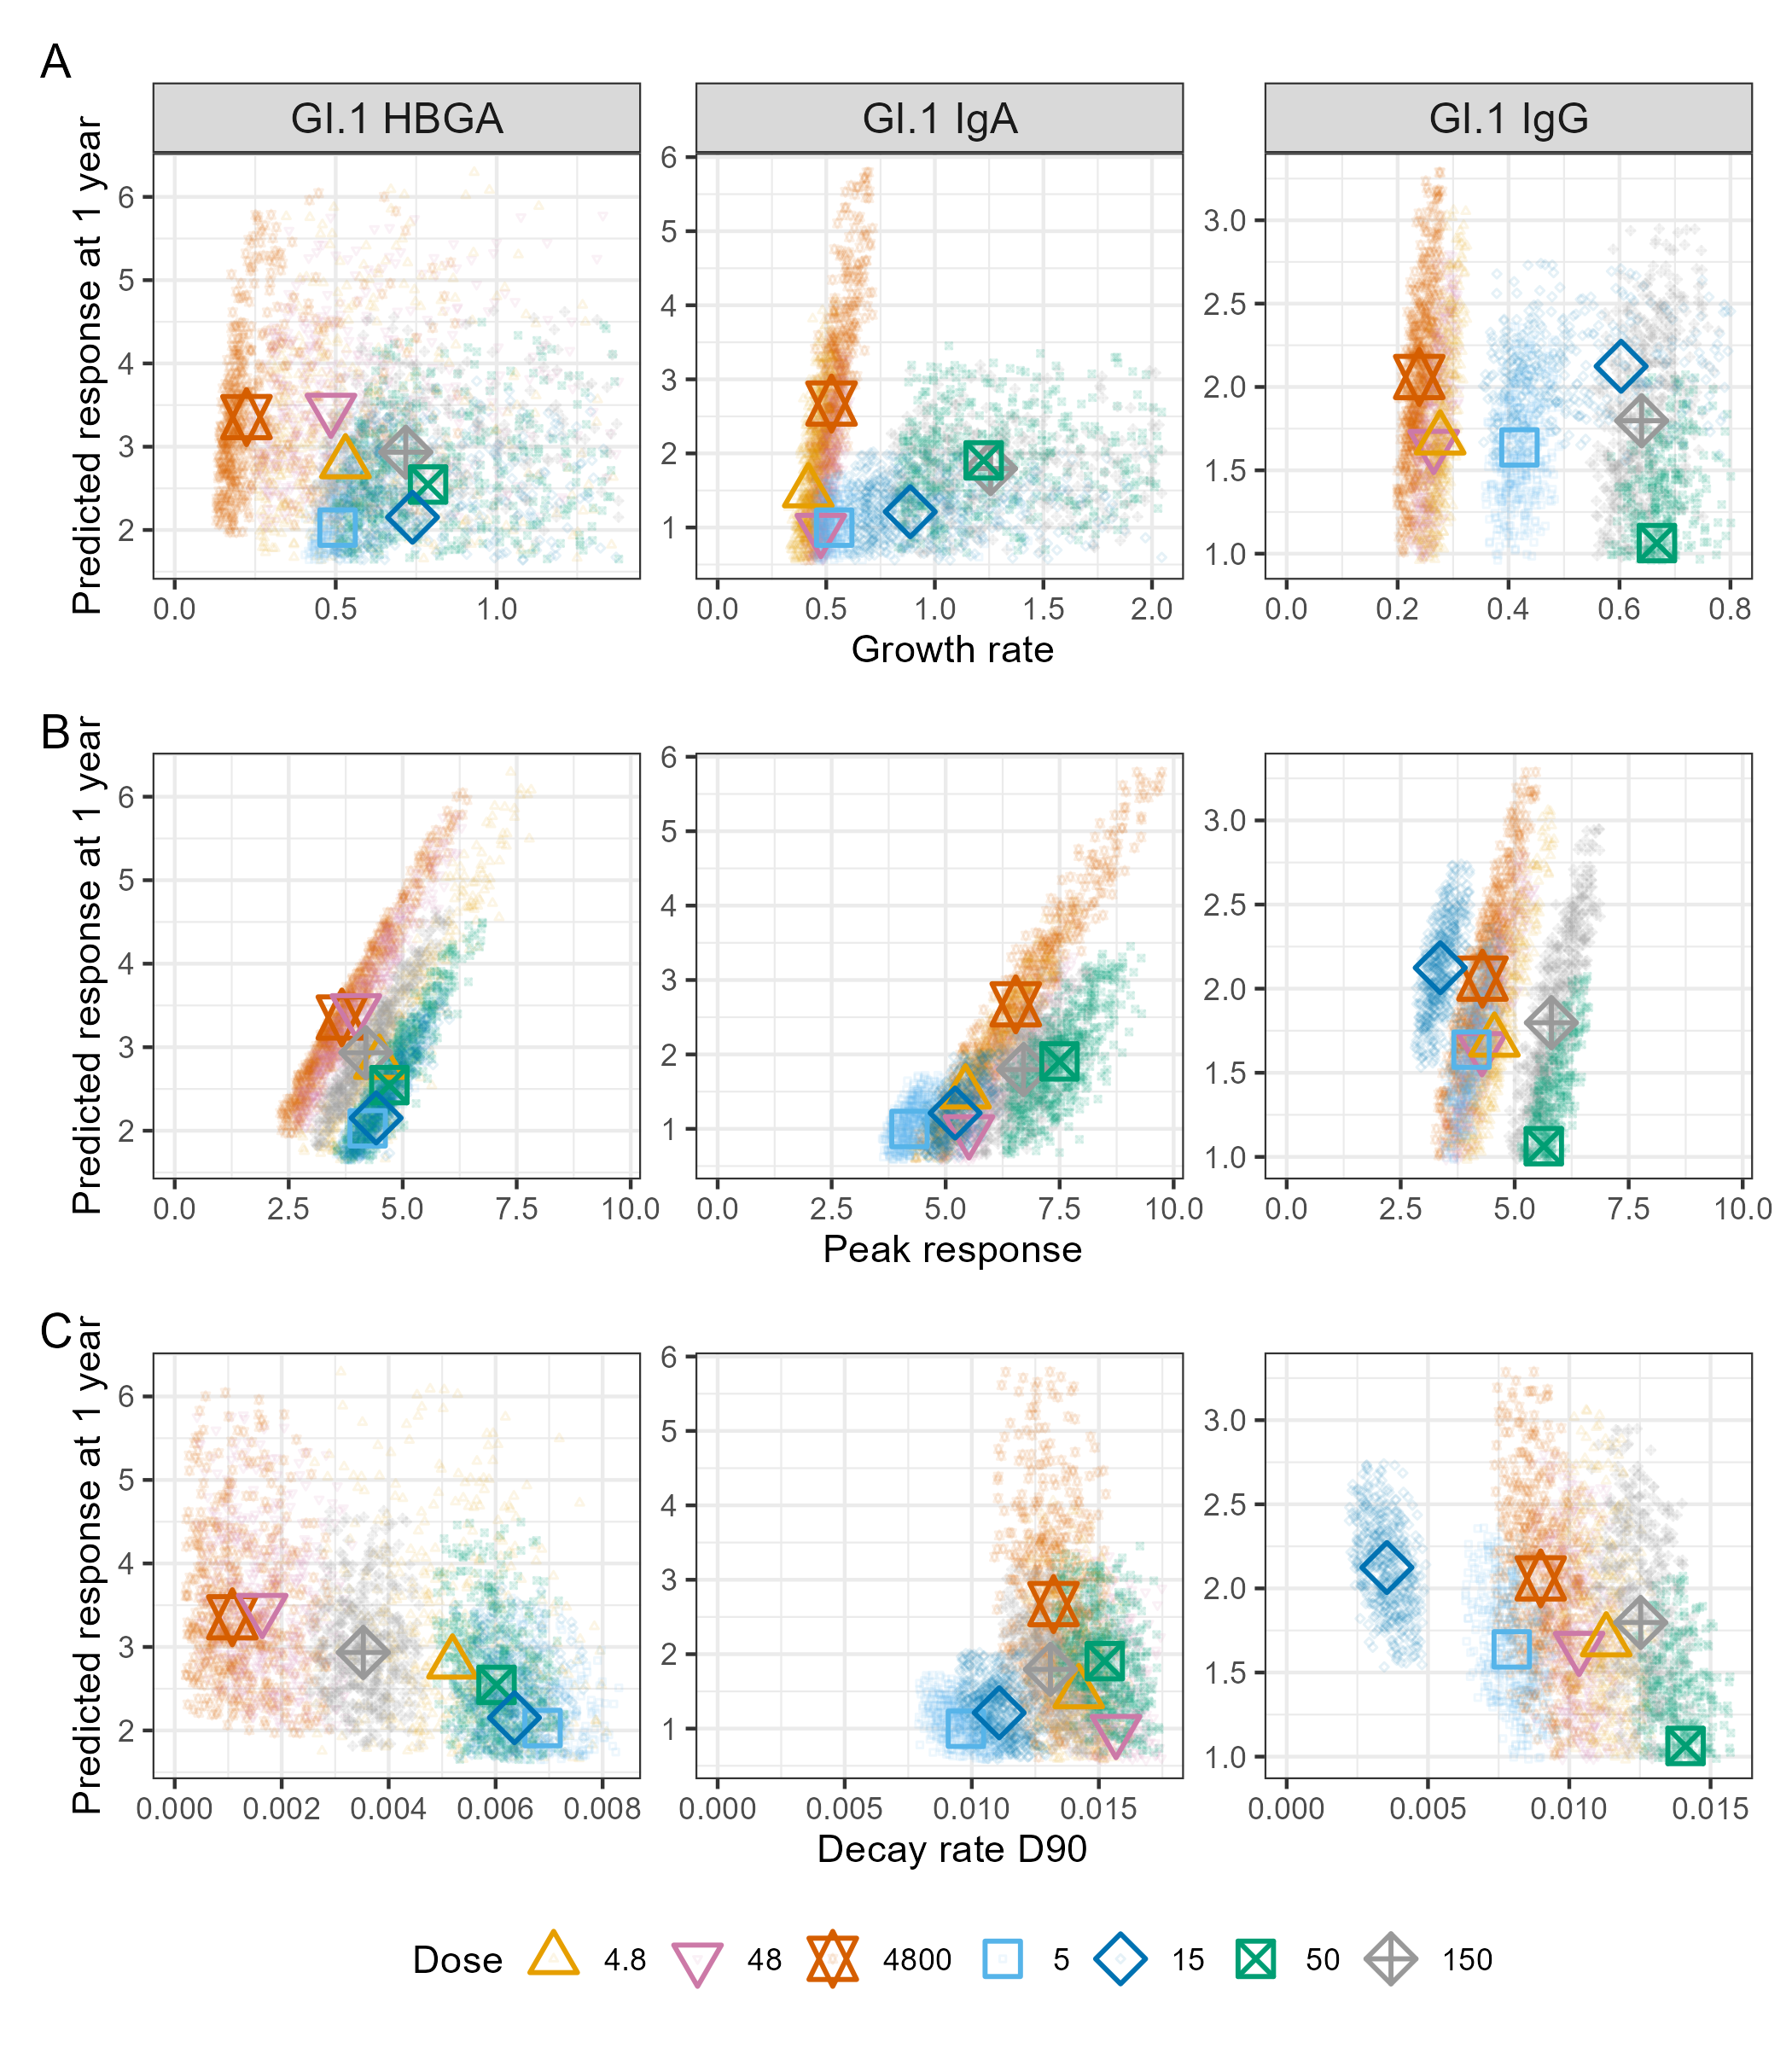
Figure 6: Power-law model-predicted antibody kinetic measures by study, dose, and antibody. Growth rate (per day), peak response, and decay rate (per day; evaluated at day 90) are plotted against predicted response at one year. Larger points represent study- and dose-specific posterior medians, while smaller points show a randomly selected subset of 500 posterior draws per study and dose, sampled after restricting to draws that fall within the 5th to 95th percentile range for all measures. Color and shape indicate study and dose, with triangle variations for the NI study and square variations for the NV study. For visualization purposes, the growth rate plot is scaled to display only the lower 95% of sampled draws to avoid skewing by extreme values. Only GI.1 antibodies are shown, as these were measured in both studies. GII.4-specific results from the NV study are provided in the SM S3.4.
Within dose groups, growth rate, peak response, and decay rate were all independently associated with predicted one-year response. Growth rate and peak response were themselves strongly correlated (see SM S3.4), and peak response showed stronger associations with one-year response. Prior studies of other antigens have reported a positive coupling between peak and subsequent waning, such that stronger early responses decay more rapidly [47,48]. Consistent with this, we observed a positive association between peak response and decay rate across posterior draws across all dose groups (Figure 7 A; $ρ$ = 0.22 for GI.1 HBGA, 0.40 for GI.1 IgA, and 0.74 for GI.1 IgG). However, this relationship was not present within dose groups, suggesting that peak response and decay rate contributed independently to one-year response. This indicates that the observed association is driven by dose-dependent variation in antibody induction and decline.
To evaluate how these dynamics jointly shape lasting immunity, we examined predicted one-year responses as a function of both peak response and decay rate (Figure 7 B). Within and across dose groups, one-year response increased with higher peak (holding decay constant) and decreased with faster decay (holding peak constant). Within dose groups, because peak and decay were uncorrelated, posterior draws varied across a range of combinations. Some achieved high peaks with slow decay, others showed modest peaks with rapid waning, and one-year responses reflected the independent, additive contribution of both features. Across dose groups, peak and decay were positively associated, such that their opposing effects on one-year response partially counteracted one another. Together, these results indicate that antibody persistence reflects the joint, and often compensatory, effects of peak response and subsequent decay. Moreover, the relationship between peak response and decay differed fundamentally within versus across dose groups.
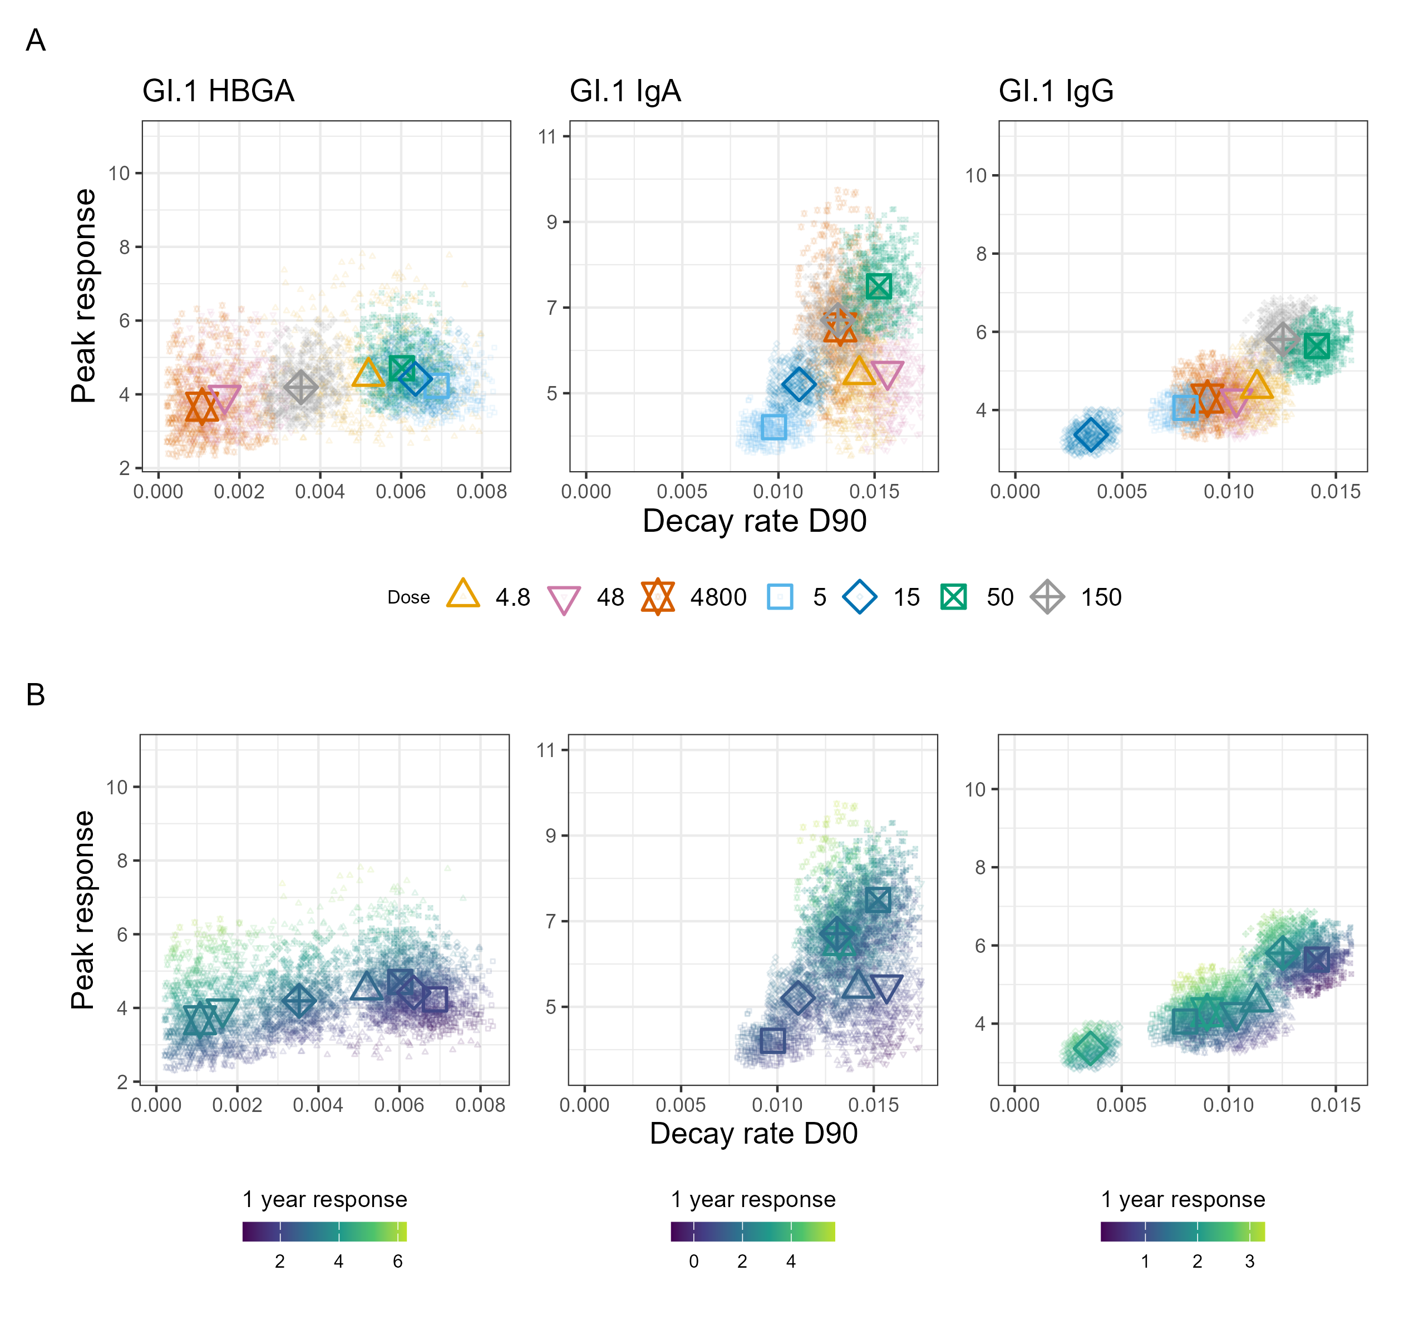
Figure 7: Joint relationships of peak response, decay rate (per day; evaluated at day 90), and predicted response at one year. Panel A shows peak response versus decay rate, with study- and dose-specific points indicated by shape and color. Triangle variations are used for the NI study and square variations for the NV study. Panel B shows the same relationship but with color representing predicted antibody response at one year. Antibody-specific color scales are shown underneath their corresponding plot. Larger points denote posterior medians. Smaller points represent a random subset of 500 posterior draws per dose, sampled after restricting to draws that fall within the 5th to 95th percentile range for all measures. Only GI.1 antibodies are shown, as these were measured in both studies. GII.4-specific results from the NV study are provided in the SM S3.4.

Additional Analyses
Our results were robust to model choice, censoring bounds, decay evaluation timepoint, and use of absolute versus baseline-relative measures (see SM S3.5-S3.8).
We presented results from the power-law model in the main text because it fit the data better than the exponential decay model. We provide corresponding results from the exponential model in the SM S3.5. Most findings were consistent across models. In the NI study, GI.1 HBGA-blocking antibody peak response remained strongest at the lowest dose; however, differences between doses were smaller under the exponential model. Consequently, the 4800 dose exhibited a one-year response approximately 2-fold higher than the 4.8 dose. We note that for this scenario, model comparison slightly favored the exponential model. Its peak and one-year response estimates may therefore be more reliable for this particular antibody and dose combination. All other analyses remained unchanged, and the joint relationship between peak response, decay rate, and one-year response persisted.
We conducted several sensitivity analyses to evaluate methodological choices. First, we assessed the lower bound used in the censoring procedure. Results were robust to the choice of censoring bound (${10}^{-6}$ in the main text; ${10}^{-2}$ and ${10}^{-14}$ evaluated in SM S3.6). Second, because decay in the power-law model is not constant over time, we evaluated decay at day 90 in the main analysis and at days 60, 180, and 365 in the SM S3.7. As expected, magnitudes differed, but qualitative trends were unchanged.
Finally, we evaluated the role of baseline antibody levels. In the main analysis, peak response and one-year response were defined relative to baseline, while absolute titers are reported in SM S3.8. Absolute titers reflect potential protection, whereas response measures capture exposure-induced change. Across both studies, baseline differences between dose groups modestly influenced both peak and one-year responses. For example, in the NI study, the 4800 dose group had the lowest baseline titers. This group also had the largest IgA peak and one-year responses but the lowest absolute peak and one-year titers. In the NV study, the 50 dose group had the lowest baseline GI.1 IgA, GII.4 IgA, and GII.4 IgG titers, which may have contributed to the smallest absolute one-year titers despite the strongest peak and one-year responses. We found that these differences did not alter the overall patterns linking growth, peak response, and decay rate to predicted one-year titers. Peak response and decay rate remained positively associated, and one-year titers reflected the combined effects of peak magnitude and waning. Although absolute and baseline-relative measures differ in interpretation, our primary conclusions regarding the joint role of response magnitude and decay dynamics remain unchanged.

Discussion
We compared antibody kinetics following norovirus infection and vaccination to assess how dose shapes the response magnitude and durability of multiple antibodies. Across both exposure modalities, antibody waning was better described by a power-law than an exponential model, supporting non-constant decay over time. A power-law decay implies a progressive slowing of antibody loss, consistent with heterogeneity in plasma cell longevity. Early antibody responses may be dominated by short-lived plasma cells that decay rapidly, whereas longer-lived populations persist and shape later titers [49]. Such heterogeneity may arise from multiple plasma cell subpopulations [50–52], competition for limited bone marrow survival niches [53], and progressive differentiation into longer-lived plasma cells [54–58]. Differences in plasma cell origin may further contribute, with germinal center-derived responses supporting greater durability than extrafollicular responses [59–62]. In this context, the superior performance of the power-law relative to the exponential model aligns with prior evidence that humoral immunity does not wane at a constant rate [27].
We found that dose can influence early antibody kinetics. Although credible intervals for many estimates overlapped across doses, several qualitative patterns emerged. Following infection, GI.1 HBGA-blocking antibody peak responses were similar across all doses, suggesting that low-dose infection may engage high-affinity B cells or promote germinal center entry [63] as effectively as high-dose exposure. Despite differences in early kinetics, predicted responses at one year mostly converged across doses, suggesting that persistence is governed by downstream regulatory constraints that are relatively insensitive to antigen load.
Vaccination showed similarly complex dose-kinetic relationships. Increasing vaccine dose did not uniformly increase response or growth rate, and effects varied by antibody type and viral strain. Doses that produced the highest peak responses also exhibited faster decay, consistent with a trade-off between early expansion and subsequent contraction of antibody-secreting populations [64–66], which limits the extent to which dose-dependent differences in early kinetics translate into durable antibody levels. In addition, interactions between vaccine components may have contributed to these patterns, with higher GI.1 antigen content attenuating GII.4 responses, consistent with antigenic interference in multivalent formulations [23,67–69].
Vaccination and infection elicited qualitatively different early antibody dynamics despite broadly similar durability. Antibody responses following vaccination exhibited faster growth rates, consistent with more synchronous antigen exposure and uniform innate activation compared with natural infection [70,71]. GI.1 IgA and IgG peak responses showed greater dose-dependent heterogeneity following vaccination than infection, indicating that controlled vaccine dosing allows greater modulation of early kinetics, whereas infection imposes tighter constraints on response magnitude [72,73]. Despite these differences in early dynamics, predicted responses at one year were largely comparable between infection and vaccination for both IgA and IgG, reinforcing the idea that antibody persistence is constrained by shared downstream mechanisms, such as limits on long-lived plasma cell survival. The duration of vaccine-induced immunity and how it compares with natural infection remains unknown, but these results provide preliminary evidence that both exposures may converge to similar IgA and IgG antibody levels over time. GI.1 HBGA-blocking antibody responses at one year were slightly higher after infection than after vaccination, suggesting that in the context of these study doses and methods, natural infection may more broadly engage immune pathways than vaccination, a finding that warrants further investigation.
Our investigation of whether early kinetic features could serve as reliable predictors of antibody persistence suggests a nuanced picture. Within dose groups, growth rate and peak response were positively associated with one-year response while decay rate was negatively associated. Across dose groups, we observed a positive association between peak response and decay rate, such that higher peaks tended to be accompanied by faster decay, partially offsetting their effects on persistence. However, this relationship was not observed within dose groups.
This study has several limitations. Infection and vaccination cohorts differed in route of exposure, dose, and strain composition, limiting direct quantitative comparison. Sample sizes within dose groups were small, sampling was infrequent, and follow-up extended to, at most, approximately one year, necessitating model-based extrapolation for longer-term persistence. Serum antibody responses represent only one dimension of immunity and do not capture mucosal responses or cellular immunity.
In conclusion, while our findings need to be validated in larger studies, they preliminarily suggest that the impact of dose can vary by antibody type and modality of delivery, and that despite differences in the early antibody kinetics, persistence seems to be minimally influenced by dose. These results suggest that effective norovirus vaccine design should focus not only on maximizing early antibody induction but also on promoting the formation and survival of long-lived plasma cells and functional immune memory.

Acknowledgments

Funding sources
AH, KK and BAL acknowledge partial support from NIH grant R01GM124280. YS acknowledges partial support from NIH grant R35GM146612. No other authors declared any relevant funding sources. The funders had no role in the decision to conduct or publish the study or in the formulation of the study.

Conflicts of interest
All authors declared no potential conflicts of interest.

Author contributions
- MJ: conceptualization, data curation, formal analysis, methodology, software, writing - original draft, writing - review & editing, visualization
- YG: conceptualization, methodology, writing - review & editing
- WZB: methodology, validation, writing - review & editing
- SLM: validation, writing - review & editing
- CH: methodology, writing - review & editing
- RA: methodology, writing - review & editing
- KK: methodology, writing - review & editing
- YS: methodology, writing - review & editing
- BAL: investigation, writing - review & editing
- RLA: investigation, writing - review & editing
- AH: conceptualization, methodology, writing - review & editing, supervision, funding acquisition
We acknowledge the use of large language models in code and manuscript preparation. All AI-suggested changes were reviewed and approved by co-authors prior to inclusion.

References
1. CDC. About Norovirus. Norovirus. 2024; Available at: https://www.cdc.gov/norovirus/about/index.html. Accessed 16 June 2025.
2. Patel MM, Widdowson M-A, Glass RI, Akazawa K, Vinjé J, Parashar UD. Systematic Literature Review of Role of Noroviruses in Sporadic Gastroenteritis. Emerging Infectious Diseases 2008; 14:1224–1231.
3. Lozano R, Naghavi M, Foreman K, et al. Global and Regional Mortality from 235 Causes of Death for 20 Age Groups in 1990 and 2010: A Systematic Analysis for the Global Burden of Disease Study 2010. The Lancet 2012; 380:2095–2128.
4. Bartsch SM, Lopman BA, Ozawa S, Hall AJ, Lee BY. Global Economic Burden of Norovirus Gastroenteritis. PloS One 2016; 11:e0151219.
5. Scallan E, Hoekstra RM, Angulo FJ, et al. Foodborne Illness Acquired in the United States—Major Pathogens. Emerging Infectious Diseases 2011; 17:7–15.
6. Atmar RL, Opekun AR, Gilger MA, et al. Determination of the 50% Human Infectious Dose for Norwalk Virus. The Journal of Infectious Diseases 2014; 209:1016–1022. Available at: http://dx.doi.org/10.1093/infdis/jit620.
7. Atmar RL, Opekun AR, Gilger MA, et al. Norwalk Virus Shedding after Experimental Human Infection. Emerging Infectious Diseases 2008; 14:1553–1557. Available at: http://dx.doi.org/10.3201/eid1410.080117.
8. Atmar RL, Bernstein DI, Harro CD, et al. Norovirus Vaccine against Experimental Human Norwalk Virus Illness. New England Journal of Medicine 2011; 365:2178–2187. Available at: https://www.nejm.org/doi/full/10.1056/NEJMoa1101245. Accessed 16 June 2025.
9. Johnston CP, Qiu H, Ticehurst JR, et al. Outbreak Management and Implications of a Nosocomial Norovirus Outbreak. Clinical Infectious Diseases 2007; 45:534–540.
10. Isakbaeva ET, Widdowson M-A, Beard RS, et al. Norovirus Transmission on Cruise Ship. Emerging Infectious Diseases 2005; 11:154–157.
11. Carling PC, Bruno-Murtha LA, Griffiths JK. Cruise Ship Environmental Hygiene and the Risk of Norovirus Infection Outbreaks: An Objective Assessment of 56 Vessels over 3 Years. Clinical Infectious Diseases 2009; 49:1312–1317.
12. Wikswo ME, Cortes J, Hall AJ, et al. Disease Transmission and Passenger Behaviors during a High Morbidity Norovirus Outbreak on a Cruise Ship, January 2009. Clinical Infectious Diseases 2011; 52:1116–1122.
13. Bitler EJ, Matthews JE, Dickey BW, Eisenberg JNS, Leon JS. Norovirus Outbreaks: A Systematic Review of Commonly Implicated Transmission Routes and Vehicles. Epidemiology & Infection 2013; 141:1563–1571.
14. Lucero Y, Vidal R, O’Ryan G M. Norovirus vaccines under development. Vaccine 2018; 36:5435–5441. Available at: https://www.sciencedirect.com/science/article/pii/S0264410X17308307. Accessed 22 April 2026.
15. Tan M. Norovirus Vaccines: Current Clinical Development and Challenges. Pathogens 2021; 10:1641. Available at: https://pmc.ncbi.nlm.nih.gov/articles/PMC8709042/. Accessed 22 April 2026.
16. Reeck A, Kavanagh O, Estes MK, et al. Serological Correlate of Protection against Norovirus-Induced Gastroenteritis. The Journal of Infectious Diseases 2010; 202:1212–1218. Available at: https://doi.org/10.1086/656364. Accessed 16 June 2025.
17. Ramani S, Estes MK, Atmar RL. Correlates of Protection against Norovirus Infection and Disease—Where Are We Now, Where Do We Go? PLOS Pathogens 2016; 12:e1005334. Available at: https://journals.plos.org/plospathogens/article?id=10.1371/journal.ppat.1005334. Accessed 6 April 2026.
18. Johnson PC, Mathewson JJ, DuPont HL, Greenberg HB. Multiple-Challenge Study of Host Susceptibility to Norwalk Gastroenteritis in US Adults. The Journal of Infectious Diseases 1990; 161:18–21. Available at: https://doi.org/10.1093/infdis/161.1.18. Accessed 15 February 2022.
19. Parrino TA, Schreiber DS, Trier JS, Kapikian AZ, Blacklow NR. Clinical immunity in acute gastroenteritis caused by Norwalk agent. The New England Journal of Medicine 1977; 297:86–89. Available at: https://www.nejm.org/doi/full/10.1056/NEJM197707142970204. Accessed 30 June 2025.
20. Simmons K, Gambhir M, Leon J, Lopman B. Duration of Immunity to Norovirus Gastroenteritis. Emerging Infectious Diseases 2013; 19:1260–1267. Available at: https://pmc.ncbi.nlm.nih.gov/articles/PMC3739512/. Accessed 30 January 2026.
21. Teunis PFM, Moe CL, Liu P, et al. Norwalk virus: How infectious is it? Journal of Medical Virology 2008; 80:1468–1476. Available at: https://onlinelibrary.wiley.com/doi/abs/10.1002/jmv.21237. Accessed 30 January 2026.
22. Ge Y, Billings WZ, Opekun A, et al. Effect of Norovirus Inoculum Dose on Virus Kinetics, Shedding, and Symptoms. Emerging Infectious Diseases 2023; 29:1349–1356. Available at: https://www.ncbi.nlm.nih.gov/pmc/articles/PMC10310361/. Accessed 6 February 2024.
23. Treanor JJ, Atmar RL, Frey SE, et al. A Novel Intramuscular Bivalent Norovirus Virus-like Particle Vaccine Candidate–Reactogenicity, Safety, and Immunogenicity in a Phase 1 Trial in Healthy Adults. The Journal of Infectious Diseases 2014; 210:1763–1771. Available at: http://dx.doi.org/10.1093/infdis/jiu337.
24. Teunis PFM, Eijkeren JCH van, Graaf WF de, Marinović AB, Kretzschmar MEE. Linking the Seroresponse to Infection to Within-Host Heterogeneity in Antibody Production. Epidemics 2016; 16:33–39.
25. Graaf WF de, Kretzschmar MEE, Teunis PFM, Diekmann O. A Two-Phase within-Host Model for Immune Response and Its Application to Serological Profiles of Pertussis. Epidemics 2014; 9:1–7.
26. Cohen KW, Linderman SL, Moodie Z, et al. Longitudinal Analysis Shows Durable and Broad Immune Memory after SARS-CoV-2 Infection with Persisting Antibody Responses and Memory B and T Cells. Cell Reports Medicine 2021; 2:100354.
27. Saha A, Ahmed H, Hirst C, et al. Quantifying the waning of humoral immunity. Immunity 2025; 58:3144–3152.e2. Available at: https://www.sciencedirect.com/science/article/pii/S1074761325005096. Accessed 9 January 2026.
28. McElreath R. Statistical Rethinking: A Bayesian Course with Examples in R and Stan. 2nd ed. Boca Raton: Taylor; Francis, CRC Press, 2020.
29. Sivula T, Magnusson M, Matamoros AA, Vehtari A. Uncertainty in Bayesian Leave-One-Out Cross-Validation Based Model Comparison. Bayesian Analysis 2025; -1:1–31. Available at: https://projecteuclid.org/journals/bayesian-analysis/advance-publication/Uncertainty-in-Bayesian-Leave-One-Out-Cross-Validation-Based-Model/10.1214/25-BA1569.full. Accessed 9 April 2026.
30. Bengio Y, Grandvalet Y. No unbiased estimator of the variance of K-fold cross-validation. Journal of Machine Learning Research (JMLR) 2003; 5:1089–1105.
31. R Core Team. R: A language and environment for statistical computing. 2025; Available at: https://www.R-project.org/.
32. William Michael Landau. The targets R package: A dynamic Make-like function-oriented pipeline toolkit for reproducibility and high-performance computing. Journal of Open Source Software 2021; 6:2959. Available at: https://doi.org/10.21105/joss.02959.
33. Kirill Müller. Here: A Simpler Way to Find Your Files. 2025; Available at: https://here.r-lib.org/.
34. Kevin Ushey, Hadley Wickham. Renv: Project Environments. 2025; Available at: https://rstudio.github.io/renv/.
35. Wickham H, Averick M, Bryan J, et al. Welcome to the Tidyverse. Journal of Open Source Software 2019; 4:1686. Available at: https://joss.theoj.org/papers/10.21105/joss.01686. Accessed 16 April 2026.
36. Hadley Wickham. ggplot2: Elegant Graphics for Data Analysis. Springer-Verlag New York, 2016. Available at: https://ggplot2.tidyverse.org.
37. Thomas Lin Pedersen. Patchwork: The Composer of Plots. 2025; Available at: https://patchwork.data-imaginist.com.
38. Malcolm Barrett. Ggokabeito: ’Okabe-Ito’ Scales for ’ggplot2’ and ’ggraph’. 2021; Available at: https://github.com/malcolmbarrett/ggokabeito.
39. Teun van den Brand. ggh4x: Hacks for ’ggplot2’. 2025; Available at: https://github.com/teunbrand/ggh4x.
40. Daniel D. Sjoberg, Karissa Whiting, Michael Curry, Jessica A. Lavery, Joseph Larmarange. Reproducible Summary Tables with the gtsummary Package. The R Journal 2021; 13:570–580. Available at: https://doi.org/10.32614/RJ-2021-053.
41. David Gohel, Panagiotis Skintzos. Flextable: Functions for Tabular Reporting. 2026; Available at: https://CRAN.R-project.org/package=flextable.
42. Yihui Xie. Knitr: A Comprehensive Tool for Reproducible Research in R. In: Implementing Reproducible Computational Research. Chapman; Hall/CRC, 2014.
43. J.J. Allaire, Charles Teague, Carlos Scheidegger, Yihuni Xie, Christophe Dervieux, Gordon Woodhull. Quarto. 2026; Available at: https://github.com/quarto-dev/quarto-cli.
44. Bürkner P-C. Bayesian Item Response Modeling in R with brms and Stan. Journal of Statistical Software 2021; 100:1–54. Available at: https://doi.org/10.18637/jss.v100.i05. Accessed 16 April 2026.
45. Jonah Gabry, Rok Češnovar, Andrew Johnson, Steve Bronder. Cmdstanr: R Interface to ’CmdStan’. 2025; Available at: https://mc-stan.org/cmdstanr/.
46. Posit team. RStudio: Integrated Development Environment for R. 2025; Available at: http://www.posit.co/.
47. Choi MJ, Heo JY, Seo YB, et al. Six-month longitudinal immune kinetics after mRNA-1273 vaccination: Correlation of peak antibody response with long-term, cross-reactive immunity. Frontiers in Immunology 2023; 13:1035441. Available at: https://pmc.ncbi.nlm.nih.gov/articles/PMC9868900/. Accessed 19 February 2026.
48. Gutiérrez-Bautista JF, López-Nevot MÁ, Gómez-Vicente E, et al. Study of humoral and cellular immunity in vaccinated with mRNA-1273. APMIS 2022; 130:261–269. Available at: https://onlinelibrary.wiley.com/doi/abs/10.1111/apm.13215. Accessed 19 February 2026.
49. Amanna IJ, Carlson NE, Slifka MK. Duration of Humoral Immunity to Common Viral and Vaccine Antigens. New England Journal of Medicine 2007; 357:1903–1915. Available at: https://www.nejm.org/doi/full/10.1056/NEJMoa066092. Accessed 29 January 2026.
50. Teunis PFM, Eijkeren JCH van, Graaf WF de, Marinović AB, Kretzschmar MEE. Linking the seroresponse to infection to within-host heterogeneity in antibody production. Epidemics 2016; 16:33–39.
51. Chernova I, Jones DD, Wilmore JR, et al. Lasting antibody responses are mediated by a combination of newly formed and established bone marrow plasma cells drawn from clonally distinct precursors. Journal of Immunology (Baltimore, Md: 1950) 2014; 193:4971–4979.
52. Robinson MJ, Ding Z, Dowling MR, et al. Intrinsically determined turnover underlies broad heterogeneity in plasma-cell lifespan. Immunity 2023; 56:1596–1612.e4.
53. Radbruch A, Muehlinghaus G, Luger EO, et al. Competence and competition: The challenge of becoming a long-lived plasma cell. Nature Reviews Immunology 2006; 6:741–750.
54. Zarnitsyna VI, Akondy RS, Ahmed H, et al. Dynamics and turnover of memory CD8 T cell responses following yellow fever vaccination. PLoS computational biology 2021; 17:e1009468.
55. Akondy RS, Fitch M, Edupuganti S, et al. Origin and differentiation of human memory CD8 T cells after vaccination. Nature 2017; 552:362–367.
56. Koike T, Fujii K, Kometani K, et al. Progressive differentiation toward the long-lived plasma cell compartment in the bone marrow. Journal of Experimental Medicine 2022; 220:e20221717. Available at: https://doi.org/10.1084/jem.20221717. Accessed 8 January 2026.
57. Simons BD, Karin O. Tuning of plasma cell lifespan by competition explains the longevity and heterogeneity of antibody persistence. Immunity 2024; 57:600–611.e6.
58. Stromberg SP, Antia R, Nemenman I. Population-expression models of immune response. Physical Biology 2013; 10:035010.
59. Amitai A, Mesin L, Victora GD, Kardar M, Chakraborty AK. A Population Dynamics Model for Clonal Diversity in a Germinal Center. Frontiers in Microbiology 2017; 8:1693.
60. Elsner RA, Shlomchik MJ. Germinal Center and Extrafollicular B Cell Responses in Vaccination, Immunity, and Autoimmunity. Immunity 2020; 53:1136–1150.
61. Meyer-Hermann M. A molecular theory of germinal center B cell selection and division. Cell Reports 2021; 36:109552.
62. Victora GD, Nussenzweig MC. Germinal Centers. Annual Review of Immunology 2022; 40:413–442.
63. Molari M, Eyer K, Baudry J, Cocco S, Monasson R. Quantitative modeling of the effect of antigen dosage on B-cell affinity distributions in maturating germinal centers. eLife 2020; 9:e55678. Available at: https://doi.org/10.7554/eLife.55678. Accessed 12 January 2026.
64. Amanna IJ, Slifka MK. Mechanisms that determine plasma cell lifespan and the duration of humoral immunity. Immunological Reviews 2010; 236:125–138. Available at: https://pmc.ncbi.nlm.nih.gov/articles/PMC7165522/. Accessed 12 January 2026.
65. Andraud M, Lejeune O, Musoro JZ, Ogunjimi B, Beutels P, Hens N. Living on Three Time Scales: The Dynamics of Plasma Cell and Antibody Populations Illustrated for Hepatitis A Virus. PLoS Computational Biology 2012; 8:e1002418. Available at: https://pmc.ncbi.nlm.nih.gov/articles/PMC3291529/. Accessed 12 January 2026.
66. Choi MJ, Heo JY, Seo YB, et al. Six-month longitudinal immune kinetics after mRNA-1273 vaccination: Correlation of peak antibody response with long-term, cross-reactive immunity. Frontiers in Immunology 2023; 13:1035441. Available at: https://pmc.ncbi.nlm.nih.gov/articles/PMC9868900/. Accessed 12 January 2026.
67. Leroux-Roels G, Cramer JP, Mendelman PM, et al. Safety and Immunogenicity of Different Formulations of Norovirus Vaccine Candidate in Healthy Adults: A Randomized, Controlled, Double-Blind Clinical Trial. The Journal of Infectious Diseases 2018; 217:597–607. Available at: https://doi.org/10.1093/infdis/jix572. Accessed 21 March 2026.
68. Xie Y, Tian X, Zhang X, Yao H, Wu N. Immune interference in effectiveness of influenza and COVID-19 vaccination. Frontiers in Immunology 2023; 14. Available at: https://www.frontiersin.org/journals/immunology/articles/10.3389/fimmu.2023.1167214/full. Accessed 21 March 2026.
69. Kallas EG, Grunenberg NA, Yu C, et al. Antigenic competition in CD4+ T cell responses in a randomized, multicenter, double-blind clinical HIV vaccine trial. Science Translational Medicine 2019; 11:eaaw1673. Available at: https://www.science.org/doi/10.1126/scitranslmed.aaw1673. Accessed 21 March 2026.
70. Epsi NJ, Richard SA, Lindholm DA, et al. Understanding "Hybrid Immunity": Comparison and Predictors of Humoral Immune Responses to Severe Acute Respiratory Syndrome Coronavirus 2 Infection (SARS-CoV-2) and Coronavirus Disease 2019 (COVID-19) Vaccines. Clinical Infectious Diseases: An Official Publication of the Infectious Diseases Society of America 2023; 76:e439–e449.
71. Teijaro JR, Farber DL. COVID-19 vaccines: Modes of immune activation and future challenges. Nature Reviews Immunology 2021; 21:195–197. Available at: https://www.nature.com/articles/s41577-021-00526-x. Accessed 13 January 2026.
72. Valiante NM, O’Hagan DT, Ulmer JB. Innate immunity and biodefence vaccines. Cellular Microbiology 2003; 5:755–760. Available at: https://onlinelibrary.wiley.com/doi/abs/10.1046/j.1462-5822.2003.00318.x. Accessed 13 January 2026.
73. Shen C-F, Yen C-L, Fu Y-C, et al. Innate Immune Responses of Vaccinees Determine Early Neutralizing Antibody Production After ChAdOx1nCoV-19 Vaccination. Frontiers in Immunology 2022; 13:807454. Available at: https://pmc.ncbi.nlm.nih.gov/articles/PMC8822242/. Accessed 13 January 2026.

