Example Manuscript Template for a Data Analysis Project

The structure below is one possible setup for a manuscript stemming from a data analysis project. It loosely follows the structure of a standard scientific manuscript. Adjust as needed. You don’t need to have exactly these sections, but the content covering those sections should be addressed.
This uses MS Word as output format. See the Quarto documentation for instructions on how to use other formats.
Authors
- First Author$​^{1,2,*}$ (ORCID: 0000-0000-1234-5678)
- Second Author$​^{3,*}$
- Third Author$​^{3,†}$
- Last Author$​^{1,2,∧}$
Author affiliations
- College of Public Health, University of Georgia, Athens, GA, USA.
- Another Affiliation, Athens, GA, USA.
- Yet another Affiliation.
$*$ These authors contributed equally to this work.
$∧$ Corresponding author: corresponding-author@example.com
$†$ Disclaimer: The opinions expressed in this article are the author’s own and don’t reflect their employer.

1. Summary/Abstract
Write a summary of your project.
It is recommended to use a structured abstract with Background/Methods/Results/Discussion sections.

2. Introduction

2.1 General Background Information
Provide enough background on your topic that others can understand the why and how of your analysis

2.2 Description of data and data source
Describe what the data is, what it contains, where it is from, etc. Eventually this might be part of a methods section.

2.3 Questions/Hypotheses to be addressed
State the research questions you plan to answer with this analysis.
To cite other work (important everywhere, but likely happens first in introduction), make sure your references are in the BibTeX file specified in the YAML header above and have the right BibTeX key. Then you can include like this:
Examples of reproducible research projects can for instance be found in (1,2).

3. Methods
Describe your methods. That should describe the data, the cleaning processes, and the analysis approaches. You might want to provide a shorter description here and all the details in the supplement.

3.1 Schematic of workflow
Sometimes you might want to show a schematic diagram or figure that was created outside the analysis code, for example a conceptual overview figure. Figure 1 shows an example schematic. Store manually created figures in the assets folder and document their source.
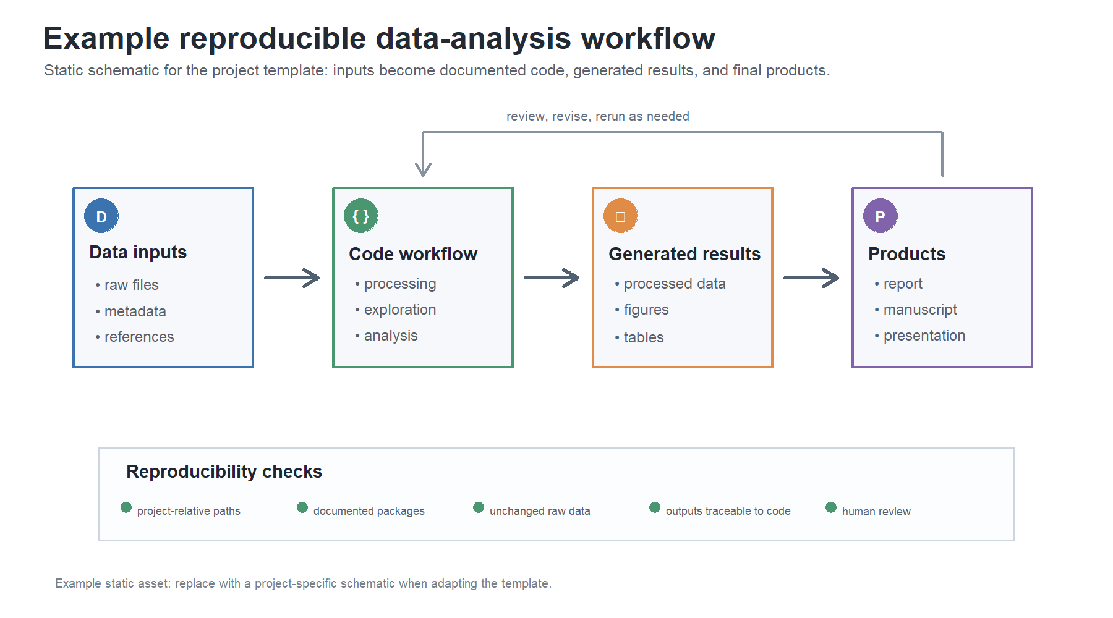
Figure 1: Example manually created schematic figure. Replace this with a project-specific figure and caption.

3.2 Data acquisition
As applicable, explain where and how you got the data. If you directly import the data from an online source, you can combine this section with the next.

3.3 Data import and cleaning
Write code that reads in the file and cleans it so it’s ready for analysis. Since this will be fairly long code for most datasets, it might be a good idea to have it in one or several scripts. If that is the case, explain here briefly what kind of cleaning/processing you do, and provide more details and well documented code somewhere (e.g. as supplement in a paper). All materials, including files that contain code, should be commented well so everyone can follow along.

3.4 Statistical analysis
Explain anything related to your statistical analyses.

4. Results

4.1 Exploratory/Descriptive analysis
Use a combination of text/tables/figures to explore and describe your data. Show the most important descriptive results here. Additional ones should go in the supplement. Even more can be in the scripts and Quarto files that are part of your project.
Table 1 shows a summary of the data.
Note the loading of the data providing a relative path using the ../../ notation. (Two dots means a folder up). You never want to specify an absolute path like C:\path\to\project\results\ because if you share this with someone, it won’t work for them since they don’t have that path. You can also use the here R package to create paths. See examples of that below. I generally recommend the here package.
Table 1: Data summary table.
skim_type | skim_variable | n_missing | complete_rate | factor.ordered | factor.n_unique | factor.top_counts | numeric.mean | numeric.sd | numeric.p0 | numeric.p25 | numeric.p50 | numeric.p75 | numeric.p100 | numeric.hist
factor | Gender | 0 | 1 | FALSE | 3 | M: 4, F: 3, O: 2 | NA | NA | NA | NA | NA | NA | NA | NA
numeric | Height | 0 | 1 | NA | NA | NA | 165.66667 | 15.97655 | 133 | 156 | 166 | 178 | 183 | ▂▁▃▃▇
numeric | Weight | 0 | 1 | NA | NA | NA | 70.11111 | 21.24526 | 45 | 55 | 70 | 80 | 110 | ▇▂▃▂▂

4.2 Basic statistical analysis
To get some further insight into your data, if reasonable you could compute simple statistics (e.g. simple models with 1 predictor) to look for associations between your outcome(s) and each individual predictor variable. Though note that unless you pre-specified the outcome and main exposure, any “p<0.05 means statistical significance” interpretation is not valid.
Figure 2 shows a scatterplot figure produced by one of the analysis scripts.
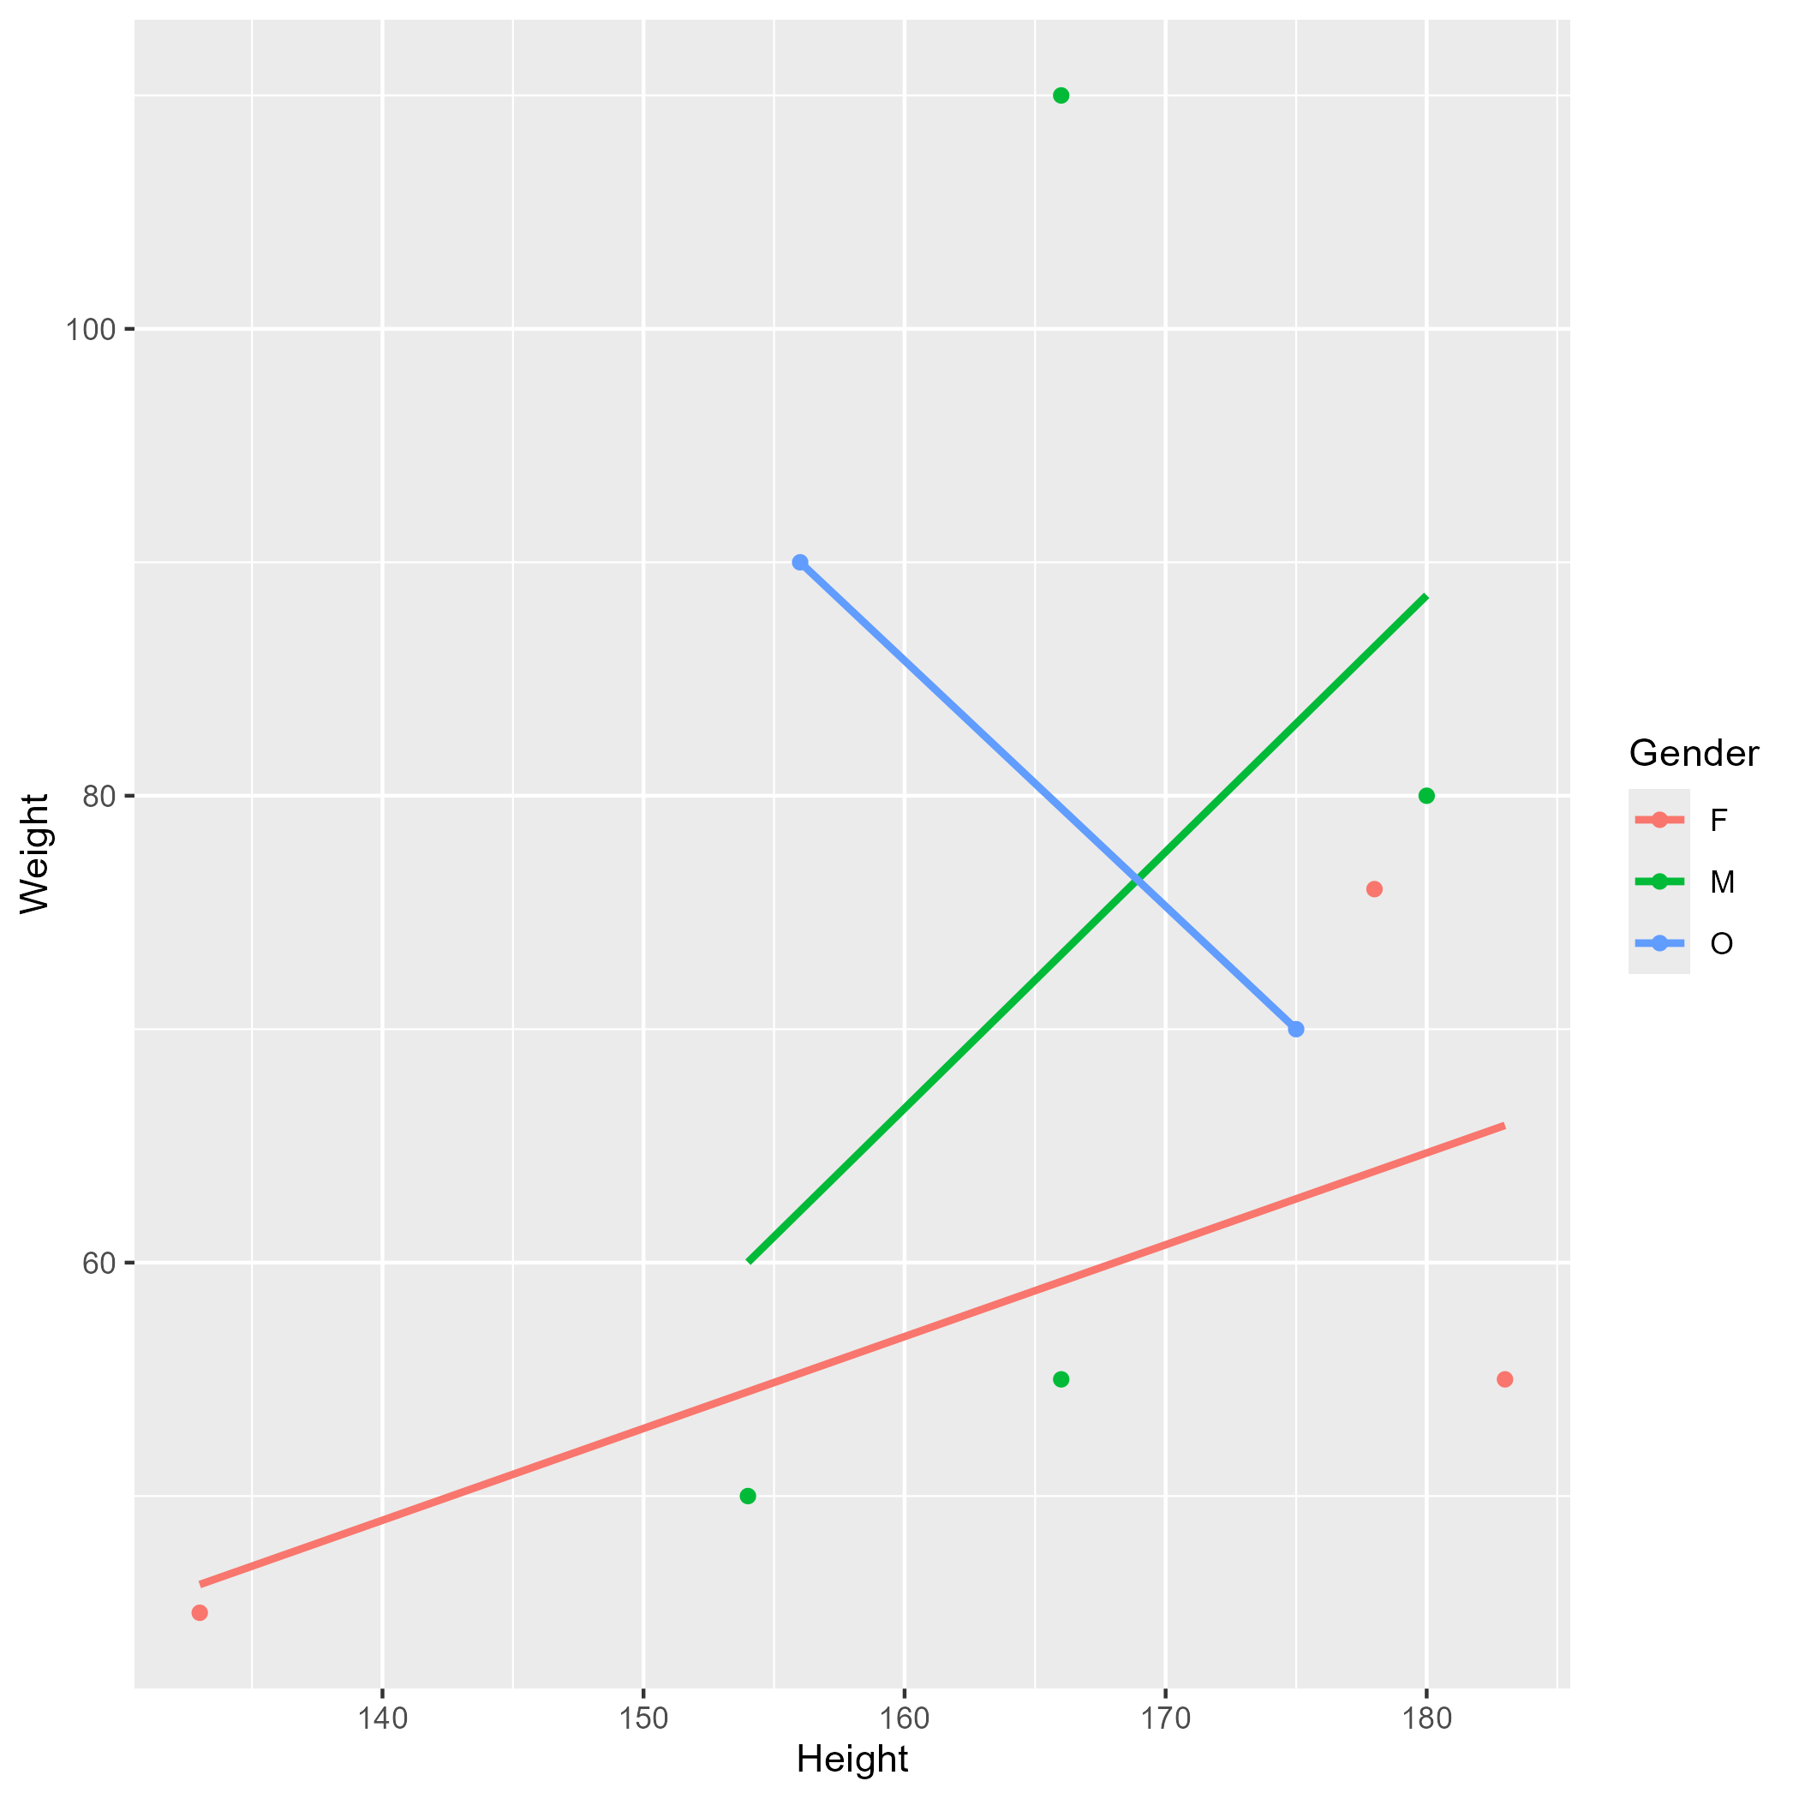
Figure 2: Height and weight stratified by gender.

4.3 Full analysis
Use one or several suitable statistical/machine learning methods to analyze your data and to produce meaningful figures, tables, etc. This might again be code that is best placed in one or several separate scripts that need to be well documented. You want the code to produce figures and data ready for display as tables, and save those. Then you load them here.
Example Table 2 shows a summary of a linear model fit.
Table 2: Linear model fit table.
term | estimate | std.error | statistic | p.value
(Intercept) | 149.2726967 | 23.3823360 | 6.3839942 | 0.0013962
Weight | 0.2623972 | 0.3512436 | 0.7470519 | 0.4886517
GenderM | -2.1244913 | 15.5488953 | -0.1366329 | 0.8966520
GenderO | -4.7644739 | 19.0114155 | -0.2506112 | 0.8120871

5. Discussion

5.1 Summary and Interpretation
Summarize what you did, what you found and what it means.

5.2 Strengths and Limitations
Discuss what you perceive as strengths and limitations of your analysis.

5.3 Conclusions
What are the main take-home messages?
Include citations in your Qmd file using BibTeX, the list of references will automatically be placed at the end
This paper (3) discusses types of analyses.
These papers (1,2) are good examples of papers published using a fully reproducible setup similar to the one shown in this template.
Note that this cited reference will show up at the end of the document, the reference formatting is determined by the CSL file specified in the YAML header. Many more style files for almost any journal are available. You also specify the location of your BibTeX reference file in the YAML. You can call your reference file anything you like.

6. Software and Session Information
The chunk below is optional. It records the R version, platform, and loaded package versions used when the manuscript was rendered. This is a lightweight way to help users understand the computing environment without requiring a full environment manager.
R version 4.6.0 (2026-04-24 ucrt)
Platform: x86_64-w64-mingw32/x64
Running under: Windows 11 x64 (build 26200)
Matrix products: default
LAPACK version 3.12.1
locale:
[1] LC_COLLATE=English_United States.utf8
[2] LC_CTYPE=English_United States.utf8
[3] LC_MONETARY=English_United States.utf8
[4] LC_NUMERIC=C
[5] LC_TIME=English_United States.utf8
time zone: America/New_York
tzcode source: internal
attached base packages:
[1] stats graphics grDevices utils datasets methods base
other attached packages:
[1] knitr_1.51 here_1.0.2
loaded via a namespace (and not attached):
[1] compiler_4.6.0 fastmap_1.2.0 rprojroot_2.1.1 cli_3.6.6
[5] tools_4.6.0 htmltools_0.5.9 otel_0.2.0 yaml_2.3.12
[9] rmarkdown_2.31 jsonlite_2.0.0 xfun_0.58 digest_0.6.39
[13] rlang_1.2.0 evaluate_1.0.5

7. References
1. McKay B, Ebell M, Billings WZ, et al. Associations Between Relative Viral Load at Diagnosis and Influenza A Symptoms and Recovery. Open forum infectious diseases. 2020;7(11):ofaa494.
2. McKay B, Ebell M, Dale AP, et al. Virulence-mediated infectiousness and activity trade-offs and their impact on transmission potential of influenza patients. Proceedings. Biological sciences. 2020;287(1927):20200496.
3. Leek JT, Peng RD. Statistics. What is the question? Science (New York, N.Y.). 2015;347(6228):1314–1315.

