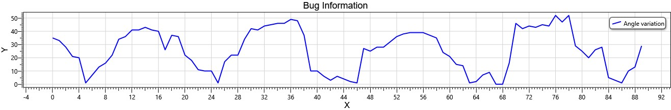

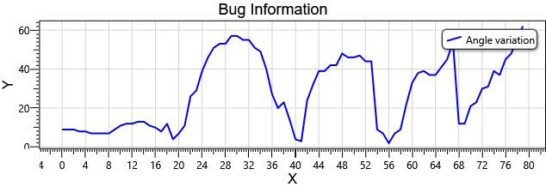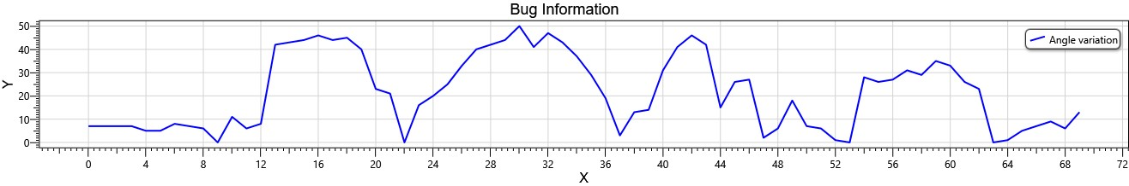

**ARYA**

**DEEPTANU**

**ANUJ**