

|  |
| --- |
| Governing AI for Humanity |
|  |

Dear Members of the UN Advisory Board,

The report unfortunately does not address the significant environmental impacts of HPC. As we strive to achieve the developmental goals set for 2030, it is imperative that HPC's environmental footprint be thoroughly examined.

Our model employs a G1-Entropy-Independence Weight Integrated Evaluation Method to assess the environmental impact of High Performance Computing (HPC). Our model evaluates environmental pollution by analyzing the impacts of thermal pollution on aquatic life, rare earth mining damage, and electronic waste from HPC centers, while introducing the WUE-Cli Cooling Water Efficiency Model to enhance water usage efficiency assessments with local climate data.

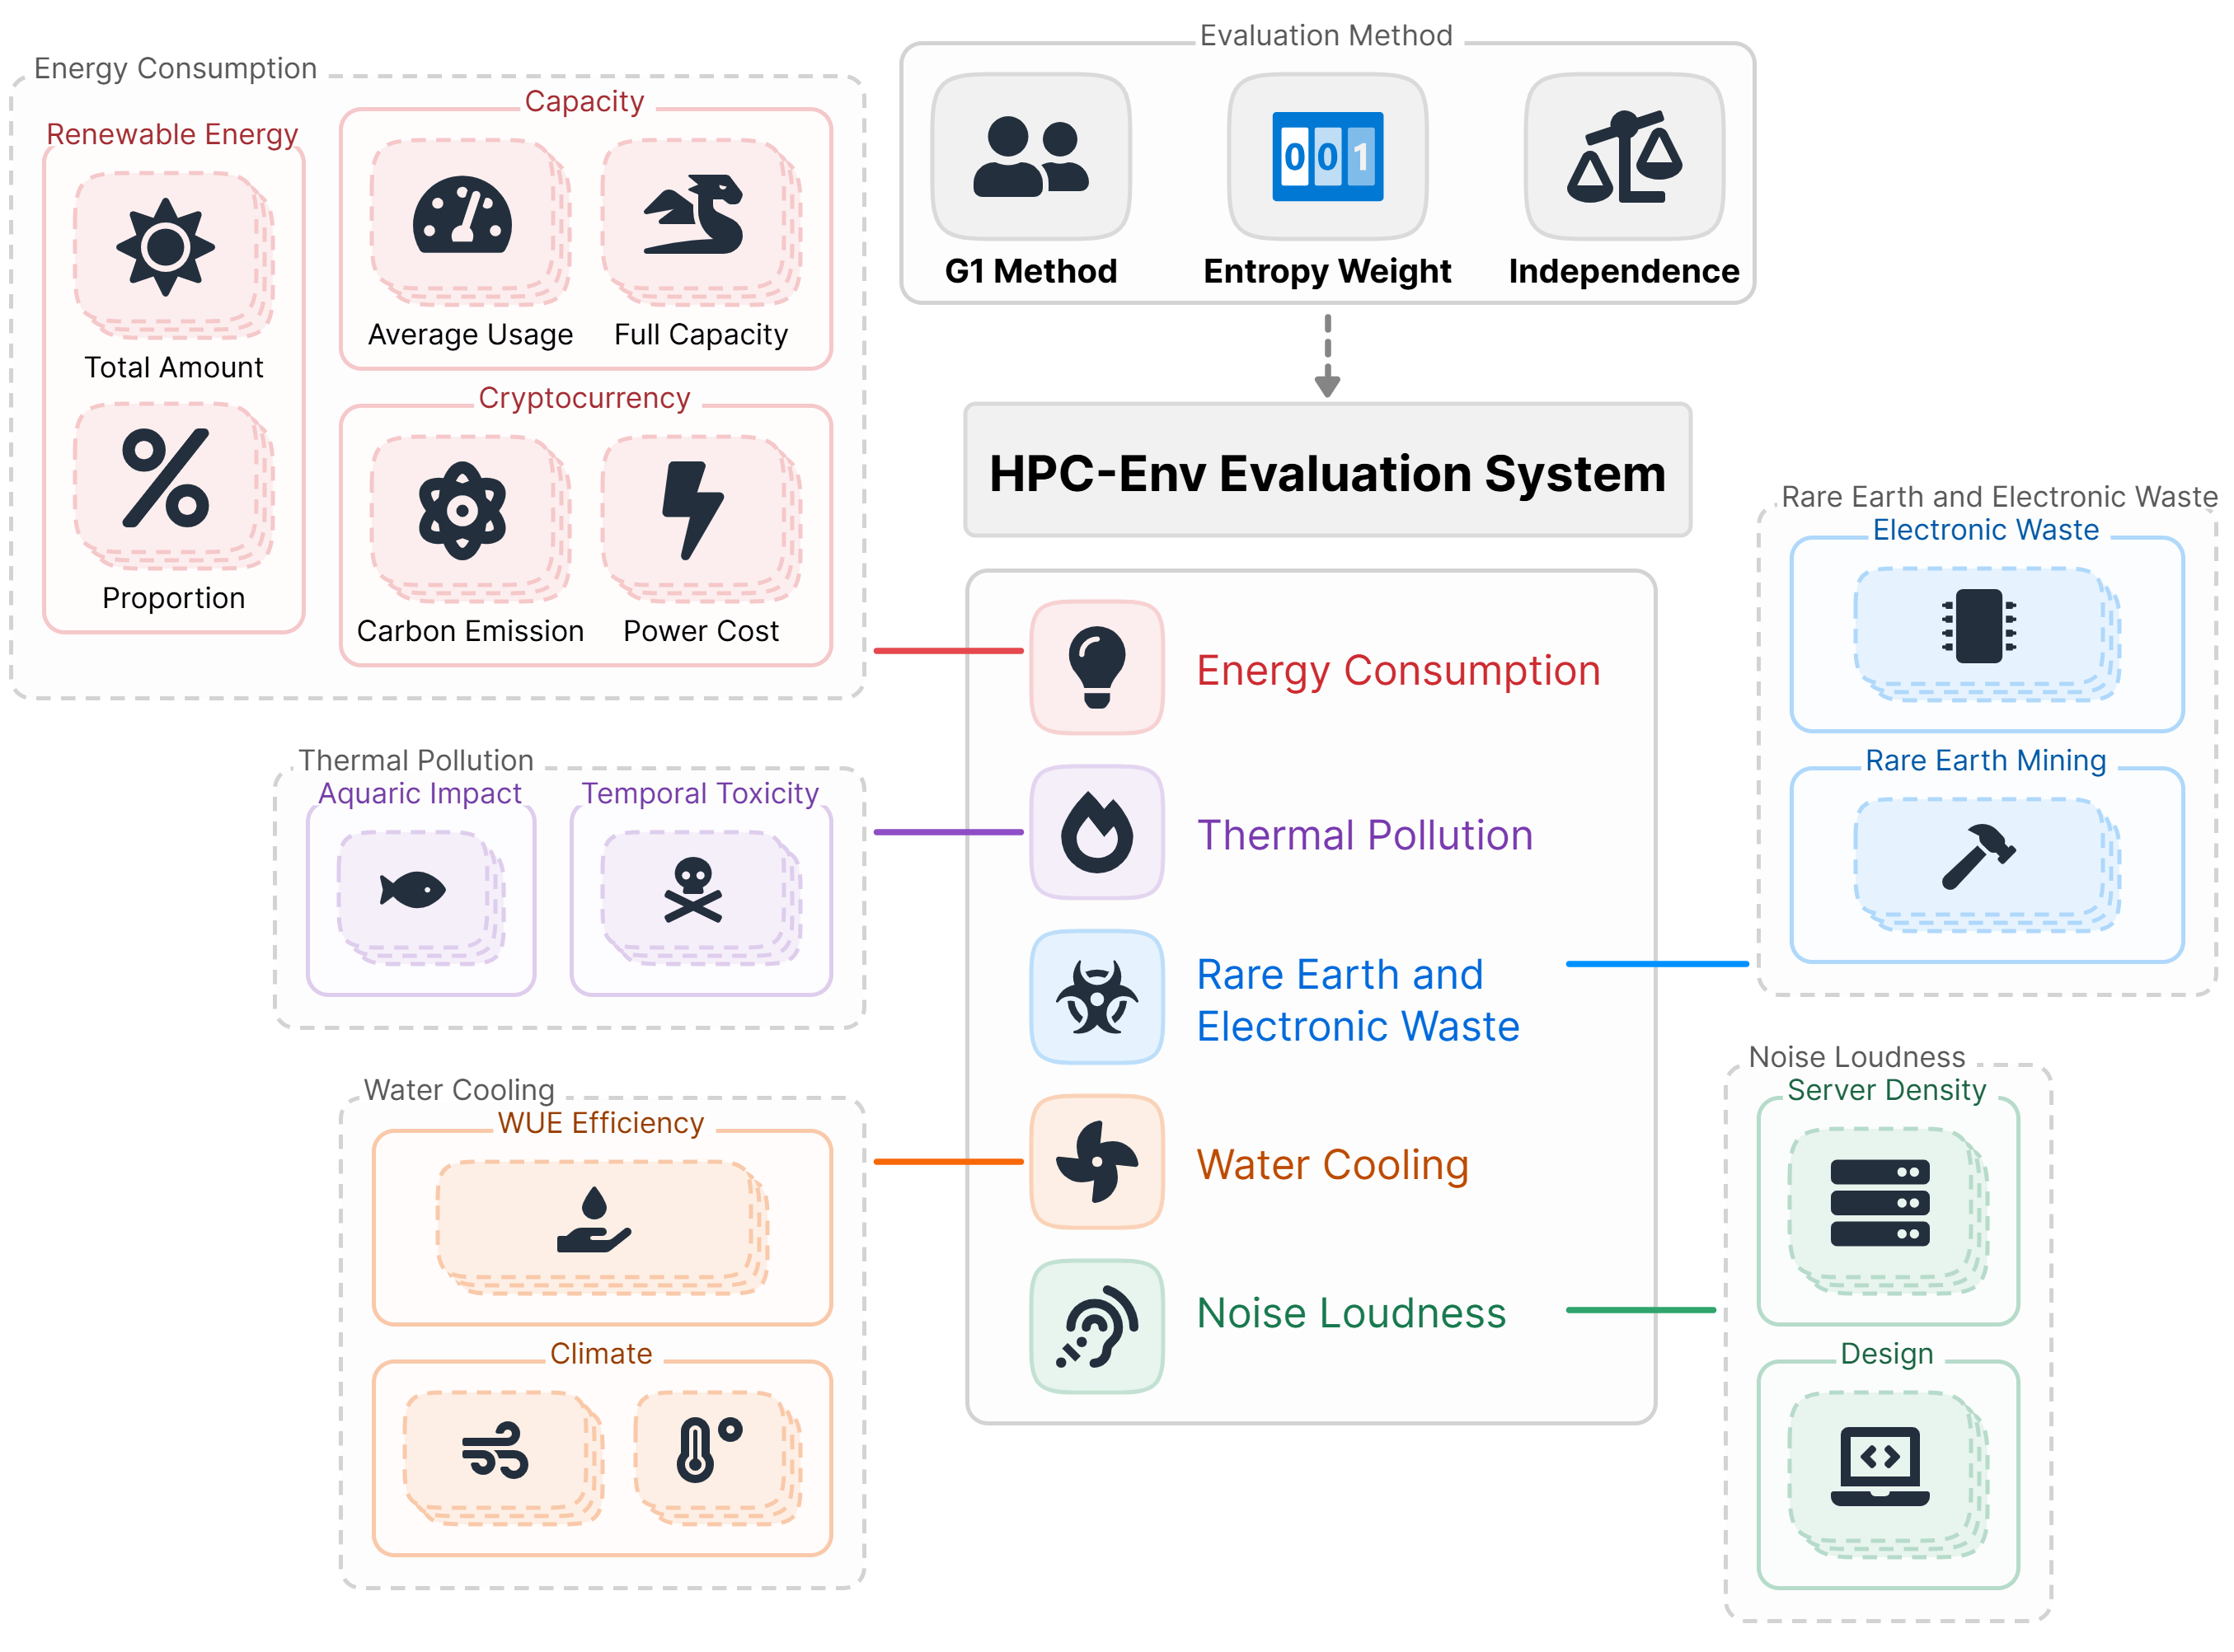

If we gradually increase the proportion of renewable energy used, carbon emissions will decrease!

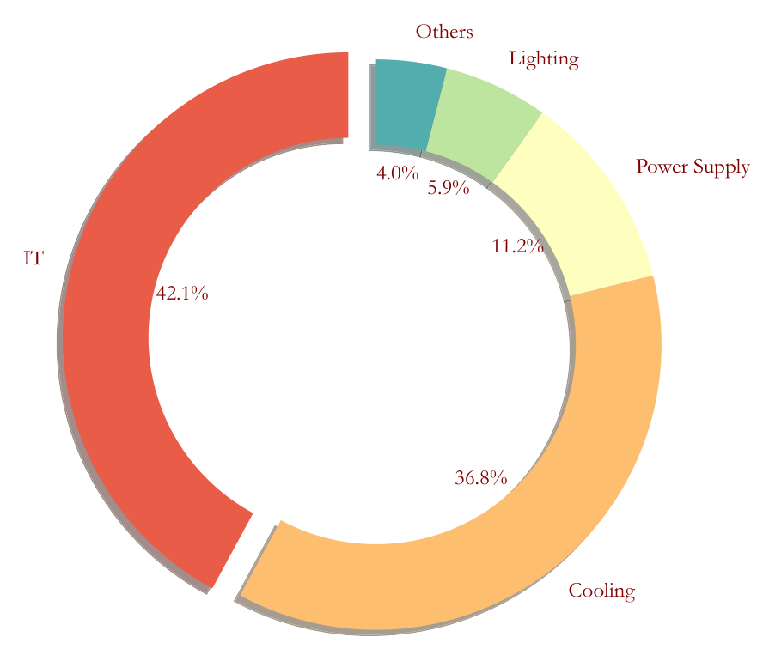The HPC have significantly increased energy consumption and total carbon emissions. We propose the following three recommendations:

Distributed Design and Relocation

HPC equipment generates substantial heat, requiring extensive cooling systems. By relocating these devices to regions with lower temperatures and abundant hydropower resources, we can effectively address cooling challenges and reduce energy costs.

Research and Green Development

Technological advancements can significantly reduce the environmental impact of HPC. Investing in R&D for green HPC infrastructure will lead to more efficient and sustainable computing solutions.

Energy Monitoring and Regulation

Effective monitoring and regulation of energy consumption are essential for optimizing resource usage and reducing waste. Real-time data collection and analysis can provide valuable insights into energy usage patterns and help identify areas for improvement.

I hope this translation meets your needs and effectively communicates the importance of addressing the environmental impacts of HPC. If you need any further adjustments, please let me know!