|  |
| --- |
| Photo & Art Print Simple map of Baltimore, Maryland, Knut Hebstreit  Robust Baltimore |
| Dear Mayor of Baltimore, |

Our team is greatly honored to present to you an innovative transport network model designed specifically for Baltimore. This model aims to offer a scientific and data-driven traffic governance solution. Below is an overview of our model and specific implementation suggestions.

Traditional models mostly rely on network topological structures and struggle to reflect real travel demands. Our model achieves precise analysis through the following breakthroughs:

Dynamic Weighting of Node Importance

📌Replace the node degree value with a composite index of the weighted degree (traffic flow intensity) and the node's own weight (net passenger flow).

📌Calculate the actual road travel time for edge weights using the BPR function, which reflects the congestion differences between morning and evening rush hours.

Balancing Mechanism for Stakeholders

📌Introduce the GDP contribution weights of various groups to ensure the balanced demands of different functional nodes such as commercial and industrial areas, residential areas, and logistics hubs.

Projects

🚩Precise Expansion of the Bus Network

We analyzed all the bus stops in the city using the KP clustering algorithm. By comprehensively considering indicators such as passenger flow,

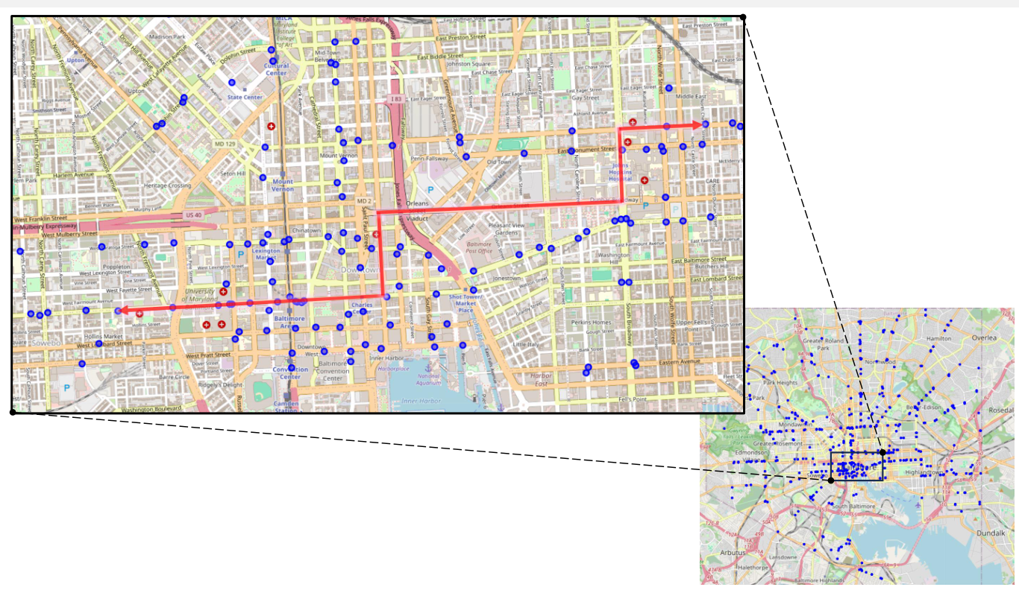

the number of bus routes, and the importance of nodes around the routes, we identified a bus route. This route passes by hospitals, schools, etc. Adding this bus route will greatly facilitate the travel of the surrounding residents.

🚩Index-based Control of Road Congestion

We constructed a traffic congestion propagation model based on the LWR fluid dynamics model and discovered the law that "traffic congestion grows exponentially in the early stage and slowly in the later stage".

⚠️In the early congestion stage, adjust signal light cycles at major intersections and quickly add traffic police.

🔔In the mid - late congestion stages, keep adjusting signal light cycles and gradually increase the number of traffic police.

🌟After congestion ends, return signal light cycles and the number of traffic police to normal.

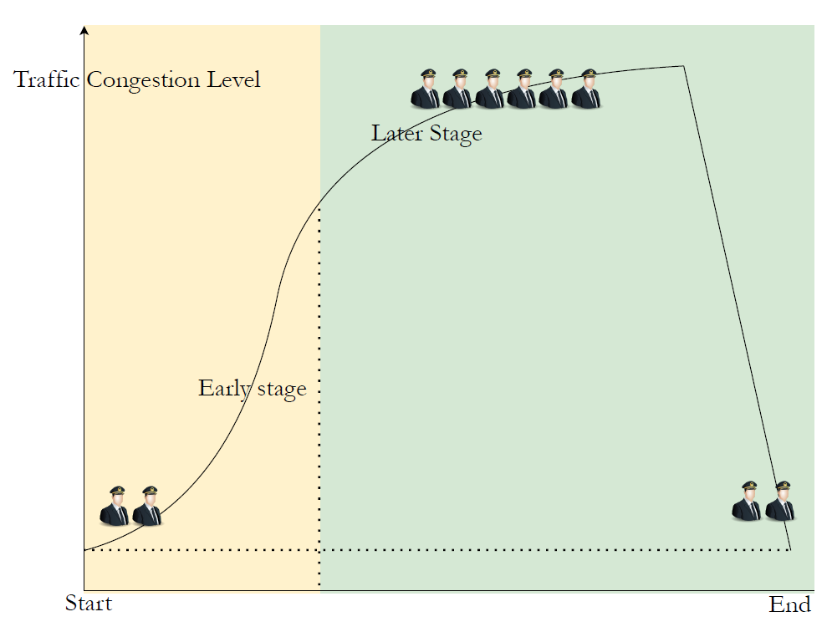

We believe that by implementing the above - mentioned projects, we can not only significantly improve the traffic conditions in Baltimore but also further enhance the quality of life of the citizens. We look forward to having in - depth discussions with your team about these proposals and jointly advancing Baltimore towards a smarter and more efficient future.

Best regards,

Team #2500387