

面向对象程序设计

2022/2023(2)



实验二 字符串学习和类与对象初步

学生姓名 陈王子
学生学号 202103150503
学生班级 大数据分析 1 班
任课教师 毛国红
提交日期 2023年4月5日
理学院

实验报告
第一题代码：拷贝字符串 n 个字符
#include <iostream>
#include <cstring>
using namespace std;

bool mystrncpy(char* to, char* from, unsigned startpos, unsigned len) {
if (startpos >= strlen(from)) {
cerr << "pos error" << endl;//位置错误
return false;
}
if (len <= 0) {
cerr << "len error" << endl;//长度错误
return false;
}
if (startpos + len > strlen(from)) {
cerr << "out of range error" << endl;//过界错误
return false;
}
//拷贝函数
for (unsigned i = startpos; i < startpos + len; i++) {
to[i - startpos] = from[i];
}
to[len] = '\0';
return true;
}

int main()
{
char from[] = "abcdefghijklmn";
char* to=new char;

if (mystrncpy(to, from, 0, 0)) {
cout << "copied string:" << to << "\n" << endl;
}
else {
cout << "copy failed\n" << endl;
}

if (mystrncpy(to, from, 3, 4)) {
cout << "copied string:" << to <<"\n" << endl;
}
else {
cout << "copy failed\n" << endl;
}

if (mystrncpy(to, from, 3, 20)) {
cout << "copied string:" << to << "\n" << endl;
}
else {
cout << "copy failed\n" << endl;
}
}

第一题测试
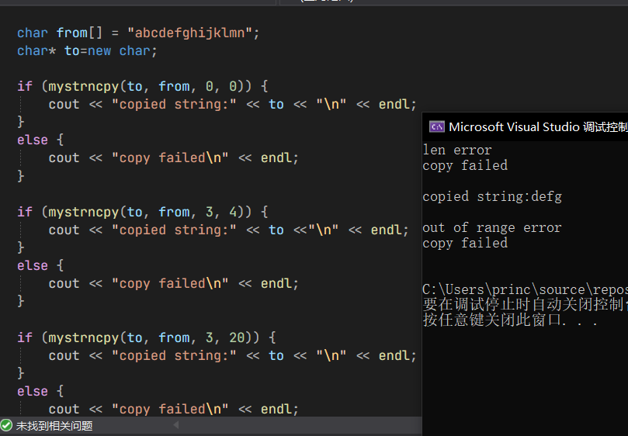

第二题代码：统计字符个数和单词数附加处理文章
#include <iostream>
#include <string>
#include <fstream>

using namespace std;

void count_chars(const string& s, int& upper, int& lower, int& digit, int& space, int& other, int& words) {
upper = lower = digit = space = other = words = 0;
bool in_word = false;
for (char c : s) {
if (isupper(c)) {
upper++;
}
else if (islower(c)) {
lower++;
}
else if (isdigit(c)) {
digit++;
}
else if (isspace(c)) {
space++;
in_word = false;
}
else {
other++;
}

if (isspace(c)) {
continue;
}

if (!in_word) {
words++;
in_word = true;
}
}
}

string readFilesToString(string text,const string& file)
{
ifstream infile1(file);
if (infile1) {
string line;
while (getline(infile1, line)) {
text += line + " ";
}
}
else {
cerr << "Failed to open file " << file << endl;
return "";
}
return text;
}

int main() {
string article;
/*
单行读入版本
cout << "Enter an article: "<<endl;
getline(cin, article);
*/

//多文件读入版本
article = readFilesToString(article, "C:\\Users\\princ\\source\\repos\\0318\\Debug\\file1.txt");
article = readFilesToString(article, "C:\\Users\\princ\\source\\repos\\0318\\Debug\\file2.txt");
article = readFilesToString(article, "C:\\Users\\princ\\source\\repos\\0318\\Debug\\file3.txt");

cout << "\nString:\n" <<article<< endl;

int upper, lower, digit, space, other, words;
count_chars(article, upper, lower, digit, space, other, words);

cout << "Uppercase letters: " << upper << endl;
cout << "Lowercase letters: " << lower << endl;
cout << "Digits: " << digit << endl;
cout << "Spaces: " << space << endl;
cout << "Other characters: " << other << endl;
cout << "Words: " << words << endl;
}

第二题测试（附加读入文本和处理多篇文章）
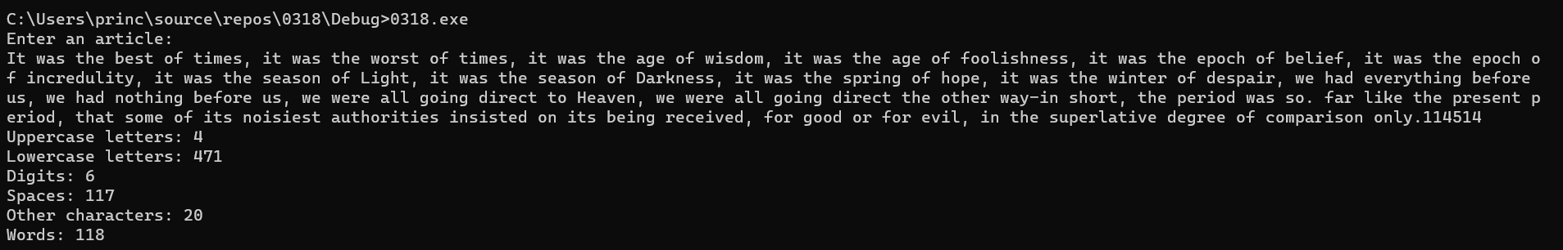
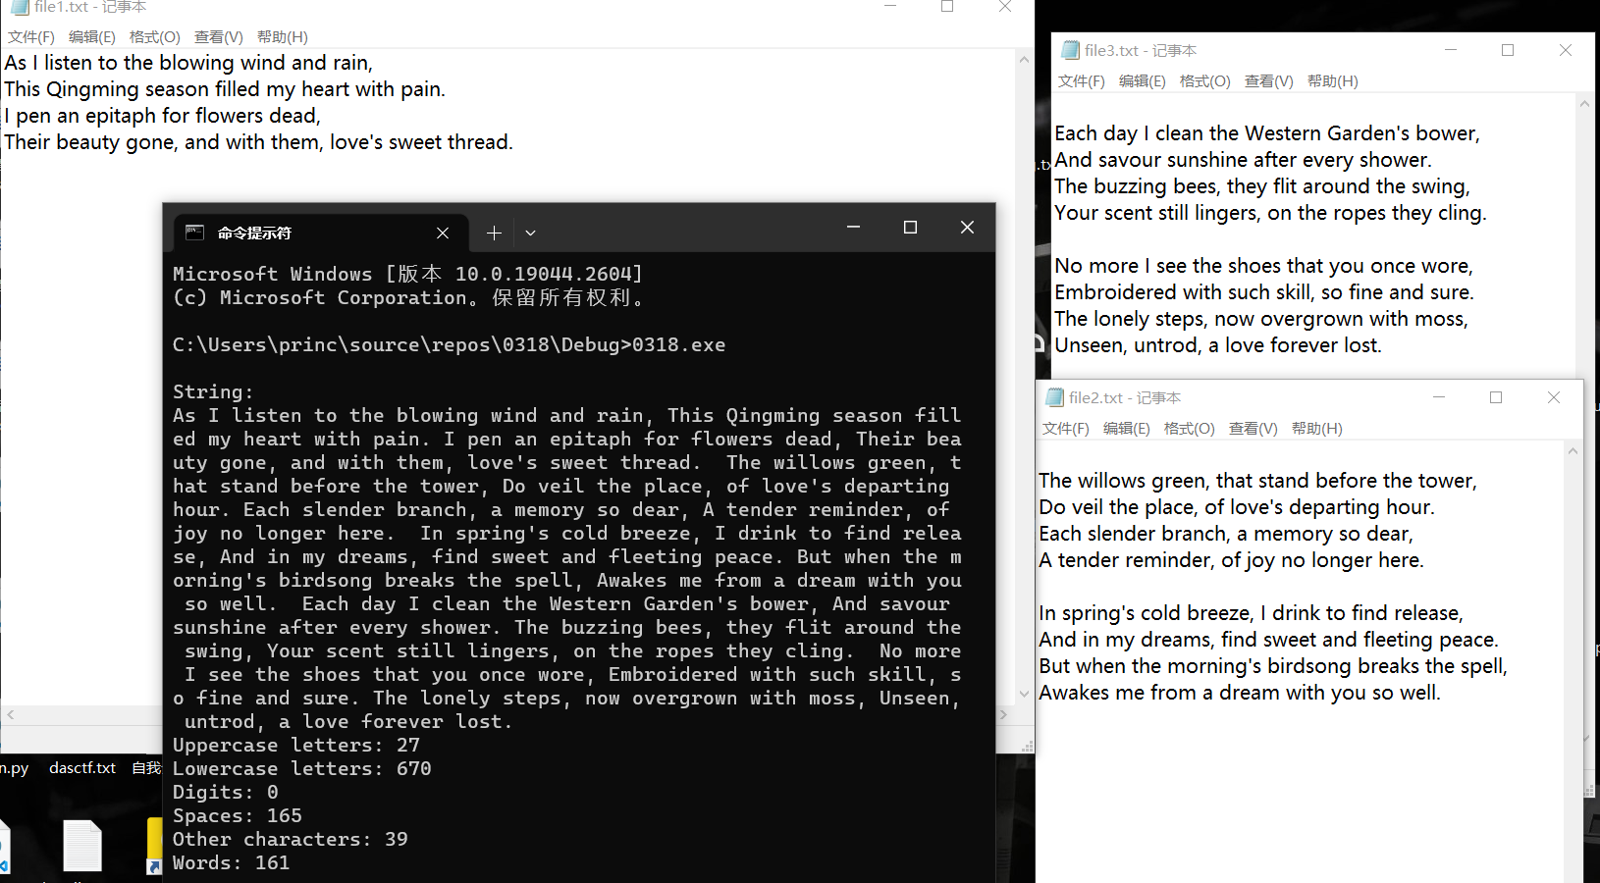

第三题大整数算术（以及随机数附加题）
#include <iostream>
#include <string>
#include <algorithm>
#include <ctime>
#include <cstdlib>
#include <random>
using namespace std;

// 加法运算
string add(string num1, string num2) {
int len1 = num1.size(), len2 = num2.size();
int carry = 0, sum;
string res;
while (len1 || len2) {
int x = len1 ? num1[--len1] - '0' : 0;
int y = len2 ? num2[--len2] - '0' : 0;
sum = x + y + carry;
carry = sum / 10;
res += (sum % 10) + '0';
}
if (carry) res += carry + '0';
reverse(res.begin(), res.end());
return res;
}

// 减法运算
string sub(string num1, string num2) {
int len1 = num1.size(), len2 = num2.size();
int borrow = 0, diff;
string res;
while (len1 || len2) {
int x = len1 ? num1[--len1] - '0' : 0;
int y = len2 ? num2[--len2] - '0' : 0;
diff = x - y - borrow;
if (diff < 0) {
diff += 10;
borrow = 1;
}
else {
borrow = 0;
}
res += diff + '0';
}
reverse(res.begin(), res.end());
while (res.size() > 1 && res[0] == '0') res.erase(0, 1);
return res;
}

// 乘法运算
string mul(string num1, string num2) {
int len1 = num1.size(), len2 = num2.size();
string res(len1 + len2, '0');
for (int i = len1 - 1; i >= 0; i--) {
int carry = 0;
for (int j = len2 - 1; j >= 0; j--) {
int tmp = (num1[i] - '0') * (num2[j] - '0') + carry + (res[i + j + 1] - '0');
res[i + j + 1] = tmp % 10 + '0';
carry = tmp / 10;
}
res[i] += carry;
}
while (res.size() > 1 && res[0] == '0') res.erase(0, 1);
return res;
}

// 处理输入的字符串，得到两个数和运算符
void parseInput(string input, string& num1, string& num2, char& op) {
int pos = input.find(',');
num1 = input.substr(0, pos);
input = input.substr(pos + 1);
pos = input.find(',');
num2 = input.substr(0, pos);
op = input[pos + 1];
}

// 生成一个指定位数的随机大数
// 生成指定位数的随机大数
string genRandNum(int numDigits) {
random_device rd;
mt19937 gen(rd());
uniform_int_distribution<> dis(0, 9);
string randNum;
randNum.reserve(numDigits);
for (int i = 0; i < numDigits; i++) {
randNum += std::to_string(dis(gen));
}
return randNum;
}

// 检查输入是否合法
bool isValidInput(const string& input) {
// 检查输入长度
if (input.size() < 3) {
return false;
}
// 检查逗号个数
int commaCount = count(input.begin(), input.end(), ',');
if (commaCount != 2) {
return false;
}
// 检查运算符合法性
char op = input[input.size() - 1];
if (op != '+' && op != '-' && op != '*') {
return false;
}
// 检查数字合法性
for (int i = 0; i < input.size() - 2; i++) {
if (!isdigit(input[i]) && input[i] != ',') {
return false;
}
}
return true;
}

int main() {
srand(time(NULL)); // 随机数种子

while (cout << "\nPlease enter your equation:" << endl) {
string input;
string num1, num2;
char op = { 0 };
getline(cin,input); // 从用户输入中解析出两个操作数和运算符
if (input == "exit") break; // 用户输入exit时退出程序

if (isValidInput(input)) { // 判断输入是否合法
parseInput(input, num1, num2, op); // 将用户输入解析为数字和运算符
if (op == '+') {
string res = add(num1, num2); // 调用加法函数
cout << num1 << " + " << num2 << " = " << res << endl;
}
else if (op == '-') {
string res = sub(num1, num2); // 调用减法函数
cout << num1 << " - " << num2 << " = " << res << endl;
}
else if (op == '*') {
string res = mul(num1, num2); // 调用乘法函数
cout << num1 << " * " << num2 << " = " << res << endl;
}
}
else {
cout << "Invalid input. Please try again." << endl;
}
}

// 生成随机大数并计算
int digits = 1000;
string num1 = genRandNum(digits);
string num2 = genRandNum(digits);
string res = add(num1, num2); // 计算num1 * num2
cout << "Random number digits:"<< digits <<"\nResult: \n" << num1 << "\n + \n" << num2 << "\n = \n" << res << endl;
}

第三题测试（上百位整数和简单计算）
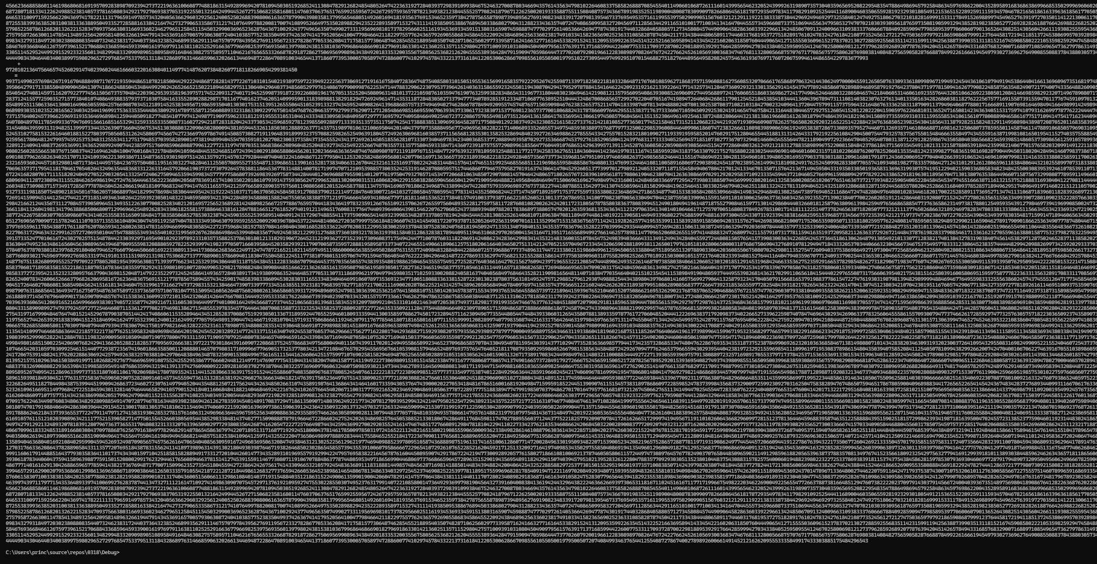
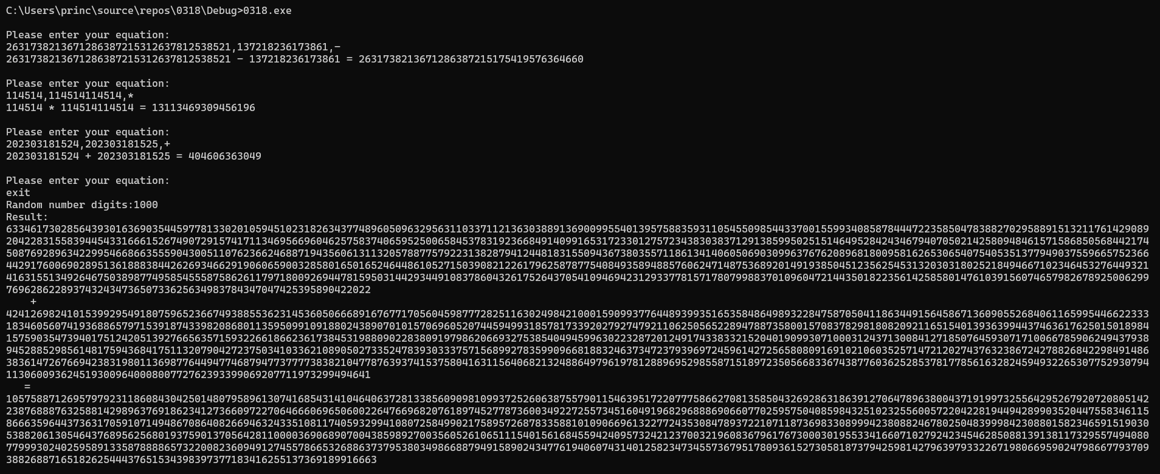
第三题思考题：
- 基本存储类型的选择：选择了 string，因为内置函数比较多，方便进行选择切片等处理。
- 理论极限：处理数字的范围应该是0到无穷大（由用户内存决定）

第四题：游泳池和停车场
- 游泳池
//pool.hpp
#include <iostream>
using namespace std;
class pool {
public:
void build();
double rail_length();
double rail_area();
private:
double radius;
double c;
};
//pool.cpp
#define pi 3.14
//#include "pool.hpp"
void pool::build()
{
cin >> radius >> c;
}
double pool::rail_area()
{
return pi * ((radius + c) * (radius + c)- radius * radius);
}
double pool::rail_length()
{
return 2 * pi * radius;
}
//pooltest.cpp
int main()
{
const double zddj = 167.5;//走道单价
const double wldj = 36.4;//围栏单价
double r;//池直径
double c;//走道宽
pool apool;
for (int I = 1; I <= 5; I++)
{
cout << "建造第"<< I << "号泳池:";
apool.build();
cout << "第"<< I << "号泳池造价为"
<< (apool.rail_length() * wldj + apool.rail_area() * zddj) << "元" << endl;
}
}

- 停车场
#include <iostream>
using namespace std;

//clock.hpp
class Clock {
public:
void show_time();
void set_time();
double diff(Clock& T);
private:
long normalize();
int hour;
int minute;
int second;
};
//clock.cpp
void Clock::show_time()
{
cout << hour << ":" << minute << ":"
<< second;
cout << endl;
}

void Clock::set_time()
{
do {
cin >> hour >> minute >> second;
} while (hour < 0 || hour>24 ||
minute < 0 || minute>59 ||
second < 0 || second>59);
}

double Clock::diff(Clock& T)
{
long d = this->normalize() - T.normalize();
if (d < 0) return 0;
int h = d / 60, m = d % 60;
if (m < 15) return h;
if (m >= 15 && m < 30) return h + 0.5;
if (m >= 30 && m < 60) return h + 1;
}

long Clock::normalize()
{
return (this->hour * 60 + this->minute);
}

//parkingcost.cpp
double parkingFee(double parkingHour) {
int parkingFeePerHour = 4;
if (parkingHour <= 1) return 0;
else if (parkingHour > 1.25 && parkingHour <= 1.5) return 0.5 * parkingFeePerHour;
else if (parkingHour > 1.5 && parkingHour <= 2) return parkingFeePerHour;
else if (parkingHour > 2) return (parkingHour) * parkingFeePerHour;
}

int main()
{
while (1) {
Clock arriveTime, leaveTime;
double parkingTime, Fee;
arriveTime.set_time();
arriveTime.show_time();
leaveTime.set_time();
leaveTime.show_time();
parkingTime = leaveTime.diff(arriveTime);
Fee = parkingFee(parkingTime);
cout << "收费：" << Fee << endl;
}
}

第四题测试：
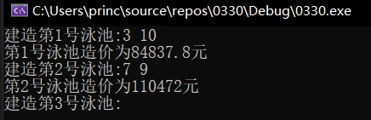
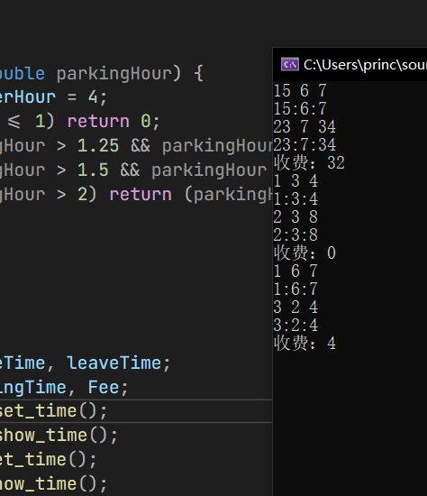

第五题：停车场改造 Date 类和 DateTime 类
- DateTime类

class DateTime {
public:
void show_time();
void set_time();
int days_in_month(int month, int year);
bool is_leap_year(int year);
double diff(DateTime& T);
private:
long normalize();
int year;
int month;
int day;
int hour;
int minute;
int second;
};

void DateTime::show_time() {
cout << year << "-" << month << "-" << day << " " << hour << ":" << minute << ":" << second << endl;
}

void DateTime::set_time() {
cout << "Enter year: ";
cin >> year;
cout << "Enter month: ";
cin >> month;
cout << "Enter day: ";
cin >> day;
cout << "Enter hour: ";
cin >> hour;
cout << "Enter minute: ";
cin >> minute;
cout << "Enter second: ";
cin >> second;
}

double DateTime::diff(DateTime& T) {
long seconds1 = normalize();
long seconds2 = T.normalize();
return (double)abs((seconds2 - seconds1) / (24 * 3600));
}

long DateTime::normalize() {
// 计算从公元0年0月0日起至当前日期的天数
long days = 0;
for (int i = 0; i < year; i++) {
days += is_leap_year(i) ? 366 : 365;
}
for (int i = 1; i < month; i++) {
days += days_in_month(i, year);
}
days += day - 1;

// 计算总秒数
long seconds = days * 24 * 3600;
seconds += hour * 3600;
seconds += minute * 60;
seconds += second;
return seconds;
}

int DateTime::days_in_month(int month, int year) {
if (month == 2) {
if (is_leap_year(year)) {
return 29;
}
else {
return 28;
}
}
else if (month == 4 || month == 6 || month == 9 || month == 11) {
return 30;
}
else {
return 31;
}
}

bool DateTime::is_leap_year(int year) {
if (year % 4 == 0 && year % 100 != 0 || year % 400 == 0) {
return true;
}
else {
return false;
}
}

//parkingcost.cpp
double parkingFee(double parkingHour) {
int parkingFeePerHour = 4;
int parkingFeePerDay = 30;
double parkingFee = 0;

if (parkingHour <= 1) {
parkingFee = 0;
}
else if (parkingHour > 1.25 && parkingHour <= 1.5) {
parkingFee = 0.5 * parkingFeePerHour;
}
else if (parkingHour > 1.5 && parkingHour <= 2) {
parkingFee = parkingFeePerHour;
}
else if (parkingHour > 2 && parkingHour <= 24) {
parkingFee = parkingHour * parkingFeePerHour;
}
else if (parkingHour <= 720) { // 超过1个月，按30元/天计费，打9折
parkingFee = (int)parkingHour / 24 * parkingFeePerDay * 0.9;
if ((int)parkingHour % 24 > 2) {
parkingFee += parkingFeePerDay * 0.9;
}
else if ((int)parkingHour % 24 > 0) {
parkingFee += parkingFeePerDay * 0.5;
}
}
else if (parkingHour <= 8760) { // 超过1年，按30元/天计费，打8折
parkingFee = (int)parkingHour / 24 * parkingFeePerDay * 0.8;
if ((int)parkingHour % 24 > 2) {
parkingFee += parkingFeePerDay * 0.8;
}
else if ((int)parkingHour % 24 > 0) {
parkingFee += parkingFeePerDay * 0.5;
}
}
else { // 超过1年按30元/天计费，打8折
parkingFee = (int)(parkingHour / 24 / 365 * parkingFeePerDay * 365 * 0.8);
int days = (int)parkingHour / 24 % 365;
if (days > 30) {
parkingFee += parkingFeePerDay * 0.8 * 30;
}
else {
parkingFee += parkingFeePerDay * 0.8 * days;
}
}

return parkingFee;
}

- Date 类
#include <iostream>
using namespace std;

class Date {
public:
void show_date();
void set_date();
int days_in_month();
void add_day();
double diff(Date& T);
private:
int year;
int month;
int day;
};

class Clock {
public:
void show_time();
void set_time();
double diff(Clock& T);
private:
long normalize();
int hour;
int minute;
int second;
};

void Date::show_date() {
cout << year << "-" << month << "-" << day << endl;
}

void Date::set_date() {
cout << "Enter year: ";
cin >> year;
cout << "Enter month: ";
cin >> month;
cout << "Enter day: ";
cin >> day;
}

int Date::days_in_month() {
if (month == 2) {
if ((year % 4 == 0 && year % 100 != 0) || year % 400 == 0) {
return 29;
}
else {
return 28;
}
}
else if (month == 4 || month == 6 || month == 9 || month == 11) {
return 30;
}
else {
return 31;
}
}

void Date::add_day() {
day++;
if (day > days_in_month()) {
day = 1;
month++;
if (month > 12) {
month = 1;
year++;
}
}
}

double Date::diff(Date& T) {
int days1 = 0;
for (int i = 1; i < month; i++) {
Date d = { year, i, 1 };
days1 += d.days_in_month();
}
days1 += day - 1;
int days2 = 0;
for (int i = 1; i < T.month; i++) {
Date d = { T.year, i, 1 };
days2 += d.days_in_month();
}
days2 += T.day - 1;
int days = 0;
if (year == T.year) {
days = days2 - days1;
}
else {
for (int i = year; i < T.year; i++) {
Date d = { i, 1, 1 };
days += d.days_in_month();
}
days -= days1;
days += days2;
}
return (double)days;
}

void Clock::show_time() {
cout << hour << ":" << minute << ":" << second << endl;
}

void Clock::set_time() {
cout << "Enter hour: ";
cin >> hour;
cout << "Enter minute: ";
cin >> minute;
cout << "Enter second: ";
cin >> second;
}

double Clock::diff(Clock& T) {
long seconds1 = normalize();
long seconds2 = T.normalize();
return (double)(seconds2 - seconds1) / (24 * 3600);
}

long Clock::normalize() {
long seconds = hour * 3600;
seconds += minute * 60;
seconds += second;
return seconds;
}

double parkingFee(Date& d1, Clock& t1, Date& d2, Clock& t2) {
int parkingFeePerHour = 4;
int parkingFeePerDay = 30;
double parkingFee = 0;

double parkingTime = d1.diff(d2) + t1.diff(t2) / 3600.0;

if (parkingTime <= 1) {
parkingFee = 0;
}
else if (parkingTime <= 1.25) {
parkingFee = 0.5 * parkingFeePerHour;
}
else if (parkingTime <= 2) {
parkingFee = parkingFeePerHour;
}
else if (parkingTime <= 24) {
parkingFee = parkingTime * parkingFeePerHour;
}
else if (parkingTime <= 720) { // 超过1个月，按30元/天计费，打9折
parkingFee = d1.diff(d2) * parkingFeePerDay * 0.9;
d1.add_day();
while (d1.diff(d2) > 0) {
parkingFee += parkingFeePerDay * 0.9;
d1.add_day();
}
if (t2.diff(t1) / 3600.0 > 2) {
parkingFee += parkingFeePerDay * 0.9;
}
else if (t2.diff(t1) / 3600.0 > 0) {
parkingFee += parkingFeePerDay * 0.5;
}
}
else if (parkingTime <= 8760) { // 超过1年，按30元/天计费，打8折
parkingFee = d1.diff(d2) * parkingFeePerDay * 0.8;
d1.add_day();
while (d1.diff(d2) > 0) {
parkingFee += parkingFeePerDay * 0.8;
d1.add_day();
}
if (t2.diff(t1) / 3600.0 > 2) {
parkingFee += parkingFeePerDay * 0.8;
}
else if (t2.diff(t1) / 3600.0 > 0) {
parkingFee += parkingFeePerDay * 0.5;
}
}
else { // 超过1年按30元/天计费，打8折
parkingFee = d1.diff(d2) * parkingFeePerDay * 365 * 0.8;
d1.set_date();
while (d1.diff(d2) > 0) {
if (d1.diff(d2) < 30) {
parkingFee += d1.diff(d2) * parkingFeePerDay * 0.8;
break;
}
else {
parkingFee += parkingFeePerDay * 0.8 * 30;
d1.add_day();
}
}
if (t2.diff(t1) / 3600.0 > 2) {
parkingFee += parkingFeePerDay * 0.8;
}
else if (t2.diff(t1) / 3600.0 > 0) {
parkingFee += parkingFeePerDay * 0.5;
}
}

return parkingFee;
}

第五题测试结果：
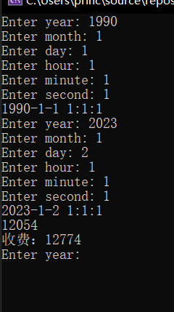
第五题倾向分析：
我更倾向于方案一，即修改 Time 的设计成为 DateTime，并增加年、月、日等数据成员和相应的类内成员函数。原因如下：
- 代码可读性更高：将年、月、日等属性与时间相关的信息放在一个 DateTime 类中，在代码中调用时更加直观明了。
- 代码复用率更高：从程序结构的角度来看，DateTime 类是 Time 类的一种扩展，这样两个类之间的部分代码可以共享，使得代码复用率更高，且能够减少代码的冗余。
- 系统可拓展性更好：如果未来需求再次变更，需要增加支持星期、季节等更多时间相关信息的时候，基于 DateTime 类设计的系统代码更容易进行拓展。
在采用补充的新类 Date 和原来的 Time 类一起工作完成停车收费程序的情况下，方案一的工作量比方案二少，因为方案一只需要在原本的 Time 类的基础上增加一些属性和方法即可，而方案二需要新建一个全新的类，并独立开发所有必要的属性和方法，这就需要额外的工作量和时间成本。同时，如果未来需求进一步变化，现有的 Date 类可能还需要进行重构，这个过程会更加繁琐。因此，综合考虑程序的可读性、复用性和拓展性等多个因素，我更倾向于方案一，即采用 DateTime 类，增加年、月、日等数据成员和相应的类内成员函数。

