Query Practice

Alejandro Hernandez

1. Average room price per neighborhood

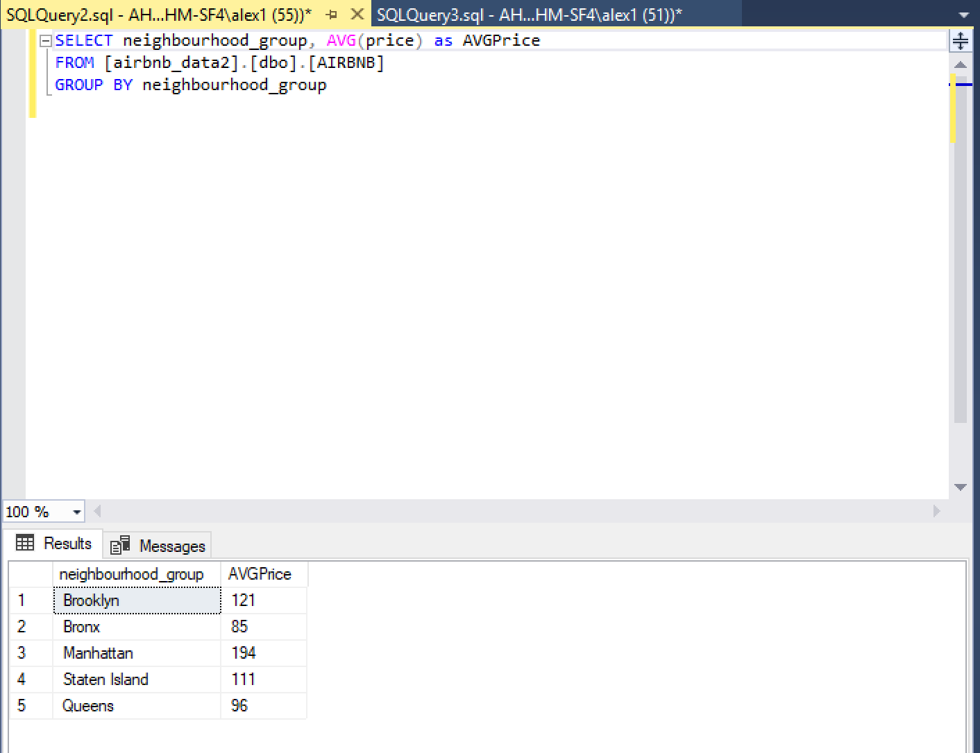

1. Number of listings per neighborhood

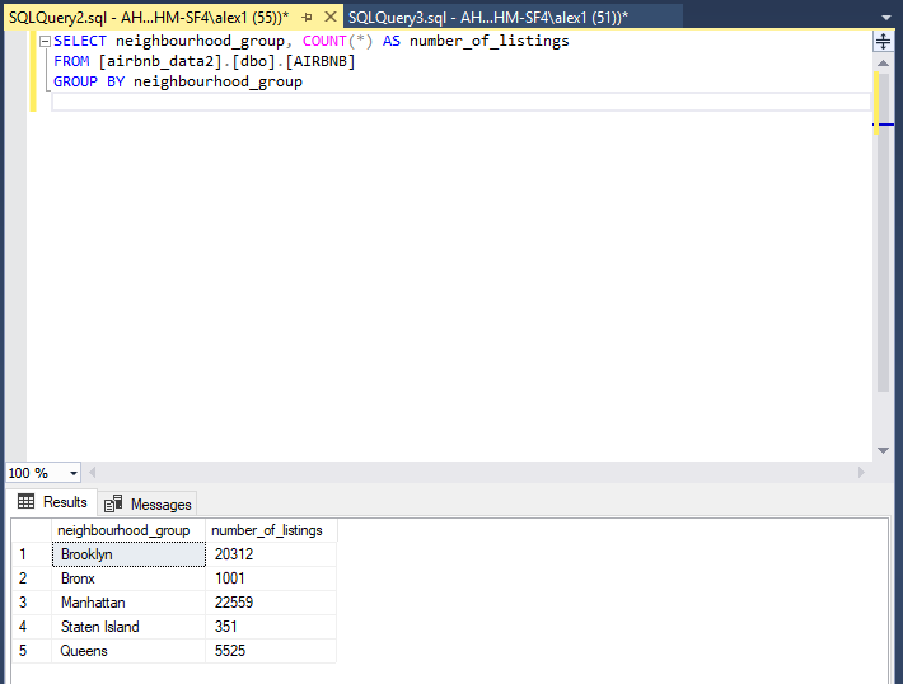

1. Listings ranked per number of reviews

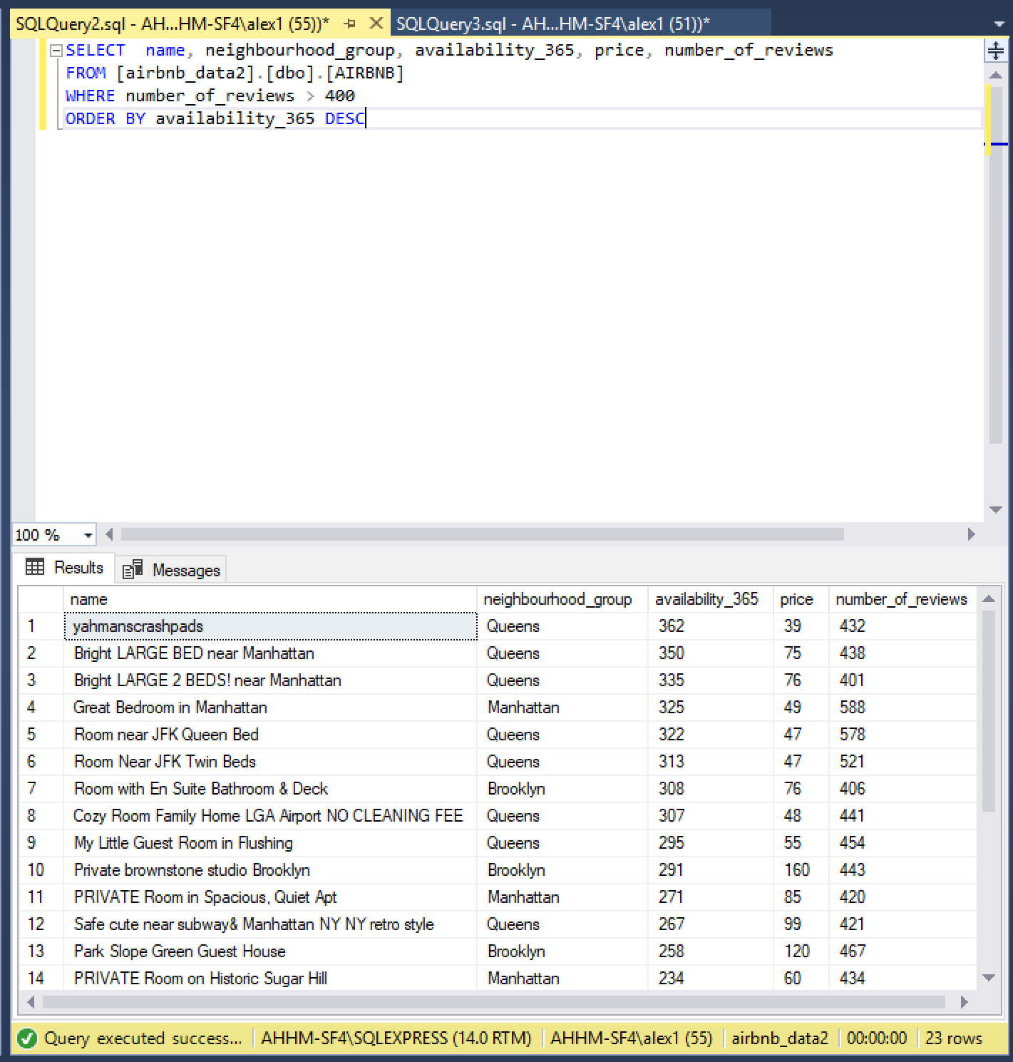

1. Number of Private rooms per neighborhood

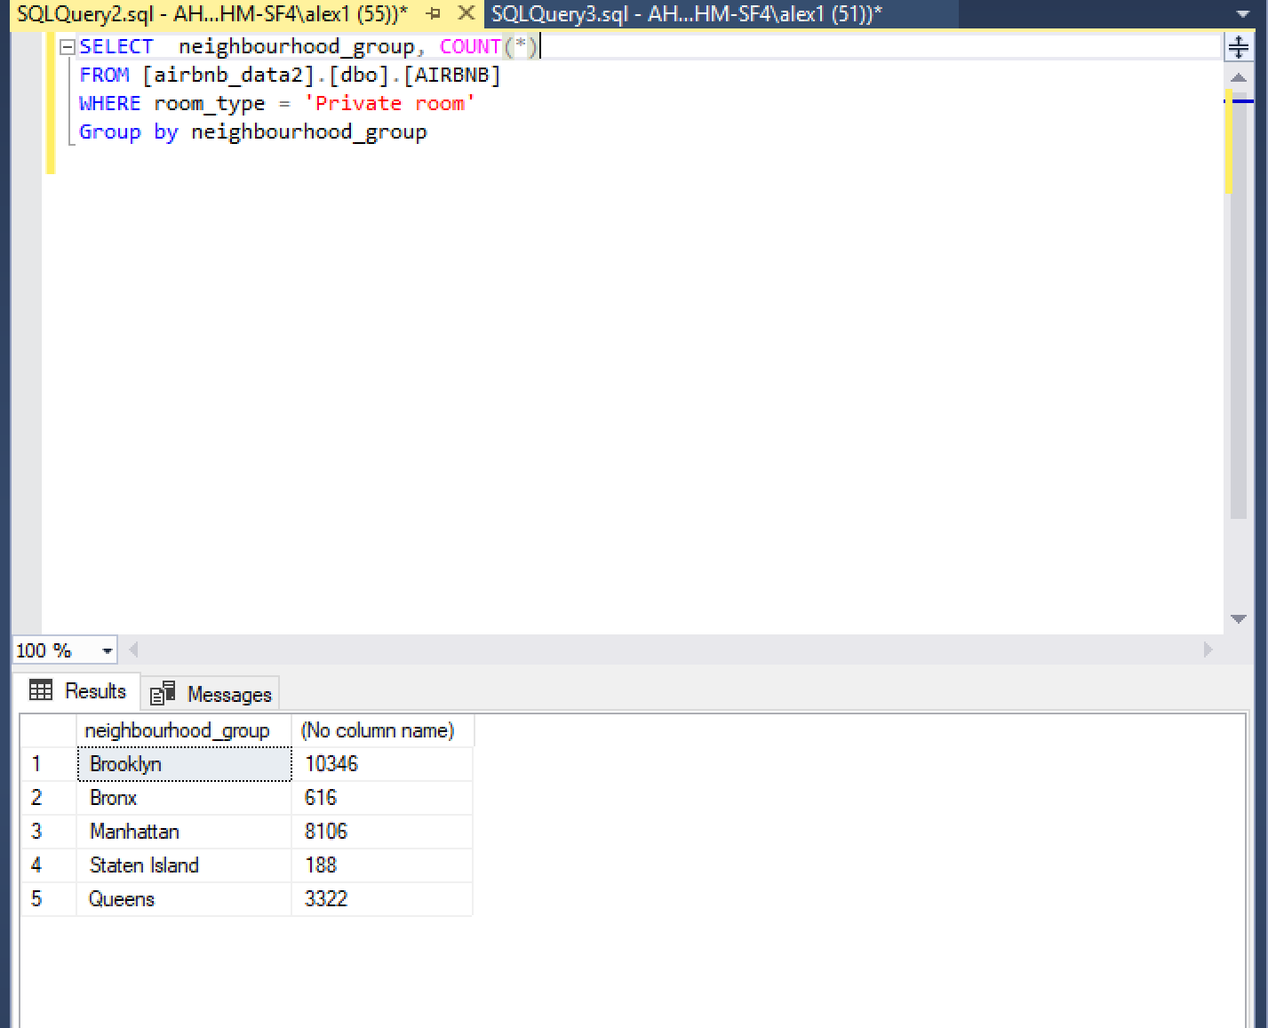

1. Number of Entire homes per neighborhood

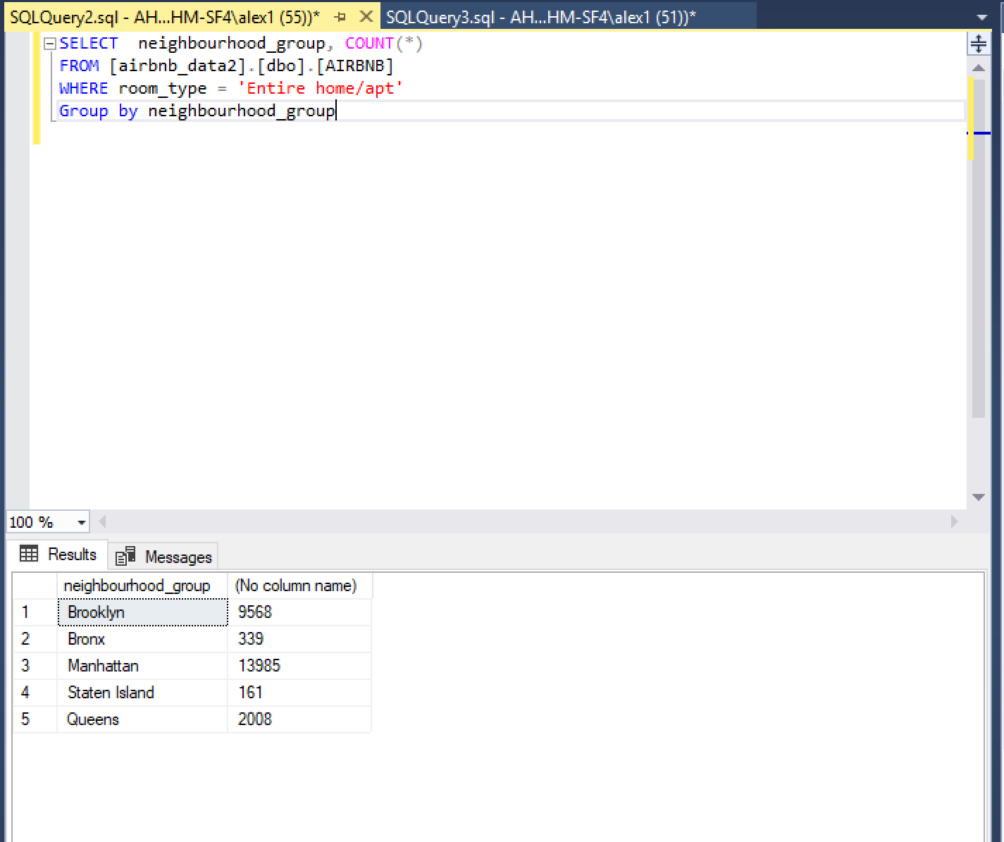

1. Number of Shared rooms per neighborhood

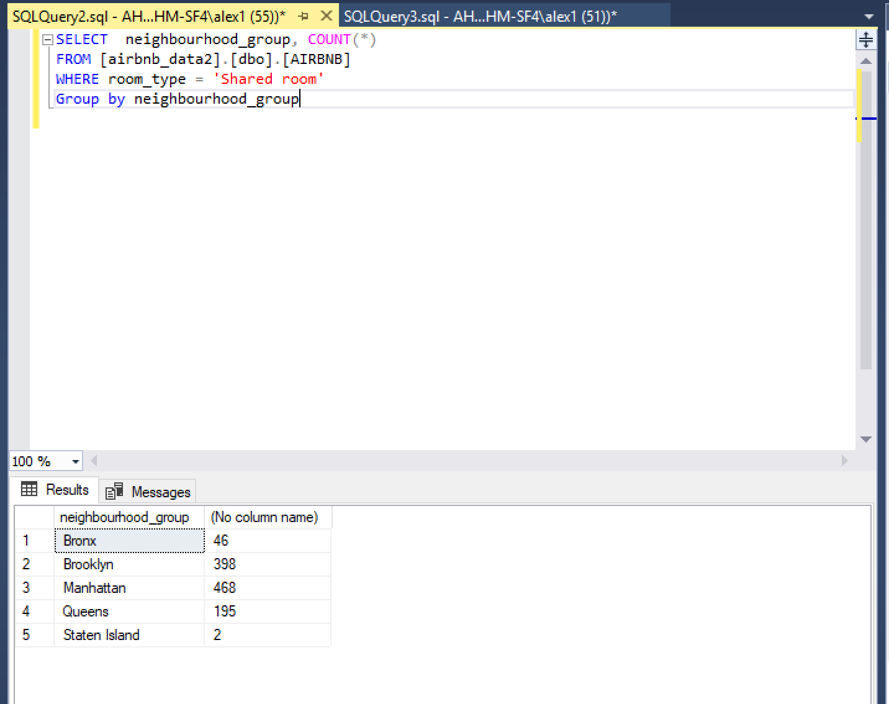

1. More expensive neighborhoods

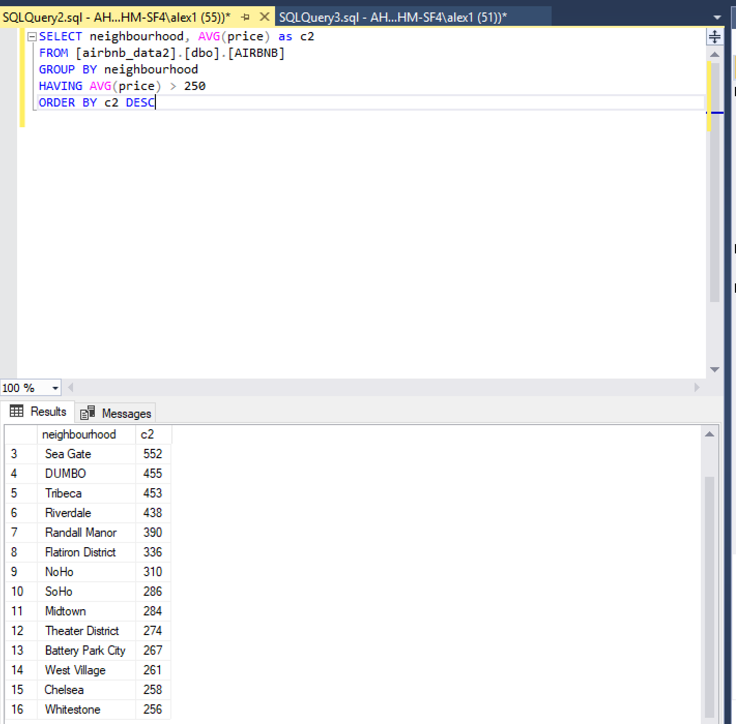

1. Creating a new table with id, name, price and number of reviews

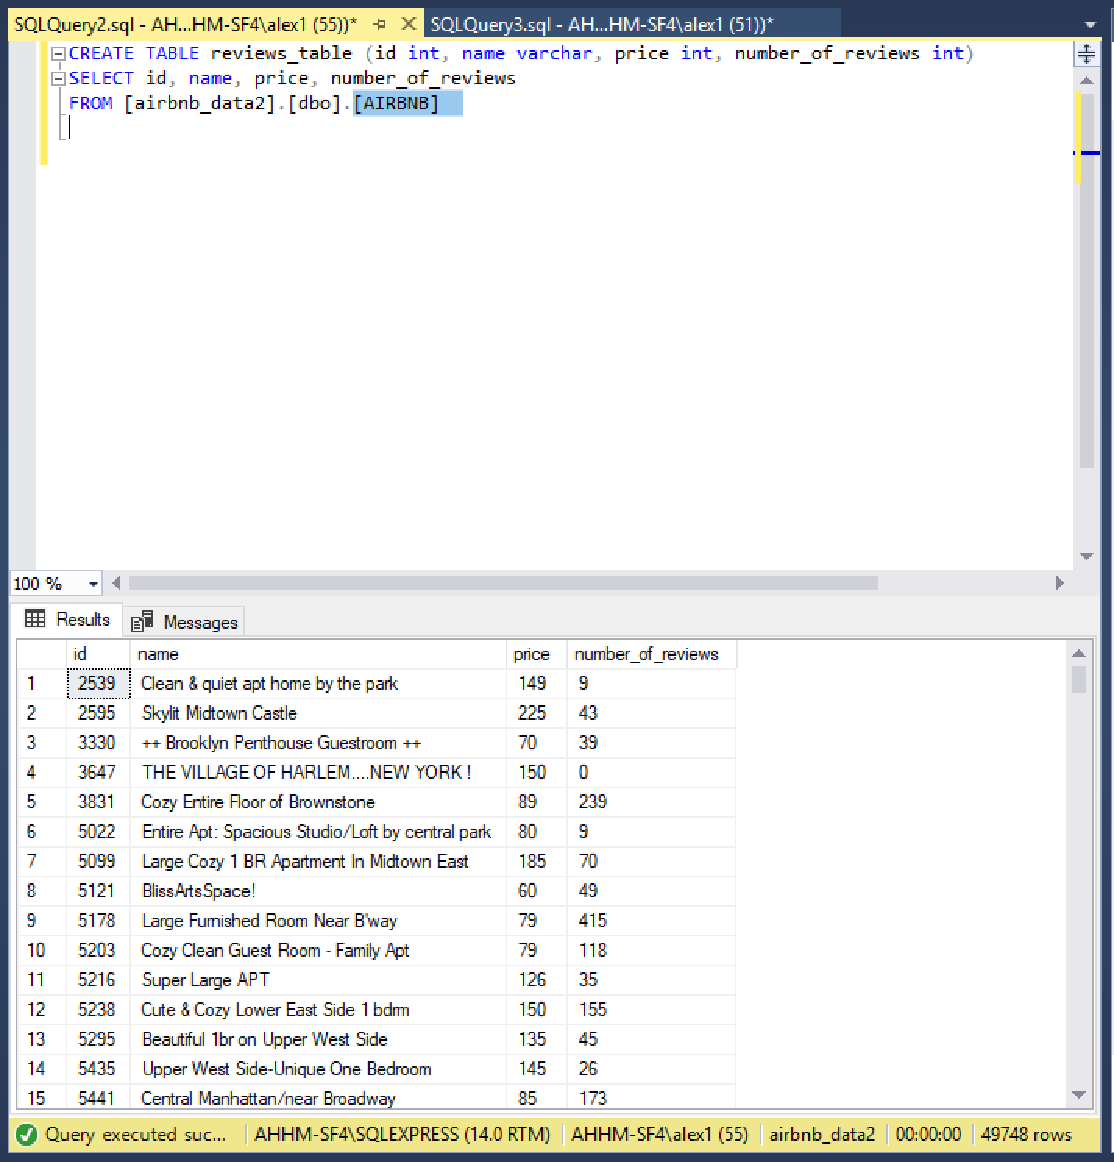

1. Registered hosts with more number of listings.

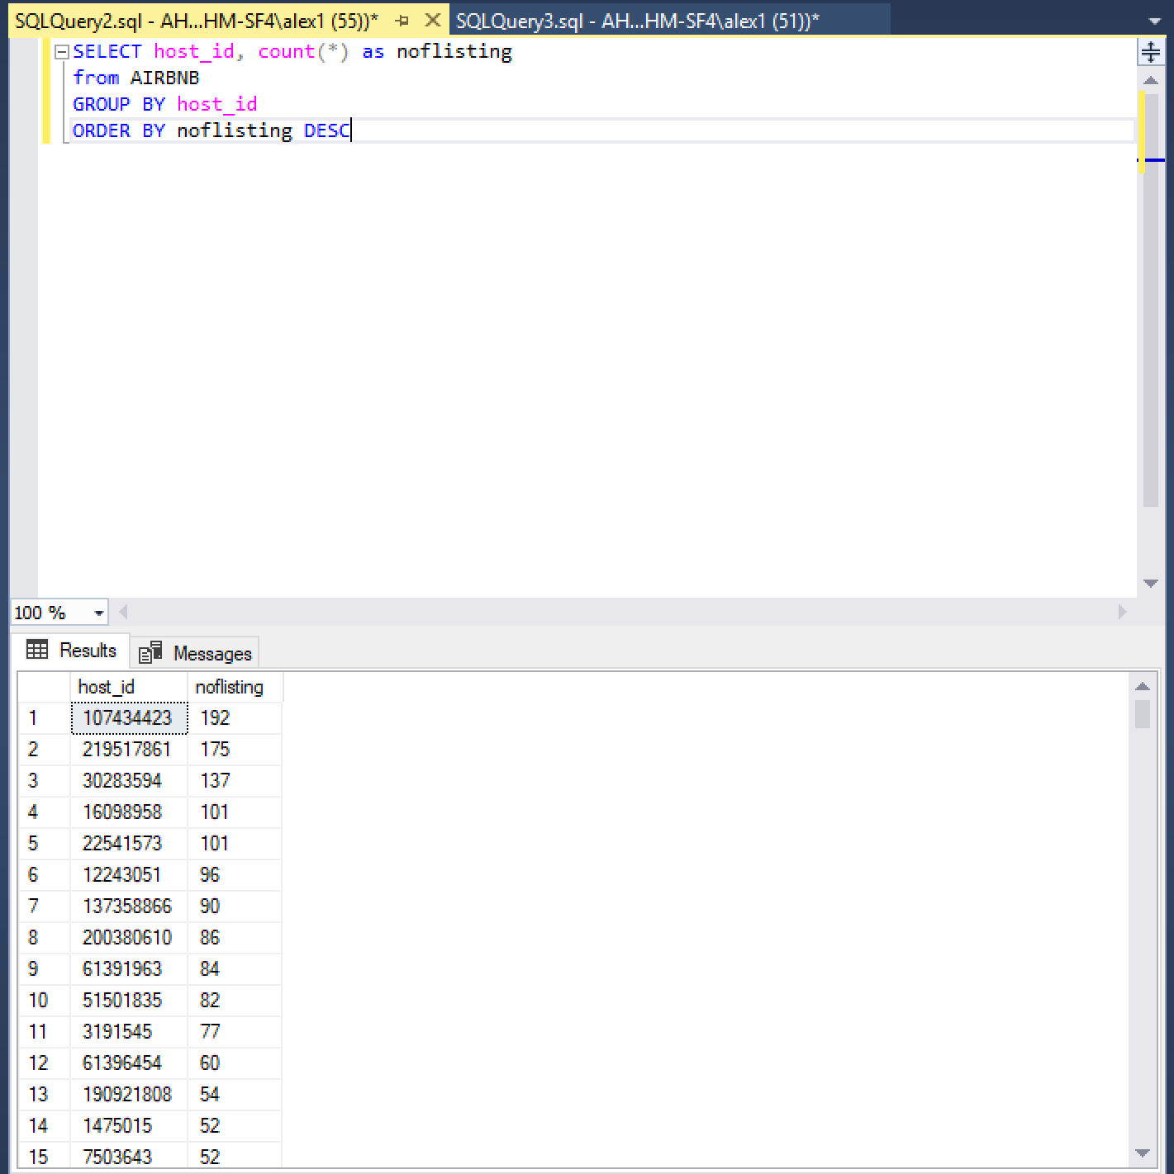

1. Host with more number of listings. Blueground.

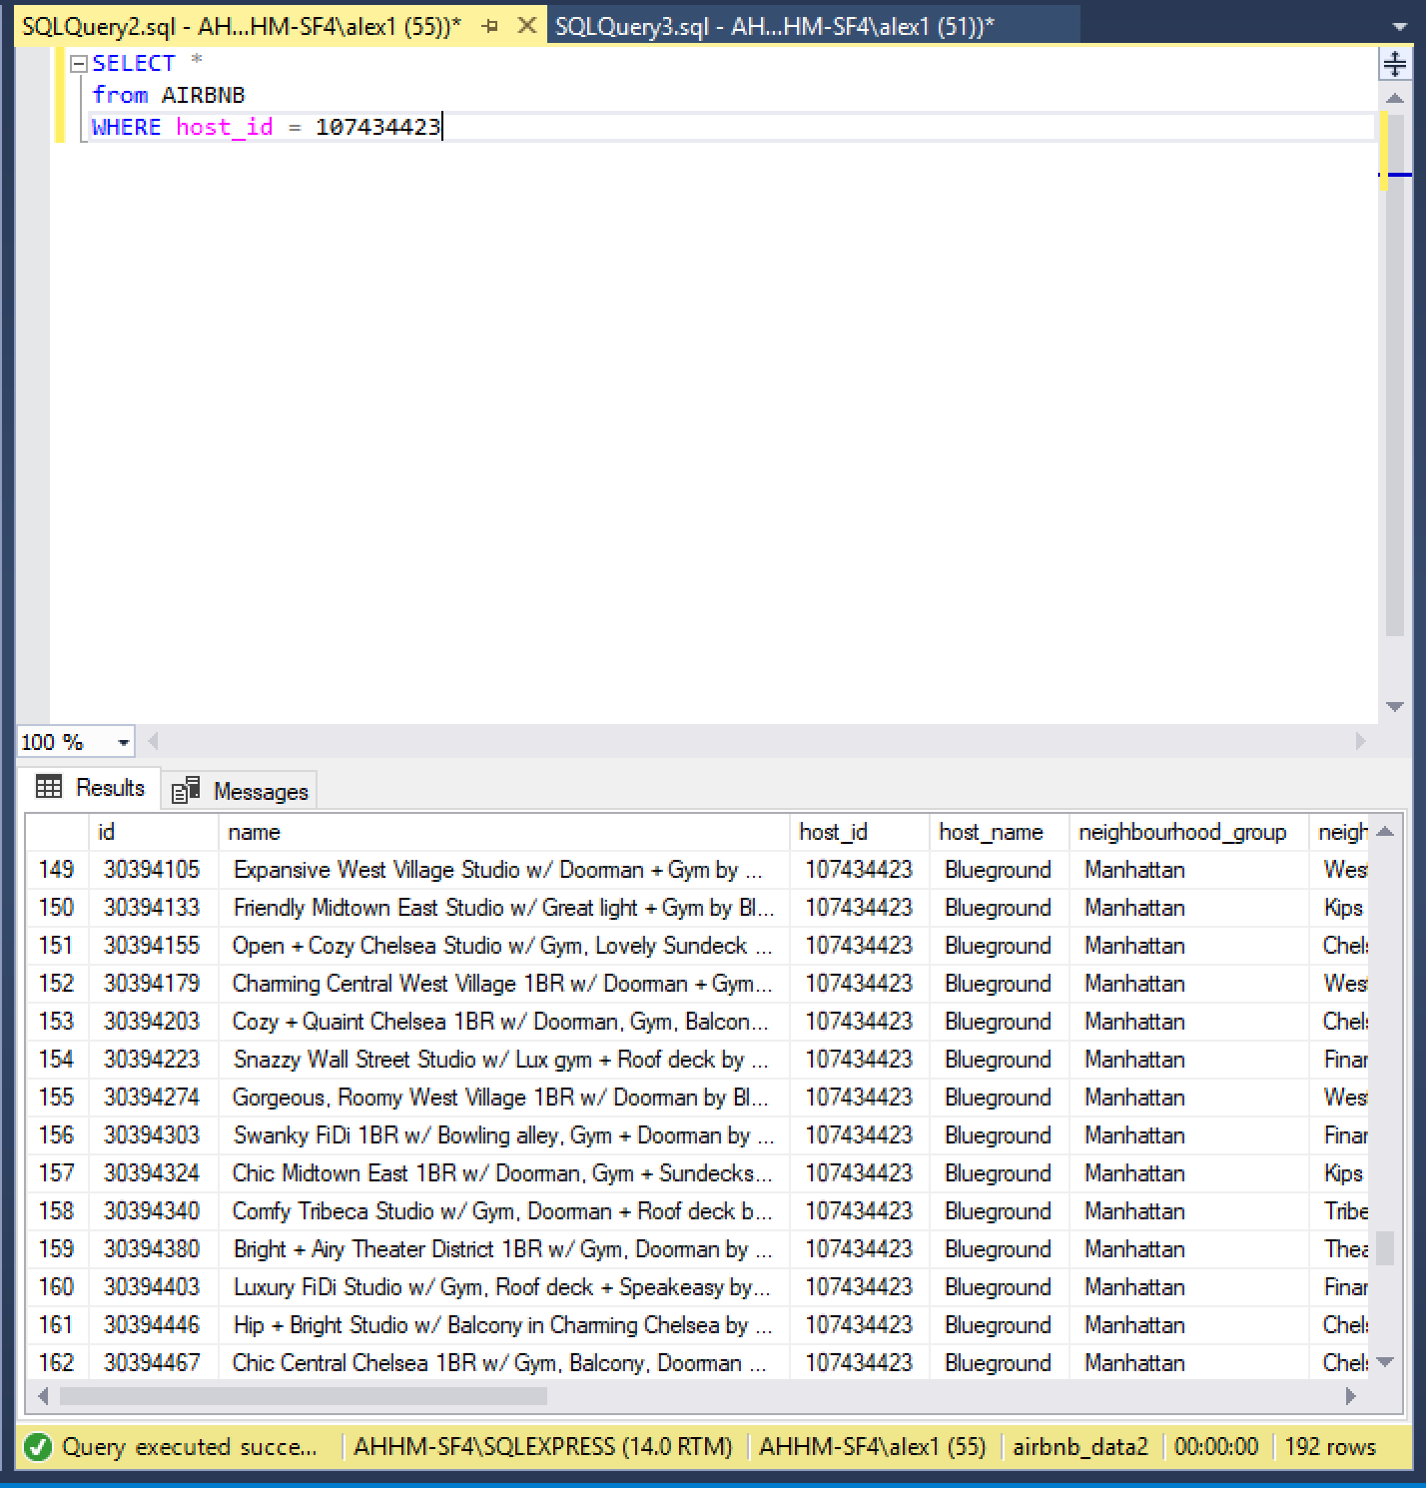



1. Another query of hosts with more number of listings

