**MIXORCERERS**

**Current Status**

Basic system of spells and map – Completed

Serializing State between Turns – Incomplete

Base Control strategy,game balance – Incomplete

LAN Server-Incomplete

Multiplayer Server-Incomplete

Profile, account, leaderboard systems – Incomplete

Art and Music, Polish - Incomplete

Issues – Full list of spells not properly enumerated

Not sure if its a fun game

**Concept Statement**

Mixorcerers is a turn based 1v1 game that combines rts elements with the unlimited power of a mage.

**Genre**

Strategy, turn based,conquest

**Target Audience**

Strategy gamers 13 and up. Maybe played an rts or moba

**Concept Paragraph**

The core loop of the game is controlling the map and changing its terrain to suit ones longterm strategy, and the way to do that is to cast spells after creating them from the base orbs.

USP – all kinds of spells, changeable terrain

**Player Experience**

Game lasts about 10 minutes. Fantasy is powerful mage. There are gonna be more units you can control

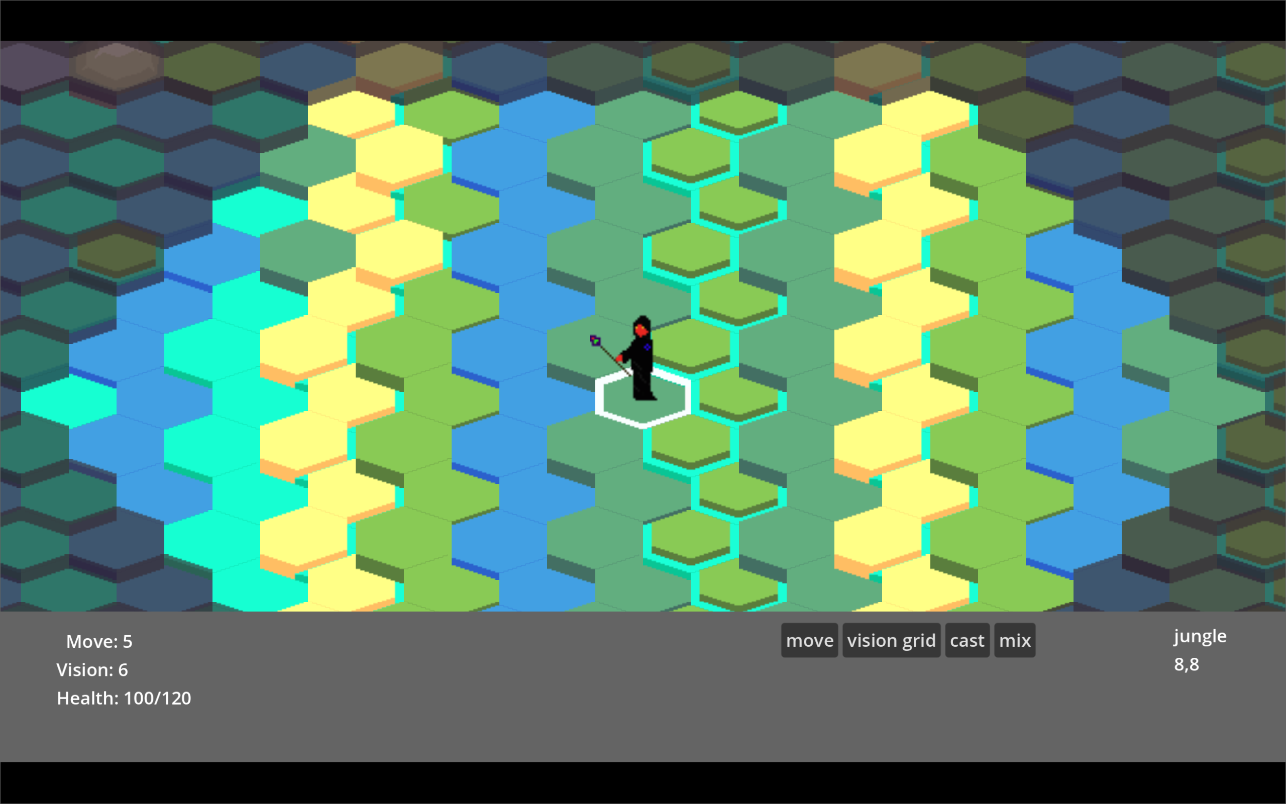

**Key Moments**

Winning a competitive 1v1 game. Key struggles – making it click

**Art,Sound and Music**

The art is retro pixel style- similar to fe7 maybe. The music is undecided but its not gonna be very metall-y mostly cus one needs a calm atmosphere to think

**Current target Platform**

PC

**Competition**

Literally nothing

**Monetization**

Skins maybe

**Player Objectives and Progression**

The player is the controller of their side

The player can see the map greyed out and their vision clearly

Players goal is to gain map control and later beat the enemy

**Game World**

Not very critical

**User Interface**

Main Menu ->

will have a profile button,

a start game with a dropdown to choose between LAN or multiplayer game

leaderboard button

main lobby splash screen

LAN mode settings screen

Animated main lobby splash screen for multiplayer queueing

Profile screen

Leaderboard screen

Game UI-> Cursor which moves and gives menus on the HUD, see image above

Game Options-> Sound Effects and Music volume, forfeit, hardcoded chat bubbles

**MVP Systems**

Game Server-

Gameplay

Connects players, connects spectators, validates turns, ultimate source of truth, distributes replays at end of game

Multiplayer Game Server:  
This will be a webserver, with an sqlite database for pooling ports for the game. It will communicate with the headless godot server via http requests as well

Combat-

Gameplay

Mixing spells and casting them, grimoires. Passive items give one attack per turn in melee range usually

Skins and Petz

Cosmetic

**GameObjects**

Pet – loyal companion, good for scouting, pet cosmetics may change but the abilities will be 1:1, spells can buff the pet

Magycke collector – can be sent to the magycke collector, it has no attack, but can go airborne by paying 1 magycke that can keep it airborne but not collecting for X turns. The magycke collector has high health but can be targeted by harassment units

Harassment unit- cannot traverse at very fast speeds but is very dangerous to the magycke collector. Can freeze resource generation

**Localization**

English only

**Tools**

Godot engine

**Technical Documentation**

Available on piecemeal basis via git repo

**Ideas and Expansions**

None for now

**Unresolved Questions**

Security

Distribution