Lab 7 - Findings Notes

Task A1
Statements supporting the screen sequence: EB01 (students can view available equipment) and EB02 (students can request an item).
Unknown business rule: what happens when two requests overlap on the same dates.
"Booking approved" would be misleading because submitting only creates a request. EB04 says staff review requests and decide to approve or reject, so approval happens later and could be a rejection.

Part B - Storyboard
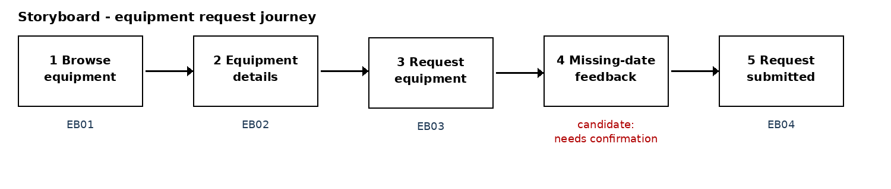

Part D - Walkthrough
Type of review: self-review (no partner). This is not stakeholder validation.
Goal used: "You want to request a laptop for a period of dates. Show where you would go."
Finding / question | Evidence type | Action or next step
Normal request: got from Screen 1 to Screen 3 fine, but I expected to see if the laptop was free for my dates before filling in the form. | Self-review | Seek confirmation - what "available" means isn't defined in the case
Missing end date: the warning only shows next to End date. Not known if this check is actually wanted or if staff just reject it later. | Candidate rule | Seek confirmation (must both dates be entered?)
"Does this final screen mean my booking is approved?" - no, Screen 5 says it is not a confirmed booking, but nothing says how/when I hear back. | Self-review | Revise screen - added open question note to Screen 5; notification rule needs confirmation
Screen 2 has no item code or quantity so I couldnt tell if there is more than one laptop. | Self-review | Seek confirmation (item identifiers not specified)

Modification made: added an open question note to Screen 5 - "How does the student find out the staff decision?". Approval notifications are not specified in the case so I didnt add a message for it.

Part E - Workshop registration
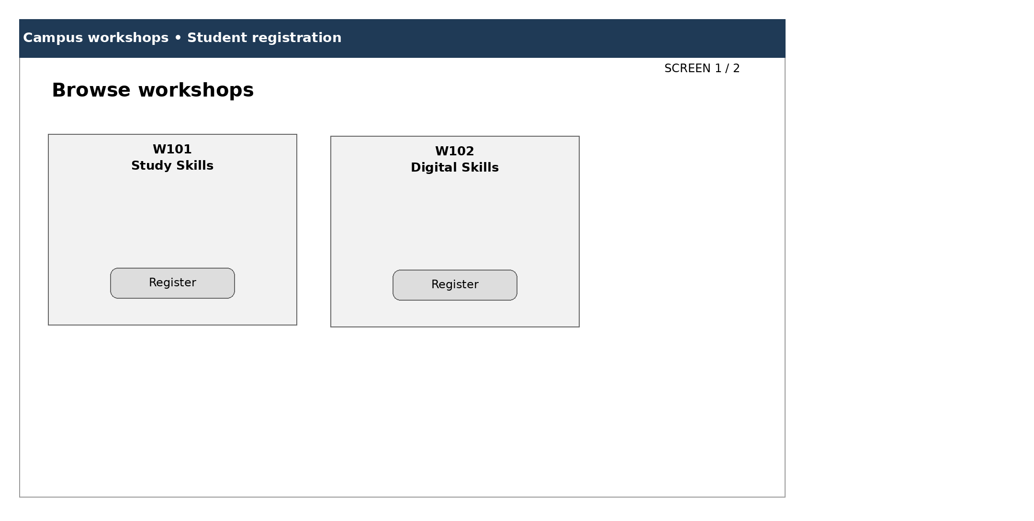
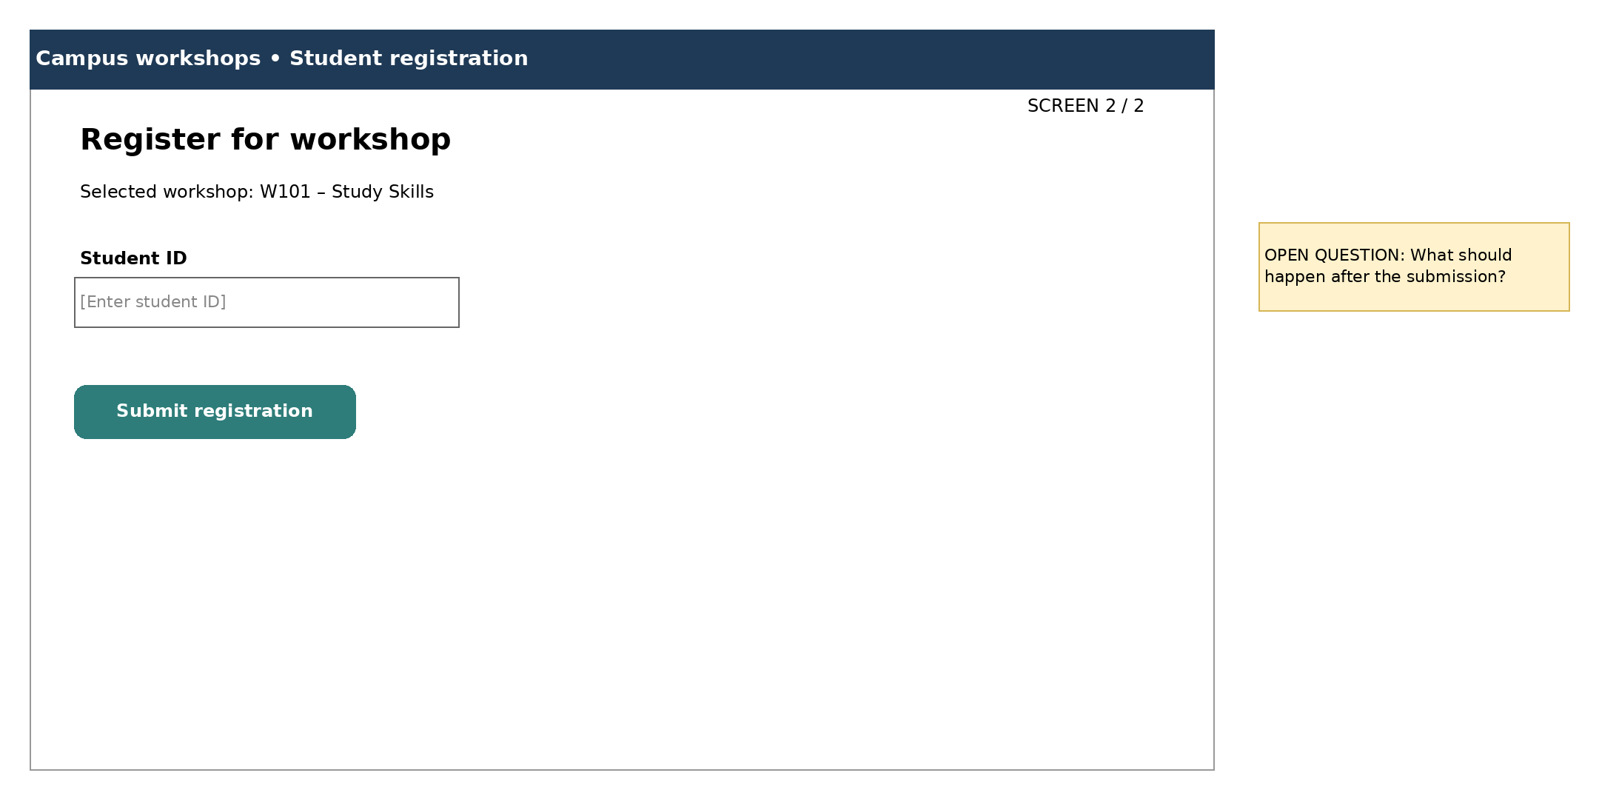
Compared to the Lab 6 class diagram, the screens show workshopCode and title from Workshop and studentId from Student, but name, registrationDate and status dont appear on screen (a Registration is what gets created when Submit registration is pressed).

