#### Brief Introduction on Object Detection

* [ComputerVision_FinalProject_ObjectDetection](https://docs.google.com/document/u/0/d/1gzsvGmAN_67sCeP6bPCpukfVr_p66OYCObcKSubB660/edit)

#### What to do next

* Write the brief introduction on key features of object detection – Jennie & Zoey
* Brief key features of object tracking – Chase
* Expand the above two parts and combine them with the proposal to – yukai
  + Write the final report – include future work on pitch classification
  + Slide& pre about 3-4 mins long

#### PitchTrack Final Code & Result Videos

* [Link](https://drive.google.com/drive/folders/16FgZs08CiOFaLx2PWAkA3lrnLcM-1vOL?usp=sharing)

#### Object Detection Method (Ahhyun & Zoey)

At each frame:

* Color to grayscale conversion
* Background subtraction so that only moving objects remain in the frame
* Edge detection as implemented in Project 2 or CV2.canny
* Hough Circle Transform to detect circular shape
* (If necessary) Thresholding circle centers to filter out those are not close to white color
* Report the final coordinate & draw center/bounding circle

#### Object Detection requirements

* Be able to deliver the bounding box or the coordinate of the baseball center in most frames
* You can test the method on an image/ single frame first
* Visualize the bounding box/ baseball center on every frame and output them to a video —- tell Chase if you don’t know how to do this

#### Video Requirements

* Only need the part that contains a clear trace of the baseball – less than 20s. You can cut the video you find to include only the trace part
* The baseball better be visible the whole time (i.e., can not be too small)
* Better have a different pitch kind
* At least 5

#### Project Proposal

<https://drive.google.com/file/d/1m9Yc3_O6gR-ESBnnbxysUNd_Hypyc-XV/view?usp=sharing>

#### 

#### 4/11/2024 yukai

Brief introduction of Kalman filter and how it might work

The Kalman Filter is an algorithm that predicts the future state of an object based on its previous states, accounting for errors in measurement and estimation. It's particularly useful in tracking applications where precision and reliability are crucial despite uncertainties and noise in data. By updating its estimates with every new measurement, it provides a refined prediction of the object's position and velocity.

In the context of object tracking, such as following a baseball's path in a pitch, the Kalman Filter estimates the ball's position in each frame of the video. It starts with a prediction based on the object's known dynamics, adjusts this prediction with actual measurements, and iteratively refines the object's estimated trajectory. This process helps in maintaining a continuous and accurate track of the baseball, even when direct observations are noisy or partially obscured.

#### 4/11/2024 Ahhyun

Project Proposal Ideas:

1. Baseball pitch detection and tracking from video sequence
   1. Baseball detection
      1. Possible Methods: Hough Circle Transform
      2. Concerns:
         1. Fast speed of pitch can produce blurry object edge in video and bring challenges in detection
            1. Find high resolution video with high fps so that clearer ball shape can be seen in each frame
   2. Pitch tracking and tracing
      1. Possible Method:
   3. Possible Extension: Pitch classification
      1. Although pitch type also depends on other conditions such as speed and pitcher’s mechanics (such as grip and release point), we can also determine by visual observations of the trajectory of the ball as it travels from the pitcher's hand to the catcher's mitt. The curve shape of the pitch with below characteristics can be used to determine pitch categories:
         1. 4-seam Fastball: Near straight line
         2. Curveball: Drop in the curve (vertical direction)
         3. Slider: Right to left direction in the curve (for right-handed pitcher)
         4. Changeup: Left to right direction in the curve (for right-handed pitcher)

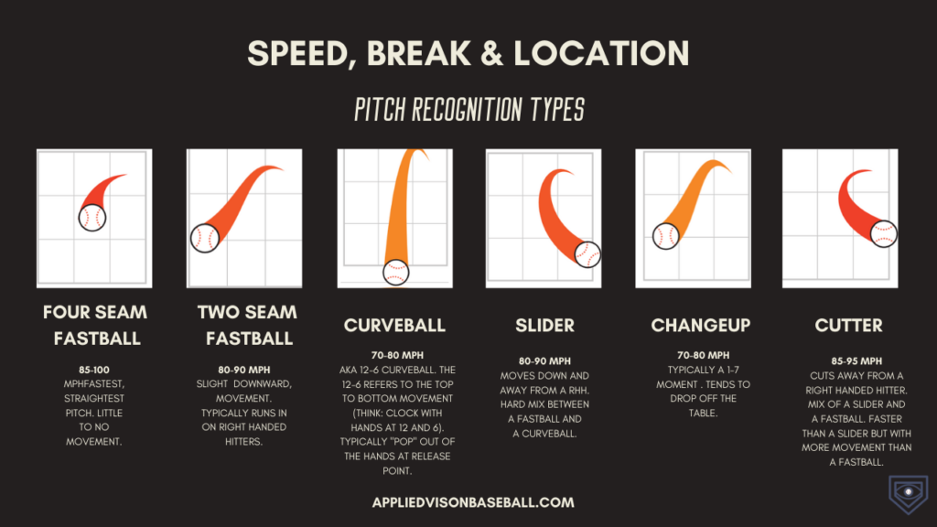

#### 4/9/2024 Chase

* [Theory of Kalman filter in object tracking](https://www.intechopen.com/chapters/73445). This is a document on how the Kalman filter works in object tracking
* Yukai can write an introduction of it which can be included in the proposal/report/slides as our methodology and I will write the implementation part
* The point is to make the readers know what’s a Kalman Filter and what role it plays in object tracking (in videos) → you don't have to read the whole thing just enough for readers to understand what it is will do