Dr Tiernan

Tu Mai

UTA ID 1001594173

1.a) Pseudo code

char CType, BkCov;

Initialize string Title, Series;

String Media1, Media2, Media3;

int SNum, MYear1, MYear2, MYear3;

double BkPr; Read character for content type.

Read next string for Title.

Read next integer for Series numbers.

Read next string for Series Names.

Read next string to remove the colon.

Read next String for Media Type 1.

Reset data Read next integer for Media Year 1.

If Media Type 1 equals “Book” Read next character for Book Cover Read next double for Price Read next String for Media Type 2.

Reset data Read next integer for Media Year 2.

Read next String for Media Type 3.

Reset data Read next integer for Media Year 3.

1.b) Please see Lab3Part1b.java for this question

1.c)

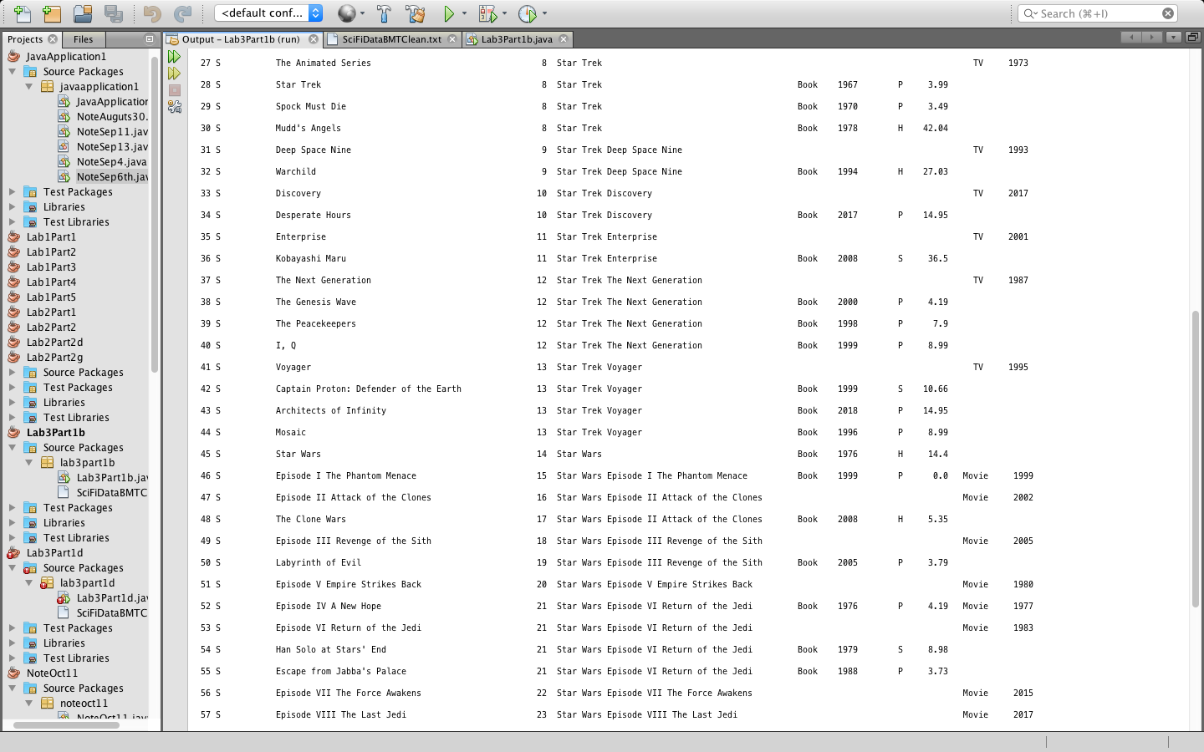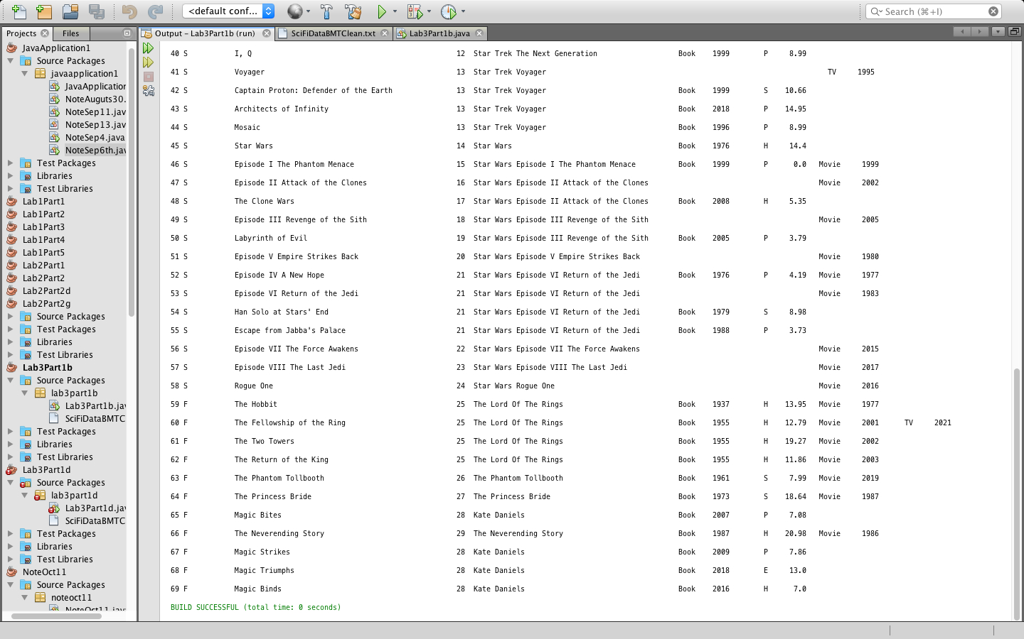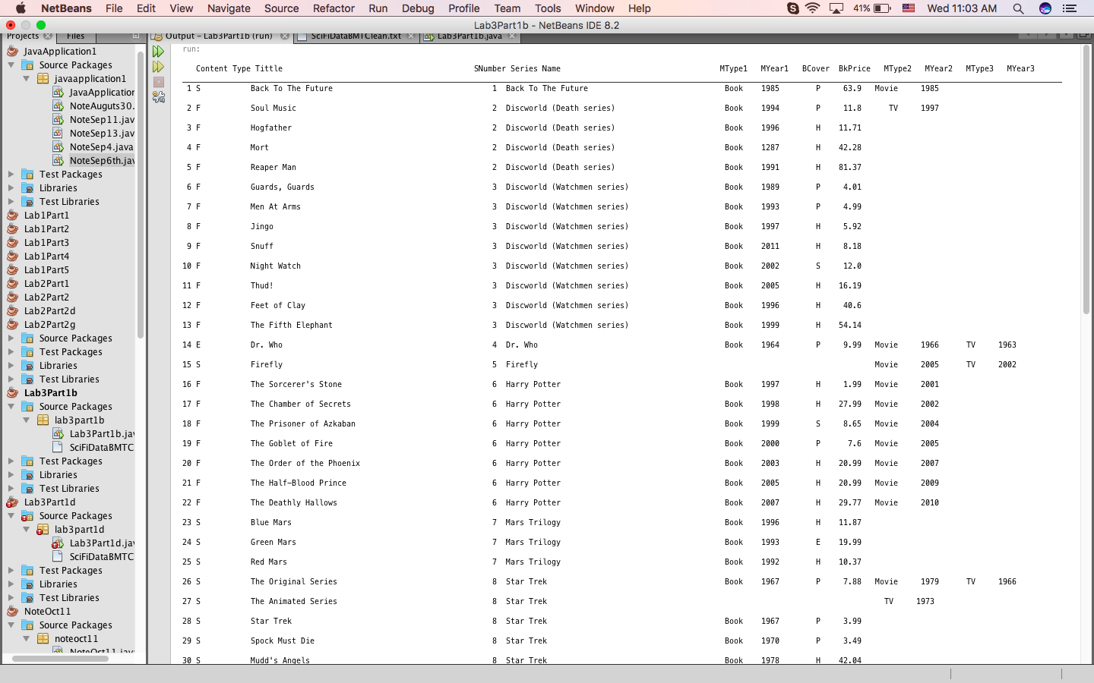

1.d) Please see Lab3Part1d.java for this question

2.a) 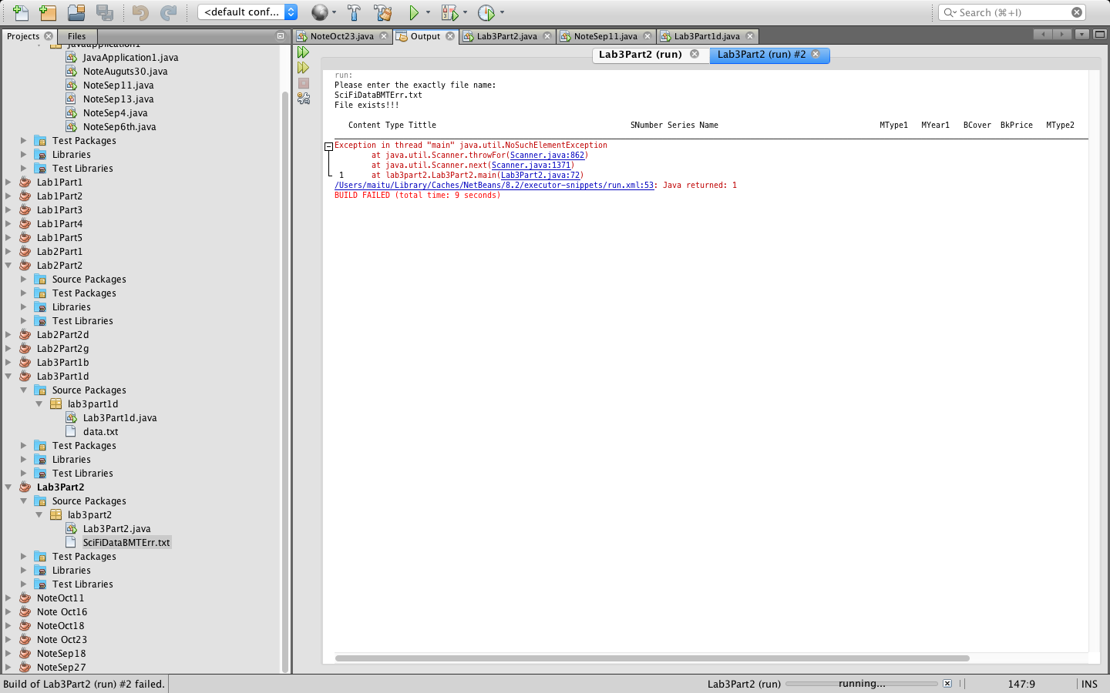

2.b) c) e) Please see Lab3Part2.java for this question

2.d) If there is no colon, the program will recognize Series and Media Type 1 together as String

2.p) Type of problems

InputMismatchException

NumberFormatException

NoSuchElementException

3)