Dr Tiernan

Tu Mai

UTA ID 1001594173

1.a) b) c) Please see Lab4Part1.java for this question

1.d)

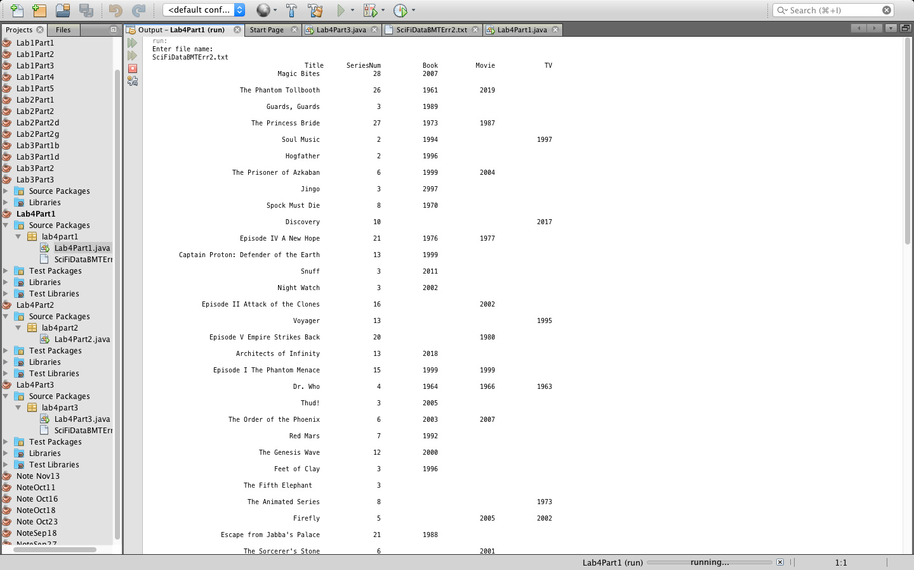

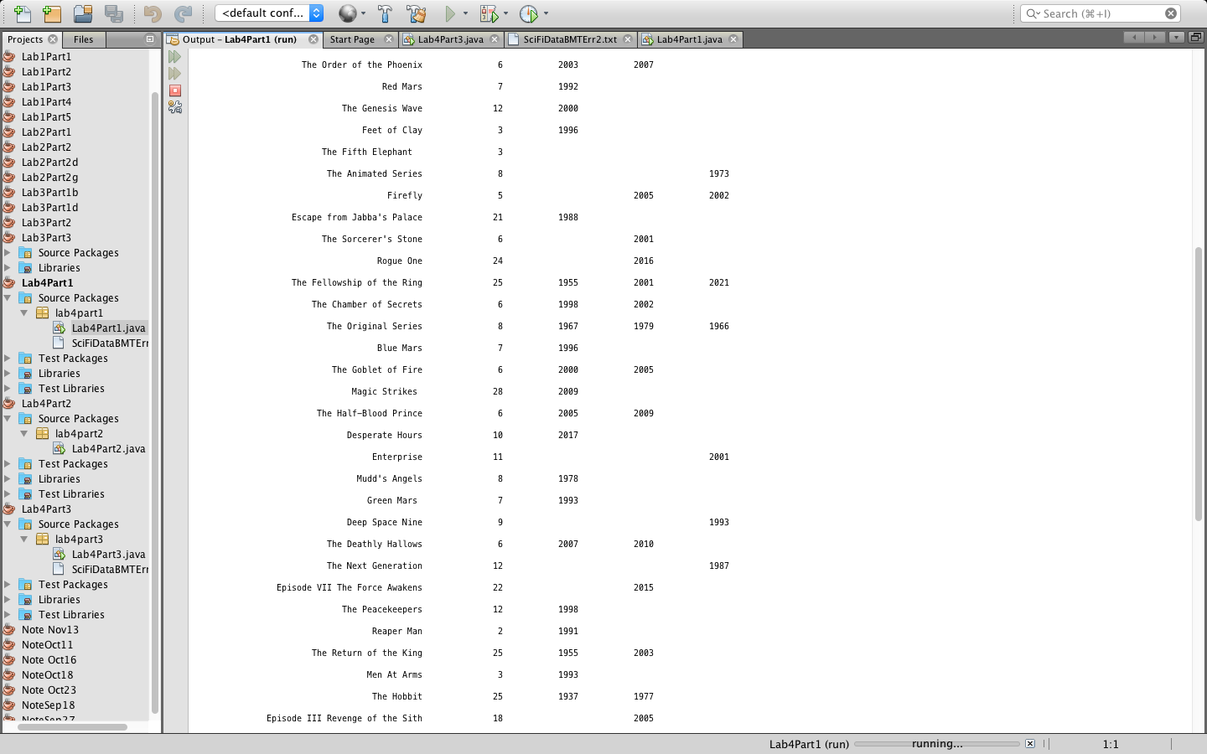

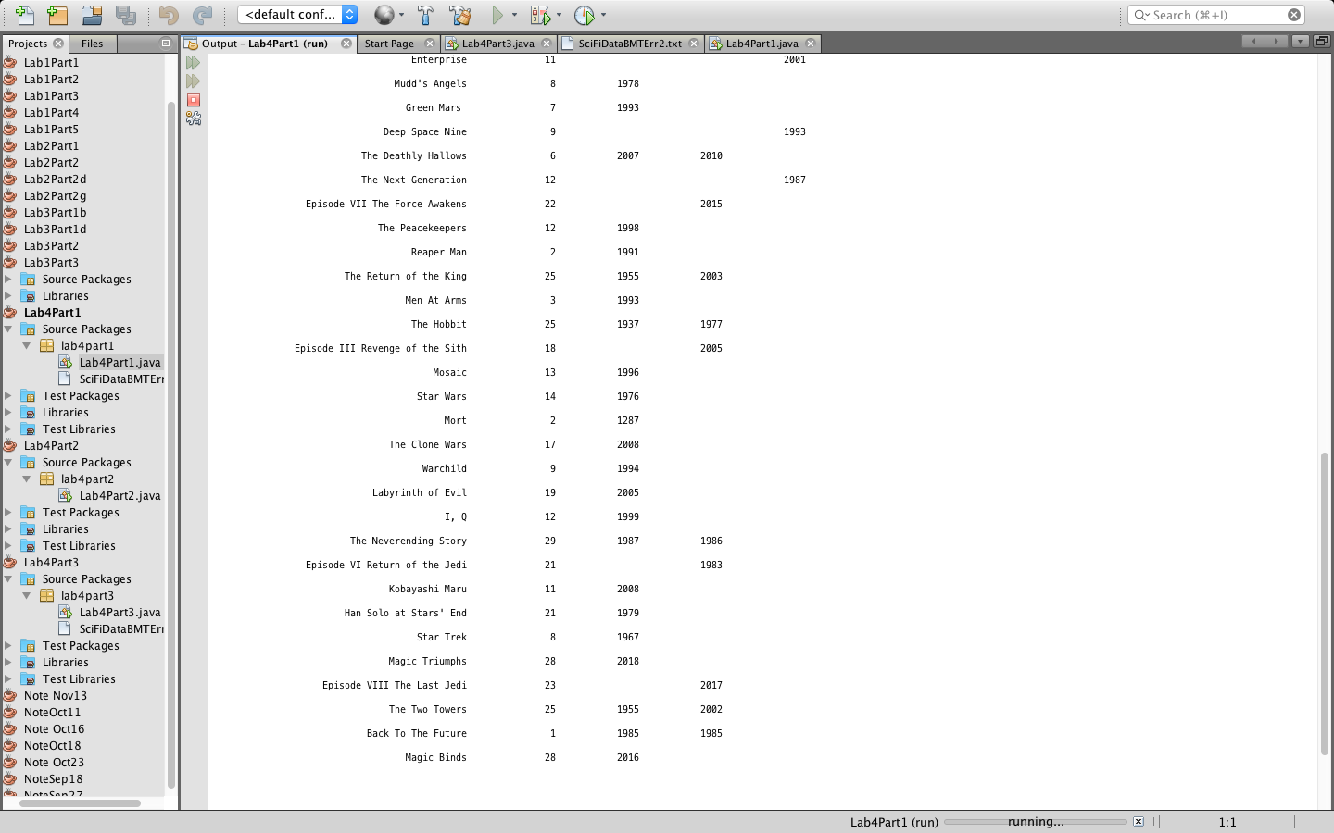

1.e)

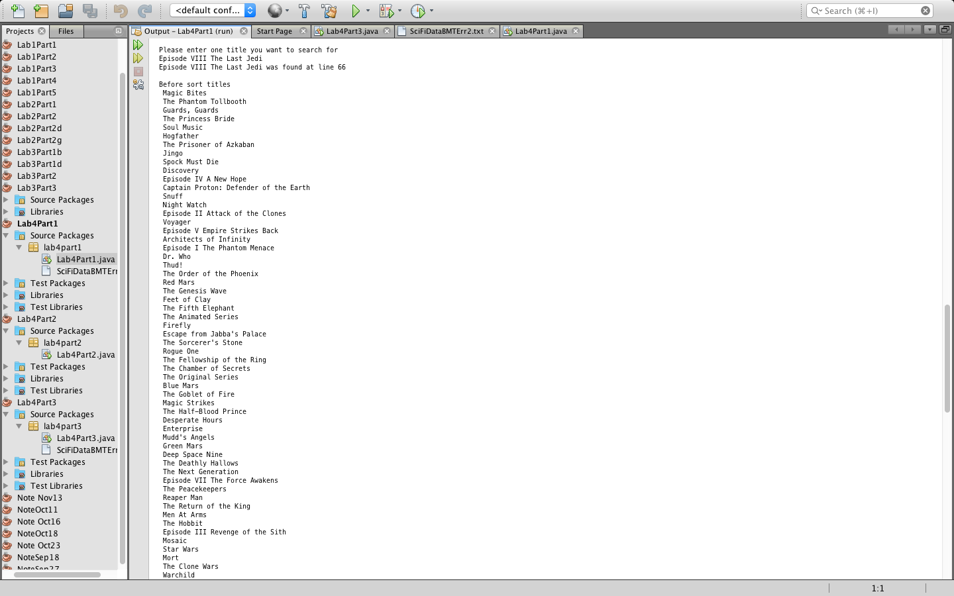

1.f)

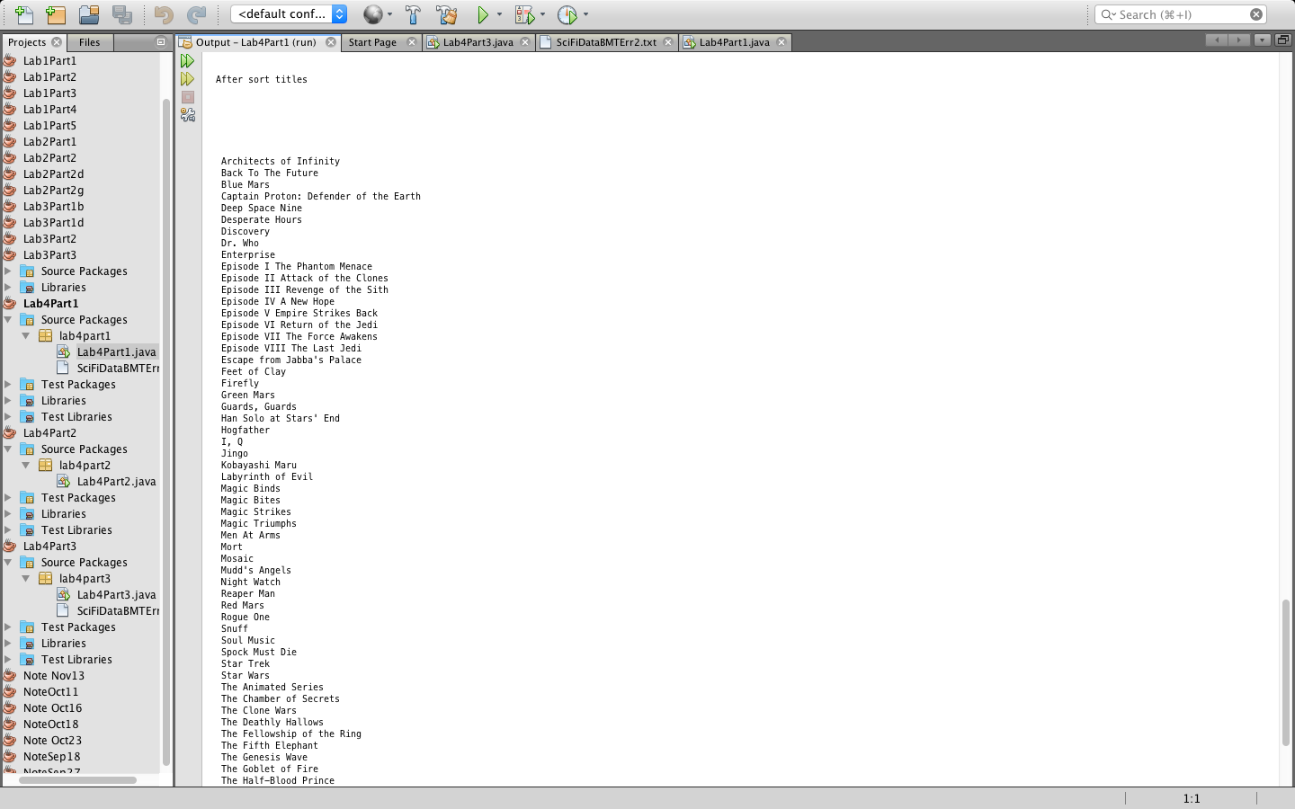

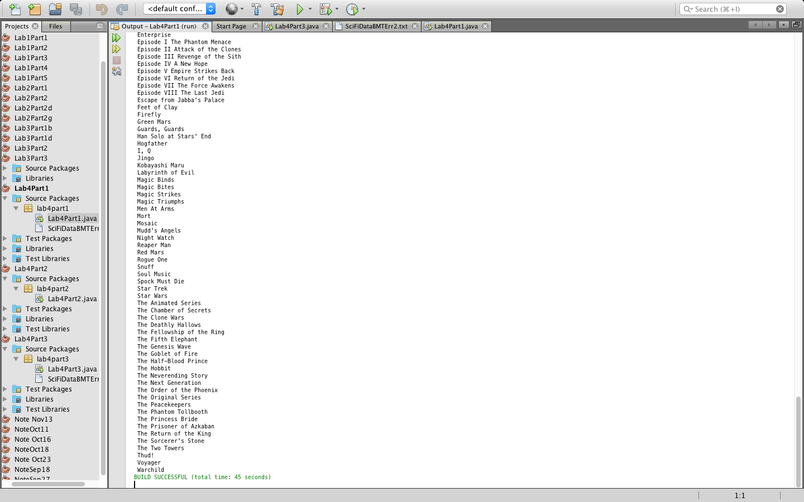

2) Please see Lab4Part2.java for this question

3)Please see Lab4Part3.java for this question