2-D Array Quiz Name: _________________

Part A: Knowledge (5 marks)

1. Write one line of code to declare a 10x3 (2-D) array used to store names. (2)

2. Write a few lines of code to print the values on the perimeter of any rectangular 2-D array of integers. (3)

Part B: Thinking (18 marks)

3. Write a small class called Board that contains the following to simulate a game of Checkers

- data field called grid (2-dimensional array of characters)

- a default constructor that creates an 8x8 grid and fills it with r’s in the first three rows, b’s in the last three rows and spaces everywhere else as shown in the picture below. (5)

- a boolean method called done that returns true if there are no r’s left or no b’s left. (5)

- a method called king that determines if the checkers have reached the other end of the board. If a red checker has reached the bottom row, change it to an R; if a blue checker has reached the top row, change it to a B. (5)

Complete the main as indicated in the comments. (3)
public class Checkers
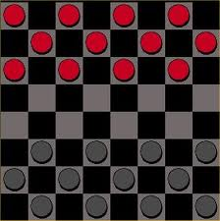
{
static Console c;

public static void main (String[] args)
{
c = new Console ();

// Create 8x8 checkerboard
Board board = _____________________;

if( ___________________ ) // game is not done

___________________ ) // king any checkers that have reached
}
}

