**Created a new issue**

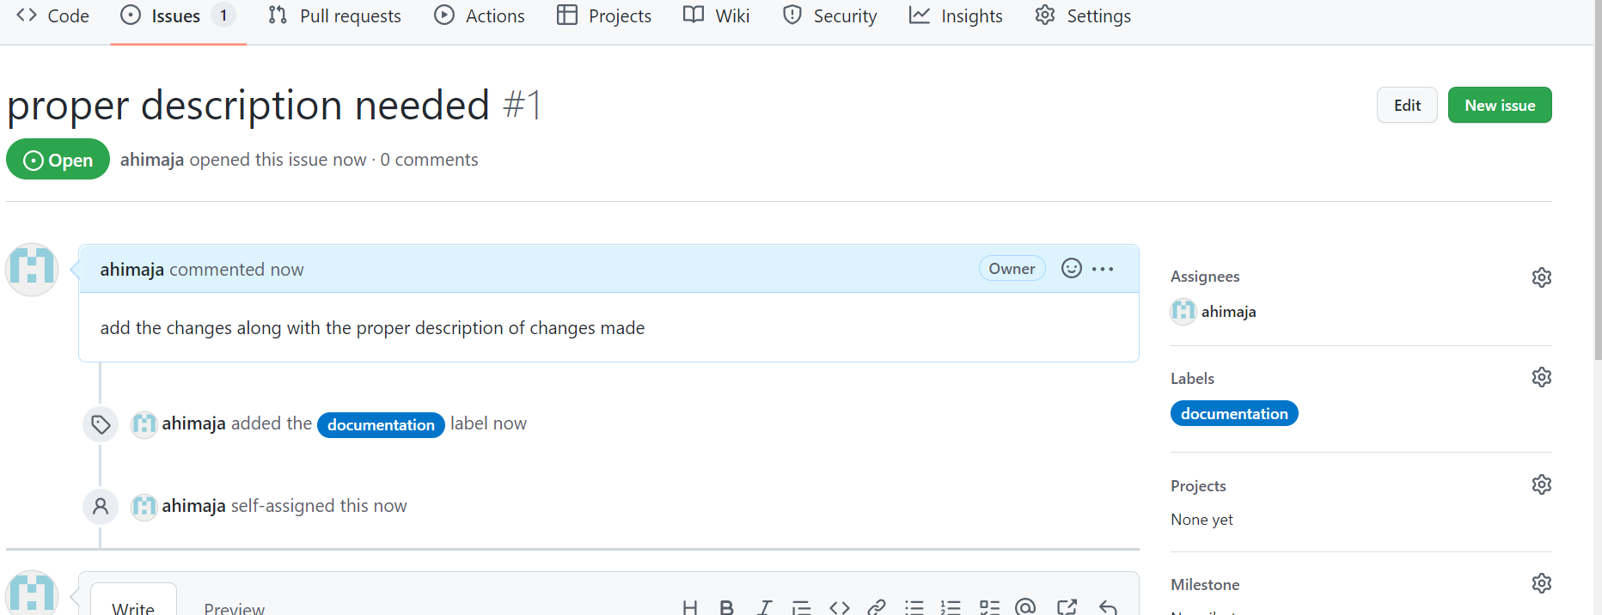

**Creating a fork**

At first I created a fork of the repository(owner : internAH) in which I want to make changes into. I cloned the forked repository into my local repo(ahimaja). After making the required changes in the files I have raised a pull request to owner repository.

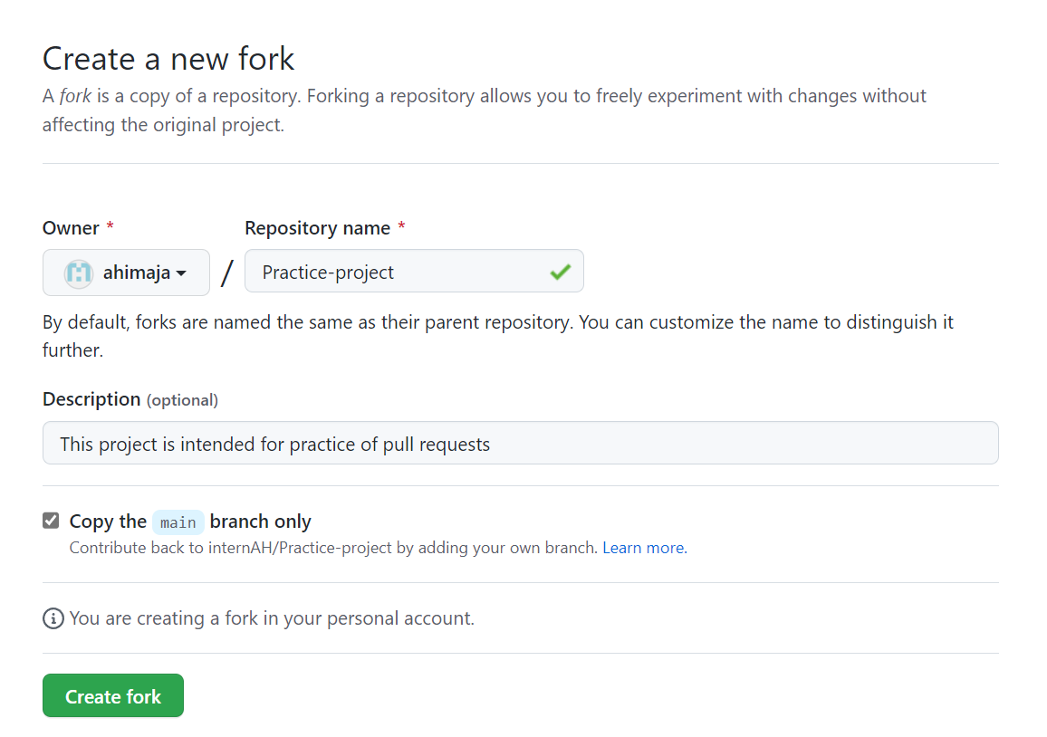

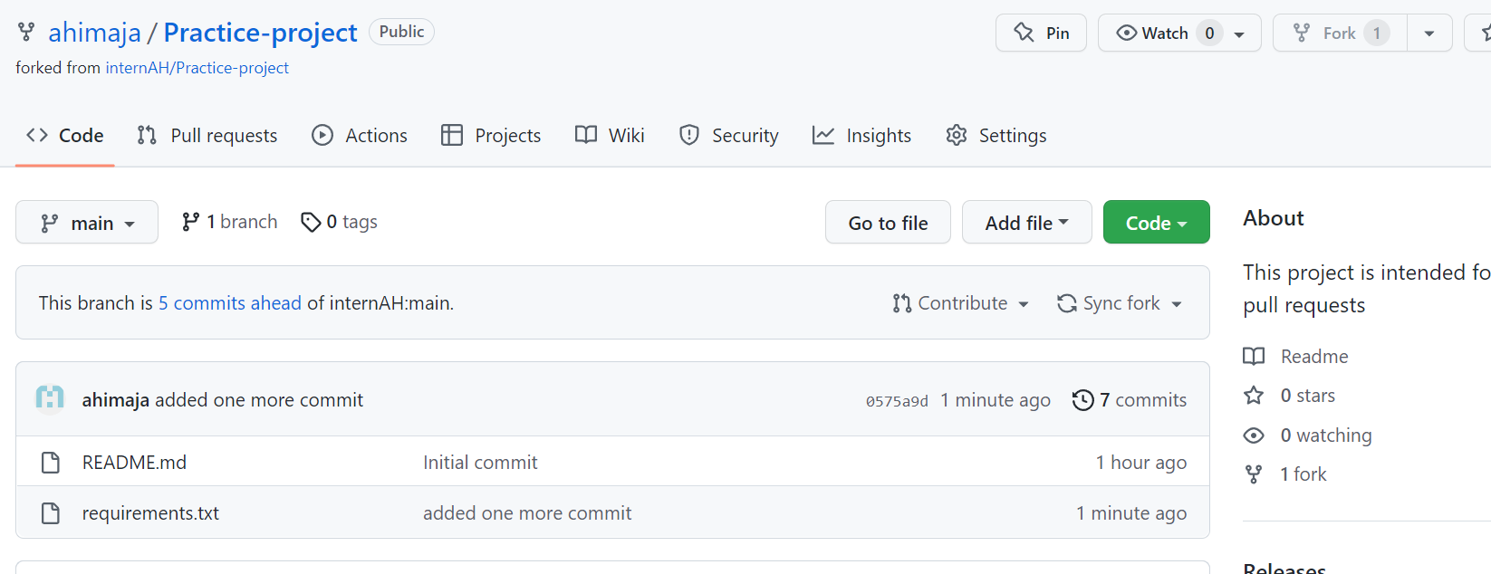

**Raising a new pull request**

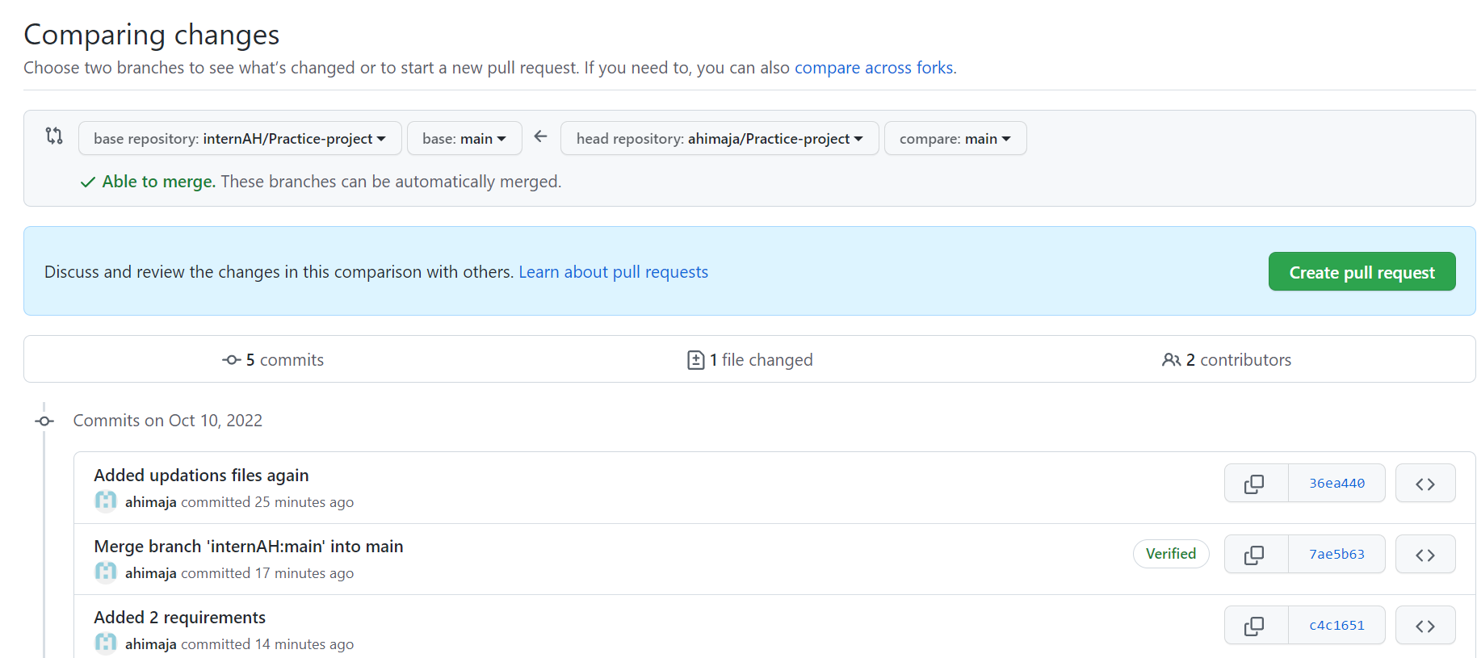

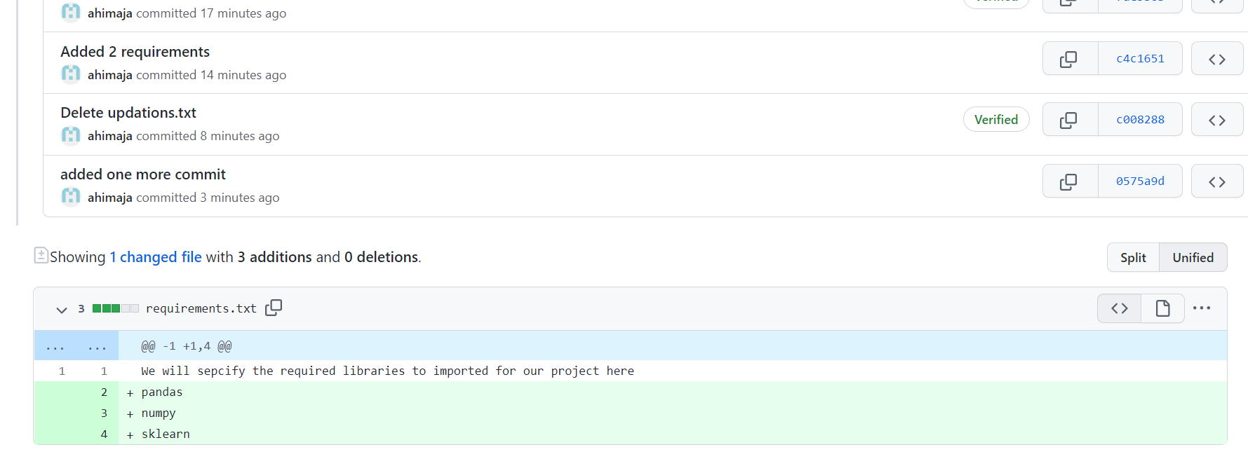

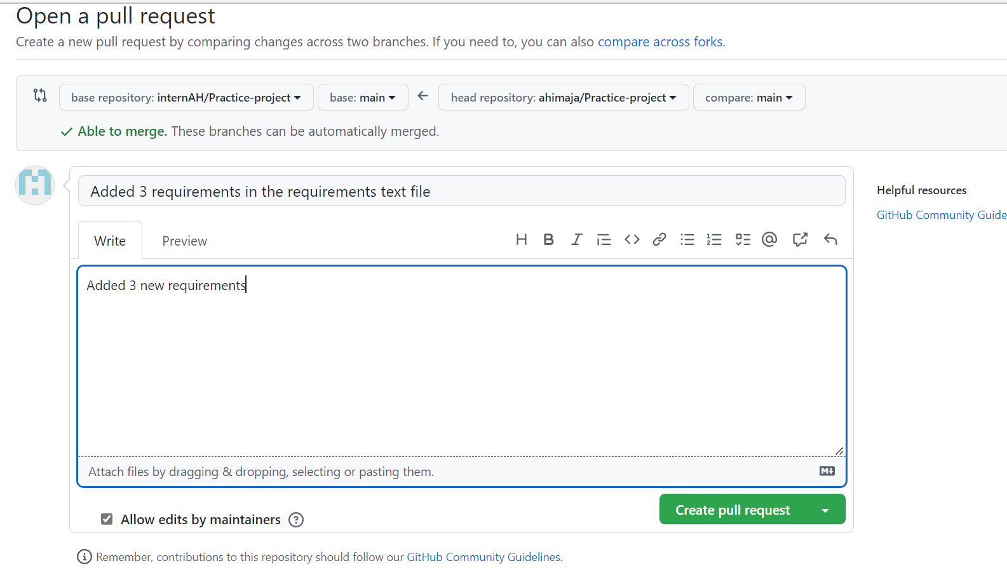

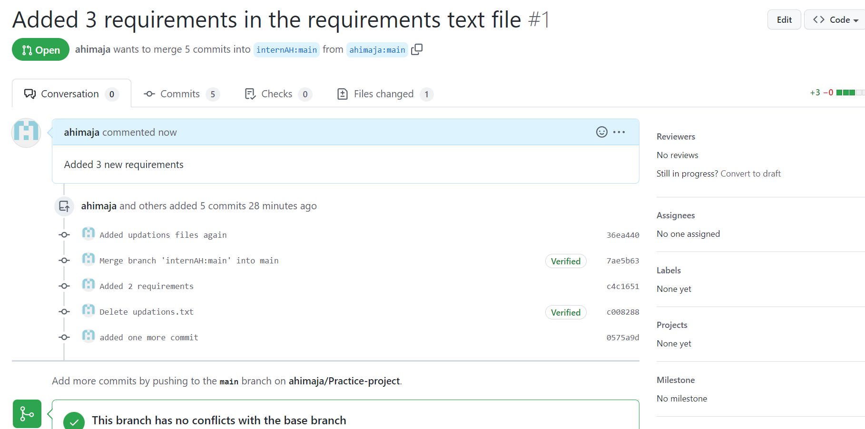

**Viewing the request from source repo owner’s github account**

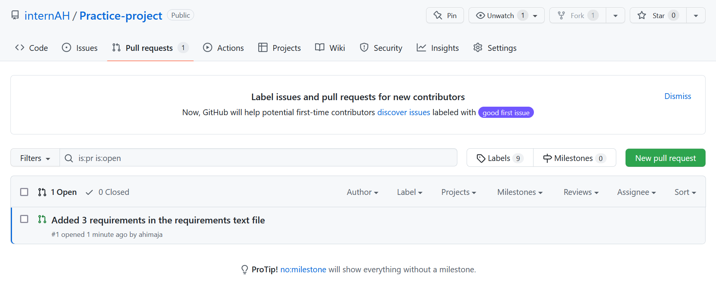

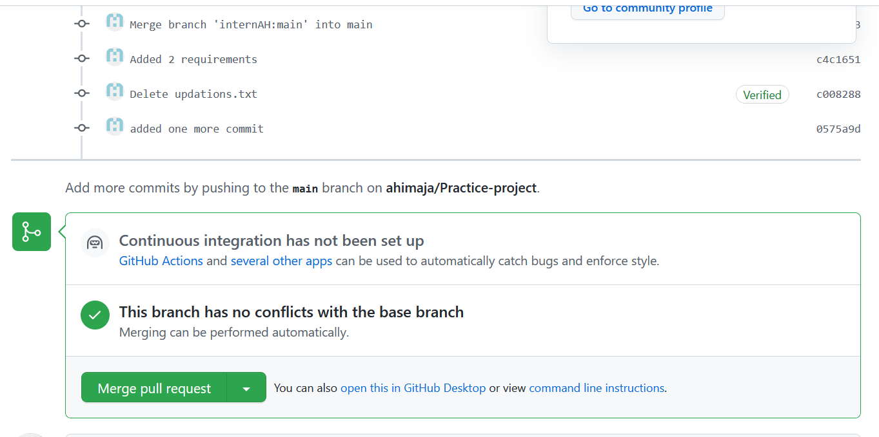

**Accepting and merging the pull request**

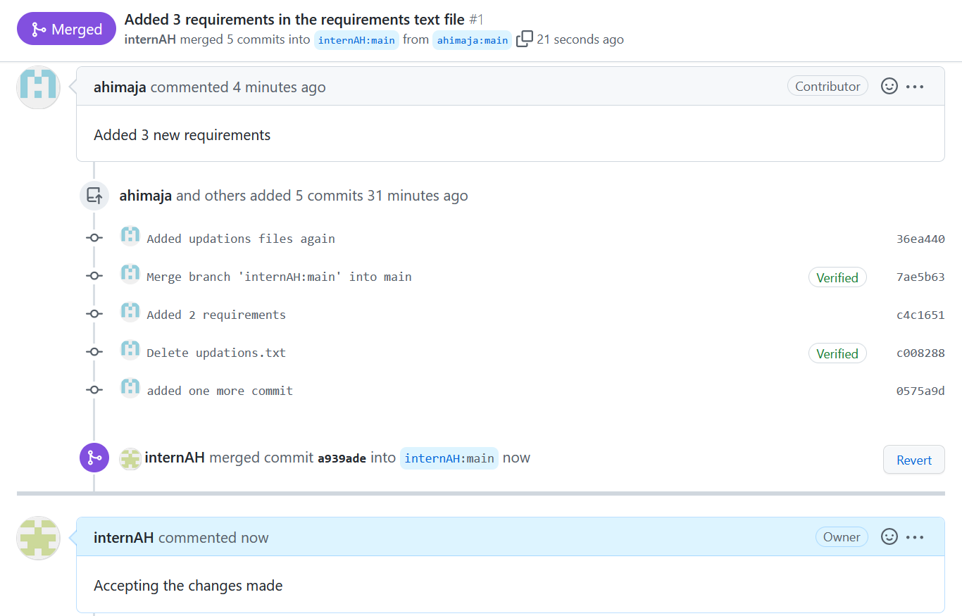

**Rejecting a pull request:**

I have made one more change to the repo of owner( internAH ), in the requirements.txt file and raised a new pull request to the owner

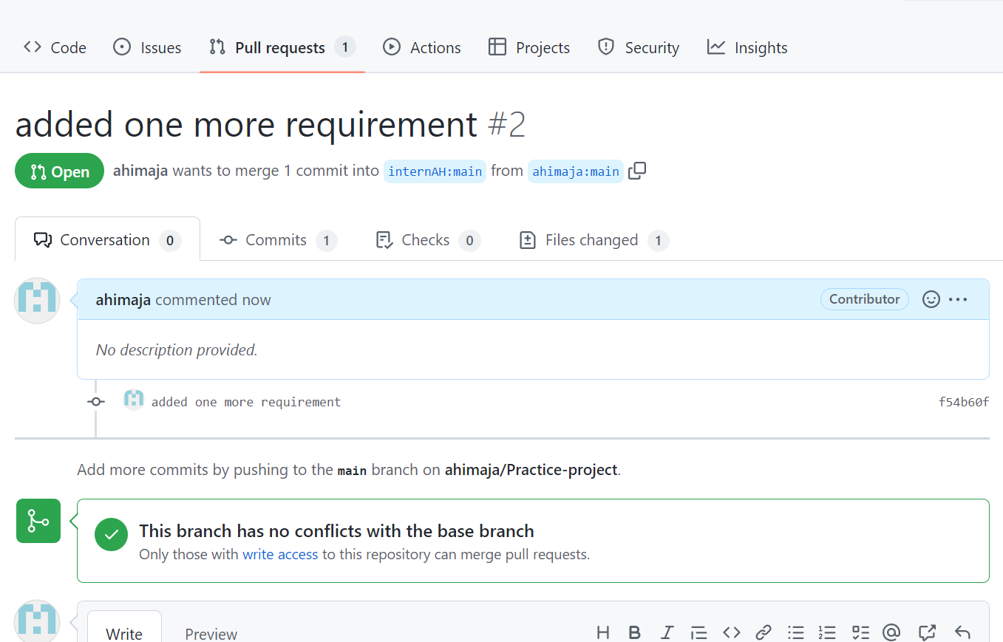

Now rejecting this pull request from repo source owner’s account

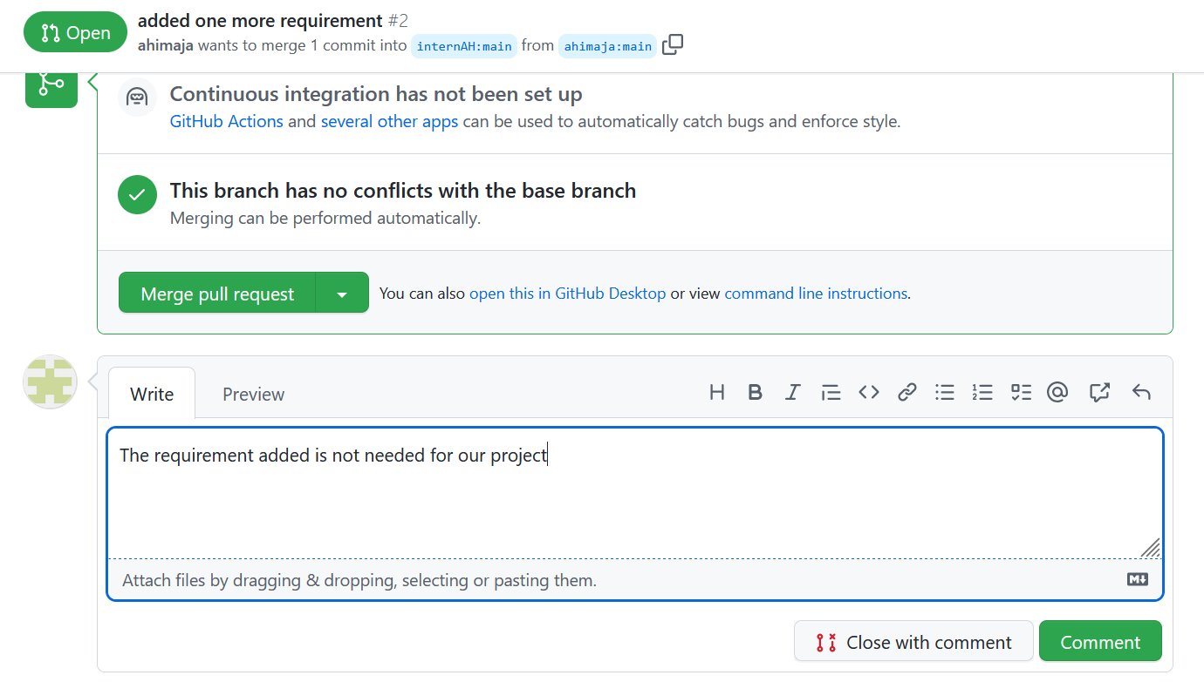

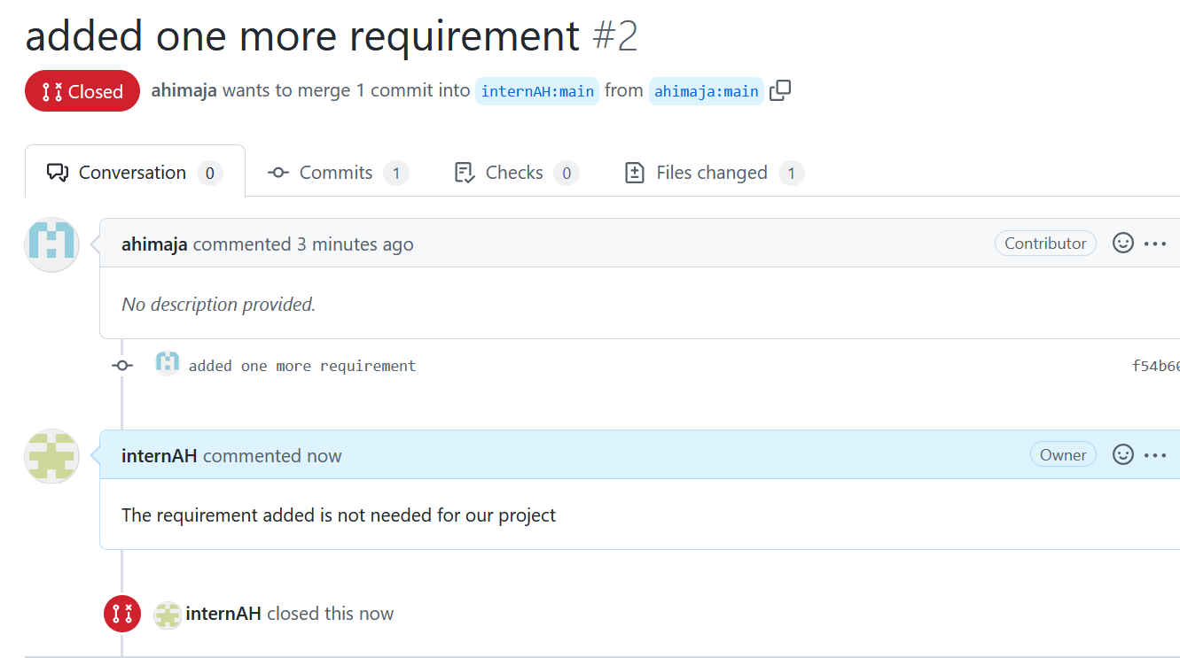

**Enabling dependabot alerts**

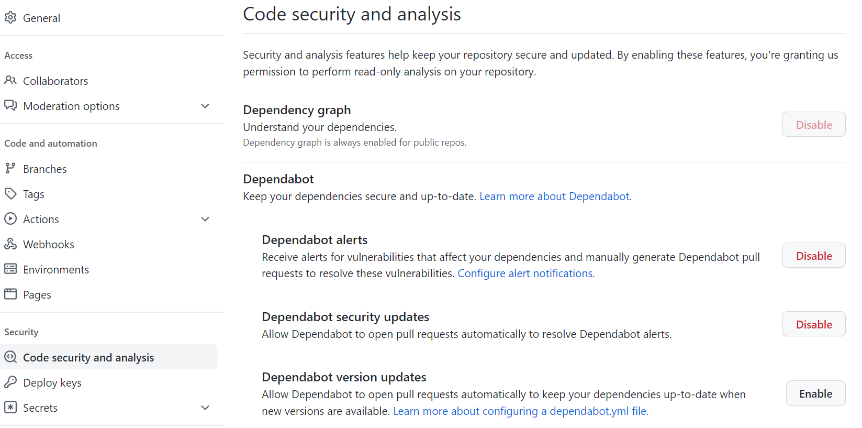

**Stash changes**

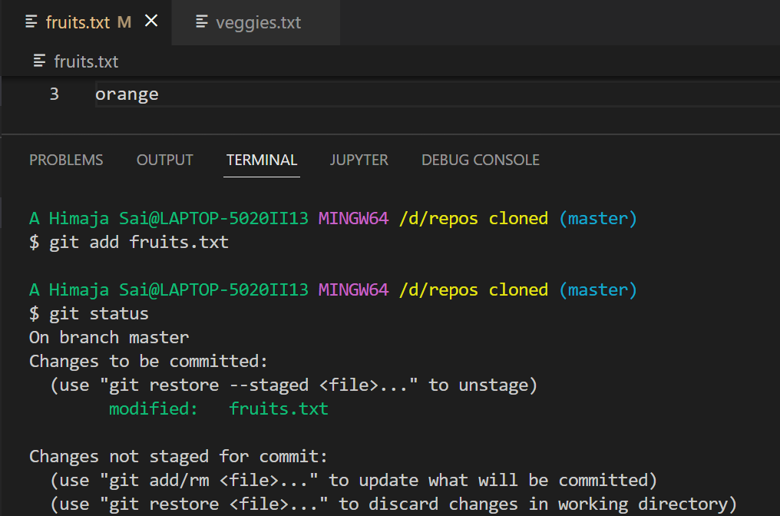

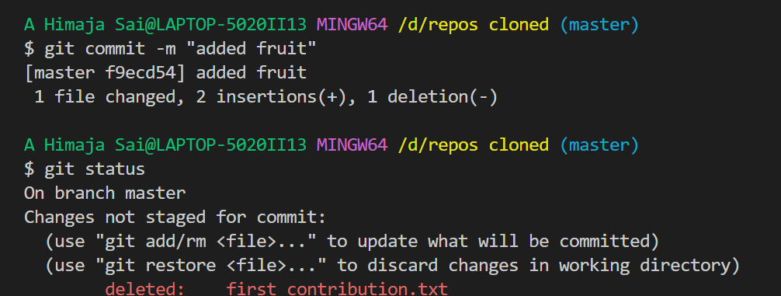

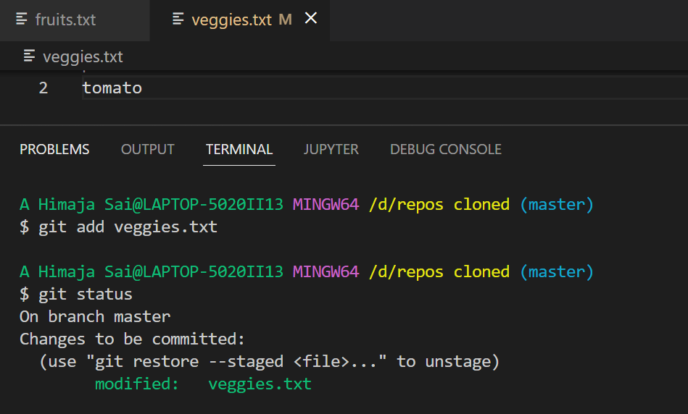

The changes in file fruits.txt is in committed state and changes in veggies.txt is in staging area. Now we will apply stash command

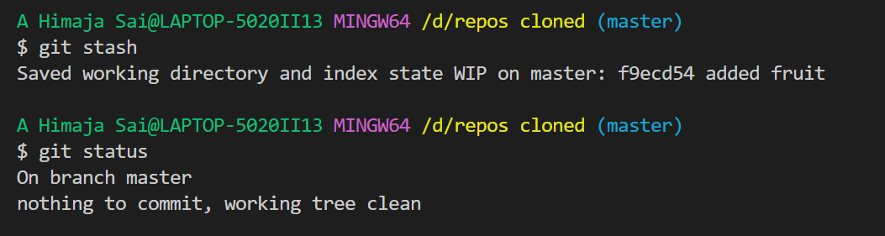

Stash command took all committed and uncommitted changes back to working directory stage

**Release of package:**

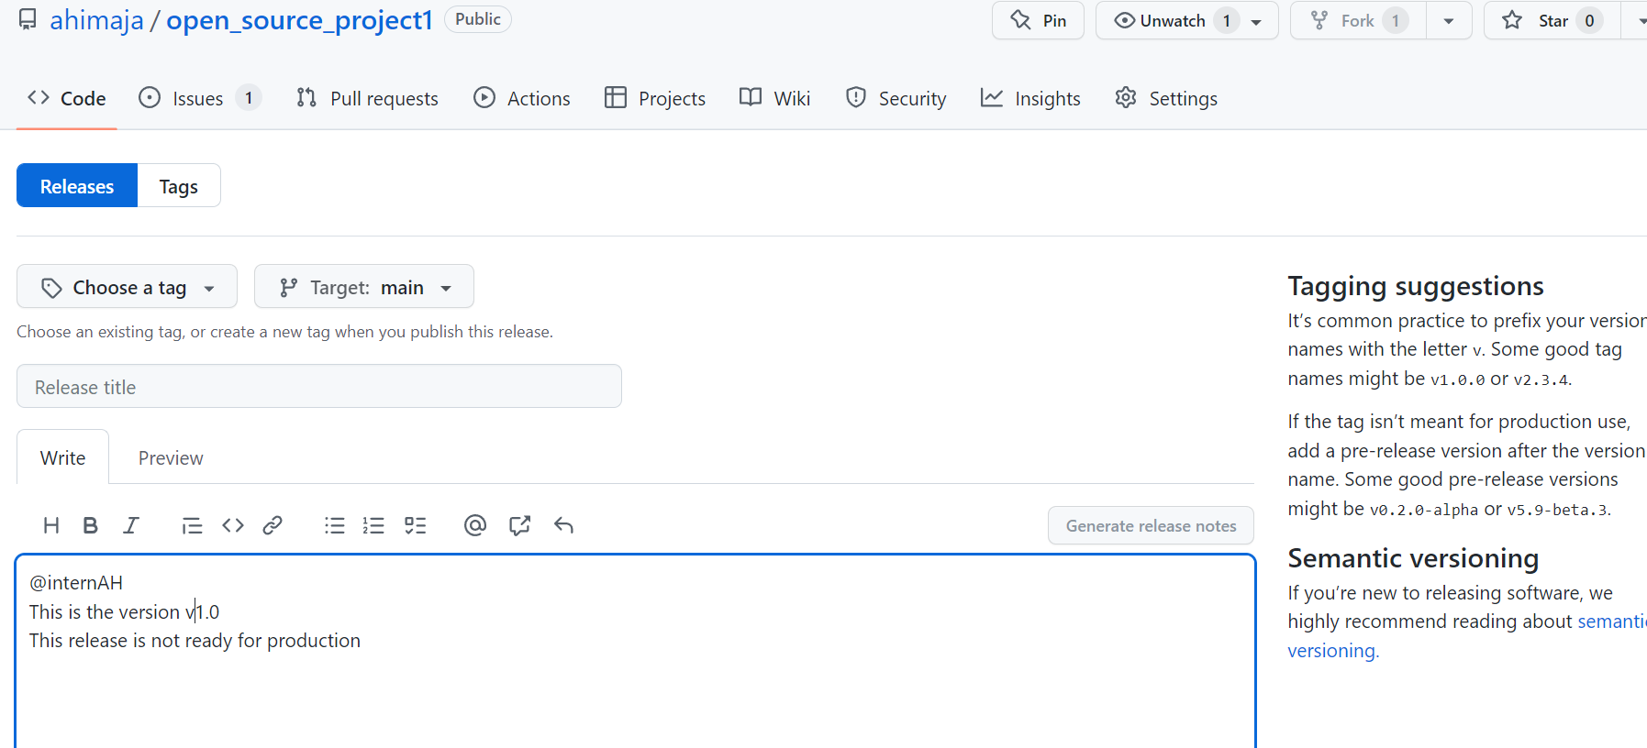

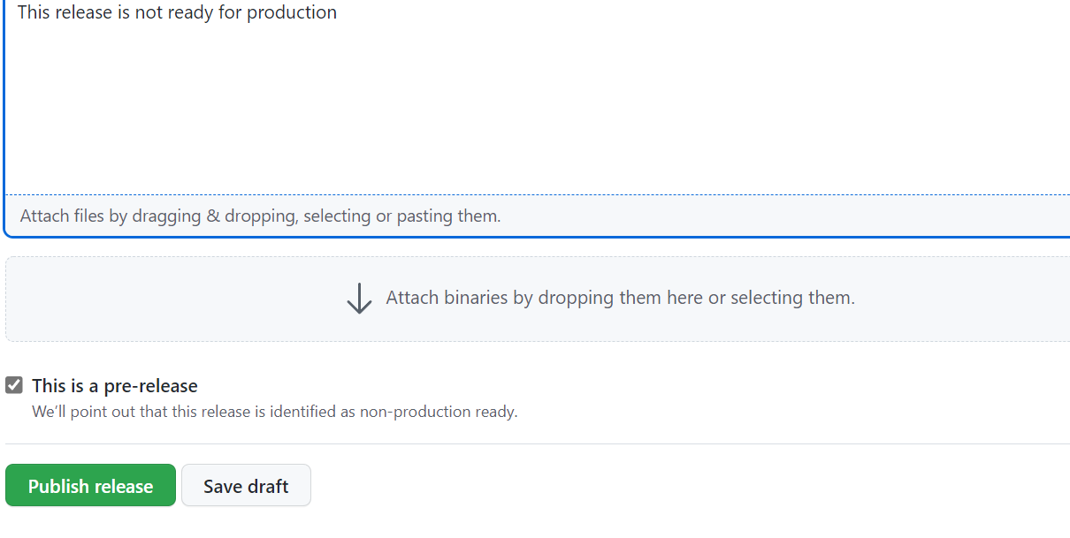

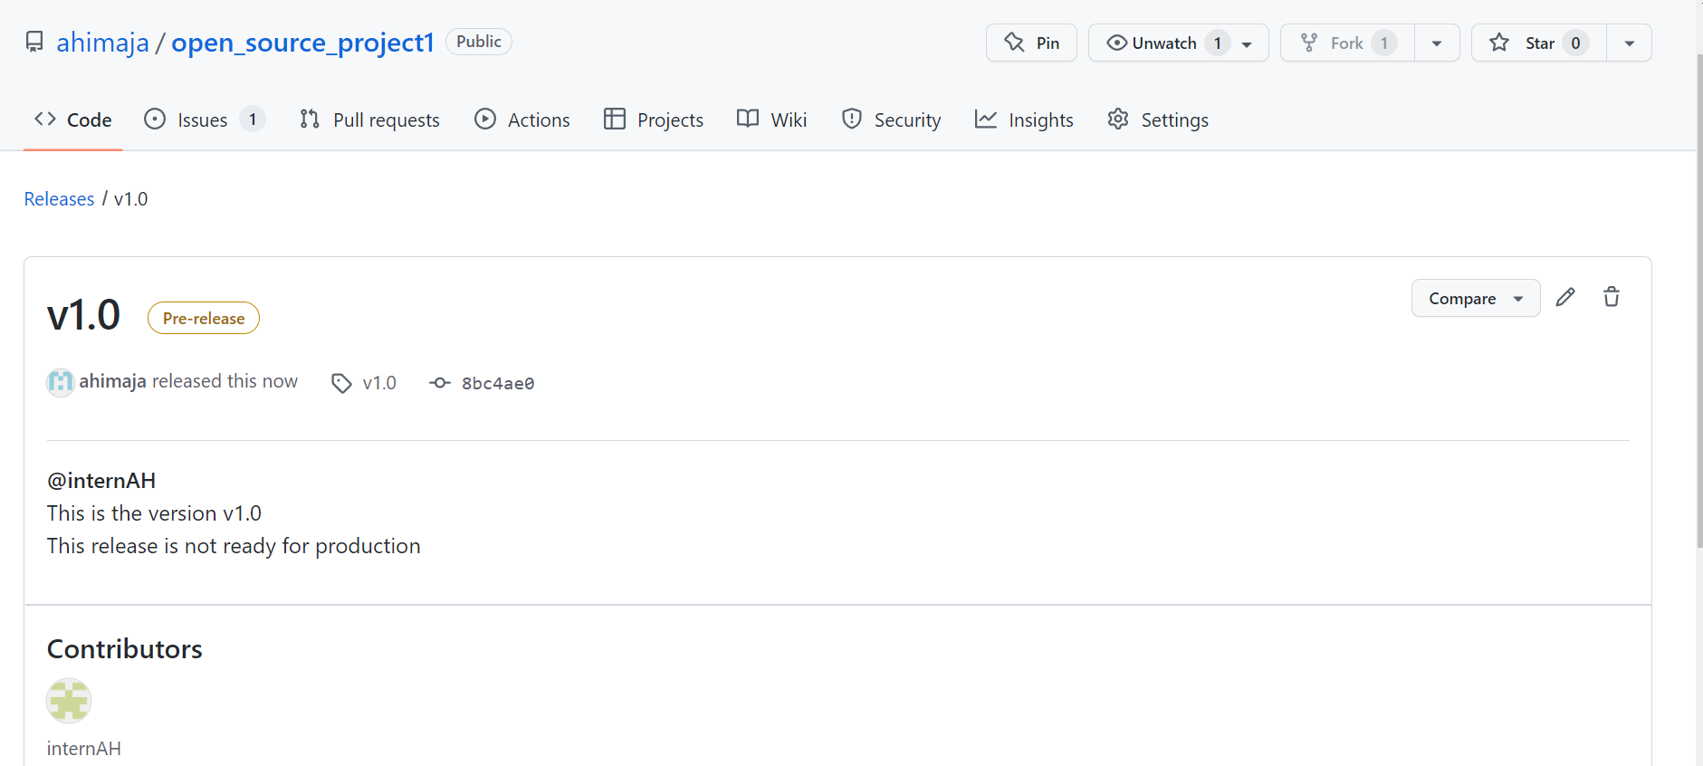

**Creating the project board**

