Three Odisha Connected
Character Worlds
  - Character development and merchandise report
  - 15 October 2026 | Edition 1
This report brings together three character sets developed for illustrated children’s stories and related products. It explains who the characters are, how their relationships create stories, what makes each visual world distinct, and what material is already available for review.
The portfolio now contains an earlier source-linked literary adaptation study, a newly developed everyday story and activity range, and a separate Koraput family adventure cast. Nilu–Chaiti has the broadest completed product exploration. The Koraput set has the most specific regional setting. Gudul–Gudli preserves the earlier adaptation and design development. These are different creative tracks with separate records.
Set | Core group | Current material
Gudul–Gudli | Two Class V children, a parrot and Elin | Character studies, character bible and three illustrated short stories
Nilu–Chaiti | Two children, an eager brown bird and a gentle puppy | Four model sheets, three bilingual stories, activity book and merchandise designs
Koraput cast | Kusum, Mandar, Reba Mausi and Chiku | Four model sheets, bilingual pilot comic, bookmark and squirrel sticker

What the report establishes
Each set has a usable concept and existing visual assets. Completion here means a digital creative deliverable exists; it does not mean the names are final, a printed sample has been tested or a retail launch has occurred. The original casts use working names. Independent fluent Odia review remains pending, and printer specifications and physical samples remain deferred.

How to read the report
Pages 2–4 cover Gudul–Gudli; pages 5–8 cover Nilu–Chaiti; pages 9–12 cover the Koraput cast. Pages 13–14 compare the options, identify the next decisions and record the source basis. The report is self-contained; it does not rely on local browser links.
Existing illustrations are development artwork. Personality extensions, clothing choices and new scenes are identified as project proposals where they go beyond the underlying source. No sales, audience-testing or production-cost evidence is claimed.
  - SET 1 | LITERARY ADAPTATION STUDY

Gudul and Gudli
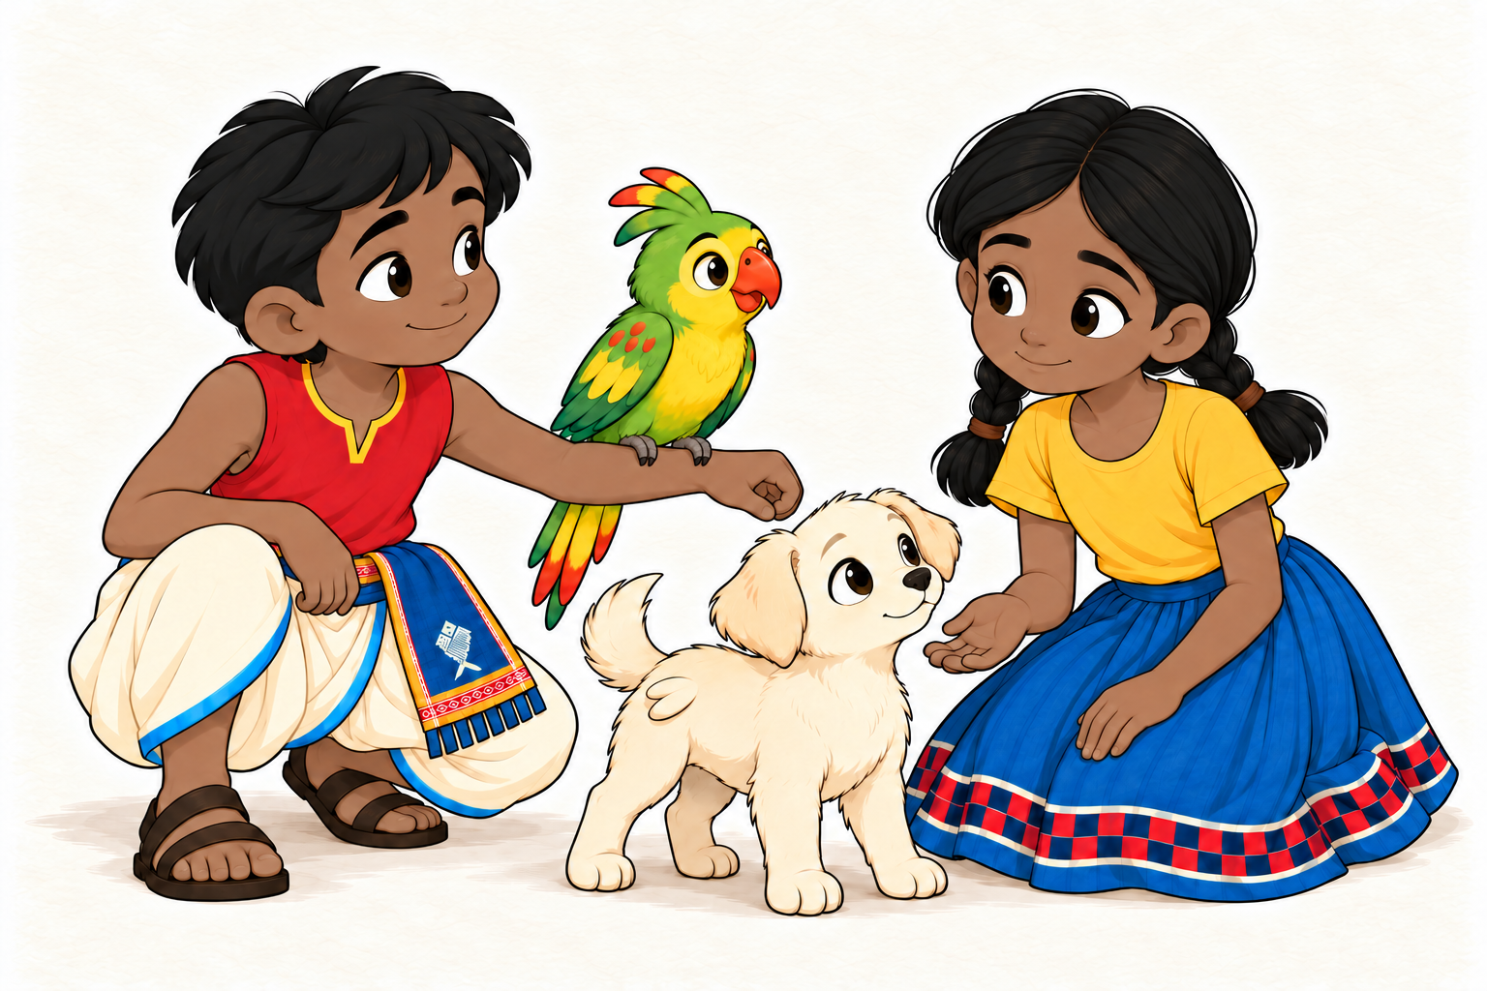
Selected ensemble study: Gudul, the parrot, Elin and Gudli. The grouping is a newly proposed scene.

Concept and origin
This set began with the characters in Snigdha Nayak’s Odia serial about Gudul and Gudli’s mysterious journey. The source establishes the children in Class V in Ajuba, their affection for the missing Elin, Gudul’s ability to understand animal language, and a shared investigation. The exact relationship between the two children is not settled in the recorded source material. [1]

Visual and emotional direction
The developed cast uses expressive faces, natural brown skin and warm interactions. Gudul’s selected presentation has an Aal Red shirt, cream lower garment and blue waistcloth. Gudli has two low plaits, a gold blouse and a blue skirt with a checker hem. These are adaptation design proposals; western, coastal and Habaspuri-inspired alternatives remain part of the archive. [2]
The strongest emotional thread is care expressed through action: listening, making room, trying something and correcting a small mistake. The new short stories explore this thread outside the unresolved serial chronology. They are separately developed project scripts, not stories credited to the serial’s author. [2, 3]
  - SET 1 | PERSONALITY AND PERFORMANCE

Gudul and Gudli character profiles

Gudul
Gudul wants to understand what is happening and do something useful for his friends. In the source, he understands animal and bird language and shares the investigation with Gudli. His developed personality adds attentive listening, an earnest wish to help and a tendency to wait for certainty or make a plan too tidy too soon.
His humour comes when a careful explanation misses an ordinary practical detail. His growth is to ask a useful question, admit what he does not know and attempt the next sensible action. Keep his dialogue brief and curious. A listening tilt, open hand and thoughtful pause can express him; he also needs impatience, delight, fear and silliness. He should not become an all-knowing interpreter. [2]

Gudli
Gudli turns an idea into something the group can try. The source already gives her active problem-solving moments, including a toy-parrot substitution and questioning a light in an apparently empty house. The developed personality emphasizes practical imagination and a willingness to act.
Her first workable idea can feel complete before she notices its effect on someone else. A confident claim followed by a self-amused correction is a useful comic beat. She grows by noticing the consequence, owning the mistake and changing the plan. Her forward lean and ready hands should coexist with hesitation and tenderness. Neither child is permanently the leader or the one who is right. [2]

The parrot
The source bird is described with green and yellow colouring, red markings, a crest and a colourful tail. It takes initiative in seeking information. Its developed role is a small participant whose contributions and physical needs matter. Pride can be interrupted by a sleepy blink, a stretch or an awkward perch. In the new short pilots, chirps and visible behaviour carry the performance. No proper name, exact species or sex has been assigned from the illustration. [1, 2]

Elin
Elin is a pale dog-like companion with large round eyes and small wing-like features near the waist. The source leaves the origin and the function of those features unresolved. The proposed short-story personality is gently persistent: Elin approaches, tries, pauses and chooses whether to join. Gaze, ears, paws and posture carry the action. Elin should be allowed ordinary agency rather than always being carried or rescued; no new flight ability or translated thoughts are established. [1, 2]
  - SET 1 | COMPLETED CREATIVE WORK

Gudul and Gudli stories and assets

Three short stories
The three-story collection develops small, self-contained situations with warm humour. Across the stories, the cast can share attention, notice an overlooked need or enjoy a game without resolving the larger serial mystery. The collection preserves 18 panels, 13 spoken lines and eight sound labels from the selected finished editions. [3]
Story | Situation and dramatic purpose
Room for One More | A limited dry space seems too small for everyone. Small changes in posture and position make room; the animals’ needs shape the solution.
Who Moved? | A keep-still game becomes funny when the surroundings move and a resting companion unexpectedly wins. Attention and timing carry the scene.
Drip, Tap! | A roof drip becomes a shared rhythm. The cast listens and joins in, then a quiet pause and a final bird call finish the joke.

What has been made
Character development. Construction, expression, colour, clothing and acting studies; selected individual illustrations; an ensemble picture; and a character bible distinguishing source facts from new personality proposals.
Story development. Scripts, staging studies, rough storyboards and finished pages for the three short stories. Selected revisions are preserved alongside earlier versions.
Reading editions. A local reading collection, offline HTML and ZIP editions, and a ten-page landscape PDF with contents navigation and embedded Odia lettering. These are digital reading editions. [3]

Role in the wider portfolio
This track documents the early literary and visual exploration. It is useful for discussing adaptation, character acting and the development of the short-story format. It should remain clearly labelled when shared alongside the newer original casts. Its source identities, distinctive animal designs and unresolved mythology are not the identity of Nilu–Chaiti.
The finished short scripts were developed within this project. Their credit should remain separate from the credit for Snigdha Nayak’s underlying characters and serial. The records do not establish author approval of the adaptation or a merchandise arrangement. This report records that distinction without reaching a legal conclusion. [1–3]

Remaining decisions
Any further adaptation work needs a defined creative scope: retain the short-story archive, develop another proposed episode, or explore a specific adaptation opportunity. The saved serial record does not settle later revelations, exact ages or kinship. These should not be filled in as facts simply because a drawing suggests an answer.
  - SET 2 | ORIGINAL STORY AND ACTIVITY RANGE

Nilu and Chaiti
Working Odia name: ନୀଳୁ–ଚଇତି. Nilu–Chaiti is the selected provisional name and may change. [4]
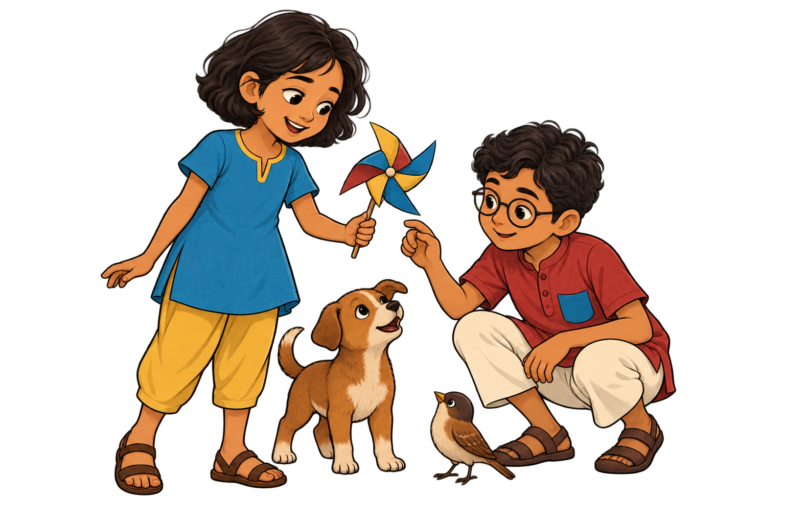
First cast concept: Chaiti, the gentle puppy, the eager bird and Nilu in an ordinary shared making moment.

The concept
Nilu–Chaiti is an Odisha-connected world of observing, making, playing and helping. A thoughtful listener and a quick practical experimenter approach the same small problem differently. Their bird and puppy companions have needs and choices visible in ordinary animal behaviour. Neither child has an inherited animal-language power. [4]

What carried forward and what changed
The project retained its newly developed personality themes and three small story premises, then created fresh character appearances, drawings and staging. The new world does not carry forward Ajuba, the serial’s household mystery, the missing-Elin quest, Elin’s unusual anatomy or the distinctive crested parrot. The development record therefore describes more than a name change, while openly acknowledging the creative work that preceded it. [4]
The setting is broadly connected with Odisha through everyday life, Odia language and a palette informed by laterite, sea blue and ripe-paddy gold. No exact district, child age or kinship is fixed in the current brief. These remain available for later world development.
  - SET 2 | PERSONALITY AND DRAWING IDENTITY

Nilu and Chaiti character profiles

Nilu the thoughtful listener
Nilu wants to understand what is happening and help a friend in a concrete way. He observes carefully, listens and looks for patterns. His flaw is turning uncertainty into an overly tidy plan, or postponing an attempt until he feels sure. His growth is to ask a useful question and try a modest next step.
A compact square face, round glasses and short wavy hair make him easy to recognise. He wears a red short kurta with a blue pocket on his anatomical left, ivory cropped trousers and sandals. Use calm attention, a listening crouch and an open-hand invitation without limiting him to one serious expression. His humour is an earnest explanation meeting a small detail he missed. [4, 5]

Chaiti the practical experimenter
Chaiti wants to turn an interesting idea into something friends can try together. Her strength is practical imagination. Her first success can make her overlook a consequence, so her growth is to own a mistake, revise it and keep her curiosity. A pause after a confident claim lets her laugh at her own correction.
Her visual identity is an oval face and short wavy bob, with a blue A-line tunic, narrow gold neckline and muted-gold cropped trousers. Trying and rethinking are equally important poses. She must not become a permanently correct girl or Nilu’s assistant; either child can discover the answer, need help or make the final joke. [4, 5]

The eager bird
This companion is a small brown bird with a short tail and no crest. It is a new visual identity, with no fixed personal name in the current records. Alertness and initiative give it a reason to enter a scene; excitement can make a small discovery seem enormous. Proud intent, a sleepy blink and an inconvenient perch create gentle comedy. Keep its movement and body language birdlike. Its response is observable behaviour, not a supernatural translation device. [4, 5]

The gentle puppy
The russet puppy has ordinary anatomy, a cream chest patch and no fixed personal name. It wants to join on its own terms. Patient attention and persistence are strengths; trying alone for a moment too long, or copying before understanding, create small difficulties. It can accept help while keeping the choice to approach, pause or move away. A serious inspection and a final paw adjustment provide its quiet comic rhythm. [4, 5]

How the group creates stories
A careful plan meets a practical attempt, while the animals draw attention to something the children missed. Rotate who notices, makes a mistake, repairs it and needs care. Kindness should be visible in what the characters do rather than added as a lesson at the end. Names and captions remain editable text outside the illustration pixels.
  - SET 2 | READING AND PARTICIPATION

Nilu and Chaiti stories and activities

Three bilingual stories
The three premises developed earlier in the project have been reworked with the new cast, fresh drawings and ordinary animal behaviour. Each has a script, rough storyboard, finished page and individual digital bundle. The combined five-page storybook contains a cover, illustrated contents and one page for each story. [6]
Odia title | English title and focus
ଆଉ ଜଣଙ୍କ ପାଇଁ ଜାଗା | Room for One More — making space and noticing an overlooked need
କିଏ ହଲିଲା? | Who Moved? — stillness, observation and an unexpected winner
ଟପ୍, ଠପ୍! | Drip, Tap! — listening, shared rhythm and comic timing

The Adventure Book
The 12-page Odia–English Adventure Book extends the cast into activities. Its intended audience is roughly ages 6–9, with an adult helping when needed. Eight activity pages invite observation, drawing, route-finding, rhythm, experimentation, patterns, inclusion, listening and storytelling. These are design intentions; learning outcomes have not been tested. [7]
Page | Activity | What the child does
3 | Look a little closer | Find and draw round, long and small objects
4 | Which way to the water | Trace a route from puppy to water bowl
5 | Make a little rhythm | Clap and pause, then invent a pattern
6 | A paper bridge | Try a paper experiment with an adult
7 | What comes next | Continue a pattern
8 | Room for everyone | Think about space and inclusion
9 | Listen for a moment | Pay attention to sounds
10 | My little story | Create a short story

The book also includes its opening pages, a note for adults and back matter. The current language revision is v2: six changes were made on pages 4, 6, 7 and 11 after an initial editorial pass. The story dialogue and artwork were retained. Independent fluent-reader review is still pending. [7]
  - SET 2 | PRODUCT CONCEPTS AND DIGITAL PROOFS

Nilu and Chaiti merchandise
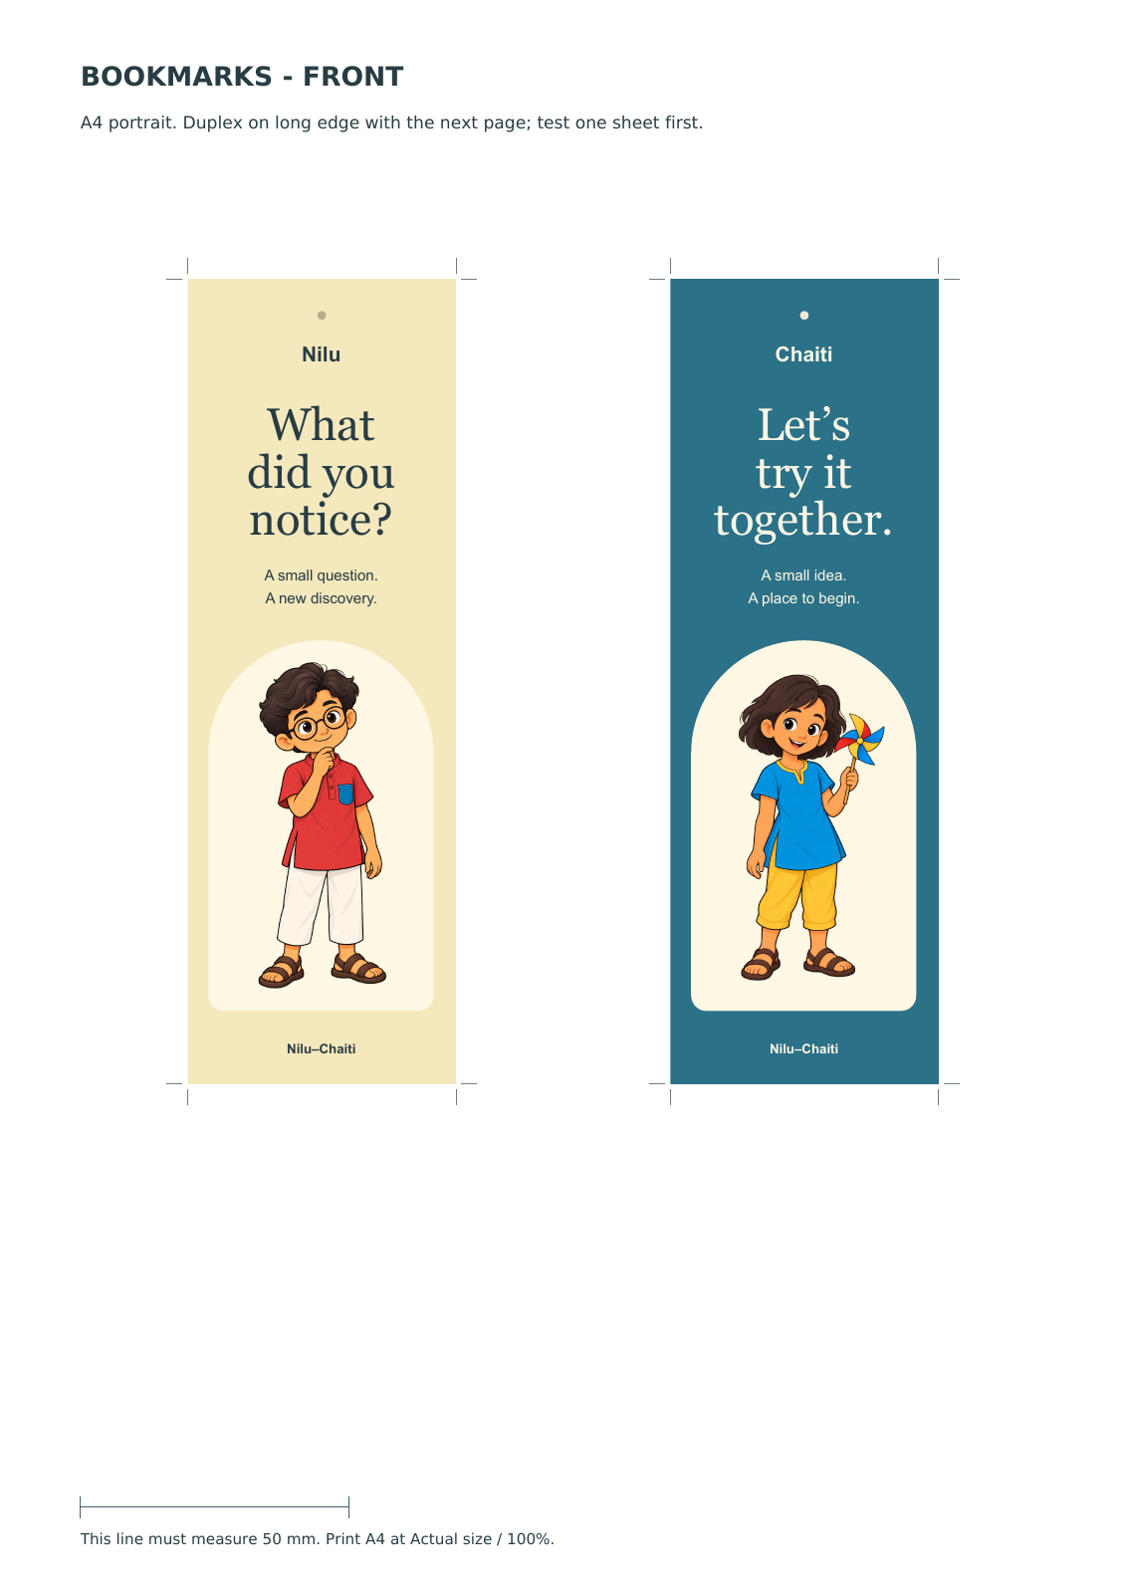
Existing A4 merchandise proof. Dimensions and layouts are design proposals awaiting printer-specific preparation.
Item | Current proposal
Bookmarks | Two individual fronts with bilingual backs; proposed finished size 50 × 150 mm
Stickers | Four-character sheet using separate Nilu, Chaiti, bird and puppy illustrations
Pouch panel | Artwork panel proposed at 100 × 65 mm; a panel design rather than a manufactured pouch
Adventure Book | 12-page A5 reading edition, bleed-layout edition and A4 booklet arrangement

The current Adventure Pack v2 includes the three book PDFs plus merchandise master and A4 proof PDFs. The filenames describe digital design deliverables; the printer’s colour requirements, stock, binding, finishing and other production specifications have not been applied. Physical samples remain deferred. [7, 8]
This is the broadest existing merchandise range in the portfolio. A small paper-goods sample batch would be a practical way to assess lettering, colour and durability when printing resumes. No price, margin, demand or retail-readiness claim is attached to the concepts.
  - SET 3 | A DISTINCT REGIONAL WORLD

The Koraput family adventure cast
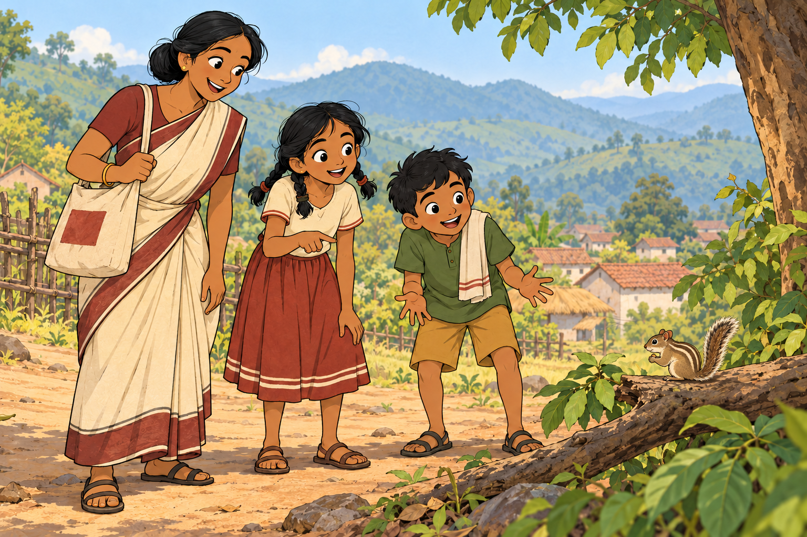
Selected group concept: Reba Mausi, Kusum, Mandar and Chiku near a fictional village in the Koraput hills.

The concept and home
Two cousins and their aunt turn everyday errands into small adventures near a fictional village and forest edge. The contemporary world includes school routes, a family courtyard, a weekly market, fields, hills and familiar paths. The working audience is children aged 6–10, with adult-supported reading for younger children. [9]
Koraput in southern Odisha replaced the earlier Sambalpur–Hirakud direction. Regional research informs the landscape and broad clothing references. The family, village and occupations are invented, and no particular Adivasi community or ceremonial identity has been selected. Cultural connection comes through language, relationships, work and place as well as clothing. [9, 13]

Why this set is distinct
The adult is a recurring participant with her own work, mistakes and humour. Kusum’s desire for a plan meets Mandar’s imagination, while Chiku’s movement changes what everyone notices. Cream, rust, maroon, green and ochre distinguish the palette. Four model sheets supply 32 studies of views, expressions and actions. [9, 10]
  - SET 3 | FOUR DIFFERENT CONTRIBUTIONS

Koraput character profiles

Kusum
କୁସୁମ | Girl aged 10 | Working profile
Kusum wants real responsibility, such as remembering the market errands. She organises tasks, recalls familiar places and follows through. Her difficulty is assuming that a remembered place must still look the same; she can become impatient or interrupt. A confident announcement followed by a quiet adjustment gives her humour. Her growth is to change a plan and share the lead. Two plaits, a cream blouse with rust sleeve bands and a rust skirt with two pale hem bands anchor her design. In the pilot, she recognises the rock at the turning place. [9, 10]

Mandar
ମନ୍ଦାର | Boy aged 8 | Working profile
Mandar wants a useful part in the outing and a good story to tell afterwards. He invents explanations, notices unexpected movement and lightens a tense moment. He can love an exciting explanation before checking it. His growth is to look again while keeping his imagination. He acts out sounds and movements, and can laugh at his own dramatic theory. Keep his short tousled hair, green shirt, ochre shorts and cream cloth on his anatomical left shoulder. In the pilot, he spots the path and supplies the hide-and-seek joke. [9, 10]

Reba Mausi
ରେବା ମାଉସୀ | Woman aged 31 | Working profile
Reba sews and repairs clothes and cloth bags. She wants to finish her work, keep her promises and enjoy time with the children. She is practical and patient, yet can underestimate an errand or hurry past a detail. A dry reply can deflate a grand theory without belittling a child. She can forget something and accept a reminder. Her model uses a low bun, cream sari with maroon border, pallu on the left shoulder, work bag on the right and one right-wrist bangle. In the pilot, she selects another familiar route. [9, 10]

Chiku
ଚିକୁ | Three-striped palm squirrel | Working nickname
Chiku is a free-living neighbour, not a pet or speaking guide. The children recognise the squirrel, which has its own activities and can come and go. Its movement brings distraction, visual comedy and occasional clues. The model retains three pale back stripes, a cream underside, small rounded ears and a bushy tail. Age and sex are unspecified. In the pilot, crossing a branch draws Mandar’s attention to the hidden path; helping is not presented as the squirrel’s intention. [9–11]
In the proposed family, the children’s mothers and Reba are three sisters, making Reba Mausi to both cousins. This invented relationship, the names and the ages remain editable. Odia leads the storytelling; English introduces Reba as their aunt before retaining Mausi as an address. [9]
  - SET 3 | THE FIRST BILINGUAL PILOT

The Path After Rain
ବର୍ଷା ପରର ବାଟ
After rain, a market errand becomes puzzling when a familiar path appears to stop. The family works out what has changed and chooses another route. The ending turns the apparent mystery into Mandar’s joke about a path playing hide-and-seek. [11]
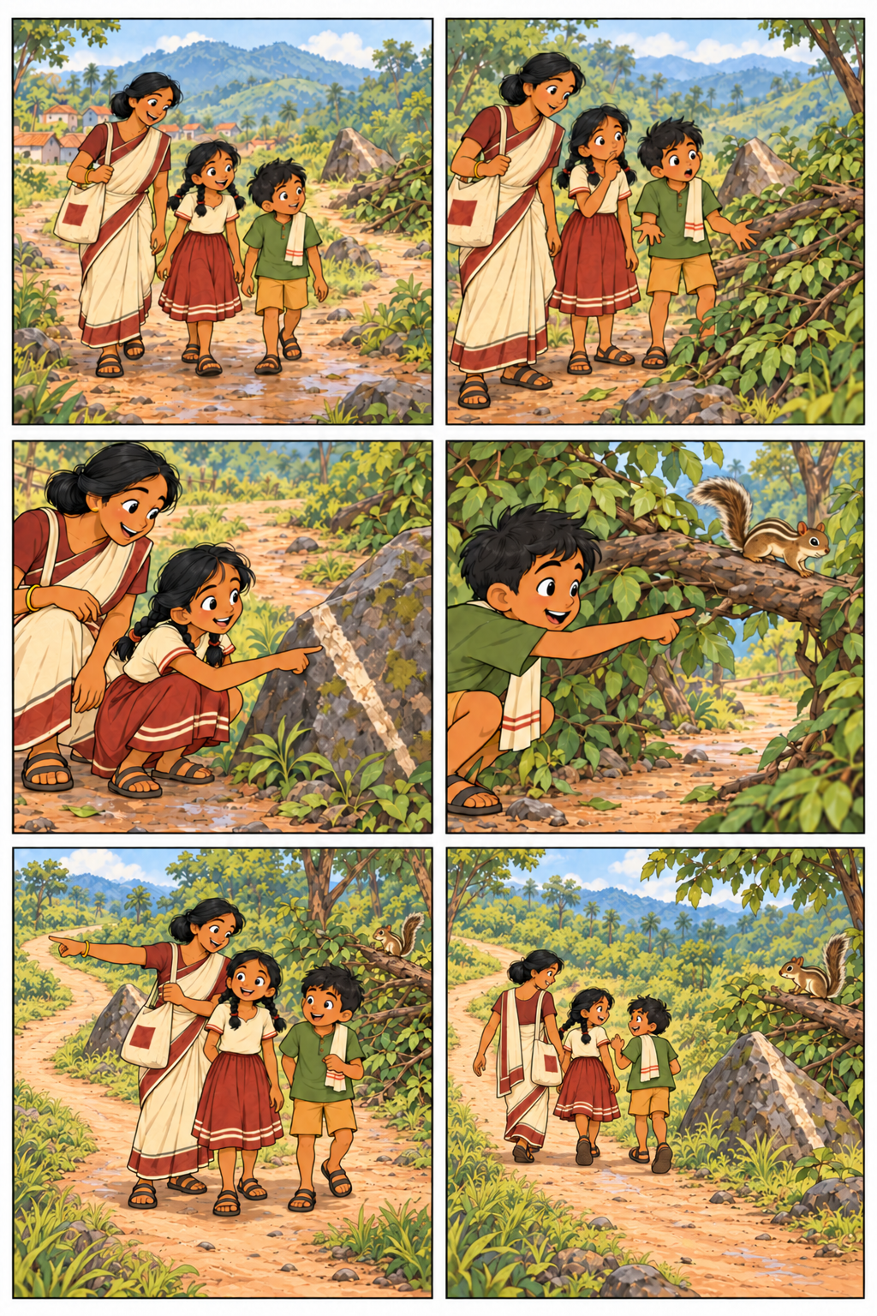
Six-panel artwork for the current lettered pilot. Odia and English lettering are supplied separately in the reading editions.

How the story works
Reba’s need for sewing thread gives the outing a purpose. Kusum first claims to know the way, then doubts it, then recognises the rock. Mandar follows Chiku’s movement and sees the path behind the leaves. Reba chooses the alternative route. Each human contributes to solving the immediate problem; the squirrel remains an independent animal.
The finished digital v1 has separate Odia and English pages, a bilingual reader, shareable page images and an offline pack. The last two panels clarify the open left fork around the rock. The original script wording was retained. The rough storyboard and earlier art remain as revision history. [11]
  - SET 3 | FIRST MERCHANDISE EXPLORATION

Koraput products and editorial review
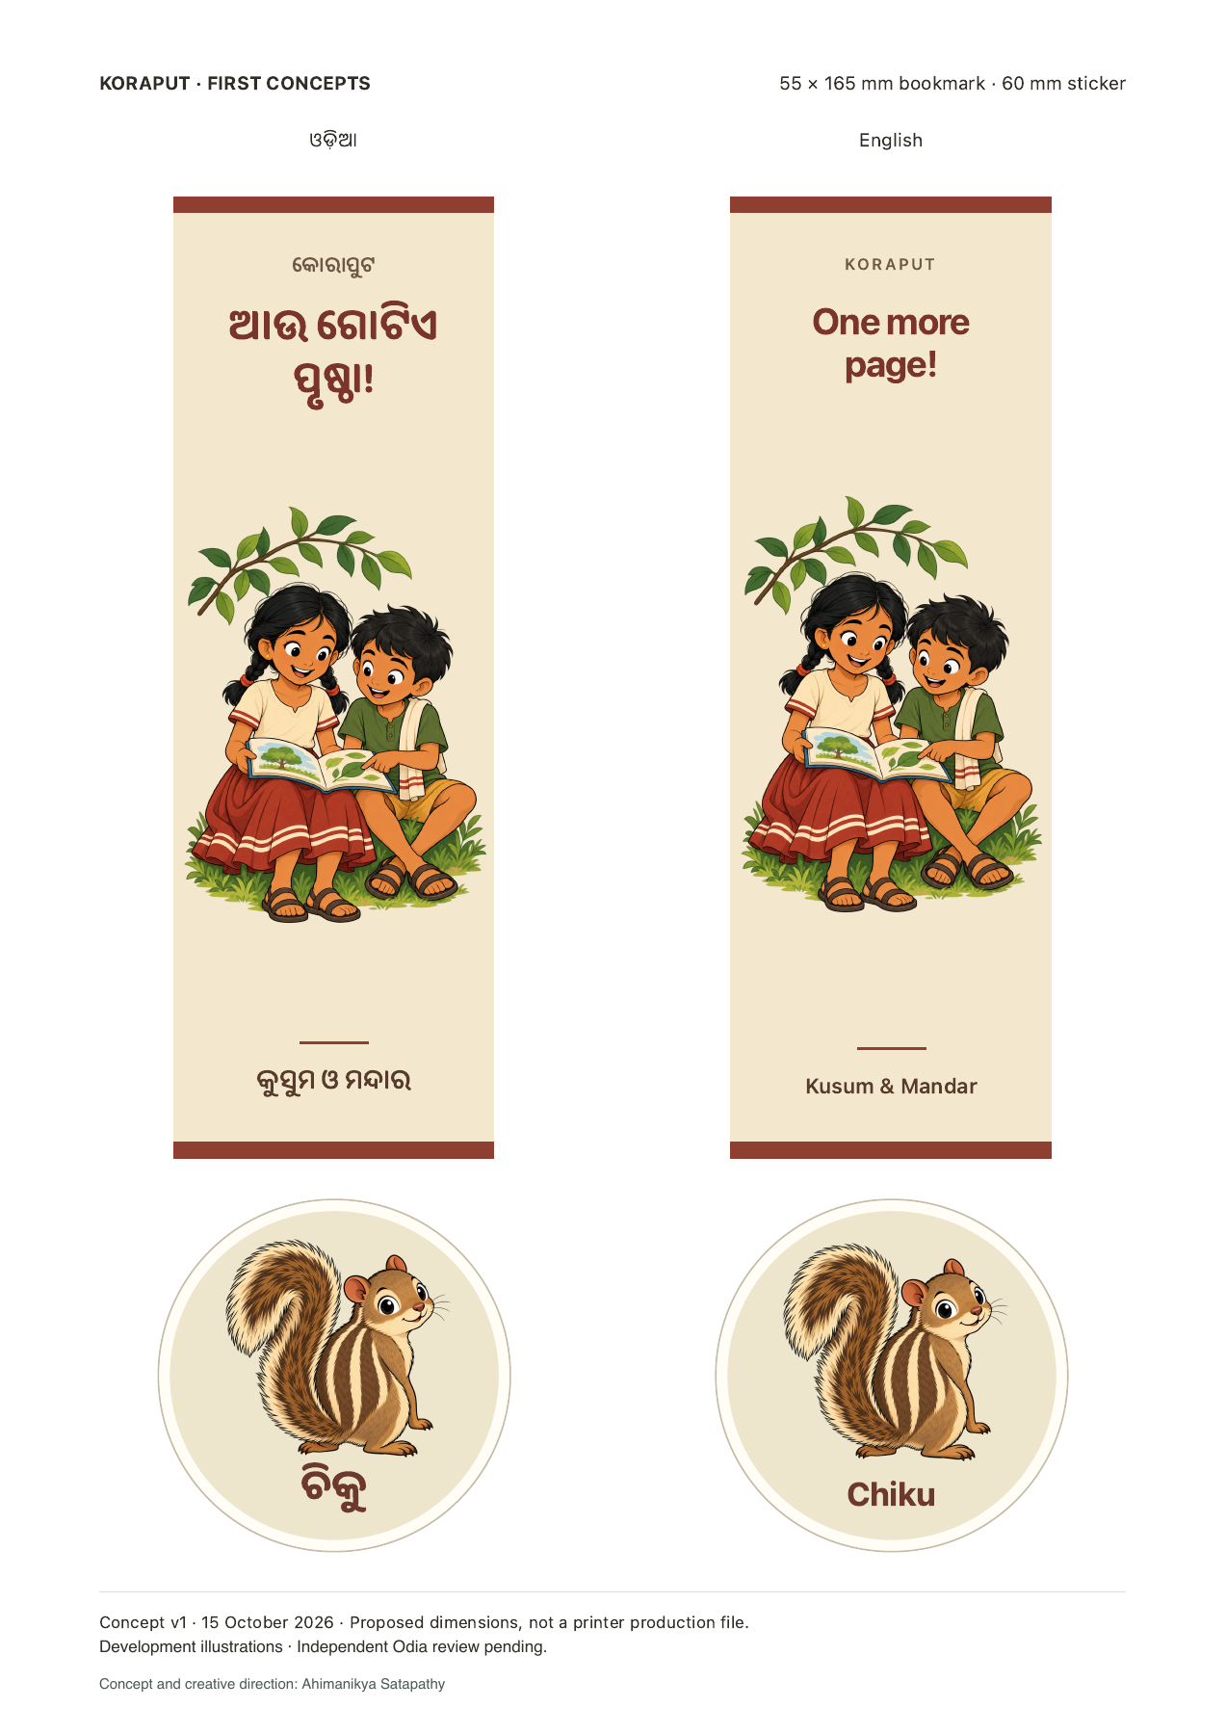
A4 size proof showing Odia and English bookmark and Chiku sticker variants.

Two focused product concepts
The bookmark front shows Kusum and Mandar reading together, with “ଆଉ ଗୋଟିଏ ପୃଷ୍ଠା!” and the companion English “One more page!” The proposed finished size is 55 × 165 mm. The Chiku sticker uses the squirrel’s recognisable silhouette and three stripes; its proposed size is 60 mm, with a 32 mm reduced preview for comparison. Transparent illustrations, editable lettering, an A4 PDF proof and an offline concept pack are available. [12]

Language review status
The initial text comparison compared 22 paired entries: one title, four names, three captions, ten dialogue lines and four product labels. No wording was changed. An illustrated review page and editable feedback copy are ready for an independent fluent Odia reader. [12]
Entry | Point to discuss
P1 D1 | Whether Reba’s English opening should express the shared plan to buy thread more explicitly
P3 D1 | Whether Kusum’s Odia phrase for taking the familiar turn sounds natural when spoken aloud
P6 D2 | Whether the English final reply should use a more playful hide-and-seek response

These are optional editorial choices, not confirmed errors. Reader feedback should give the exact proposed wording and a short reason. Naming decisions and any cast revisions remain open. Printer-specific files and physical samples remain deferred.
  - PORTFOLIO | DEVELOPMENT PRIORITIES

Comparison and next decisions
Dimension | Gudul–Gudli | Nilu–Chaiti | Koraput cast
Creative basis | Source-linked adaptation study | Original cast development with documented carryover of project-created themes | New fictional regional family and pilot
Relationship pattern | Two children and two companions | Two children and two ordinary animal companions | Two cousins, an aunt and a free-living squirrel
Story emphasis | Care, shared investigation and small comic situations | Observing, making, trying again and inclusion | Family errands, differing explanations and visible clues
Regional definition | Odia literary basis; several clothing alternatives | Broad Odisha connection; no fixed district | Fictional contemporary village in Koraput
Available stories | Three short stories | Three bilingual short stories | One bilingual pilot
Product depth | Story and character archive | Activity book, bookmarks, stickers and pouch artwork | Bookmark front and Chiku sticker
Immediate open work | Define any further adaptation scope | Fluent Odia feedback and eventual sample preparation | Fluent Odia feedback and a second story if commissioned

Recommended order of work
1 Finish language decisions. Use the prepared review copies for Nilu–Chaiti and Koraput. Apply specific feedback across scripts, lettering, exported pages and product labels, then check the affected layouts. Self-review is already recorded; independent review is still open.
2 Settle the identities. Confirm or replace working names. For Nilu–Chaiti, decide whether the animal companions need personal names and whether a fixed place or relationship adds value. For Koraput, confirm the proposed family and names before expanding the series.
3 Extend the strongest creative need. Nilu–Chaiti is the practical choice for a small paper-product pilot because the range is already broad. A second Koraput story would test whether its family dynamic works beyond the first outing. These are development recommendations, not evidence of market demand.
4 Resume printing when ready. Use the chosen printer’s specifications to prepare the selected files and a small sample batch. Check type, trim, colour, stock, binding and finish on the actual sample. Pricing and quantities can follow supplier quotes and sample results.
For sharing now, use this report to discuss characters and direction. The digital storybooks and product packs are supporting creative material; no physical stock, sales performance or calibrated production result is represented.
  - REFERENCE | DEVELOPMENT RECORDS

Sources and asset register
The numbered references identify the project records supporting this report. Artwork and character proposals remain versioned in three separate archives. Local folder references below are archive identifiers; the report itself can be read without access to those folders. This edition records the state on 15 October 2026.

Gudul and Gudli
[1] Source provenance record in the Gudul–Gudli archive, covering Snigdha Nayak’s serial instalments from July to October 2026. [2] Character bible v1 and selected ensemble v2, including the boundary between source facts and proposed personalities, clothing and scenes. [3] Three-story collection handoff and PDF edition record, updated 15 October 2026.
Source serial reference in Sishu Kishore
Archive: 2026-10-12/character-studio. Shareable story file: gudul-gudli-three-stories-v1.pdf. The serial source is credited for the source characters; the separately developed short scripts are project work.

Nilu and Chaiti
[4] Original world brief v1 and visual brief v1. [5] Character models record and selected listener, experimenter, bird and puppy model sheets v2. [6] Stories record and collection v1. [7] Adventure content v2, language review v2 and current handoff. [8] Product artwork record and Adventure Pack v2.
Archive: 2026-10-15/original-merchandise. Shareable files: nilu-chaiti-three-little-stories-v1.pdf; nilu-chaiti-adventure-pack-v2.zip; nilu-chaiti-language-review-v2.zip. The pack includes activity-book and merchandise PDFs.

Koraput cast
[9] Project brief v11, world brief v9 and character profiles v1. [10] Model sheet guide and selected sheets: Kusum v1, Mandar v1, Reba v2 and Chiku v1. [11] Pilot script v1 and finished review v1. [12] Merchandise manifest v1 and editorial review record v1.
Archive: 2026-10-15/koraput-cast. Shareable files: koraput-lettered-pilot-v1.zip; koraput-merchandise-concepts-v1.zip; koraput-editorial-review-v1.zip; koraput-character-model-sheets-v1.zip.

Regional evidence and its scope
[13] Odisha Tourism’s Southern Odisha overview supports the regional framing of Koraput’s hills and markets. The project’s animal research cites the Odisha Forest Department’s Koraput Forest Division working plan, section 3.6.1, for the three-striped palm squirrel. Clothing reference notes include the Government of India’s Kotpad weaver profile. These references inform context; the family, village, garments and events are inventions.
Odisha Tourism Southern Odisha
Koraput Forest Division working plan 2021–22 to 2030–31
Government of India handloom profile for Gobardhan Panika
All reproduced illustrations are existing project assets; this report adds no new character artwork. Exact generation prompts and earlier versions remain in the project archives. The report does not record independent language or cultural approval, final naming, or a production launch.

