GSE Analysis Code

Instructions for use

1. Image requirements for analysis:

a. Fluorescence microscopy images (not brightfield)

b. Images must be acquired in one of the two following ways:

i. A continuous time-sequence of 10,000 images (any frame rate)

ii. A shuttered (discontinuous) time-sequence of images, in which image clusters (containing 100 images each) are acquired within 1-second intervals, alternating between 9-second gaps in which no images are acquired. There should be a total of 10 image clusters, or in other words 1000 images taken over the space of 100 s.

c. Images must be saved as individual .tif files using the format *filename*_0001.tif, *filename*_0002.tif, *filename*_0003.tif, etc. The sequential file numbers should have 4 digits, as shown.

*NOTE: the frame rate (in frames per second) and the pixel values (e.g. 65536 for 16-bit images) of the images will need to be specified in the GSE_Analysis.m script.

2. Use Video Spot Tracker, downloadable from CISMM website (not included, link: <http://cismm.web.unc.edu/software/>), to track fluorescent particles in the image sequence. Tracks are saved in a *.vrpn file.

3. Use “VRPN log to matlab” software (downloadable at <http://cismm.web.unc.edu/software/>, see under “Legacy Software”) to convert .vrpn file with particle tracks to matlab (.m) file. **Save this file into the same folder that contains the analyzed images.**

4. Open Matlab and “set path” to folder containing downloaded scripts.

5. Set “current folder” to folder containing images and *.vrpn.mat file containing tracks.

4. Open “GSE_Analysis.m” script, which serves as a wrapper program to call other scripts.

5. Scroll down to section of code titled “USER INPUTS”

It should look like this, for provided sample data:

%************************USER INPUTS**************************************

%Shuttered or continuous imaging scheme?

imgscheme = 1; %0 for continuous, 1 for shuttered

% frame rate

frame_rate = 100;

% pixels to microns conversion factor

pixeldistance = 9.23; %pixels/micron for PCO Edge camera at 60x (for magnification knob at 1x, use 9.23; for 1.5x, use 13.845)

%pixelvalues for 16-bit camera (PCO Edge)

pixelvalues = 65536;

%region of interest size around particle. Should be even number. Depends on particle size.

ROIsize = 30;

%temperature of particle environment (in Kelvins)

T = 310; % e.g. 298 (25 degrees C, room temperature) or 310 (37 degrees C, body temperature)

%automatic sizing of each particle? (0 for no, 1 for yes) If no, set fixed diameter in "onesize.m" script.

%(In onesize.m script, default diamter = 1.025 microns).

sizing = 1;

%**************************************************************************

User Input Variable Descriptions

**imgscheme**: 0 or 1, depending on whether images were acquired at a constant frame rate, or shuttered (as explained in image requirements, step #1).

**frame_rate**: The number of image frames acquired per second

**pixeldistance**: The number of pixels per micron in the images (depends on camera and objective magnification used for image acquisition).

**pixelvalues**: Bit depth of images (gray levels, e.g. 256 for 8-bit images, 65536 for 16-bit images)

**ROIsize**: Size of region of interest around each particle. Used during automatic sizing of particles. Must be an even number. Should be large enough to include some background around each particle, but not so large to include many other particles in the ROI and throw off the fitting.

**T**: The temperature of the particle environment during image acquisition in Kelvin. Use 298 for room temperature.

**sizing**: 0 or 1, depending on whether particle radii are known and uniform, or need to be automatically sized on an individual basis by the software. If particle radii are known and uniform, define this variable as “0”, then open “onesize.m” script to manually insert known radius (in microns) into line 62 of the code, in place of the highlighted number below:

M_sort_r_finalcut((M_sort_cut(:,3) == i-1),7) = 1.025/(2*10^6); %distance2/(2 * 10^6); %2 converts from diameter to radius, and from microns to meters for GSE calculations

Type in all appropriate inputs (for sample data, use inputs shown in code excerpt).

6. Save GSE_Analysis.m

7. Run GSE_Analysis.m

8. The command window will prompt you to select the *.vrpn.mat file that contains your particle tracks. A window should automatically open to the folder containing this file and your images. If you cannot see the file, make sure “*.mat” files are visible. Select the file, and click open.

9. The command window will ask if you want to “check Trackers”. This is a way to eliminate any particles that were not properly tracked by VST. It is time consuming to visually check a large number of particles one at a time, and only needs to be done once. If this is the first run of the data, type “y” for yes. If you do not wish to check trackers, type “n” for no. Press enter.

10. Prepare a notebook and pen to record the ID numbers of particles that should be eliminated (that appear badly tracked by visual inspection)

11. A window will open to the file containing your images. Select the **first image** in your image sequence. Click open.

12. A window like the one below will open and play a video of the first particle moving. The black crosshairs should match the movements of the particle throughout the length of the video. Record whether it did or not. At the end of the video, press any key to start the video of the next particle. Repeat till all particles have been checked.

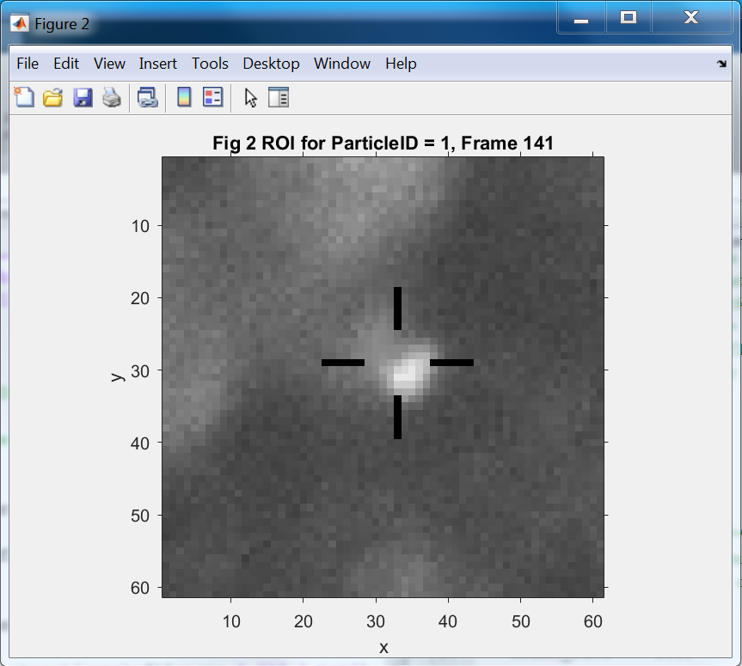

Note: options for how the video plays can be set in the “USER INPUTS” section of the **trackermovie.m** script (see below).

**loop**: 0 or 1. Determines whether video player loops through all particles automatically or only plays individually selected particle (by ID number)

**speed**: 1 or 10. Determines how fast the videos play by showing every frame or only every 10th frame.

**follow**: 0 or 1. Determines whether ROI stays in place throughout video (recommended for small, undirected particle motions) or follows particle’s motions (recommended for large, directed particle motions).

**ROIsize**: Use even number (recommended: 50). Determines size of the viewing field around the particle in the video.

%********************USER INPUTS*******************************************

loop = 1; %0 for individual vesicle selection; 1 for loop over all vesicles

speed = 10; %1 for slow (shows every frame); 10 for fast(shows every 10th

% frame)

follow = 0; %0 for stationary viewing field (ideal for random vesicle motion restricted to small area); 1 for

% following vesicles (better for directed vesicle motion)

ROIsize = 60;% size of viewing field. Use even number. Recommended = 50.

%**************************************************************************

For provided sample data, use the inputs shown above.

13. After the last video plays, you will be prompted to type in the particle IDs that should be deleted, so for example for the provided sample dataset, you would type:

[01 07 09 13 14 15 18 19 22 23 24 25 26 27 29 30 32 34 36 38 44 45 56 59]

Press enter.

14. The command window will display how many particles are left in the dataset after those particles have been deleted.

Press enter again. If you selected automatic particle sizing in the USER INPUTS of the GSE_Analysis.m script, the software will size each particle at this point, displaying figures of the 2D Gaussian fits to each. To approximate the radius of the particle, each particle is fit with a 2D Gaussian, and sigma of the fitted Gaussian is calculated. The radius is approximated as sigma. The radius of each particle will be used in the calculation of the viscoelastic moduli. If you did not select automatic particle sizing because the particles are a known, uniform size, you will need to change the default radius in the onesize.m script. See step 5.

15. From this point on the code runs without any pauses, and will proceed to drift-correct the particle tracks, calculate the MSDs and viscoelastic moduli for each particle, and save the data to files in the “current folder” (containing the images).

OUTPUT FILES: MSD files are saved as *.txt files and are formatted into two columns, the first containing the values for Tau (time intervals over which MSD is calculated, in seconds), and the second containing the MSD values in microns squared. (See example below).

0.01 0.0013067

0.02 0.0019084

0.05 0.0032837

0.1 0.0044937

0.2 0.007074

0.5 0.012067

0.99 0.0084632

10 0.13397

20 0.2001

50 0.2025

90.9 0.21822

The files containing the G and η (eta) values are saved as *.xls files

For the files containing G moduli, the first column is the angular frequency (ω) in rad/s, then G*, G’, G” in columns B, C, and D, respectively.

For the files containing η (eta) moduli, first column is frequency (f) in Hz, then η*, η’, η” in columns B, C, and D, respectively.