**Hubble’s Law and the Expanding Universe:**

**Background:**

There are hundreds of billions of galaxies beyond the Milky Way, each one containing upwards of hundreds of billions of stars. These galaxies are scattered across enormous distances – distances so vast that light, traveling at *c* = 300,000 kilometers per second takes many millions of years to reach Earth. However, when examining the light from these galaxies, it became apparent that the galaxies were moving away from us, causing the light to become redder – a phenomenon known as redshift.

While it may be tempting to assume that Earth must be special if just about all of the galaxies in the universe are moving away from *us*, but an alien in another galaxy would see the exact same thing – all galaxies moving away from *them*. It turns out that space itself is expanding! This expansion of the universe makes it appear as if the galaxies are moving away from us, similar to how polka dots on a balloon all move away from one another when the balloon is inflated.

If space is expanding, galaxies that are further away should appear to be moving away from us much faster than those close to us. This is Hubble’s Law and we will test it in today’s lab. Namely, the redshift (z) of a galaxy can be measured, and is related to the speed (v) of the galaxy via the following equation:

$$z= \frac{v}{c}$$

If such a galaxy contains a type Ia supernova, the distance to the galaxy can be determined as well, as type Ia supernovae explode in a very predictable manner such that they have the same peak absolute magnitude (M = -19.5). By measuring the apparent magnitude (m) of the supernova and comparing this to the absolute magnitude (M), one can determine the distance to the galaxy (d) containing the supernova:

$$m-M={5*log}_{10}\left(\frac{d}{10 pc}\right)$$

where log10 stands for the base-ten logarithm.

The goal for today’s lab is to use data on galaxy redshift and the apparent magnitude of supernovas in order to produce a Hubble Diagram, which plots the speed at which a galaxy is receding from us on the vertical axis and the distance to that galaxy on the horizontal axis.

**Skills:**

First, we’ll need to recall a few things about python syntax:

* To read in data from a file and create a “Data Frame”, use the following:  
  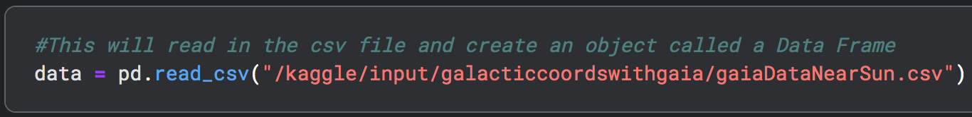
* To access a particular column (in this case the column named c) in a Data Frame, you can code the following (note the first column just tells you the index):  
  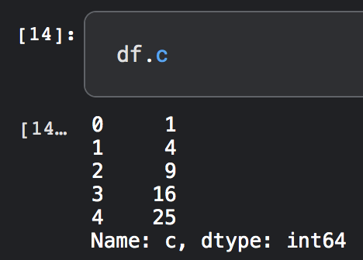
* You can do mathematical operations with each column:  
  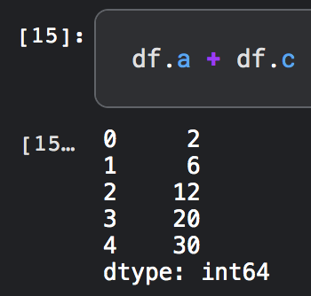
* You can assign a variable with the following syntax, and the program will know what that variable represents:  
  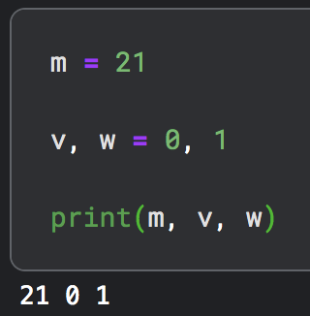

**Problems:**

1. Let’s do an example calculation before we start our program.
   1. If a galaxy has a redshift of 0.035, how fast is it moving away from us?
   2. If a type Ia supernova is observed to have an apparent magnitude of +16.4, how far away is it in units of parsecs? What about Megaparsecs? (Note, 1 Mpc = 1,000,000 pc.)
2. In Kaggle, go to the following notebook template that has been created for you: <https://www.kaggle.com/code/austinhinkel/hubbleslawtemplate>. Click the three dots at the top right and select copy and edit notebook. Run the first few cells in the notebook in order to read in the data file.
3. Create a new column in your Data Frame called v, which will contain the speed at which each galaxy is receding from us. Use the equation relating redshift and the recession velocity above to create an equation that calculates this column.
4. Create a new column in your Data Frame called d_pc, which will contain the distance to each galaxy in units of parsecs. You will have to rearrange the equation relating absolute magnitude, apparent magnitude, and distance – solve it for distance and use the resulting equation in your code when you calculate the d_pc column. It may be helpful to do the algebra below first and check with your professor ahead of coding it.
5. Create another column in your notebook called d_Mpc that contains the distance to each galaxy in units of Megaparsecs.
6. Create a plot with the distance to each galaxy in units of Mpc on the horizontal axis and the velocity of each corresponding galaxy on the vertical axis. Sketch your result below:
7. Now let’s create a copy of the above plot (just copy and paste the code into a new cell). This time, though, we are going to plot a line as well, so that we can determine the slope of the line formed by our data. The code for this is available in the notebook template – you will have to change the slope value until it matches your data.
8. What slope do you find? What are the units of your slope?
9. The slope of the line is Hubble’s Constant, which describes the expansion of the universe. The value has been measured to be about 70 km/s/Mpc. Does your result agree?

Your instructor will check your Kaggle notebook and will sign off here when it is complete:  
  
__________________________