**Kepler’s Laws and the Moons of Jupiter:**

**Background:**

Jupiter is the closest gas giant to the Sun and, with a mass more than 300 times that of Earth, is far and away the most massive planet in our solar system. But how do scientists know the mass of Jupiter when it is roughly 400 million miles away from Earth on average? Surely scientists have not directly weighed the planet on a bathroom scale, right?

As Jupiter is so far away, astronomers have to be clever in order to measure the mass of this hulking giant. Fortunately, Jupiter boasts roughly 100 moons in its orbit, making it an ideal object for the study of orbital dynamics. This, it turns out, is the key to measuring the mass of Jupiter indirectly – even from millions of miles away!

Indeed, careful study of the orbits of the planets around the Sun have resulted in the discovery of a relationship between the orbital distance of a planet around the Sun and the time it takes for the planet to complete one orbit (the “period”). Further understanding of the physics of gravity and forces have allowed scientists to piece together Kepler’s Third Law:

(1)

where is the length of the semi-major axis of a planet’s orbit around the Sun (in units of meters), is the orbital period of the planet (in seconds), is the mass of the Sun, and is a universal constant that describes gravity: .

While the equation is often used to describe orbits around the Sun, it is valid for orbits around other massive bodies, like Jupiter. That means that one can measure both the orbital period and the length of the semi-major axis of a moon in order to calculate the mass of the body being orbited! We’ll make these measurements in a simulation program so that we do not have to actually observe Jupiter 30 times over the next month.

So now our job of measuring the mass of Jupiter comes down to making two easier measurements. First, let’s think about how we can measure the orbital period of a moon going around Jupiter. From our perspective, Jupiter appears as a disk in the sky and the moon appears as a bright point, moving across the sky from night to night (see image below). Suppose you wait until the moon is at its furthest point from Jupiter. The time it takes for the moon to return to its starting position is the moon’s period – we can measure this!

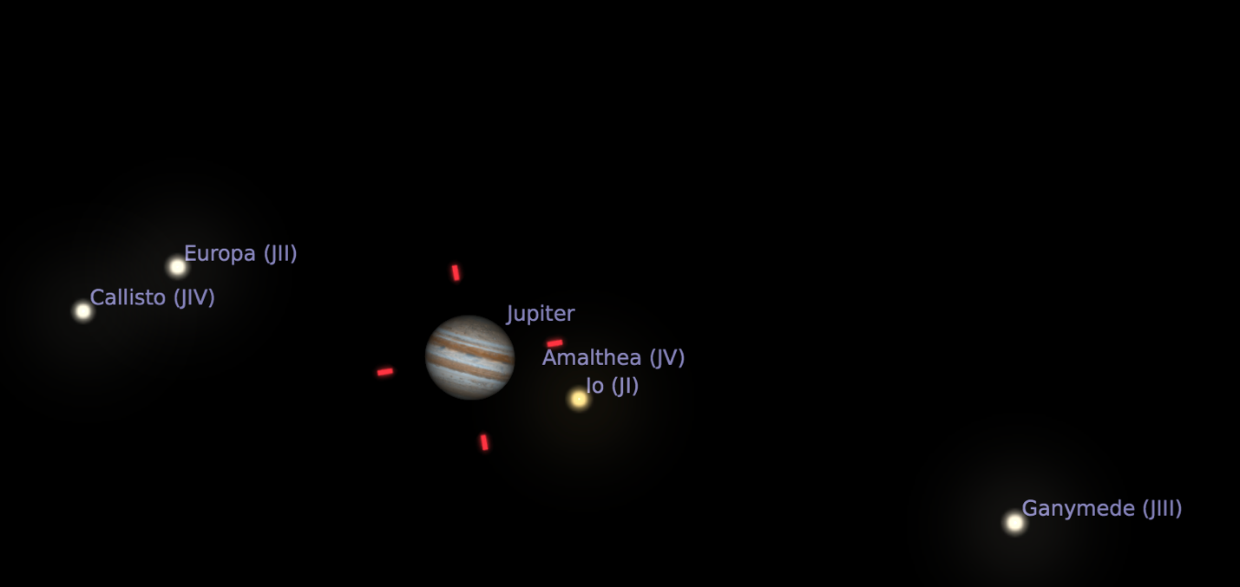

If the moon has a circular orbit around Jupiter (a good approximation), the furthest distance from the planet is the length of its semi-major axis. However, we can’t just measure such a distance with a yardstick, we again run into the issue that Jupiter is millions of miles away! Instead, we have to be clever again. Since we know how far away Jupiter is, its angular size in the sky is easily related to its actual size, which we can find with some geometry. We are able to use the ratios below to convert the angular measurement of a moon’s semi-major axis length to its actual length in meters:

Where Jupiter has a diameter of m.

Therefore, the semi-major axis as measured in arcmins can be converted to meters via the following equation:

(2)

Now with a measurement of the orbital period, , and the length of the semi-major axis, , we can calculate the mass of the body being orbited:

(3)

**Skills:**

Here are the skills we are developing today:

* Excel
  + How to write a formula – all formulae in Excel begin with an equal sign (=). You can add (+), subtract (-), multiply (*), and divide (/) just like you would in a calculator:  
    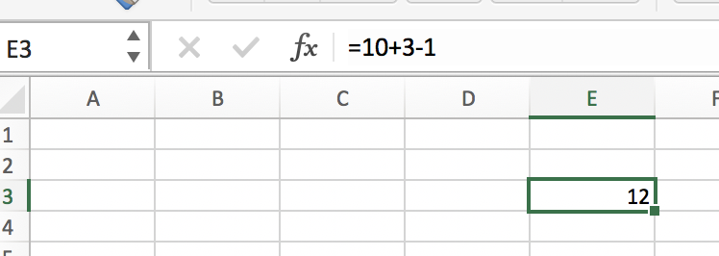  
    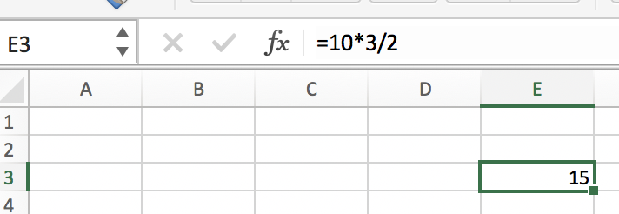
  + Cell references – to reference another cell in Excel, you can simply type that cell’s address:  
    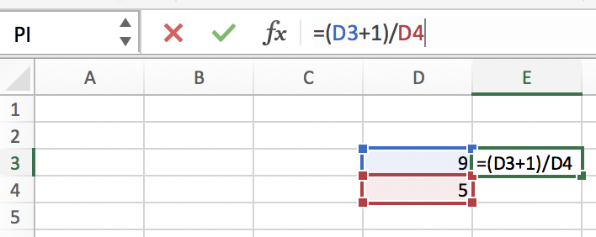
  + A useful shortcut to copy a reference down a column – hover over the bottom right of the cell you entered a formula into. You can double click the tiny green box on the corner (you’ll see a black plus sign symbol when you hover over the tiny green box) and Excel will automatically copy the formula down a column:  
    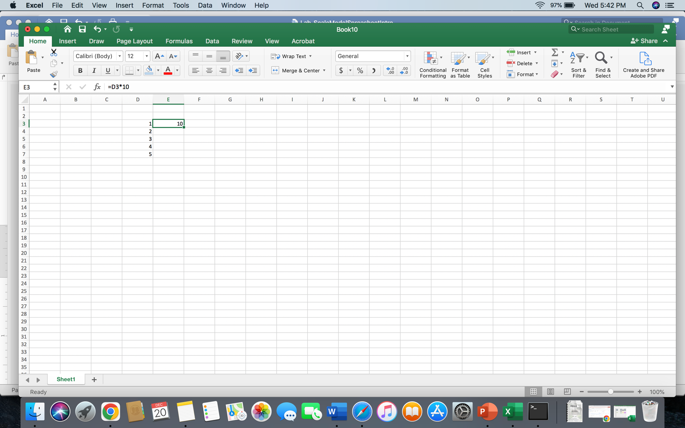

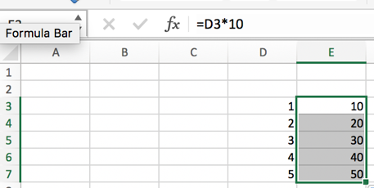

* + How to “freeze” a reference in Excel so that it doesn’t change when you copy a formula – when we copy an equation down a column, Excel updates all cell references to move down their columns as well. Sometimes this behavior is useful, but other times we may want to avoid this. To “freeze” a cell reference in place, use dollar signs like the below example. Notice the formula now references D7 but still references C2.  
    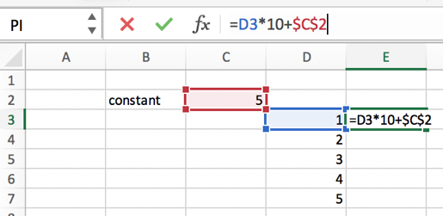 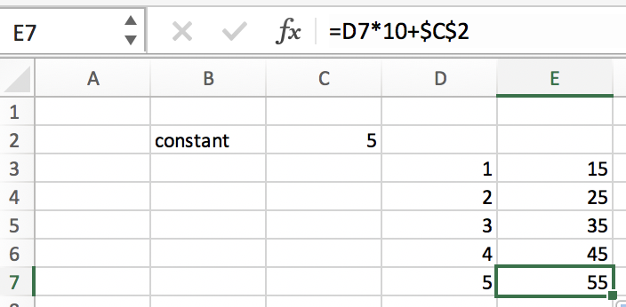

**Problems:**

1. Rearrange the final equation in the background section (Equation 3) to solve for the mass of Jupiter in terms of all of the other quantities. Please show your work.
2. Open Stellarium on your computer and carefully follow the following steps:
   1. Open the Configuration window (F2, or function F2 on a Mac).
   2. Click the Plug-ins tab.
   3. Select “Angle Measure” and check the box corresponding to “Load at startup”.
   4. Close the Configuration window and restart Stellarium so that the angle measure tool will be available.
   5. Once you have reopened Stellarium, reopen the configuration window again and click the “Information” tab.
   6. Set the “Selected Object Information” to “None”
   7. Make sure your location is Fort Mitchell, KY (F6).
   8. Pause the time in Stellarium (mouse to the bottom of the screen, select the play/pause button)
   9. Set the time and date to 20 August 2024 at 22:00:00 ET (10 pm) – make sure it stays paused!
   10. Turn off the atmosphere and ground, both of which are options on the bottom menu.
   11. Find Jupiter in the sky and click it with your mouse. Then, press the “center on selected object” button in the bottom menu.
   12. Zoom in on Jupiter until you can see 4 moons as bright points of light like in the screen shot above.
3. Choose either Ganymede or Callisto for your measurements. Indicate your choice below.
4. Make sure the date is still set to 20 August 2024 at 22:00:00 ET (10 pm). You will take data at 22:00:00 across 30 consecutive days. To take the data, complete the following steps:
   1. Turn on the “Angle Measure” tool by pressing Cmd-A or ctrl-A.
   2. Drag from the center of Jupiter to the chosen moon. Be as precise as you can, as this will help you avoid headaches later in this lab.
   3. Enter the number of arc minutes of separation into the spreadsheet template. ***This number should be positive if the moon is to the right of Jupiter and negative if it is to the left of Jupiter. If the moon is behind Jupiter, enter zero. Enter the number of arc seconds into the corresponding column in the template spreadsheet as a positive or negative number just like you did for the arcminutes.*** An equation is written for you that will convert these numbers into purely arcminutes.
   4. Step forward in time by one day.
   5. Repeat steps b-d for all 30 days of observation.
   6. Finally, measure the angular size of Jupiter with the angular measure tool. Include this number below.
5. Now examine the graph of your data and the model intended to describe it. The model likely does a poor job describing the data. You can tweak the parameters of the model by changing the numbers in the green cells at the top right of your template. The parameters are:
   1. Period – The time in days that it takes for the moon to complete one orbit around Jupiter. On the graph, this represents the horizontal separation between adjacent peaks.
   2. Amplitude – The maximal amount of angular separation between the moon and Jupiter in units of arcminutes. This is related to the semi-major axis of the moon’s orbit. On the graph, this represents the height of a peak.
   3. Phase – A number that shifts the graph left or right. It is easiest to try to guess and check for this parameter. Additionally, you may need to adjust the period again after lining up the phase and vice versa.
6. Once you have fine-tuned the fit parameters so that your mathematical model fits the data you have taken, write your fit parameters below. Note that the period is the orbital period of the moon, which we will need to calculate the mass of Jupiter. Convert this to seconds and report your answer in both days and seconds.
7. We also have all of the data we need to determine the semimajor axis of the moon’s orbit around Jupiter. Using the amplitude from your model fit as the semi-major axis in arcminutes, , and the angular size of Jupiter in arcminutes, , calculate the semi-major axis of the moon’s orbit in units of meters. Recall, meters. Pause and ask yourself if your answer makes sense. Explain.
8. Now that we have the semi-major axis in meters and period of your chosen moon’s orbit in seconds, we can use the equation you derived in problem 1 to calculate the mass of Jupiter. Please do this calculation below and show any work. Include units.
9. The scientific literature reports a mass of about kilograms. Use the equation below to calculate the percent error in your measurement of Jupiter’s mass.

Your instructor will check your Excel spreadsheet and will sign off here when it is complete:  
  
__________________________