**Scale Models and Introduction to Excel:**

**Background:**

Scale Models:

Astronomers often deal with astronomically large numbers like meters or meters. What do numbers this large even mean and how can we get a feel for them? One way to understand numbers this large is to build a *scale model*. That is, let’s scale down the numbers to something we are more comfortable dealing with.

While it may help a little to provide the context that the value meters is approximately the distance from the Sun to the nearest star, while meters is the diameter of the Sun, these numbers are still unimaginably large. Let’s instead scale the Sun down to the size of a ping pong ball (a diameter of about 4 cm) using a scale model:

This equation sets up a ratio that scales down a real measurement to a scale model measurement. For the example above, that ratio is:

We call the number on the right-hand side of the equation above the *scale factor*, which states what every unit of measurement in the scale model represents in the real world. In this case, we’ve scaled down the Sun’s diameter to 4 cm, so every 1 m in the real world is now represented by in our scale model:

If we then want to imagine how far away the nearest star would be in this scale model, we use the original equation to solve:

After some algebra (note the meters cancel and we are left with cm), we find:

Or written a different way:

That’s still not very enlightening, because the number is so big. Let’s convert that to km and miles to get a better feel:

So, if we scale the Sun down to the size of a ping pong ball, the nearest star would be over 700 miles away! Now that’s something we can comprehend a bit better! If the Sun was a ping pong ball on our campus, the nearest ping pong ball would be a bit outside of Dallas, Texas! Indeed, the Milky Way Galaxy is mostly just empty space.

**Skills:**

Here are the skills we are developing today:

* Scale Models
  + Creating/Solving scale models – see the math above!
  + Interpreting scale models – it is important to get a feel for the numbers you’ve found. By comparing the distance between two ping pong balls above, we’ve made the distances between stars much easier to comprehend. Always remember to interpret your scale model!
* Excel
  + How to write a formula – all formulae in Excel begin with an equal sign (=). You can add (+), subtract (-), multiply (*), and divide (/) just like you would in a calculator:  
    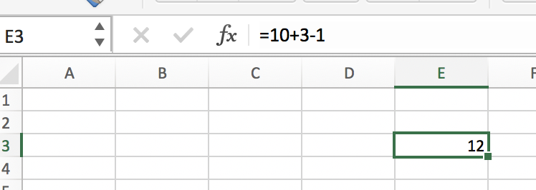  
    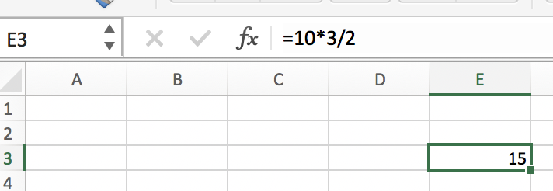
  + Cell references – to reference another cell in Excel, you can simply type that cell’s address:  
    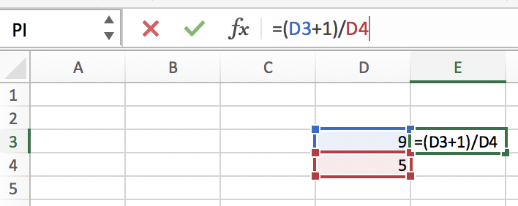
  + A useful shortcut to copy a reference down a column – hover over the bottom right of the cell you entered a formula into. You can double click the tiny green box on the corner (you’ll see a black plus sign symbol when you hover over the tiny green box) and Excel will automatically copy the formula down a column:  
    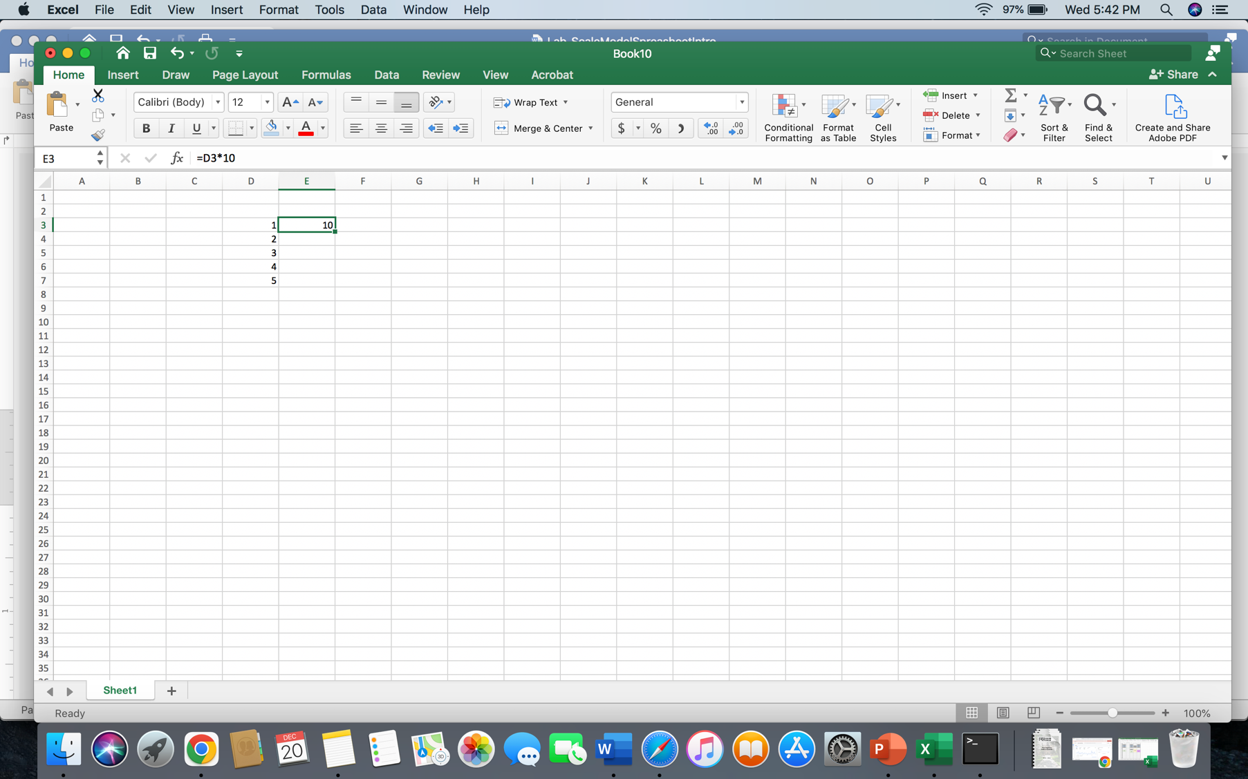

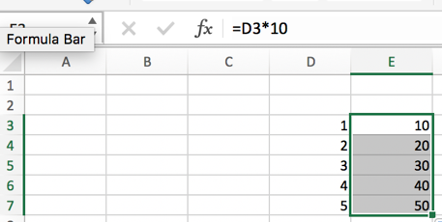

* + How to “freeze” a reference in Excel so that it doesn’t change when you copy a formula – when we copy an equation down a column, Excel updates all cell references to move down their columns as well. Sometimes this behavior is useful, but other times we may want to avoid this. To “freeze” a cell reference in place, use dollar signs like the below example. Notice the formula now references D7 but still references C2.  
    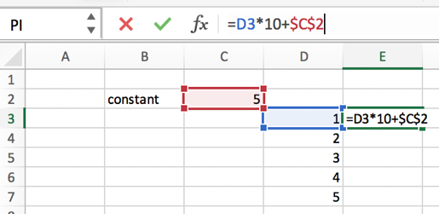 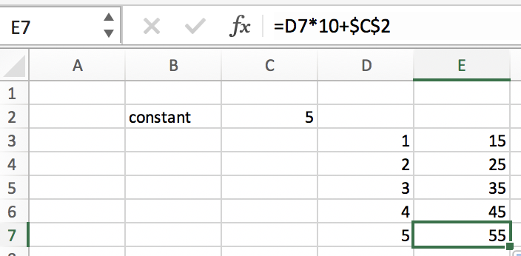

**Problems:**

1. Let’s see how big the solar system would be in the above example. If the Sun is scaled down to a ping pong ball (a diameter of about 4 cm), fill in the Excel spreadsheet template to find the sizes of the listed objects in your scale model. We’ll call this Scale Model 1. Find the scale factor by hand below before you fill in your Excel sheet:

1. Now let’s consider the hallway outside of our classroom. Take a tape measure and measure the length of the hallway in meters. For Scale Model 2, let’s scale down the Orbit of Neptune to the length of the hallway. In other words, the Sun is located at one end of the hall while Neptune’s orbit is at the other. Where along the hallway would the other planets be? Would the nearest star to the Sun be on campus? If not, approximately where would it be? Calculate the distances in your Excel sheet and then go to the hallway with your group to get a feel for where each planet would lie as you travel the length of the hall. Draw a rough sketch below:
2. Now it’s your turn! Create a custom scale model (we’ll call this one Scale Model 3). Specify below which object you are scaling down and the model object you are scaling it down to. What is your scale factor (with units)? Complete the final scale model in your Excel spreadsheet.

Your instructor will check your Excel spreadsheet and will sign off here when it is complete:  
  
__________________________