**Analyzing the Solar Rotation Rate with Excel:**

**Background:**

In this lab, you’ll observe and track two sunspots as they cross the Sun using images from the Solar Dynamics Observatory (SDO). SDO is a solar observatory in orbit around the Earth. It has been observing the Sun since the observatory's launch in 2010. SDO uses an array of instruments and cameras to observe the Sun at different wavelengths. We will use images taken in the visible part of the spectrum to follow two sunspots as they move across the face of the Sun.

We will be tracking the location of two different sunspots – one is (hopefully) still observable today! We will be observing the Sun using the images on the SolarMonitor.org website (there is a link on the Canvas page). Start by going to the website and looking at the Sun today in the visible part of the spectrum by clicking on the image labeled *HMI 6173Å*. This is an image of the Sun in the orange part of the spectrum.

Download the Lab spreadsheet from Canvas to record your data.

**Skills:**

Here are the skills we are developing today:

* Excel
  + How to write a formula – all formulae in Excel begin with an equal sign (=). You can add (+), subtract (-), multiply (*), and divide (/) just like you would in a calculator:  
    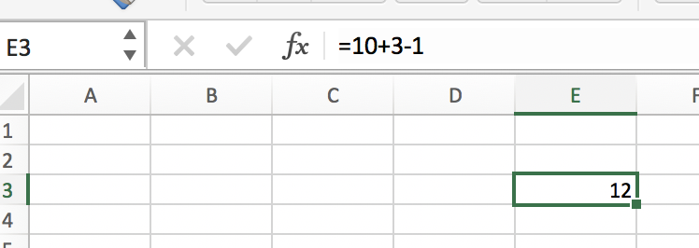  
    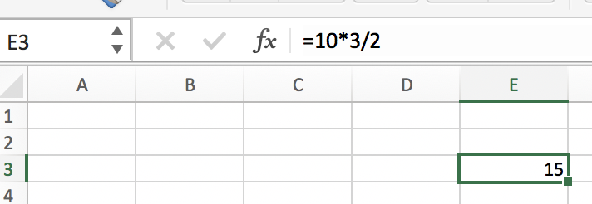
  + Cell references – to reference another cell in Excel, you can simply type that cell’s address:  
    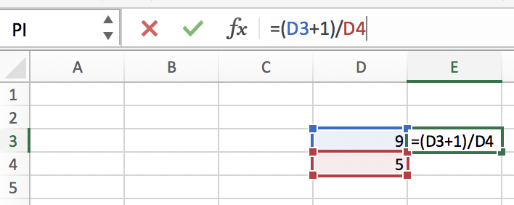
  + A useful shortcut to copy a reference down a column – hover over the bottom right of the cell you entered a formula into. You can double click the tiny green box on the corner (you’ll see a black plus sign symbol when you hover over the tiny green box) and Excel will automatically copy the formula down a column:  
    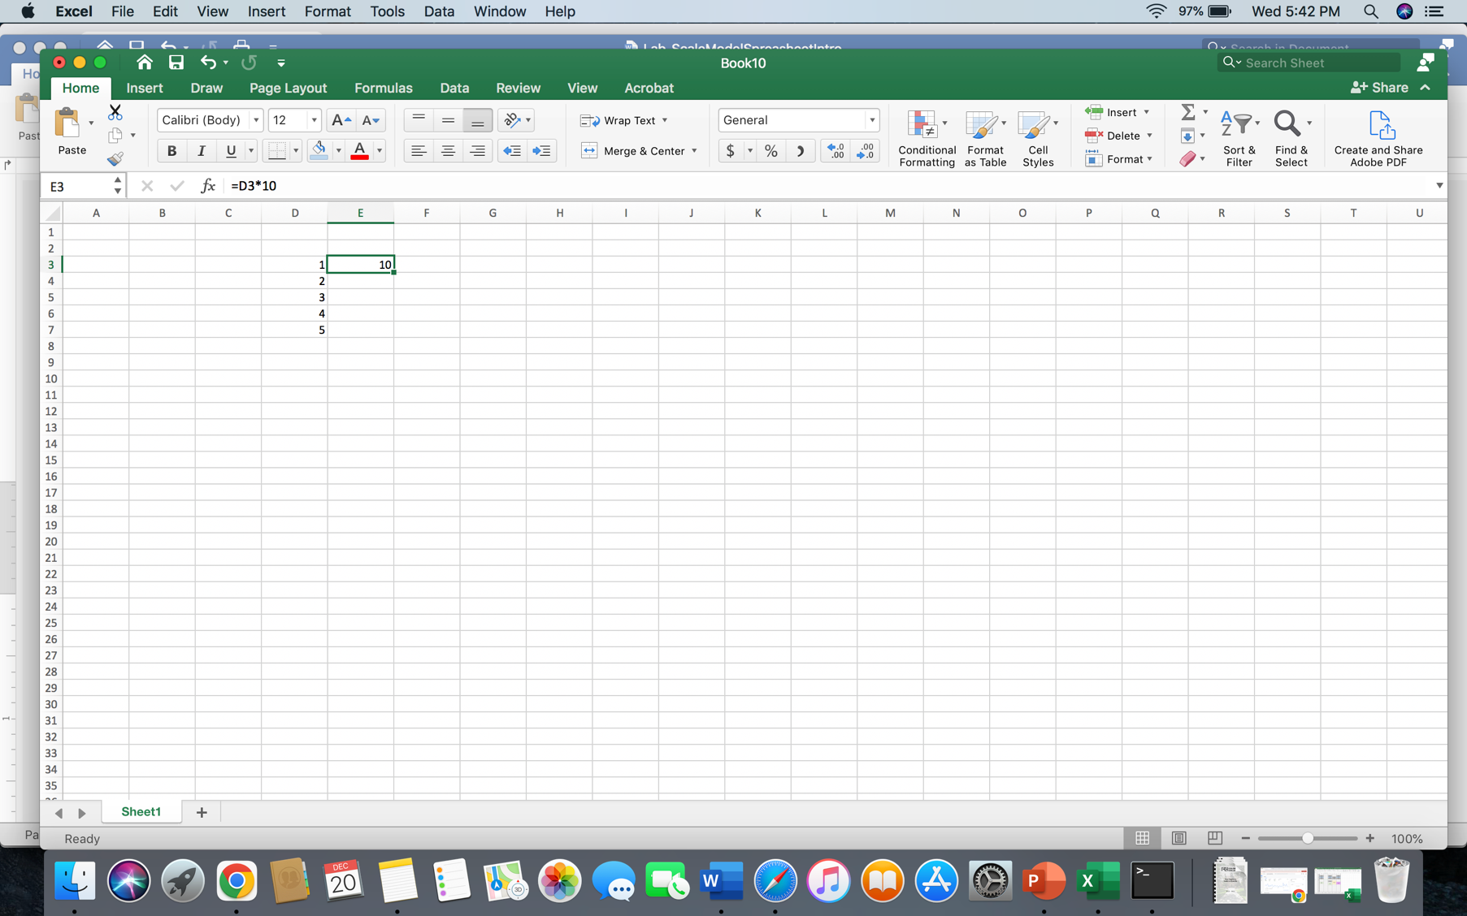

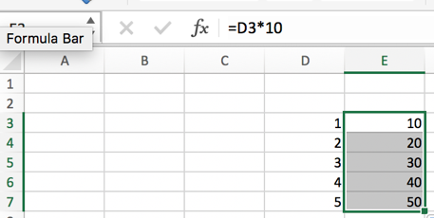

* + How to “freeze” a reference in Excel so that it doesn’t change when you copy a formula – when we copy an equation down a column, Excel updates all cell references to move down their columns as well. Sometimes this behavior is useful, but other times we may want to avoid this. To “freeze” a cell reference in place, use dollar signs like the below example. Notice the formula now references D7 but still references C2.  
    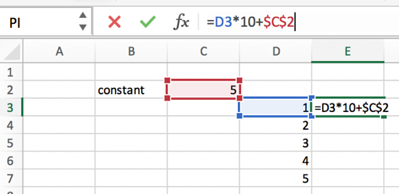 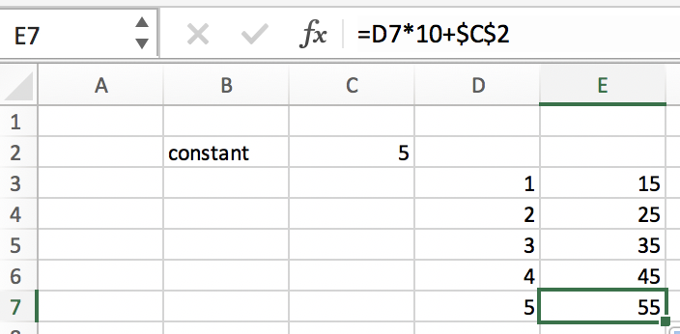

**Problems:**

1. First, let’s collect some data:

***Sunspot 13433:***

1. Use the *Date Search* button in the upper left corner of the page to navigate to 13 Sep 2023. Identify the sunspot labeled 13433, above the equator on the left (East) side of the Sun.
2. Click on the sunspot to open a zoomed in view. Record the latitude of this sunspot (degrees above and below the equator should be positive and negative respectively). Each grid line corresponds to 10°, but you should be able to approximate the position within the gridlines to 1° or 2°.
3. Record the full date and time of the image (shown at the top).
4. Determine the longitudinal position of the sunspot in degrees East of the longitudinal center. Longitudinal center is the vertically straight longitude line. **Make sure to treat positions East (to the left) of the longitudinal center as negative.** Record the longitudinal position.
5. Advance the time by clicking the button on the upper right of the page labeled with the next date.
6. Repeat steps I-V until you have recorded as many days of data as you can before the sunspot is no longer visible. *(NOTE: it may be hidden behind other labels. Click near 13433 to see an enlarged view.)*

***Sunspot 13439:***

1. Navigate to 19 Sep 2023. Identify the sunspot labeled 13439, above the equator on the left (East) side of the Sun.
2. Record the latitude of this sunspot (positive/negative degrees above/below the equator).
3. Record the date and time of the image. Determine the longitudinal sunspot position as you did for the sunspot above and record the position. Make sure to treat positions East of the longitudinal center as negative.
4. Advance the time by clicking the button on the upper right of the page labeled with the next date.
5. This sunspot should be currently visible! Record as many data points as are available. Weather permitting, we will try to find the sunspot on the Sun through the solar telescope during lecture/lab.

1. Now let’s process the data a bit, so that we can create a plot in the next problem. Notice that not every observation was taken exactly one day apart! To be precise, we must first convert the date and time information for both sunspots into days since the first observation (so the first observation will be time = zero). (Excel knows how to subtract dates from one another).
2. Create a scatter plot in Excel for each sunspot which includes:
   1. the time since the first observation (in days) on the horizontal axis and the longitude of the sunspot (in degrees) on the vertical axis,
   2. appropriate axis labels (with units!),
   3. and a chart title to clearly indicate which sunspot the data describes.
3. The data should form a straight line, and the equation describing this line tells the rotation rate of the Sun.
   1. Add a trendline to your data in Excel. (Right click on the data in your plot to add a "trendline" to your data to determine the line of best fit. Under "Format Trendline" be sure to click "Display Equation on chart" so you can extract the slope of your best fit.)
   2. Your best fit line should be of the form , where m is the slope and b is the y-intercept. What are the units of the slope? How does the slope relate to the Sun’s rotation rate?
4. Each sunspot should have its own line of best fit with a corresponding slope. If we assume this rate of sunspot motion is constant, we can use it to find the total time it takes a sunspot to rotate once around the Sun by relating the rate (in degrees per day) to one full rotation (360°) and the total time it takes to complete that full rotation:

Where *S* is the slope of the line of best fit and *Psynodic* is the **synodic period**, or the period of the Sun’s rotation *as seen from Earth, which is moving around the Sun*.

Use your two slope values to calculate the synodic period of each sunspot.

1. The Earth is orbiting the Sun in the same direction as the Sun's rotation. This means that the actual period of rotation, called the **sidereal period** (or the period as seen from a stationary reference point) is a little shorter than the synodic period. We'll skip the derivation here, but it's possible to show that:

where *P*Earth is the period of the Earth’s orbit (365.25 days), *P*synodic is the synodic period you found above, and *P*sidereal is the sidereal (true) period of the sunspot.

Calculate the sidereal periods of each sunspot.

1. Previous research has shown that the rotation rate of the Sun near its equator is about 24 or 25 days, while it is closer to 35 days near the poles. Do your results agree?