**There and Back Again: A Hydrogen Atom’s Adventure**

**Background:**

The Milky Way is home to a few hundred billion stars which, at one point or another, formed from the collapse of massive clouds of Hydrogen (and a smattering of other things). Although a star may live for billions of years, it will eventually run out of its nuclear fuel and – depending on how massive the star is – will end its life in a supernova or will become a white dwarf after it sheds much of its mass into a planetary nebula. Although the topic of stellar death may elicit sadness, these supernovas and planetary nebulas contribute to something rather beautiful: new stars!

Yes, supernovae remnants are themselves quite beautiful, but the explosion itself sends shock waves through the Milky Way’s Hydrogen gas, compressing it into denser regions that will eventually gravitationally collapse due to their newfound density, so that new stars can form. The end of one star may be the beginning of another! The supernova also creates and distributes heavier elements which then enrich the next generation of stars. Planetary nebulae also enrich the surrounding gas clouds with elements like Oxygen, Carbon, etc. The entire process is rather poetic, with each star contributing a verse in the Galaxy’s roughly twelve-billion-year record.

While supernovae and planetary nebulae are not the only force behind the complex cycle of stellar birth and death, they play an important role. The goal for today’s lab is to explore a program that simulates this complex story in a rather rudimentary way, in order to better visualize the process. Just know that there are plenty of other fantastically complicated factors in the Milky Way’s story – we will cover only some of them later in this class. If you’d like to learn more of the story, you may want to become a physics major or astronomy minor!

A simplified summary of the process is illustrated below:

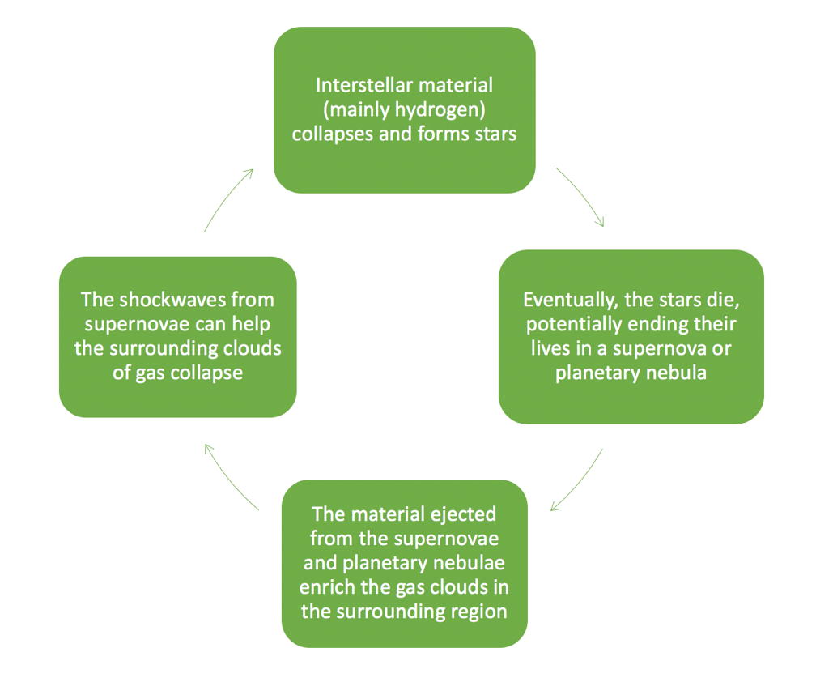

**Skills:**

First, we’ll need to recall a few things about python syntax:

* A function:
  + Takes in **arguments** (inputs).
  + And may **return** (output) something.
* To define a function:  
  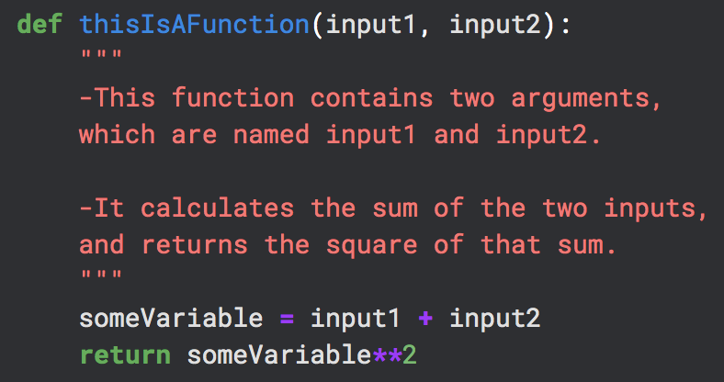
* To call a function:  
  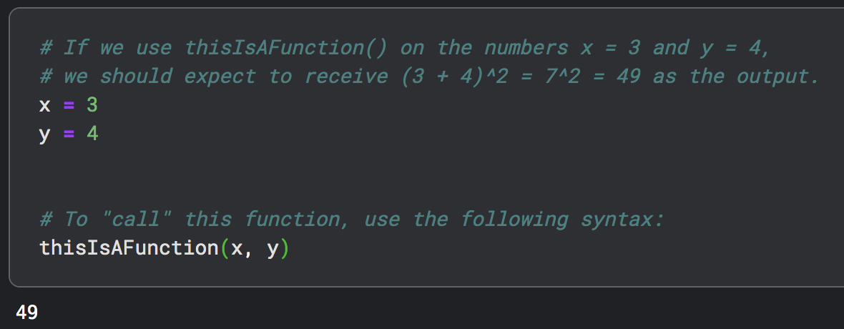

**Problems:**

1. A Kaggle notebook has already been written for you and can be found at [this link](https://www.kaggle.com/code/austinhinkel/stellarlifecyclessimulation). Click the three dots at the top right and select copy and edit notebook.
2. Run the first several cells of code (up through and including Simulation 1). While the code may look complicated, the idea is this:
   1. We start with a bunch of gas particles, sprinkled randomly throughout the simulation.
   2. We’ll define a function that creates a “supernova,” driving some of the gas particles spherically outward away from the supernova’s center.
   3. We also define a function that simulates the formation of a planetary nebula, ejecting gas particles out radially from the dying star.
   4. This process can repeat multiple times, allowing us to glimpse what happens to the distribution of gas particles over time.
3. Plot the result of your first supernova (Simulation 2). Can you find the “bubble” it has created in the gas? Notice how the edges of the “bubble” are denser than the surrounding gas. Briefly sketch the X-Y plot from your code below. Be sure to include axis titles:
4. Now let’s plot the results of your first planetary nebula (Simulation 3). Chances are it is difficult to find the planetary nebula in your data. Run Simulation 4, which removes some of the background particles so that you can see the planetary nebulae that you create. Briefly sketch the X-Y plot from your code below. Be sure to include axis titles:
5. Now let’s crank it up a notch. Blow up 25 more stars and create 10 more planetary nebulae and see what effect this has on the distribution of the gas particles (Simulation 5). What do you notice? Are there regions of denser gas? Sketch the X-Y plot below. Be sure to include axis titles:
6. Let’s create 25 more supernovae and 10 more planetary nebulae (continue Simulation 5). Now what happens to the distribution of gas particles? Sketch the X-Y plot below. Be sure to include axis titles. Circle or highlight the regions on the plot where you suspect star formation may take place. Explain your choices.
7. How is this simulation limited? That is – can you think of various factors that should be taken into account which were not simulated in this code?
8. This simulation includes some randomness, so it is different every time you run the program. However, the code I have written for you has a few predetermined things, like the relative number of planetary nebulae and supernovae. Create a new simulation (Simulation 6) at the bottom of the notebook – copy and paste code to build it:  
   1. Create a background distribution of gas particles with the createBackgroundDist() function.
   2. Simulate several supernovae (goBoom()) and planetary nebulae (makePlanetaryNebula()) at various places in your simulation.
   3. Plot the results! (makePlots())

Your instructor will check your Kaggle notebook and will sign off here when it is complete:  
  
__________________________