Planetary Defense Lab

Background:
NASA’s Planetary Defense Coordination Office (PDCO) oversees the agency’s detection and ongoing tracking of asteroids and comets that could potentially pose a threat to the Earth. By continually refining measurements of an object’s position and velocity on the sky through repeated observations, astronomers are able to better predict the orbital path of that object via simulations. Today, we will examine a simplified model of these simulations.

Suppose the PDCO has heard about your stellar performance in NSP-233 and has asked you to help them determine the risks posed by several asteroids. Your job is to run the simulations for the asteroids tabulated below and report the missing pieces to NASA. You must also determine which of the asteroids (if any) pose a direct collision threat with the Earth over the next 50 years.

Data:
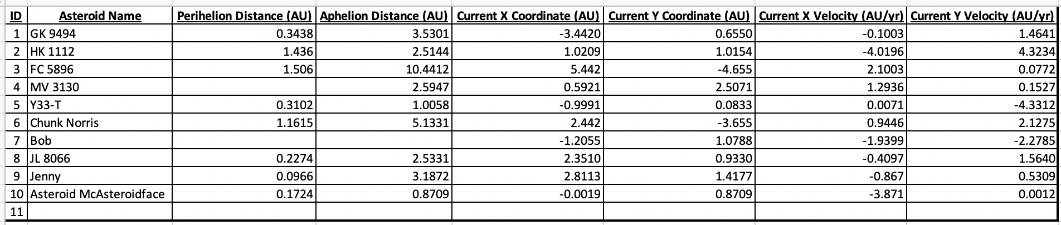
(Excel sheet also available in canvas.)

Problems:

- Several asteroids on the list can be safely ruled out without worrying about simulating their orbits. Which ones? How do you know?
- Create a fork (or “copy”) of the Kaggle notebook here and complete the exercises below by altering the indicated cell in the notebook. You may need to log in to Kaggle and verify your phone number for the notebook to work correctly.
- How close does Asteroid GK 9494 come to Earth? Report your answer in units of AU.
- What is asteroid MV 3130’s perihelion distance?
- How close does asteroid MV 3130 come to Earth?
- What is the semi-major axis of asteroid Chunk Norris?
- What is the orbital period of asteroid Bob in units of years?
- Which (if any) of the asteroids are a threat to Earth in the next 50 years? If you found any asteroids that collide with Earth, in what year will they impact? Please also create an animation of the orbits of the two bodies.
- Study the animation of the orbits closely. Which object is faster and at which times? Is the same object always fastest or does it change? Why or why not? How are each of Kepler’s Laws illustrated in the animation?
- Create your own asteroid and see if it’ll hit Earth! (That is, name the asteroid and define a current X and Y position and a current X and Y velocity. Then, run the simulation.). Does your asteroid hit Earth? What are its perihelion and aphelion? Complete all missing values in the table above or write them clearly below. Sketch the simulated orbit below as well:
- The asteroids in this lab are made up. But let’s say an asteroid actually was heading straight for the Earth. What might we do to defend the Earth from it?
- Let’s go back to any asteroids you found that collided with Earth over the next 50 years. Change that asteroid’s y velocity to be just 0.002 AU/yr lower than tabulated. Does this change the outcome of the simulation? That is, did you save the planet?
- A change of 0.002 AU/yr was the difference between a civilization-destroying asteroid collision and a near miss. Does this mean it is easy to change an asteroid’s orbit and save the Earth? Why or why not? Defend your position.

