|  |
| --- |
| Primer analysis for PCR over 4 species that exist in the HOMB |
| Human Oral Microbiome |
| University of North Carolina - Charlotte |

|  |
| --- |
| Adam Hipp  November 22 2019 |

**Primer Design Report**

**Introduction:**

Polymerase chain reaction (PCR) is a technique used to create millions of copies of a specific sequence of DNA. A variety of materials are used to accomplish this, including the primers which bind to the template to determine the nucleotide sequence that is to be replicated. The sequence of the primer must be specifically designed based on the sequence of interest that is to be amplified, therefore PCR is considered a closed assay. The primer is a short single-stranded string of nucleotides, ideally between 17-25 base pairs, that will be shared among the organisms contained within the sample. Two primers are used, so there will be a forward and reverse primer. This allows the primer to function as the start and stop positions that bookend the sequence of nucleotides being replicated. After all the materials are combined, the sample endures a series of heating and cooling stages, called thermal cycling. Thermal cycling will denature DNA when exposed to heat creating single stranded DNA. As the sample cools, primers bind to DNA forming the template to be polymerized. The process repeats with the sample being heated again with twice the number of DNA strands available to be polymerized.

The purpose of this assignment is to design a PCR primer that can be used to amplify a DNA sequence over four different organisms that exists within the human oral microbiome. I chose to examine Escherichia coli and three organisms in the oral microbiome that have been found to corelate with type II diabetes. These include: Aggregatibacter aphrophilus, Neisseria menigitidis, Mycobacterium tuberculosis. The main goal is to design a forward and reverse primer sequence that will be similar between these organisms. The forward and reverse primer will be used to flank the regions of interest of the four organisms. The region being flanked by the primers of the four organisms constitutes the region being amplified, therefore will be much more varied so that the product is distinguishable for each organism. The region of interest I chose for the experiment is the beta subunit of the RNA polymerase gene. Software is available that will compare the sequence of the four organisms to locate the best possible options.

**Materials and Methods:**

**Primer Design**

* NCBI – research and genomic sequences
  + Aggregatibacter aphrophilus - NCBI accession # NZ_CP012067.1
  + Neisseria meningitidis - NCBI accession # NC_003112.2
  + Mycobacterium tuberculosis - NCBI accession # NC_000962.3
  + Escherichia coli - NCBI accession # NC_000913.3
* Clustal Omega – Multiple Sequence Alignment
* Integrated DNA Technologies – PrimerQuest and OligoAnalyzer
* Excel – Compare sequence similarities
* IUPAC codes for degeneracy

The research article I used to inspire the primer design assignment, Oral Microbiota: A New View of Body Health, was accessed through NCBI PubMed and submitted by the researchers of Tsinghua University in Beijing on January 3, 2019. From that paper, I selected three organisms that correlate with diabetes. I searched the NCBI gene database using the organism name and focused on the RNA polymerase (subunit beta) gene of each organism. I also collected the E. coli RNA polymerase (subunit beta) gene to serve as the positive control. This species details are shown below in figure 1.

**Results**:

* The RNA polymerase gene for each organism was retrieved from NCBI and saved as .txt file.
* Performed multiple sequence alignment of the .txt files using EMBL-EBI Clustal Omega.
* Input the aligned sequence file generated by Clustal-Omega in IDT to produce a combination of possible primers. From these files it shows identity matches, so I chose the first 450 base pairs of each organism because they showed areas of variation coupled with areas highly similar. Select tools from the main taskbar, then PrimerQuest
  + PCR/hybridization conditions
    - dNTP Conc(mM) – 0.2
    - 3’ GC clamp (nt) – 1
    - Maintain default settings for remaining options
* PrimerQuest creates exportable excel file with primer pairs they have generated. You can analyze each primer in the IDT tool OligoAnalyzer
  + - Submit each primer individually for hairpin analysis and homo-dimer analysis
    - Submit a forward and reverse primer pair for hetero-dimer analysis



Figure :Identifiable information for species collected from NCBI

I opened the FASTA file for each organism and copied the nucleotide sequence into a .txt file. A sample of the FASTA file for E. coli is shown below.

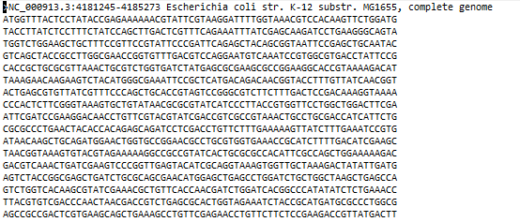

Figure :Partial Fasta file for E. Coli - beta subunit - Collected from NCBI

After copying the sequences of each organism, I accessed the multiple sequence alignment tool from Clustal Omega, a tool designed by EMBL’s European Bioinformatics Institute (EMBL-EBI), to align the nucleotide sequences. The report from Clustal Omega aligned the sequences of the four organisms and inserted gaps were the sequences were not similar. A snapshot of the multiple sequence alignment for the first 400 nucleotides generated from Clustal Omega is shown in figure 3.

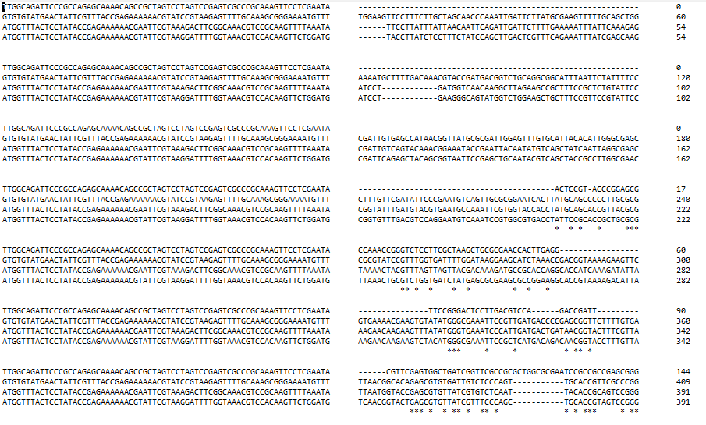

Figure : Sample of the MSA generated by Clustal Omega from EMBL-EBI

Then I accessed Integrated DNA technologies and opened the tool PrimerQuest. An account is required to access these tools, so it may be required to set up a free account before using this tool. I submitted the first 450 base pairs from each organism. I also set the Design Parameter conditions to change dNTP Conc (mM) to 0.2 and 3’ GC Clamp to 1. The report generated by IDT can be exported to excel, and a sample of this report is shown below in figure 4.

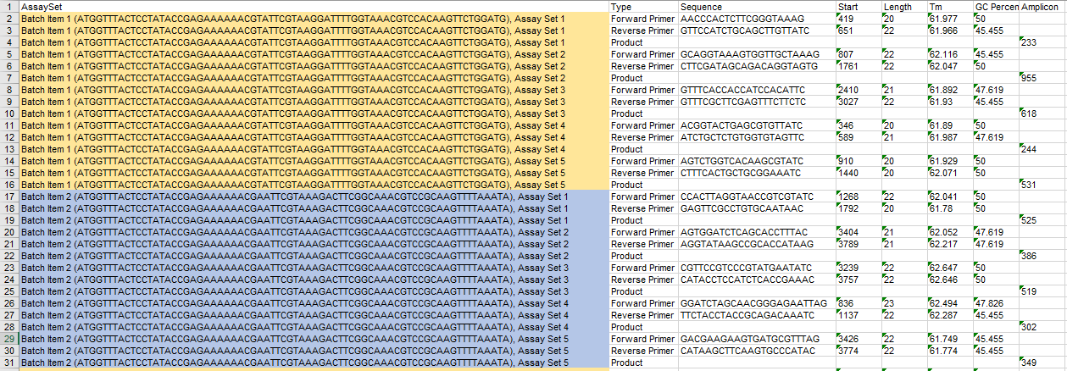

Figure : Sample primer batches generated by PrimerQuest from IDT

IDT also provides tools to analyze the primer structure. Select the OligoAnalyzer tool to begin this process. After you enter the primer pair you want to analyze, you can select from different tools that allow you to analyze hairpin structure, homo-dimers, and hetero-dimers. I analyzed the forward primers and reverse primers using these tools. After using this tool, I chose the forward and reverse primer from batch 2 set 1. This primer pair had a GC % of 50, amplicon length of 525, and an annealing temperate (Tm) between 61.76-62.041 degrees Celcius. The sequence details and analysis figures are shown below in figures 5-11.



Figure : Sample primer pair selected for analysis based on amplicon length and GC percent.

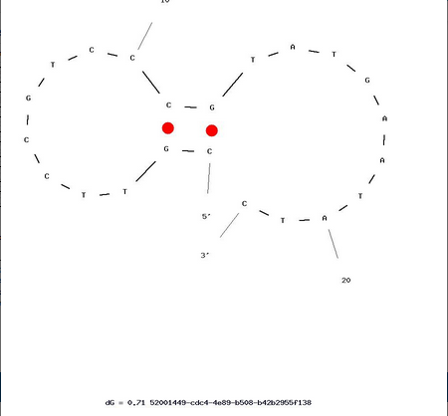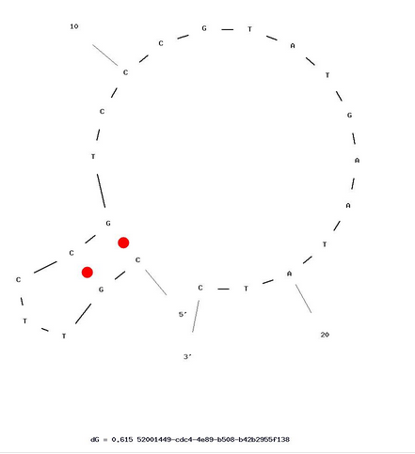

Figure : Hairpin shape from batch item 2 assay set 1 forward Primer. Delta G = 0.71 kcal/mol

Figure : Alternative hairpin shape from batch item 2 assay set 1 forward primer. Delta G = 0.61 kcal/mol

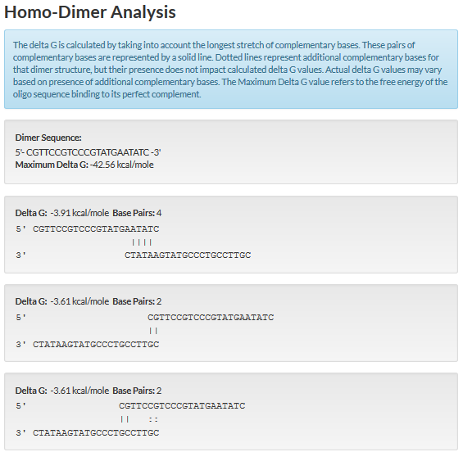

Figure : Calculation of delta G based on homo-dimer analysis for of forward primer in batch 2 set 1 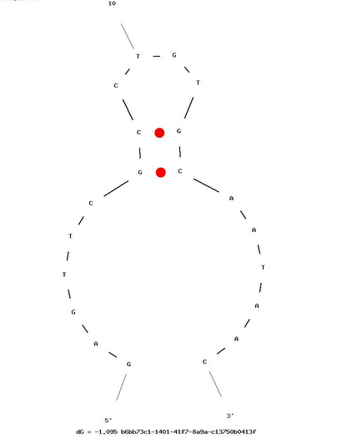

Figure : Hairpin shape of batch item 2 assay set 1 reverse primer. Delta G = -1.095 kcal/mol

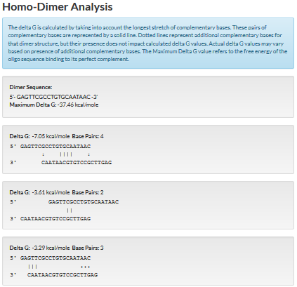

Figure : delta G calculated for self-dimer of batch item 2 assay set 1 reverse primer

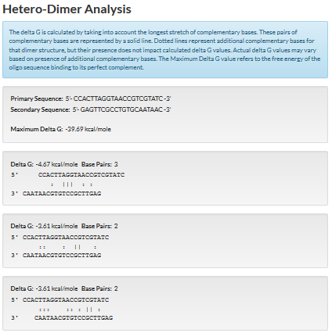

Figure : Hetero-dimer analysis of batch item 2 assay set 1 forward-reverse primers

I used NCBI BLAST to compare the primers against each organism once more. The primers showed a 100% identity for each organism. A sample of the BLAST output (figure 12) and the alignment (figure 13) for the primers and E. Coli is shown below.

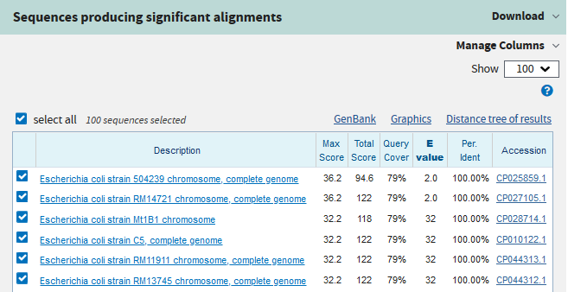

Figure : First six scores returned after using NCBI Blast on primer pairs against E. Coli - NC.0007779.1

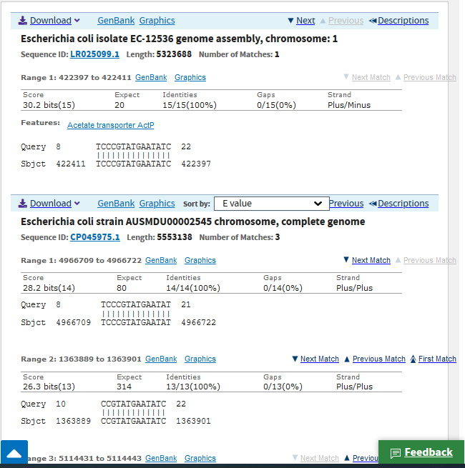

Figure : Alignment of forward primer after NCBI Blast

**PCR Experiment**

**Reagents**:

* E coli gDNA – labeled EC
* Aggregatibacter aphrophilus gDNA – labeled AA
* Neisseria menigitidis gDNA – labeled NM
* Mycobacterium tuberculosis gDNA – labeled MT
* 2X KAPA Hifi Hotstart Ready Mix (2XRM)
* 16s rRNA designed primer

**Materials/Equipment:**

* Nanodrop spectrophotometer
* 0.2ml PCR tubes
* PCR machine with adjacent lab cooler to hold samples until ready

**Procedure: Part 1- Quantify Samples**

1. Label 1 tube for each organism sample. AA-1, NM-2, MT-3, EC-4
2. Check the concentration of each sample using Nanodrop.
   1. Make a 1:10 dilution of each sample using 2ul of sample and 18ul Low-TE.
   2. Cap the tubes, vortex briefly, then pulse spin in minifuge for 2-3 seconds.
   3. Blank the Nanodrop with Low-TE. Make 3 measurements of each dilution.
3. Dilute the gDNA samples to 5ng/ul using Low-TE for a final volume of 20ul.

**Part 2 – PCR**

1. Label tubes 1-3 for each sample: AA-1, NM-2, MT-3
2. Label tube 4 for positive control – E. coli.
3. Label tube 5 that will contain all 3 samples.
4. Label tube 6 for negative control. Use molecular biology grade water as negative control.
5. Create a master mix. Pipette 104.5ul of 2XRM into tube (Label CMM-1)
   1. Add 83.5 ul of designed primer to CMM-1
   2. Vortex and quick spin
6. Add 22.5 ul of CMM-1 to each of the 5 tubes.
   1. Pipette 2.5 ul of each sample to its corresponding tube (1-4).
   2. Pipette 0.83 ul of each sample into tube 5.
   3. Pipette 2.5 ul of MB-H20 into tube 6.
7. Take tubes to thermocycler and leave in the cooler until all samples are collected. After thermocycle is complete, the samples will be ready to run in a gel.
8. The forward and reverse primers total 44 base pairs, and the product is 525 base pairs, so the gel should indicate bands between 500-600 base pairs.

**Discussion:**

The Human Microbiota Program has afforded additional attention to the bacteria that reside in our mouth. The human oral microbiome is a complex group of communities that contains around 700 kinds of microorganisms. Research suggest that diseases can be related to concentrations of certain bacteria. The ability to recognize various systemic diseases based on the oral microbiota presents a huge area of opportunity for additional research. One area where microbiota has shown potential for indicating disease is in people with type II diabetes. Research shows that type II diabetes and oral diseases are closely related. Through Illumina Next-Gen sequencing, the oral microbiota in patients with type II diabetes were found to be significantly different than non-diabetic patients. For example, a much larger percentage of Aggregatibacter, Neisseria, and Mycobacterium are observed in diabetic patients. These three bacteria present the basis for this PCR primer design assignment. Diabetes effects so many people, and further research on the oral microbiota can be used to improve our current knowledge base of diabetes and develop more effective treatments for it.

The primers designed for this experiment would likely not provide an adequate environment to proceed with PCR. PCR can be used as a functional test to examine the reliability of the sample to what is expected or desired. The primer selected would not be ideal for practical use because the forward and reverse reads form relatively large hairpin structures, with large being more than 5 base pairs. Additionally, the free energy (ΔG) calculated for the forward and reverse primers were too high, 0.6 kcal/mole and -1.095 kcal/mole respectively. The target free energy is generally less than -5 kcal/mole. However, the hetero-dimer analysis provided positive results. When comparing the forward and reverse reads, the maximum ΔG is -39.69 kcal/mole and the 3’ end is not stabilized by base pairing. From these results, it follows that these primers are close to being appropriate for use in a practical setting, but more work would need to be done to locate a primer sequence for more optimal PCR production.

**References:**

Chen et.al. The Human Oral Microbiome Database. The Forsyth Institute, Boston, MA 02115, USA and 2 Department of Oral Medicine, Infection and Immunity, Harvard School of Dental Medicine. Boston, MA 02115, USA. 20 June 2010

https://www.bioinformatics.org/sms/iupac.html

http://www.idtdna.com/analyzer/Applications/OligoAnalyzer/

https://www.ncbi.nlm.nih.gov/

Maoyang Lu et.al. Oral Microbiota: A New View of Body Health. MOE Key Laboratory of Protein Science, School of Pharmaceutical Science, Tsinghua University, Beijing 100084, PR China. 3 January 2019.

Weller, Jennifer. (Fall, 2019). Lab 4: PCR Functional Test of Bacterial gDNA.

Weller, Jennifer. (Fall, 2019). Tutorial and Example on Primer Design for Targeted Amplicons.