AI CAREER FOR WOMEN
Science
PREGNANCY COMPLICATION
PREDICTION USING MACHINE LEARNING
A Project Report
submitted in partial fulfillment of the requirements
of the AICW project.
by
Ahir Diya Bharatbhai
ahirdiya977@gmail.com
Dhole Neha Bharatbhai
bed143243@gmail.com
Dhimmar Mahi Anilbhai
mahidhimmar038@gmail.com
Under the Guidance of
Prajapati Jyoti Harinarayanbhai

ACKNOWLEDGEMENT
- We would like to take this opportunity to express our sincere gratitude to all individuals who supported us directly or indirectly during the development of this project. We are especially thankful to our guide, Prajapati Jyoti Harinarayanbhai, for valuable guidance, encouragement, constructive suggestions, and continuous support throughout the project.
- We also thank our teachers, classmates, and family members for their encouragement and assistance. Their support helped us complete the Machine Learning implementation, analysis, model comparison, and project presentation successfully.

ABSTRACT OF THE PROJECT
- Pregnancy complications can create significant risks for both the mother and baby. This project develops a Machine Learning classification system for predicting whether a pregnancy record indicates a complication or no complication using clinical and pregnancy-related attributes.
- The working dataset contains 500 records and 17 columns. The input attributes include Age, Systolic Blood Pressure, Diastolic Blood Pressure, Blood Sugar, BMI, Heart Rate, Body Temperature, Hemoglobin, Pregnancy Trimester, Previous Pregnancies, Previous Complication, Gestational Weeks, Physical Activity, Family History, Gestational Diabetes, and Proteinuria. The target variable is Pregnancy_Complication, where 0 represents no pregnancy complication and 1 represents pregnancy complication.
- The notebook performs data inspection, statistical analysis, missing-value and duplicate checks, target distribution analysis, correlation analysis, feature analysis, train-test splitting, scaling for Logistic Regression, and classification using Logistic Regression, Decision Tree, Random Forest, and XGBoost. The 80:20 split produces 400 training records and 100 testing records.
- In the current experiment, Logistic Regression achieved 70% accuracy, Decision Tree 83%, Random Forest 89%, and XGBoost 86%. XGBoost achieved 0.953125 ROC-AUC with weighted precision, recall, and F1-score of 0.86. The accompanying presentation describes a Streamlit interface as the convenient preliminary prediction interface.

TABLE OF CONTENTS
Abstract of the Project ................................ i
Acknowledgement ........................................ ii
Chapter 1. Introduction ................................ 1
1.1 Problem Statement .................................. 1
1.2 Motivation ......................................... 1
1.3 Objectives ......................................... 2
1.4 Scope of the Project ............................... 2
Chapter 2. Literature Survey ........................... 3
Chapter 3. Proposed Methodology ........................ 5
3.1 System Design ...................................... 5
3.2 Dataset Description ................................ 6
3.3 Data Preprocessing ................................. 7
3.4 Feature Engineering ................................ 8
3.5 Machine Learning Algorithms ........................ 9
3.6 Prediction Approach ................................ 11
3.7 Modules of the System .............................. 12
3.8 Data Flow Diagram .................................. 13
3.9 Advantages ......................................... 14
3.10 Requirement Specification ......................... 14
Chapter 4. Implementation and Results .................. 16
4.1 Development Environment ............................ 16
4.2 EDA and Data Preparation Results ................... 17
4.3 Results of Model Training .......................... 18
4.4 Model Evaluation ................................... 19
4.5 Comparison of Machine Learning Models .............. 20
4.6 Prediction Output .................................. 21
4.7 User Interface / Output Screens .................... 22
Chapter 5. Discussion and Conclusion ................... 23
5.1 Discussion of Results .............................. 23
5.2 Key Findings ....................................... 24
5.3 Project Demonstration .............................. 24
5.4 Limitations ........................................ 25
5.5 Future Work ........................................ 25
5.6 Conclusion ......................................... 26
References ............................................. 27
Appendices ............................................. 28

LIST OF FIGURES

Figure 1 | System Architecture of the Pregnancy Complication Prediction System | 5
Figure 2 | Target Variable Distribution | 17
Figure 3 | Correlation Heatmap of Numerical Features | 17
Figure 4 | XGBoost Feature Importance | 18
Figure 5 | XGBoost Confusion Matrix | 19
Figure 6 | XGBoost ROC Curve | 19
Figure 7 | Model Accuracy Comparison | 20

LIST OF TABLES

Table 1 | Dataset Description | 6
Table 2 | Hardware Requirements | 14
Table 3 | Software Requirements | 15
Table 4 | Model Performance Comparison | 20
Table 5 | XGBoost Classification Report | 21

CHAPTER 1

Introduction

1.1 Problem Statement
Pregnancy complications can create significant health risks for both the mother and baby. The presence of clinical and pregnancy-related factors such as blood pressure, blood sugar, BMI, heart rate, hemoglobin level, previous complications, gestational information, family history, gestational diabetes, and proteinuria may be associated with pregnancy risk.
Therefore, there is a need for a data-driven preliminary classification system that can analyse these attributes and classify a pregnancy record into no complication or pregnancy complication. The proposed system applies Machine Learning algorithms to identify patterns in the available records and produce a preliminary risk class.

1.2 Motivation
The motivation of this project is to demonstrate how Machine Learning can be applied to structured pregnancy and clinical data for preliminary risk classification. Early identification of patterns may support better monitoring and can provide an easy-to-use educational prediction interface. The system is not intended to replace medical diagnosis or professional clinical judgement.

1.3 Objectives
- Develop a Machine Learning-based system for pregnancy complication classification.
- Collect, inspect, and analyse clinical and pregnancy-related attributes.
- Check missing values and duplicate records and prepare the dataset for modelling.
- Perform exploratory data analysis, target-distribution analysis, and correlation analysis.
- Train and compare Logistic Regression, Decision Tree, Random Forest, and XGBoost models.
- Evaluate models using Accuracy, Precision, Recall, F1-Score, confusion matrix, and ROC-AUC where applicable.
- Identify an effective model and provide a preliminary prediction interface using Streamlit.

1.4 Scope of the Project
The project focuses on binary classification of pregnancy records using the supplied 500-record dataset. It considers 16 input attributes and one target variable. The project covers data inspection, preprocessing, model training, evaluation, model comparison, and preparation for a user-facing Streamlit prediction interface. The system is a preliminary Machine Learning project and should not be used as a clinical diagnostic system.

CHAPTER 2

Literature Survey

2.1 Review of Relevant Approaches
Machine Learning classification is widely used for analysing structured healthcare-related datasets. Supervised learning methods learn relationships between input variables and a labelled outcome. In a binary pregnancy-complication setting, the model learns from clinical and pregnancy-related attributes and predicts one of two target classes.

2.2 Existing Models and Techniques
- Logistic Regression: provides a probability-based baseline for binary classification and works effectively when the transformed feature space is reasonably separable.
- Decision Tree: uses rule-based splits and can model non-linear relationships while remaining relatively interpretable.
- Random Forest: combines multiple decision trees and aggregates their predictions, making it suitable for structured tabular data.
- XGBoost: uses gradient-boosted decision trees and can capture complex relationships in tabular data. The project uses tuned parameters including 200 estimators, depth 4, learning rate 0.05, subsample 0.8, and column sampling 0.8.

2.3 Need for the Proposed System
A simple profile-based prediction system can bring several pregnancy-related measurements together and provide a preliminary classification result. The proposed project compares several algorithms rather than relying on a single method, allowing the observed test-set performance to guide model selection.

CHAPTER 3

Proposed Methodology

3.1 System Design
The proposed system follows a standard Machine Learning workflow: dataset collection, data inspection, exploratory analysis, preprocessing, feature preparation, train-test splitting, model training, model evaluation, model comparison, and prediction. For a new record, the same feature structure is supplied to the selected trained classifier to obtain a preliminary class.
Figure 1: System Architecture of the Pregnancy Complication Prediction System
User Input → Data Preprocessing → Trained ML Model → Risk Classification → Prediction Result

3.2 Dataset Description
Column | Description
Age | Age of the pregnant woman
Systolic_BP | Systolic blood pressure
Diastolic_BP | Diastolic blood pressure
Blood_Sugar | Blood sugar measurement
BMI | Body Mass Index
Heart_Rate | Heart rate
Body_Temperature | Body temperature
Hemoglobin | Hemoglobin level
Pregnancy_Trimester | Pregnancy trimester (1, 2, or 3)
Previous_Pregnancies | Number of previous pregnancies
Previous_Complication | Indicator of previous pregnancy complication
Gestational_Weeks | Gestational age in weeks
Physical_Activity | Physical activity indicator
Family_History | Family history indicator
Gestational_Diabetes | Gestational diabetes indicator
Proteinuria | Proteinuria indicator
Pregnancy_Complication | Target: 0 = No complication; 1 = Complication

3.3 Data Preprocessing
- Load the CSV dataset using Pandas.
- Check dataset dimensions, column names, data types, and statistical summaries.
- Check missing values; the notebook reports zero missing values across all 17 columns.
- Check duplicate records; the notebook reports zero duplicate records.
- Separate the target variable Pregnancy_Complication from the 16 input features.
- Split the data into 80% training and 20% testing using random_state=42 and stratification.
- Apply StandardScaler to the training and testing features for Logistic Regression.

3.4 Feature Engineering and Feature Selection
The dataset is already structured into numerical input columns. The notebook uses the 16 clinical and pregnancy-related fields as model features and Pregnancy_Complication as the target. Standard scaling is applied to the feature matrix used by Logistic Regression. Tree-based models use the original feature values.

3.5 Machine Learning Algorithms

3.5.1 Logistic Regression
Logistic Regression is used as a baseline binary classifier. In the notebook, max_iter=1000 is used and the standardized training features are supplied to the model.

3.5.2 Decision Tree
The Decision Tree classifier uses max_depth=8 and random_state=42. It learns a sequence of decision rules to separate the two pregnancy-complication classes.

3.5.3 Random Forest
The Random Forest classifier uses 300 trees, max_depth=8, min_samples_leaf=2, and random_state=42. It combines multiple decision trees to improve generalisation on the structured dataset.

3.5.4 XGBoost
The tuned XGBoost classifier uses n_estimators=200, max_depth=4, learning_rate=0.05, subsample=0.8, colsample_bytree=0.8, random_state=42, and eval_metric='logloss'. It achieved 86% accuracy and ROC-AUC of 0.953125 in the notebook.

3.6 Prediction Approach
The project treats pregnancy complication prediction as a supervised binary classification problem. The trained classifier maps the 16 input attributes to the Pregnancy_Complication target. The output is interpreted as 0 (No Pregnancy Complication) or 1 (Pregnancy Complication).

3.7 Modules of the System
- Dataset Module: stores and loads pregnancy records.
- EDA Module: generates descriptive statistics, target distribution, correlation heatmap, and feature analysis.
- Preprocessing Module: performs train-test splitting and scaling where required.
- Machine Learning Module: trains Logistic Regression, Decision Tree, Random Forest, and XGBoost.
- Evaluation Module: calculates classification metrics and displays confusion matrix and ROC curve.
- Prediction Module: accepts a pregnancy record and returns the predicted class.
- Deployment Module: the PPT proposes a Streamlit interface for convenient preliminary prediction.

3.8 Data Flow Diagram
Pregnancy / Clinical Inputs
↓
Data Validation & Preprocessing
↓
Feature Vector
↓
Trained Classification Model
↓
0 = No Complication | 1 = Pregnancy Complication

3.9 Advantages
- Uses multiple clinical and pregnancy-related attributes together.
- Provides a data-driven preliminary classification.
- Compares multiple Machine Learning algorithms.
- Uses standard evaluation metrics and visual diagnostics.
- Can be integrated with a Streamlit interface for easier use.

3.10 Requirement Specification
Component | Specification
Processor | Intel Core i5 / equivalent or higher
RAM | 8 GB minimum; 16 GB recommended
Storage | At least 10 GB free space
GPU | Optional; not required for classical ML models
Software | Specification
Operating System | Windows 10/11, macOS, or Linux
Programming Language | Python 3.x
Libraries | Pandas, NumPy, Matplotlib, Seaborn, Scikit-learn, XGBoost, Joblib
Development Environment | Jupyter Notebook / VS Code / Google Colab
Deployment | Streamlit (as proposed in PPT)

CHAPTER 4

Implementation and Results

4.1 Development Environment
The notebook implementation uses Python and common Machine Learning libraries. Pandas is used for data handling, NumPy for numerical operations, Matplotlib and Seaborn for visualisation, Scikit-learn for model training and evaluation, XGBoost for boosted-tree classification, and Joblib for saving a trained model.

4.2 EDA and Data Preparation Results
Attribute | Observed Value
Total Records | 500
Raw Columns | 17
Input Features | 16
Target Variable | Pregnancy_Complication
Missing Values | 0
Duplicate Records | 0
Class 0 | 260 records
Class 1 | 240 records
Training Records | 400
Testing Records | 100
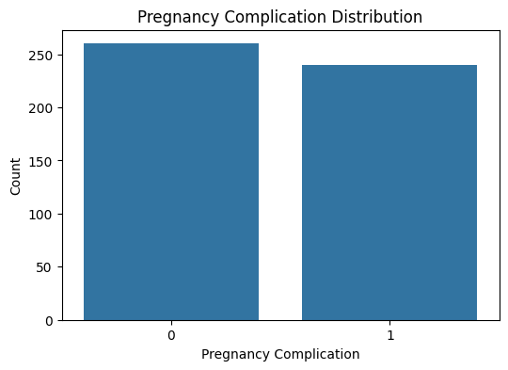
Figure 2: Pregnancy Complication Target Distribution

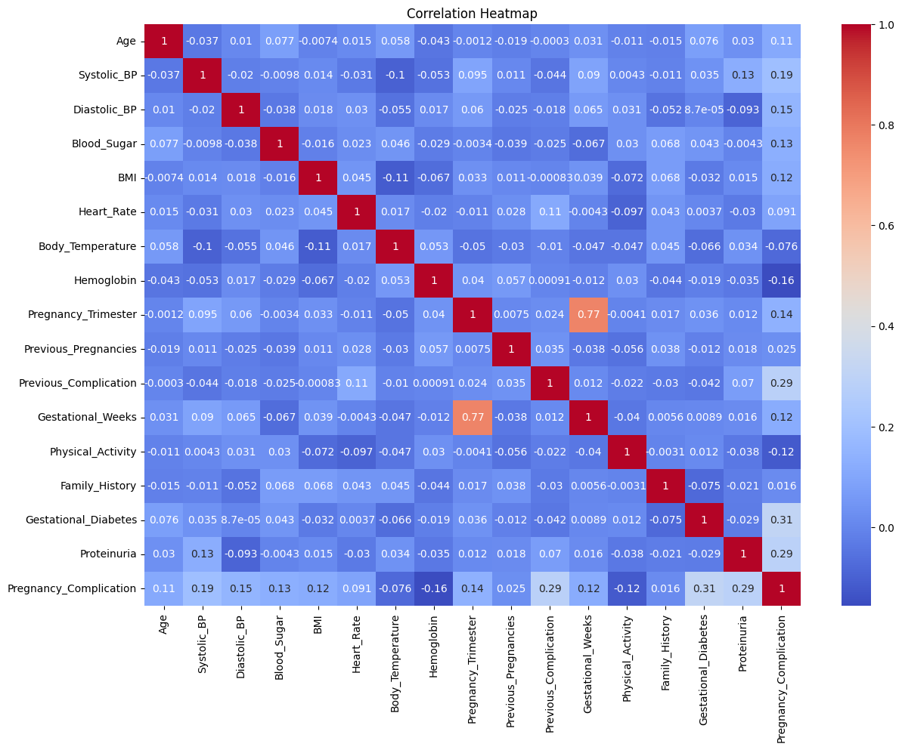
Figure 3: Correlation Heatmap

4.3 Results of Model Training
Four classification algorithms were trained and evaluated on the same 80:20 stratified split. The observed test-set accuracies from the notebook are shown below.
Model | Accuracy
Logistic Regression | 70.0%
Decision Tree | 83.0%
Random Forest | 89.0%
XGBoost | 86.0%
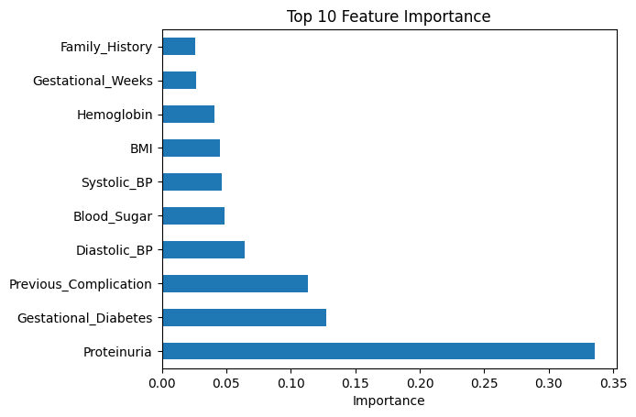
Figure 4: XGBoost Feature Importance

4.4 Model Evaluation
The XGBoost model produced an accuracy of 0.86 on the 100-record test set. Its weighted precision, recall, and F1-score were all 0.86. The confusion matrix contained 46 true negatives, 6 false positives, 8 false negatives, and 40 true positives. The ROC-AUC was 0.953125.
Metric | XGBoost Result
Accuracy | 0.86
Weighted Precision | 0.86
Weighted Recall | 0.86
Weighted F1-Score | 0.86
ROC-AUC | 0.953125
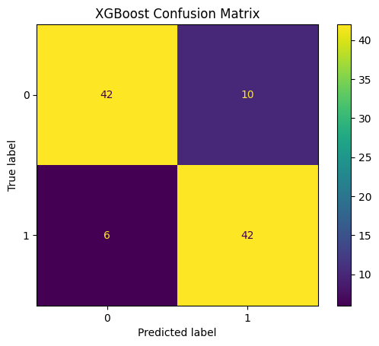
Figure 5: XGBoost Confusion Matrix
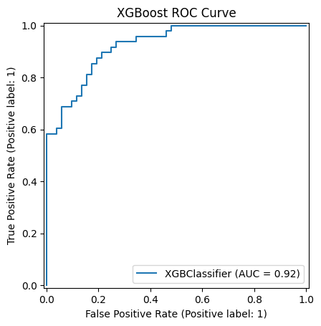
Figure 6: XGBoost ROC Curve

4.5 Comparison of Machine Learning Models
Model | Accuracy | Observation
Logistic Regression | 70% | Baseline model
Decision Tree | 83% | Improved over baseline
Random Forest | 89% | Highest raw accuracy in the notebook run
XGBoost | 86% | Strong performance with ROC-AUC 0.953125
The notebook shows Random Forest achieving the highest raw test accuracy at 89%, while the project PPT highlights the optimized XGBoost result of 86% accuracy and 0.9531 ROC-AUC. Therefore, model selection should consider more than accuracy alone. XGBoost provides strong discrimination according to ROC-AUC, whereas Random Forest has the highest observed accuracy in this run.
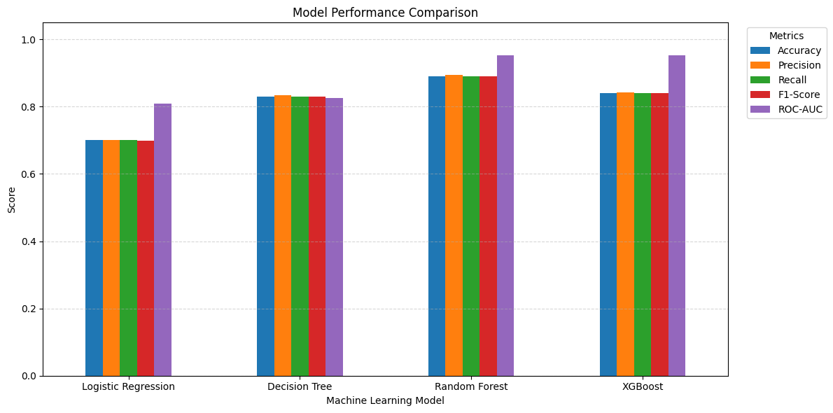
Figure 7: Model Accuracy / Metric Visualization

4.6 Prediction Output
The prediction output is a binary class. A value of 0 means No Pregnancy Complication and a value of 1 means Pregnancy Complication. The project PPT describes a Streamlit interface where the user can enter pregnancy and clinical parameters and view the predicted class.
Predicted Value | Meaning
0 | No Pregnancy Complication
1 | Pregnancy Complication

4.7 User Interface / Output Screens
- The project PPT includes a planned Streamlit interface for entering pregnancy and clinical parameters and viewing the prediction result. The supplied PPT describes the live-demo flow as: enter parameters, submit the data, and view the predicted complication/no-complication class.
- A final Streamlit screenshot should be inserted here if the deployed interface is available. The current source files do not contain a final Streamlit screenshot, so no screenshot has been invented in this report.

CHAPTER 5

Discussion and Conclusion

5.1 Discussion of Results
The experimental results show meaningful differences among the tested classifiers. Logistic Regression achieved 70% accuracy, Decision Tree achieved 83%, Random Forest achieved 89%, and XGBoost achieved 86%. The Random Forest result is the highest accuracy in the current notebook run. XGBoost, however, produced a strong ROC-AUC of 0.953125 and balanced weighted precision, recall, and F1-score of 0.86.

5.2 Key Findings
- The dataset contains 500 records and 17 columns, including 16 input features and one target.
- No missing values or duplicate records were reported by the notebook.
- The target distribution is reasonably balanced: 260 no-complication records and 240 complication records.
- The 80:20 stratified split produced 400 training and 100 testing records.
- Random Forest achieved the highest observed test accuracy of 89%.
- XGBoost achieved 86% accuracy and ROC-AUC of 0.953125.
- The model can provide a preliminary classification but must not be treated as a medical diagnosis.

GitHub Link Of The Project
https://github.com/ahirdiya002/PREGNANCY-COMPLICATION-PREDICTION-USING-MACHINE-LEARNING

5.4 Limitations
- The working dataset contains 500 records and may not represent the full diversity of real-world pregnancy cases.
- The project is a preliminary Machine Learning classification system and is not a clinical diagnostic tool.
- The current notebook does not provide evidence of external clinical validation.
- The notebook's final model-saving cell saves a Logistic Regression object, while the PPT highlights XGBoost as the optimized model. Deployment should save and load the intended final model consistently.
- Additional real-world data and clinical validation would be required before any practical medical use.

5.5 Future Work
- Use larger and more diverse clinical datasets.
- Add more clinically relevant attributes where appropriate.
- Compare additional tuned and ensemble models.
- Use cross-validation and systematic hyperparameter tuning.
- Integrate the selected final model consistently with the Streamlit interface.
- Provide clearer preliminary risk information and model explanations.
- Consider real-time or updated measurements only with appropriate clinical validation.

5.6 Conclusion
This project presents a Machine Learning-based Pregnancy Complication Prediction System that analyses clinical and pregnancy-related attributes to classify records into no complication or pregnancy complication. The notebook demonstrates a complete workflow covering data inspection, exploratory analysis, preprocessing, model training, evaluation, visualisation, and model saving. Among the tested models, Random Forest achieved the highest observed accuracy of 89%, while XGBoost achieved 86% accuracy with a ROC-AUC of 0.953125. The project demonstrates the feasibility of using Machine Learning for preliminary pregnancy-risk classification and provides a foundation for future improvement, validation, and user-interface deployment.

REFERENCES
[1] Pedregosa, F., et al. (2011). Scikit-learn: Machine Learning in Python. Journal of Machine Learning Research, 12, 2825–2830.
[2] Breiman, L. (2001). Random Forests. Machine Learning, 45(1), 5–32.
[3] Chen, T. & Guestrin, C. (2016). XGBoost: A Scalable Tree Boosting System. Proceedings of the 22nd ACM SIGKDD International Conference on Knowledge Discovery and Data Mining.
[4] Cortes, C. & Vapnik, V. (1995). Support-Vector Networks. Machine Learning, 20, 273–297.
[5] The supplied Pregnancy Complication Prediction Jupyter Notebook and project presentation (2026).

APPENDICES

Appendix A: Main Dataset Fields
Age, Systolic_BP, Diastolic_BP, Blood_Sugar, BMI, Heart_Rate, Body_Temperature, Hemoglobin, Pregnancy_Trimester, Previous_Pregnancies, Previous_Complication, Gestational_Weeks, Physical_Activity, Family_History, Gestational_Diabetes, Proteinuria, and Pregnancy_Complication.

Appendix B: Model Evaluation Metrics
Accuracy measures the proportion of correctly classified test instances. Precision measures the correctness of positive predictions. Recall measures the coverage of actual positive instances. F1-score is the harmonic mean of precision and recall. ROC-AUC measures the model's ability to distinguish between the two classes across classification thresholds.

Appendix C: XGBoost Classification Report
Class | Precision | Recall | F1-Score | Support
0 | 0.85 | 0.88 | 0.87 | 52
1 | 0.87 | 0.83 | 0.85 | 48
Weighted Avg | 0.86 | 0.86 | 0.86 | 100
Confusion Matrix: [[46, 6], [8, 40]]. ROC-AUC: 0.953125.

Appendix D: Model-Saving Note
The notebook contains a Joblib model-saving step using the filename 'pregnancy_complication_model .pkl'. The saved object in the final notebook cell is Logistic Regression. If XGBoost is selected as the deployment model, the deployment workflow should save the trained XGBoost model and load that same model in the Streamlit application.

Appendix E: Project Team
Student | Email
Ahir Diya Bharatbhai | ahirdiya977@gmail.com
Dhole Neha Bharatbhai | bed143243@gmail.com
Dhimmar Mahi Anilbhai | mahidhimmar038@gmail.com

Guide: Prajapati Jyoti Harinarayanbhai

