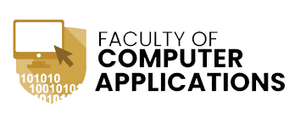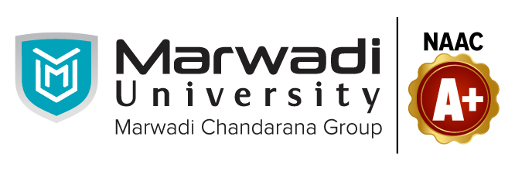

**A Python Project for Academic Year 2024 - 2025**

**ChatBot**

Subject Code : 05BC3404

Subject Name : Python Programing

Submitted By :

Prince Jakhotra

[92300527149]

Submitted To:

Prof. Tirth Bhadeshiya

**Introduction**

Project Title:

" Chatbot "

* Introduction to my project:

My project is about chatbot. Chatbot means it works like Ai. Like we want to ask something and chatbot gives us the answer.

* Overview:

This project is a basic rule-based chatbot developed using Flask (Python web framework). It allows users to interact with the chatbot via a simple web interface, where they can input questions, and the bot provides predefined responses. The project demonstrates how to handle user inputs, process them on the backend, and dynamically update responses on a webpage.

* Create a chatbot that responds to user queries using predefined answers.
* Develop a web-based interface for easy interaction using Flask.
* Understand backend processing by handling user inputs and returning responses.
* Demonstrate full-stack development by integrating Python (Flask) with HTML, CSS.

**Technical Information**

* Technologies Used:

Programming Languages:

Python – Used for backend development and chatbot logic.

HTML, CSS, JavaScript (optional) – If a frontend is added for user interaction.

* Frameworks & Libraries:

Flask – A lightweight web framework for creating the CHATBOT.

Tools & Editors

* VS Code
* Notepad
* IDLE
* Recommended for writing and debugging Python code.

System Requirements

* Software Requirements

Python 3.x (Recommended: Python 3.8+)

Flask & Dependencies (Install using pip install flask )

* Hardware Requirements

RAM: 8GB+ (For smooth execution)

Processor: Intel i3 + or better

Storage: 256GB+ (for dependencies)

**Diagram(s)**

Name of Diagram : flowchart of Chatbot

Flowchart of Chatbot

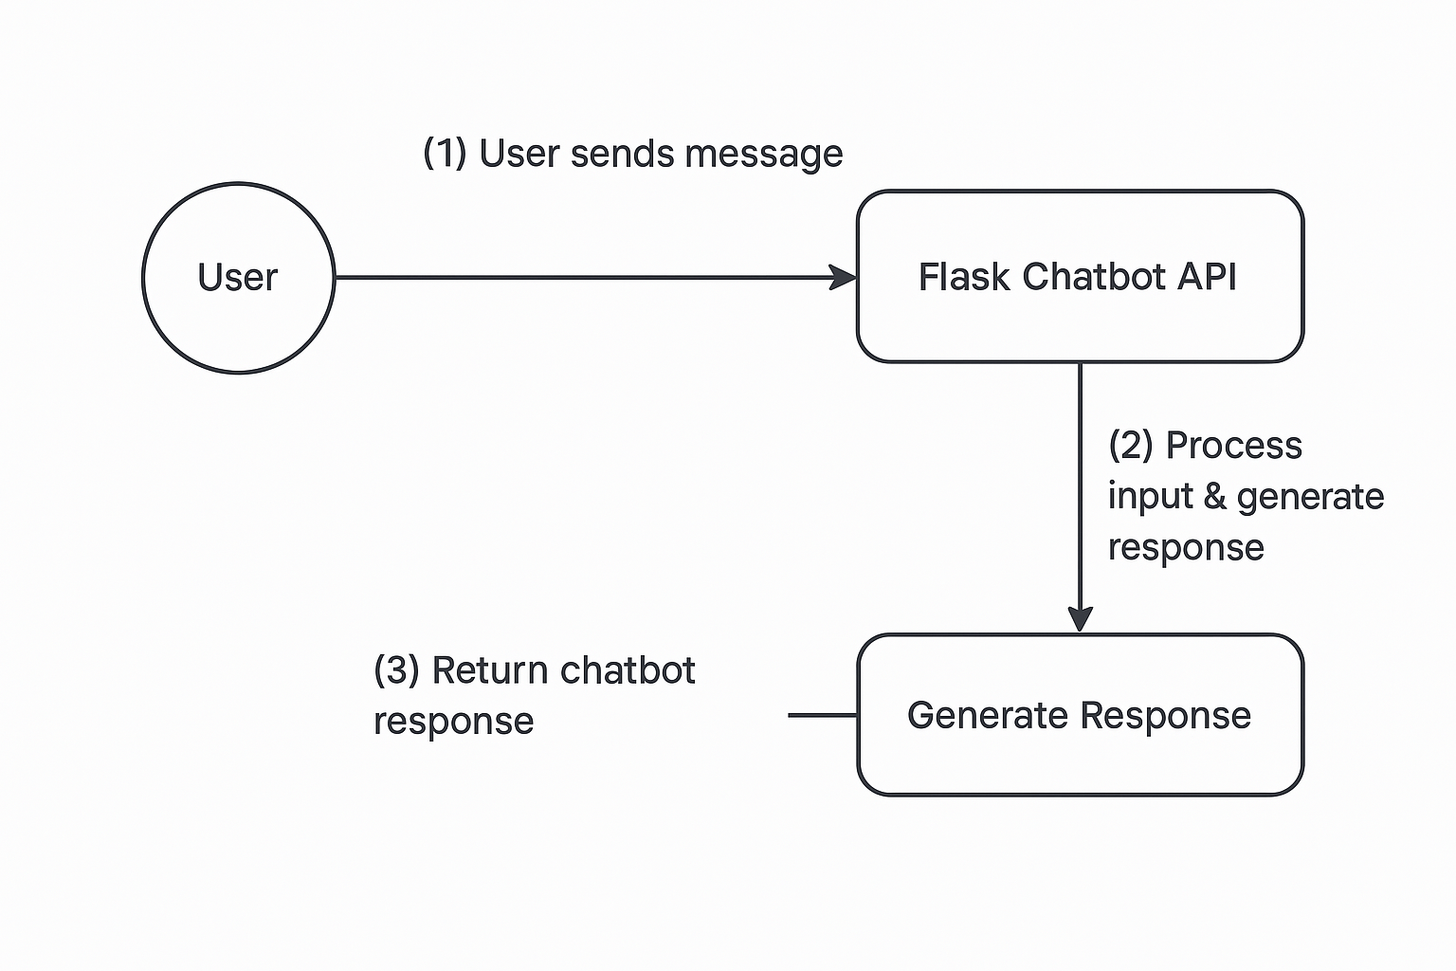

**Learning Objectives**

**1. How to Build a Chatbot**

* Learned how chatbots work and how they respond to user inputs.
* Understood how to create **predefined responses** for different questions.

**2. Working with Flask (Python Web Framework)**

* Learned how to create a **Flask web application**.
* Explored how Flask handles **user requests and responses**.

**3. Creating a Simple Web Page (Frontend)**

* Learned how to design a **basic webpage using HTML & CSS**.
* Understood how to create **forms** where users can type their questions.
* Explored how to **display chatbot responses dynamically** on the webpage.

**4. Connecting Frontend with Backend**

* Learned how to **send user input** from the webpage to Flask using forms.
* Understood how Flask **processes input and returns a response**.
* Explored **how the chatbot logic runs in the background** and updates the webpage.

**5. Debugging and Fixing Errors**

* Learned how to **identify and fix errors** in Python and Flask.
* Understood how to handle **missing inputs and incorrect responses**.
* Explored how to use Flask’s **debugging mode** for testing the chatbot.

**Conclusion**

Developing this Simple Chatbot Project was a valuable learning experience in Python, Flask, and web development. The project demonstrated how to build a chatbot using predefined responses and connect it to a web-based interface using HTML and CSS. It helped in understanding how frontend and backend interact, with Flask handling user inputs and returning chatbot responses dynamically.