A Project Report On

Library Management System

Submitted in partial fulfillment of the requirement for the award of the degree

Bachelor of Computer Application (BCA)

Academic Year 2025 – 26

Prince jakhotra Dharmik jiyani
92300527149 92300527173

Internal Guide
(Kishita doshi)



Rajkot-Morbi Road, At & PO : Gauridad, Rajkot 360 003. Gujarat. India.

Faculty of Computer Applications (FCA)



This is to certify that the project work entitled

<Library management system>

submitted in partial fulfillment of the requirement for

the award of the degree of

Bachelor of Computer Application

of the

Marwadi University

is a result of the bonafide work carried out by

<Prince Jakhotra(92300527149)>

<Dharmik Jiyani(92300527173)>

during the academic year 2025-26

Kishita Doshi Sunil bajeja RSreedaran
Faculty Guide |  | HOD |  | Dean

DECLARATION

I/We hereby declare that this project work entitled Library Management System is a record done by me.

I also declare that the matter embodied in this project is genuine work done by me and has not been submitted whether to this University or to any other University / Institute for the fulfillment of the requirement of any course of study.

Place : marwadi university-rajkot
Date :28/08/2025

Prince jakhotra (92300527149) Signature : prince
Dharmik jiyani (92300527173) Signature : dharmik

ACKNOWLEDGEMENT

It is indeed a great pleasure to express our thanks and gratitude to all those who helped us. No serious and lasting achievement or success one can ever achieve without the help of friendly guidance and co-operation of so many people involved in the work.

We are very thankful to our guide kishita doshi, the person who makes us to follow the right steps during our project work. We express our deep sense of gratitude to for his /her guidance, suggestions and expertise at every stage. A part from that his/her valuable and expertise suggestion during documentation of our report indeed help us a lot.

Thanks to our friend and colleague who have been a source of inspiration and motivation that helped to us during our project work.

We are heartily thankful to the Dean of our department Dr. R. Sridaran sir and HoD Dr. Sunil Bajeja sir for giving us an opportunity to work over this project and for their end-less and great support to all other people who directly or indirectly supported and help us to fulfil our task.

<Prince jakhotra> (92300527149) Signature:__________
<Dharmik jiyani > (92300527173) Signature:___________

CONTENTS

Chapters | Particulars | Page No.
1 | SYNOPSIS | 6
2  2.1  2.2 | PREAMBLE  General Introduction  Module description | 6
3 | REVIEW OF LITERATURE | 7
4  4.1  4.2 | TECHNICAL DESCRIPTION  Hardware Requirement  Software Requirement | 8
5  5.1  5.2  5.2.1  5.3  5.3.1  5.3.2  5.3.3  5.4  5.4.1  5.4.2 | SYSTEM DESIGN AND DEVELOPMENT  (Only applicable diagrams)  Architectural Design  - Class Diagram  Dynamic Modeling  - Use Case Diagram  - Sequence Diagram  - Activity Diagram  - Any other applicable diagram (applicable)  Database Design (If applicable)  Relationship Diagram (ER)  Menu Design  Screen Design | 9
6 | CONCLUSION | 14
7 | LEARNING DURING PROJECT WORK | 14
8  8.1  8.2 | BIBLIOGRAPHY  Online References  Offline References | 15

1.SYNOPSIS

➢ The Library Management System is a web-based application developed using PHP and MySQL to automate the routine tasks of a library. It enables librarians to manage books, student records, and transactions like issuing and returning of books efficiently.

➢The system is divided into several modules:

• Admin Module: Manage books, students, and staff records.
• Book Management Module: Add, update, delete, and search books.
• Issue/Return Module: Handle issuing and returning of books with due dates and fines.
• User Module (Students/Staff): View available books, check issued books, and due dates.
• Reports Module: Generate detailed reports of transactions and usage.

2.PREAMBLE

2.1. General Introduction:

➢The Library Management System is a web-based application that automates the process of managing books, students, and transactions in a library. It reduces manual work, saves time, and ensures accurate record-keeping. The system allows librarians to manage books and members efficiently, while students can easily search, view, and issue books online.

2.2.Module description:

• Admin Module: Manage books, students, and staff records.
• Book Module: Add, update, delete, and search books.
• Issue/Return Module: Handle book issuing, returning, and fines.
• User Module: Students can view available books and check their issued books.
• Report Module: Generate reports of transactions and usage.

3.REVIEW OF LITERATURE

➢Our Library Management System, developed using PHP and MySQL, is a simplified version designed for academic purposes. It focuses on providing core functionalities like book management, issuing/returning, and generating reports in a user-friendly and cost-effective way, making it suitable for small and medium-sized institutions.

➢Many libraries still rely on manual systems for managing books and records, which are time-consuming and prone to errors. To overcome these issues, several digital library systems have been developed worldwide.

4.TECHNICAL DESCRIPTION

4.1. Hardware Requirement:

• Processor: Intel i3 or higher
• RAM: Minimum 4 GB
• Hard Disk: 500 GB or more
• Monitor: 15” or higher
• Input Devices: Keyboard, Mouse

4.2.Software Requirement:

• Operating System: Windows / Linux
• Frontend: HTML, CSS, JavaScript, PHP
• Backend: MySQL Database
• Server: Apache (XAMPP )
• Browser: Chrome / Firefox / Edge

5.SYSTEM DESIGN AND DEVELOPMENT

5.1Architectural Design:
• Client Side (User): Students and admin interact through a web interface built using HTML, CSS, JavaScript, and PHP.
• Server Side (Application): PHP scripts handle business logic, process requests, and connect to the database.
• Database (Backend): MySQL stores all records, including books, users, and transactions.
5.2 Class Diagram:

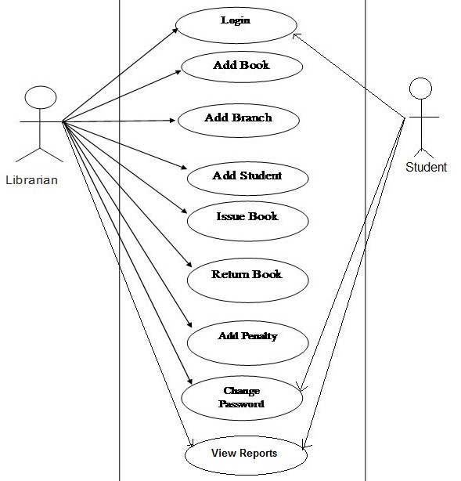

5.3.SequenceDiagram:

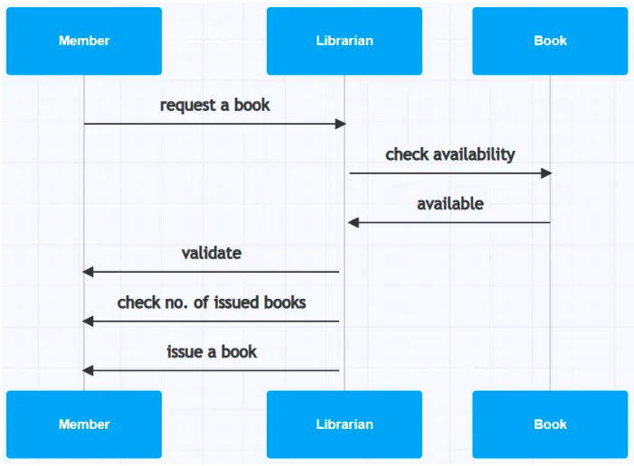

5.3.2. Activity Diagram:

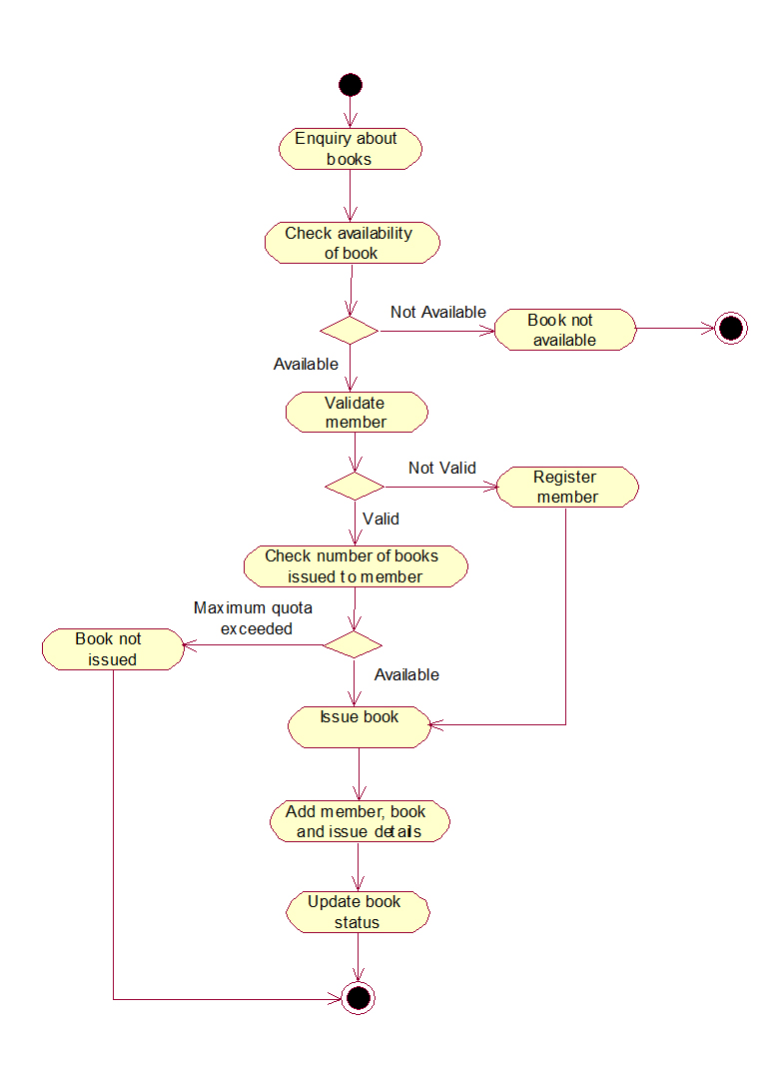

5.4.2. Menu Design:



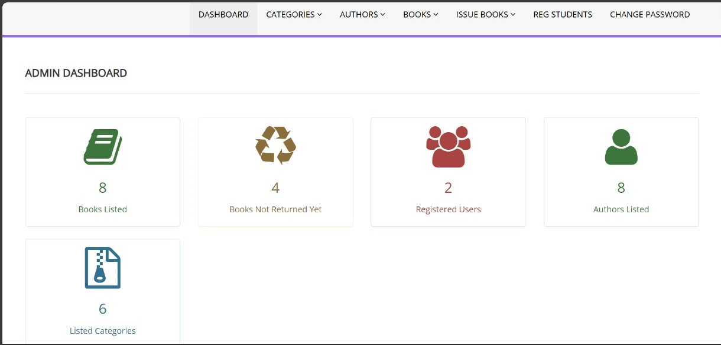

Screen Design:

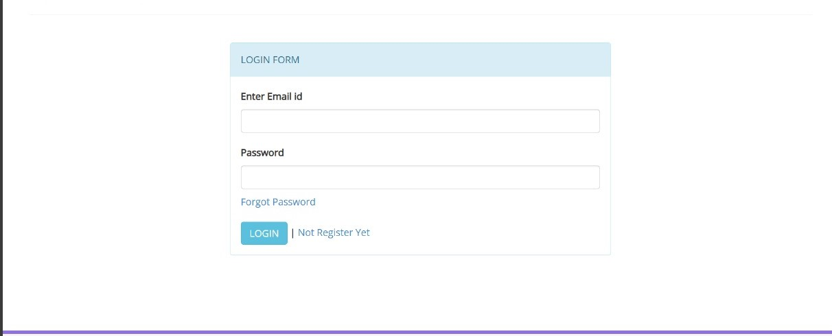

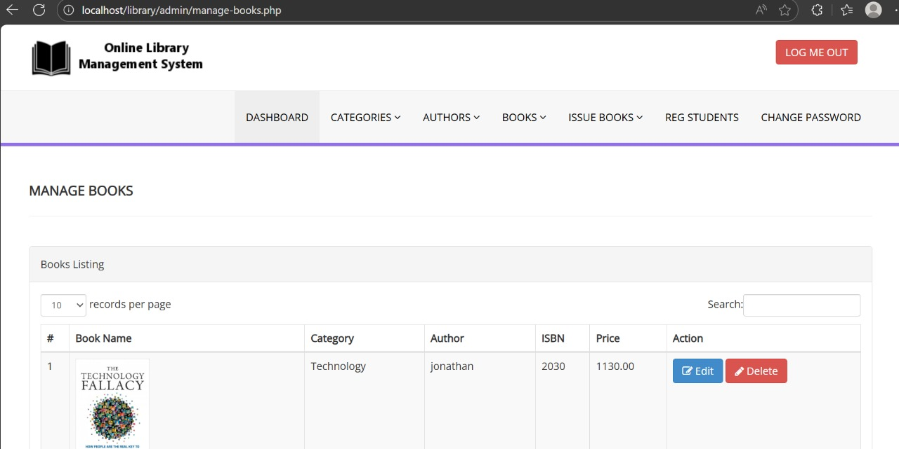

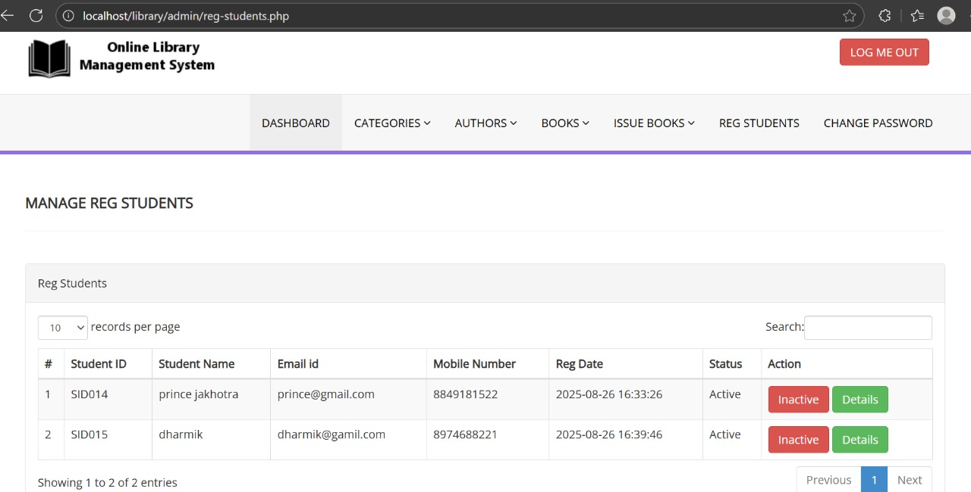
6. CONCLUSION

➢The Library Management System successfully automates the core activities of a library such as book management, student records, and transactions of issue/return. It eliminates the need for manual record-keeping, reduces errors, and provides quick access to information.
➢By using PHP and MySQL, the system ensures a reliable, scalable, and user-friendly platform that benefits both librarians and students. It saves time, improves efficiency, and maintains accurate records, making library operations smoother and more effective.

7.LEARNING DURING PROJECT WORK

➢During the development of this project, we gained valuable practical knowledge and skills, such as:
1.Understanding client-server architecture and web application workflow.
2.Developing dynamic web pages using PHP and integrating them with a MySQL database.
3.Performing operations Create, Read, Update, Delete for managing books and users.
4.Designing and implementing ER diagrams, use case diagrams, and class diagrams for system modeling.

8.BIBLIOGRAPHY

8.1 Online References:
• https://www.php.net/ – Official PHP Documentation
• https://www.mysql.com/ – MySQL Official Website
• https://www.w3schools.com/ – Tutorials on HTML, CSS, PHP, and SQL

8.2.Offline References

• PHP & MySQL programming textbooks
• Database Management System (DBMS) textbooks
• Class notes and study materials

