# Software Engineering Bootcamp Assignment

## Question 03

Upcasting and down casting are fundamental concepts in object-oriented programming that allow us to work with objects of different types. In simple words, upcasting refers to casting an object to its parent type, while down casting refers to casting an object to its child type. Let's explore these concepts further with some code examples in Java.

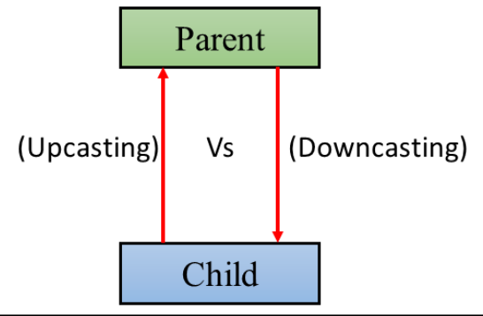

### Up Casting

Upcasting (Generalization or Widening) allows us to treat an object of a subclass as if it were an object of its superclass. This is also known as generalization or widening. Let's consider a simple example:

class Animal {

public void eat() {

System.out.println("Eating...");

}

}

class Dog extends Animal {

public void bark() {

System.out.println("Barking...");

}

}

public class Main {

public static void main(String[] args) {

Dog dog = new Dog();

Animal animal = dog; // Upcasting

animal.eat(); // Calling superclass method

}

}

In the above code, we have two classes, Animal and Dog. Dog is a subclass of Animal. We create an object of the Dog class and then upcast it to its superclass Animal. After that, we call the eat() method using the upcasted object. As expected, the output of the program will be Eating....

### Down Casting

Down casting is the opposite of upcasting. It allows us to cast an object of a superclass to its subclass. This is also known as specialization or narrowing. Let's consider another example:

class Animal {

public void eat() {

System.out.println("Eating...");

}

}

class Dog extends Animal {

public void bark() {

System.out.println("Barking...");

}

}

public class Main {

public static void main(String[] args) {

Animal animal = new Dog(); // Upcasting

Dog dog = (Dog) animal; // Downcasting

dog.bark(); // Calling subclass method

}

}

In the above code, we first create an object of the Dog class and upcast it to its superclass Animal. Then, we downcast the Animal object back to the Dog class using explicit casting. Finally, we call the bark() method using the down casted object. As expected, the output of the program will be Barking....

To sum up, upcasting and down casting are essential concepts in Java that allow us to work with objects of different types. Upcasting is casting an object to its superclass, while down casting is casting an object to its subclass. In general, upcasting is always allowed, but down casting involves a type of check and can throw a **ClassCastException**.