**PROJECT REPORT**

**Voyage Vista:**

**Illuminating Insights from Uber expeditionary Analysis**

TEAM ID : 57A3BC683CADD0288704F57AF76C8E1F

TEAM MEMBERS

R. Kavyasree (Team leader)

S.A.Harini

I.R.Abijah

M.Vincy Royce

Introduction

* 1. **Overview**

The ride-sharing business revolutionized a business model that had been functioning in the same way for generations: On a busy city street, a person in need of a ride stood on a street corner and waved down a taxi. On quieter streets, or in towns without roving taxis, the person would phone a local car service and request a pickup. The Major of our project is to use data Analyzing techniques to find unknown patterns in the Uber Drives dataset. The research is carried out on Uber drives data collected from the year 2016.

* 1. **Purpose**

Connects the physical and digital worlds to help make movement happen at the tap of a button. Because we believe in a world where movement should be accessible. So, you can move and earn safely. In a way that's sustainable for our planet.

1. **Problem Definition and Design Thinking**
   1. **Empathy Map**

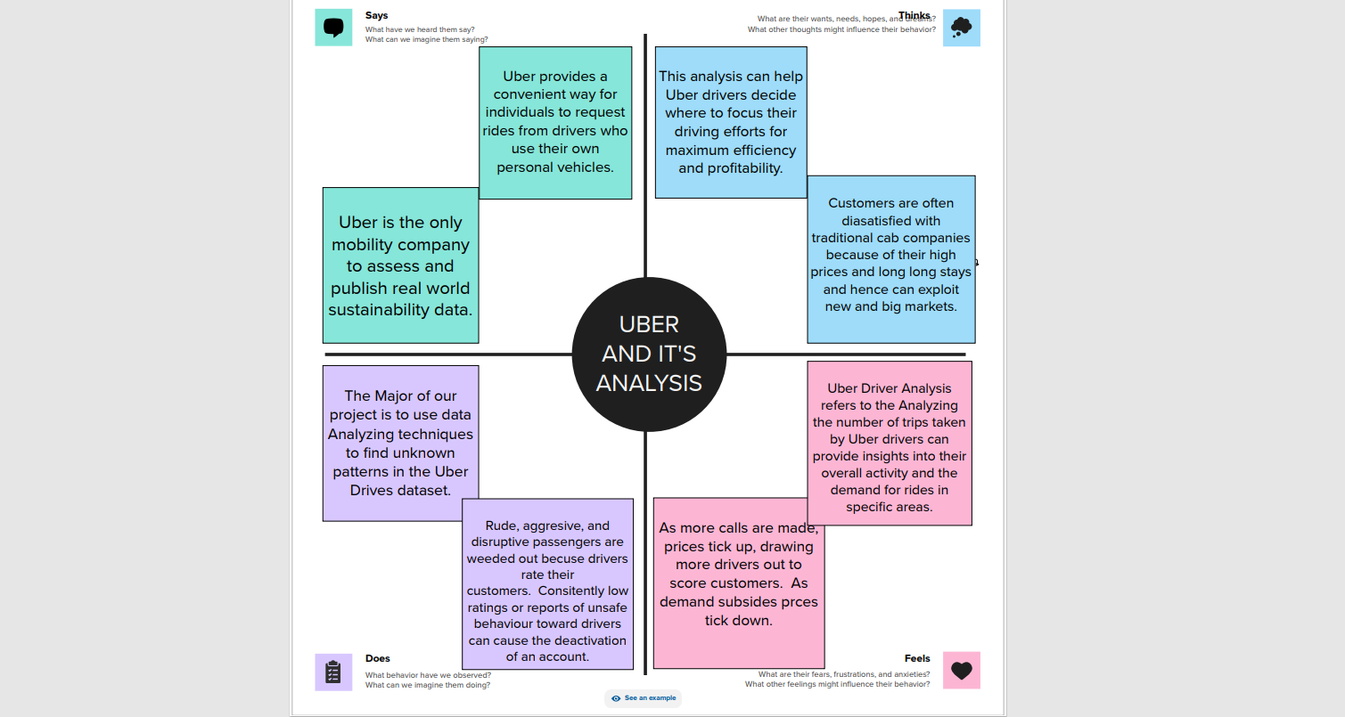

* 1. 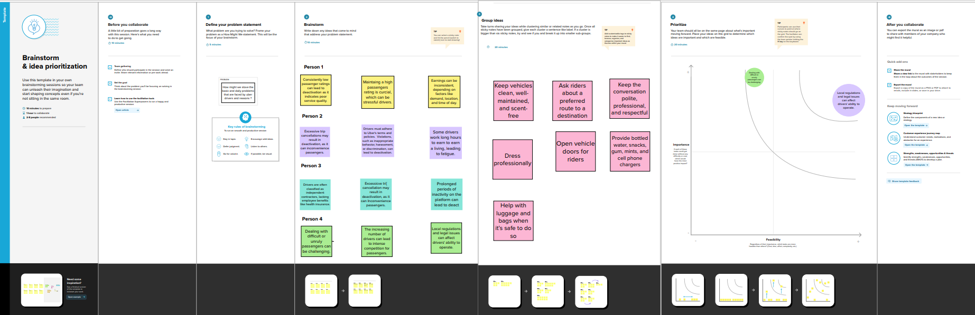**Ideation and Brain Storming**

**3. Result**

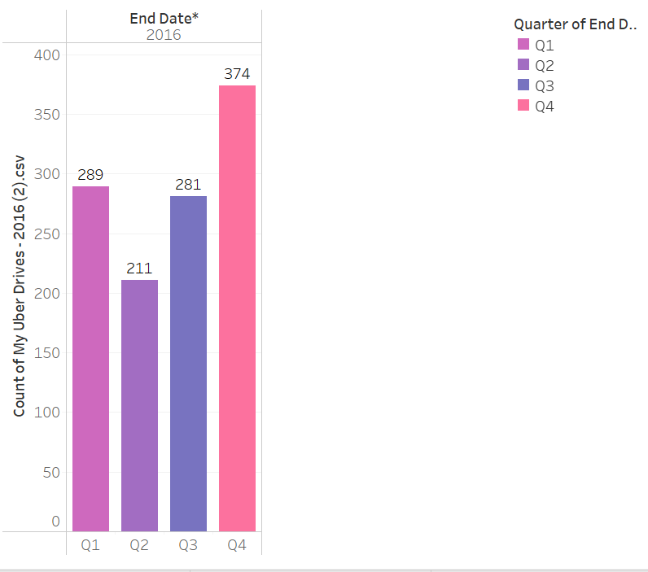

In Q4 more uber trips have been took place.

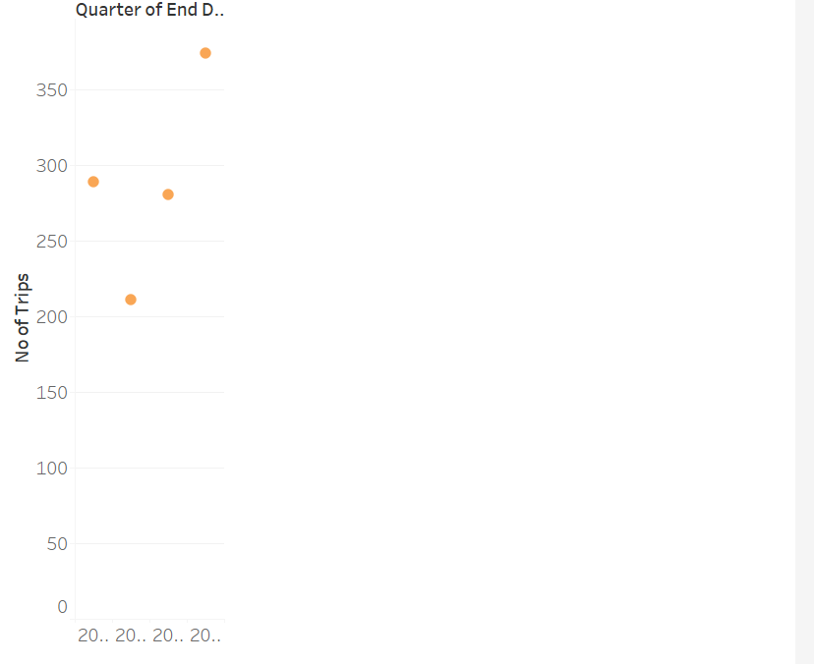

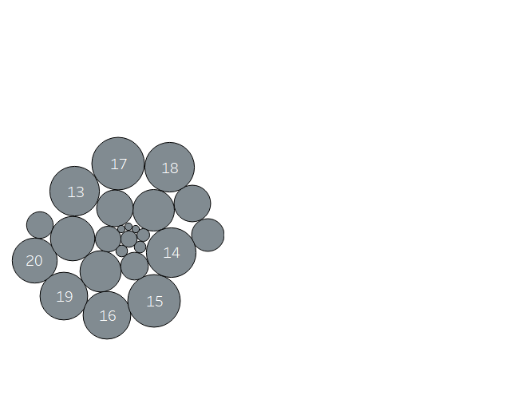In December more number of Uber Trips have been took place.

Uber is busy from 3pm -7pm.

1. **Advantages and Disadvantages**

Advantages

* Convenient and Cashless.
* Professional Service.
* Competitive Pricing.
* Safety and Flexibility for Drivers.
* Controversial Labor Practices.
* Surge Pricing.
* Impact of Price Competition.

Disadvantages

* Pricing. There's no way to predict how much an Uber ride might cost. ...
* Driver Cancelations. Uber drivers can cancel rides. ...
* Not Available in All Cities and Locations.

1. **Application**

Uber allows users to easily hail a ride with a few taps on their smartphones, providing a convenient and accessible alternative to traditional taxi services.

Uber has created a new form of flexible employment for many people, allowing them to work as independent contractors and earn income by providing rides to users.

By providing a convenient and reliable transportation option, Uber has contributed to improved urban mobility and reduced the reliance on personal vehicles, thereby potentially decreasing traffic congestion and emissions.

**5** **Conclusion**

Uber is a multinational transportation network company that operates a ride-hailing platform. It was founded in 2009 by Garrett Camp and Travis Kalanick and is based in San Francisco, California. Uber provides a convenient way for individuals to request rides from drivers who use their own personal vehicles. Uber Driver Analysis refers to the Analyzing the number of trips taken by Uber drivers can provide insights into their overall activity and the demand for rides in specific areas. Daily, Weekly, or Monthly Analysis: Uber's data can be analyzed on a daily, weekly, monthly basis to understand the trends and patterns of trip volumes. This analysis can help identify peak hours or days of high demand and optimize driver availability during those times. Trips can be analyzed based on geographic regions or specific cities to identify areas with higher demand. This analysis can help Uber drivers decide where to focus their driving efforts for maximum efficiency and profitability.

1. **Future scope**

While I can't predict the future, the direction of Uber seems to be geared towards further expansion of its services, potentially branching out into new areas such as autonomous vehicles and drone delivery. Additionally, it's likely that Uber will continue to focus on enhancing user experience through technological advancements and improving its relationship with drivers and customers alike.

**THANKING YOU**!