1. INTRODUCTION

Overview

In the 2019 Lok Sabha elections in India ,political juggernauts refer to major political parties and leaders who played pivotal roles in the electoral process . These included the Bharatiya Janata Party (BJP) led by Narendra Modi and the Indian National Congress led by Rahul Gandhi . A quantitative analysis of this election would involve examining factors such as seat distribution voter turnout ,and the impact of alliances to understand the electoral dynamics and the BJP’s significant victory ,securing a majority in the Lok Sabha. This analysis may also consider factors like campaign spending ,demographics , and regional variations in the election regional variations in the election results.

Purpose

This project is likely to provide an in-depth ,data driven examination of the 2019 Indian general elections . This analysis would involve using quantitative methods to study various aspects of the elections ,such as voter behaviour , party performance , constituency dynamics , and more . It aims to offer insights and a deeper understanding of this important political event .

1. Problem Definition &Design Thinking

2.1 Empathy map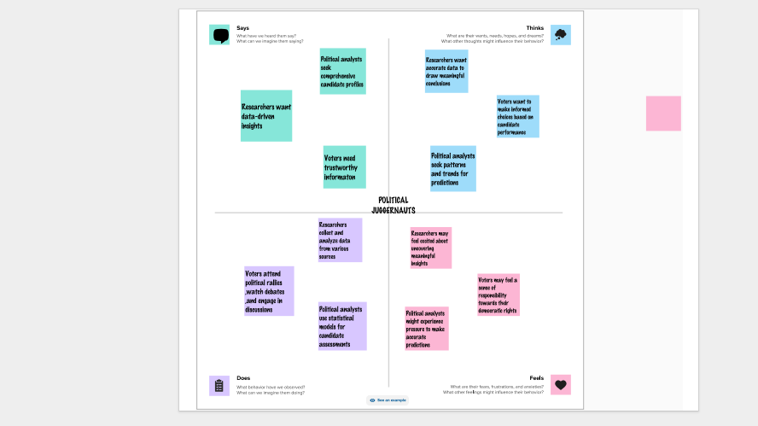

* 1. Ideation&Brainstorming Map

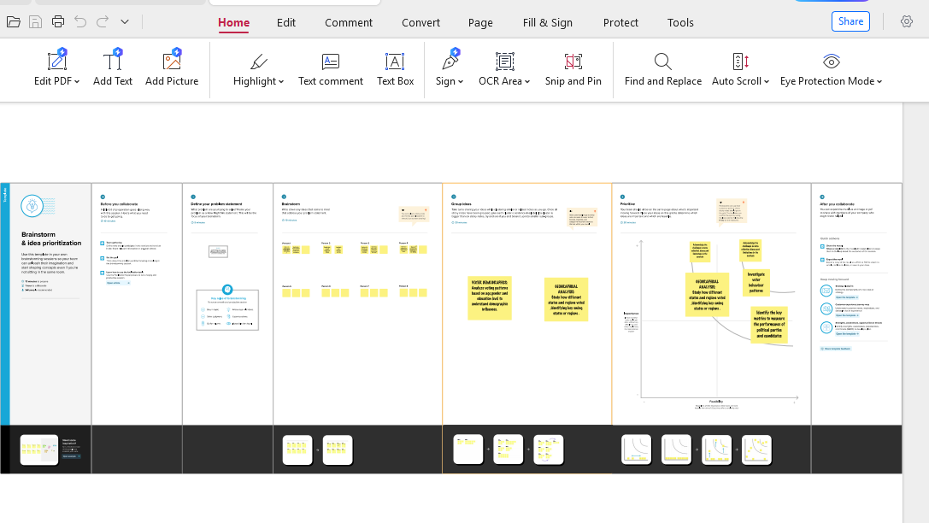

1. RESULT

Activity 1.1

