

Interview Session Report

Question 1 : What does success mean to you?
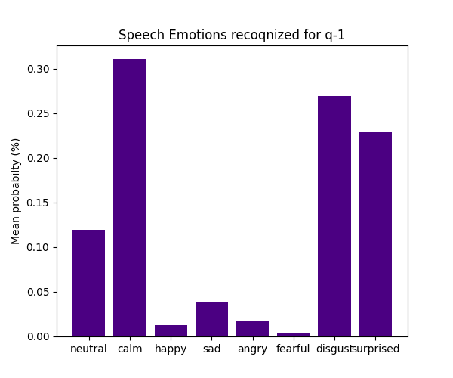Question 1 : What does success mean to you?
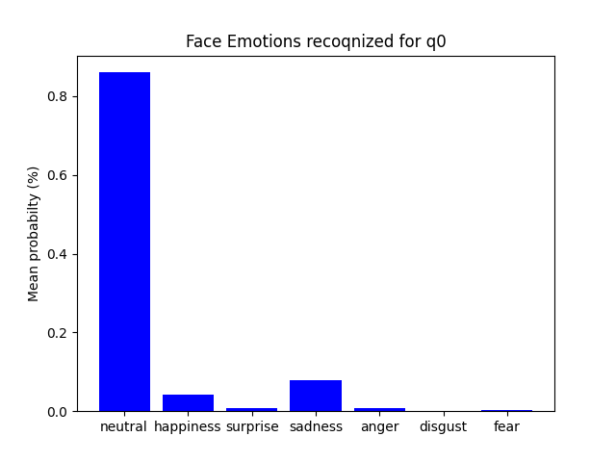Question 2 : Are you applying for other jobs also?
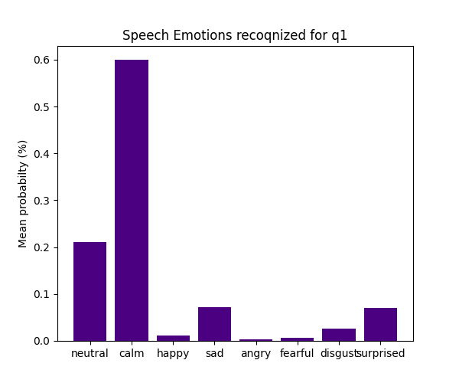Question 2 : Are you applying for other jobs also?
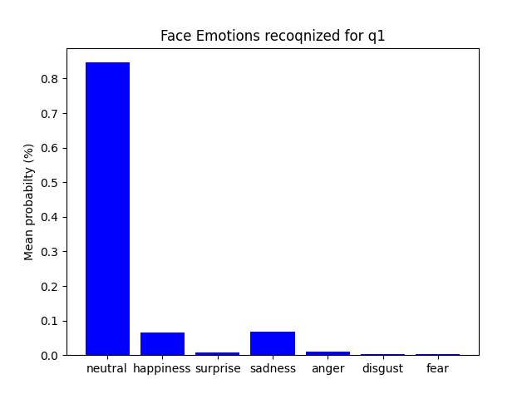Question 3 : Why do you want this job?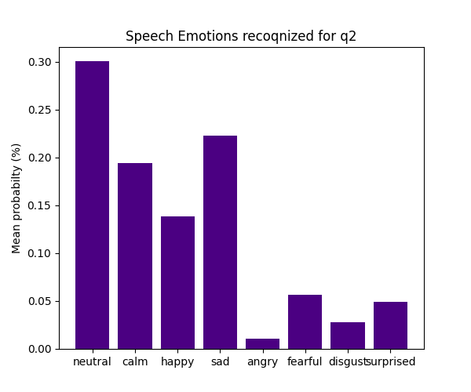Question 3 : Why do you want this job?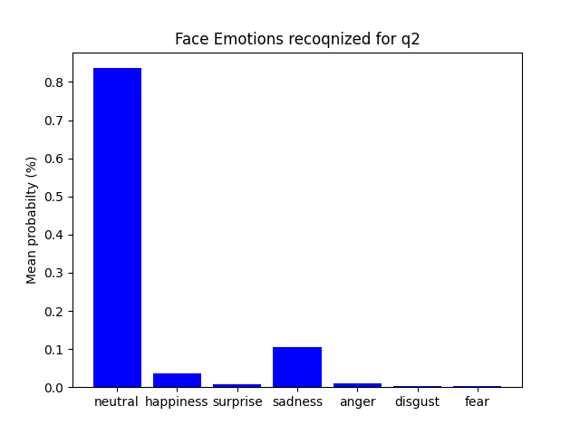Question 4 : Why do you want to work at this company?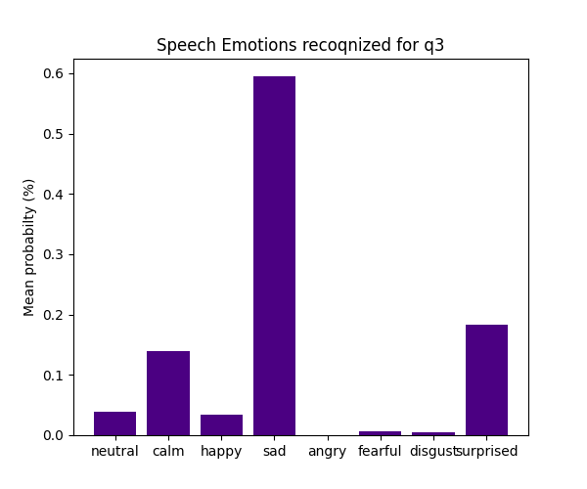Question 4 : Why do you want to work at this company?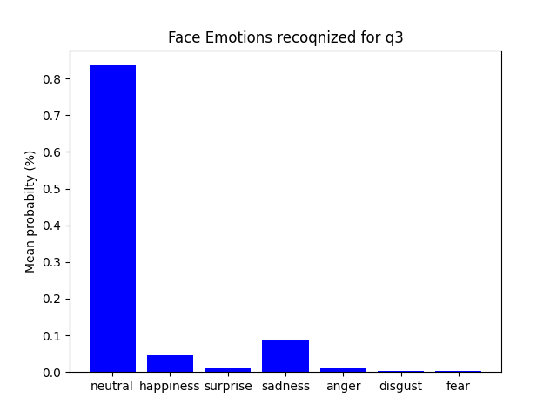Question 5 : Would you like to work over time or more hours?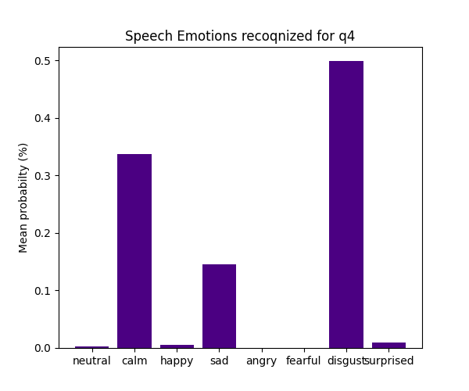Question 5 : Would you like to work over time or more hours?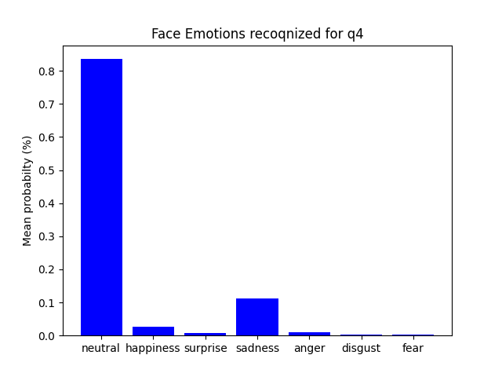Here is your volume loudness through out your interview session: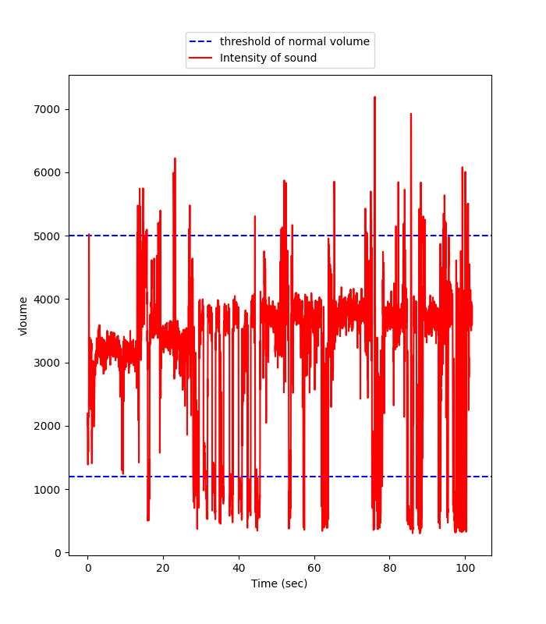Now eyes analysis:  
  
your interview session lasted for 6.687135322888692 mins.  
your maintained good eye contact with interviewer for 100.0 %  
you blinked 0 times in 6.687135322888692 mins, that is less than an average human bieng, Not blinking normally can indicate discomfort or shock  
Your posture showed that you were confident and engaged in the interview, Great Job.0  
Finally, Practice makes perfect. You can always redo this interview session and improve your self.
  
Oh if there's a question that you don't know how to answer, just ask Sam the chatbot he knows great tips for every question.
  
  
We wish you good luck and good salary :)