The report for Your session

# Probabilties:

## From Audio session we detect this Probabilty:

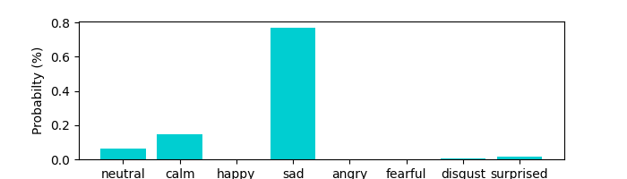

# From Audio session we detect this summry:

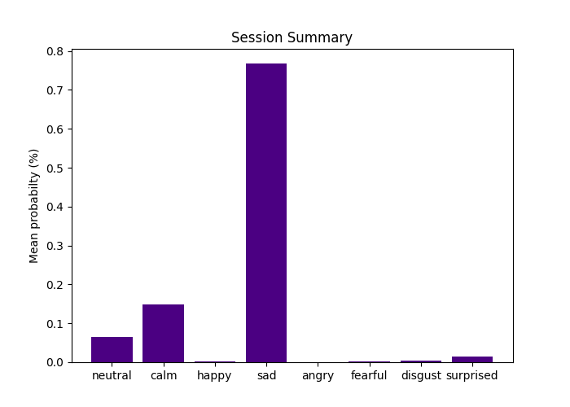

## From Audio session we detect volume summry:

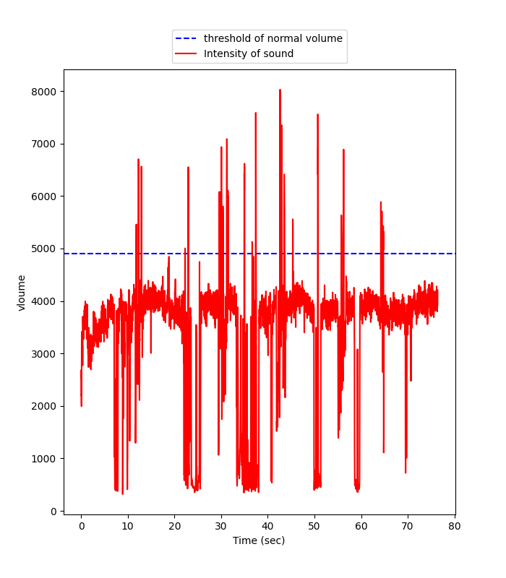

# From Facial session we detect this summry:

# Session time= 65.40369009971619 sec

# Time puse =0.10788583755493164 sec

# Eye contact =99 %

# Total blinks = 0

