The report for Your session

# Probabilties:

## From Audio session we detect this Probabilty:

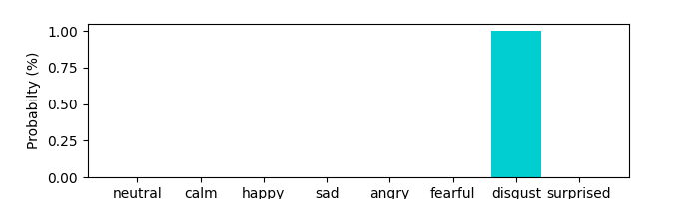

# From Audio session we detect this summry:

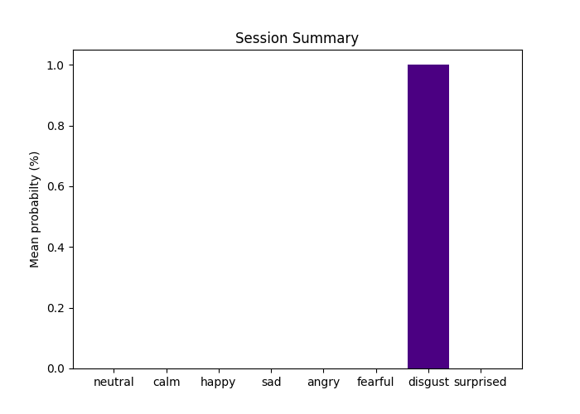

## From Audio session we detect volume summry:

