SDN Project2 0516327 李昂軒

1. Answer Questions:
2. How many Flow-Mod messages are installed in captured packets?

首先，我打開了onos並下了指令：app deactivate proxyarp，並在mininet裡輸入h1 ping h2，同時也打開了wireshark監聽loopback:lo，在監聽到的資料中我以arp為filter來篩選封包

1. What are the matching fields and the corresponding actions in

each of Flow-Mod messages?

1. What are the idle timeout, hard timeout and priority of all

Flow-Mod messages?

1. Install Flow Rules(I):

Install following flow rules to forward ARP packets

首先我關掉了reactive forwarding與proxy arp這2個app也在網頁的GUI中把所有的flow rules都刪掉了，之後我輸入h1 arping h2得到以下結果：

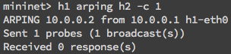

代表L2 broadcast沒有正確被handle。最後，我將自己的flow rules寫在arp.json中並成功的post到switch上，也成功的handle L2 broadcast。(註：ethType中的0x806即代表arp)

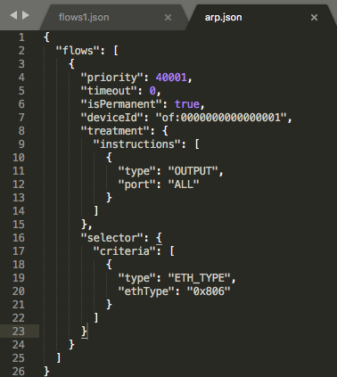

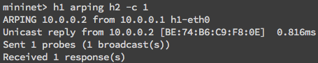

1. Install Flow Rules(II):
2. Bonus