***\*\*\*\*\*\*\*\*\*\*\*\*\*\*\*\*\*\*\*\*\*\*\*\*\*\*\*\*\*\*\*\*\*\*\*\*\*\*\*\*\*\*\*\*\*\*\*\*\*\*\****

***Appian Local Debugging in Eclipse: Plugin Development***

***\*\*\*\*\*\*\*\*\*\*\*\*\*\*\*\*\*\*\*\*\*\*\*\*\*\*\*\*\*\*\*\*\*\*\*\*\*\*\*\*\*\*\*\*\*\*\*\*\*\*\*\****

***Debugging the Existing Plugins:***

Step 1: Download the plugin form the Shared Component in Appian forum.

Step 2: Import the Existing the Eclipse Environment

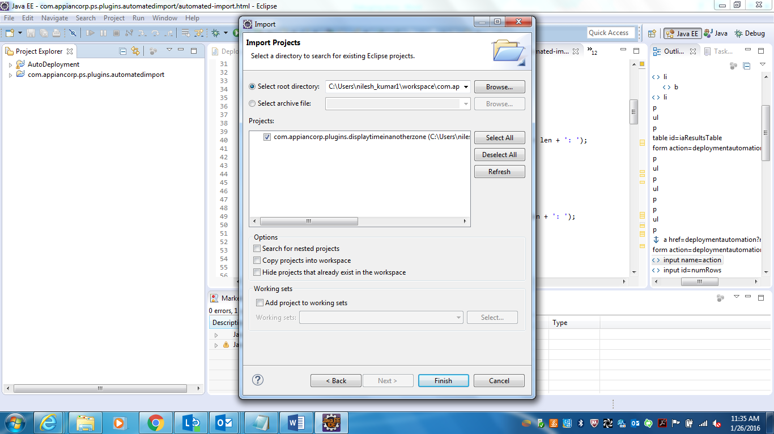

Step 3 : Make Sure that same jar is deployed in the JBOSS Local Server for debugging to work and also JBOSS is running in debug mode.

Step 4: Right Click on the plugin in the project explorer and select Debug Cong >> right click in Remote Java Application >> select New

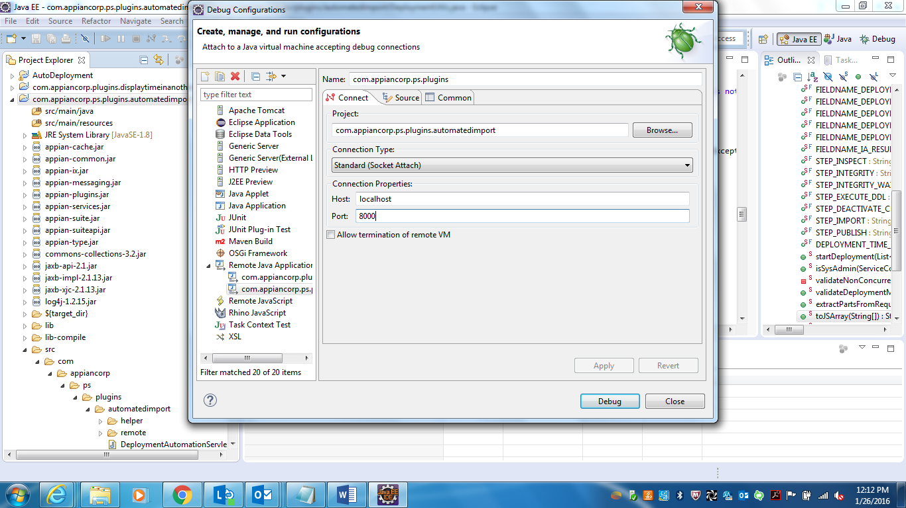

Step 5: Fill the following config parameter in Connection Properties.

Host : localhost (If JBOSS Server is installed on your local machine)

10.203.50.241 (Dev Plugin Enviroment : Remote Server Accessed by All)

Port : 8787

Step 6: Click on Apply and than Debug

Step 7 : Open the Debug Perspective in Eclipse to see the Debugging Thread

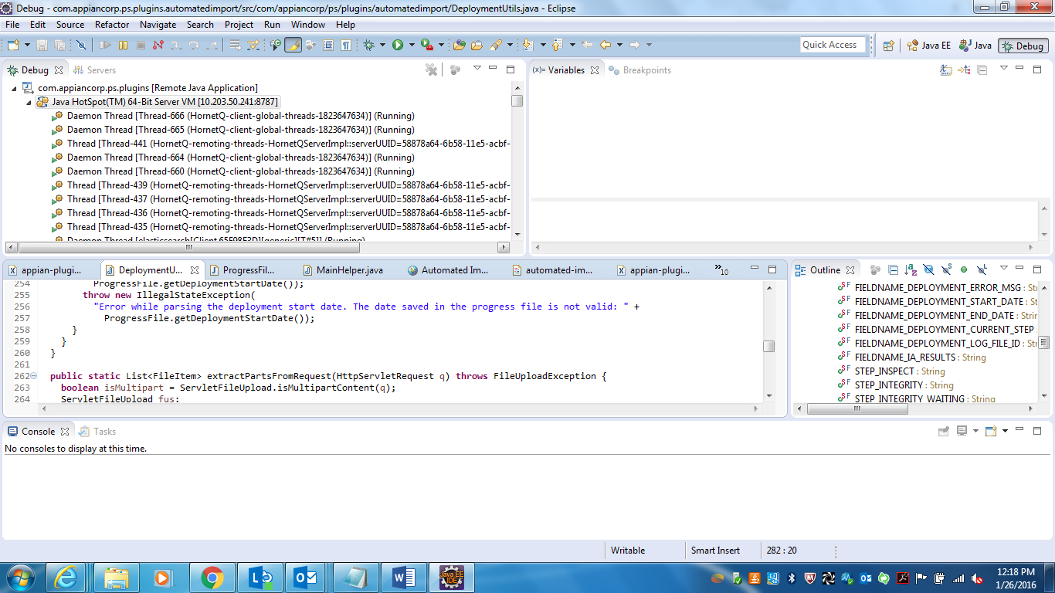

***Note : “10.203.50.241” can only listen to one debugger at a time. It cannot handle two simultaneous connections.***

Step 8 : Apply breakpoints in the Application and start the process model which consumes those jar and run the Application in Debugging mode.