# **Advanced Interfaces Exercises - Solutions**

**Exercise 1: Expression View**

1. The form should save to only one rule input of type CDT. Create a CDT called VFM_request with the following fields:
   1. requestId (integer)
   2. partId (integer)
   3. repairCost (decimal)
   4. reason (text)
   5. dateNeeded (date)
   6. isRoutine (Boolean)

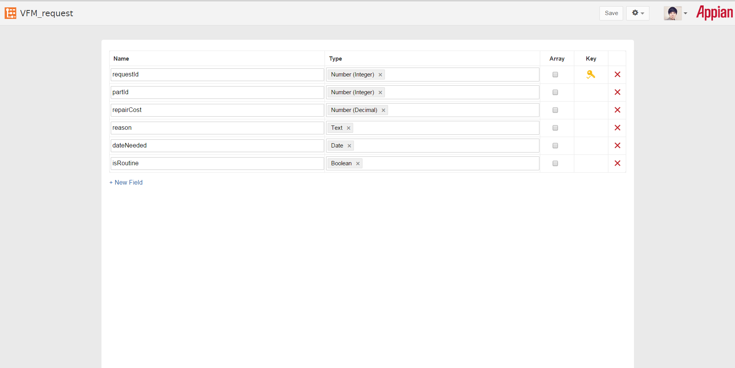

1. Create an interface that collects all fields in the CDT except the request Id. For each field, create the corresponding component.
   1. Part--Dropdown (use the provided getAllVehicleParts query rule to populate the labels and values)
   2. Cost of repair--Decimal
   3. Reason--Paragraph
   4. Needed date--date
   5. Routine Maintenance--Radio button
2. The reason field should only be visible if maintenance is not routine

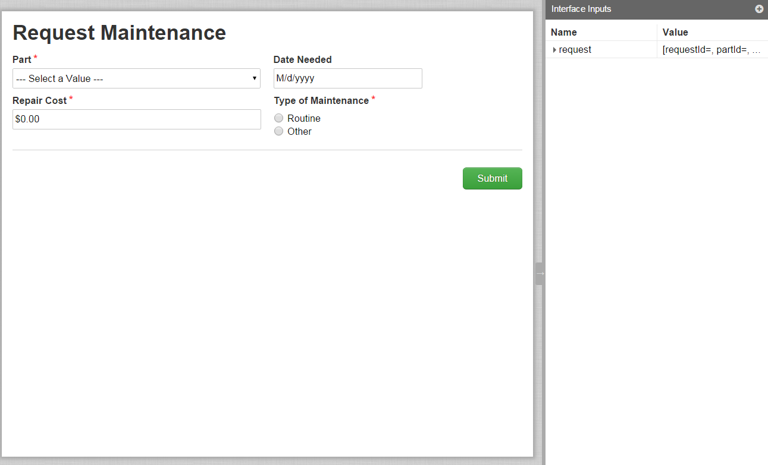

STRETCH GOAL: Show the repair cost with a currency symbol and default 2 decimal places.

Full SAIL Expression:

a!formLayout(

label: "Request Maintenance",

firstColumnContents: {

a!dropdownField(

label: "Part",

labelPosition: "ABOVE",

choiceLabels: rule!VFM_getAllVehicleParts().name,

placeholderLabel: "--- Select a Value ---",

choiceValues: rule!VFM_getAllVehicleParts().id,

value: ri!request.partId,

saveInto: ri!request.partId,

required: true,

validations: {}

),

a!textField(

label: "Repair Cost",

labelPosition: "ABOVE",

value: dollar(ri!request.repairCost),

saveInto: ri!request.repairCost,

refreshAfter: "UNFOCUS",

required: true,

validations: {}

)

},

secondColumnContents: {

a!dateField(

label: "Date Needed",

labelPosition: "ABOVE",

value: ri!request.dateNeeded,

saveInto: ri!request.dateNeeded,

validations: {}

),

a!radioButtonField(

label: "Type of Maintenance",

labelPosition: "ABOVE",

choiceLabels: {"Routine", "Other"},

choiceValues: {true, false},

value: ri!request.isRoutine,

saveInto: ri!request.isRoutine,

required: true,

choiceLayout: "STACKED",

validations: {}

),

if(

or(ri!request.isRoutine, isnull(ri!request.isRoutine)),

{},

a!paragraphField(

label: "Description of Repair",

labelPosition: "ABOVE",

value: ri!request.reason,

saveInto: ri!request.reason,

refreshAfter: "UNFOCUS",

required: true,

height: "MEDIUM",

validations: {}

)

)},

buttons: a!buttonLayout(

primaryButtons: {

a!buttonWidgetSubmit(

label: "Submit",

style: "PRIMARY"

)

}

)

)