# **Evaluation Functions Exercises - Solutions**

**Exercise 1: Evaluation functions**

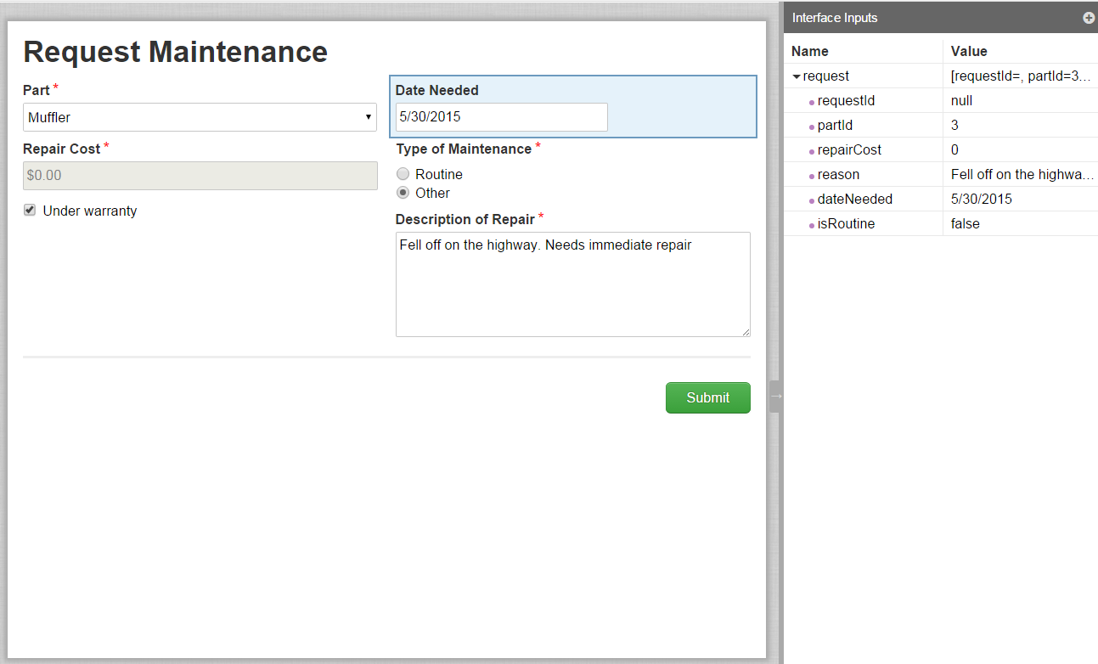

SAIL Expression:

**load(**

**local!parts: rule!VFM_getAllVehicleParts(),**

**local!warranty,**

a!formLayout(

label: "Request Maintenance",

firstColumnContents: {

a!dropdownField(

label: "Part",

labelPosition: "ABOVE",

choiceLabels: local!parts.name,

placeholderLabel: "--- Select a Value ---",

choiceValues: local!parts.id,

value: ri!request.partId,

saveInto: ri!request.partId,

required: true,

validations: {}

),

a!textField(

label: "Repair Cost",

labelPosition: "ABOVE",

value: dollar(

ri!request.repairCost

),

saveInto: ri!request.repairCost,

refreshAfter: "UNFOCUS",

required: true,

disabled: local!warranty,

validations: {}

),

**a!checkboxField(**

**label: "",**

**labelPosition: "COLLAPSED",**

**choiceLabels: {**

**"Under warranty"**

**},**

**choiceValues: {**

**true**

**},**

**value: local!warranty,**

**saveInto: {**

**local!warranty,**

**a!save(**

**ri!request.repairCost,**

**0**

**)**

**},**

**validations: {}**

**)**

},

secondColumnContents: {

a!dateField(

label: "Date Needed",

labelPosition: "ABOVE",

value: ri!request.dateNeeded,

saveInto: ri!request.dateNeeded,

validations: {}

),

a!radioButtonField(

label: "Type of Maintenance",

labelPosition: "ABOVE",

choiceLabels: {

"Routine",

"Other"

},

choiceValues: {

true,

false

},

value: ri!request.isRoutine,

saveInto: ri!request.isRoutine,

required: true,

choiceLayout: "STACKED",

validations: {}

),

if(

or(

ri!request.isRoutine,

isnull(

ri!request.isRoutine

)

),

{},

a!paragraphField(

label: "Description of Repair",

labelPosition: "ABOVE",

value: ri!request.reason,

saveInto: ri!request.reason,

refreshAfter: "UNFOCUS",

required: true,

height: "MEDIUM",

validations: {}

)

)

},

buttons: a!buttonLayout(

primaryButtons: {

a!buttonWidgetSubmit(

label: "Submit",

style: "PRIMARY"

)

}

)

)

)