# **Partial Evaluation Exercises - Solutions**

**Exercise 1: Partial Evaluation of Functions**

1. Interface to build one section

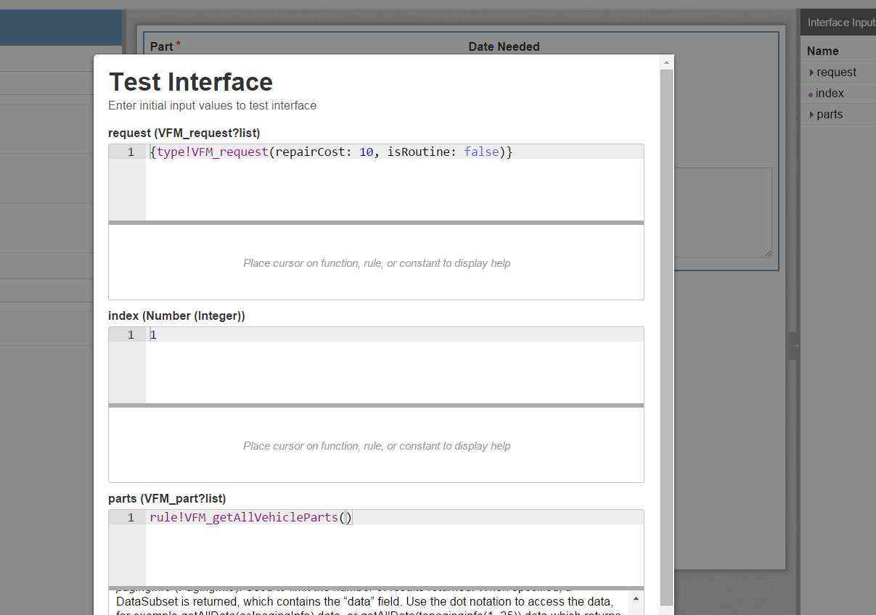

SAIL Code:

**a!sectionLayout(**

firstColumnContents: {

a!dropdownField(

label: "Part",

labelPosition: "ABOVE",

choiceLabels: ri!parts.name,

placeholderLabel: "--- Select a Value ---",

choiceValues: ri!parts.id,

value: **ri!request[ri!index].partId**,

saveInto: **ri!request[ri!index].partId**,

required: true,

validations: {}

),

a!textField(

label: "Repair Cost",

labelPosition: "ABOVE",

value: **dollar(**

**ri!request[ri!index].repairCost**

**),**

saveInto: **ri!request[ri!index].repairCost**,

refreshAfter: "UNFOCUS",

required: true,

validations: {}

)

},

secondColumnContents: {

a!dateField(

label: "Date Needed",

labelPosition: "ABOVE",

value: **ri!request[ri!index].dateNeeded**,

saveInto: **ri!request[ri!index].dateNeeded**,

validations: {}

),

a!radioButtonField(

label: "Type of Maintenance",

labelPosition: "ABOVE",

choiceLabels: {

"Routine",

"Other"

},

choiceValues: {

true,

false

},

value: **ri!request[ri!index].isRoutine**,

saveInto: **ri!request[ri!index].isRoutine**,

required: true,

choiceLayout: "STACKED",

validations: {}

),

if(

or(

ri!request[ri!index].isRoutine,

isnull(

ri!request[ri!index].isRoutine

)

),

{},

a!paragraphField(

label: "Description of Repair",

labelPosition: "ABOVE",

value: **ri!request[ri!index].reason**,

saveInto: **ri!request[ri!index].reason**,

refreshAfter: "UNFOCUS",

required: true,

height: "MEDIUM",

validations: {}

)

)

}

)

1. Interface to build multiple sections

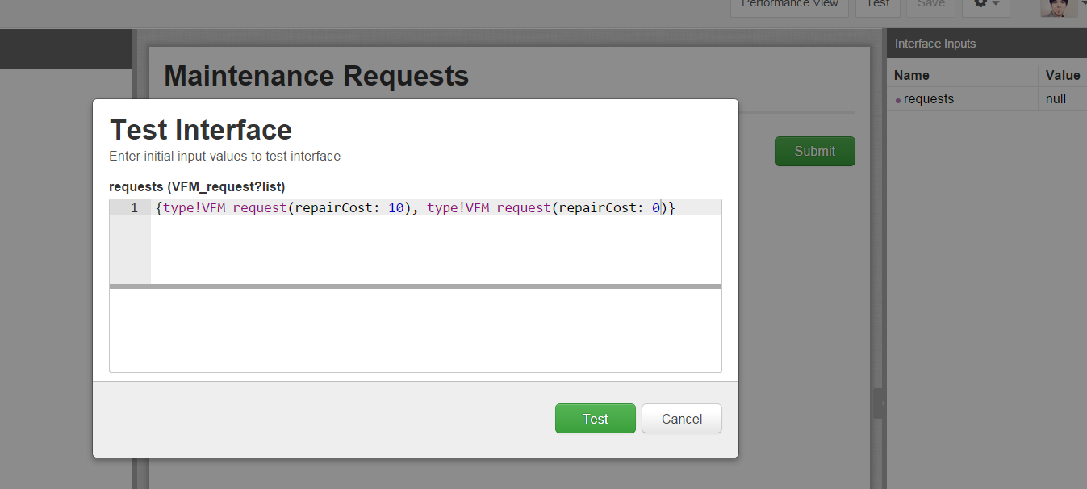

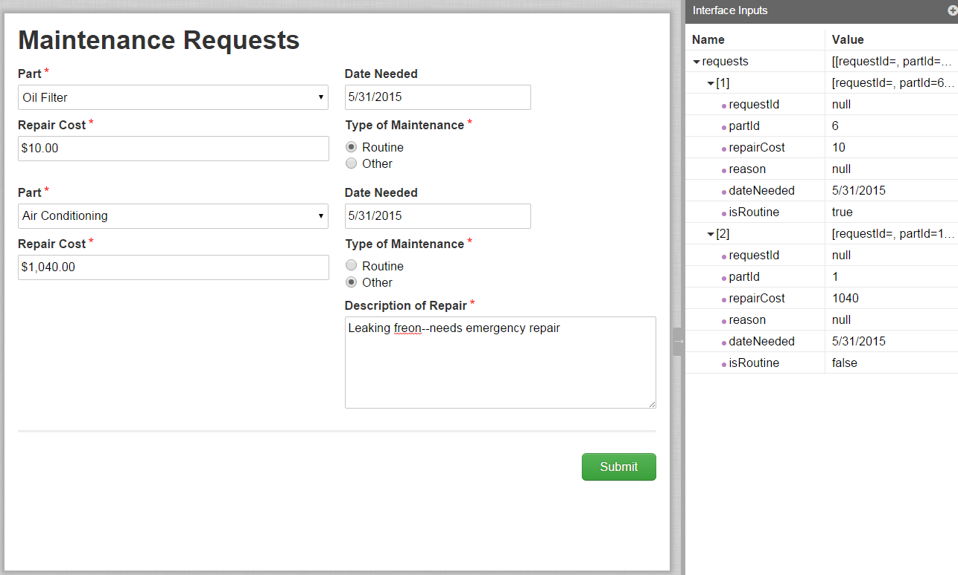

SAIL Code:

load(

local!parts: rule!VFM_getAllVehicleParts(),

a!formLayout(

label: "Maintenance Requests",

firstColumnContents: {

a!applyComponents(

function: rule!VFM_requestRepair(

request: ri!requests,

index: _,

parts: local!parts

),

array: if(

or(

isnull(ri!requests),

count(ri!requests)<1

),

{},

1+enumerate(count(ri!requests))

)

)

},

buttons: a!buttonLayout(

primaryButtons: {

a!buttonWidgetSubmit(

label: "Submit",

style: "PRIMARY"

)

}

)

)

)

STRETCH GOAL:

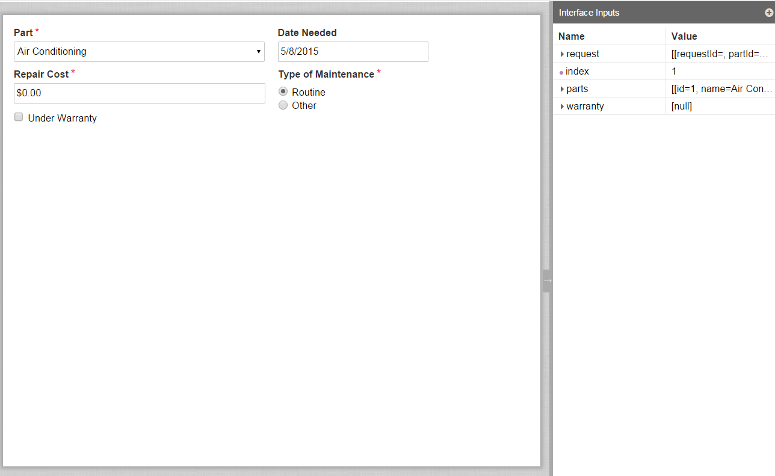

SAIL Code:

a!sectionLayout(

firstColumnContents: {

a!dropdownField(

label: "Part",

labelPosition: "ABOVE",

choiceLabels: ri!parts.name,

placeholderLabel: "--- Select a Value ---",

choiceValues: ri!parts.id,

value: ri!request[ri!index].partId,

saveInto: ri!request[ri!index].partId,

required: true,

validations: {}

),

a!textField(

label: "Repair Cost",

labelPosition: "ABOVE",

value: dollar(ri!request[ri!index].repairCost),

saveInto: ri!request[ri!index].repairCost,

refreshAfter: "UNFOCUS",

required: true,

**disabled: ri!warranty[ri!index],**

validations: {}

),

**a!checkboxField(**

**label: "",**

**labelPosition: "COLLAPSED",**

**choiceLabels: {"Under Warranty"},**

**choiceValues: {true},**

**value: ri!warranty[ri!index],**

**saveInto: {ri!warranty[ri!index],**

**a!save(ri!request[ri!index].repairCost, 0)**

**}**

**)**

},

secondColumnContents: {

a!dateField(

label: "Date Needed",

labelPosition: "ABOVE",

value: ri!request[ri!index].dateNeeded,

saveInto: ri!request[ri!index].dateNeeded,

validations: {}

),

a!radioButtonField(

label: "Type of Maintenance",

labelPosition: "ABOVE",

choiceLabels: {"Routine", "Other"},

choiceValues: {true, false},

value: ri!request[ri!index].isRoutine,

saveInto: ri!request[ri!index].isRoutine,

required: true,

choiceLayout: "STACKED",

validations: {}

),

if(

or(ri!request[ri!index].isRoutine, isnull(ri!request[ri!index].isRoutine)),

{},

a!paragraphField(

label: "Description of Repair",

labelPosition: "ABOVE",

value: ri!request[ri!index].reason,

saveInto: ri!request[ri!index].reason,

refreshAfter: "UNFOCUS",

required: true,

height: "MEDIUM",

validations: {}

)

)}

)

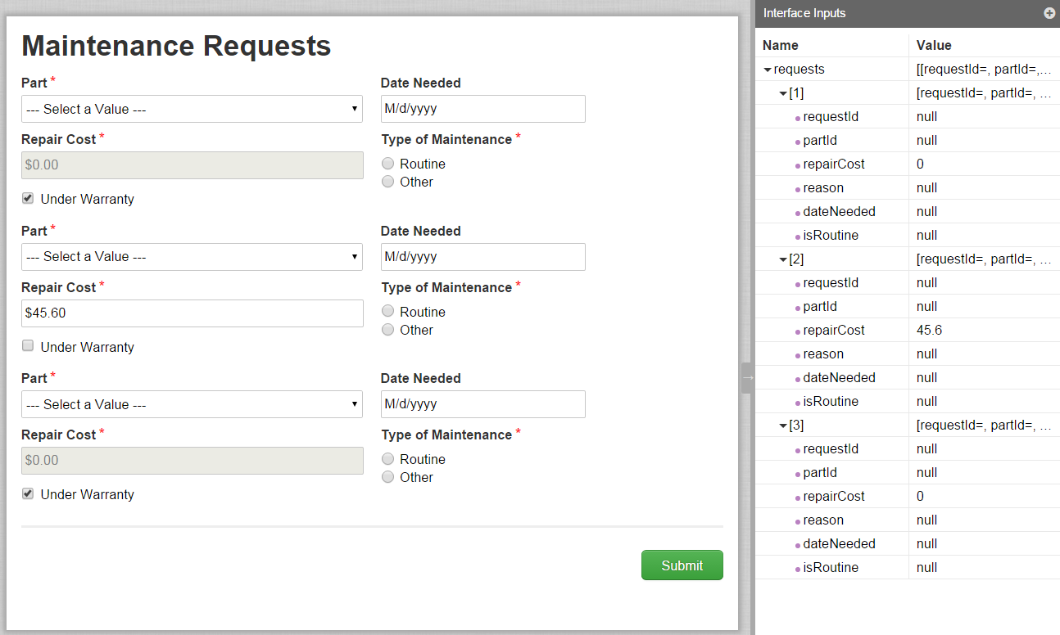

load(

local!parts: rule!VFM_getAllVehicleParts(),

**local!warranty: {true,null,true},**

a!formLayout(

label: "Maintenance Requests",

firstColumnContents: {

a!applyComponents(

function: rule!VFM_ex4StretchGoalSupporting(

request: ri!requests,

index: _,

parts: local!parts,

**warranty: local!warranty**

),

array: if(

or(

isnull(ri!requests),

count(ri!requests)<1

),

{},

1+enumerate(count(ri!requests))

)

)

},

buttons: a!buttonLayout(

primaryButtons: {

a!buttonWidgetSubmit(

label: "Submit",

style: "PRIMARY"

)

}

)

)

)