**Paging Grids Exercises - Solutions**

**Exercise 1: Paging Grids**

1. Create a read only paging grid

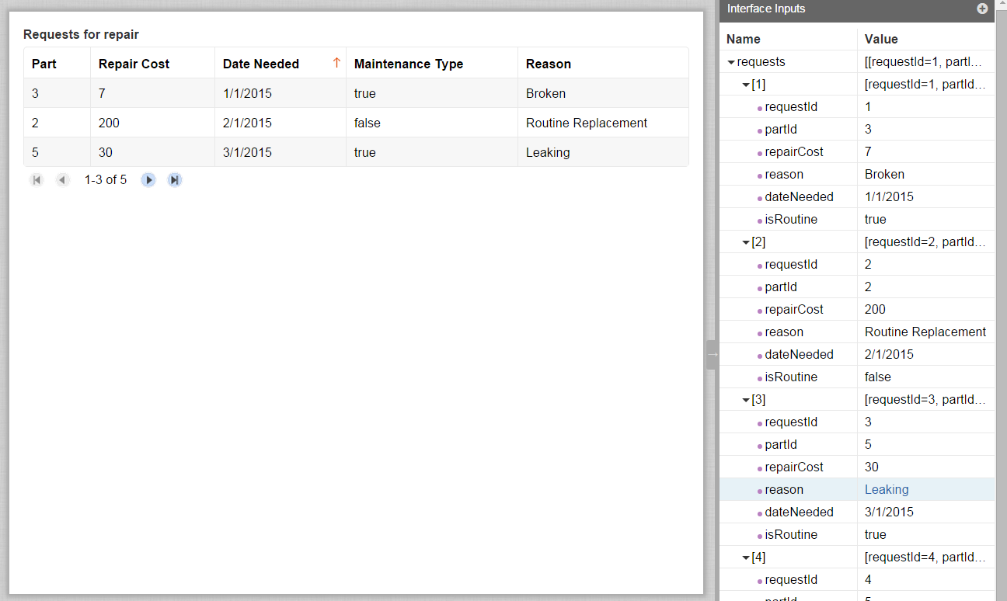

load(

local!pagingInfo: a!pagingInfo(

startIndex: 1,

batchSize: 3,

sort: a!sortInfo(field: "dateNeeded", ascending: true)

),

with(

local!datasubset: todatasubset(ri!requests, local!pagingInfo),

a!gridField(

label: "Requests for repair",

totalCount: local!datasubset.totalCount,

columns: {

a!gridTextColumn(

label: "Part",

field: "partId",

data: local!datasubset.data.partId

),

a!gridTextColumn(

label: "Repair Cost",

field: "repairCost",

data: local!datasubset.data.repairCost

),

a!gridTextColumn(

label: "Date Needed",

field: "dateNeeded",

data: local!datasubset.data.dateNeeded

),

a!gridTextColumn(

label: "Maintenance Type",

field: "isRoutine",

data: local!datasubset.data.isRoutine

),

a!gridTextColumn(

label: "Reason",

field: "reason",

data: local!datasubset.data.reason

)

},

value: local!pagingInfo,

saveInto: local!pagingInfo

)

)

)

1. Create a selectable paging grid

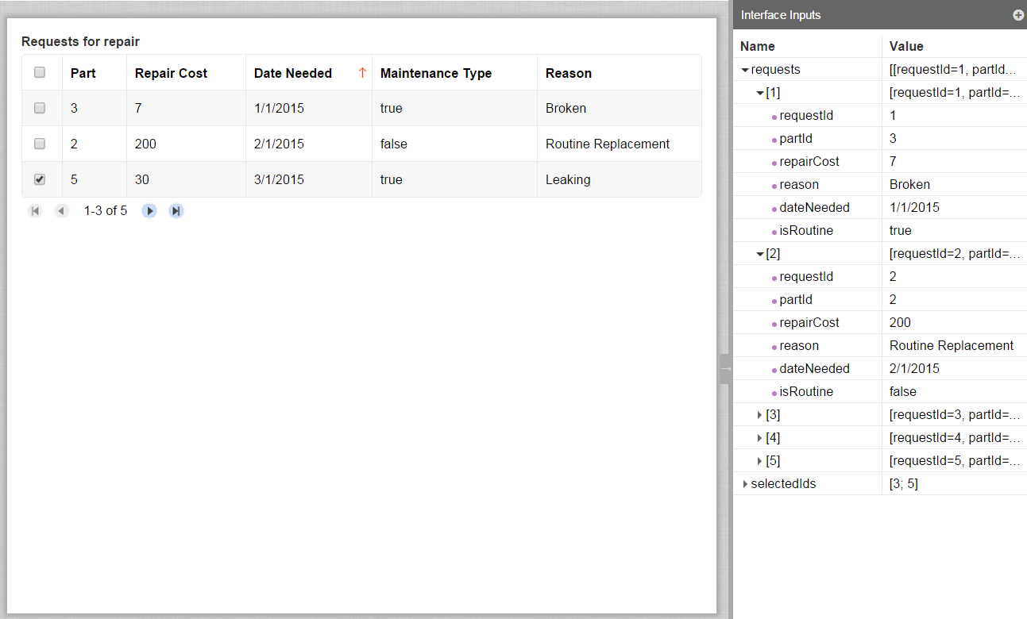

load(

**local!selection: a!gridSelection(**

**pagingInfo:** a!pagingInfo(

startIndex: 1,

batchSize: 3,

sort: a!sortInfo(field: "dateNeeded", ascending: true)

)

),

with(

local!datasubset: todatasubset(ri!requests, **local!selection.pagingInfo**),

a!gridField(

label: "Requests for repair",

totalCount: local!datasubset.totalCount,

**selection: true,**

**identifiers: local!datasubset.data.requestId**,

columns: {

a!gridTextColumn(

label: "Part",

field: "partId",

data: local!datasubset.data.partId

),

a!gridTextColumn(

label: "Repair Cost",

field: "repairCost",

data: local!datasubset.data.repairCost

),

a!gridTextColumn(

label: "Date Needed",

field: "dateNeeded",

data: local!datasubset.data.dateNeeded

),

a!gridTextColumn(

label: "Maintenance Type",

field: "isRoutine",

data: local!datasubset.data.isRoutine

),

a!gridTextColumn(

label: "Reason",

field: "reason",

data: local!datasubset.data.reason

)

},

**value: local!selection,**

**saveInto: {local!selection,**

**a!save(ri!selectedIds,**

**index(local!selection, "selected", null))**

**}**

)

)

)

STRETCH GOAL: Add formatting to the grid fields:

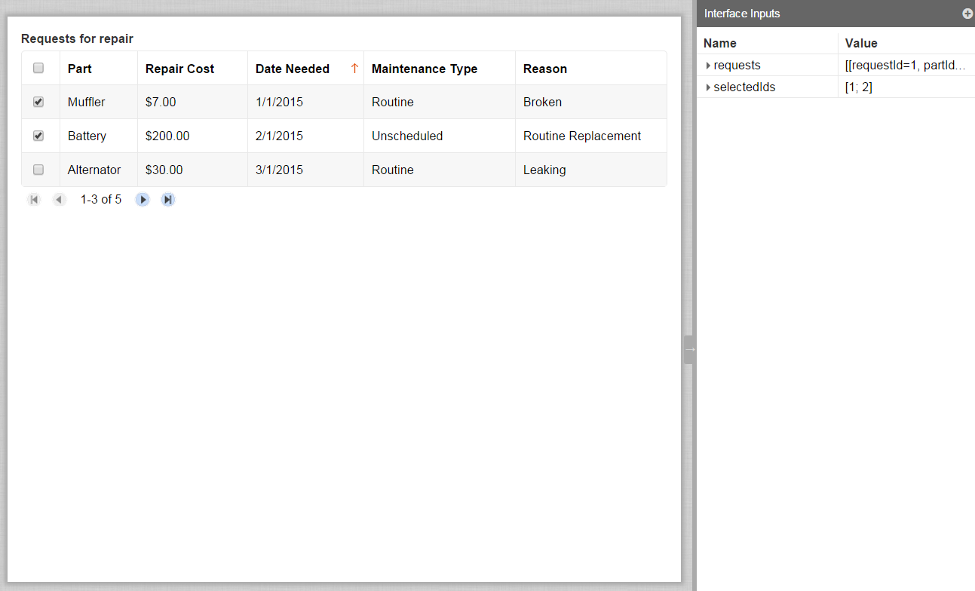

load(

local!selection: a!gridSelection(

pagingInfo: a!pagingInfo(

startIndex: 1,

batchSize: 3,

sort: a!sortInfo(field: "dateNeeded", ascending: true)

)

),

**local!parts: rule!VFM_getAllVehicleParts()**,

with(

local!datasubset: todatasubset(ri!requests, local!selection.pagingInfo),

a!gridField(

label: "Requests for repair",

totalCount: local!datasubset.totalCount,

selection: true,

identifiers: local!datasubset.data.requestId,

columns: {

a!gridTextColumn(

label: "Part",

field: "partId",

**data: apply(**

**fn!displayvalue(_, local!parts.id, local!parts.name,**

**null),**

**local!datasubset.data.partId)**

),

a!gridTextColumn(

label: "Repair Cost",

field: "repairCost",

**data: dollar(local!datasubset.data.repairCost)**

),

a!gridTextColumn(

label: "Date Needed",

field: "dateNeeded",

data: local!datasubset.data.dateNeeded

),

a!gridTextColumn(

label: "Maintenance Type",

field: "isRoutine",

**data: apply(fn!if(_, "Routine", "Unscheduled"),**

**local!datasubset.data.isRoutine)**

),

a!gridTextColumn(

label: "Reason",

field: "reason",

data: local!datasubset.data.reason

)

},

value: local!selection,

saveInto: {local!selection,

a!save(ri!selectedIds,

index(local!selection, "selected", null))

}

)

)

)