# **Dynamic Links Exercises - Solutions**

**Exercise 1: Dynamic Links**

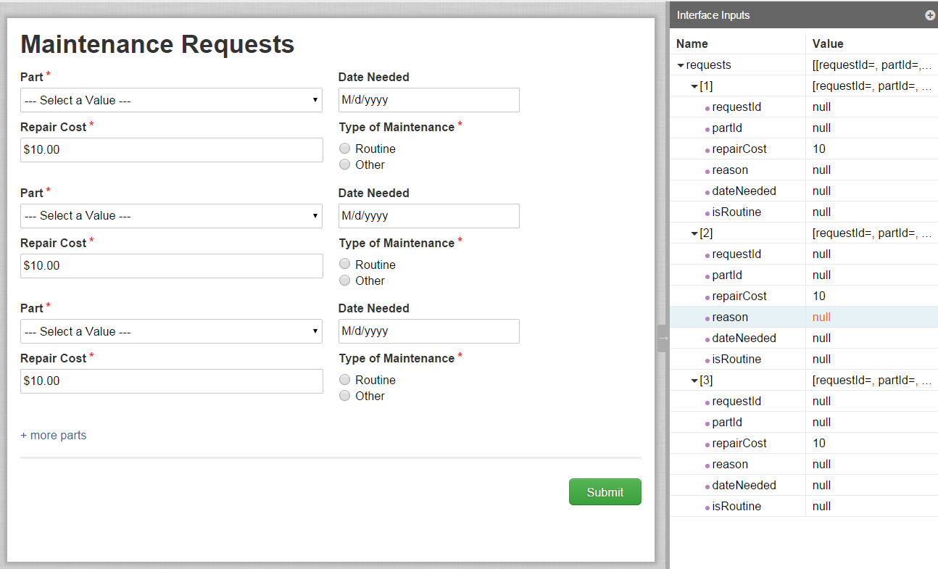

load(

local!parts: rule!VFM_getAllVehicleParts(),

**local!token,**

a!formLayout(

label: "Maintenance Requests",

firstColumnContents: {

a!applyComponents(

function: rule!VFM_requestRepair(

request: ri!requests,

index: _,

parts: local!parts

),

array: if(

or(

isnull(ri!requests),

count(ri!requests)<1

),

{},

1+enumerate(count(ri!requests))

),

**arrayVariable: local!token**

),

**a!linkField(**

**links: a!dynamicLink(**

**label: "+ more parts",**

**value: type!VFM_request(repairCost: 10),**

**saveInto: {a!save(ri!requests, append(ri!requests, save!value)),**

**a!save(local!token, append(local!token, save!value))**

**}**

**)**

**)**

},

buttons: a!buttonLayout(

primaryButtons: {

a!buttonWidgetSubmit(

label: "Submit",

style: "PRIMARY"

)

}

)

)

)

STRETCH GOAL:

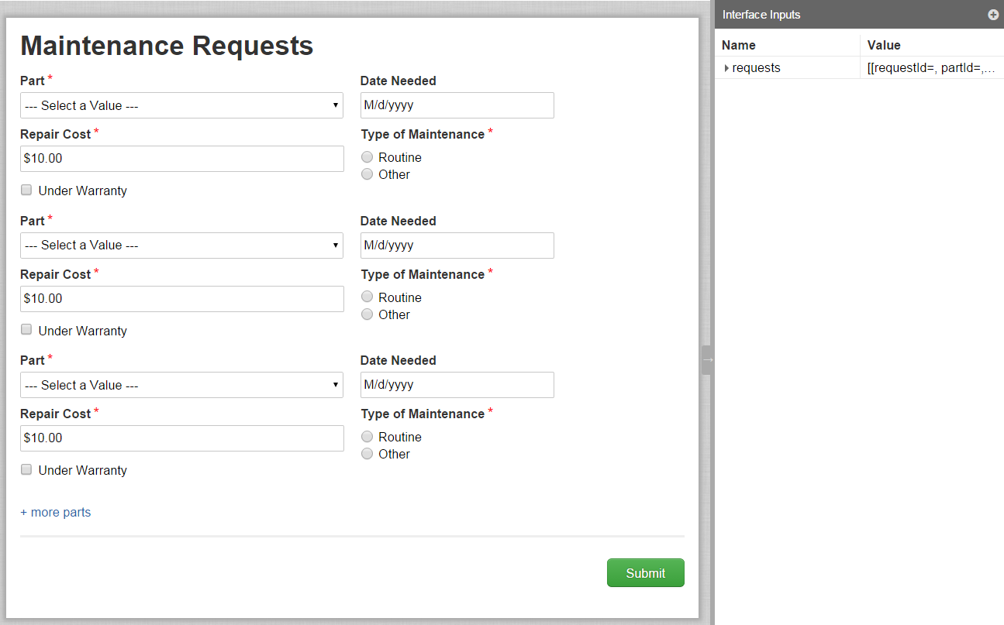

load(

local!parts: rule!VFM_getAllVehicleParts(),

**local!warranty,**

local!token,

a!formLayout(

label: "Maintenance Requests",

firstColumnContents: {

a!applyComponents(

function: rule!VFM_ex4StretchGoalSupporting(

request: ri!requests,

index: _,

parts: local!parts,

**warranty: local!warranty**

),

array: if(

or(

isnull(ri!requests),

count(ri!requests)<1

),

{},

1+enumerate(count(ri!requests))

),

arrayVariable: local!token

),

a!linkField(

links: a!dynamicLink(

label: "+ more parts",

value: type!VFM_request(repairCost: 10),

saveInto:{

a!save(ri!requests, append(ri!requests, save!value)),

a!save(local!token, append(local!token, save!value)),

**a!save(local!warranty, append(local!warranty, null))**

}

)

)

},

buttons: a!buttonLayout(

primaryButtons: {

a!buttonWidgetSubmit(

label: "Submit",

style: "PRIMARY"

)

}

)

)

)