# **Task Report Exercises - Solutions**

**Exercise 1: Task Reports**

1. Create a process report
   1. Create a process report in the Appian designer called **D203 Process Model Task Report** and select “Task” as the report type and “Tasks by Process Model” as the context type. *Note: If you do not already have a document hierarchy, you may need to create it before creating your process report.*

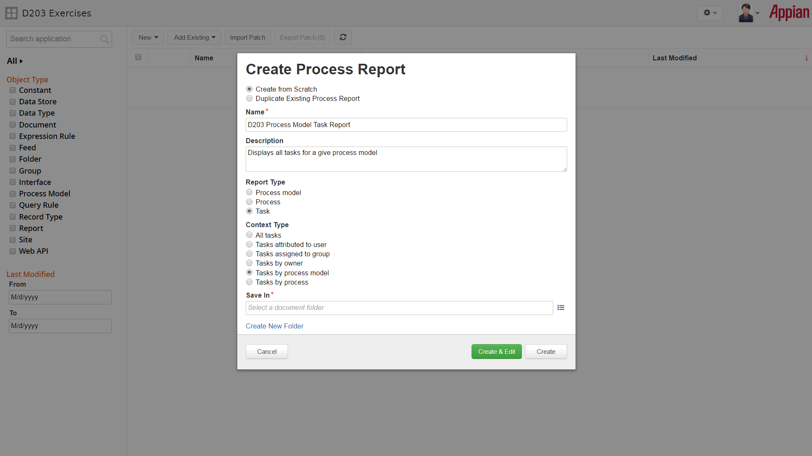

* 1. By default, the report should include Name, Status, Process, and Start Time. Add the additional fields to the process report as well:
     1. Task Owner (tp!owner)
     2. Overdue (is_task_overdue())
     3. Task ID (tp!id)
  2. Make sure to save the process report when you make those changes.

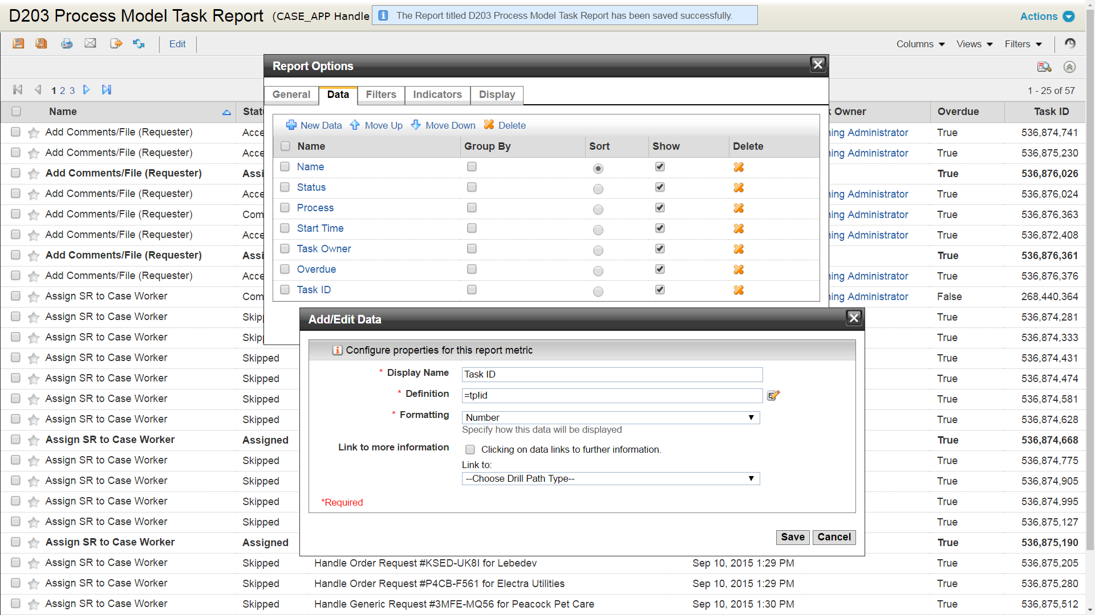

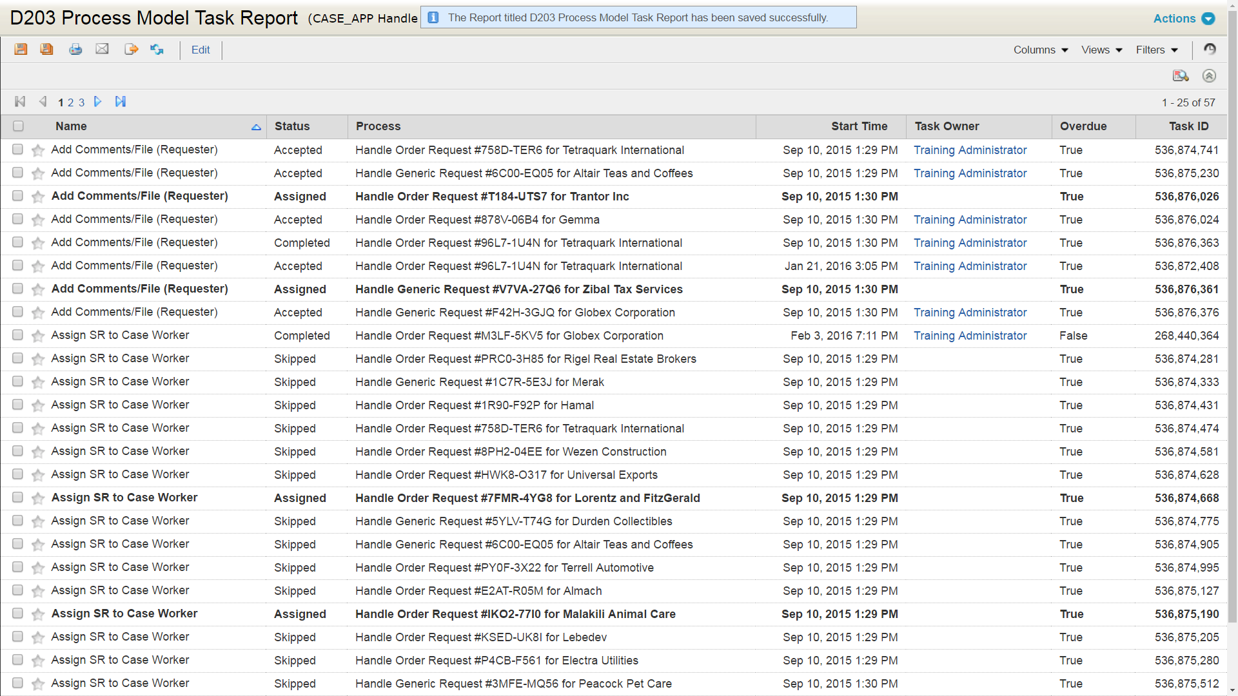

1. Create two constants to reference the task report and the relevant process model
   1. The first constant should reference the process report. Name this constant **D203_PROCESS_REPORT**. *Hint: Process reports are of data type document.*

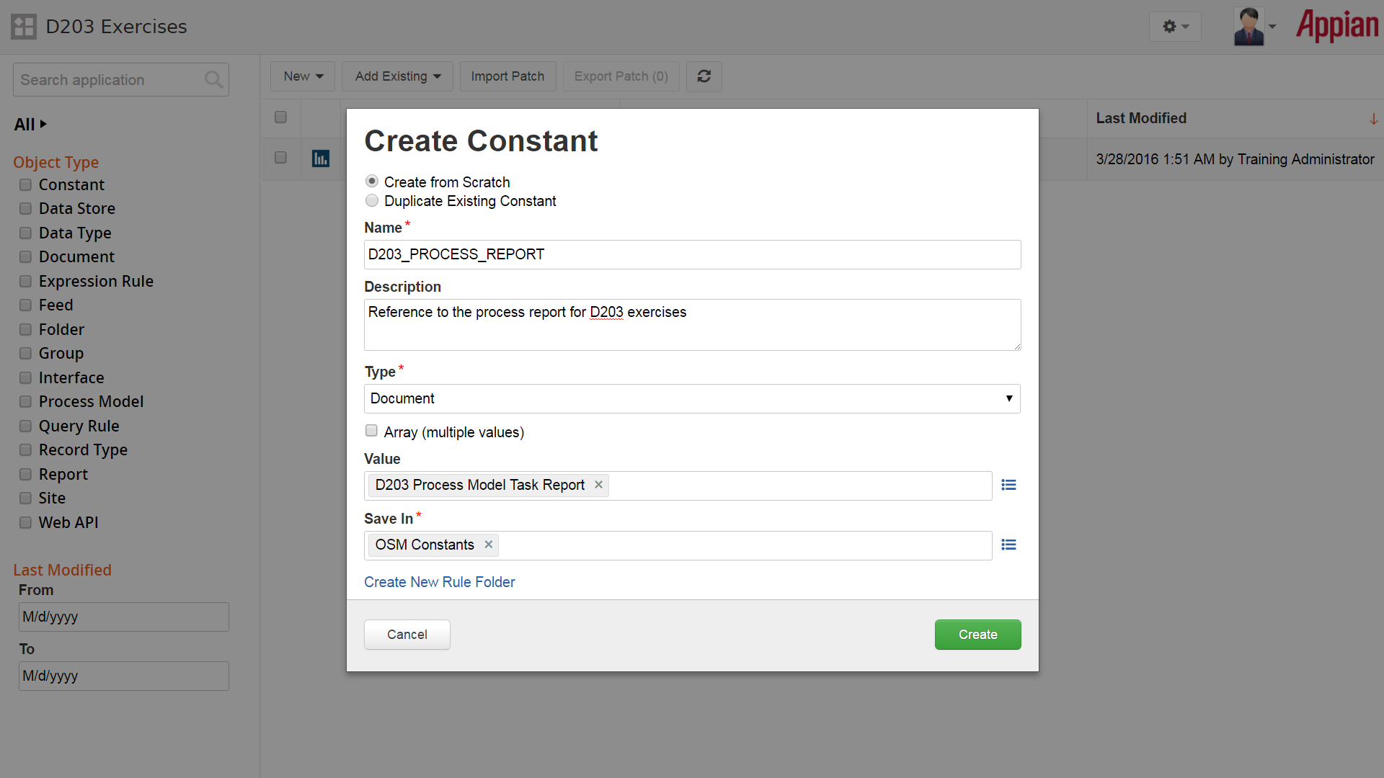

* 1. The second constant should reference the process model you would like to reference for tasks. Call it **D203_PROCESS_MODEL**.

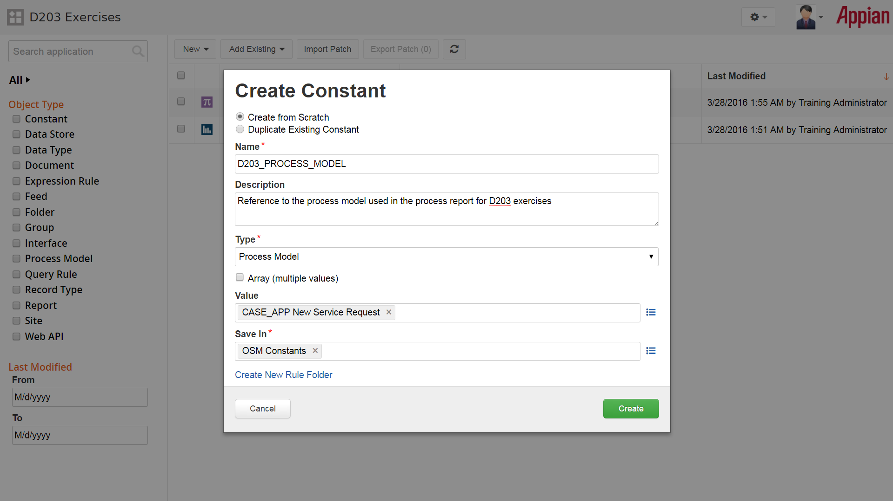

1. Create a new interface to create the task report and define it as a dashboard.
   1. Use a with variable to save the data from the task report, and query the task report using the a!queryProcessAnalytics() function.
      1. Add a reference to the constants for the task report and process model to the appropriate parameters for the function.
      2. Define the paging info for the grid to use a batch size of 10 inside of a load variable and add the paging info inside of the query for the process report.
   2. Add a paging grid to display the fields of the report. *Hint: the fields are available based on columns (e.g. c0, c1, c2, etc.) where c0 is the first column in the report.*
   3. Add the following fields to the paging grid:
      1. Task Name - This field should also include a task link to the appropriate task using a!processTaskLink() and the Task ID
      2. Status - The status displays as an integer by default. To see how to convert the integer to a text value, see the following link the Task Report Tutorial: <https://forum.appian.com/suite/help/16.1/Task_Report_Tutorial.html#Format_the_Status_Column>
      3. Start Date - The date the task was assigned
      4. Owner - The task owner
      5. Overdue - True or false whether the task is overdue

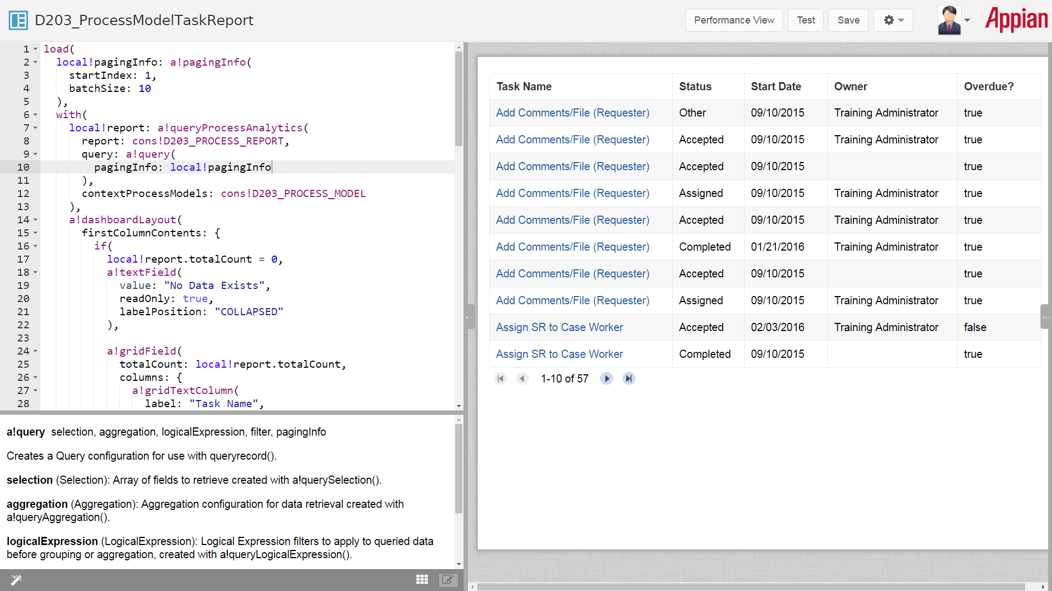

1. Stretch Goal: Add a filter based on status of the task.
   1. Create a local variable to store the selected status.
   2. Add a dropdown menu to the report that will allow a user to select from a list of statuses.
   3. Use the selected status to filter the data using the a!queryProcess Analytics function. *Hint: Consider what happens if the selected status is null. You may need to include an if statement around the a!queryFilter() to manage this case.*

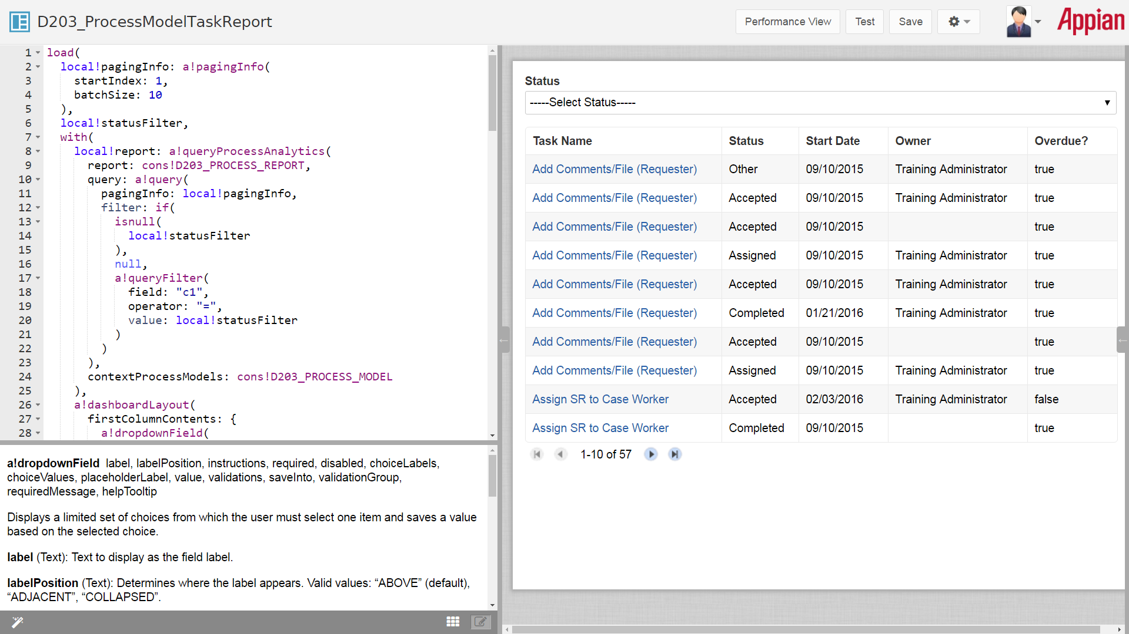

See the full SAIL Code below:

load(

local!pagingInfo: a!pagingInfo(

startIndex: 1,

batchSize: 10

),

local!statusFilter,

with(

local!report: a!queryProcessAnalytics(

report: cons!D203_PROCESS_REPORT,

query: a!query(

pagingInfo: local!pagingInfo,

filter: if(

isnull(

local!statusFilter

),

null,

a!queryFilter(

field: "c1",

operator: "=",

value: local!statusFilter

)

)

),

contextProcessModels: cons!D203_PROCESS_MODEL

),

a!dashboardLayout(

firstColumnContents: {

a!dropdownField(

label: "Status",

placeholderLabel: "-----Select Status-----",

value: local!statusFilter,

saveInto: local!statusFilter,

choiceLabels: {

"Assigned",

"Accepted",

"Completed",

"Not Started",

"Cancelled",

"Paused",

"Unattended",

"Aborted",

"Cancelled By Exception",

"Submitted",

"Running",

"Error"

},

choiceValues: enumerate(

12

) + 1

),

if(

local!report.totalCount = 0,

a!textField(

value: "No Data Exists",

readOnly: true,

labelPosition: "COLLAPSED"

),

a!gridField(

totalCount: local!report.totalCount,

columns: {

a!gridTextColumn(

label: "Task Name",

field: "c0",

data: index(

local!report.data,

"c0",

null

),

links: apply(

a!processTaskLink(

task: _

),

index(

local!report.data,

"c6",

null

)

)

),

a!gridTextColumn(

label: "Status",

field: "c1",

data: apply(

rule!D203_GetTaskStatusDisplay(

data: index(

local!report.data,

"c1",

""

),

index: _

),

enumerate(

count(index(local!report.data, "c1",null))

)

)

),

a!gridTextColumn(

label: "Start Date",

field: "c3",

data: text(

index(

local!report.data,

"c3",

null

),

"mm/dd/yyyy"

)

),

a!gridTextColumn(

label: "Owner",

field: "c4",

data: apply(

rule!OSM_FormatUserName,

index(

local!report.data,

"c4",

""

)

)

),

a!gridTextColumn(

label: "Overdue?",

field: "c5",

data: index(

local!report.data,

"c5",

""

)

)

},

value: local!pagingInfo,

saveInto: local!pagingInfo

)

)

}

)

)

)