Lab 3: Campus Cafe Order System
Name: Ahmed Hassaan
Roll no: 04072313022
Seed: 22 (t=2, u=2)
Command: dart run --enable-asserts lab3.dart
Step 1:
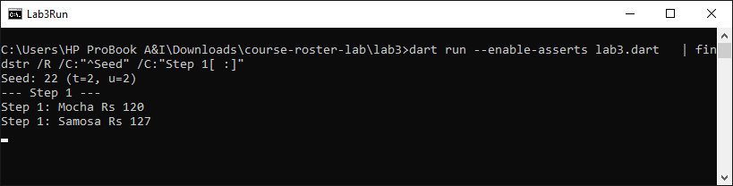
Step 2:
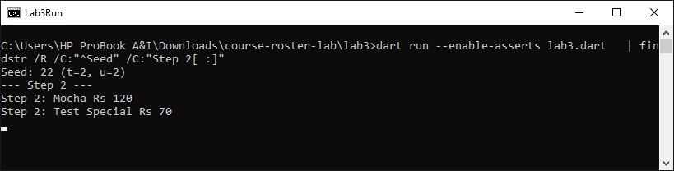
Step 3:
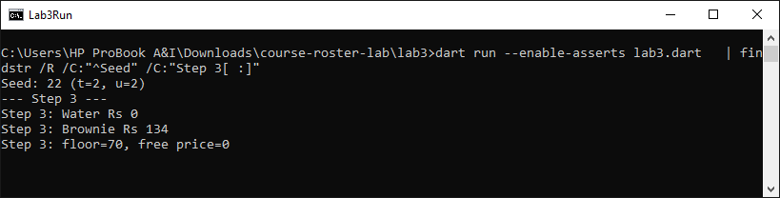
Step 4:
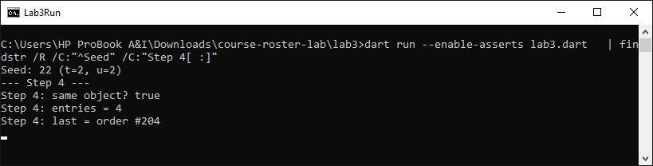
Step 5:
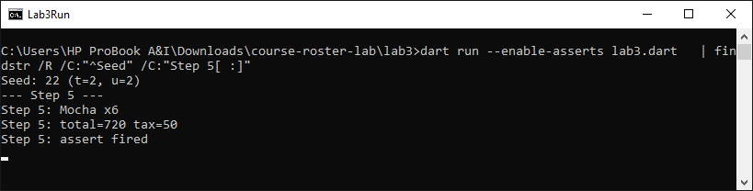
Step 6:
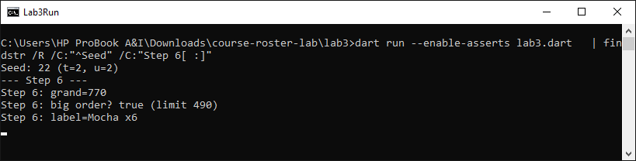
Step 7:
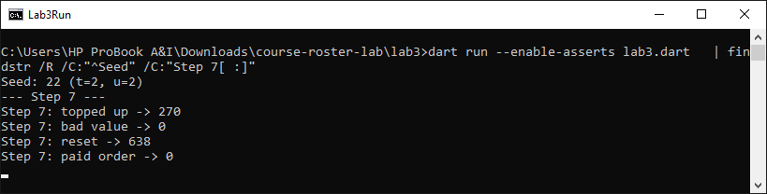
Step 8:
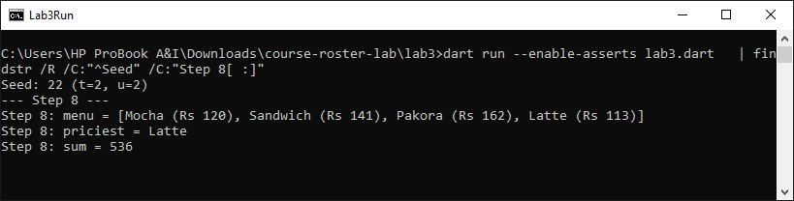
Step 9:
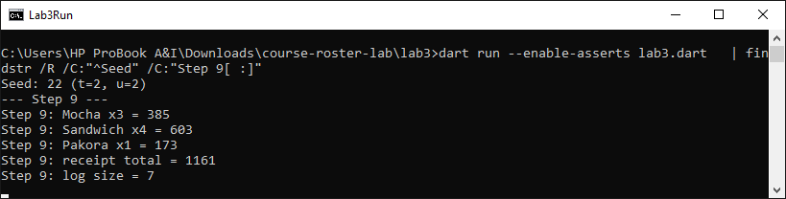
Step 10:
