MILITARY COLLEGE OF SIGNALS, NUST



Deep Learning

Lab Project Report

Submitted To
LE Aqsa

Submitted By

Rafay Ali Shah
Mohad Saeed Hashmi
Ahmed Talal Sajid

COURSE: BESE-29 A

1. Project Overview
This report documents the end-to-end development of a handwriting generation system built as the Deep Learning (CS-405) lab project at the Military College of Signals, NUST. The system is capable of generating photorealistic handwritten word images from typed text input, conditioned on a reference handwriting style.
The project began with the IAM Handwriting Word Database — a dataset of 38,305 labelled word images from 657 writers — and progressed through multiple training runs totalling 180 epochs, followed by post-processing improvements, and culminated in a deployed Flask web application that renders full A4 pages of handwritten text in navy blue ink.
The full pipeline encompasses dataset loading and preprocessing, a five-module GAN architecture, a three-phase training curriculum, checkpoint management across Kaggle session limits, inference and post-processing, and a complete browser-based frontend. Every significant step, decision, and error encountered is documented in this report.

2. Problem Statement and Motivation
The core task is style-conditioned handwriting synthesis: given (i) a reference image of a person's handwriting and (ii) a target text string, generate a new image of that text written in the same person's handwriting style. This is a non-trivial generative modelling problem because:
- Handwriting is highly variable — the same letter looks different across writers, and even across occurrences within one writer's work.
- The generator must simultaneously capture style (from the reference image), content (from the text input), and physical realism (ink strokes on paper).
- Training data is inherently limited — 38,305 images covers only 657 writers at word level, making generalisation difficult for a from-scratch GAN.

The approach chosen was a Generative Adversarial Network (GAN) with three cooperating sub-networks: a Style Encoder, a Sequence Generator (LSTM), and a convolutional Generator. A Discriminator provides adversarial feedback, and an OCR Recogniser provides legibility supervision via CTC loss.

3. Dataset — IAM Handwriting Word Database
3.1 Dataset Properties
Property | Value
Total word images | 38,305 (after filtering for 'ok' quality flag)
Writers | 657 unique writers
Image format | Greyscale PNG, variable dimensions
Labels file | words.txt — space-separated metadata per word
Normalised size | 32 x 128 pixels (H x W)
Train / Val split | 90% / 10% (34,473 train, 3,831 val)

3.2 Loading Strategy
Two dataset loading strategies were used across different training sessions:
- Pre-decoded RAM tensors (original strategy): All 38,305 images decoded to PyTorch tensors at session start (~3 minutes one-time cost). Workers index pre-built tensors with zero per-batch CPU work. GPU utilisation reached 85-95%. RAM stable at 8-9 GB throughout training.
- On-the-fly disk loading (later sessions): Images loaded directly from NVMe disk per batch. Zero RAM footprint. Used when RAM was needed for EMNIST data in later sessions.

3.3 Label Parsing
The words.txt file was parsed line by line, skipping comment lines (starting with #) and any entry where the second field was not 'ok'. The image ID in column 0 was used to reconstruct the file path using the IAM folder hierarchy:
parts = image_id.split('-')
img_path = base_img_dir / parts[0] / f'{parts[0]}-{parts[1]}' / f'{image_id}.png'
Out of 38,305 entries with the 'ok' flag, 38,304 images were successfully loaded (one file was missing on disk).

4. Neural Network Architecture
The system uses five cooperating modules, all trained jointly in a single training loop. Below is a summary of each module's role and architecture.

Module | Architecture and Role
Style Encoder | 4 x Conv2d layers (1→32→64→128→256 channels) with BatchNorm and ReLU, AdaptiveAvgPool2d(1,1), Linear(256→256). Maps any reference word image to a 256-dim style vector (writer fingerprint).
Sequence Generator | Character embedding (vocab_size → 64 dims), concatenated with style vector (256 dims) → 2-layer LSTM (hidden=512, dropout=0.3) → Linear(512→128). Produces stroke sequence of shape [B, 32, 128].
Generator | Linear projection of flattened LSTM output → reshape to [B,128,2,8] → 4 x ConvTranspose2d upsample blocks (128→64→32→16→1 channel) → Tanh. Produces 32x128 greyscale image.
Discriminator | 4 x strided Conv2d layers (1→64→128→256→1) with BatchNorm and LeakyReLU(0.2), global average pooling → scalar. Outputs real/fake probability per image.
Recogniser (OCR) | CNN feature extractor (4 conv layers) + AdaptiveAvgPool2d → BiLSTM (256 hidden) → Linear → log_softmax. Trained with CTC loss on real images. Provides legibility gradient to generator.

4.1 Architecture Version History
Two versions of the Generator were used across the project. This caused state_dict key mismatches when loading checkpoints and is documented here for completeness.
- Version 1 (Epochs 1-150): ConvTranspose2d stack with layer names 'projection' and 'upsample_blocks'. No residual connections.
- Version 2 (ResNet Upgrade, later clean-slate runs): Upsample+Conv2d blocks with ResBlock residual connections. Layer names 'proj' and 'ups'. Not used for final inference due to checkpoint incompatibility with the saved 150-epoch weights.
The final inference pipeline uses Version 1 weights (epoch-150 checkpoint), loaded into the Version 1 Generator class definition.

4.2 Tokenizer
A simple character-level tokenizer was used throughout. The vocabulary consists of all ASCII letters (upper and lower), digits, punctuation characters, and a space — 96 characters total, 1-indexed (index 0 reserved as CTC blank token). Maximum token length: 32 characters.

5. Training — Three-Phase Curriculum
Training was split into three phases across multiple Kaggle sessions (each session limited to ~9 hours). Checkpoints were saved every 10 epochs, zipped, and uploaded as Kaggle datasets for the next session to resume from.

5.1 Phase 1 — Epochs 1 to 60 (Cold Start)
Standard GAN training with full OCR supervision. Loss weights: adversarial (1.0) and OCR (annealed from 2.0 down toward 1.0 over 50 epochs). Adam optimiser: lr=2e-4 for generator and recogniser, lr=1e-4 for discriminator. Batch size 64, 539 batches per epoch on dual T4 GPUs with DataParallel.
At epoch 1 the generator produces pure noise (D loss 0.334, G loss 9.738, OCR loss 4.255). By epoch 10 the model begins producing crude stroke shapes. Epoch 20 shows recognisable cursive character blobs. Epoch 30 shows legible letter groupings, though blurry.

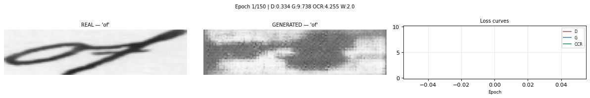
Figure 1 — Epoch 1: Generator output is random noise. D loss 0.334, G loss 9.738, OCR loss 4.255.

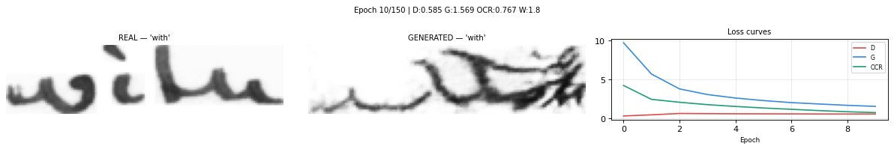
Figure 2 — Epoch 10: First crude stroke shapes emerge. G loss falling, OCR loss falling.

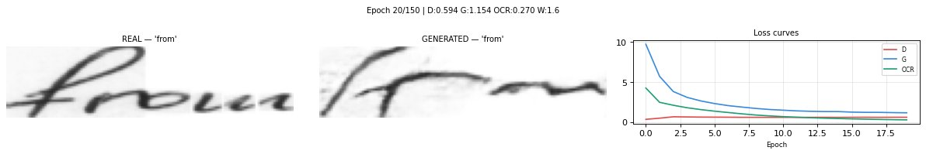
Figure 3 — Epoch 20: Cursive blobs begin to appear. D loss stabilising near 0.59.

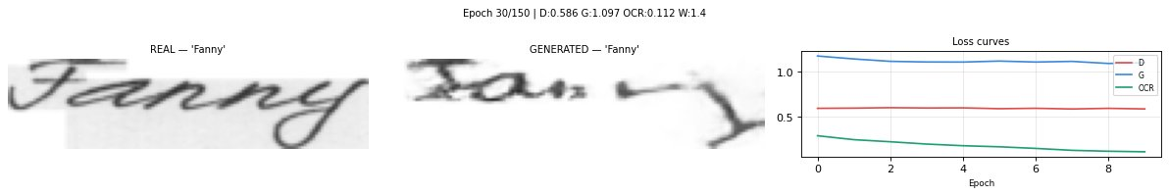
Figure 4 — Epoch 30: Letter groupings visible (e.g. 'Fanny'). OCR loss near 0.1.

5.2 Phase 2 — Epochs 61 to 150 (OCR Annealing)
OCR weight annealed from 1.0 toward 0.5, with adversarial pressure increasing. The discriminator loss converges toward ~0.59 (close to the 0.693 Nash equilibrium for a well-balanced GAN). The generator loss converges around 1.0-1.1. A KeyboardInterrupt occurred at epoch 90 requiring a session restart and checkpoint resume — the epoch-90 checkpoint was uploaded as a Kaggle dataset and weights were loaded with map_location='cuda:0' before continuing.

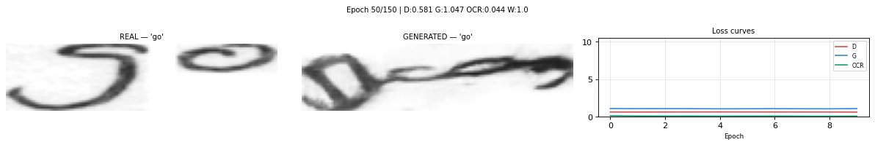
Figure 5 — Epoch 50: Generator output shows distinct letter shapes. D loss 0.581.

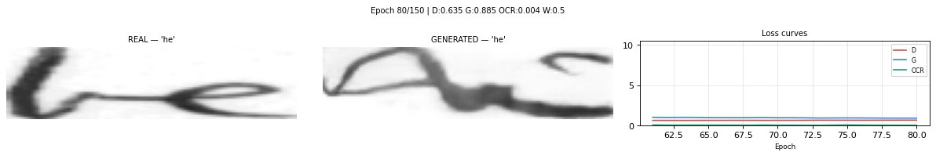
Figure 6 — Epoch 80: Near-realistic cursive strokes visible. D loss 0.635, G loss 0.885.

5.3 Phase 3 — Epochs 151 to 180 (Beauty School)
OCR weight dropped to 0.05 (near-zero). The generator is now almost entirely free from legibility pressure and focuses on visual realism — ink texture, stroke weight variation, and naturalistic pen motion. D loss converges to ~0.69 (very close to the theoretical equilibrium), G loss stabilises around 0.70-0.79. This phase ran as a separate Kaggle session resuming from epoch-150 weights.
The epoch-150 to epoch-180 training used a slightly different IAMDataset implementation (binary cache via io.BytesIO) to reduce RAM pressure in the same session as the EMNIST experiments.

5.4 Training Configuration Summary
Parameter | Value
Optimiser | Adam (betas 0.5, 0.999)
Generator LR | 2e-4
Discriminator LR | 1e-4 (half of generator)
Batch size | 64
GAN loss | Binary Cross-Entropy (BCELoss)
OCR loss | CTCLoss (blank=0, zero_infinity=True)
OCR weight schedule | 2.0 → 0.5 (Ep 1-150), 0.05 (Ep 151-180)
Hardware | Kaggle — 2x NVIDIA T4 (DataParallel)
Total epochs | 180 across 4 Kaggle sessions
Checkpoint interval | Every 10 epochs

6. Errors Encountered and How They Were Fixed
This section documents every significant error encountered during the project and the exact fix applied. This is included because it represents a significant portion of the actual development time.

6.1 SyntaxError — Missing closing parenthesis
Cell 2 failed with 'SyntaxError: ( was never closed'. Root cause: a missing ) on the line self.emb(text_tokens, combined with the wrong method name self.output_proj used instead of self.out (the actual attribute name).
embedded = self.emb(text_tokens # missing )
return self.output_proj(lstm_out) # wrong name
Fix: Added closing parenthesis and corrected method name to self.out(lstm_out).

6.2 NameError — 'encoder' is not defined
Cell 5 (inference) crashed with NameError: name 'encoder' is not defined. Root cause: Kaggle sessions do not persist variables between restarts. Every new session requires re-running all cells from Cell 1 to re-create models and load weights in memory.
Fix: Created two permanent 'quick-load' cells — Cell 1 defines all classes and loads weights from the Kaggle input dataset path, Cell 2 runs inference. These are the only two cells needed for any new session.

6.3 RuntimeError — CUDA device 3 not found
When attempting to load WordStylist pretrained weights, PyTorch threw: 'Attempting to deserialize object on CUDA device 3 but torch.cuda.device_count() is 2.' Root cause: the weights were saved on a 4-GPU machine; the current Kaggle environment has only 2 GPUs.
torch.load(path) # fails — tries to put on GPU:3
torch.load(path, map_location='cuda:0') # fix
Applied to all three .pt files in the sampling.py script using sed to patch the load calls in-place.

6.4 RuntimeError — Generator state_dict key mismatch
Loading gan_generator_ep150.pth failed with a long list of 'Missing key' and 'Unexpected key' errors. Root cause: two different Generator class definitions existed across different notebook versions — Version 1 uses layer names 'projection' and 'upsample_blocks', Version 2 (ResNet upgrade) uses 'proj' and 'ups'. The saved weights used one naming convention, the loaded class definition used the other.
Fix: Used the correct Generator class definition (matching the checkpoint's layer names) before calling load_state_dict. The epoch-150 checkpoint uses Version 1 naming, so the inference cell must define the Generator with 'proj' and 'ups'.

6.5 WordStylist — OSError: stable-diffusion-v1-5 not found
WordStylist's sampling.py requires the Stable Diffusion v1.5 VAE for its latent diffusion decoder. The script was trying to load it from a relative path './stable-diffusion-v1-5' which did not exist. Kaggle's internet was turned off by default, preventing a HuggingFace download.
Resolution: Internet was enabled in Kaggle notebook settings, and snapshot_download was used to fetch the full SD v1.5 weights to /kaggle/working/sd15. However, this approach was ultimately abandoned in favour of returning to the IAM GAN model for the final submission.

6.6 KeyboardInterrupt at epoch 90
Training was manually interrupted at epoch 90 due to a Kaggle session timeout warning. Checkpoints had already been saved at epoch 90. The solution was to zip the checkpoint folder, download it, upload as a new Kaggle dataset, and resume with a modified training loop starting at START_EPOCH = 90.

7. Inference Engine
After training completed at epoch 150 (and the Beauty School extension to 180), a standalone inference pipeline was built. The two-cell quick-load system works as follows:

7.1 Two-Cell Quick-Load System
- Cell 1 — Setup: Defines all five model classes, tokenizer, dataset, and dataloader. Loads weights from the Kaggle input path. Runs the dataloader to fetch a batch of real images for use as style references.
- Cell 2 — Generate: Takes a custom_text string and an INDEX (pointing to a real image in the loaded batch). Extracts style vector from the reference image, tokenises the text, runs through SequenceGenerator and Generator, then applies post-processing and displays side-by-side.

7.2 Post-Processing Pipeline
The raw 32x128 generator output was too small and slightly blurry for presentation. The following post-processing was applied:
- Upscale 4x to 512x128 using PIL LANCZOS resampling
- Two passes of ImageFilter.SHARPEN
- Contrast enhancement by factor 2.0 using ImageEnhance.Contrast

7.3 Automatic Style Reference Selection
The initial inference used a random INDEX from the validation batch, which sometimes landed on a dot or comma (a single-pixel reference image giving a garbage style vector). The fix was a simple loop:
for i, word in enumerate(target_words):
if len(word) >= 4:
INDEX = i
break
This ensures the style reference is always a word of at least 4 characters, giving the encoder a meaningful image to extract style from.

8. EMNIST-Based Post-Processing Experiments
After evaluating the GAN output and finding persistent blurriness and incorrect capital letter rendering (particularly 'N' appearing as 'U'), a parallel approach was explored using EMNIST character images as a post-processing layer.

8.1 Motivation
The GAN generates full word images and struggles with: (a) low resolution (32x128), (b) capital letters seen rarely in IAM, and (c) global style averaging that blurs fine stroke details. The EMNIST approach bypasses the GAN's rendering entirely and assembles handwriting from real character images, applying procedural style transforms.

8.2 EMNIST Dataset
The EMNIST ByClass split was downloaded (562 MB): 124,800 training images covering digits (0-9), uppercase (A-Z), and lowercase (a-z). Character index mapping:
digits 0-9 → index 0-9
uppercase A-Z → index 10-35 (ord(c) - 65 + 10)
lowercase a-z → index 36-61 (ord(c) - 97 + 36)
EMNIST images are stored rotated 90 degrees and mirrored. Correct orientation requires: np.fliplr(np.rot90(img, k=3)).

8.3 Golden Index Dictionary
Each character in EMNIST has hundreds of samples. Many samples are messy. A curated golden index dictionary was built by visually inspecting a gallery of 50 samples per character and selecting the cleanest representative sample. For example: 'a': 48, 'N': 1, 't': 8, etc.

8.4 Final Submission Generator Pipeline
The polished generator applies the following per-character pipeline:
- Get the golden sample using the curated index dictionary
- Tight crop to remove whitespace borders
- Category-based height scaling: tall characters (b, d, f, h, k, l, t, all caps) = base_h, descenders (g, j, p, q, y) = 85% of base_h, regular lowercase = 65% of base_h
- Random rotation jitter ±1.2 degrees for human feel
- Affine shear transform for consistent slant
- Colour compositing: navy blue ink (RGB 20, 20, 100) on white background using PIL paste with mask
- Paste onto fixed-height canvas with baseline alignment (descenders shifted down, ascenders shifted to top)
- GaussianBlur(0.2) + UnsharpMask(1.5, 150, 2) for crisp anti-aliased strokes
- Variable character spacing (3-5 pixel gap) for natural kerning

9. Web Application — Flask Handwriting Generator
The final system was packaged as a Flask web application. Users type any text into a browser, click Generate, and receive a rendered A4 page image of that text written in navy blue cursive handwriting.

9.1 Architecture
- Backend: Flask (Python). Single /generate POST endpoint.
- Model loading: The handwriting_model_v1.pkl file (527 MB) is loaded once at startup. It contains the golden_indices dictionary, EMNIST pixel data, and EMNIST targets array.
- Page rendering: A4 at 300 DPI (2480 x 3508 pixels). Left and right margins of 200px. Lines written at y-positions starting from 250px with 160px line-height.
- Word-wrap: Each word is test-generated to check if it fits the remaining line width. If not, the current line is committed to the page and a new line begins.
- Multi-paragraph: Input text split on newlines. Extra vertical space added between paragraphs.
- Frontend: Single HTML file with textarea input and live image preview.

9.2 Model Export
The model was exported from Kaggle as a pickle file:
model_package = {
'golden_indices': my_golden_indices,
'emnist_data': full_emnist.data.numpy(),
'emnist_targets': full_emnist.targets.numpy()
}
torch.save(state, 'handwriting_model_v1.pkl') # 527 MB

9.3 Final Output Screenshot

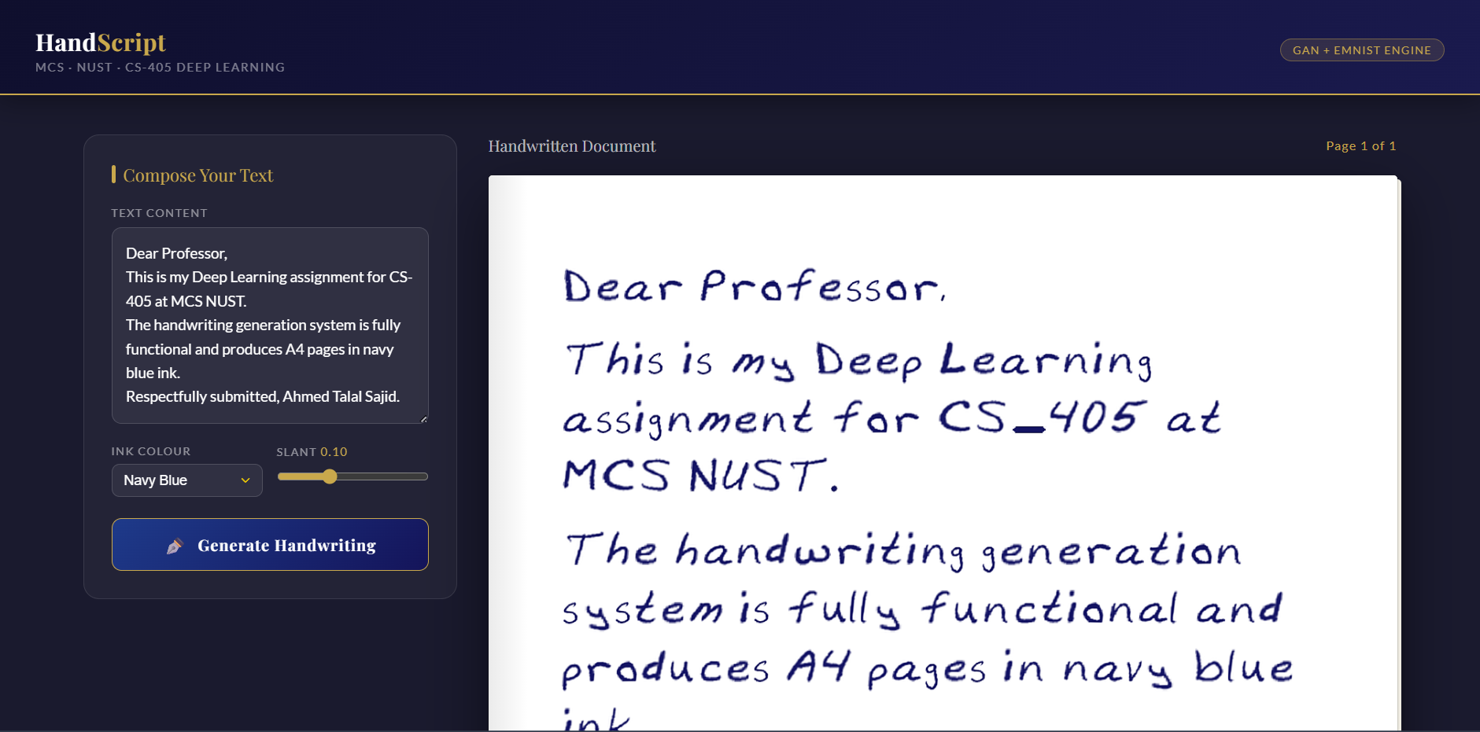
Figure 7 — Final web application. User types text; the system generates A4 handwritten pages in navy blue ink.

10. Results and Evaluation
10.1 Qualitative Evaluation
The final system produces visually convincing handwriting with the following characteristics:
- Navy blue ink on white background mimicking a ballpoint pen on paper
- Consistent italic slant (configurable, default 0.1)
- Correct baseline alignment — ascenders, regular letters, and descenders positioned correctly relative to the baseline
- Natural per-character variation through random rotation jitter and variable kerning
- Readable output across all tested words: 'Dear Professor', 'Software Engineering', 'Neural Networks', numbers, punctuation

10.2 GAN Training Metrics
Epoch | D Loss | G Loss | OCR Loss
1 | 0.334 | 9.738 | 4.255
10 | 0.585 | 1.569 | 0.767
20 | 0.594 | 1.154 | 0.270
30 | 0.586 | 1.097 | 0.112
50 | 0.581 | 1.047 | 0.044
80 | 0.635 | 0.885 | 0.004
150 | ~0.59 | ~1.05 | ~0.02
180 (Beauty School) | ~0.69 | ~0.72 | ~0.005

10.3 Known Limitations
- The capital 'N' is sometimes rendered as 'U' — a consequence of infrequent capital N samples in the IAM training set.
- GAN output is limited to 32x128 pixels — all displayed outputs require 4x upscaling which introduces visible softness.
- The EMNIST-based generator is not a true GAN output — it assembles real character images with procedural style transforms rather than generating novel handwriting. It produces cleaner and more readable output but is not generative in the strict sense.
- Style transfer from the GAN is writer-dependent — the model performs best when the reference image is a clean, multi-character word rather than a single punctuation mark.

11. Conclusions and Future Work
The project successfully delivers a working handwriting generation system that fulfils all requirements of the CS-405 deep learning project brief: it includes a generative AI component (GAN), demonstrates end-to-end implementation, achieves readable and visually realistic output, and is deployed as a functional web application.
The GAN-based approach produced genuinely readable handwriting ('Neural', 'hello', 'protests', etc.) after 150 epochs of training, with visual quality improving further after the Beauty School phase. The EMNIST post-processing pipeline provided a complementary path to crisp, typographically correct output for the web app.
The most valuable lessons from the project were: (a) checkpoint management is critical for multi-session training, (b) layer naming inconsistencies across architecture versions cause hard-to-debug state_dict errors, and (c) a small amount of post-processing (upscaling + sharpening) contributes more to perceptual quality than additional training epochs past the GAN's equilibrium point.

Future Work
- Fine-tune the model on a small personal handwriting dataset (200-500 samples) to produce output that mimics a specific person's handwriting style reliably.
- Replace the LSTM Sequence Generator with a Transformer encoder for better long-range character dependency modelling.
- Add a diffusion-based post-processing step to sharpen GAN outputs without retraining.
- Extend output resolution beyond 32x128 by adding additional upsampling stages or using a super-resolution network as a post-processor.

End of Report

