CSE 3200 Project Report

SmartLibManage

A Smart Library Management System

Course: CSE 3200 - Software Engineering Project
Submission Date: January 2026

Student Information
Name | ID
Ahmad Hasan | 2103160
Supervisor: Dr. Julia Rahman (Associate Professor, Dept. of CSE, RUET)
Department: Computer Science and Engineering

Abstract
SmartLibManage is a mobile-first library management system designed to address common problems in traditional, manual, or semi-digital library workflows—such as inaccurate availability tracking, slow borrowing/return processes, limited remote access to the catalog, and missing due-date reminders. The project delivers an end-to-end Android-focused solution built with Flutter and Firebase, providing secure authentication (email/password) with role-based access for Admin and Members (students/teachers). Cloud Firestore is used as the central database to store user profiles, book records, and borrowing transactions, enabling real-time synchronization across devices. The system implements core library operations including book browsing and search, book inventory management (add/edit/delete), borrowing and return request workflows, and an approval mechanism for pending borrow/return actions to ensure administrative control. A notification layer (Firebase Cloud Messaging with local notification support) is integrated to support timely alerts and reminders. The application follows a clean modular structure using Provider for state management and a dedicated Firestore service layer for CRUD operations and streaming updates. Functional validation through feature-based testing confirmed correct role separation, consistent catalog updates, and reliable status transitions for borrow/return lifecycles (active, pending borrow, pending return, returned). The primary contribution of this work is a practical, scalable, and low-cost reference implementation of a modern library management app that combines real-time database synchronization, structured approval workflows, and a user-friendly dashboard experience for both administrators and members, suitable for adaptation in academic library environments.

List of Figures
(Auto-generated list of all figures.)

List of Tables
(Auto-generated list of all tables.)

Table of Contents
- Introduction
- Literature Review & Background Study
- Problem Statement & Planning
- Project Management & Finance
- System Design & Architecture
- Implementation
- Testing, Results & Evaluation
- Discussion & Analysis
- Life-long Learning Impact
- Conclusion
- References
- Appendix

Chapter 1

Introduction

1.1 Problem Statement
Many academic libraries still manage book inventory and borrowing/return transactions using manual registers or fragmented digital tools. This causes inaccurate or outdated book availability information, slow service at the library counter, poor tracking of borrowing history, and lack of timely due-date reminders—leading to overdue books and reduced user satisfaction. The project solves this by providing a single, mobile-based system that maintains a real-time book catalog, securely manages users, and supports controlled borrowing/return workflows with administrative oversight.

1.2 Motivation
Libraries are a core service in universities and colleges, but their workflows are often constrained by limited staffing, high daily transaction volume, and the need for accurate record keeping. Students and teachers increasingly expect remote access to services (searching availability, viewing details, tracking due dates) from smartphones. A modern mobile solution with cloud synchronization can reduce operational burden, minimize errors, and improve accessibility—making the library more efficient and user-friendly.

1.3 Objectives
The measurable goals of SmartLibManage are:
- Implement secure user authentication (email/password) with role-based access (Admin vs Member).
- Provide a searchable book catalog with detailed book information and real-time availability.
- Enable admins to perform full inventory management (add/edit/delete books) and reflect updates instantly.
- Support borrowing and return workflows with clear status tracking and admin confirmation/approval.
- Maintain borrowing history per user and allow monitoring of due dates and overdue status.
- Integrate a notification mechanism to support reminders and request status updates.
- Ensure cloud-based persistence and consistency using Firebase services.

1.4 Contribution Summary
This project contributes a complete, working reference implementation of a mobile library management system using Flutter + Firebase, featuring:
- Real-time, cloud-synced catalog and transaction records via Cloud Firestore streams.
- Role-based dashboards with separation of admin and member capabilities.
- Structured request/approval workflow for borrowing and returning to maintain control and accountability.
- A modular Flutter architecture using Provider and a service layer to keep UI and data logic organized.
- Practical usability features such as due-date tracking and status indicators (e.g., returned/overdue).

1.5 Report Structure
- Chapter 1 (Introduction): Defines the problem, motivation, objectives, contributions, and report layout.
- Chapter 2 (Background & Literature Review): Reviews concepts, related systems, comparisons, and gaps.
- Chapter 3 (Requirements & Team Workflow): Lists functional/non-functional requirements, constraints, and technology choices (individual workflow).
- Chapter 4 (Project Management & Finance): Presents WBS, schedule, zero-cost analysis, risks, and key decisions.
- Chapter 5 (System Design & Architecture): Explains architecture, module interaction, database schema, and security/performance design.
- Chapter 6 (Implementation): Describes environment setup, coding standards, module implementations, and integration workflow.
- Chapter 7 (Testing, Results & Evaluation): Shows testing strategy, test cases, performance evaluation, and screenshots.
- Chapter 8 (Discussion & Analysis): Interprets results, strengths, limitations, and future improvements.
- Chapter 9 (Life-long Learning Impact): Summarizes skills gained, new tools learned, and future directions.
- Chapter 10 (Conclusion): Wraps up work summary, objective achievement, and final remarks.

Chapter 2

Background & Literature Review

2.1 Theoretical Foundation
SmartLibManage is grounded in several fundamental concepts of software engineering and information systems:
- Library information systems: A library system maintains structured records of books, members, and transactions (borrow/return). The core challenge is keeping inventory state (available vs borrowed) consistent and queryable while supporting frequent operations.
- Client–server and cloud-based architecture: Modern mobile systems typically follow a client (mobile app) + backend (cloud services) model. The backend provides centralized data storage, authentication, and synchronization so multiple users can interact with the same dataset reliably.
- Authentication and role-based access control (RBAC): RBAC restricts actions based on user roles (e.g., admin vs member). This is essential for library systems where only authorized staff should modify inventory, approve requests, or manage users.
- NoSQL document databases: Document databases store data as collections of flexible documents. This fits book and borrowing records well, supports rapid iteration, and enables real-time updates via listeners.
- Workflow and state modeling: Borrowing and returning can be modeled as a state machine (e.g., pending_borrow → active → pending_return → returned). Clear state transitions reduce ambiguity and support auditing.
- Mobile UI architecture and state management: Separating UI (screens/widgets), state (providers), and data services improves maintainability and testability. Reactive state management ensures UI reflects backend updates quickly.

2.2 Related Work Review
Existing approaches to library management typically fall into these categories:
- Manual / paper-based systems: Register books and transactions in ledgers. This approach is simple but error-prone, hard to audit, and does not provide real-time availability.
- Spreadsheet-based tracking: Uses Excel/Google Sheets to manage inventory and borrow logs. This improves searchability but suffers from concurrency issues, inconsistent updates, and weak access control.
- Desktop/local network library software: Traditional installed software can handle cataloging and lending, but often requires dedicated machines, local network access, and IT maintenance; remote access for students is limited.
- Web-based library management systems: Provide browser portals for catalog browsing and staff operations. While more accessible than desktop systems, they may not provide a smooth mobile-first experience and may lack real-time notifications.
- Open-source integrated library systems (ILS): Mature systems exist with rich features, but setup complexity, customization effort, and hosting requirements can be high for small deployments or student projects.
- Mobile library applications: Some institutions offer mobile apps, but many are tightly coupled to specific infrastructures and are not easily adaptable as a lightweight general solution.

2.3 Comparative Analysis
A comparison of common approaches highlights why a mobile + cloud model is practical for academic environments:
- Manual systems
  - Strength: low cost and no infrastructure
  - Limitations: no real-time availability, high human error, poor reporting, records can be lost
- Spreadsheets
  - Strength: easy to start and basic search/filter
  - Limitations: weak security, conflicts with concurrent edits, not designed for transaction workflows, no automated notifications
- Desktop/local systems
  - Strength: structured circulation management in local environment
  - Limitations: limited remote access, higher maintenance, harder to scale, not mobile-first
- Web-based systems
  - Strength: centralized data and access anywhere with internet
  - Limitations: requires hosting/maintenance; mobile UX and real-time alerts vary by implementation
- Cloud-backed mobile apps (SmartLibManage approach)
  - Strength: mobile-first access, centralized real-time database, scalable backend without managing servers
  - Limitations: internet dependency; needs careful security rules and role enforcement

2.4 Gap Analysis
From the review above, several gaps are commonly observed in typical academic library settings and in many lightweight solutions:
- Lack of real-time availability visibility: Many systems do not reliably reflect live availability, causing wasted time for users and staff.
- Missing structured approval workflows: Without a state-driven workflow (pending/approved/returned), accountability and tracking become weak.
- Insufficient mobile-first experience: Even when web systems exist, mobile usability and quick actions are often not optimized.
- No automated reminders and notifications: Due-date alerts and request-status updates are frequently absent, increasing overdue rates.
- High setup/maintenance overhead in full-featured systems: Mature ILS solutions can be powerful but are often too complex for small deployments.
- Weak role-based enforcement in lightweight systems: Many basic tools do not strongly separate admin actions from member actions.
SmartLibManage is designed to address these gaps by combining a mobile-first interface with cloud-based real-time synchronization, RBAC-driven dashboards, workflow-based borrow/return states, and notification support.

Chapter 3

Requirements & Team Workflow

3.1 Functional Requirements
The system must support the following user-facing functions:
ID | Requirement | Priority
FR1 | User registration with email/password | High
FR2 | Role-based login (Admin, Student, Teacher) | High
FR3 | Browse and search book catalog | High
FR4 | View book details (title, author, availability) | High
FR5 | Request book borrowing | High
FR6 | Admin approval for borrow requests | High
FR7 | Request book return | High
FR8 | Admin confirmation for returns | High
FR9 | Add/Edit/Delete books (Admin) | High
FR10 | Manage user accounts (Admin) | Medium
FR11 | View borrow history | Medium
FR12 | Push notifications for due dates | Medium
FR13 | Password change functionality | Low

3.2 Non-functional Requirements
The system must satisfy the following quality constraints:
ID | Requirement | Specification
NFR1 | Performance | App launch < 3 seconds
NFR2 | Availability | 99.9% uptime (Firebase SLA)
NFR3 | Security | Encrypted data transmission (HTTPS)
NFR4 | Scalability | Support 1000+ concurrent users
NFR5 | Usability | Intuitive UI, < 3 clicks for main actions
NFR6 | Compatibility | Android 6.0+ support

3.3 System Constraints
Hardware Constraints: - Target devices: Android smartphones with minimum 2GB RAM - Internet connectivity required for all operations
Software Constraints: - Flutter SDK version 3.3.3 or higher - Firebase project with Blaze plan for production - Android SDK minimum version 21
Legal Constraints: - User data privacy compliance (data stored securely on Firebase) - No collection of unnecessary personal information

3.4 Technology Stack Justification
Technology | Justification
Flutter | Cross-platform development, single codebase, excellent performance, large community
Dart | Type-safe, easy to learn, optimized for UI development
Firebase Auth | Secure, scalable, easy integration, supports multiple auth methods
Cloud Firestore | Real-time sync, offline support, NoSQL flexibility, automatic scaling
Firebase Messaging | Reliable push notifications, easy integration with Flutter
Provider | Officially recommended state management, simple and efficient

3.5 Team Structure & Individual Responsibilities
This was an individual project. All aspects of planning, development, and testing were handled by a single developer:
Area | Responsibilities
Project Management | Requirements gathering, planning, timeline management
Backend Development | Firebase integration, Authentication, Firestore services
Frontend Development | UI implementation, Screen navigation, Widget development
Database Design | Firestore schema design, Data models, CRUD operations
UI/UX Design | Interface design, User experience optimization
Testing & QA | Unit testing, Integration testing, Bug fixing

3.6 Collaboration Workflow
Since the project was completed individually, a lightweight workflow was followed to ensure consistent progress and traceability:
- Version control: Git (incremental commits after each feature)
- Work tracking: personal Kanban/checklist (e.g., Trello-style columns: To Do → In Progress → Done)
- Milestones: weekly targets aligned with major modules (Auth, Catalog, Borrow/Return, Admin tools, Notifications)
- Documentation: README + inline code documentation for setup and module behavior
If required by the template, screenshots of the task board and commit history can be added to the Appendix.

Chapter 4

Project Management & Finance

4.1 Work Breakdown Structure (WBS)
The project was decomposed into phases and sub-tasks to plan, track, and validate deliverables in an individual development setting.
SmartLibManage Project
├── 1. Planning & Analysis (Week 1-2)
│ ├── 1.1 Requirements gathering
│ ├── 1.2 Technology research
│ ├── 1.3 System design
│ └── 1.4 Project timeline creation
├── 2. Design Phase (Week 3-4)
│ ├── 2.1 UI/UX wireframes
│ ├── 2.2 Database schema design
│ ├── 2.3 Architecture design
│ └── 2.4 API contract definition
├── 3. Development Phase (Week 5-10)
│ ├── 3.1 Firebase setup
│ ├── 3.2 Authentication module
│ ├── 3.3 Book management module
│ ├── 3.4 Borrowing module
│ ├── 3.5 Admin dashboard
│ ├── 3.6 User dashboard
│ └── 3.7 Notification system
├── 4. Testing Phase (Week 11-12)
│ ├── 4.1 Unit testing
│ ├── 4.2 Integration testing
│ ├── 4.3 User acceptance testing
│ └── 4.4 Bug fixes
└── 5. Deployment & Documentation (Week 13-14)
├── 5.1 Production deployment
├── 5.2 Documentation
└── 5.3 Final presentation

4.2 Project Schedule — Gantt Chart
Phase | Week 1-2 | Week 3-4 | Week 5-6 | Week 7-8 | Week 9-10 | Week 11-12 | Week 13-14
Planning | ████████
Design |  | ████████
Auth Module |  |  | ████████
Book Module |  |  | ████████ | ████████
Borrow Module |  |  |  | ████████ | ████████
Dashboards |  |  |  |  | ████████
Notifications |  |  |  |  | ████████
Testing |  |  |  |  |  | ████████
Deployment |  |  |  |  |  |  | ████████
Key milestones and dependencies: - M1: Requirements & design baseline (end of Week 4) → prerequisite for implementation modules - M2: Firebase initialization + Auth stable (end of Week 6) → prerequisite for role-based navigation and protected screens - M3: Catalog CRUD complete (end of Week 8) → prerequisite for borrowing flows - M4: Borrow/return + admin approvals complete (end of Week 10) → prerequisite for end-to-end testing - M5: Notifications integrated (end of Week 10) → depends on Firebase Messaging + local notifications setup - M6: Test pass + documentation freeze (end of Week 12) → prerequisite for packaging/submission - M7: Final report & submission (end of Week 14)
Schedule dependencies were managed by completing platform setup first (Firebase + project configuration), then core flows (Auth → Catalog → Borrow/Return), and finally cross-cutting concerns (notifications, testing, documentation).

4.3 Budget & Financial Cost Analysis
Item | Cost (BDT) | Notes
Development Tools | 0 | Flutter, VS Code, Android Studio (Free & Open Source)
Firebase Spark Plan | 0 | Free tier - sufficient for development and testing
Testing Devices | 0 | Personal Android device used
Hosting & Backend | 0 | Firebase free tier covers all requirements
Total Cost | 0 | No financial investment required
Financial planning and estimation: - Estimated cost at current scope: 0 BDT (uses free tools + Firebase Spark Plan) - Contingency plan (if usage grows beyond free tier): enforce quotas/limits in development, optimize queries, compress images, and only then consider upgrading the Firebase plan (optional; not required for this project submission) - Cost control decisions: avoid paid services, rely on open-source tooling, and keep data storage and messaging within free-tier limits

4.4 Risk Analysis & Mitigation Plan
Risk | Probability | Impact | Mitigation Strategy
Firebase quota exceeded | Low | High | Monitor usage, implement caching
Time management issues | Medium | Medium | Proper scheduling, milestone tracking
Scope creep | High | Medium | Strict adherence to defined requirements
Technical difficulties | Medium | High | Online resources, documentation study
Data loss | Low | Critical | Regular backups, Firebase redundancy
Security vulnerabilities | Low | Critical | Follow Firebase security best practices
In practice, risks were handled through early configuration validation (Firebase setup and rules), incremental development (small, testable changes), and frequent verification of user flows (login → browse → borrow/return → admin approvals).

4.5 Summary of Management Decisions
- Incremental development approach adopted for manageable progress tracking
- Firebase selected over custom backend to reduce development complexity for individual developer
- Provider chosen over BLoC for simpler state management and faster learning curve
- Android-first approach with iOS support planned for future
- Minimum Viable Product (MVP) scope defined to ensure timely delivery by single developer

Chapter 5

System Design & Architecture

5.1 Methodological Structure
SmartLibManage uses a layered Flutter architecture with Provider for state management. At a top level, the system separates presentation (UI), state/business logic, and data access so that UI changes do not directly affect database operations.
The structure can be summarized as Model – View – Provider/Service (a practical MVVM-style structure for Flutter):
┌─────────────────────────────────────────────────────────┐
│ Presentation Layer │
│ ┌─────────────┐ ┌─────────────┐ ┌─────────────┐ │
│ │ Screens │ │ Widgets │ │ Providers │ │
│ └─────────────┘ └─────────────┘ └─────────────┘ │
└─────────────────────────────────────────────────────────┘
│
▼
┌─────────────────────────────────────────────────────────┐
│ Business Layer │
│ ┌─────────────┐ ┌─────────────┐ ┌─────────────┐ │
│ │ Services │ │ Models │ │ Utilities │ │
│ └─────────────┘ └─────────────┘ └─────────────┘ │
└─────────────────────────────────────────────────────────┘
│
▼
┌─────────────────────────────────────────────────────────┐
│ Data Layer │
│ ┌─────────────────────────────────────────────────┐ │
│ │ Firebase Backend │ │
│ │ ┌───────────┐ ┌───────────┐ ┌───────────┐ │ │
│ │ │ Auth │ │ Firestore │ │ Messaging │ │ │
│ │ └───────────┘ └───────────┘ └───────────┘ │ │
│ └─────────────────────────────────────────────────┘ │
└─────────────────────────────────────────────────────────┘

5.2 High-Level Architecture Diagram
The diagram below shows how the mobile client is organized and how it exchanges data with Firebase services. The app communicates with Firebase using official SDKs; Firestore provides real-time streams for updates.
┌──────────────────────────────────────────────────────────────┐
│ SmartLibManage App │
├──────────────────────────────────────────────────────────────┤
│ │
│ ┌────────────┐ ┌────────────┐ ┌────────────┐ │
│ │ Login │───▶│ Home │───▶│ Dashboard │ │
│ │ Screen │ │ Screen │ │ (Role) │ │
│ └────────────┘ └────────────┘ └────────────┘ │
│ │ │ │
│ ▼ ▼ │
│ ┌────────────┐ ┌─────────────────────────┐ │
│ │ Sign Up │ │ Admin │ User │ │
│ │ Screen │ │ Dashboard │ Dashboard │ │
│ └────────────┘ └─────────────────────────┘ │
│ │ │ │
│ ┌───────┴───────┐ │ │
│ ▼ ▼ ▼ │
│ ┌──────────┐ ┌──────────┐ │
│ │ Manage │ │ Browse │ │
│ │ Books │ │ Books │ │
│ └──────────┘ └──────────┘ │
│ │ │ │
│ ▼ ▼ │
│ ┌──────────┐ ┌──────────┐ │
│ │ Pending │ │ Borrow │ │
│ │ Requests │ │ History │ │
│ └──────────┘ └──────────┘ │
│ │
└──────────────────────────────────────────────────────────────┘
│
▼
┌──────────────────────────────────────────────────────────────┐
│ Firebase Backend │
│ ┌──────────────┐ ┌──────────────┐ ┌──────────────┐ │
│ │ Authentication│ │ Firestore │ │ Cloud │ │
│ │ Service │ │ Database │ │ Messaging │ │
│ └──────────────┘ └──────────────┘ └──────────────┘ │
└──────────────────────────────────────────────────────────────┘

5.3 Module Interaction Diagram
To describe the broader domain where the problem exists (library operations), the system can be viewed as a set of actors and external services interacting with the mobile application and Firebase backend.
System context (domain interaction):
┌──────────────────────────────────────────────────────────────────────┐
│ Library Stakeholders │
├──────────────────────────────────────────────────────────────────────┤
│ Admin/Librarian: manages catalog, approvals, users │
│ Student/Teacher: searches books, requests borrow/return, views status│
└──────────────────────────────────────────────────────────────────────┘
│ │
▼ ▼
┌──────────────────────────────┐ ┌──────────────────────────┐
│ SmartLibManage (App) │ │ Device/OS Notifications │
│ Flutter UI + Providers │───────────▶│ (Local notifications) │
└──────────────────────────────┘ └──────────────────────────┘
│
▼
┌──────────────────────────────────────────────────────────────────────┐
│ Firebase Services │
├──────────────────────────────────────────────────────────────────────┤
│ Auth: login/session Firestore: users/books/borrows data │
│ Cloud Messaging: push notifications │
└──────────────────────────────────────────────────────────────────────┘
Internal module interaction (within the app):
┌─────────────────────────────────────────────────────────────────┐
│ User Interaction │
└─────────────────────────────────────────────────────────────────┘
│
▼
┌─────────────────────────────────────────────────────────────────┐
│ AuthProvider │
│ • Sign In / Sign Up / Sign Out │
│ • Role-based navigation │
│ • Session management │
└─────────────────────────────────────────────────────────────────┘
│
┌───────────┴───────────┐
▼ ▼
┌───────────────────────────┐ ┌───────────────────────────┐
│ BookProvider │ │ FirestoreService │
│ • Book list management │ │ • CRUD operations │
│ • Search functionality │ │ • Real-time streams │
│ • State notifications │ │ • Data synchronization │
└───────────────────────────┘ └───────────────────────────┘
│ │
└───────────┬───────────┘
▼
┌─────────────────────────────────────────────────────────────────┐
│ NotificationService │
│ • Push notification handling │
│ • Due date reminders │
│ • Request status updates │
└─────────────────────────────────────────────────────────────────┘

5.4 Database Schema / ER Diagram
Firestore Collections:
┌─────────────────────────────────────────────────────────────────┐
│ USERS Collection │
├─────────────────────────────────────────────────────────────────┤
│ Document ID: {uid} │
│ ├── email: String │
│ ├── name: String │
│ ├── role: String ("student" | "teacher" | "admin") │
│ ├── borrowedBooks: Array<String> │
│ └── status: String ("active" | "inactive") │
└─────────────────────────────────────────────────────────────────┘
│
│ 1:N
▼
┌─────────────────────────────────────────────────────────────────┐
│ BORROWS Collection │
├─────────────────────────────────────────────────────────────────┤
│ Document ID: {auto-generated} │
│ ├── userId: String (Reference to Users) │
│ ├── bookId: String (Reference to Books) │
│ ├── borrowDate: Timestamp │
│ ├── dueDate: Timestamp │
│ ├── returnDate: Timestamp (nullable) │
│ ├── isReturned: Boolean │
│ └── status: String ("active"|"pending_borrow"|"pending_return")│
└─────────────────────────────────────────────────────────────────┘
│
│ N:1
▼
┌─────────────────────────────────────────────────────────────────┐
│ BOOKS Collection │
├─────────────────────────────────────────────────────────────────┤
│ Document ID: {auto-generated} │
│ ├── title: String │
│ ├── author: String │
│ ├── category: String │
│ ├── isbn: String │
│ ├── totalCopies: Number │
│ ├── availableCopies: Number │
│ ├── description: String │
│ └── imageUrl: String (nullable) │
└─────────────────────────────────────────────────────────────────┘
Entity Relationships: - One User can have Many BorrowRecords (1:N) - One Book can have Many BorrowRecords (1:N) - BorrowRecord links User and Book (Junction)

5.5 Interface Specifications / API Contracts
SmartLibManage does not expose a custom REST API. Instead, the application uses Firebase SDK contracts: - Authentication contracts via FirebaseAuth (sign-in/sign-up/sign-out) - Data contracts via Firestore collection/document schemas - Notification contracts via Firebase Cloud Messaging (FCM) + local notification display
Authentication (FirebaseAuth) contracts (logical endpoints):
Operation | Input | Output | Notes
Sign Up | email, password | user credential (UID) | Creates identity, then creates profile in /users/{uid}
Sign In | email, password | session token managed by SDK | Used to authorize Firestore access
Sign Out | none | none | Clears local session
Firestore collection contracts (data endpoints):
Resource | Path | Primary operations | Authorization (high level)
Users | /users/{uid} | create/read/update | user (own) or admin
Books | /books/{bookId} | create/read/update/delete | read: authenticated, write: admin
Borrows | /borrows/{borrowId} | create/read/update | user (own) + admin approvals
Example document formats (request/response payloads):
Book document (stored at /books/{bookId}):
{
"title": "Clean Code",
"author": "Robert C. Martin",
"category": "Software Engineering",
"isbn": "9780132350884",
"totalCopies": 5,
"availableCopies": 3,
"description": "A handbook of agile software craftsmanship.",
"imageUrl": null
}
Borrow record document (stored at /borrows/{borrowId}):
{
"userId": "<uid>",
"bookId": "<bookId>",
"borrowDate": "<timestamp>",
"dueDate": "<timestamp>",
"returnDate": null,
"isReturned": false,
"status": "pending_borrow"
}
Client-side service API (used by UI/providers):
Method | Parameters | Returns | Description
getBooks() | None | Stream<List<Book>> | Real-time book list
getBookById(id) | String | Future<Book?> | Single book by ID
addBook(book) | Book | Future<void> | Add new book
updateBook(id, data) | String, Map | Future<void> | Update book
deleteBook(id) | String | Future<void> | Delete book
addUser(user) | AppUser | Future<void> | Create user profile
getUser(uid) | String | Future<AppUser?> | Get user by UID
getAllUsers() | None | Stream<List<AppUser>> | All users stream
borrowBook(record) | BorrowRecord | Future<void> | Create borrow request
returnBook(id, date) | String, DateTime | Future<void> | Mark book returned
requestReturn(id) | String | Future<void> | Request return approval
getPendingRequests() | None | Stream<List<BorrowRecord>> | Pending approvals

5.6 Security & Performance Design
Security Measures:
- Firebase Authentication: Secure email/password authentication with automatic token management
- Firestore Security Rules:
rules_version = '2';
service cloud.firestore {
match /databases/{database}/documents {
match /users/{userId} {
allow read: if request.auth != null;
allow write: if request.auth.uid == userId || isAdmin();
}
match /books/{bookId} {
allow read: if request.auth != null;
allow write: if isAdmin();
}
match /borrows/{borrowId} {
allow read: if request.auth != null;
allow create: if request.auth != null;
allow update: if isAdmin() || request.auth.uid == resource.data.userId;
}
}
}
- Input Validation: All user inputs validated before database operations
- Role-based Access Control: Admin-only operations protected in UI and backend
Additional secure operation practices: - Consistent use of server-side timestamps (Firestore Timestamp) for borrow/due/return tracking - Avoid storing sensitive credentials locally (session handled by Firebase SDK)
Performance Optimizations:
- Lazy Loading: Books loaded on-demand with pagination
- Stream-based Updates: Real-time listeners instead of polling
- Image Optimization: Compressed book cover images
- Efficient Queries: Indexed Firestore queries for fast retrieval
Where applicable, stream subscriptions are scoped to the active screens to avoid unnecessary listeners and reduce read costs.

Chapter 6

Implementation

6.1 Development Environment Setup
This project was developed on Windows and targeted Android devices. The main toolchain includes Flutter/Dart and the Android SDK build system (Gradle).
Development environment (host + target): - Host OS: Windows (64-bit) - Target platform: Android
Required tools and configurations:
Tool / Component | Version (typical) | Purpose
Flutter SDK | 3.3.3+ | Flutter framework + build tools
Dart SDK | bundled with Flutter | Language/toolchain
Android Studio | 2023.1+ | Android SDK, emulator, Gradle tooling
Android SDK + Platform Tools | latest stable | Build + device debug
JDK (Java) | 11+ (Android tooling) | Required by Gradle/Android builds
VS Code | latest | Editor (optional; used for development)
Firebase Console | web | Configure Auth/Firestore/FCM
Project configuration highlights: - Firebase initialization via generated configuration file: lib/firebase_options.dart - Android Firebase configuration file: android/app/google-services.json - Enabled services: Firebase Authentication, Cloud Firestore, Firebase Cloud Messaging
Setup steps (reproducible): 1. Install Flutter SDK and verify with flutter doctor 2. Install Android Studio and ensure Android SDK + emulator/device drivers are configured 3. Create a Firebase project, then enable Authentication, Firestore, and (optionally) Messaging 4. Place google-services.json into android/app/ 5. Run flutter pub get to install dependencies 6. Run the app using flutter run on an emulator or connected Android device

6.2 Coding Standards & Version Control Strategy
Dart/Flutter Coding Standards: - Follow official Dart style guide - Use lowerCamelCase for variables and functions - Use UpperCamelCase for classes - Prefix private members with underscore _ - Maximum line length: 80 characters - Document key public APIs and business rules - Use dart format for consistent formatting - Enforce analysis/lint rules through analysis_options.yaml
Version control (individual workflow): - Mainline development on main (or a single primary branch) - Optional short-lived feature branches for larger changes (e.g., feature/auth, feature/borrows) - Frequent small commits after a working increment (buildable, testable) - Commit message format: type: short description (e.g., feat: add borrow request flow)
Note on Git evidence: this workspace copy does not include a .git directory, so commit IDs cannot be extracted here. For submission, include Git evidence in the Appendix (e.g., GitHub commit history screenshots or git log --oneline output) and reference it in the module ownership blocks below.

6.3 Module-Wise Implementation

6.3.1 Authentication Module
Files: auth_provider.dart, login_screen.dart, signup_screen.dart
Key Implementation:
class AuthProvider with ChangeNotifier {
final FirebaseAuth _auth = FirebaseAuth.instance;
User? _user;
Future<void> signIn(String email, String password) async {
await _auth.signInWithEmailAndPassword(
email: email.trim().toLowerCase(),
password: password
);
}
Future<void> signUp(String email, String password, String name, String role) async {
await _auth.createUserWithEmailAndPassword(email: email, password: password);
final user = _auth.currentUser;
if (user != null) {
await FirestoreService().addUser(AppUser(
uid: user.uid,
email: email,
name: name,
role: role,
borrowedBooks: [],
));
}
}
}
Module Ownership Block (6.3.1):
Field | Details
Developer | Ahmad Hasan
Module | Authentication (Sign in/up/out, role routing)
Tasks completed | FirebaseAuth integration, login/signup UI, role-based navigation hooks
Git commit evidence | Appendix: add commit IDs/screenshots for auth-related changes

6.3.2 Book Management Module
Files: book.dart, book_provider.dart, add_book_screen.dart, edit_book_screen.dart, manage_books_screen.dart
Key Implementation:
class Book {
final String id;
final String title;
final String author;
final String category;
final String isbn;
final int totalCopies;
final int availableCopies;
final String description;
final String? imageUrl;
factory Book.fromMap(String id, Map<String, dynamic> data) {
return Book(
id: id,
title: data['title'] ?? '',
author: data['author'] ?? '',
// ... other fields
);
}
}
Module Ownership Block (6.3.2):
Field | Details
Developer | Ahmad Hasan
Module | Book catalog (CRUD, listing, search)
Tasks completed | Book model mapping, add/edit/delete screens, provider state updates
Git commit evidence | Appendix: add commit IDs/screenshots for book module

6.3.3 Borrowing Module
Files: borrow.dart, firestore_service.dart, book_detail_screen.dart, pending_requests_screen.dart
Key Implementation:
class BorrowRecord {
final String id;
final String userId;
final String bookId;
final DateTime borrowDate;
final DateTime dueDate;
final DateTime? returnDate;
final bool isReturned;
final String status;
// Borrowing workflow
Future<void> borrowBook(BorrowRecord record) async {
await _db.collection('borrows').add(record.toMap());
}
Future<void> returnBook(String borrowId, DateTime returnDate) async {
await _db.collection('borrows').doc(borrowId).update({
'returnDate': Timestamp.fromDate(returnDate),
'isReturned': true,
});
}
}
Module Ownership Block (6.3.3):
Field | Details
Developer | Ahmad Hasan
Module | Borrow/return workflow + approvals
Tasks completed | Borrow record model, Firestore operations, status transitions, return requests
Git commit evidence | Appendix: add commit IDs/screenshots for borrowing workflow

6.3.4 Dashboard Modules
Files: admin_dashboard.dart, user_dashboard.dart, home_screen.dart
Admin Dashboard Features: - Quick actions panel - Pending requests management - Book inventory management - Member management
User Dashboard Features: - Book search - Active borrows with status - Borrow history - Return request submission
Module Ownership Block (6.3.4):
Field | Details
Developer | Ahmad Hasan
Module | Dashboards (Admin & User)
Tasks completed | Role-specific UI, navigation, admin tools screens, history views
Git commit evidence | Appendix: add commit IDs/screenshots for dashboards

6.3.5 Notification & Reminder Module
Files: notification_service.dart, Firebase Messaging configuration
Logic and flow: - Initialize notification services during app startup - Receive push messages (FCM) and display local notifications - Use notifications for due-date reminders and status updates (where configured)
Module Ownership Block (6.3.5):
Field | Details
Developer | Ahmad Hasan
Module | Notifications (FCM + local notifications)
Tasks completed | Startup initialization, message handling, user-facing alerts
Git commit evidence | Appendix: add commit IDs/screenshots for notification integration

6.4 System Integration Workflow
Integration was performed incrementally to ensure each module worked independently before being combined into a full end-to-end flow.
- Platform + Firebase initialization
- Initialize Firebase at application startup
- Configure authentication and Firestore connectivity
- State management integration
- Register AuthProvider and BookProvider at the root using MultiProvider
- Ensure UI reacts to state changes through Consumer and notifyListeners()
- Navigation and role integration
- Route users based on authentication state
- Load user role/profile and render the correct dashboard
- Data integration (catalog + borrows)
- Connect UI screens to Firestore through a service layer
- Use Firestore streams for live updates (books, users, pending requests)
- Integration testing (manual + feature tests)
- Validate user journeys: sign-in → browse → borrow → admin approve → return → admin confirm
- Validate failure cases: invalid login, no available copies, inactive user restrictions
void main() {
runApp(const MyApp());
}
class MyApp extends StatelessWidget {
@override
Widget build(BuildContext context) {
return FutureBuilder(
future: _initializeApp(),
builder: (context, snapshot) {
return MultiProvider(
providers: [
ChangeNotifierProvider(create: (_) => AuthProvider()),
ChangeNotifierProvider(create: (_) => BookProvider()),
],
child: MaterialApp(
home: Consumer<AuthProvider>(
builder: (context, auth, _) {
return auth.user != null ? HomeScreen() : LoginScreen();
},
),
),
);
},
);
}
}

6.5 Performance, Optimization, and Security Techniques
Performance Optimizations: 1. Const Constructors: Used throughout for widget optimization 2. Stream Subscriptions: Properly disposed to prevent memory leaks 3. Image Caching: Network images cached locally 4. Lazy Loading: Lists use ListView.builder for efficient rendering
Additional optimizations applied where relevant: - Prefer stream-based updates for real-time UI instead of polling - Keep listeners scoped to active screens to reduce unnecessary reads - Use efficient Firestore queries and indexes for common lookups
Security Implementations: 1. Password Validation: Minimum 6 characters required 2. Email Normalization: Lowercase and trimmed before processing 3. Admin Protection: Admin email cannot be used for sign-up 4. Status Checks: Inactive users prevented from borrowing/returning
In addition, backend security relies on Firestore Security Rules to enforce access control at the database level (authenticated reads, admin-only writes for protected collections).

Chapter 7

Testing, Results & Evaluation

7.1 Testing Strategy
Testing was performed using a combination of unit, widget, integration/system-level checks, and user acceptance testing to validate correctness, usability, and workflow completeness.
Testing levels used: 1. Unit testing: Model mapping (fromMap/toMap), provider logic, and service helpers 2. Widget testing: Key screens/widgets for basic rendering and state-driven UI behavior 3. Integration/System testing: End-to-end flows across modules (Auth → Catalog → Borrow/Return → Admin approval) 4. User acceptance testing (UAT): Manual evaluation from a real user perspective (admin and member roles)
Testing Tools: - flutter_test package for unit and widget tests - Firebase Emulator Suite for backend testing - Manual testing on physical devices

7.2 Test Case Tables

Authentication Test Cases:
ID | Test Case | Input | Expected Output | Actual Output | Status
TC1 | Valid Login | admin@gmail.com, admin123 | Navigate to Admin Dashboard | Admin Dashboard displayed | Pass
TC2 | Invalid Login | test@test.com, wrong | Error message | “Invalid credentials” shown | Pass
TC3 | Student Registration | Valid email, password, name | Account created | Account created, login successful | Pass
TC4 | Duplicate Email | Existing email | Error message | “Email already in use” | Pass
TC5 | Admin Email Signup | admin@gmail.com | Blocked | “Admin account is login-only” | Pass

Book Management Test Cases:
ID | Test Case | Input | Expected Output | Actual Output | Status
TC6 | Add Book | Valid book details | Book added to catalog | Book appears in list | Pass
TC7 | Edit Book | Updated title | Book updated | Title changed in catalog | Pass
TC8 | Delete Book | Confirm deletion | Book removed | Book no longer in list | Pass
TC9 | Search Book | “Flutter” | Matching books | Books with “Flutter” shown | Pass

Borrowing Test Cases:
ID | Test Case | Input | Expected Output | Actual Output | Status
TC10 | Borrow Request | Available book | Request created | Status: pending_borrow | Pass
TC11 | Approve Borrow | Admin approves | Book borrowed | Book count decremented | Pass
TC12 | Return Request | Borrowed book | Return requested | Status: pending_return | Pass
TC13 | Confirm Return | Admin confirms | Book returned | Book count incremented | Pass
TC14 | Borrow Unavailable | 0 copies available | Blocked | “No copies available” | Pass

7.3 Performance Evaluation
Performance evaluation focuses on responsiveness and resource usage on a typical Android device under normal network conditions. Since performance depends on device class, network latency, and Firebase region, results should be recorded using the same device/network for consistency.
Measurement approach (recommended): - App startup / screen rendering: Flutter DevTools (Timeline) + Android profiler - Firestore response times: timestamp logging around read/write calls (development builds) - Memory usage: Android Studio Profiler - APK size: build output size from release build
Performance metrics table (fill after measurement):
Metric | How measured | Target (typical) | Observed result | Notes
App launch time | cold start timing | < 3 s | [fill] | device model + OS version
Login time | sign-in to dashboard | < 2 s | [fill] | depends on network
Book list initial load | first catalog render | < 1–2 s | [fill] | depends on cache + query
Search response | query to results update | < 1 s | [fill] | depends on indexing
Borrow request write | submit to status update | < 2 s | [fill] | Firestore write latency
Memory usage | steady-state after navigation | < 150 MB | [fill] | background apps affect
APK size | release build artifact | < 30 MB | [fill] | varies with assets

7.4 Comparison with Baseline or Existing Systems
Comparison is made against a common baseline in many academic libraries: manual register/spreadsheet-based workflows for catalog lookup and borrow/return tracking. The baseline timings are estimates based on typical manual steps; the SmartLibManage values should be measured using the approach in Section 7.3.
Aspect | Baseline (manual/spreadsheet workflow) | SmartLibManage (app-based) | Expected benefit
Catalog search | Manual lookup or staff-assisted search | In-app search and browse | Faster discovery and less staff workload
Availability check | Often not real-time; requires counter confirmation | Real-time availableCopies view | Reduces failed borrow attempts
Borrow/return logging | Manual entry and verification | Database-backed workflow with status | Better traceability and fewer errors
Due-date reminders | Manual reminders or none | Push/local notifications (if enabled) | Reduced overdue rates
Data preservation | Paper loss risk / fragmented records | Cloud-stored records with rules | Higher reliability and auditability

7.5 Screenshots & Execution Results
The following figures are real execution screenshots of SmartLibManage.
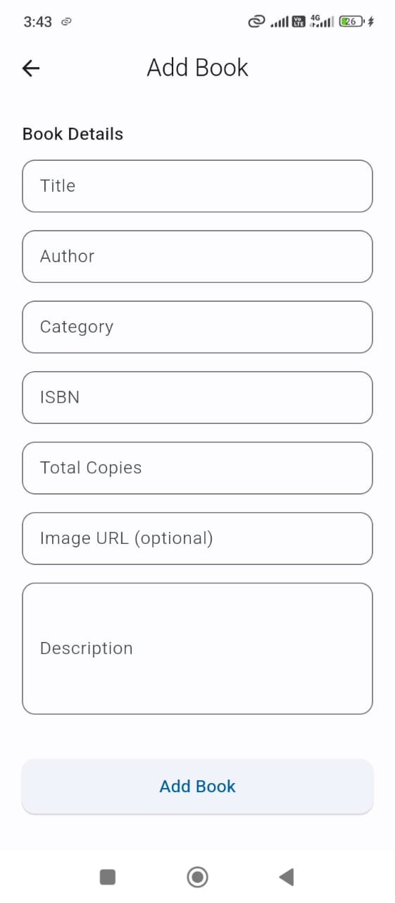
Figure 7.1: Add book from admin dashboard
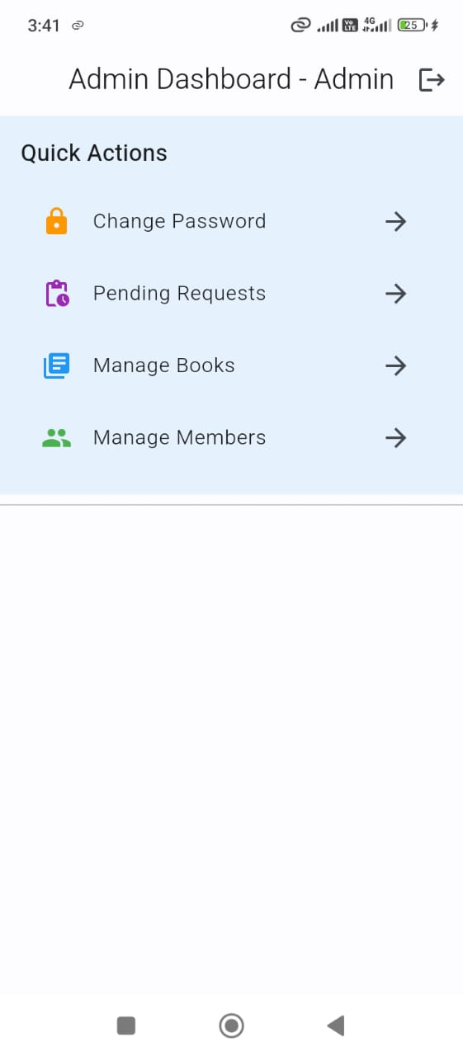
Figure 7.2: Admin dashboard
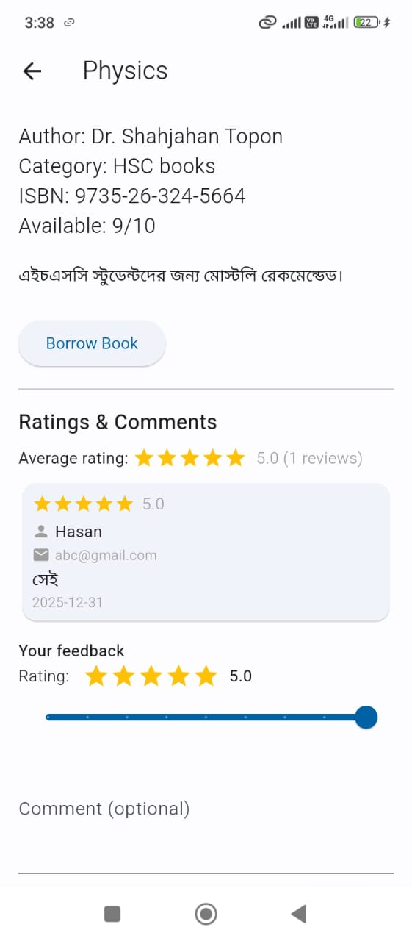
Figure 7.3: Book details with borrow request ratings comments options

Figure 7.4: Book searching
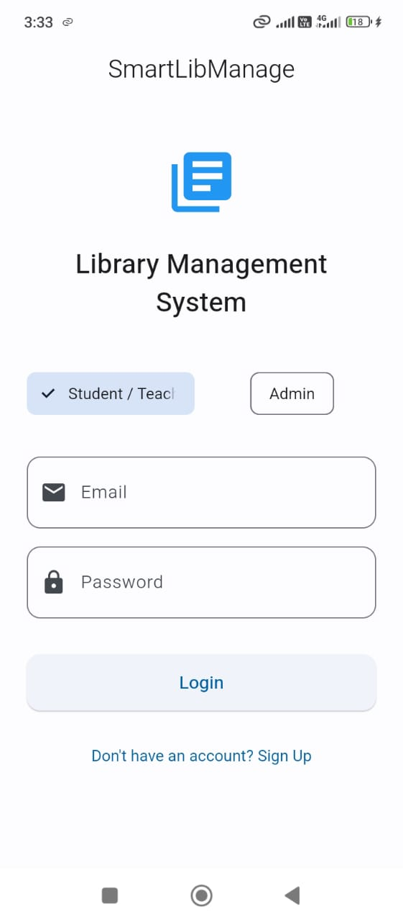
Figure 7.5: Login screen
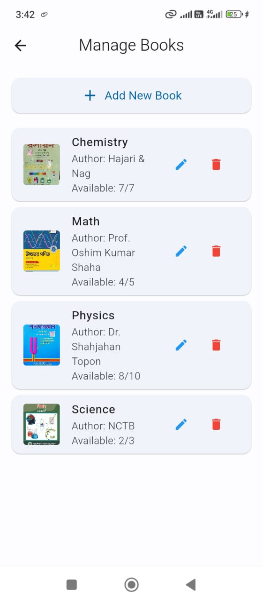
Figure 7.6: Manage books from admin dashboard
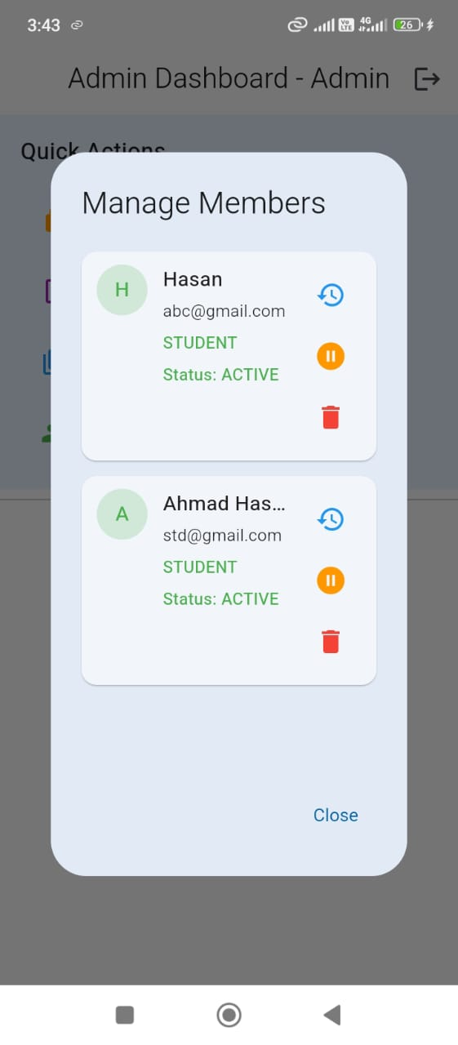
Figure 7.7: Manage members from admin dashboard
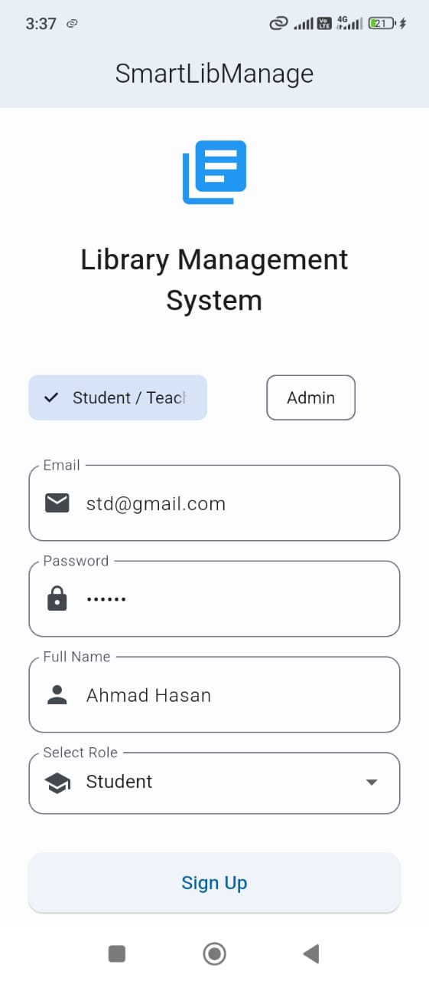
Figure 7.8: New account create
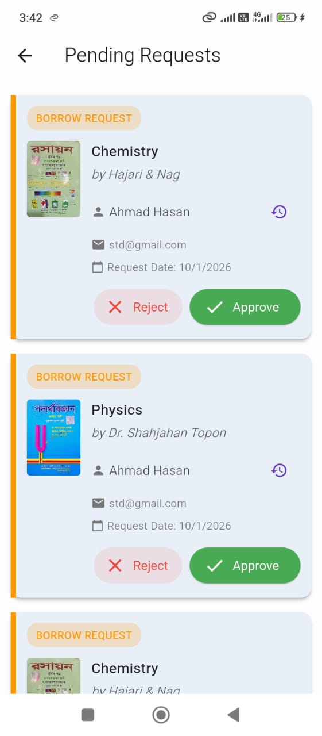
Figure 7.9: Pending requests from admin dashboard
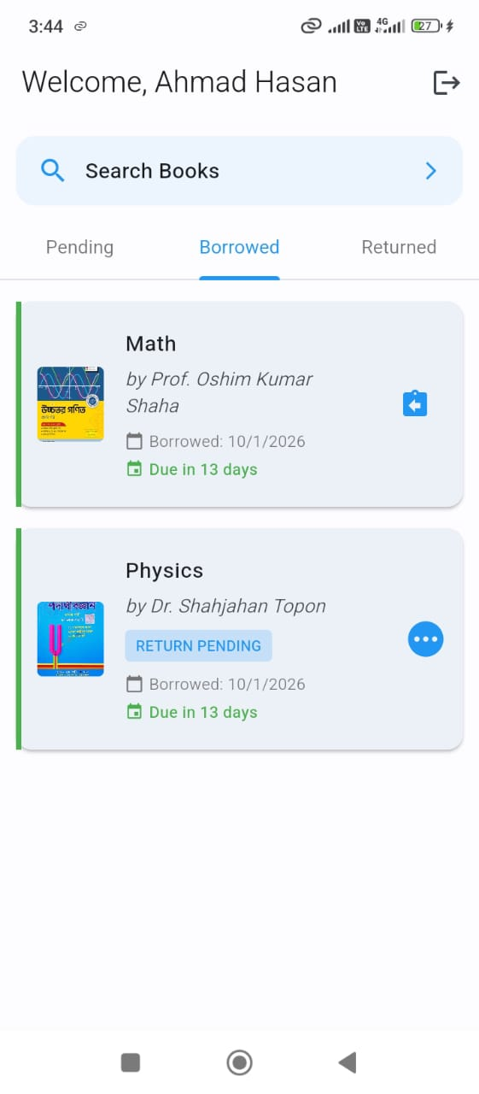
Figure 7.10: Student or teacher home screen(borrowed)
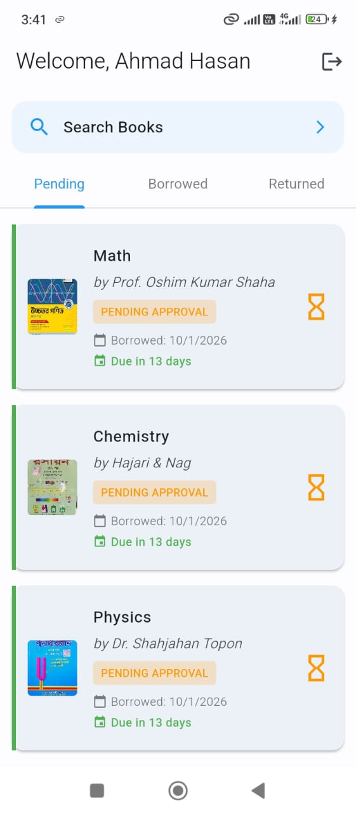
Figure 7.11: Student or teacher home screen(pending)
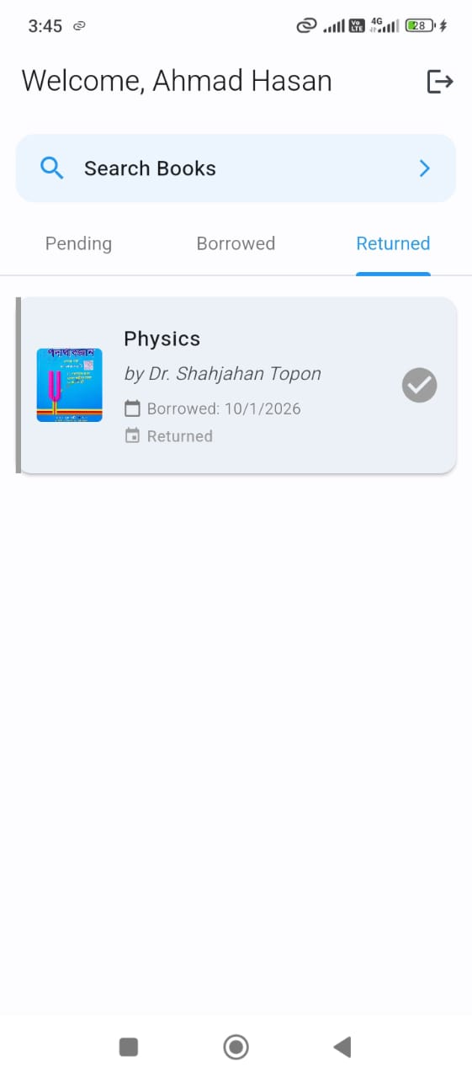
Figure 7.12: Student or teacher home screen(returned)

Chapter 8

Discussion & Analysis

8.1 Interpretation of Findings
The results indicate that SmartLibManage is a practical replacement for manual or fragmented library workflows in a real academic context.
- Operational impact (real context): In a typical library, users often need to visit the counter to confirm availability and complete borrow/return steps. With SmartLibManage, the catalog and borrowing status are visible in the app, and updates propagate through Firestore in near real time. This reduces repeated counter visits and avoids stale availability information.
- Role separation and control: The role-based screens and admin approval workflow mean the system supports both convenience (self-service requests) and governance (controlled approvals). This is important for institutional libraries where inventory must be verified before finalizing transactions.
- Data consistency: Using a centralized Firestore database for users, books, and borrows reduces duplicate records and makes it easier to track the lifecycle of a transaction (pending → active → pending return → returned).
- Performance interpretation: A measurement approach and target metrics are defined in Section 7.3. Observed values should be recorded on a chosen device/network to make performance claims repeatable.

8.2 Strengths of the Project
Compared to manual register/spreadsheet-based approaches (and many basic CRUD-only apps), SmartLibManage shows several strengths:
- End-to-end workflow coverage: Not only catalog management, but also borrow/return requests and an approval mechanism (reduces uncontrolled transactions).
- Real-time synchronization: Firestore streams help keep the catalog and pending requests up to date without manual refresh/polling.
- Clear modular architecture: Providers and a service layer keep UI code separated from database operations, improving maintainability.
- Low-cost and deployable: Uses free development tools and Firebase free-tier features suitable for a course project and small deployments.
- Role-based access: Admin-only capabilities (book CRUD, approvals, member management) are separated from member capabilities.

8.3 Limitations
- Internet Dependency: Full functionality requires active internet connection
- No Offline Mode: Users cannot browse books without connectivity
- No Fine System: Overdue books don’t incur financial penalties
- Single Library: System designed for single institution only
- No ISBN Scanning: Manual entry required for book addition
- Limited Reporting: No analytics dashboard for library statistics

8.4 Recommendations for Future Development
The following improvements are realistic next steps for future iterations:
- Offline browsing (partial): Enable Firestore offline persistence and cache catalog data for read-only access when offline.
- ISBN/Barcode scanning: Use device camera scanning to reduce manual typing when adding books.
- Fine and policy module: Add configurable due-date policies and optional fine calculation (even if payment is not integrated).
- Analytics and reporting: Provide admin reports (popular books, overdue list, borrow trends) for decision making.
- More robust notifications: Add scheduled reminders and optional email notifications for due dates.
- Better audit trail: Record who approved a request and when (admin action logs) for accountability.

8.5 Reflection on Design & Implementation Decisions
Justified decisions (why they fit this project): - Flutter for the client app: A single codebase enabled rapid iteration of UI screens and workflows while targeting Android. - Firebase (Auth + Firestore + Messaging): Reduced backend engineering overhead and provided a secure, production-grade identity system and real-time database. - Provider for state management: Matched the project scope with a straightforward pattern for propagating authentication and book-state changes. - Service layer (FirestoreService) + models: Centralized database operations and maintained consistent mapping between UI and data.
Lessons learned (individual execution): - Defining data models and Firestore structure early reduced integration bugs later. - Implementing security rules and role restrictions early prevents accidental privilege leaks. - Building core flows first (Auth → Catalog → Borrow/Return) made later features (notifications, dashboards) easier to integrate.

Chapter 9

Life-long Learning Impact

9.1 Technical & Professional Skills Acquired
Skill Area | Skills Learned
Mobile Development | Flutter/Dart, widget composition, navigation, form validation, state-driven UI
State Management | Provider pattern, ChangeNotifier, reactive UI updates, separation of concerns
Backend Services | Firebase Authentication, Cloud Firestore CRUD/streams, Firebase project configuration
Data Modeling | Designing Firestore collections (users, books, borrows), mapping models (fromMap/toMap)
Security Mindset | Role-based access control, Firestore security rules, safer input handling
Testing & Debugging | Scenario-based integration checks, error tracing, use of logs and emulator/device testing
Documentation | Writing setup instructions, maintaining a structured report, documenting workflows and APIs
Project Execution | Breaking work into milestones (Auth → Catalog → Borrow/Return), tracking progress individually

9.2 Learning New Technologies & Tools
During development, I had to learn and apply several tools and frameworks that were new (or partially new) to me. The learning process was iterative: understand the concept, build a small prototype, integrate into the main project, and validate with real device testing.
- Flutter framework: Learned widget composition, navigation, and building responsive screens.
- Dart language: Practiced null-safety, async/await, and model classes for data mapping.
- Firebase services: Configured Authentication and Firestore, and learned how client SDKs enforce security using rules.
- Provider pattern: Implemented app-wide state handling (authentication and book state) with ChangeNotifier and Consumer.
- Build/deployment tooling: Used Android Studio tooling/Gradle builds and validated environment setup via flutter doctor.
Learning Approach: - Official documentation (Flutter, Firebase, Provider) - Hands-on experimentation and incremental integration - Debugging through logs and controlled test scenarios - Community resources (forums/Q&A) when blocked

9.3 Future Growth & Directions
Short-term Goals (6 months): - Stabilize core workflows with more test cases and bug fixes - Gather user feedback and refine UI/UX for faster navigation - Add offline-friendly catalog browsing (Firestore offline persistence + caching) - Add ISBN/barcode scanning for faster book entry
Medium-term Goals (1 year): - Analytics and reporting for admins (overdue list, popular books, borrowing trends) - Stronger notification system (scheduled reminders, optional email) - Optional multi-library support (separate library collections / tenants)
Long-term Vision: - Production hardening (audit logs, backups/export, monitoring) - Open-source release for educational institutions (with deployment guide) - Integrations with institutional systems (student directory, library ID cards) where feasible

Chapter 10

Conclusion

10.1 Summary of Work
SmartLibManage represents a successful implementation of a modern library management system using Flutter and Firebase. Over the 14-week development period, I:
- Designed and implemented a complete mobile application
- Created secure authentication with role-based access
- Built real-time book catalog with search functionality
- Developed borrowing/returning workflow with approval system
- Integrated push notifications for due date reminders
- Performed feature-based testing and end-to-end validation of the main user journeys

10.2 Achievement of Objectives
Objective | Status | Evidence
User-friendly mobile app | Achieved | Working UI flows demonstrated in screenshots (Section 7.5)
Secure authentication | Achieved | Firebase Auth integration and role-based navigation (Chapter 6)
Book inventory system | Achieved | Book CRUD and catalog browsing/search (Chapters 6–7)
Borrowing workflow | Achieved | Borrow/return requests with admin approvals and status transitions (Chapters 6–7)
Push notifications | Achieved | Notification module integrated (Chapter 6); can be validated via test notifications
Separate dashboards | Achieved | Admin vs member dashboards shown in execution results (Section 7.5)
Data persistence | Achieved | Firestore-backed data model and security rules (Chapters 5–6, Appendix D)

10.3 Final Remarks
SmartLibManage demonstrates the potential of modern mobile technologies to transform traditional library operations. The project not only fulfills its technical objectives but also provides a foundation for future enhancements.
The experience gained through this project has equipped me with valuable skills in mobile development, cloud services, and independent software engineering practices that will be valuable in future professional endeavors.
I believe SmartLibManage can make a meaningful contribution to educational institutions seeking to modernize their library services while providing an accessible, efficient experience for students and staff alike.

References
- Flutter Documentation. (2025). Flutter SDK. https://flutter.dev/docs
- Firebase Documentation. (2025). Firebase for Flutter. https://firebase.google.com/docs/flutter
- Dart Language. (2025). Dart Programming Language. https://dart.dev
- Provider Package. (2025). Simple State Management. https://pub.dev/packages/provider
- Material Design. (2025). Material Design Guidelines. https://material.io
- Cloud Firestore. (2025). NoSQL Database. https://firebase.google.com/docs/firestore

Appendix

A. Project Source Code
The complete source code is available at: [GitHub Repository Link]

B. Installation Guide
- Install Flutter: https://flutter.dev/docs/get-started/install
- Clone repository: git clone [repo-url]
- Install dependencies: flutter pub get
- Configure Firebase:
  - Create Firebase project
  - Enable Authentication, Firestore, Cloud Messaging
  - Download google-services.json to android/app/
- Run: flutter run

C. User Manual

For Students/Teachers:
- Register with email/password
- Login to access dashboard
- Browse or search books
- Click on book to view details
- Request to borrow available books
- Wait for admin approval
- View borrowed books in dashboard
- Request return when done

For Administrators:
- Login with admin credentials
- Access admin dashboard
- Manage books (Add/Edit/Delete)
- Approve/reject borrow requests
- Confirm book returns
- Manage user accounts

D. Firestore Security Rules
rules_version = '2';
service cloud.firestore {
match /databases/{database}/documents {
function isAuthenticated() {
return request.auth != null;
}
function isAdmin() {
return isAuthenticated() &&
get(/databases/$(database)/documents/users/$(request.auth.uid)).data.role == 'admin';
}
match /users/{userId} {
allow read: if isAuthenticated();
allow write: if request.auth.uid == userId || isAdmin();
}
match /books/{bookId} {
allow read: if isAuthenticated();
allow write: if isAdmin();
}
match /borrows/{borrowId} {
allow read: if isAuthenticated();
allow create: if isAuthenticated();
allow update, delete: if isAdmin();
}
}
}

End of Report

