
Faculty of Engineering Department of
Informatics Engineering-Software and
Information Systems Engineering

Hajj and Umrah Booking and Trip
Management System
Senior Project

Prepared by
Ahmad Kassem Wael Ali Hasan mnjed
Supervised by
Dr.Shadi bleidi

Abstract

In the era of rapid technological advancement and digital transformation in religious services, the Hajj and Umrah Booking System emerges as an innovative solution designed to simplify and manage religious travel arrangements for individuals and organizations alike. This system provides an integrated digital platform that allows users to book trips, manage accommodations and hotels, and track travel details easily and securely.
The platform offers a unified environment enabling pilgrims and visitors to browse available packages, book trips, hotels, and cities, and manage their reservations through an intuitive and efficient interface. Administrators and service providers are granted extended privileges to manage cities, hotels, and trips while ensuring the quality of services provided.
The project aims to support digital transformation in the field of religious tourism and enhance user experience by simplifying booking procedures, ensuring continuous information updates, and improving operational efficiency for service providers through flexible and effective data management.
Through this system, full integration can be achieved across all stages of the Hajj or Umrah journey — from registration and verification to booking and accommodation management — ensuring a smooth, organized, and spiritually fulfilling experience for every pilgrim.

Chapter 1
Introduction

1.1 Purpose
The Hajj and Umrah Trip Management System aims to create a safe and user-friendly digital platform that enables pilgrims to explore, book, and manage pilgrimage trips efficiently.
The system seeks to simplify the booking process for Hajj and Umrah journeys by providing access to detailed trip information — including hotel data, city destinations, duration, and cost — and allowing online reservations.
It also provides an administrative dashboard for managing trips, hotels, and destinations, ensuring smooth coordination between users and administrators.

1.2 Project Scope
The Hajj and Umrah Booking System is designed to provide a comprehensive digital environment for managing pilgrimage trips.
It allows users to explore available Hajj and Umrah packages, book trips online, and manage their reservations through an intuitive web interface.
Administrators can manage trip data, hotel information, city destinations, and website content through a dedicated dashboard.
A super administrator has additional privileges to monitor platform activity and control administrator access.
The project focuses on improving user experience, reliability, and administrative efficiency in organizing religious journeys.

1.2.1 First Phase (MVP – Minimum Viable Product)
The first version of the system focuses on developing the essential functions that ensure a complete and usable core experience for both users and administrators:
- User Account Management:
  - User registration, login, logout, and profile management.
- Trip Browsing:
  - View available Hajj and Umrah trips with details (name, price, duration, hotel, and destination).

- Trip Booking:
  - Reserve a selected trip, specify ticket quantity, and confirm booking.
  - View booking history and track reservation status (Pending / Accepted / Canceled).
- Admin Management:
  - Add, edit, delete, and view trips.
  - Manage hotels and city destinations.
  - Monitor and update user reservations.
- Hotel and City Management:
  - Add and manage hotels with details such as name, location, and room information.
  - Add and manage cities and associate them with trips.

1.2.2 Second Phase
- Introduce a Super Admin role for managing administrators’ access and monitoring the system.
- Enable online payment options for secure financial transactions.
- Integrate Google Maps API to display hotel locations and trip destinations.
- Add notification and alert features to keep users informed about trip updates and booking confirmations.

1.2.3 Third Phase
- Implement secure e-payment gateways for integrated financial transactions.
- Add statistical reports for administrators to analyze bookings and performance.
- Enhance system performance and scalability to support more users and trips.

1.3 Technical Scope
The technical scope of the Hajj and Umrah Trip Management System includes all the technological components necessary to build a secure, interactive, and scalable web-based platform.
The system has been developed using modern web technologies to ensure reliability, maintainability, and flexibility for future enhancements.

1.3.1 Frontend (User Interface)
The system’s frontend was developed using:
- HTML5, CSS3, Bootstrap, and JavaScript
These technologies were used to build responsive and user-friendly interfaces that allow users to browse trips, view details, and make bookings easily.
The design focuses on clarity, simplicity, and accessibility, ensuring a smooth user experience across all devices.

1.3.2 Backend (Server Side)
- The backend was developed using the Laravel Framework (PHP).
Laravel provides a robust MVC (Model-View-Controller) structure that enhances system organization and scalability.
It supports essential features such as:
  - Secure authentication and session management.
  - Efficient handling of trip, hotel, and reservation data.
  - Integration with third-party services such as Google Maps and email notifications.
Laravel’s built-in routing and ORM (Eloquent) ensure clean and maintainable code with strong performance.

1.3.3 Database
- The system uses MySQL as its primary relational database management system (RDBMS).
It stores structured data related to users, trips, hotels, cities, and bookings.
Proper indexing and relational design have been implemented to ensure fast data retrieval and integrity.

1.3.4 Map Integration
- The system integrates Google Maps API to display hotel locations and trip destinations.
This feature allows users to view geographical locations and choose suitable accommodations based on proximity and preference.

1.3.5 Security and Data Protection
- Secure login and role-based access (User, Admin, Super Admin).
- Encrypted passwords and sensitive data.
- HTTPS encryption for secure communication between client and server.
- Input validation and regular backups to ensure data safety.

1.3.6 Development Tools
- Visual Studio Code (VS Code): main development environment.
- XAMPP / PHP Artisan: for local server and Laravel environment setup.
- phpMyAdmin: for database management.
- GitHub: for version control and collaboration.

1.3.7 Future Enhancements
- Integration with payment gateways for online payments.
- Mobile application version for Android and iOS.
- Advanced reporting and analytics dashboard for administrators.
- AI-based trip recommendation system for personalized suggestions.

Chapter2
Project management

2.1 Project Overview
The Hajj and Umrah Trip Management System is a web-based platform designed to simplify the process of exploring, booking, and managing pilgrimage trips for users while providing administrative tools for managing trip, hotel, and city data.
The project focuses on providing a user-friendly interface, reliability, and security for both users and administrators.
The system was developed under the supervision of Mr. Shadi Bleidi, who guided the planning, design, and implementation phases.

2.2 Project Charter
Project Title | Hajj and Umrah Trip Management System
Supervisor | Mr. Shadi Bleidi
Project Type | Web Site
Development Methodology | Incremental Model
Programming Languages | PHP, React, Tailwind Css, Vite
Frameworks & Tools | Laravel, Bootstrap, MySQL, VS Code, XAMPP
Target Users | Pilgrims, Administrators, Super Admin
Main Objective | To design and implement a digital platform for managing Hajj and Umrah trips efficiently.
Start Date | [Add your project start date]
End Date | [Add your project end date]

2.3 Project Objectives
- Facilitate the process of booking Hajj and Umrah trips online.
- Provide detailed trip, hotel, and city information for users.
- Enable administrators to manage trips, hotels, and reservations efficiently.
- Implement a secure login and user management system.
- Integrate Google Maps for location-based trip exploration.
- Support notifications and alerts for users and admins.
- Ensure system scalability and future expansion for new features.

2.4 Development Methodology – Incremental Model
The Incremental Software Development Model was chosen for this project.
This approach divides the system into multiple incremental modules, each developed, tested, and delivered independently.
Each increment adds new functionality while maintaining full compatibility with previous modules.
Advantages of the Incremental Model in this project:
- Early delivery of core functions (MVP).
- Reduced development risk by validating each stage.
- Flexibility to incorporate feedback from users and supervisors.
- Easier maintenance and future feature expansion.
Increments planned for this project:
- Increment 1: User account management and trip browsing.
- Increment 2: Trip booking, hotel and city management.
- Increment 3: Admin and Super Admin dashboards.
- Increment 4: Online payment integration and reporting module.

2.5 Stakeholders
Stakeholder | Role / Responsibility
Project Supervisor | Provide academic and technical guidance (Mr. Shadi Bleidi)
Developers | Design, implement, and test system modules
Users (Pilgrims) | Explore and book Hajj & Umrah trips
Admins | Manage trips, hotels, cities, and user bookings
Super Admin | Monitor the system, assign roles, and control access

2.6 Work Breakdown Structure (WBS)
- Requirement Analysis
  - Collect system requirements
  - Define system functionalities
  - Prepare SRS document
- System Design
  - Design UI mockups
  - Create database schema
  - Design system architecture
- Implementation (Incremental)
  - Increment 1: Authentication and user interface
  - Increment 2: Trip and booking management
  - Increment 3: Admin dashboard and reporting
- Testing & Validation
  - Unit testing and integration testing
  - Bug fixing and optimization
- Deployment & Maintenance
  - Host system on web server
  - Conduct user training and final evaluation

2.7 Risk Management
Risk | Probability | Impact | Mitigation Strategy
Delay in development | Medium | High | Apply incremental delivery and schedule reviews
Data loss or corruption | Low | High | Implement regular database backups
Integration issues with APIs | Medium | Medium | Conduct early testing of external APIs
Security vulnerabilities | Medium | High | Use encryption, HTTPS, and role-based access
Server or hosting failure | Low | Medium | Maintain backups and use reliable hosting service

2.8 Project Schedule
A Gantt chart was prepared to illustrate the timeline of tasks, including analysis, design, development (per increment), testing, and deployment phases.
Each phase overlaps slightly to maintain progress and support incremental delivery.

Chapter 3 Fundamental Concepts and Literature Review

3.1 Introduction
This chapter presents the fundamental concepts underlying the Hajj and Umrah Trip Management System and provides a comprehensive literature review. The purpose is to establish a theoretical foundation that guided the design, structure, and development of the system. The chapter includes an examination of digital platforms, usability principles, web technologies, and existing pilgrimage-related systems.

3.2 Fundamental Concepts

3.2.1 Digital Trip Management Systems
Digital trip management systems enable users to browse, book, and manage travel services through interactive online platforms. These systems typically include trip listings, hotel information, reservation modules, payment integration, and user dashboards. Digital transformation has significantly enhanced trip management, particularly in large-scale activities like Hajj and Umrah (Saudi Ministry of Hajj and Umrah, 2021).

3.2.2 Hajj and Umrah Digital Services
Pilgrimage services require a reliable and well-structured system that organizes trip schedules, hotel stays, transportation, and packages. Digital solutions improve accessibility, accuracy, and efficiency, supporting millions of pilgrims annually.

3.2.3 User Roles
The system defines three main roles:
- User: Browses trips, views details, manages profile, and books trips.
- Admin: Manages trips, hotels, cities, reservations, and system content.
- Super Admin: Controls administrative access and oversees all system operations.

3.2.4 Reservation Workflow
The reservation workflow follows a standard structured process:
- User selects a trip
- User reviews trip details
- User completes an online reservation
- Admin reviews, approves, or rejects the booking
- User receives booking status notifications
This workflow aligns with the procedures used by major booking platforms such as UmrahBooking.com (2023).

3.2.5 Incremental Development Model
The system was developed using the Incremental Model, where modules are built and delivered in increments.
Benefits include:
- Early delivery of essential features
- Reduced development risk
- Easier feedback incorporation
- High system scalability
This approach follows IEEE recommendations for evolutionary software development (IEEE, 2004).

3.3 Literature Review

3.3.1 Reference Platforms
One of the platforms referenced in the project documentation is the Expo Saudi Arabia Platform, which features:
- Organized service structure
- High-quality UI/UX
- Clear navigation
- Effective content presentation
(Expo2030SaudiArabia.com, 2023)
These elements inspired the trip browsing and content organization in the developed system.

3.3.2 Existing Pilgrimage Booking Platforms
Platforms such as UmrahBooking.com offer features including:
- Umrah packages
- Hotel listings
- Online reservations
These platforms highlight industry standards but often lack:
- A multi-role permission system
- A dedicated Super Admin control
- A scalable incremental architecture
The proposed system addresses these gaps.

3.3.3 Technical Foundation
The technical literature that supported the system includes:
- Laravel Documentation: backend security, authentication, routing, ORM
- MySQL Documentation: relational data modeling and optimization
- Google Maps API Documentation: integrating map-based location services
- Nielsen’s Usability Principles (1994): emphasizing intuitive, accessible, and responsive UI design
- Travel System Usability Research: emphasizes importance of user-centered design (Alsmadi & Prybutok, 2018)

3.4 Summary
This chapter presented the essential concepts and relevant literature that shaped the Hajj and Umrah Trip Management System. By analyzing digital platforms, academic studies, and technological documentation, the system was designed using proven practices that enhance usability, reliability, and scalability.

الميزة | Expo Saudi Arabia Platform | UmrahBooking.com & Similar Platforms | haj.gov.sa / Nusuk Platform | النظام المقترح (مشروعكم)
هيكل خدمات منظم وواضح | نعم (منظم جيد، إلهام لتنظيم المحتوى) | جزئيًا (حزم عمرة وفنادق) | نعم (حزم شاملة رسمية) | نعم (إدارة رحلات، فنادق، مدن بشكل متكامل)
واجهة مستخدم عالية الجودة (UI/UX) | نعم (عالية الجودة، تنقل واضح) | متوسطة (تركيز على الحجز البسيط) | جيدة (رسمية وآمنة) | نعم (مستوحاة من Nielsen’s Principles لتكون intuitive وresponsive)
تصفح رحلات/حزم مع تفاصيل (تواريخ، فنادق، تكلفة) | محدود (معارض وفعاليات) | نعم (حزم عمرة، فنادق، نقل) | نعم (حزم حج شاملة: إقامة، نقل، تأشيرات) | نعم (تصفح رحلات مع صور، خرائط، ليالي في مكة/مدينة)
حجز عبر الإنترنت | لا | نعم (حجز فنادق، نقل، حزم مخصصة) | نعم (حجز حزم حج رسمية مع تأشيرات) | نعم (حجز تذاكر، إدارة حجوزات pending/accepted)
إدارة متعددة الأدوار (Multi-role Permissions) | لا | نادرًا (غالباً B2C فقط) | محدود (رسمي للحجوزات) | نعم (User vs Admin vs Super Admin)
لوحة تحكم إدارية مخصصة (Dedicated Admin Dashboard) | لا | جزئيًا (للوكلاء في بعض الأنظمة) | نعم (للإدارة الرسمية) | نعم (إدارة رحلات، فنادق، مدن، حجوزات، محتوى)
تحكم Super Admin (لإدارة الوصول) | لا | لا | لا | نعم (Super Admin للتحكم في حسابات الـ Admins)
تكامل خرائط (Google Maps) | محدود | جزئيًا (مواقع فنادق) | نعم (مواقع مقدسة) | نعم (عرض مواقع فنادق على خريطة)
قابلية التوسع والمرونة | جيدة (للمعارض) | متوسطة (حزم ثابتة غالبًا) | عالية (رسمية لملايين الحجاج) | عالية (هندسة قابلة للتوسع، Agile Scrum كما في الوثيقة)
التركيز على سهولة الاستخدام (Usability Principles) | نعم (إلهام رئيسي) | متوسطة | جيدة | نعم (مستوحى من Nielsen 1994 ودراسات usability)

3.5 References
- Saudi Ministry of Hajj and Umrah. https://www.haj.gov.sa
- Expo Saudi Arabia Platform. https://www.expo2030saudiarabia.com
- UmrahBooking.com. https://www.umrahbooking.com
- Nielsen, J. (1994). Usability Engineering. Academic Press.
- W3C. Responsive Web Design Standards. https://www.w3.org/TR/css-flexbox-1/
- Laravel Documentation. https://laravel.com/docs
- MySQL Documentation. https://dev.mysql.com/doc/
- Google Maps API Documentation. https://developers.google.com/maps/documentation
- IEEE (2004). Software Development Models. https://ieeexplore.ieee.org/document/1702235
- Alsmadi, I., & Prybutok, V. (2018). Developing and testing a travel system usability model. https://doi.org/10.1016/j.ijinfomgt.2018.01.010

Chapter 4

System Analysis

4.1 Introduction
This chapter presents a detailed system analysis for the Hajj and Umrah Trip Management System. It defines the system’s overall behavior, identifies stakeholders and users, and specifies both functional and non-functional requirements. The analysis ensures a clear understanding of system operations before proceeding to design and implementation phases.

4.2 System Overview
The Hajj and Umrah Trip Management System is a web-based platform designed to facilitate the exploration, booking, and management of pilgrimage trips. The system allows users to view available trips, review hotel and destination information, and make reservations online.
Administrators manage trip data, reservations, hotels, and cities through a dedicated dashboard, while the Super Admin oversees administrative access and system-wide configurations.

4.3 Stakeholders
The primary stakeholders involved in the system are:
- Pilgrims (Users): End-users who browse trips and make reservations.
- System Administrators: Manage operational data and reservations.
- Super Administrator: Oversees system security, permissions, and administration.
- Project Supervisor: Shadi Blaidy.
- Development Team: Responsible for implementation and maintenance.

4.4 User Classes and Characteristics

4.4.1 User (Pilgrim)
- Basic technical knowledge
- Uses the system to browse trips, view details, and make bookings
- Requires a simple, intuitive interface

4.4.2 Admin
- Moderate to advanced technical knowledge
- Manages trips, hotels, cities, reservations, and content
- Requires efficient management tools and data accuracy

4.4.3 Super Admin
- Advanced technical knowledge
- Manages admins, permissions, and system settings
- Responsible for system reliability and security

4.5 Operating Environment
The system operates in a web-based environment with the following specifications:
- Frontend: HTML, CSS, JavaScript, Bootstrap
- Backend: Laravel (PHP Framework)
- Database: MySQL
- Server: Web server compatible with PHP (Apache / Nginx)
- APIs: Google Maps API (for location-based services)
- Browsers: Chrome, Firefox, Edge, Safari

4.6 Functional Requirements

4.6.1 Authentication and Account Management
- The system shall allow users to register and log in.
- The system shall allow users to update personal profile information.
- The system shall provide role-based access control.

4.6.2 Trip Management
- The system shall allow admins to add, edit, and delete trips.
- The system shall display trip details including schedule, price, and availability.
- The system shall allow users to view all available trips.

4.6.3 Hotel and City Management
- The system shall allow admins to manage hotel information.
- The system shall allow admins to manage city and destination data.
- The system shall associate trips with specific hotels and cities.

4.6.4 Reservation Management
- The system shall allow users to book trips online.
- The system shall allow admins to approve, reject, or update reservations.
- The system shall notify users of reservation status updates.

4.6.5 Content Management
- The system shall allow admins to manage website content.
- The system shall allow the Super Admin to control admin access.

4.7 Non-Functional Requirements

4.7.1 Performance
- The system shall support multiple concurrent users.
- System response time should not exceed 3 seconds under normal load.

4.7.2 Security
- The system shall protect user data through authentication and authorization.
- Passwords shall be encrypted.
- Access shall be restricted based on user roles.

4.7.3 Usability
- The system shall provide a user-friendly and intuitive interface.
- The system shall be accessible on multiple devices.

4.7.4 Scalability
- The system shall support future expansion such as online payments and advanced reports.

4.7.5 Reliability
- The system shall ensure data integrity and minimize downtime.

4.8 Assumptions and Constraints

4.8.1 Assumptions
- Users have access to the internet.
- Users possess basic web browsing skills.

4.8.2 Constraints
- The system is limited to web-based deployment.
- Development timeline follows the incremental development methodology.

4.9 Use Case Diagram (Overview)
The system supports the following main use cases:
- Register / Login
- Browse Trips
- View Trip Details
- Book Trip
- Manage Trips (Admin)
- Manage Hotels and Cities (Admin)
- Manage Reservations
- Manage Admins (Super Admin)

4.9.1 Use Case Diagram (High-Level)

Use Case Diagram (High-Level-) – Figure 2

4.9.2 Use Case Diagram (Low-Level)

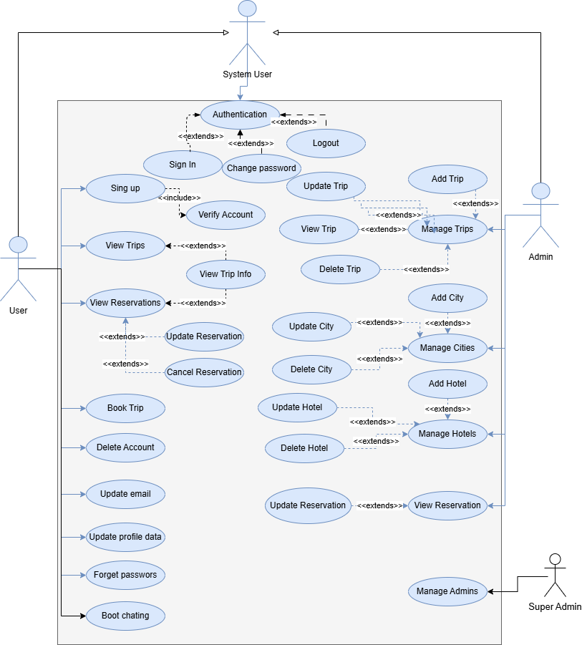
Use Case Diagram (Low-Level-) – Figure 3
Use Case ID | UC-1
Use Case | Sign In
Actor | System User
Pre-Condition | Has an account in the system
Main Scenario | - User clicks on “Login”  - User enter (username or email) and password  - System checks credentials data  - System returns success message with capability for access to the system
Alternative Scenario | In step 3 if the credentials data is incorrect the system returns error message and redirect user to login again

5. Use Case Specification & Activity Diagrams & Sequence Diagrams
5.1. System-User Requirements
5.1.1. Sign in

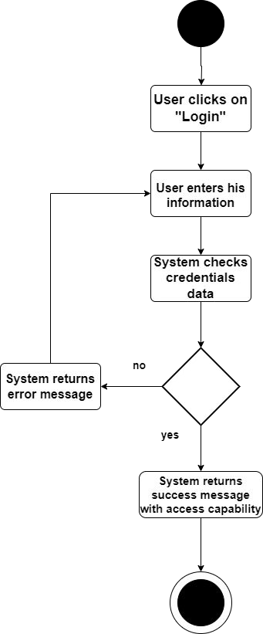
Activity diagram(log in) – Figure 4

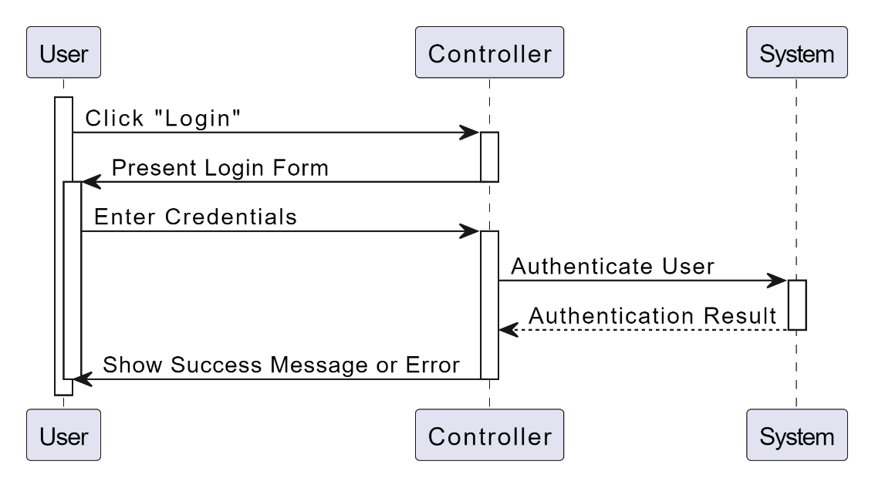

Sequence diagram(log in) – Figure 5

Use Case ID | UC-2
Use Case | Logout
Actor | System User
Pre-Condition | Already logged in
Main Scenario | - User clicks on “Logout”  - System cancels user capability for access to the system
Alternative Scenario
5.1.2. Log out
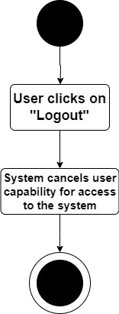
Activity diagram(log out) – Figure 6

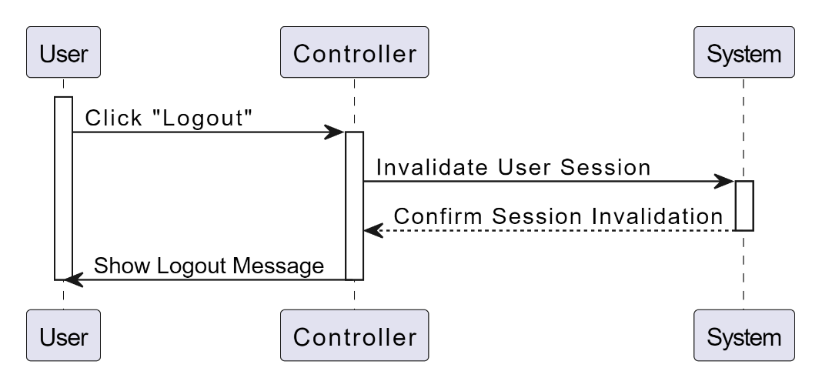

Sequence diagram(log out) – Figure 7

Use Case ID | UC-5
Use Case | Sign up
Actor | User
Pre-Condition | -
Main Scenario | - User clicks on “Register”  - System presents form with (name, email, address, phone number)  - User enter data then clicks on “Register”  - System checks if the email and phone number are unique  - System creates new account in the system  - System creates verification code and send it via email  - User receive verification code via his email  - User enter verification code  - System check if verification code is correct  - System marks account as verified
Alternative Scenario | In step 4 if the email or phone number are not unique, system return error message and redirect user to enter data again  In step 9 if the verification code incorrect the system return error message and redirect user to enter code again
5.1.3. Sign up

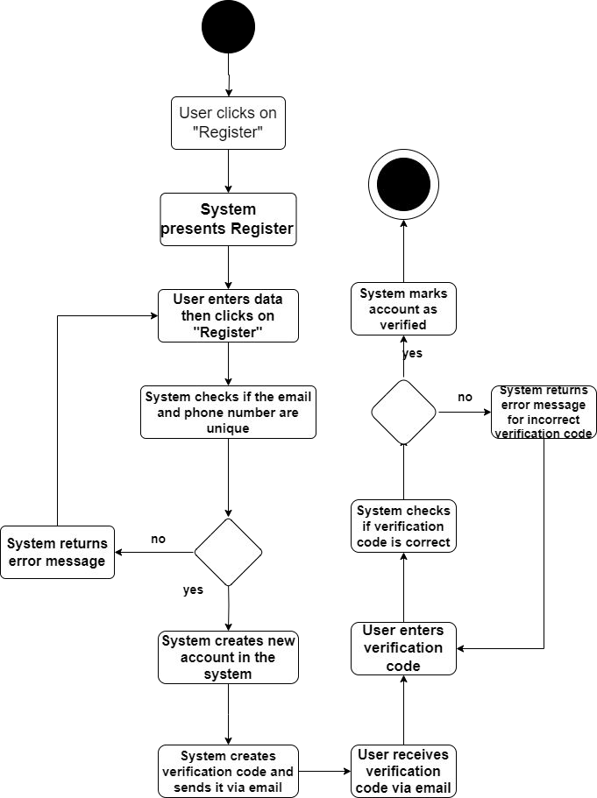
Activity diagram(Sign up) – Figure 8
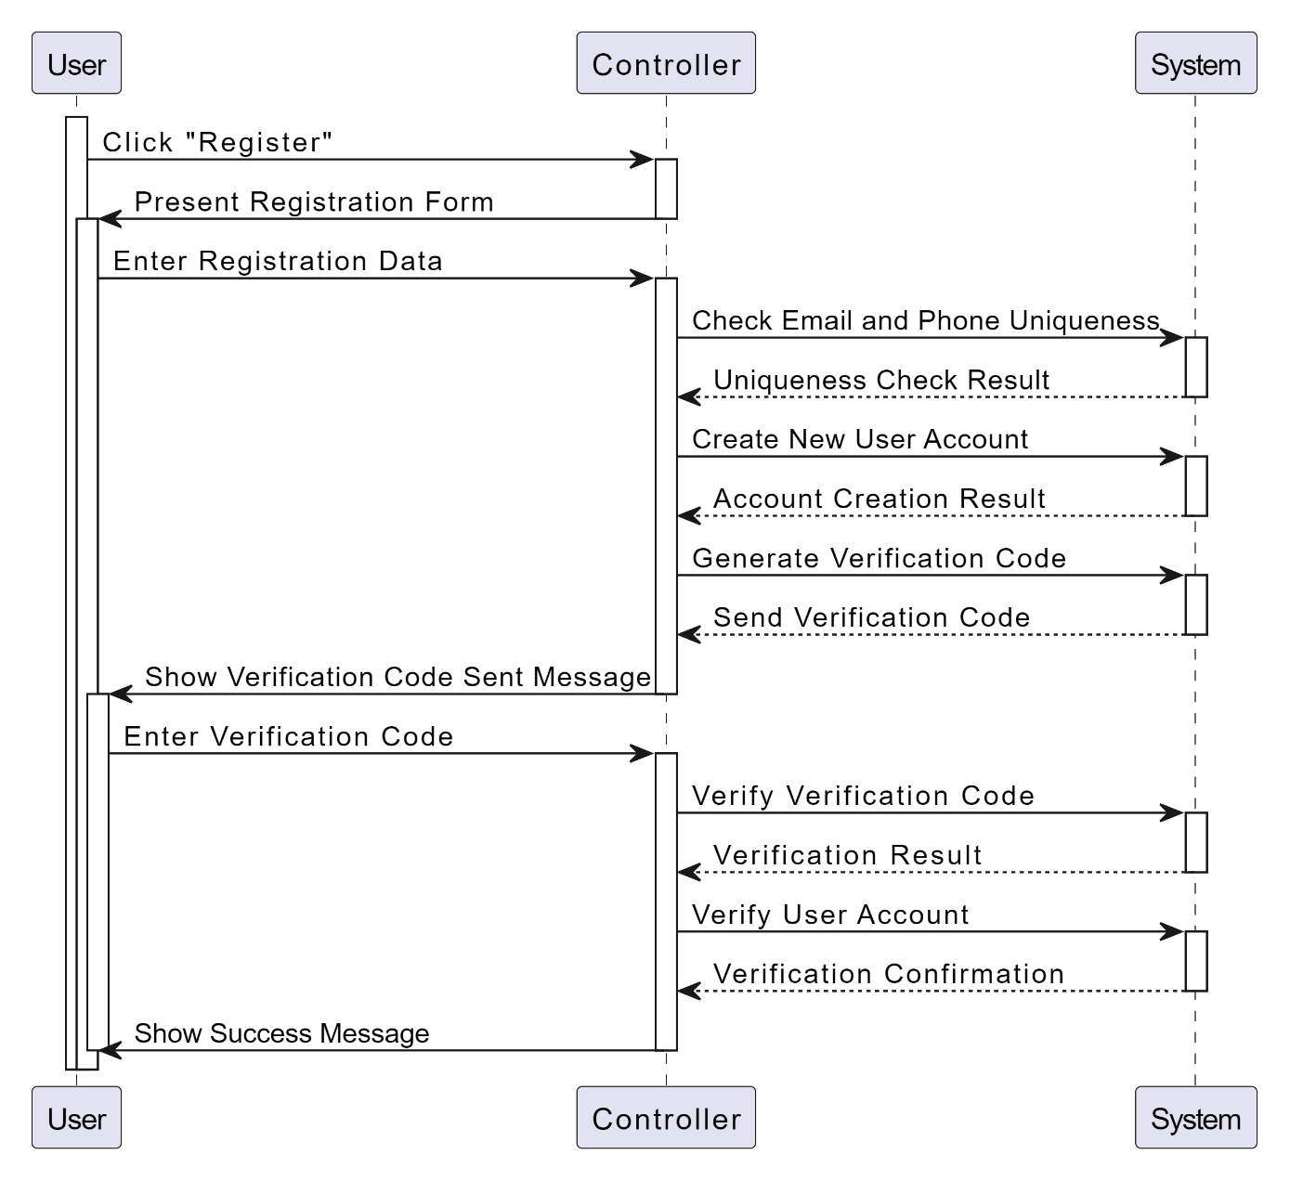

Sequence diagram(Sign up) – Figure 9

Use Case ID | UC-6
Use Case | Update email
Actor | User
Pre-Condition | Already logged in
Main Scenario | - User clicks on “Profile”  - User clicks on “Change email”  - User enter new email  - System checks if new email is used before  - System creates verification code and send it via new email  - User receive the verification code via his new email  - User enter verification code  - System checks if verification code is correct  - System update user email to new email
Alternative Scenario | In step 4 if the entered email is not unique, system return error message and redirect user to his profile  In step 8 if the verification code is incorrect, system return error message and redirect user to enter code again
5.1.4 Update email

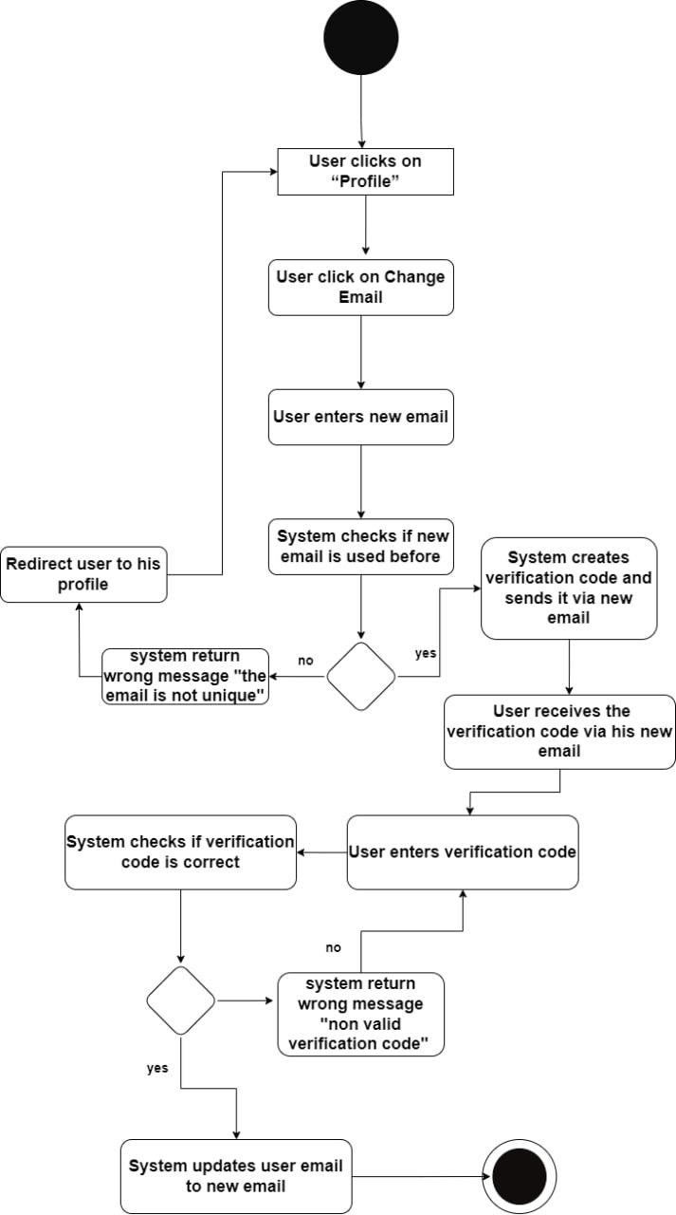

Activity diagram(Update email) – Figure 10

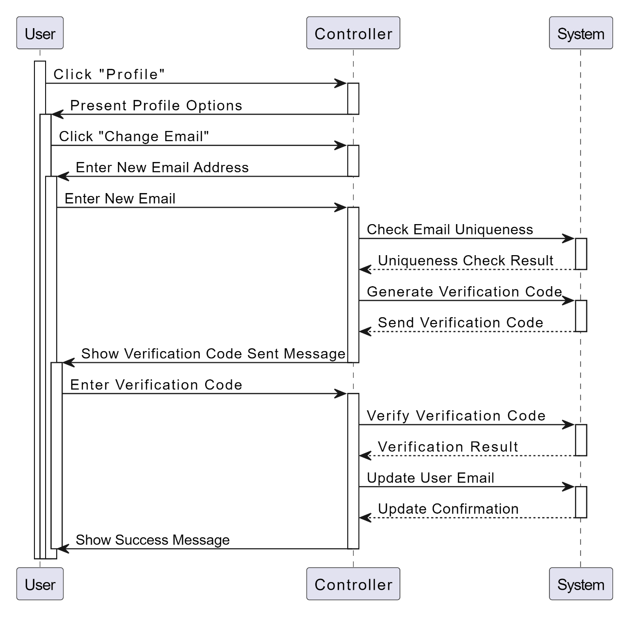
Sequence diagram(Update email) – Figure 11

Use Case ID | UC-7
Use Case | Update profile data
Actor | User
Pre-Condition | Already logged in
Main Scenario | - User clicks on “Profile”  - System present old data (name, phone number, address)  - User change presented data then clicks on “Save”  - System checks if the entered phone number is unique  - System update entered data
Alternative Scenario | In step 4 if the entered phone number is not unique, system return error message and redirect user to his profile
5.1.5 Update profile data

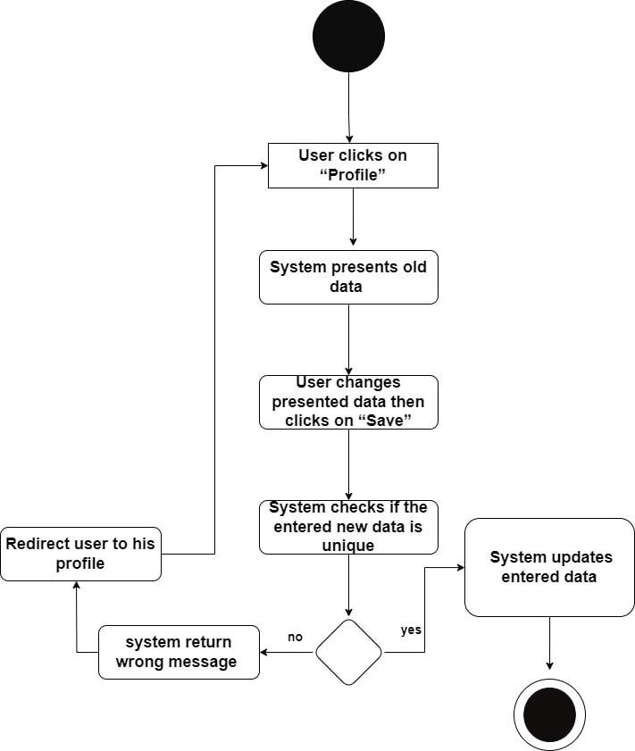
Activity diagram(Update profile data) – Figure 12

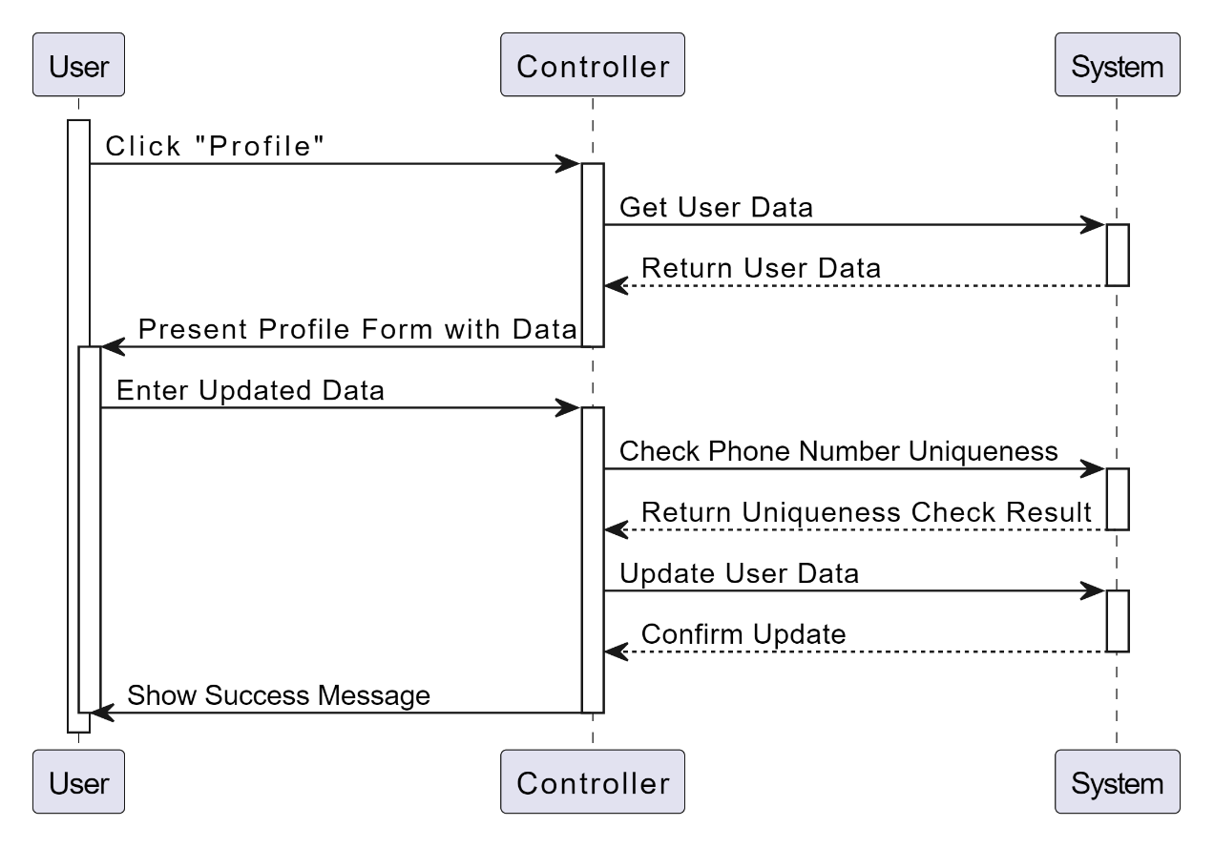
Sequence diagram(Update profile data) – Figure 13

Use Case ID | UC-8
Use Case | Forget password
Actor | User
Pre-Condition | Has an account in the system, User in sign in page
Main Scenario | - User clicks on “Forget Password”  - User enter his email  - System checks if the email exists in the system  - System creates verification code and send it via entered email  - User receive forget password code  - User enter verification code  - System checks if the verification code is correct  - User enter new password  - System update user password
Alternative Scenario | In step 3 if the email dose not exists the system return error message and redirect user to enter email again  In step 7 if the verification code is incorrect the system return error message and redirect user to enter password again
5.1.6 Forget password

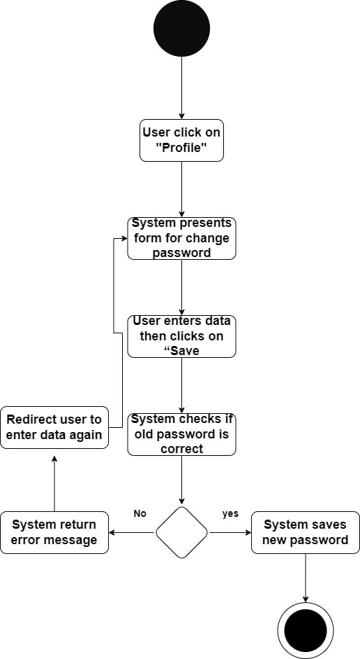

Activity diagram(Forget password) – Figure 14

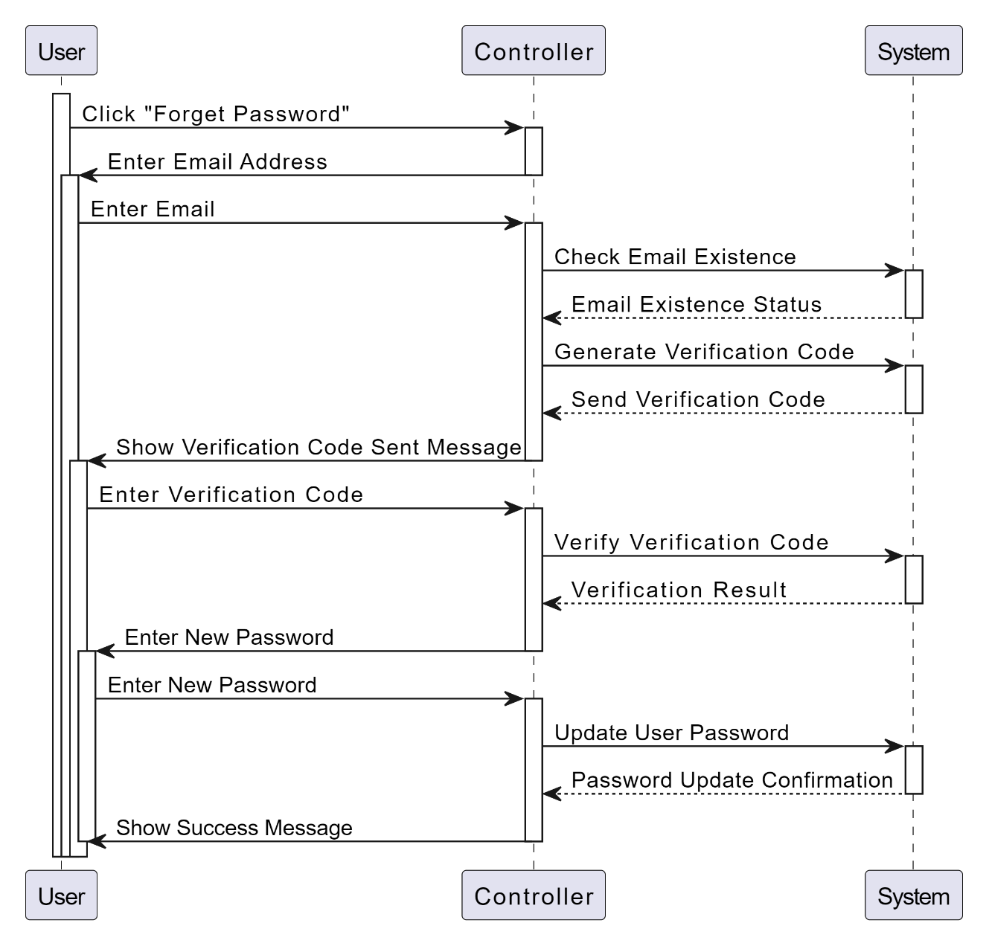

Sequence diagram(Forget password) – Figure 15

5.1.7 View trip

Use Case ID | UC-9
Use Case | View Trips
Actor | User
Pre-Condition | User in home page
Main Scenario | 1. System presents list of active and the start date is after today trips (name, price, photo, start date, end date, list of nights (e.g. 3 nights in Makkah) and description) and each trip is clickable to show more details
Alternative Scenario | -

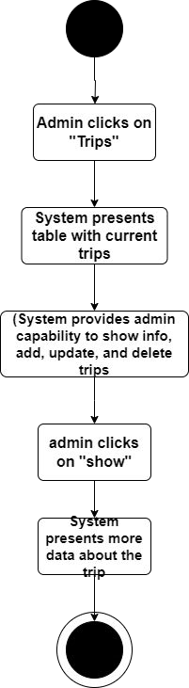
Activity diagram(View Trips) – Figure 16

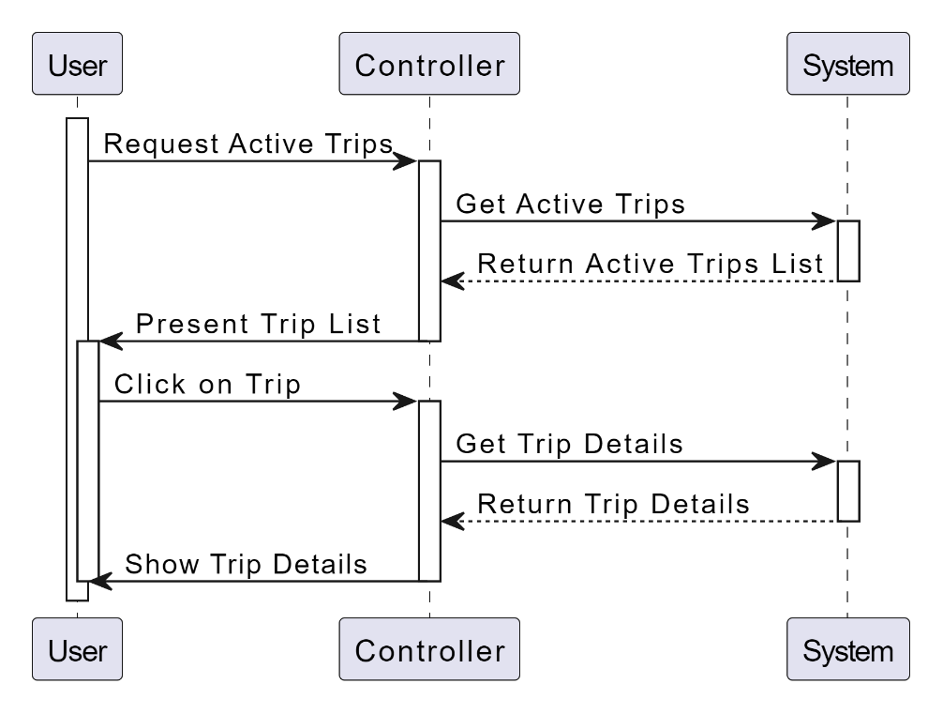

Sequence diagram(view trips) – Figure 17

5.1.8 View Trip info

Use Case ID | UC-10
Use Case | View Trip Info
Actor | User
Pre-Condition | User in home page
Main Scenario | - System presents list of trips each trip is clickable to show more details  - User clicks on any trip  - System presents more info about trip (name, price, photo, start date, end date, list of nights (e.g. 3 nights in Makkah), description, list of hotels info (name, location (as map), room description, photos))
Alternative Scenario | -

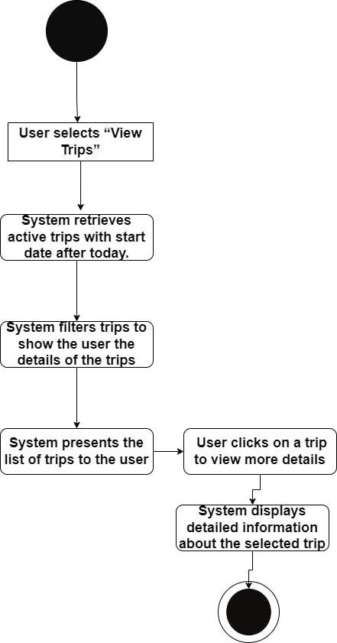
Activity diagram(View Trips info) – Figure 18

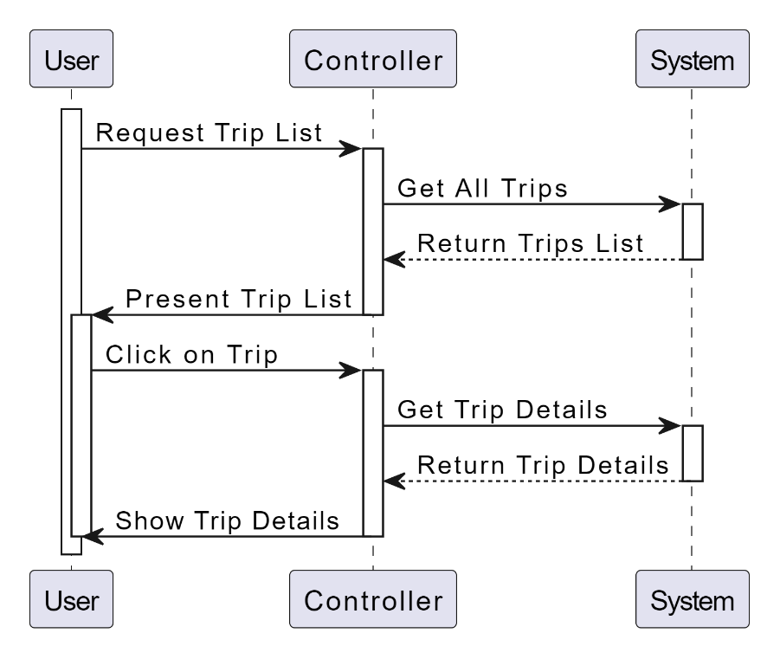

Sequence diagram(view trips info) – Figure 19

5.1.9 View Reservations
Use Case ID | UC-11
Use Case | View Reservations
Actor | User
Pre-Condition | Already logged in
Main Scenario | - User clicks on “Reservations”  - System present list of reservations (name of trip, photo of trip, price of trip, start date, number of tickets, status (Pending, Accepted, Cancelled, Done), total price, reason of canceling If it is canceled) and each one is clickable and will redirect user to view trip info and tow buttons (Cancel, Edit)
Alternative Scenario | -

Activity diagram(View Reservation) – Figure 20

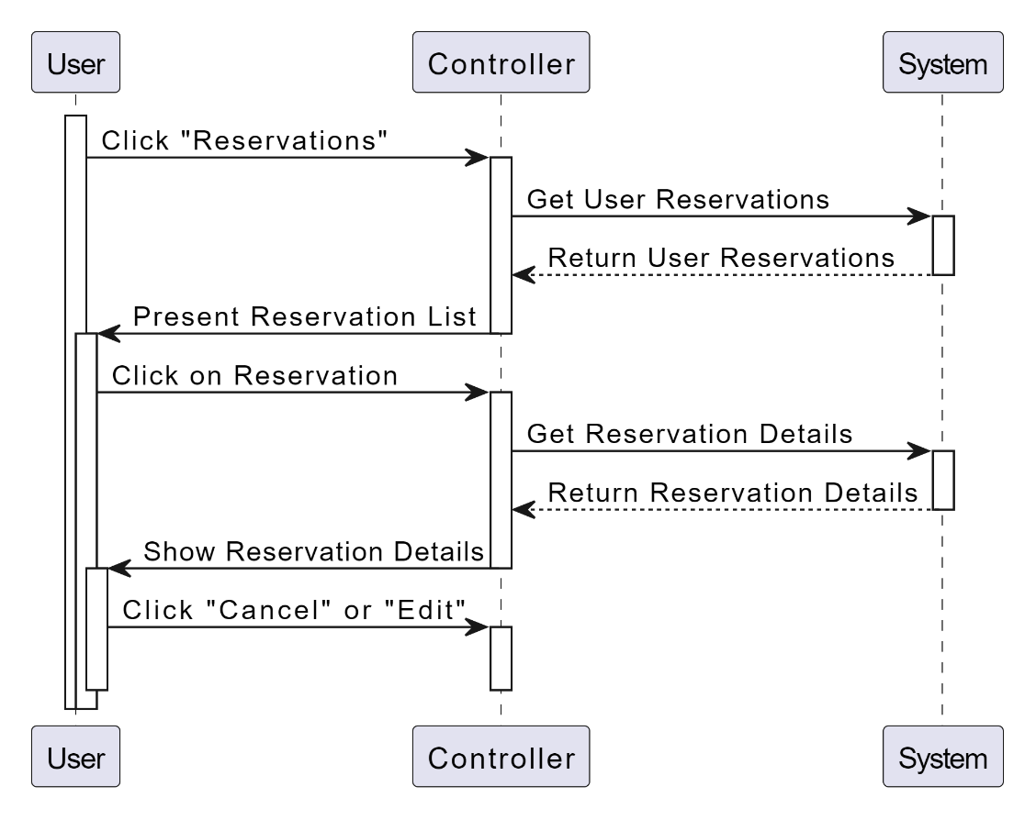

Sequence diagram(View Reservation) – Figure 21

5.1.10 Book trip

Use Case ID | UC-12
Use Case | Book Trip
Actor | User
Pre-Condition | Already logged in, and in view trip info page
Main Scenario | - User clicks on “view reservation”  - System presents dialog have details of trip  - user click on reservation  - System presents dialog have form to select number of ticket  - User enter number greater than 0 and less or equals 10  - System checks the number presents total price  - User clicks on “Confirm”  - system create new reservation assigned to user
Alternative Scenario | in step 4 if the number is less than 1 make it 1 automatically and if the number greater than 10 make 10 automatically

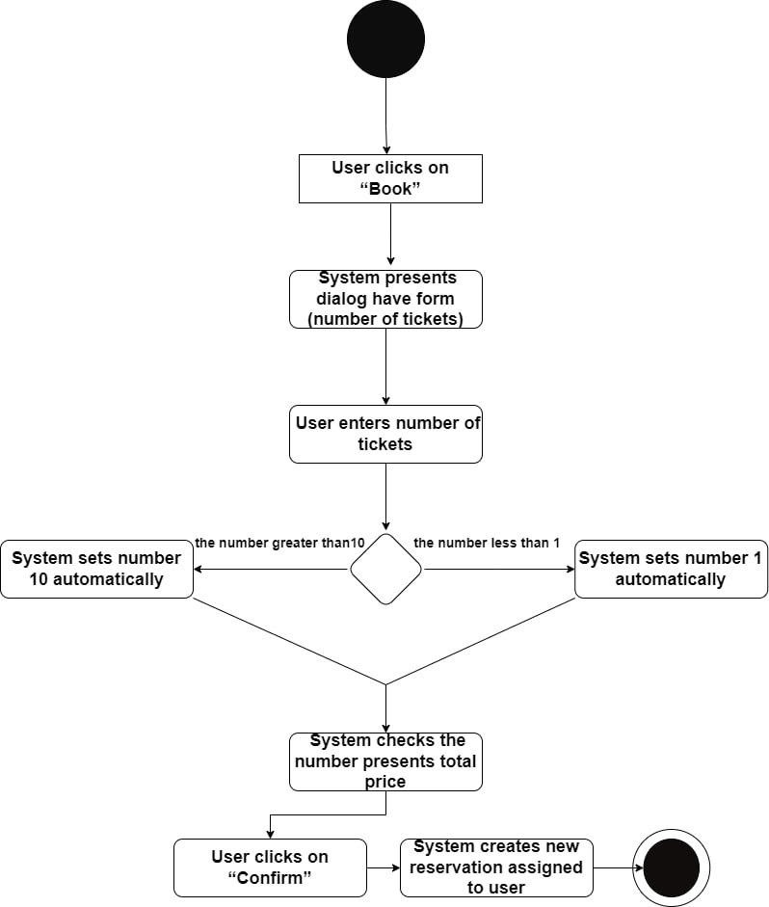
Activity diagram(Book Trip) – Figure 22

Sequence diagram(Book trip) – Figure 23
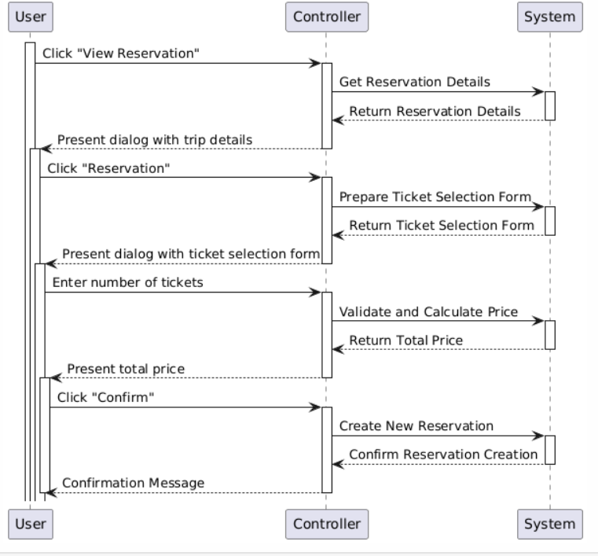

Use Case ID | UC-13
Use Case | Update Reservation
Actor | User
Pre-Condition | Already logged in, and in view reservations page
Main Scenario | - User clicks on “Update” in any reservation  - System present dialog with old number of tickets  - User change the number of tickets with previous conditions then clicks on “Save”  - System checks the reservation status is “Pending”  - System updates number of tickets
Alternative Scenario | In step 4 if the status is not “Pending” the system return error message and the user must contact the admins to update reservation
5.1.11 Update Reservation

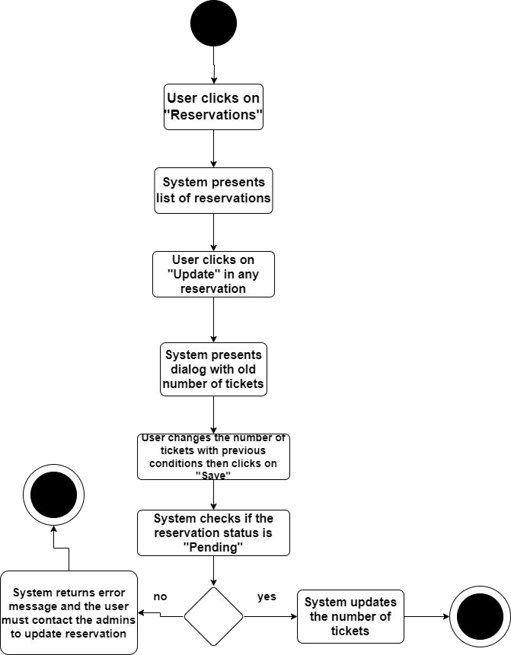

Activity diagram(Update Reservation) – Figure 24

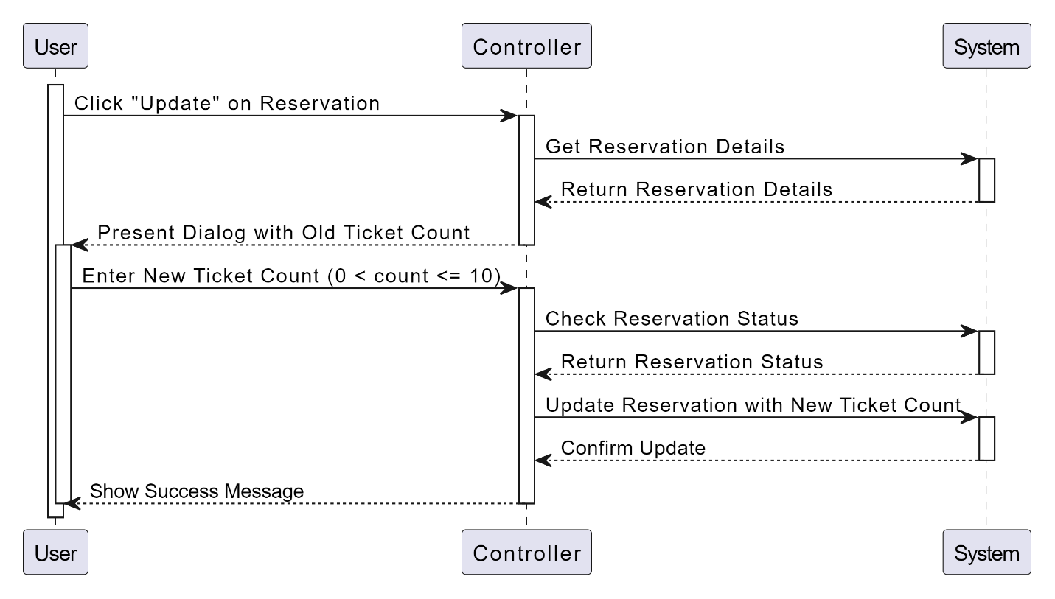

Sequence diagram(Update Reservation) – Figure 25

Use Case ID | UC-14
Use Case | Cancel Reservation
Actor | User
Pre-Condition | Already logged in, and in view reservations page
Main Scenario | - User clicks on “Cancel” in any reservation  - System present dialog with field reason  - User enter the reason of canceling  - System checks the reservation status is “Pending”  - System marks the reservation as canceled
Alternative Scenario | In step 4 if the status is not “Pending” the system return error message and the user must contact the admins to cancel reservation
5.1.12 Cancel Reservation

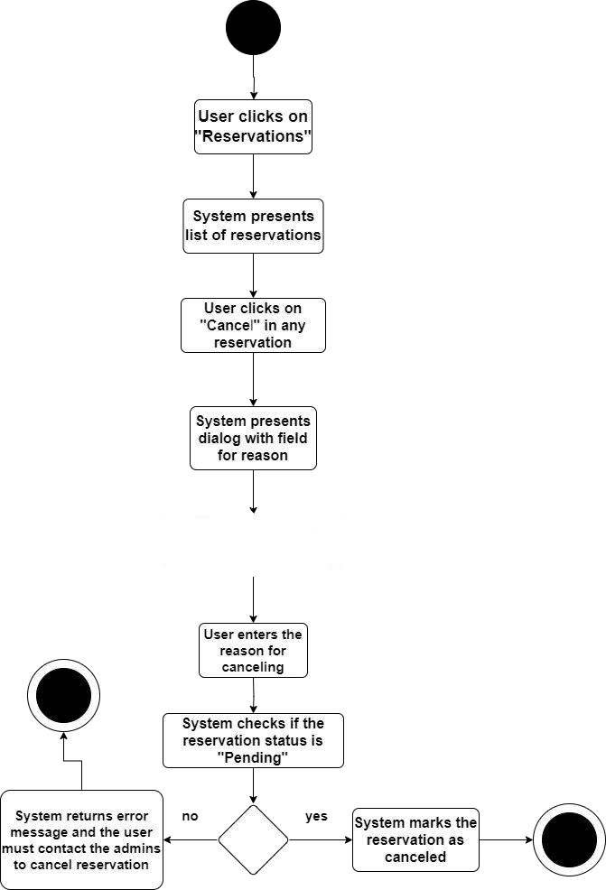
Activity diagram(Cancel Reservation) – Figure 26

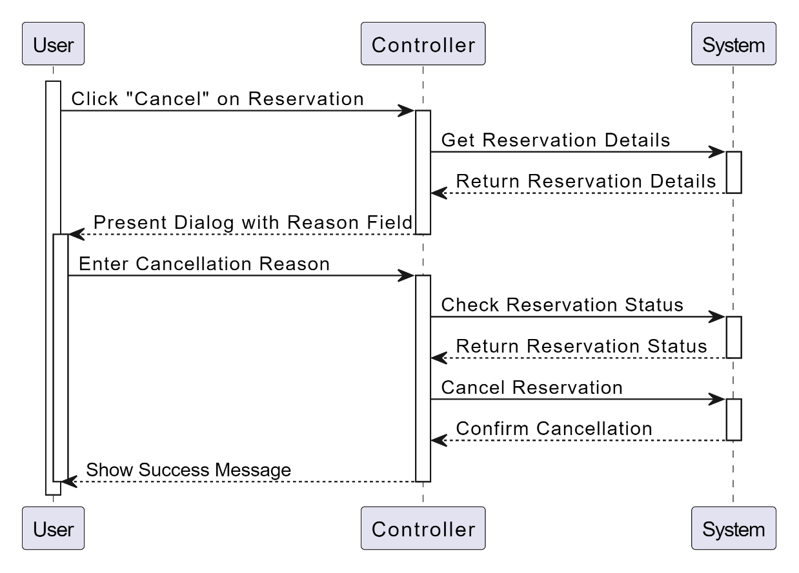

Sequence diagram(Cancel Reservation) – Figure 27

Use Case ID | UC-15
Use Case | Manage Trips
Actor | Admin
Pre-Condition | Already logged in
Main Scenario | - User clicks on “Trips”  - System Presents table with current tips (name, price, photo, start date, end date)  - System provides admin capability to show info, add, update and delete trips
Alternative Scenario
5.1.13 Manage trips
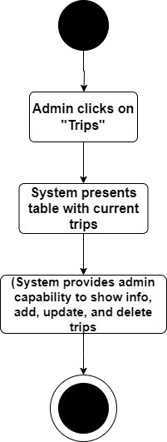
Activity diagram(Manage trips) – Figure 28
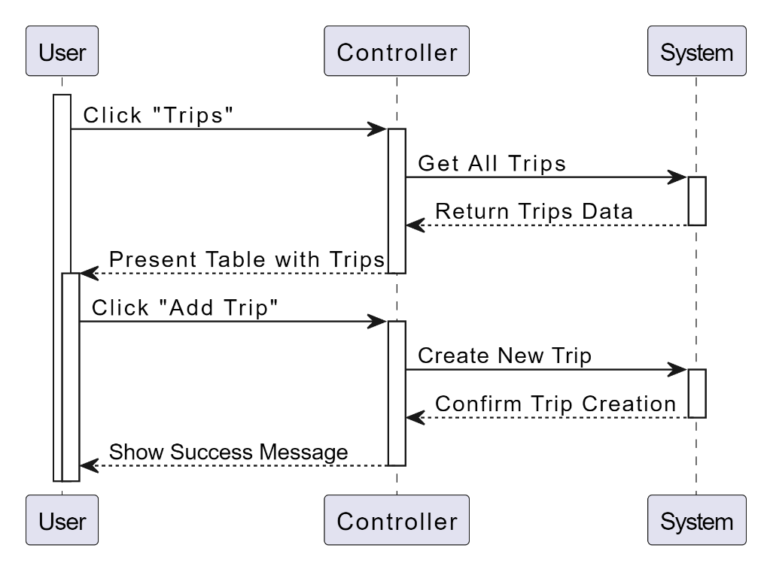

Sequence diagram(Manage trips) – Figure 29

Use Case ID | UC-16
Use Case | Add Trip
Actor | Admin
Pre-Condition | Already logged in, and in manage trips page
Main Scenario | - User clicks on “Add”  - System Presents from with (name, price, photo, start date, end date, description, is active, list of selected hotels (add 1 or more hotel in this trip by select any hotel stored in the system before), list of nights (add 1 or more nights by set number of nights and select any city stored in the system before)  - User enter needed data then clicks on “Create”  - System checks if the number on nights is correct by comparing it with period between start and end date  - System creates new trip in the system
Alternative Scenario | In step 4 if the number of nights is not correct the system returns error message and redirect user to add trip page to correct data
5.1.13 Add Trip

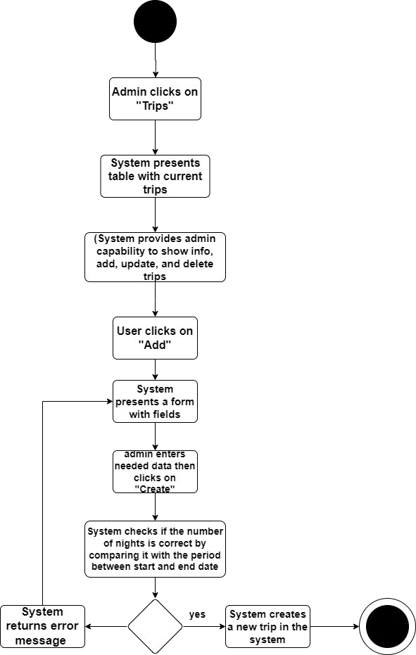
Activity diagram(Add Trip) – Figure 30

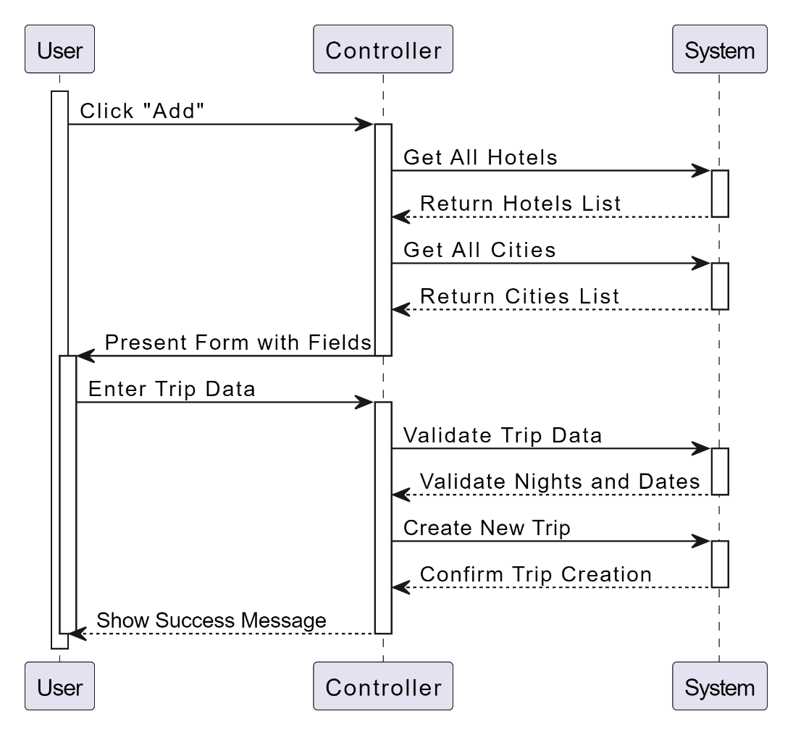
Sequence diagram(Add Trip) – Figure 31

5.1.14 Update Trip

Use Case ID | UC-17
Use Case | Update Trip
Actor | Admin
Pre-Condition | Already logged in, and in manage trips page
Main Scenario | - User clicks on “Edit” in any trip  - System checks if the trip does not end (start date before today)  - System Presents from with data of trip (presented before in add)  - User change needed data then clicks on  “Update”  - System checks if the number on nights is correct by comparing it with period between start and end date  - System checks if the important data (start date, end date, price) is updated and any user have been reserved this trip the system shall notify the users  - System update trip in the system
Alternative Scenario | In step 2 if the trip ends the update button is not active

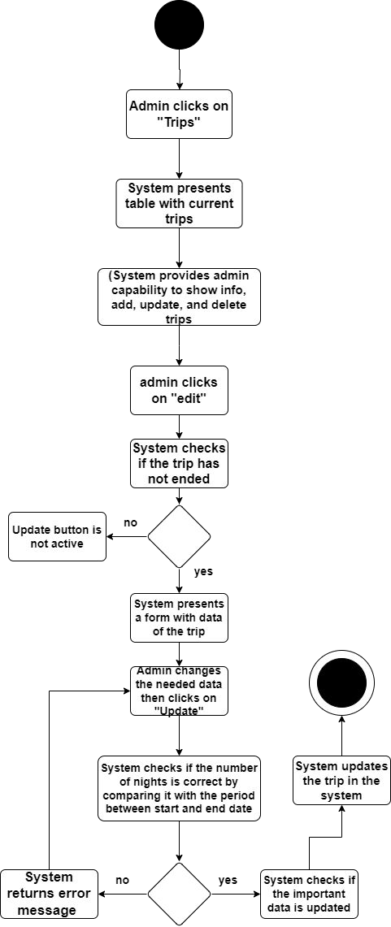
Activity diagram(Update Trip) – Figure 32

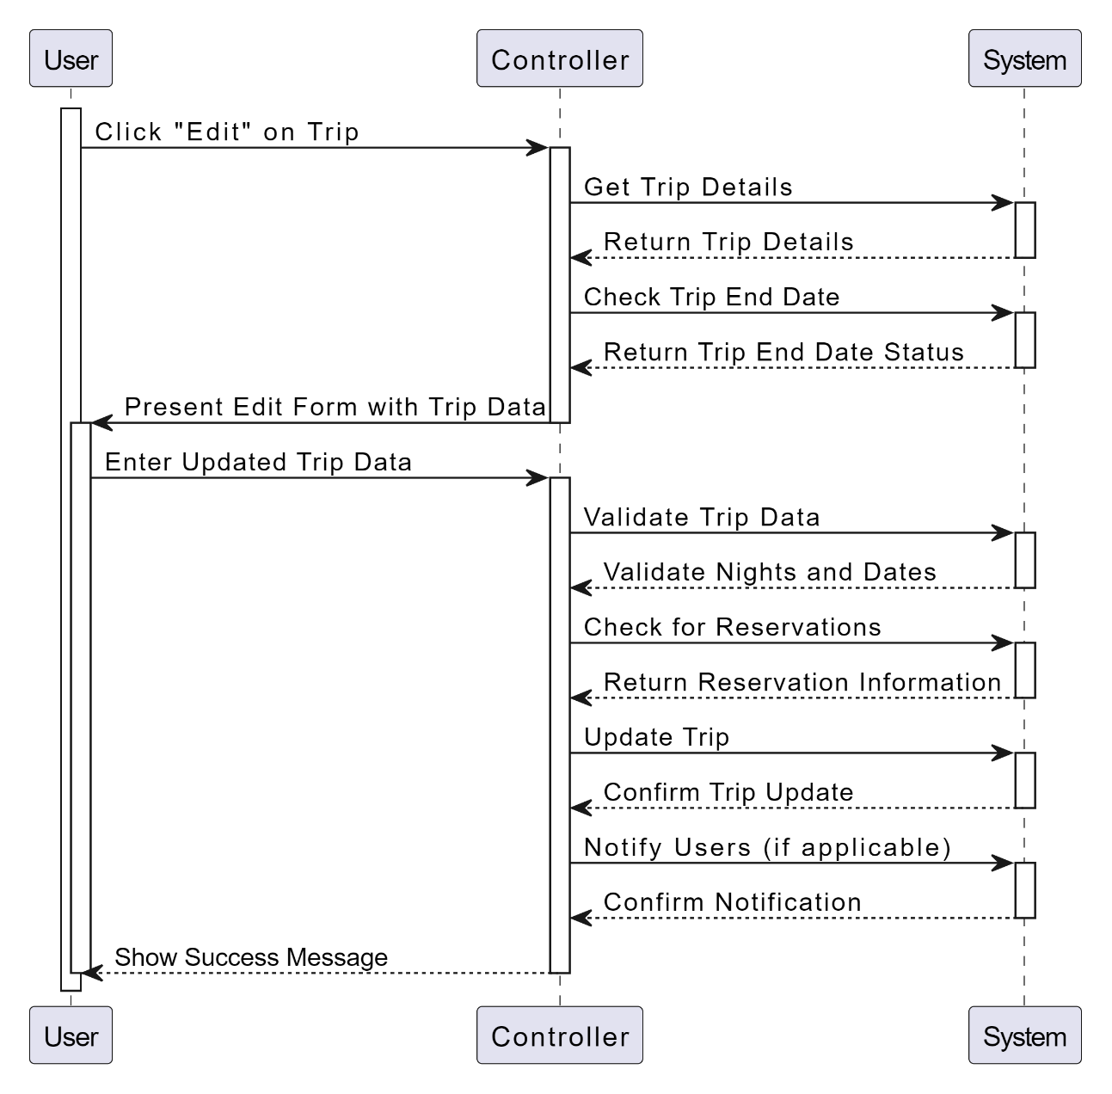

Sequence diagram(Update Trip) – Figure 33

Use Case ID | UC-18
Use Case | Delete Trip
Actor | Admin
Pre-Condition | Already logged in, and in manage trips page
Main Scenario | - User clicks on “Delete” in any trip  - System checks if the trip does not end (start date before today)  - System ask user to delete (confirm)  - User confirm delete  - System delete trip
Alternative Scenario | In step 2 if the trip ends the update button is not active
5.1.15 Delete Trip

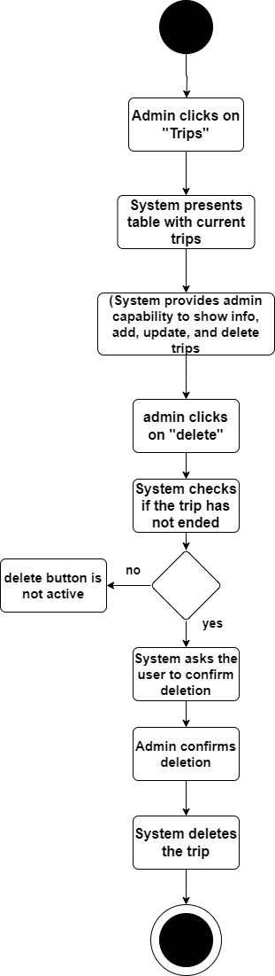
Activity diagram(Delete Trip) – Figure 34

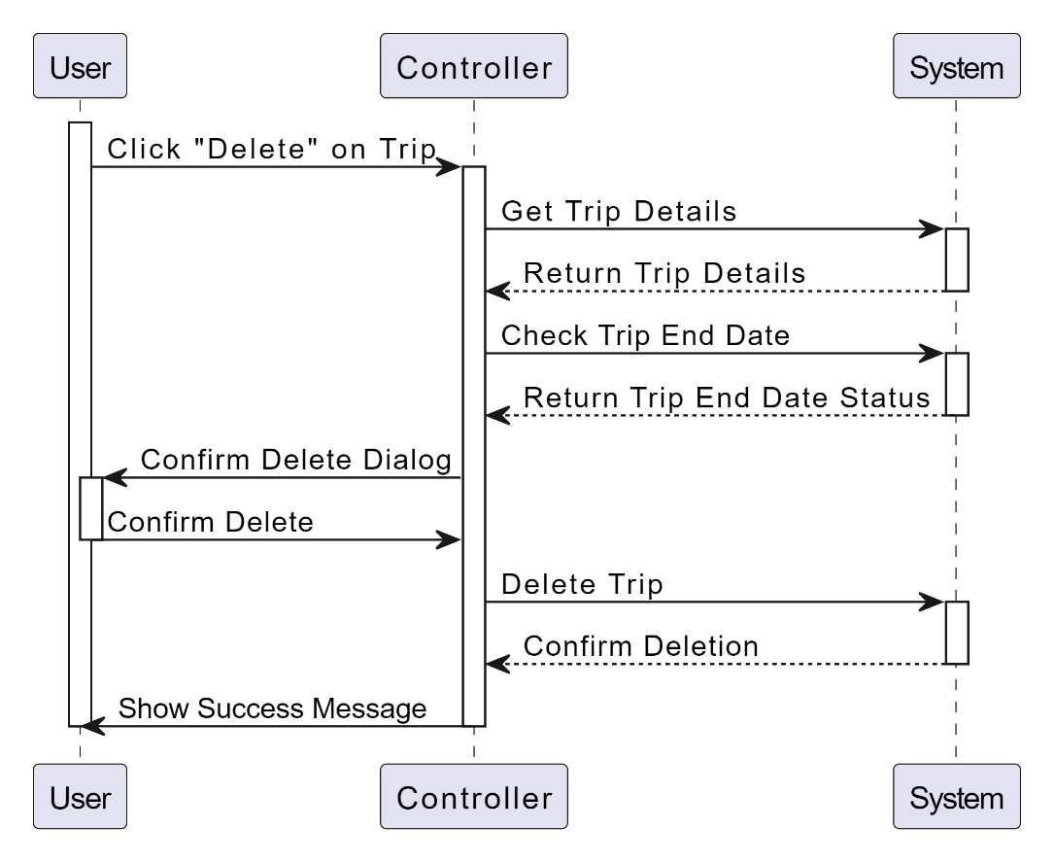

Sequence diagram(Delete Trip) – Figure 35

Use Case ID | UC-19
Use Case | View Trip
Actor | Admin
Pre-Condition | Already logged in, and in manage trips page
Main Scenario | - User clicks on “Show” in any trip  - System presents more data about trip (name, price, photo, start date, end date, is active, list of nights (e.g. 3 nights in Makkah), description, list of hotels info (name, location (as map), room description, photos), list of reservations (name of user, email, number of tickets, total price))
Alternative Scenario | -
5.1.16 View Trip

Activity diagram(View Trip) – Figure 35

Sequence diagram(View Trip) – Figure 36

Use Case ID | UC-20
Use Case | Manage Cities
Actor | Admin
Pre-Condition | Already logged in
Main Scenario | - User clicks on “Cities”  - System Presents table with current trips  - System provides admin capability to show info, add, update and delete cities
Alternative Scenario | -
5.1.17 Manage Cities

Activity diagram(Manage Cities) – Figure 37

Sequence diagram(Manage Cities) – Figure 38

Use Case ID | UC-21
Use Case | Add City
Actor | Admin
Pre-Condition | Already logged in, User in Manage Cities page
Main Scenario | - User clicks on “Add”  - System Presents table form with name field  - User enter name then clicks on “Create”  - System checks if name is used before  - System creates new city
Alternative Scenario | In step 4 if the name is not unique system return error message and redirect user to form again
5.1.18 Add City

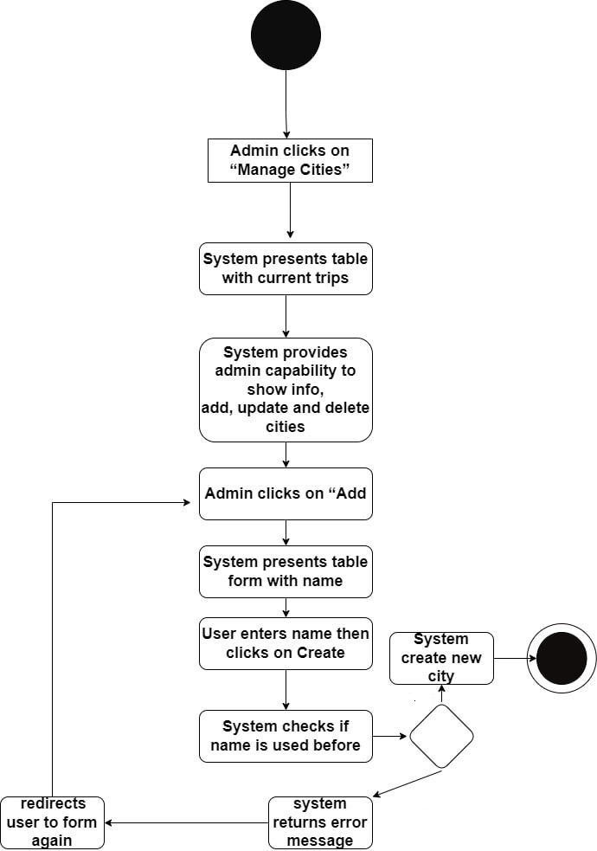
no
yes

Activity diagram(Add City) – Figure 39

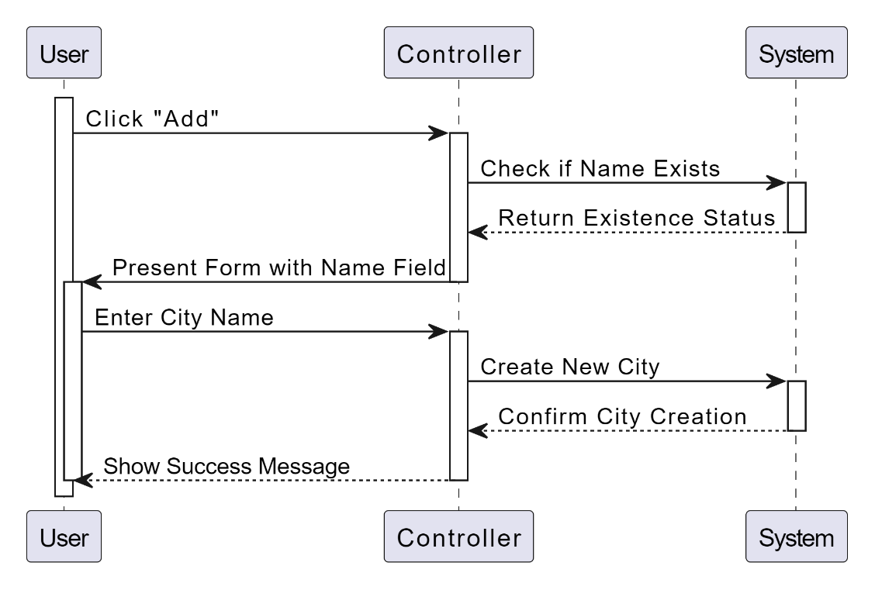

Sequence diagram(Add City) – Figure 40

5.1.19 Update City

Use Case ID | UC-22
Use Case | Update City
Actor | Admin
Pre-Condition | Already logged in, User in Manage Cities page
Main Scenario | - User clicks on “Edit” in any city  - System presents form with old name  - User change name then clicks on “Save”  - System checks if name is used before  - System update city name
Alternative Scenario | In step 4 if the name is not unique system return error message and redirect user to form again

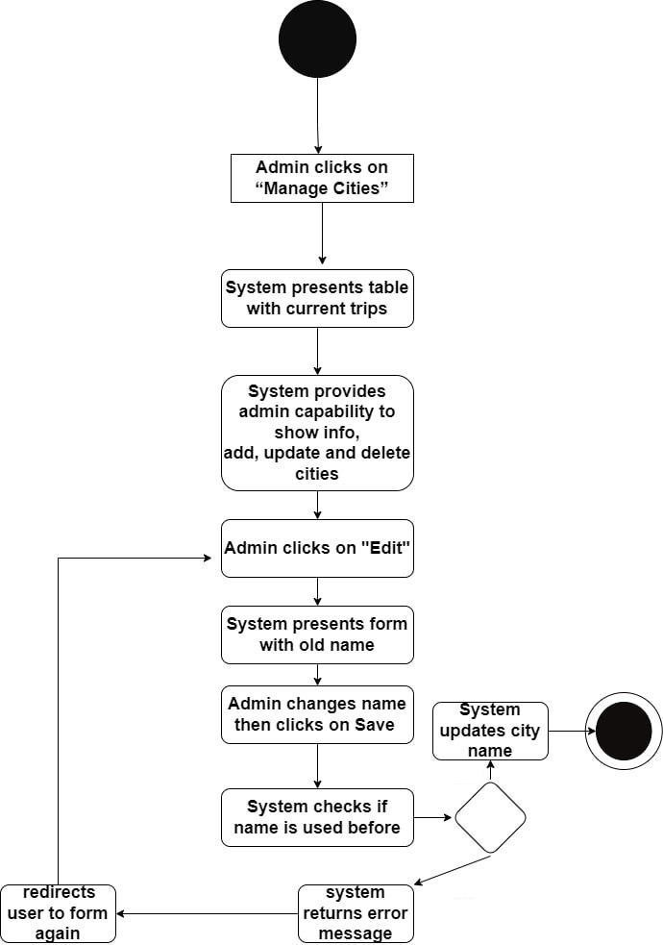
no
yes
Activity diagram(Update City) – Figure 41

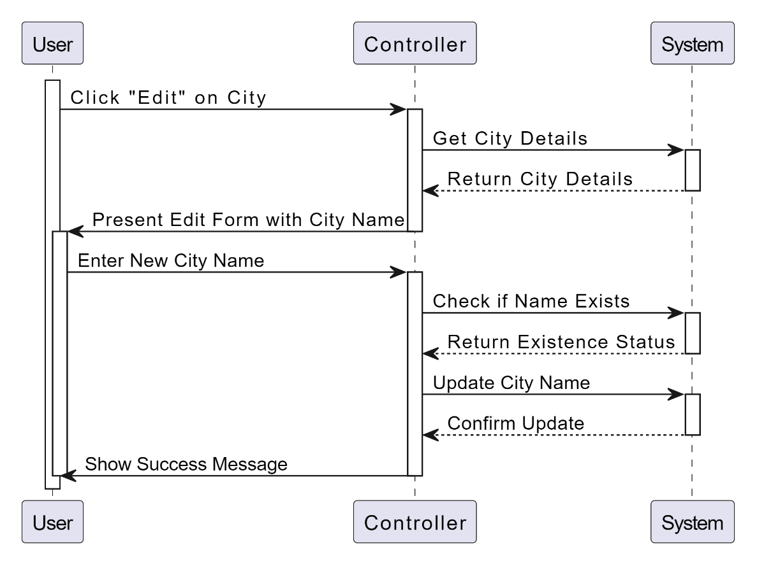

Sequence diagram(Update City) – Figure 42

Use Case ID | UC-23
Use Case | Delete City
Actor | Admin
Pre-Condition | Already logged in, User in Manage Cities page
Main Scenario | - User clicks on “Delete” in any city  - System checks if the city does not use in not started trips  - System ask user to delete (confirm)  - User confirm delete  - System deletes city (soft delete)
Alternative Scenario | In step 2 if the city used in trips not started yet, system return error message
5.1.20 Delete City

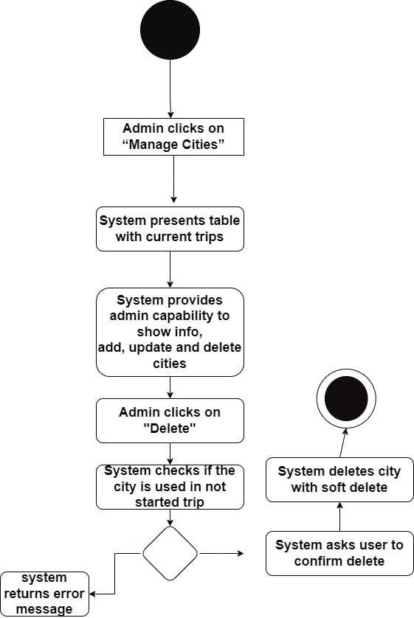
no
yes
not

Activity diagram(Delete City) – Figure 43

5.1.21 Manage Hotels
Use Case ID | UC-24
Use Case | Manage Hotels
Actor | Admin
Pre-Condition | Already logged in
Main Scenario | - User clicks on “Hotel”  - System Presents table with current hotels (name, location (as map), room description, photos)  - System provides admin capability to show info, add, update and delete hotels
Alternative Scenario | -

Activity diagram(Manage Hotels) – Figure 44

Sequence diagram(Manage Hotels) – Figure 45

Use Case ID | UC-25
Use Case | Add Hotel
Actor | Admin
Pre-Condition | Already logged in, User in Manage Hotels page
Main Scenario | - User clicks on “Add”  - System presents form with (name, location (as map), room description, photos)  - User enter date then clicks on “Create”  - System checks if name is used before  - System creates new hotel
Alternative Scenario | In step 4 if the name is not unique system return error message and redirect user to form again
5.1.22 Add Hotels

