

Department of Electrical & Computer Engineering

ENCS4380 - INTERFACING TECHNIQUES

Homework 2

Arduino UNO inputs/outputs basic operations

Prepared by:

Loor Sawalhi – 1190075

Ahmad Abbas – 1190245

Aseel Sabri – 1190114

Kareem Afaneh –1190359

Instructor: Wasel Ghanem

Section 1

21, Dec 2022

# **Idea behind the design:**

First, we built the BCD Decoder circuit using Tinkercad in order to simulate and test before implementing it using hardware components. We developed a code that receives three inputs through push buttons, these inputs represent the 3-bit binary number decoded by our circuit. Since it is a 3-bit input, the output will be produced through 8 (23) pins as signals that lighten up 8 LEDs. The circuit acts like an active high decoder, with active low enable signal.

In Tinkercad the following components were used:

1. 8 LEDs
2. 4 push buttons
3. 12 1kΩ resisters
4. Arduino UNO
5. Breadboard
6. Some wires

After that, the code was developed using C++, and simulated on the virtual circuit to make sure it is logically correct. The final circuit was as shown in the following figure:

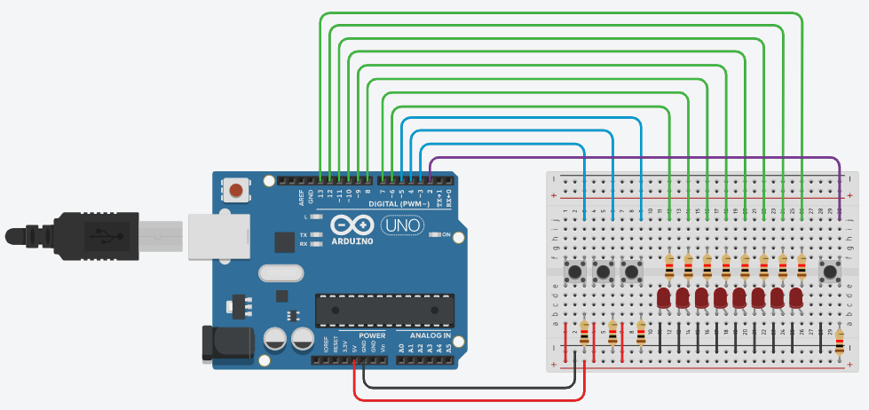

Figure 1: Tinkercad Circuit

The code is attached in *Appendix A**.*

Then, we started to connect the hardware circuit as designed virtually using the same mentioned components, expect that the resisters used were 220Ω instead of 1kΩ, because there were no 1kΩ ones in the lab. The code was downloaded on the Arduino chip using Arduino IDE.

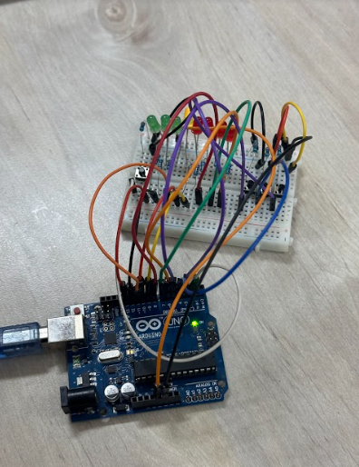

Figure 2: Connected 3-8 BCD decoder in hardware

# **Problems faced:**

During the hardware part, we suffered from unexpected outputs, due to some problems in the hardware components. The first problem was caused by having a defected pin in the Arduino we used. The second was caused by having a damaged LED and wire that we needed to change to get a correct output for the BCD decoder.

Also, while we were connecting the circuit, we have noticed the floating pins problem, which happened when the pull-down circuit for some buttons was disconnected.

# **Links:**

The following link shows a drive that contains videos and photos of our circuit:

<https://drive.google.com/drive/folders/1T6s32LDOR2-pcMmciR9KrU4B-TzRTzcU?fbclid=IwAR3RUe5sbJccyd58aGAJpVBknHQl75PsGRZdz-WEFHX3l5YTTiURaJnEiog>

And the following link shows the simulated circuit using Tinkercad

<https://www.tinkercad.com/things/aAnAImqAW7b?sharecode=-e-eC6zyPdmDCimWQWHi5YKwlSiMIQg5ntsnVdydmzo>

# **Appendices:**

## Appendix A:

#define b0 5

#define b1 4

#define b2 3

int en=1;

int dec;

void setup(){

for(int i = 6; i <= 13; i++){

pinMode(i, OUTPUT);

}

for(int i=3; i<=5; i++){

pinMode(i, INPUT);

}

attachInterrupt(0,enable,CHANGE);

}

void enable(){

en = digitalRead(2);

}

void loop(){

if(!en){

int prevDec = dec;

dec = digitalRead(b2) << 2;

dec += digitalRead(b1) << 1;

dec += digitalRead(b0);

digitalWrite(prevDec + 6, LOW);

digitalWrite(dec + 6, HIGH);

}

delay(500); // Wait for 500 millisecond(s)

}