SAAS-based Smart Academy Management System
Software Requirements Specification

Version 1.0
Group Id: F24PR7BB92
Supervisor Name :Muhammad Umair Mujahid

Revision History
Date (dd/mm/yyyy) | Version | Description | Author
21/11/2024 | 1.0 | Introduction of the project | BC190406304
SRS Document

Scope of Project:
The Smart Academy Management System (SAMS) is a unified platform designed to enhance the efficiency and effectiveness of educational institutions by integrating administrative, academic, and student-focused operations. This system provides tailored modules for administrators, teachers, and students, ensuring that each user group has access to features aligned with their roles and responsibilities.
For administrators, the AMS simplifies core operations such as student enrollment, fee management, timetable creation, and infrastructure oversight. It streamlines workflows, automates routine tasks,and offers powerful tools like role-based access control, financial management, and comprehensive reporting, enabling informed decision-making.
Teachers benefit from features designed to support academic delivery and performance monitoring. The system allows them to manage attendance, upload course materials, assign and evaluate assignments, track student progress, and communicate effectively with both students and parents.
Students are empowered with easy access to essential resources, such as class schedules, learning materials, assignment submissions, and progress tracking. The system also facilitates seamless communication with teachers and administration, making the academic experience more interactive and engaging.
Note: Due to time limitation, we have scoped the project to only limited modules. Student, teacher and parent modules will be developed in future.

Functional and non Functional Requirements:
Functional Requirements:
Here is the list of functional modules which have to develop using state of the art software development tools and technologies.
Admin Dashboard Modules

Admission Management
Admission Status: View and update the status of student admissions.
Application Forms: Submit and manage student application forms.

Administration Management
Events & Notices: Create and manage events, notices, and announcements.
Infrastructure: Manage the physical and technological infrastructure.
Roles & Permissions: Define and manage user roles and access permissions.
Staff Management: Manage staff data, schedules, and activities.

Timetable Management
Class Schedules: Create, modify, and view class schedules.
Exam Timetable: Set up and publish exam timetables.
Faculty Allocation: Assign faculty members to specific classes.
Room Allocation: Allocate rooms for classes and events.
Special Events: Schedule and manage special academic or extracurricular events.

Student Management
Disciplinary Actions: Manage and record disciplinary actions for students.
Parent Communication: Facilitate communication with parents.
Performance Tracking: Track student performance in academics and extracurricular.
Profiles: Manage student profile data.

Finance Management
Budgeting: Plan and monitor the institution’s budget.
Expense Tracking: Track expenses for various operations.
Fee Management: Oversee fee payments and records.
Financial Reports: Generate reports on financial performance.

Payroll Management
Employee Benefits: Manage employee benefits and perks.
Salary Processing: Process employee salaries.
Salary Slips: Generate and distribute salary slips.
Taxation: Handle taxation and compliance for payroll.

Exam Management
Exam Schedule: Publish and manage exam schedules.
Question Papers: Upload and manage exam question papers.
Reevaluation: Facilitate reevaluation requests for exam results.
Results: Publish exam results.

Attendance Management
Attendance Reports: Generate and view attendance reports.
Holiday Calendar: Maintain and display the holiday calendar.
Leave Requests: Process leave requests for students and staff.
Staff Attendance: Monitor staff attendance.
Student Attendance: Monitor and record student attendance.

HR Management
Employee Records: Manage and store employee records.
Leave Management: Process employee leave requests.
Payroll: Handle employee payroll and salary distribution.
Recruitment: Manage recruitment processes for hiring new staff.

Multi-Campus Management
Campus Management: Manage multiple campuses under a single system.
Campus Reports: Generate and view reports for each campus.
Inter-Campus Transfers: Handle inter-campus student or staff transfers.
Resource Allocation: Allocate resources across different campuses.

Classroom Management

Class Schedules: View and manage assigned class schedules.
Attendance Management: Mark and review student attendance.
Lesson Planning: Create and update lesson plans for classes.

Exam Management

Exam Papers: Create and upload question papers for exams.
Exam Grading: Evaluate student exams and enter grades.
Exam Timetable: Review the published exam timetable for classes.

Assignment Management (Optional)

Create Assignments: Develop and assign coursework to students.
Evaluate Submissions: Review and grade student submissions.
Feedback: Provide personalized feedback to students.

Performance Tracking (Optional)

Student Performance: Monitor academic performance and progress for individual students.
Class Reports: Generate reports summarizing class performance.

Communication (Optional)
Parent Communication: Send and receive messages or updates to/from parents.
Admin Notifications: Stay updated with admin announcements, events, or notices.

Resource Management (Optional)

Course Materials: Upload and organize course content, such as presentations, notes, and other resources.
Resource Requests: Request additional resources or tools needed for teaching.

Academic Progress (Optional)

View Grades: Access grades for assignments, exams, and overall performance.
Performance Reports: Review personal academic performance reports.

Attendance Tracking (Optional)

Attendance Overview: View attendance records and identify absences.
Leave Requests: Submit leave requests to teachers or admins.

Learning Resources (Optional)

Course Materials: Access uploaded study materials, notes, and presentations.
Online Classes: Join and manage online classes scheduled by teachers.

Extra-Curricular (Optional)

Special Events: Register and participate in academic or extracurricular events.
Activity Calendar: View the calendar for upcoming events and deadlines.

Certificates (Optional)

Request Certificates: Apply for academic or extracurricular certificates.
Download Digital Certifications: Access digitally issued certificates

Learning Management (Optional)
Assignments: Assign and manage assignments for students.
Course Materials: Upload and organize course materials for students.
Grading: Manage the grading process for assignments and exams.
Online Classes: Schedule and conduct online classes.

Certifications Management (Optional)
Certificate Requests: Process requests for certificates.
Digital Certifications: Issue and manage digital certifications.
Issuing Certificates: Handle the issuance of physical or digital certificates.
Verification: Verify the authenticity of certificates.

Non-Functional Requirements
Performance Requirements:
The system should handle 500 concurrent users without lag.
All operations must complete within 7 seconds.
Security Requirements:
Role-based access control for different users.
Data encryption for sensitive information.
Scalability Requirements:
The system should scale to accommodate new campuses or additional users.
Availability:
The system must provide 99.9% uptime.
Usability:
The UI must be intuitive and follow WCAG accessibility guidelines.
Reliability:
Minimal downtime to ensure availability during critical periods like exams or grade submission deadlines.
Responsiveness:
Optimized for use across multiple devices, including desktops, tablets, and mobile phones
Use Case Diagram(s):
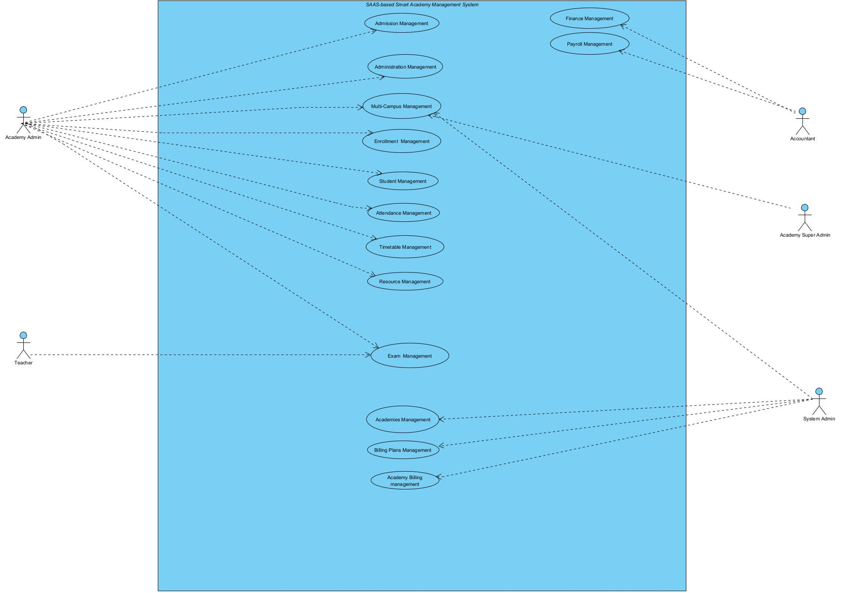

Usage Scenarios:
Admission Management
Use Case Title | Use Case ID | Actions | Description | Alternative Paths | Pre-Conditions | Post-Conditions | Exceptions
Admission Status | UC_ADM_01 | 1. View admission statuses  2. Update admission details | Admin reviews and updates the admission status of applicants. | Status reports can be exported for external use. | Admin must have appropriate permissions. | Status is successfully updated. | Errors in retrieving or updating status due to missing data.
Application Forms | UC_ADM_02 | 1. Submit application  2. Edit submitted applications | Only Admin will update their application forms. | Incomplete applications can be flagged. | Application submission portal must be active. | Applications are successfully stored in the system. | System crashes or data is lost during submission.
Admission Fee Submission | UC_ADM_03 | 1. Accept payment  2. Record transaction  3. Issue receipts | Admin handles the submission and tracking of admission fees. | Payments will be made offline and entered manually. | Payment gateway or offline payment details must be available. | Fee is recorded, and confirmation is sent to the student. | Payment failure or mismatched amounts in the transaction.

Administration Management
Use Case Title | Use Case ID | Actions | Description | Alternative Paths | Pre-Conditions | Post-Conditions | Exceptions
Events & Notices | UC_ADMIN_01 | 1. Create events  2. Publish notices | Admin creates, edits, and shares important events and notices. | Event cancellation or notice modification can occur. | Admin has access to the events module. | Events and notices are visible to stakeholders. | Stakeholders are not notified due to communication failure.
Roles & Permissions | UC_ADMIN_02 | 1. Assign roles  2. Update permissions | Super Admin defines roles and sets permissions for users. | Permissions can be assigned dynamically. | Access control module must be functional. | Roles and permissions are successfully assigned. | Unauthorized changes to permissions or conflicting role definitions.
Staff Management | UC_ADMIN_03 | 1. Add staff details  2. Schedule activities  3. Assign roles | Admin manages staff profiles, schedules, and activities. | Staff may request modifications to schedules. | Staff records are up-to-date in the system. | Staff profiles and schedules are updated correctly. | Errors in assigning roles or incorrect scheduling due to missing data.

Timetable Management
Use Case Title | Use Case ID | Actions | Description | Alternative Paths | Pre-Conditions | Post-Conditions | Exceptions
Class Schedules | UC_TIME_01 | 1. Create schedules  2. Assign classes  3. Publish schedules | Admin creates and publishes schedules for all classes. | Room conflicts can prompt rescheduling. | Faculty and room data must be available. | Schedules are visible to students and staff. | Schedule conflicts due to double-booked resources.
Exam Timetable | UC_TIME_02 | 1. Set exam dates  2. Assign venues  3. Publish timetable | Admin sets up and shares exam timetables with students and faculty. | Changes can be made for unexpected conflicts. | Exam and venue data are finalized. | Timetables are successfully communicated to users. | System downtime causes delays in timetable publishing.

Student Management
Use Case Title | Use Case ID | Actions | Description | Alternative Paths | Pre-Conditions | Post-Conditions | Exceptions
Attendance Monitoring | UC_STU_01 | 1. Mark attendance  2. View attendance records | Teachers and admins track student attendance. | Attendance can be exported for reports. | Attendance tracking module must be accessible. | Attendance data is accurately recorded. | Errors in marking attendance or system crashes.
Performance Tracking | UC_STU_02 | 1. Record performance  2. Generate reports | Admins and teachers track and report on student academic performance. | Performance can be viewed by individuals or class. | Grading and attendance data must be complete. | Performance reports are generated. | Incorrect grading data causes inaccurate reports.

Finance Management
Use Case Title | Use Case ID | Actions | Description | Alternative Paths | Pre-Conditions | Post-Conditions | Exceptions
Fee Management | UC_FIN_01 | 1. Process payments  2. Generate fee receipts | Admin oversees and manages fee submissions and records. | Fee reports can be generated for admin use. | Fee structures and student details must be updated. | Payments are accurately recorded. | Payment gateway failures or data mismatches cause errors.
Financial Reporting | UC_FIN_02 | 1. Generate reports  2. Monitor expenses | Admin tracks expenses and generates detailed financial reports. | Reports can be filtered by date or department. | Expense and revenue data must be complete. | Reports are successfully generated. | Missing data results in incomplete reports.

Learning Management (optional)
Use Case Title | Use Case ID | Actions | Description | Alternative Paths | Pre-Conditions | Post-Conditions | Exceptions
Assignments | UC_LM_01 | 1. Create assignments  2. Distribute assignments  3. Track submissions | Admin creates and manages assignments for students. | Teachers can edit assignments before deadlines. | Assignment module must be active and accessible. | Assignments are distributed successfully. | Assignment distribution fails due to server downtime.
Course Materials | UC_LM_02 | 1. Upload materials  2. Organize by course  3. Share materials | Admin uploads and organizes course-related documents and media. | Students and teachers can download materials in bulk. | File storage and directory structure must be intact. | Materials are accessible to authorized users. | File upload fails due to storage issues or large file sizes.
Online Classes | UC_LM_03 | 1. Schedule sessions  2. Notify participants  3. Conduct sessions | Admin schedules and manages online class sessions. | Notifications can be sent via SMS or email. | Video conferencing integration must be configured. | Classes are successfully conducted. | Session fails due to integration issues with video conferencing tools.

Exam Management
Use Case Title | Use Case ID | Actions | Description | Alternative Paths | Pre-Conditions | Post-Conditions | Exceptions
Exam Schedule | UC_EXAM_01 | 1. Set up exam dates  2. Assign venues  3. Notify students and faculty | Admin creates, updates, and publishes exam timetables. | Rescheduling can occur in case of conflicts. | Exam module must have access to faculty and venue data. | Exam schedule is visible to all stakeholders. | Scheduling conflicts or missing venue details disrupt the process.
Question Papers | UC_EXAM_02 | 1. Upload questions  2. Secure papers  3. Distribute papers | Admin uploads, secures, and distributes exam question papers. | Papers can be shared with specific teachers for review. | Secure file storage system must be available. | Papers are securely stored and accessed. | Unauthorized access compromises security.
Results | UC_EXAM_03 | 1. Publish results  2. Notify students  3. Allow reevaluation requests | Admin releases exam results and manages reevaluation requests. | Results can also be published as downloadable PDFs. | Grading data must be complete and verified. | Results are successfully published. | Errors in grading data cause delays in publishing results.

Attendance Management
Use Case Title | Use Case ID | Actions | Description | Alternative Paths | Pre-Conditions | Post-Conditions | Exceptions
Attendance Reports | UC_ATT_01 | 1. Generate reports  2. View summary by student or staff | Admin creates and views attendance reports for students and staff. | Reports can be exported as CSV files. | Attendance data must be accurate and up-to-date. | Reports are successfully generated. | Errors in retrieving attendance data affect report generation.
Holiday Calendar | UC_ATT_02 | 1. Add holidays  2. Publish calendar | Admin maintains and shares a calendar of holidays and vacations. | Calendar updates are shared via notifications. | Calendar module must be integrated with other scheduling modules. | Holidays are visible to all users. | Calendar fails to update due to module synchronization issues.

Certifications Management (optional)
Use Case Title | Use Case ID | Actions | Description | Alternative Paths | Pre-Conditions | Post-Conditions | Exceptions
Certificate Requests | UC_CERT_01 | 1. Receive requests  2. Verify eligibility  3. Approve or reject | Admin processes requests for certificates submitted by students or staff. | Requests can be flagged for missing details. | Certificate modules must have eligibility criteria. | Requests are processed successfully. | Missing information leads to delays in processing.
Digital Certifications | UC_CERT_02 | 1. Issue digital certificates  2. Notify recipients | Admin generates and shares digital certificates. | Certificates can be downloaded by users. | Digital certificate templates must be uploaded. | Certificates are issued without errors. | Errors in template data or failed email notifications.

HR Management
Use Case Title | Use Case ID | Actions | Description | Alternative Paths | Pre-Conditions | Post-Conditions | Exceptions
Employee Records | UC_HR_01 | 1. Add new employee  2. Update details  3. Archive records | Admin manages and maintains employee records. | Archived records can be restored if needed. | The HR module must be active and secure. | Records are saved and updated successfully. | Inconsistent data or storage issues lead to failed updates.
Leave Management | UC_HR_02 | 1. Receive leave requests  2. Approve or reject  3. Notify employees | Admin processes leave requests from employees. | Requests can be escalated to higher authority for approval. | Leave policies and quotas must be defined. | Leaves are successfully processed. | Errors in calculating leave balances cause delays.

Multi-Campus Management
Use Case Title | Use Case ID | Actions | Description | Alternative Paths | Pre-Conditions | Post-Conditions | Exceptions
Campus Management | UC_MC_01 | 1. Add campuses  2. Manage resources | Admin adds and manages multiple campuses within the system. | Inter-campus transfers can be initiated from this module. | Each campus must have a unique identifier. | Campuses are successfully added to the system. | Duplicate campus entries or missing data disrupt management.
Resource Allocation | UC_MC_02 | 1. Allocate resources  2. Monitor usage | Admin allocates and tracks resources for different campuses. | Resources can be reassigned dynamically. | Resource pool must be defined and centralized. | Resources are utilized effectively. | Misallocated or unavailable resources cause operational delays.

Payroll Management
Use Case Title | Use Case ID | Actions | Description | Alternative Paths | Pre-Conditions | Post-Conditions | Exceptions
Salary Processing | UC_PAY_01 | 1. Calculate salaries  2. Process payments  3. Generate pay slips | Admin calculates and processes employee salaries. | Pay slips can be downloaded by employees. | Payroll module must have updated employee data. | Salaries are processed without errors. | Errors in tax calculation or missing employee data delay payments.
Taxation Compliance | UC_PAY_02 | 1. Calculate taxes  2. Generate tax reports | Admin ensures compliance with taxation rules and generates reports. | Reports can be shared with financial auditors. | Tax rules and regulations must be updated in the system. | Taxes are calculated accurately. | Outdated tax rules lead to incorrect deductions or reports.
Classroom Management (optional)
Use Case Title | Use Case ID | Actions | Description | Alternative Paths | Pre-Conditions | Post-Conditions | Exceptions
Class Schedules | UC_CM_01 | 1. View schedule  2. Update schedules  3. Notify changes | Teachers can view and manage their assigned class schedules. | Notify admin for scheduling conflicts. | Scheduling data must be accessible. | Schedules are updated and communicated successfully. | Changes fail to reflect due to system sync issues.
Attendance Management | UC_CM_02 | 1. Mark attendance  2. Edit records  3. View summaries | Teachers mark and update student attendance for their classes. | Attendance can be delegated to assistants. | Student records must be loaded for the class. | Attendance is saved successfully. | Marking attendance fails due to database connection errors.
Lesson Planning | UC_CM_03 | 1. Create plans  2. Modify plans  3. Share plans with students | Teachers design and share lesson plans for upcoming classes. | Teachers can reuse previous plans. | Lesson plan templates must be accessible. | Plans are created and shared without errors. | Plan fails to save due to format incompatibility or storage issues.

Assignment Management(optional)
Use Case Title | Use Case ID | Actions | Description | Alternative Paths | Pre-Conditions | Post-Conditions | Exceptions
Create Assignments | UC_AM_01 | 1. Design assignments  2. Assign to students  3. Notify students | Teachers create and assign coursework to students. | Assignments can be customized for specific groups. | Assignment module must be active and accessible. | Assignments are created and shared successfully. | Assignment creation fails due to missing required fields.
Evaluate Submissions | UC_AM_02 | 1. View submissions  2. Grade work  3. Provide feedback | Teachers review, grade, and give feedback on submitted assignments. | Grading rubrics can be uploaded. | Assignment submissions must be available in the system. | Grades and feedback are saved successfully. | Submissions fail to load due to corrupted files.
Feedback | UC_AM_03 | 1. Create feedback  2. Notify students | Teachers provide personalized feedback for student improvement. | Feedback can be batch-updated for similar errors. | Feedback templates must be accessible. | Feedback is communicated to students successfully. | Feedback fails to save due to server errors.

Performance Tracking (optional)
Use Case Title | Use Case ID | Actions | Description | Alternative Paths | Pre-Conditions | Post-Conditions | Exceptions
Student Performance | UC_PT_01 | 1. View student records  2. Monitor trends  3. Highlight issues | Teachers monitor individual student performance for academic and extracurricular activities. | Reports can be exported for parent-teacher meetings. | Performance data must be updated in real-time. | Insights are communicated to stakeholders successfully. | Performance tracking fails due to incomplete data records.
Class Reports | UC_PT_02 | 1. Generate reports  2. Share with admin and parents | Teachers compile and share summaries of class performance. | Customizable templates can be used. | Class data must be available and consolidated. | Reports are generated and distributed successfully. | Errors in generating reports due to system load or incomplete data.

Communication (optional)
Use Case Title | Use Case ID | Actions | Description | Alternative Paths | Pre-Conditions | Post-Conditions | Exceptions
Parent Communication | UC_COM_01 | 1. Send messages  2. Receive replies  3. Schedule meetings | Teachers send messages to parents and schedule discussions regarding student progress. | Messages can include attachments like reports. | Parent contact data must be accessible. | Messages are sent successfully. | Communication fails due to incorrect contact details.
Admin Notifications | UC_COM_02 | 1. View notices  2. Acknowledge updates | Teachers stay informed about updates and announcements from the admin. | Notifications can be scheduled for reminders. | Admin portal must be functional. | Updates are acknowledged. | Notifications fail to deliver due to system downtime.

Student Academic Progress (optional)
Use Case Title | Use Case ID | Actions | Description | Alternative Paths | Pre-Conditions | Post-Conditions | Exceptions
View Grades | UC_AP_01 | 1. Access grades  2. View breakdown  3. Save or print report | Students view their grades for assignments, exams, and overall. | Reports can be shared with parents. | Grades must be uploaded by teachers. | Grades are displayed successfully. | Grades fail to load due to database issues.
Performance Reports | UC_AP_02 | 1. Access reports  2. Track progress  3. Share with parents | Students review their academic progress via detailed reports. | Generate PDF versions for sharing. | Reports must be up-to-date. | Reports are accessed without errors. | Reports fail to load due to system lag.

Assignment Management (optional)
Use Case Title | Use Case ID | Actions | Description | Alternative Paths | Pre-Conditions | Post-Conditions | Exceptions
Submit Assignments | UC_AM_01 | 1. Upload files  2. Verify submission  3. Receive confirmation | Students upload completed assignments before deadlines. | Submit multiple files simultaneously. | Assignment portal must be functional. | Submissions are recorded successfully. | Submissions fail due to file size or format issues.
View Feedback | UC_AM_02 | 1. Access feedback  2. View grades  3. Save comments | Students access teacher feedback on submitted assignments. | Export feedback for personal records. | Feedback must be entered by teachers. | Feedback is displayed without errors. | Feedback fails to load due to missing records.

Student Attendance Tracking (optional)
Use Case Title | Use Case ID | Actions | Description | Alternative Paths | Pre-Conditions | Post-Conditions | Exceptions
Attendance Overview | UC_AT_01 | 1. View attendance records  2. Monitor absences  3. Download reports | Students track their attendance and identify any absences. | Share reports with parents. | Attendance must be updated daily. | Records are displayed accurately. | Data fails to sync or load correctly.
Leave Requests | UC_AT_02 | 1. Submit leave  2. Attach documents  3. Track request status | Students apply for leave and track the approval process. | Inform parents about pending requests. | Leave module must be active. | Leave requests are processed without errors. | Requests are delayed due to missing attachments or admin inaction.

Student Communication (optional)
Use Case Title | Use Case ID | Actions | Description | Alternative Paths | Pre-Conditions | Post-Conditions | Exceptions
Teacher Communication | UC_COM_01 | 1. Send queries  2. Receive responses  3. Attach files | Students communicate with teachers for academic queries. | Save chat history for later reference. | Teacher contact details must be accessible. | Messages are sent and acknowledged. | Messages fail to send due to incorrect teacher details.
Admin Notices | UC_COM_02 | 1. View announcements  2. Acknowledge notices  3. Download attachments | Students stay informed about events, holidays, or updates. | Filter notices by date or relevance. | Notices must be posted by the admin. | Notices are accessed without issues. | Notices fail to display due to expired posts.

Student Examinations Reports
Use Case Title | Use Case ID | Actions | Description | Alternative Paths | Pre-Conditions | Post-Conditions | Exceptions
Exam Results | UC_EX_01 | 1. Access results  2. View detailed grades  3. Print report | Students view and download their exam results. | Results can be shared with parents. | Results must be published. | Results are displayed correctly. | Results fail to load due to incomplete data.
Reevaluation Requests | UC_EX_02 | 1. Submit request  2. Attach supporting documents  3. Track status | Students request reevaluation for specific exams. | Admin can expedite urgent requests. | Reevaluation portal must be active. | Requests are processed successfully. | Requests are delayed due to system issues.

Adopted Methodology

Waterfall Model
The first published model of the software development process was derived from other engineering processes. Because of the cascade from one phase to another, this model is known as the waterfall model. This model is also known as linear sequential model. This model is depicted in the following diagram.
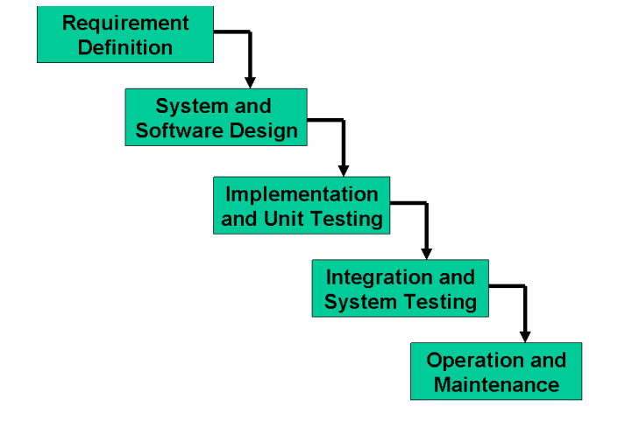
The principal stages of the model map directly onto fundamental development activities. It suggests a systematic, sequential approach to software development that begins at the system level and progresses through the analysis, design, coding, testing, and maintenance. In the literature, people have identified 5 to 8 stages of software development. The five stages above are as follows:
1. Requirement Analysis and Definition: What - The systems services, constraints and goals are established by consultation with system users. They are then defined in detail and serve as a system specification.
2. System and Software Design: How – The system design process partitions the requirements to either hardware of software systems. It establishes an overall system architecture. Software design involves fundamental system abstractions and their relationships.
3. Implementation and Unit Testing: - How – During this stage the software design is realized as a set of programs or program units. Unit testing involves verifying that each unit meets its specifications.
4. Integration and system testing: The individual program unit or programs are integrated and tested as a complete system to ensure that the software requirements have been met. After testing, the software system is delivered to the customer.
5. Operation and Maintenance: Normally this is the longest phase of the software life cycle. The system is installed and put into practical use. Maintenance involves correcting errors which were not discovered in earlier stages of the life-cycle, improving the implementation of system units and enhancing the system’s services as new requirements are discovered
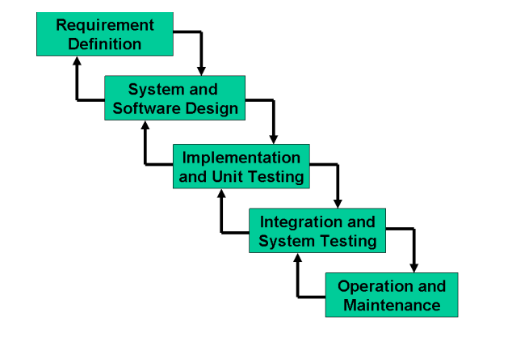
Spiral Model
This model was developed by Barry Boehm. The main idea of this model is to avert risk as there is always an element of risk in development of software. For example, key personnel may resign at a critical juncture, the manufacturer of the software development may go bankrupt, etc. In its simplified form, the Spiral Model is Waterfall model plus risk analysis. In this case each stage is preceded by identification of alternatives and risk analysis and is then followed by evaluation and planning for the next phase. If risks cannot be resolved, the project is immediately terminated. This is depicted in the following diagram.
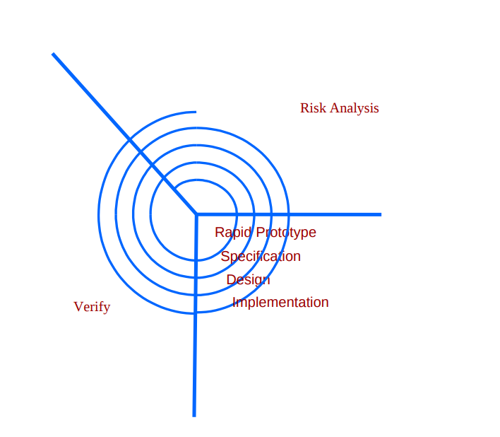
As can be seen, a Spiral Model has two dimensions. Radial dimension represents the cumulative cost to date and the angular dimension represents the progress through the spiral. Each phase begins by determining objectives of that phase and at each phase a new process model may be followed.
A full version of the Spiral Model is shown below:
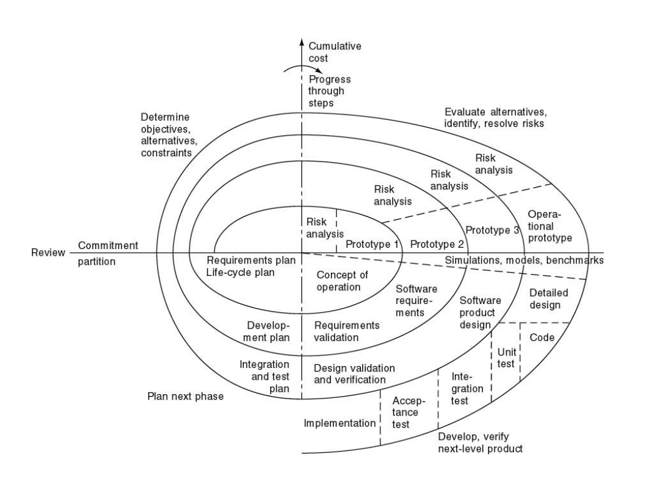
The main strength of the Spiral Model comes from the fact that it is very sensitive to risk. Because of the spiral nature of development it is easy to judge how much to test and there is no distinction between development and maintenance. It however can only be used for large-scale software development and that too for internal (in-house) software only.
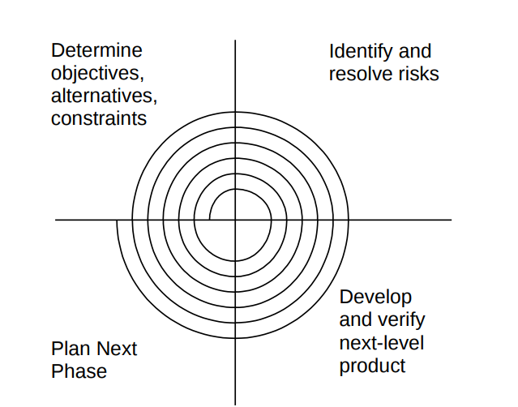
VU Process Model
The adopted methodology for this project is the VU Process Model, a hybrid approach that integrates elements of both the Waterfall Model and the Spiral Model. This combination leverages the structured planning and clear stages of the Waterfall Model while incorporating the iterative flexibility and risk management aspects of the Spiral Model. Below is a detailed explanation of the methodology:
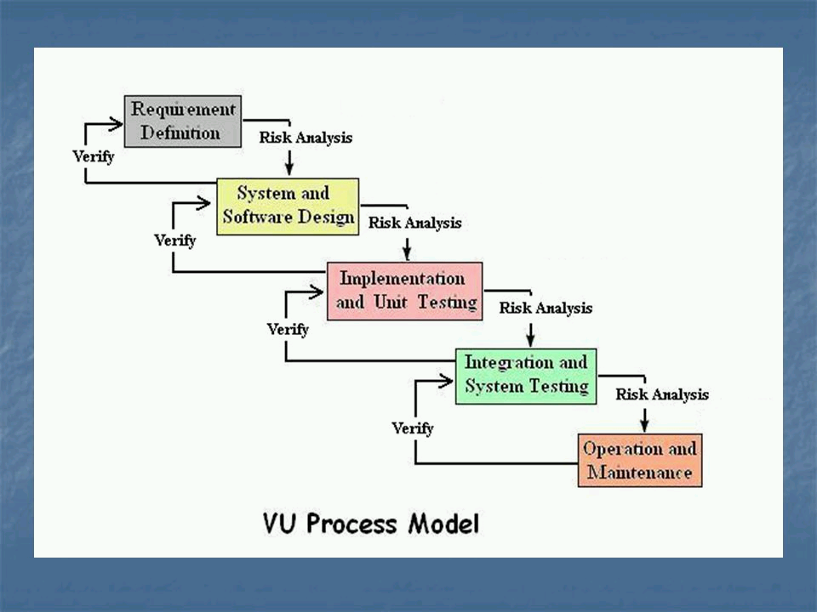

Why VU Process Model?
The VU Process Model is specifically designed to address the complexities of software projects that require both a well-defined structure and adaptability for evolving requirements. For our project, "Academy Management System," this methodology ensures:
- Structured Development: A systematic approach with clear deliverables at each stage.
- Flexibility: Allows revisiting and improving previous stages when new requirements arise.
- Risk Mitigation: Early identification and management of risks through iterative refinement.

Key Features of the VU Process Model
- Combination of Waterfall and Spiral Models:
  - The Waterfall component provides a sequential progression through phases, ensuring all requirements are addressed in a logical order.
  - The Spiral component introduces iterative cycles for refinement, enabling better risk assessment and requirement adjustments.
- Focus on Risk Management:
  - Risks are evaluated at every iteration in the spiral phase, ensuring a proactive approach to potential issues.
- Iterative Development:
  - Each spiral iteration focuses on refining a subset of features, making the project adaptive to changes.
- Structured Deliverables:
  - Deliverables are defined for each phase, ensuring transparency and accountability.

Work Plan (Use MS Project to create Schedule/Work Plan)
