نجدة · Najda
Blood Donor Matching Platform
Software Requirements Specification
Phase 1 — Project Overview · Functional & Non-Functional Requirements

Orange Coding Academy — Graduation Project
Student: Ahmad Ziad Abu Serdaneh

1. Project Overview

1.1 Project Idea
Najda (Arabic for “rescue / aid”) is a web platform that connects hospitals and blood banks that urgently need blood with the nearest compatible and available blood donors. Instead of relying on scattered phone calls and social-media appeals, Najda automates the search: a hospital posts a blood request, and the system instantly surfaces the donors whose blood type is compatible and who are closest to the hospital.

1.2 Purpose of the System
The platform aims to solve a real, time-critical problem — finding the right blood donor during an emergency — while adding a layer of trust and encouraging repeat donation.
- Reduce the time to find a suitable donor in emergencies from hours to minutes.
- Replace the chaotic, manual donor-search process with an organized, reliable system.
- Add a trust layer: a donor’s entered blood type is treated as preliminary and is confirmed (verified) by a hospital laboratory at the first real donation.
- Encourage repeat donation through eligibility reminders (the 56-day rule) and a community rewards program.
- Stay ethical: the platform is free for both donors and hospitals; revenue comes from around the platform (community partners and responsible sponsors), never from the blood itself.

1.3 Main Features
- Three user roles: Donor, Hospital, and Administrator.
- Donor registration with a preliminary blood type and location.
- Hospital blood-request posting with priority (Urgent / Normal).
- Automatic matching by blood-type compatibility, geographic proximity, availability, and eligibility.
- Blood-type verification by hospitals (unverified → verified).
- Donation history and 56-day next-eligibility tracking.
- Administration: approve / suspend hospitals, manage donors, and a platform overview.
- Bilingual interface (Arabic by default, English) with full right-to-left support.
- A sustainable revenue model (community-partner rewards and responsible sponsors).

1.4 Target Users
User | Description
Donor | An individual who registers to donate blood and responds to matching requests.
Hospital / Blood Bank | An institution that posts blood requests and verifies donor blood types after donation.
Administrator | The platform operator who approves hospitals, manages donors, and oversees the system.
(Indirect) | Patients who receive the blood, and commercial partners / sponsors on the business side.

2. Functional Requirements
The functional requirements describe what the system must do. They are grouped by area. Priority indicates whether a requirement is core (High) or an enhancement (Medium).

2.1 Authentication & Authorization
ID | Requirement | Priority
FR-A1 | A visitor can register as either a Donor or a Hospital. | High
FR-A2 | On registration, the system creates the account, assigns the matching role, and creates the corresponding Donor or Hospital record. | High
FR-A3 | Registered users can log in using email and password. | High
FR-A4 | The system provides a password-recovery (“forgot password”) flow. | Medium
FR-A5 | Users can log out. | High
FR-A6 | Each area (Donor / Hospital / Admin) is restricted to users holding the matching role (role-based authorization). | High
FR-A7 | New hospital accounts are created in a “Pending” state and require admin approval. | High
FR-A8 | The system seeds the three roles and a default administrator account on first run. | High

2.2 Donor Features
ID | Requirement | Priority
FR-D1 | A donor registers a preliminary blood type, city/area, and contact details. | High
FR-D2 | A donor views a dashboard summarizing blood type, verification status, availability, next-eligible date, and total donations. | High
FR-D3 | A donor browses and filters blood requests compatible with their blood type. | High
FR-D4 | A donor can respond to a matching request. | High
FR-D5 | A donor can toggle their availability (available / paused). | Medium
FR-D6 | A donor views their donation history (hospital, date, verification status). | High
FR-D7 | A donor views and edits their profile; a verified blood type is read-only. | High
FR-D8 | The system computes and shows the next eligible donation date (56 days after the last donation). | Medium

2.3 Hospital Features
ID | Requirement | Priority
FR-H1 | A hospital posts a blood request (blood type, units needed, priority, reason/department). | High
FR-H2 | A hospital views a dashboard with request counts by status and donor availability by blood type. | High
FR-H3 | A hospital manages its requests and tracks each status (Open / Matched / Fulfilled / Cancelled). | High
FR-H4 | A hospital views the donors matched to a request. | High
FR-H5 | A hospital verifies (confirms or corrects) a donor’s blood type after a real donation. | High
FR-H6 | Recording a donation updates the donor’s verification and last-donation date and the request’s confirmed units. | High

2.4 Administrator Features
ID | Requirement | Priority
FR-M1 | An admin views a platform overview (totals, demand by blood type, verified %, recent activity). | High
FR-M2 | An admin views and manages the list of donors (search / filter). | High
FR-M3 | An admin views the list of hospitals, including pending approvals. | High
FR-M4 | An admin approves or rejects pending hospitals. | High
FR-M5 | An admin opens a hospital management page showing details, contact person, and requests. | High
FR-M6 | An admin edits a hospital’s data and its contact-person details. | Medium
FR-M7 | An admin suspends or reactivates a hospital account. | Medium

2.5 Matching & Verification (Core Logic)
ID | Requirement | Priority
FR-E1 | The system determines donor–recipient compatibility using standard red-blood-cell rules. | High
FR-E2 | Given a request, the system returns donors who are compatible, available, and eligible (≥ 56 days since last donation, or never donated). | High
FR-E3 | Matched donors are ranked by proximity (same city first), then by verification status. | High
FR-E4 | An entered blood type is treated as unverified until a hospital confirms it. | High

2.6 CRUD Operations
ID | Requirement | Priority
FR-C1 | Create: register donors/hospitals, post requests, record donations, add partners/coupons. | High
FR-C2 | Read: list and view donors, hospitals, requests, and donations. | High
FR-C3 | Update: edit donor profile, hospital data, request status, availability, and verification. | High
FR-C4 | Deactivate: suspend hospitals (soft state changes are preferred over hard deletion for auditability). | Medium

2.7 Additional System Behavior
ID | Requirement | Priority
FR-G1 | The interface is bilingual (Arabic default, English), switchable at runtime, with the choice remembered. | High
FR-G2 | The system gives the user feedback via toast messages for key actions. | Medium
FR-G3 | The public landing page shows live urgent requests and real platform counts. | Medium
FR-G4 | The data model supports the revenue-model entities (partners, coupons, redemptions, sponsors). | Medium

3. Non-Functional Requirements
The non-functional requirements describe how the system should behave — its quality attributes.

3.1 Performance
ID | Requirement
NFR-P1 | Common pages load quickly under normal conditions.
NFR-P2 | The matching query is supported by database indexes on blood type, availability, and city for efficient lookups.

3.2 Security
ID | Requirement
NFR-S1 | Passwords are stored hashed (ASP.NET Core Identity).
NFR-S2 | Role-specific areas are protected by role-based authorization.
NFR-S3 | Forms are protected against cross-site request forgery (anti-forgery tokens).
NFR-S4 | Input is validated on both the client and the server.
NFR-S5 | The password-recovery flow does not reveal whether an email is registered.
NFR-S6 | Changing a verified blood type is restricted to hospitals.

3.3 Usability
ID | Requirement
NFR-U1 | The interface is clean and consistent, using a calm, trustworthy visual design.
NFR-U2 | The interface is fully bilingual with correct RTL / LTR layout.
NFR-U3 | Key actions provide immediate visual feedback.
NFR-U4 | Navigation is role-appropriate: each role sees only its relevant menu.

3.4 Scalability
ID | Requirement
NFR-SC1 | The architecture (ASP.NET Core MVC + Entity Framework Core + SQL Server) supports growth in users and requests.
NFR-SC2 | The data model is normalized with clear relationships, so new cities, hospitals, and partners can be added without redesign.

3.5 Responsiveness
ID | Requirement
NFR-R1 | All pages are responsive across desktop, tablet, and mobile.
NFR-R2 | Dashboard layouts adapt on small screens (collapsible sidebar).

3.6 Reliability
ID | Requirement
NFR-RL1 | Operations that change multiple tables (e.g., recording a donation) are atomic (database transaction).
NFR-RL2 | Referential integrity is enforced through foreign keys.
NFR-RL3 | Seed data initializes the system to a consistent, usable state.

3.7 Maintainability & Localization
ID | Requirement
NFR-M1 | The code follows the MVC pattern with clear separation of concerns (Models, Views, Controllers).
NFR-M2 | Shared UI is centralized (layouts, partials, helpers) to avoid duplication.
NFR-L1 | The system defaults to Arabic and supports English.
NFR-L2 | Semantic markup and visible focus states support basic accessibility.

4. Database Design & Connection
The database is built with SQL Server using the Entity Framework Core Code-First approach: the tables are defined as C# model classes, and Entity Framework generates and updates the schema through migrations. Authentication tables (AspNet…) are created by ASP.NET Core Identity in the same database.

4.1 Approach & Connection
Item | Detail
Database engine | Microsoft SQL Server (LocalDB / SQL Express).
Approach | Code First — model classes define the schema.
ORM | Entity Framework Core (ApplicationDbContext).
Schema creation | EF Core Migrations (Add-Migration / Update-Database).
Authentication | ASP.NET Core Identity (AspNetUsers, AspNetRoles, …) in the same database.
Connection | Configured via the DefaultConnection string in appsettings.json.

4.2 Entity-Relationship Diagram (ERD)
The diagram below shows every table, its columns, primary keys (PK), foreign keys (FK), and the relationships between them. Crow's-foot heads mark the “many” side of each one-to-many relationship; dashed lines mark optional links (including the link to the Identity user table).
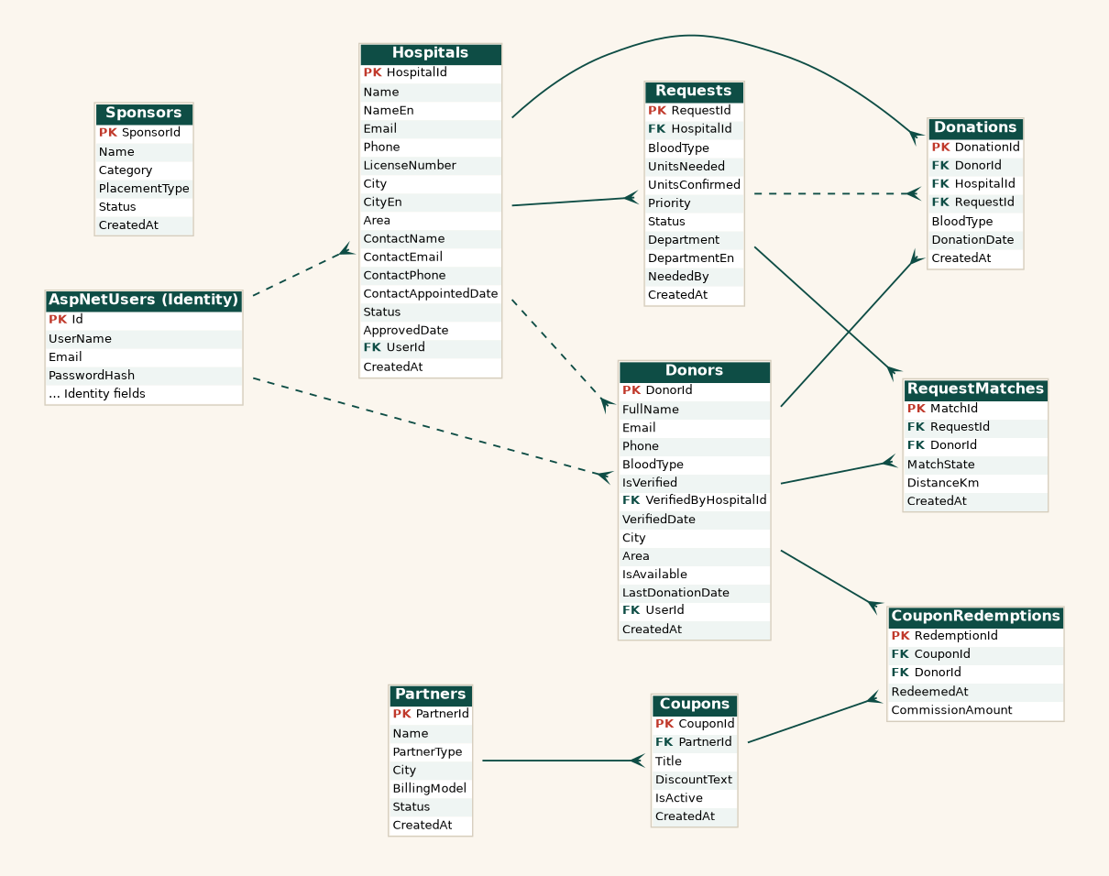
Figure 1 — Najda database ERD.

4.3 Structured Tables (columns, types & keys)
Each table below lists its columns with the SQL Server data type generated by Entity Framework, the key role (PK / FK), and whether the column is required (NOT NULL).
Hospitals
Column | Data type | Key | Required
HospitalId | int (identity) | PK | Yes
Name | nvarchar(150) | — | Yes
NameEn | nvarchar(150) | — | —
Email | nvarchar(256) | — | Yes
Phone | nvarchar(30) | — | —
LicenseNumber | nvarchar(50) | — | —
City | nvarchar(80) | — | Yes
CityEn | nvarchar(80) | — | —
Area | nvarchar(80) | — | —
ContactName | nvarchar(120) | — | —
ContactEmail | nvarchar(256) | — | —
ContactPhone | nvarchar(30) | — | —
ContactAppointedDate | datetime2 | — | —
Status | nvarchar(10) | — | Yes
ApprovedDate | datetime2 | — | —
UserId | nvarchar(450) | FK | —
CreatedAt | datetime2 | — | Yes
Donors
Column | Data type | Key | Required
DonorId | int (identity) | PK | Yes
FullName | nvarchar(120) | — | Yes
Email | nvarchar(256) | — | Yes
Phone | nvarchar(30) | — | —
BloodType | nvarchar(3) | — | Yes
IsVerified | bit | — | Yes
VerifiedByHospitalId | int | FK | —
VerifiedDate | datetime2 | — | —
City | nvarchar(80) | — | Yes
Area | nvarchar(80) | — | —
IsAvailable | bit | — | Yes
LastDonationDate | datetime2 | — | —
UserId | nvarchar(450) | FK | —
CreatedAt | datetime2 | — | Yes
Requests
Column | Data type | Key | Required
RequestId | int (identity) | PK | Yes
HospitalId | int | FK | Yes
BloodType | nvarchar(3) | — | Yes
UnitsNeeded | int | — | Yes
UnitsConfirmed | int | — | Yes
Priority | nvarchar(10) | — | Yes
Status | nvarchar(10) | — | Yes
Department | nvarchar(150) | — | —
DepartmentEn | nvarchar(150) | — | —
NeededBy | datetime2 | — | —
CreatedAt | datetime2 | — | Yes
RequestMatches
Column | Data type | Key | Required
MatchId | int (identity) | PK | Yes
RequestId | int | FK | Yes
DonorId | int | FK | Yes
MatchState | nvarchar(12) | — | Yes
DistanceKm | decimal(5,1) | — | —
CreatedAt | datetime2 | — | Yes
Donations
Column | Data type | Key | Required
DonationId | int (identity) | PK | Yes
DonorId | int | FK | Yes
HospitalId | int | FK | Yes
RequestId | int | FK | —
BloodType | nvarchar(3) | — | Yes
DonationDate | datetime2 | — | Yes
CreatedAt | datetime2 | — | Yes
Partners
Column | Data type | Key | Required
PartnerId | int (identity) | PK | Yes
Name | nvarchar(150) | — | Yes
PartnerType | nvarchar(20) | — | Yes
City | nvarchar(80) | — | —
BillingModel | nvarchar(20) | — | Yes
Status | nvarchar(10) | — | Yes
CreatedAt | datetime2 | — | Yes
Coupons
Column | Data type | Key | Required
CouponId | int (identity) | PK | Yes
PartnerId | int | FK | Yes
Title | nvarchar(150) | — | Yes
DiscountText | nvarchar(100) | — | —
IsActive | bit | — | Yes
CreatedAt | datetime2 | — | Yes
CouponRedemptions
Column | Data type | Key | Required
RedemptionId | int (identity) | PK | Yes
CouponId | int | FK | Yes
DonorId | int | FK | Yes
RedeemedAt | datetime2 | — | Yes
CommissionAmount | decimal(6,2) | — | Yes
Sponsors
Column | Data type | Key | Required
SponsorId | int (identity) | PK | Yes
Name | nvarchar(150) | — | Yes
Category | nvarchar(20) | — | Yes
PlacementType | nvarchar(20) | — | Yes
Status | nvarchar(10) | — | Yes
CreatedAt | datetime2 | — | Yes

4.4 Tables & Relationships
Table | Purpose & key relationships
Hospitals | Hospitals and blood banks. PK HospitalId. Links to AspNetUsers (UserId). One hospital → many Requests, Donations; may verify many Donors.
Donors | Registered donors. PK DonorId. Links to AspNetUsers (UserId) and to the verifying Hospital (VerifiedByHospitalId). One donor → many Donations, RequestMatches, CouponRedemptions.
Requests | Blood requests posted by hospitals. PK RequestId, FK HospitalId. One request → many RequestMatches and Donations.
RequestMatches | Which donors were matched to a request. PK MatchId, FK RequestId, FK DonorId.
Donations | Verified donation records. PK DonationId, FK DonorId, FK HospitalId, FK RequestId (optional).
Partners | Community reward partners (restaurants, pharmacies). PK PartnerId. One partner → many Coupons.
Coupons | Reward offers. PK CouponId, FK PartnerId. One coupon → many CouponRedemptions.
CouponRedemptions | Each time a donor redeems a coupon. PK RedemptionId, FK CouponId, FK DonorId.
Sponsors | Responsible sponsors / ads. PK SponsorId. Standalone reference table.
AspNetUsers | Identity accounts (login). Referenced by Donors.UserId and Hospitals.UserId.

4.5 Keys Summary
Table | Primary key → Foreign keys
Hospitals | PK HospitalId · FK UserId → AspNetUsers
Donors | PK DonorId · FK VerifiedByHospitalId → Hospitals · FK UserId → AspNetUsers
Requests | PK RequestId · FK HospitalId → Hospitals
RequestMatches | PK MatchId · FK RequestId → Requests · FK DonorId → Donors
Donations | PK DonationId · FK DonorId → Donors · FK HospitalId → Hospitals · FK RequestId → Requests
Coupons | PK CouponId · FK PartnerId → Partners
CouponRedemptions | PK RedemptionId · FK CouponId → Coupons · FK DonorId → Donors
Partners / Sponsors | PK PartnerId / SponsorId (no outgoing foreign keys)

Appendix A — Roles & Permissions
Role | Can do
Donor | Register; manage profile & availability; browse and respond to compatible requests; view donation history and next-eligible date.
Hospital | Post and manage blood requests; view matched donors; verify donor blood types after donation. (Requires admin approval.)
Administrator | Approve / suspend hospitals; edit hospital data & contact person; manage donors; view the platform overview.

Appendix B — Glossary
Term | Meaning
Najda | The platform name; Arabic for “rescue / aid”.
Verified type | A blood type confirmed by a hospital laboratory at donation; trusted for matching.
Preliminary type | A blood type entered by the donor at registration; used only to narrow the search until verified.
Eligibility | A donor is eligible again 56 days after their last donation.
Compatibility | Whether a donor’s blood type may be given to a patient of a given type (red-blood-cell rules).
Priority | Whether a request is Urgent or Normal.
Status | A request’s lifecycle stage: Open, Matched, Fulfilled, or Cancelled.

