AppUser
[Description — describe the purpose of this table here]

Design View
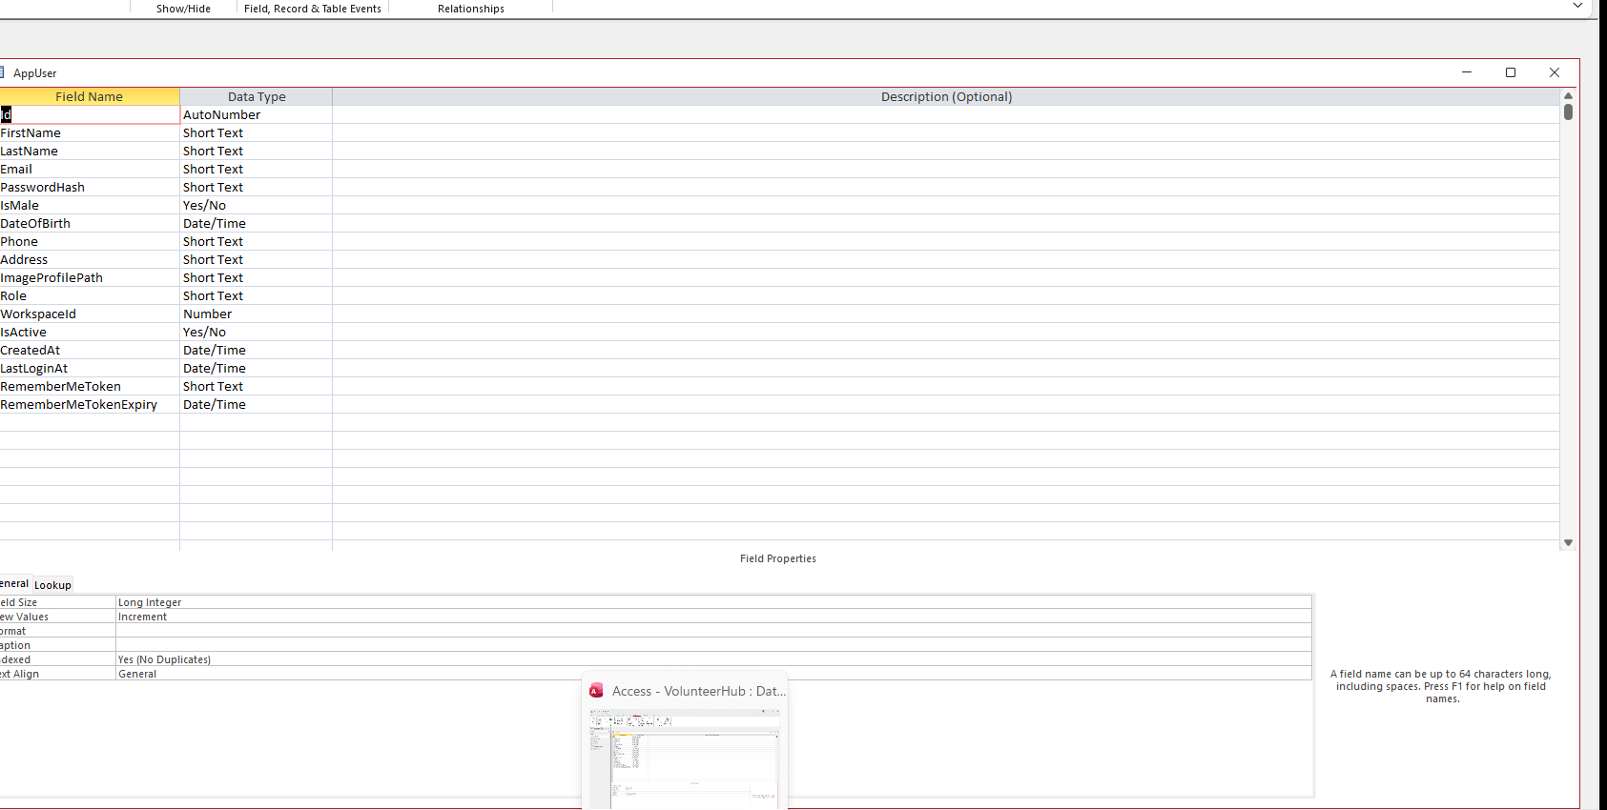

Datasheet View
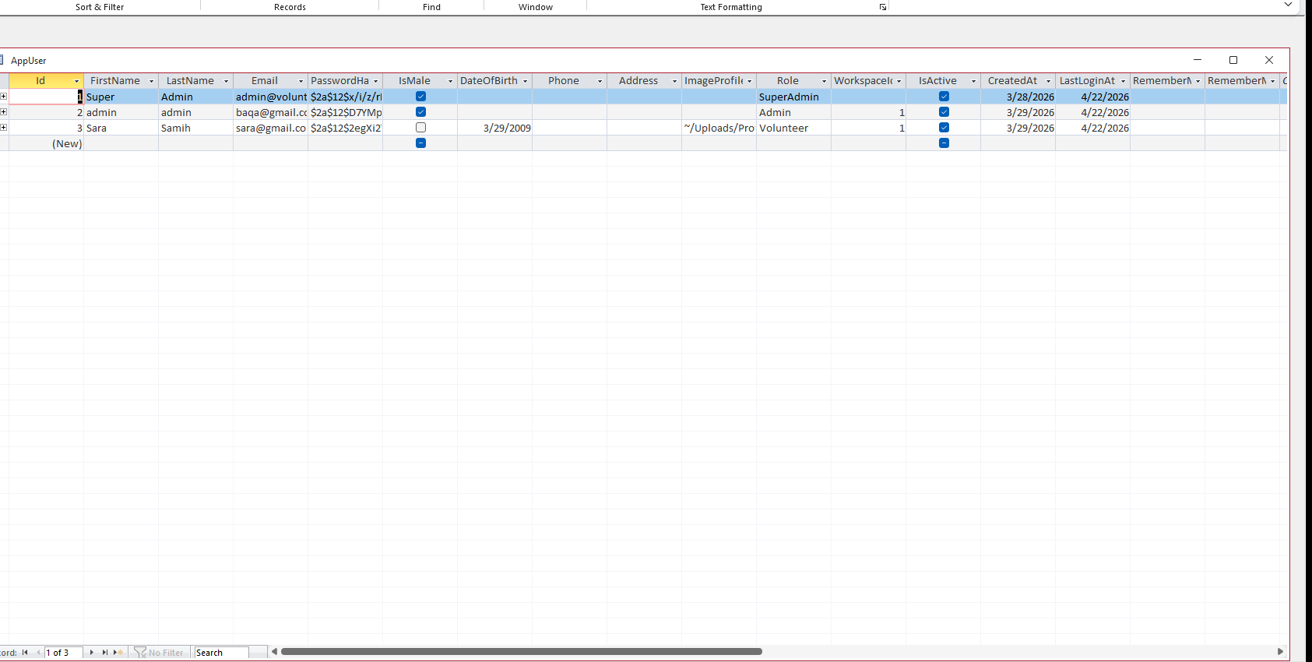

EventImages
[Description — describe the purpose of this table here]

Design View
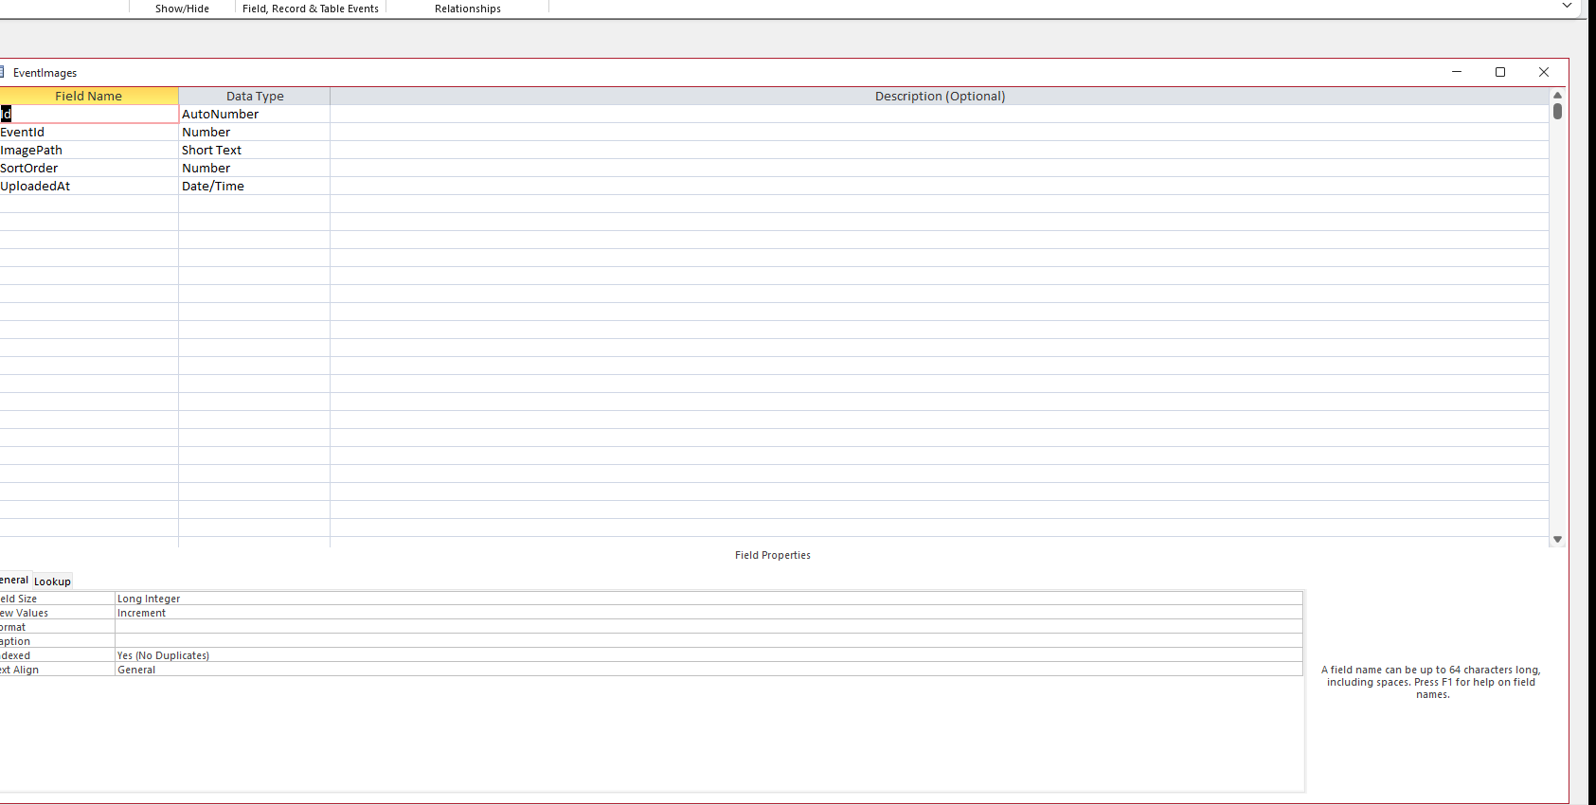

Datasheet View
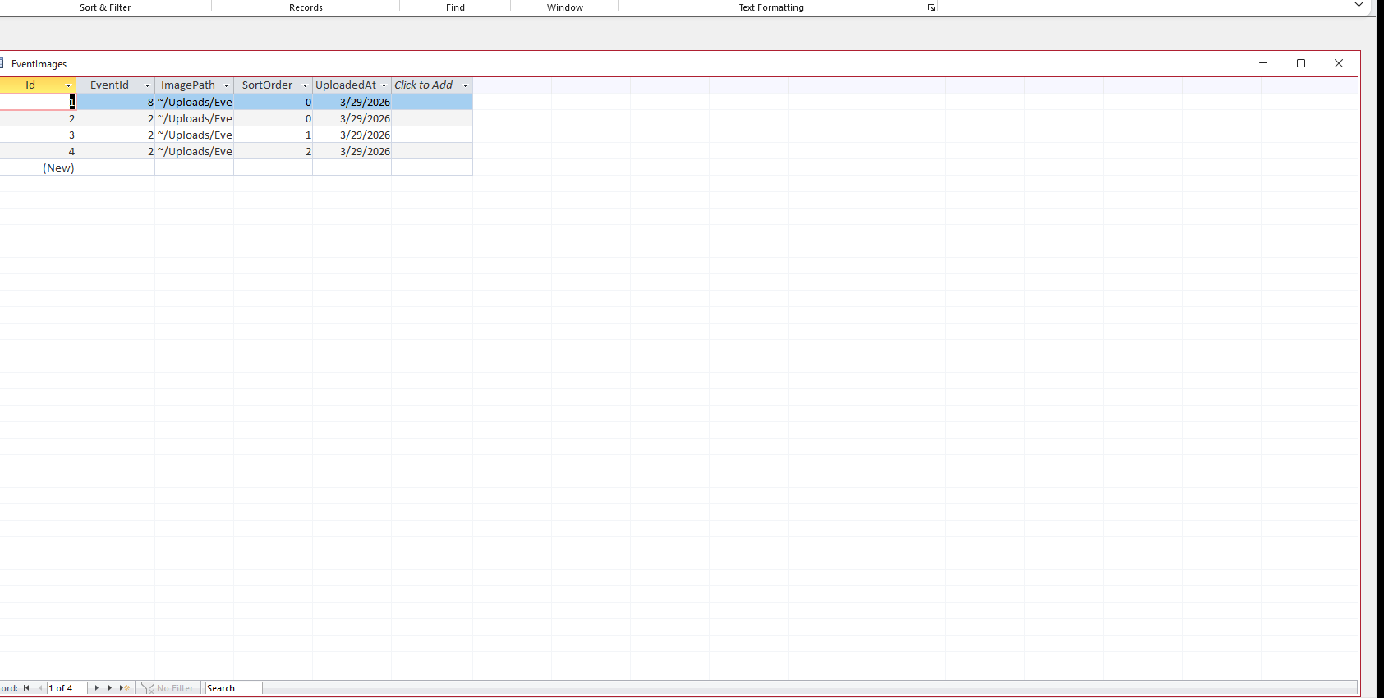

Events
[Description — describe the purpose of this table here]

Design View
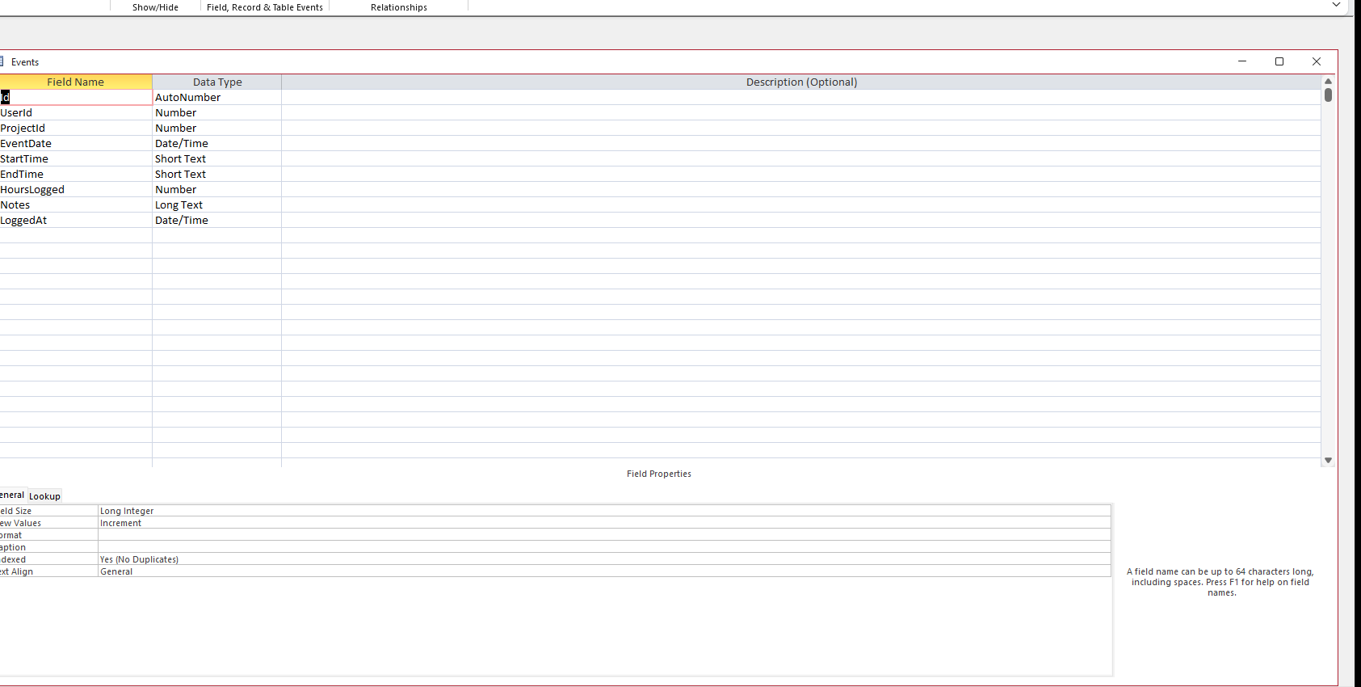

Datasheet View
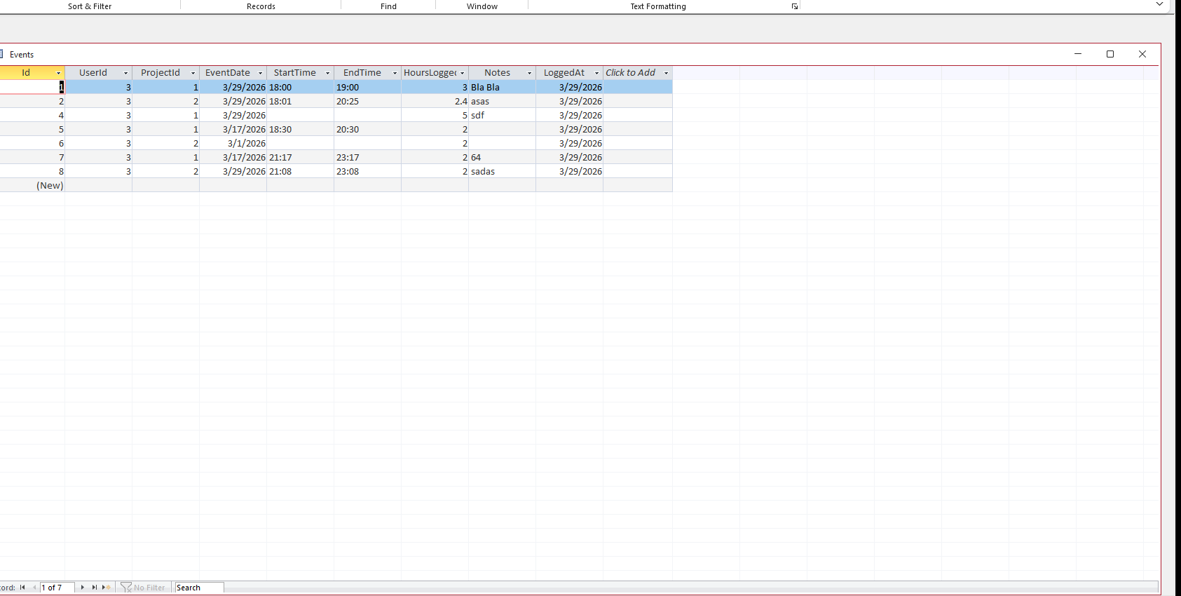

Projects
[Description — describe the purpose of this table here]

Design View
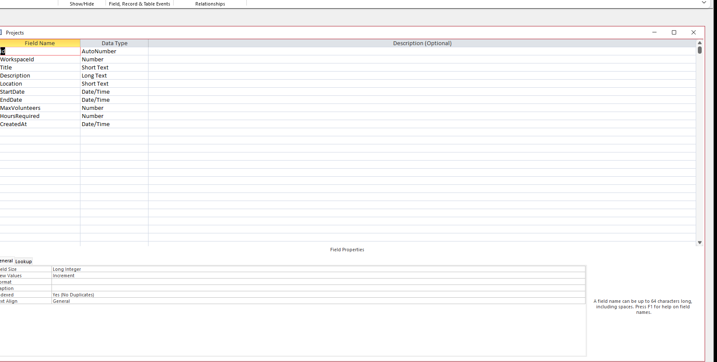

Datasheet View
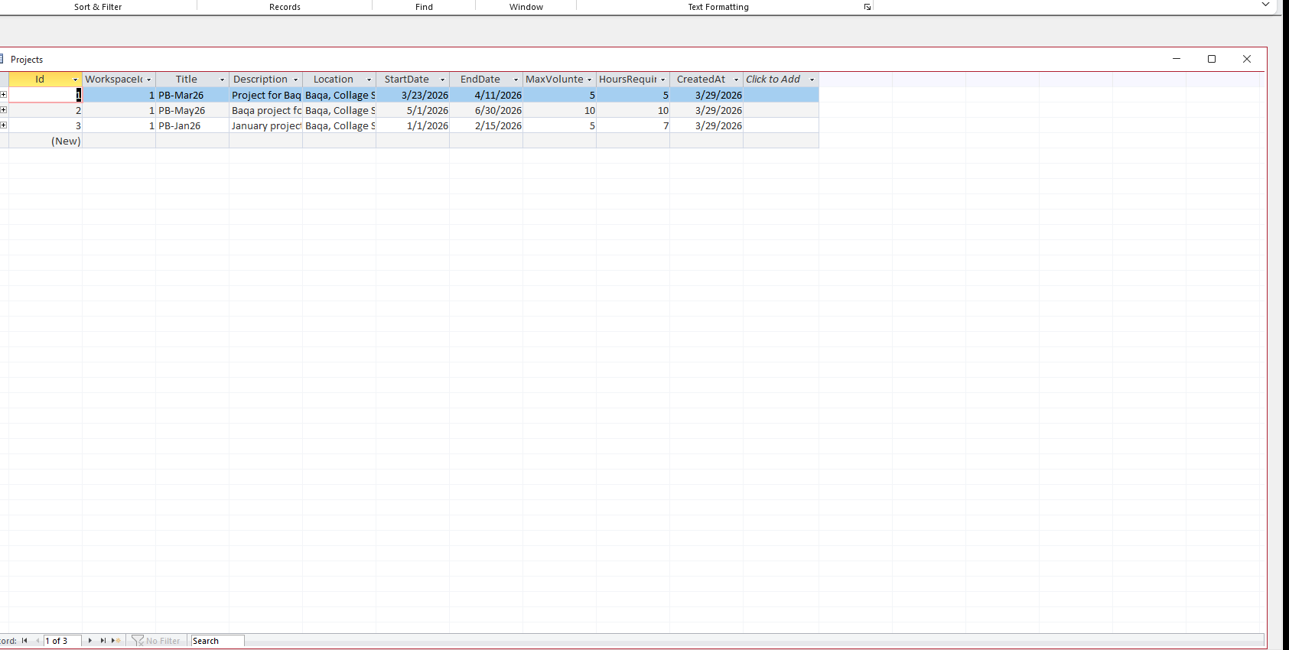

VolunteerProject
[Description — describe the purpose of this table here]

Design View
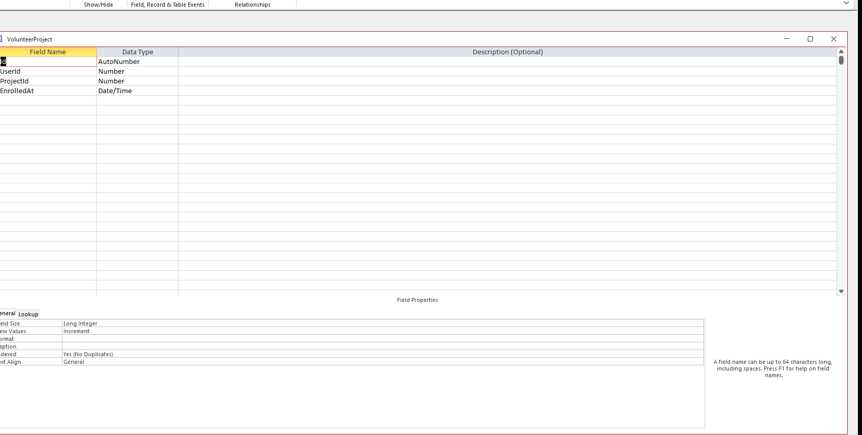

Datasheet View
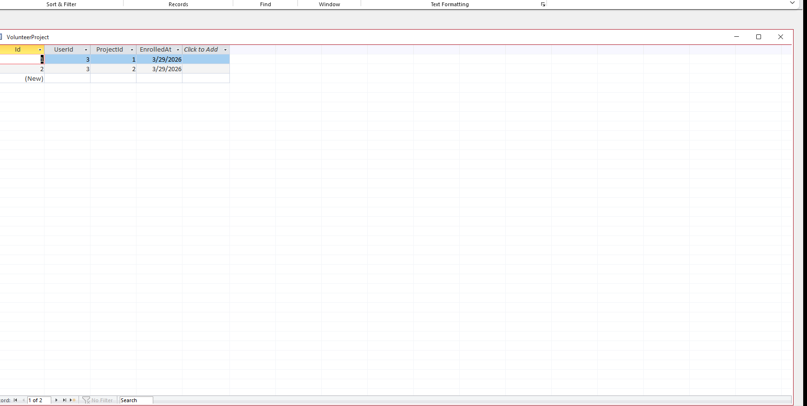

Workspaces
[Description — describe the purpose of this table here]

Design View
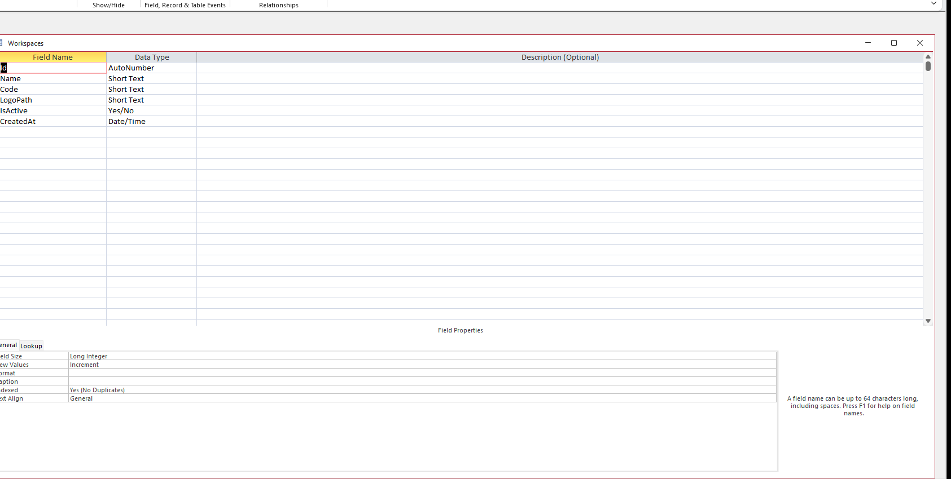

Datasheet View
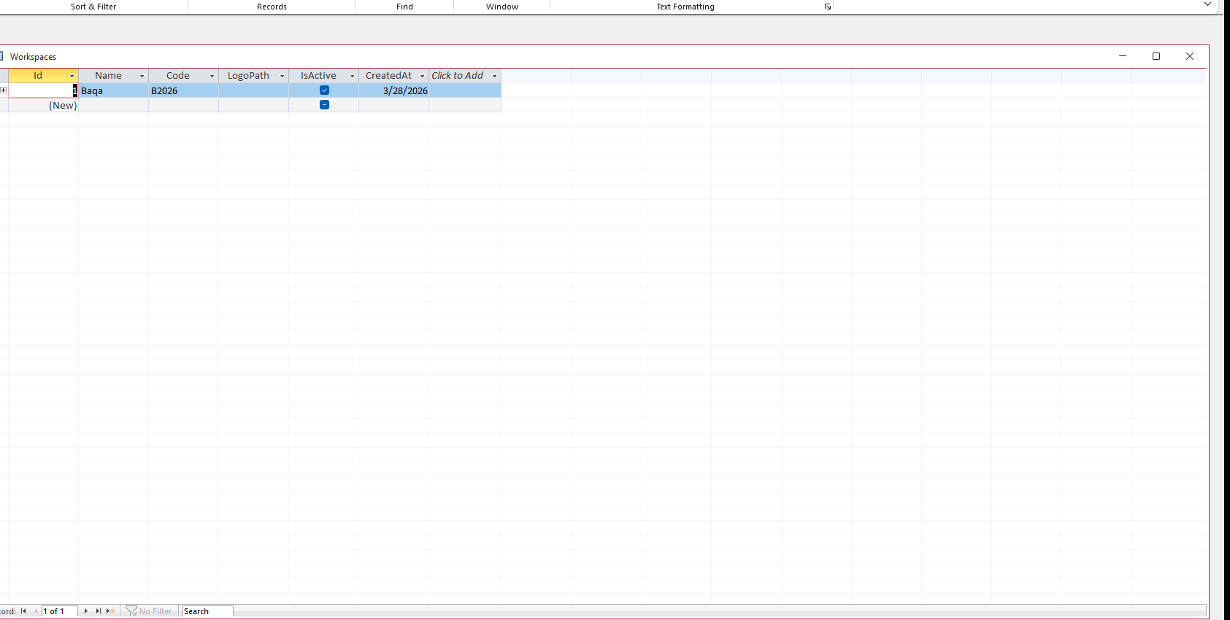

Relationships
[Description — describe the relationships between tables here]
